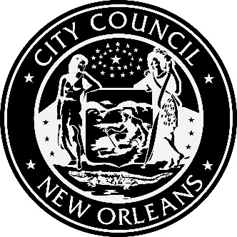

Notice of Initial Public Meeting

New Orleans City Council Utility Docket UD-20-02, Entergy 2021 Integrated Resource Plan

Every three years an Entergy New Orleans (ENO) Integrated Resource Plan (IRP) is produced. This is the planning process by which Entergy assesses the resources available to meet the power supply needs of New Orleans. The IRP is produced following an open, transparent planning process through which all relevant resources are investigated. Resources considered include supply-side (such as power plants, including both conventional and renewable sources of power) and demand-side (programs to modify customer loads to reduce or shift loads from hours with high electricity costs or reliability constraints to other hours, such as demand response programs, the Energy Smart energy efficiency program, and energy storage). The factors influencing choice among these resources are considered in the planning process. The goal is to identify the optimal set of resources to meet current and future electric service needs at the lowest total cost to customers and ENO, in a manner consistent with the long-run public interest and the Council’s energy policy goals. The expected combination of costs, reliability, risks and uncertainty are considered.

The planning process to develop the 2021 IRP is underway. An initial public meeting will be held:

Wednesday, October 14, 2020 from 1:00 p.m. – 3:00 p.m.
New Orleans City Council Chamber,
City Hall, 1300 Perdido St., Room 1E07, New Orleans.

In the event that restrictions on public gatherings due to the COVID-19 pandemic will still be in effect on October 14, 2020, the public meeting will be held via videoconference in a manner that allows public participation. The Council Utilities Regulatory Office will determine whether a videoconference will be necessary, and will publish notice of how to participate via videoconference on the Council’s website no later than October 1, 2020.

The public is invited and encouraged to attend/view this meeting, to hear presentations by the Council’s Advisors and/or ENO regarding (1) the purpose of the IRP; (2) the IRP process, timeline and procedural schedule; (3) analyses performed in the IRP process, including the inputs and assumptions thereto; and (4) ways in which the public may participate in the proceeding.

The Council’s Utilities Regulatory Office will maintain a sign-up sheet for Interested Persons who wish to receive copies of all filings, issuances, and notices occurring in the proceeding. If you wish to be included on this list, please contact CURO at 504-658-1112 or by email to Bobbie Mason at bfmason1@nola.gov. You are also welcome to watch the meeting, either as it is live-streamed or once it is archived, at http://www.nolacitycouncil.com/video/video_legislative.asp.

