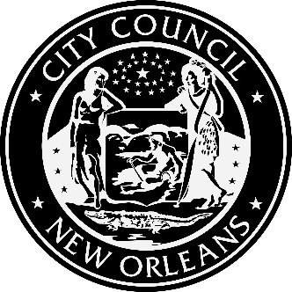

AGENDA
Demand Side Management Potential Study Kickoff Meeting
Wednesday, April 4, 2018, 9:00 A.M. - NOON
New Orleans City Council Chambers
City Hall First Floor, 1300 Perdido Street, New Orleans, LA

2018 TRIENNIAL INTEGRATED RESOURCE PLAN OF ENTERGY NEW ORLEANS, INC.; Council Utility Docket UD-17-03

1. Study Methodology Presentation (30 minutes)
a. Walk through of Optimal’s planned methodology for the study
b. Information on the development of:
i. Load forecasts
ii. Avoided costs
iii. Measure characterizations
iv. Cost-effectiveness tests

2. Comments and Discussion related to the Methodology Presentation (1 hour)

3. Draft Measure List Discussion (30 minutes)
a. Walk through of Optimal’s proposed energy efficient measures that will be include in the study
b. Measures include efficiency, demand response, and rate structures i. Particular emphasis to be placed on emerging technologies that will be investigated

4. Comments and Discussion related to the Proposed Measure List (1 hour)

This meeting is accessible to people with disabilities. Should you require any accommodation to participate fully, please contact Tom Stratton at 504 658-1110 (Voice); TTY: 711, LA Relay Service or by email to wtstrattonjr@nola.gov at least 18 hours prior to this event. This communiqué’ is available in alterative formats upon request.
Posted: March 26, 2018 at 12:15 pm

