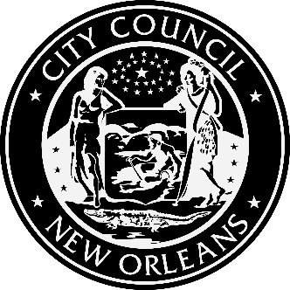

AGENDA
Demand Side Management Potential Study Kickoff Meeting
Wednesday, April 4, 2018, 9:00 A.M. - NOON
New Orleans City Council Chambers
City Hall First Floor, 1300 Perdido Street, New Orleans, LA

2018 TRIENNIAL INTEGRATED RESOURCE PLAN OF ENTERGY NEW ORLEANS, INC.; Council Utility Docket UD-17-03

1. Review of ENO’s Response to the 1st Set of Data Requests
a. Energy Smart Program details
b. Past DSM Potential Study details
c. Customer Rate Tariff Data
i. Specific information regarding LIS
d. Energy Sales and Forecast Data
i. Commercial & Residential
e. Additional Data
i. Avoided Costs & Cost Effectiveness
ii. 2017 WACC
iii. Equipment Saturations & Baseline Efficiencies
iv. Resolutions & Motions
2. Review of available data
a. DSM Loadshapes
b. 2012 IRP Reports
3. Questions from Optimal provided at the meeting
a. Interpretation of data
4. Review of other available information
a. Available information to improve the quality of the study
5. Discussion of ENOs plans to integrate the results into the IRP process
a. What format does ENO want the results provided in?
b. Ways to make the transfer of results easiest

This meeting is accessible to people with disabilities. Should you require any accommodation to participate fully, please contact Tom Stratton at 504 658-1110 (Voice); TTY: 711, LA Relay Service or by email to wtstrattonjr@nola.gov at least 18 hours prior to this event. This communiqué’ is available in alterative formats upon request.
Posted: March 26, 2018 at 11:00 am

