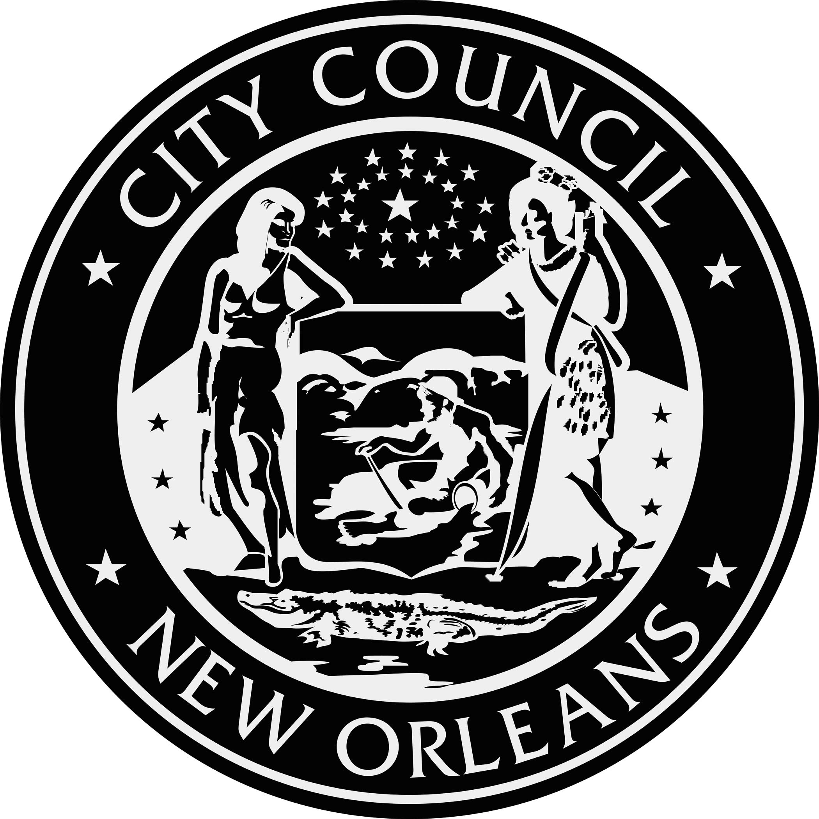
PUBLIC NOTICE

PUBLIC HEARING
Monday, October 16, 2017 from 5:30 - 7:30 PM
The New Orleans City Council, through its Utilities Regulatory Office, will convene a public hearing on Monday, October 16, 2017 from 5:30 - 7:30 PM in the City Council Chamber on the first floor of City Hall.

As required by Council Resolution No. R-17-426, the hearing is for the purpose of allowing members of the public to attend and comment on applications by Entergy New Orleans for approval to construct an electricity generating station in New Orleans and recover its costs. The application is being considered in Council Utility Docket UD-16-02.

A court reporter will be present to record the statements made during the public hearing. The court reporter’s transcript will be filed in the docket and made available for review in the Clerk of Council's office upon completion.

Please direct any questions by email to wtstrattonjr@nola.gov or by phone to 504 658-1110.

CITY COUNCIL UTILITY, CABLE, TELECOMMUNICATIONS AND TECHNOLOGY COMMITTEE
JASON ROGERS WILLIAMS, COMM. CHAIRPERSON, COUNCILMEMBER-AT-LARGE
STACY HEAD, COUNCILMEMBER-AT-LARGE
SUSAN G. GUIDRY, COUNCILMEMBER, DISTRICT “A”
JARED C. BROSSETT, COUNCILMEMBER, DISTRICT "D"
JAMES A. GRAY, II, COUNCILMEMBER, DISTRICT "E"

FOR MORE INFORMATION PLEASE CONTACT:
COUNCIL UTILITY REGULATORY OFFICE, 658-1110

This meeting is accessible to people with disabilities. Should you require any accommodation to participate fully, please contact Tom Stratton at 504 658-1110 (Voice); TTY: 711, LA Relay Service or by email to wtstrattonjr@nola.gov at least 18 hours prior to this event. This communiqué’ is available in alterative formats upon request.
Posted 10.4.17 at 3pm

