Evaluation of PY6 Energy Efficiency Programs Portfolio

Submitted to:

*Entergy New Orleans*

*August 2017*

*Final*

Submitted by:

**

ADM Associates, Inc.   
3239 Ramos Circle  
Sacramento, CA 95827  
916.363.8383

# Prepared by:

**Adam Thomas**

**Jeremy Offenstein, Ph.D.**

**Zephaniah Davis**

**Jordan Christenson**

**Jennifer Shen**

**Chris Johnson**

**Lily Forest**

Table of Contents

1. Executive Summary 1-1

2. General Methodology 2-1

3. Home Performance with ENERGY STAR® 3-1

4. Assisted Home Performance with ENERGY STAR 4-1

5. Green Light Direct install 5-1

6. Consumer Products 6-1

7. Residential Heating & Cooling 7-1

8. Energy Smart School Kits & Education 8-1

9. Small Business Solutions 9-1

10. Large Commercial & Industrial 10-1

11. Direct Load Control Pilot 11-1

12. Appendix A: Site Reports 12-1

13. Appendix B: Survey Instruments & Interview Guides 13-1

14. Appendix C: Cost Benefit Testing 14-1

List of Tables

Table 1‑1 Summary of Data Collected 1-2

Table 1‑2 Gross Impact Summary – New Orleans 1-2

Table 1‑3 Gross Impact Summary - Algiers 1-3

Table 1‑4 Net kWh and kW Impacts – New Orleans 1-3

Table 1‑5 Net kWh and kW Impacts – Algiers 1-4

Table 1‑6 Summary of Goal Attainment – New Orleans 1-4

Table 1‑7 Summary of Goal Attainment – Algiers 1-5

Table 1‑8 Cost-Effectiveness by Program – New Orleans 1-8

Table 1‑9 Cost-Effectiveness by Program - Algiers 1-8

Table 1‑10 Program Performance Comparison 1-10

Table 2‑1 Stratified Sampling Summary 2-3

Table 3‑1 Summary of Measures and Expected Savings – New Orleans 3-1

Table 3‑2 Summary of Measures and Expected Savings – Algiers 3-2

Table 3‑3 Summary of Program Goals 3-2

Table 3‑4 HPwES Summary of kWh Goal Achievement 3-2

Table 3‑5 Deemed Savings Values for Air Infiltration Reduction 3-3

Table 3‑6 Deemed Savings Values for Duct Sealing Calculations 3-3

Table 3‑7 Summary of Measures and Expected Savings – New Orleans 3-6

Table 3‑8 Air Infiltration Savings Multipliers 3-8

Table 3‑9 Expected and Realized Air Sealing Savings – New Orleans 3-8

Table 3‑10 Expected and Realized Air Sealing Savings - Algiers 3-8

Table 3‑11 Savings Parameter Differences by Parameter 3-10

Table 3‑12 Expected and Realized Duct Sealing Savings – New Orleans 3-11

Table 3‑13 Expected and Realized Duct Sealing Savings - Algiers 3-11

Table 3‑14 Program Tracking Baseline R-Values 3-12

Table 3‑15 Savings Multiplier Changes by Heating Type 3-13

Table 3‑16 Expected and Realized Attic Insulation Savings – New Orleans 3-13

Table 3‑17 Expected and Realized Attic Insulation Savings - Algiers 3-13

Table 3‑18 Gross Realization Summary – New Orleans 3-14

Table 3‑19 Gross Realization Summary – Algiers 3-14

Table 3‑20 Participant Reported Spillover Impacts 3-17

Table 3‑21 HPwES Summary of Verified Net Savings 3-18

Table 3‑22 HPwES Summary of Verified Net Peak Demand Reductions 3-18

Table 3‑23 HPwES Average Free Ridership by Measure 3-18

Table 3‑24 HPwES Process Evaluation – Summary of Data Collection 3-19

Table 3‑25 HPwES Incentives 3-20

Table 3‑26 Assessment of ENO HPwES against National Guidelines 3-21

Table 3‑27 Program Activity by Measure Type 3-23

Table 3‑28 Number of Measures and Expected Savings by Engagement Type 3-24

Table 3‑29 Program Activity by Participating HPwES Contractor 3-24

Table 3‑30 Participant Home Demographics 3-26

Table 3‑31 Average Household size 3-27

Table 3‑32 HPwES Participant Satisfaction with Entergy 3-34

Table 3‑33 Effect of Program on Satisfaction with Entergy 3-34

Table 4‑1 aHPwES Summary of Measures and Expected Savings – New Orleans 4-2

Table 4‑2 aHPwES Summary of Measures and Expected Savings – Algiers 4-2

Table 4‑3 Summary of Program Goals 4-2

Table 4‑4 aHPwES Summary of Goal Achievement 4-2

Table 4‑5 Expected and Realized Air Sealing Savings – New Orleans 4-3

Table 4‑6 Expected and Realized Air Sealing Savings - Algiers 4-3

Table 4‑7 Expected and Realized Duct Sealing Savings – New Orleans 4-3

Table 4‑8 Expected and Realized Duct Sealing Savings - Algiers 4-4

Table 4‑9 Expected and Realized Attic Insulation Savings – New Orleans 4-4

Table 4‑10 Expected and Realized Attic Insulation Savings - Algiers 4-4

Table 4‑11 Gross Realization Summary – New Orleans 4-5

Table 4‑12 Gross Realization Summary – Algiers 4-5

Table 4‑13 aHPwES Process Evaluation – Summary of Data Collection 4-6

Table 4‑14 Income Limits for Participation in aHPwES 4-6

Table 4‑15 Incentives for Assessments and Measures 4-7

Table 4‑16 Program Activity by Measure Implemented 4-7

Table 4‑17 Program Activity by Participating Contractor 4-8

Table 4‑18 Participant Demographics 4-10

Table 4‑19 Household Demographics 4-11

Table 4‑20 Non-Energy Benefits of the Program 4-17

Table 4‑21 Overall Satisfaction with Entergy 4-18

Table 4‑22 Effect of Program on Satisfaction with Entergy 4-18

Table 5‑1 Summary of Measures and Expected Savings – New Orleans 5-1

Table 5‑2 Summary of Measures and Expected Savings - Algiers 5-2

Table 5‑3 GLDI Savings Goals & Attainment by Utility 5-2

Table 5‑4 EISA Baseline Assumptions (Standard Lamps) 5-3

Table 5‑5 EISA Baseline Assumptions (Specialty Lamps) 5-4

Table 5‑6 IEFE Assumptions 5-4

Table 5‑7 IEFD Assumptions 5-4

Table 5‑8 Verified Gross Savings – New Orleans 5-5

Table 5‑9 Verified Gross Savings – Algiers 5-5

Table 5‑10 Timing Adjustment Score 5-6

Table 5‑11 GLDI Summary of Ex Post Net kWh Savings 5-6

Table 5‑12 GLDI Summary of Ex Post Net Peak kW Reductions 5-6

Table 5‑13 GLDI Process Evaluation – Summary of Data Collection 5-7

Table 5‑14 Participant Demographics 5-9

Table 5‑15 Participant Residence Characteristics 5-9

Table 5‑16 GLDI Satisfaction with Entergy as an Electrical Service Provider 5-13

Table 5‑17 GLDI Change in Satisfaction with Entergy as a Result of Program Participation 5-14

Table 6‑1 Summary of Measures and Expected Savings - Total 6-1

Table 6‑2 Summary of Measures and Expected Savings – New Orleans 6-1

Table 6‑3 Summary of Measures and Expected Savings - Algiers 6-1

Table 6‑4 Savings Goals by Utility 6-2

Table 6‑5 CPP Data Sources by Measure 6-3

Table 6‑6 Deemed Savings Values for Lighting Calculations 6-3

Table 6‑7 Baseline Wattages by Lamp Type 6-4

Table 6‑8. Hours of Use by Area 6-5

Table 6‑9 Overall Model Coefficients 6-5

Table 6‑10 Room Model Coefficients 6-6

Table 6‑11. Window AC Replacement – Baseline and Efficiency Standards 6-8

Table 6‑12 Deemed Savings Values for Room Air Conditioner Calculations 6-8

Table 6‑13 Parameters for kWh usage of conventional and ENERGY STAR® Pool Pump 6-9

Table 6‑14 Conventional Pool Pumps Assumptions 6-9

Table 6‑15 ENERGY STAR® Multi-Speed Pool Pumps Assumptions 6-10

Table 6‑16 ENERGY STAR® Variable Speed Pool Pumps – Deemed Savings Values 6-10

Table 6‑17 ENERGY STAR® Multi-Speed Pool Pumps – Deemed Savings Values 6-10

Table 6‑18 Expected and Realized Lighting Savings – New Orleans 6-11

Table 6‑19 Expected and Realized Lighting Savings - Algiers 6-12

Table 6‑20 Expected and Realized Power Strip Savings – New Orleans 6-12

Table 6‑21 Expected and Realized Power Strip Savings – Algiers 6-12

Table 6‑22 Expected and Realized Pool Pump Savings – New Orleans 6-12

Table 6‑23 Expected and Realized Pool Pump Savings - Algiers 6-12

Table 6‑24 Expected and Realized Room AC Savings – New Orleans 6-13

Table 6‑25 Expected and Realized Room AC Savings - Algiers 6-13

Table 6‑26 kWh and Peak kW Realization Summary – New Orleans 6-13

Table 6‑27 kWh and Peak kW Realization Summary - Algiers 6-13

Table 6‑28 Participant Reported Spillover Impacts 6-17

Table 6‑29 Net to Gross Ratios for CFLs and LEDs 6-17

Table 6‑30 Summary of Verified Net Savings – Lighting Component 6-18

Table 6‑31 Summary of Verified Net Peak Demand Reductions – Lighting Component 6-18

Table 6‑32 Summary of Verified Net Savings – Appliance Component 6-18

Table 6‑33 Summary of Verified Net Peak Demand Reductions – Appliance Component 6-19

Table 6‑34 Average Free Ridership by Measure 6-19

Table 6‑35 Verified Net Savings – New Orleans 6-19

Table 6‑36 Verified Net Savings – Algiers 6-19

Table 6‑37 CP Process Evaluation – Summary of Data Collection 6-20

Table 6‑38 Number of Participating Retailers 6-21

Table 6‑39 Appliance Rebates 6-21

Table 6‑40 Summary of CP Program Activity 6-22

Table 6‑41 CPP Participant Demographics 6-25

Table 6‑42 CPP Residence Characteristics 6-25

Table 6‑43 CPP Overall Satisfaction with Entergy 6-29

Table 6‑44 CPP Effect of Program on Satisfaction with Entergy 6-29

Table 7‑1 RH&C Summary of Measures and Expected Savings 7-1

Table 7‑2 RH&C Savings Goals & Attainment by Utility 7-1

Table 7‑3 RH&C CAC/HP Tune-up Savings Summary – New Orleans 7-3

Table 7‑4 RH&C CAC/HP Tune-up Savings Summary – Algiers 7-4

Table 7‑5 RH&C CAC/HP Savings Summary – New Orleans 7-6

Table 7‑6 RH&C CAC/HP Savings Summary - Algiers 7-6

Table 7‑7 Deemed Savings Values for Duct Sealing Calculations 7-7

Table 7‑8 Expected and Realized Duct Sealing Savings – New Orleans 7-9

Table 7‑9 Expected and Realized Duct Sealing Savings - Algiers 7-9

Table 7‑10 Realization Summary – New Orleans 7-9

Table 7‑11 Realization Summary - Algiers 7-10

Table 7‑12 Participant Reported Spillover Impacts 7-13

Table 7‑13 RH&C Summary of Verified Net Savings 7-13

Table 7‑15 RH&C Summary of Verified Net Peak Demand Reductions 7-14

Table 7‑16 Average Free Ridership by Measure 7-14

Table 7‑17 Residential Heating & Cooling Process Evaluation – Summary of Data Collection 7-15

Table 7‑17 Program Activity by Measure Implemented 7-15

Table 7‑18 AC Tune Up Activity by Unit Size the Type 7-16

Table 7‑19 RH&C Participant Demographics 7-22

Table 7‑20 RH&C Residential Demographics 7-22

Table 7‑21 RH&C Source of Program Awareness 7-23

Table 7‑22 RH&C Overall Satisfaction with Entergy 7-29

Table 7‑23 RH&C Effect of Program on Satisfaction with Entergy 7-30

Table 8‑1 SK&E Summary of Measures and Expected Savings 8-2

Table 8‑2 SK&E Savings Goals by Utility 8-2

Table 8‑3 SK&E Savings Inputs 8-3

Table 8‑4 SK&E Savings Parameters for CFL/LEDs 8-4

Table 8‑5 SK&E Savings Parameters for Nightlights 8-5

Table 8‑6 SK&E Savings Parameters for Faucet Aerators 8-6

Table 8‑7 SK&E Savings Parameters for Low Flow Showerheads 8-7

Table 8‑8 SK&E Verified Savings by Measure Type – New Orleans 8-8

Table 8‑9 SK&E Verified Savings by Measure Type - Algiers 8-9

Table 8‑10 SK&E Summary of Verified Net Savings 8-11

Table 8‑11 SK&E Summary of Verified Net Peak Demand Reductions 8-11

Table 8‑12 SK&E Average Free Ridership by Measure 8-12

Table 8‑13 SK&E Data Collection Activities 8-13

Table 8‑14 SK&E Program Activity by Utility 8-13

Table 8‑15 SK&E Participant Demographics 8-15

Table 8‑16 SK&E Participant Home Characteristics 8-15

Table 8‑17 SK&E Barriers to Installing CFLs 8-16

Table 8‑18 SK&E Barriers to Installing Faucet Aerators 8-16

Table 8‑19 SK&E Barriers to Installing Shower Heads 8-16

Table 8‑20 SK&E Satisfaction with Entergy 8-18

Table 8‑21 SK&E Effect of Program on Satisfaction with Entergy 8-19

Table 9‑1 Savings Expectations by Program Component ENO 9-1

Table 9‑2 Savings Expectations by Program Component Algiers 9-1

Table 9‑3 SBS Savings Goals by Utility 9-2

Table 9‑4 Data Sources for Gross Impact Parameters – SBS program 9-3

Table 9‑5 Commercial EFLHc 9-4

Table 9‑6 PY6 Small Business Program Participation Summary 9-4

Table 9‑7 Small Business Sample Summary 9-5

Table 9‑8 Small Business Program Lighting Sample Design (Pooled) 9-5

Table 9‑9 SBS Expected Savings for Sampled and Non-Sampled Lighting Projects by Stratum 9-6

Table 9‑10 SBS Summary of Lighting kWh Savings for Small Business Program by Sample Stratum (Pooled) 9-6

Table 9‑11 SBS Expected and Realized Savings by Sampled Project 9-7

Table 9‑12 Small Business - Lighting Realization by Stratum 9-7

Table 9‑13 SBS Lighting Savings by Contractor 9-8

Table 9‑14 Small Business – Causes of Variance in Savings 9-8

Table 9‑15 SBS Duct Sealing Realized Savings 9-9

Table 9‑16 SBS Tune-Ups Realized Savings 9-10

Table 9‑17 SBS Program-Level Realized Savings - ENO 9-10

Table 9‑18 SBS Program-Level Realized Savings - Algiers 9-10

Table 9‑19 Free Ridership Scores for Combinations of Indicator Variable Responses 9-14

Table 9‑20 Free-Ridership Scoring Results 9-15

Table 9‑21 Summary of Net Ex Post kWh Savings 9-15

Table 9‑22 Summary of Ex Post Net Peak kW Reductions 9-16

Table 9‑23 Small Business Program Process Evaluation – Summary of Data Collection 9-16

Table 9‑24 Program Savings and Cost per kWh Saved by Measure Type 9-17

Table 9‑25 Share of Expected Energy Savings by Contractor 9-19

Table 9‑26 Water and Space Heating Fuel Types 9-21

Table 9‑27 Satisfaction with Entergy as Electrical Service Provider 9-25

Table9‑28 Effect of Program on Satisfaction with Entergy 9-26

Table 10‑1 Large C&I Summary of Program Incentives 10-1

Table 10‑2 Large C&I Savings Goals by Utility 10-1

Table 10‑3 PY6 Large C&I program Participation Summary 10-1

Table 10‑4 Large C&I program Sample Summary 10-2

Table 10‑5 Large C&I program Sample Design 10-2

Table 10‑6 Large C&I program Sample Design Sans Certainty Site 10-3

Table 10‑7 Expected Savings for Sampled and Non-Sampled Projects by Stratum 10-3

Table 10‑8 Summary of kWh Savings for Large C&I by Sample Stratum 10-3

Table 10‑9 Expected and Realized Savings by Project 10-4

Table 10‑10 Large C&I Program-Level Realization by Stratum 10-4

Table 10‑11 Large C&I program Savings by Measure Category 10-4

Table 10‑12 Large C&I Program Savings by Utility 10-5

Table 10‑13 Large C&I – Causes of Deviation in Savings Estimates 10-5

Table 10‑14.Free Ridership Scores for Combinations of Indicator Variable Responses 10-9

Table 10‑15 Free-Ridership Scoring Results 10-10

Table 10‑16 Summary of Net Ex Post kWh Savings 10-11

Table 10‑17 Summary of Ex Post Net Peak kW Reductions 10-11

Table 10‑18 Large Commercial & Industrial Solutions Process Evaluation – Summary of Data Collection 10-12

Table 10‑19 Incentive Amount by End-Use for the C&I Program 10-12

Table 10‑20 Expected kWh Savings by Measure Type 10-13

Table 10‑21 Contributors to the Incentive Application 10-18

Table 10‑22 Satisfaction with Entergy as Electrical Service Provider 10-21

Table 10‑23 Effect of Program on Satisfaction with Entergy 10-21

Table 11‑1 Event Summary 11-3

Table 11‑2 Event Performance (kW/ton) 11-3

Table 11‑3 Event Performance (kW/Unit) 11-4

Table 11‑4 Event Performance – 3-of-5 Baseline 11-4

Table 11‑5 Event Performance – 3-of-10 Baseline 11-4

Table 11‑6 Event Performance – 5-of-10 Baseline 11-4

Table 11‑7 Event Performance – 3-of-8 Baseline 11-5

Table 11‑6 DLC Pilot Data Collection Activities 11-11

Table 11‑7 Benchmark Program Cycling Strategies 11-11

Table 11‑1, Lighting Retrofit kW Savings Calculations 12-20

Table 13‑1 Cost-Effectiveness by Program – New Orleans 14-2

Table 13‑2 Cost-Effectiveness by Program - Algiers 14-2

Table 14‑3 HPwES Benefit/Cost Tests – New Orleans 14-3

Table 14‑4 HPwES Benefit/Cost Tests - Algiers 14-3

Table 14‑5 RH&C Benefit/Cost Tests – New Orleans 14-3

Table 14‑6 RH&C Benefit/Cost Tests - Algiers 14-3

Table 14‑7 Consumer Products Benefit/Cost Tests – New Orleans 14-4

Table 14‑8 Consumer Products Benefit/Cost Tests - Algiers 14-4

Table 14‑9 SE&K Benefit/Cost Tests – New Orleans 14-4

Table 14‑10 SE&K Benefit/Cost Tests - Algiers 14-4

Table 14‑11 SBS Benefit/Cost Tests – New Orleans 14-5

Table 14‑12 SBS Benefit/Cost Tests - Algiers 14-5

Table 14‑13 LCI Benefit/Cost Tests – New Orleans 14-5

Table 14‑14 LCI Benefit/Cost Tests - Algiers 14-5

Table 14‑13 DLC Pilot Benefit/Cost Tests – New Orleans 14-6

Table 14‑14 DLC Pilot Benefit/Cost Tests - Algiers 14-6

Table 14‑15 Whole-Portfolio Benefit/Cost Tests – New Orleans 14-6

Table 14‑16 Whole-Portfolio Benefit/Cost Tests - Algiers 14-6

List of Figures

Figure 1‑1 Savings Adjustments – New Orleans 1-6

Figure 1‑2 kWh Savings Adjustments - Algiers 1-7

Figure 1‑3 Percent of Participants Satisfied with the Program, PY5 and PY6 1-11

Figure 1‑4 Percent of Participants for whom Participation Increased their Satisfaction with the Companies PY5 and PY6 1-12

Figure 3‑1 Air Infiltration Field Testing Results 3-7

Figure 3‑2 Dust Sealing Field Testing Results 3-9

Figure 3‑3 Percentage of Homes by Heating Type (Ex Ante) 3-10

Figure 3‑4 Baseline R-Value for Inspected Attic Insulation (Non-Project Homes) 3-12

Figure 3‑5 Summary of Free Ridership Scoring Algorithm 3-16

Figure 3‑6 Home Energy Yardstick Sample Output 3-22

Figure 3‑7 Activity and Average Expected Savings by Number of Measures Implemented per Project 3-23

Figure 3‑8 Measure Mix by HPwES Contractor 3-25

Figure 3‑9 Measures Implemented by HPwES Participants 3-26

Figure 3‑10 HPwES Source of Program Awareness 3-28

Figure 3‑11 HPwES Reasons for Participation 3-29

Figure 3‑12 HPwES Non-Energy Benefits 3-30

Figure 3‑13 Experience with Program Contractor 3-31

Figure 3‑14 Average Agreement Ratings for Contractors 3-32

Figure 3‑15 HPwES Satisfaction with Program Components 3-33

Figure 3‑16 HPwES Satisfaction with Quality of Work Performed by Contractors 3-33

Figure 4‑1 aHPwES: Average Expected Savings by Number of Measures Implemented 4-8

Figure 4‑2 aHPwES Measure Mix by Contractor 4-9

Figure 4‑3 aHPwES Measures Installed through Program 4-10

Figure 4‑4 aHPwES Source of Program Awareness 4-12

Figure 4‑5 aHPwES Reasons for Participation 4-13

Figure 4‑6 aHPwES Satisfaction with Contractor 4-14

Figure 4‑7 aHPwES Average Agreement Ratings for Contractors 4-15

Figure 4‑8 aHPwES Satisfaction with Program Components 4-16

Figure 4‑9 aHPwES Satisfaction with Quality of Work Performed by Contractors 4-16

Figure 5‑1 GLDI Distribution of Number of CFLs Installed in Participant Residences 5-8

Figure 5‑2 GLDI Source of Program Awareness 5-10

Figure 5‑3 GLDI Reasons for Participating in the Program 5-11

Figure 5‑4 GLDI Awareness of ENO POS Lighting Discounts 5-12

Figure 5‑5 GLDI Participant Satisfaction 5-13

Figure 6‑1 Average Logger Hours vs. Day Length 6-6

Figure 6‑2 Lighting Logger Home Locations 6-7

Figure 6‑3 Summary of Free Ridership Scoring Algorithm 6-16

Figure 6‑4 CP Program Lighting Sales by Retailer 6-22

Figure 6‑5 CPP Monthly and Cumulative Accrual of Lighting kWh Savings 6-23

Figure 6‑6 CP Program Monthly and Cumulative Accrual of Appliance kWh Savings 6-23

Figure 6‑7 CPP Measures Implemented by Survey Respondents 6-24

Figure 6‑8 CPP Source of Program Awareness 6-26

Figure 6‑9 CPP Reasons for Participation 6-27

Figure 6‑10 Satisfaction with Program Components 6-28

Figure 6‑11 CPP Non-Energy Benefits 6-28

Figure 7‑1 EER Gain for M&V Sites 7-3

Figure 7‑2 RH&C Free Ridership Scoring Algorithm 7-12

Figure 7‑3 Monthly and Cumulative HVAC Tune Up Expected kWh Savings 7-17

Figure 7‑4 Monthly and Cumulative AC Replacement Expected Savings 7-17

Figure 7‑5 Monthly and Cumulative Duct Sealing Expected Savings 7-18

Figure 7‑6 Tune-Up Savings by Program Contractor 7-19

Figure 7‑7 Replacement Savings by Program Contractor 7-20

Figure 7‑8 RH&C Age of Tuned-Up Units 7-21

Figure 7‑9 RH&C Reasons for Participation 7-24

Figure 7‑10 RH&C Tune-Up/Duct Sealing Satisfaction with Contractor 7-25

Figure 7‑11 RH&C Average Agreement Ratings for Contractors 7-26

Figure 7‑12 Tune-Up Satisfaction with Program Components 7-27

Figure 7‑13 RH&C Satisfaction with Quality of Work Performed by Contractors 7-28

Figure 7‑14 RH&C Non-Energy Benefits 7-29

Figure 8‑1 SK&E Monthly and Cumulative Expected Savings 8-14

Figure 8‑2 Which Kit Item was Most Useful 8-17

Figure 8‑3 Satisfaction with the Energy Education and Kits Contents 8-18

Figure 9‑1 SBS Accrual of Expected kWh Savings during PY6 9-18

Figure 9‑2 SBS Survey Respondent Facility Type 9-20

Figure 9‑3 SBS Respondents’ Number of Business Locations 9-20

Figure 9‑4 SBS Ownership Status 9-21

Figure 9‑5 SBS Satisfaction with Contractor 9-23

Figure 9‑6 Program Satisfaction 9-24

Figure 10‑1 Monthly and Cumulative Accrual of Expected kWh Savings 10-14

Figure 10‑2 Large C&I Participating Business Types 10-15

Figure 10‑3 Large C&I Number of Business Locations 10-15

Figure 10‑4 Large C&I Site Ownership 10-16

Figure 10‑5 Large C&I Sources of Program Awareness 10-16

Figure 10‑6 Large C&I Reasons for Participation 10-17

Figure 10‑7 Large C&I Time until Incentive Payment was Received 10-18

Figure 10‑8 Comparison of Actual and Expected Incentive Size 10-19

Figure 10‑9 Large C&I Satisfaction with Program Components 10-20

Figure 11‑1 Variation in Load Reduction from Baseline Specification 11-5

Figure 11‑2 September 1st Load Profile 11-6

Figure 11‑3 September 8th Load Profile 11-6

Figure 11‑4 September 12th Load Profile 11-7

Figure 11‑5 September 20th Load Profile 11-7

Figure 11‑6 September 21st Load Profile 11-8

Figure 11‑7 September 28th Load Profile 11-8

Figure 11‑8 September 29th Load Profile 11-9

Figure 11‑9 Temperature Increase During DLC Events 11-10

Figure 11‑10 DLC Sources of Program Awareness 11-12

Figure 11‑11 Customer Occupancy During DLC Events 11-13

Figure 11‑12 Extent of Noticing Home Comfort Impacts 11-13

Figure 11‑13 Effect of Events on Home Comfort 11-14

Figure 11‑14 Importance of Pre-notification for DLC Events 11-14

Figure 11‑15 Respondent Preferences for Prenotification 11-15

Figure 11‑16 Preferences for Prenotification Among Respondents that State Prenotification is “Very Important” 11-15

Figure 11‑17 Participant Satisfaction 11-16

Figure 11‑18 Interest in Future Participation 11-17

Figure 11‑19 Likelihood of Referral 11-17

# Executive Summary

This report is to provide a summary of the evaluation effort of the 2016-2017 (“Program Year 6” or “PY6”) Energy Efficiency (EE) portfolio by Energy New Orleans (ENO) and Entergy New Orleans-Algiers (Algiers). This evaluation was led by ADM Associates Inc. (herein known as “ADM”, or “the Evaluators”). This report provides verified gross and net savings estimates for the evaluated programs.

## Summary of ENO Energy Efficiency Programs

In PY5, the ENO EE portfolio contained the following programs:

* Home Performance with Energy Star (HPwES);
* Assisted Home Performance with Energy Star (aHPwES);
* Residential Heating & Cooling;
* Energy Smart Lighting and Appliances Program (CP);
* Energy Smart School Kits and Education (SK&E);
* Small Business Solutions (SBS);
* Large Commercial and Industrial Solutions (Large C&I); and
* Direct Load Control Pilot (DLC).

During PY 6 programs were administered by CLEAResult Consulting Inc. (CLEAResult) with support from Green Light New Orleans and the Energy Wise Alliance.

## Evaluation Objectives

The goals of the PY6 EM&V effort were as follows:

* For prescriptive measures, verify that savings are being calculated according to the appropriate protocols.
* For custom measures, this effort comprises the calculation of savings according to accepted protocols (e.g., IPMVP, etc.). These protocols ensure that custom measures are cost-effective and provide reliable savings.
* Conduct limited process evaluation. Process evaluation activities included an interview with the Companies program manager, surveys of program participants, and analysis of program activity.

## Summary of Data Collection

The data collected as part of this EM&V effort is detailed in Table 1‑1. The Evaluators collected on-site data for HPwES, SBS, and the Large C&I Programs. In addition to activities described below, the Evaluators completed an interview with the Companies program manager to discuss any program changes made during PY6, key successes, and new challenges.

Table 1‑1 Summary of Data Collected

|  |  |  |
| --- | --- | --- |
| ***Program*** | ***Site Visits*** | ***Participant Surveys*** |
| HPwES | 64 | 58 |
| aHPwES | 29 | 38 |
| Green Light New Orleans | 0 | 60 |
| Consumer Products | 0 | 55 |
| Residential Heating & Cooling | 0 | 75 |
| Energy Smart School Kits and Education | 0 | 10 |
| Small Business Solutions | 18 | 15 |
| Large C&I | 12 | 8 |
| Direct Load Control | 68 | 60 |
| **Total** | **191** | **379** |

## Impact Findings

### Verified Savings

Table 1‑2 and Table 1‑3 present verified impacts by program for ENO and ELL-Algiers, respectively. The values in these tables are comparisons of the savings listed by ENO and their program implementation staff (“Expected Savings”) and those verified by the Evaluators (“Verified Savings”).

Table 1‑2 Gross Impact Summary – New Orleans

|  |  |  |  |  |  |  |
| --- | --- | --- | --- | --- | --- | --- |
| ***Program*** | ***Annual Energy Savings (kWh)*** | | ***Realization Rate*** | ***Peak kW*** | | ***Realization Rate*** |
| ***Expected*** | ***Verified*** | ***Expected*** | ***Verified*** |
| HPwES | 3,962,443 | 4,266,646 | 107.68% | 852.5 | 1,127.09 | 132.21% |
| aHPwES | 1,578,020 | 1,822,693 | 115.51% | 390.79 | 631.3 | 161.54% |
| Green Light Direct Install | 119,802 | 153,825 | 128.40% | 25.9 | 26.5 | 102.32% |
| Consumer Products | 732,413 | 818,591 | 111.77% | 206.12 | 193.38 | 93.82% |
| Residential Heating & Cooling | 2,367,236 | 1,738,775 | 73.45% | 677.5 | 578.75 | 85.38% |
| Energy Smart School Kits and Education | 487,273 | 688,317 | 141.26% | 57.6 | 85.58 | 148.58% |
| Small Business Solutions | 2,932,998 | 3,374,304 | 115.05% | 269.52 | 290.91 | 107.94% |
| Large C&I | 11,989,882 | 11,901,529 | 99.26% | 2,424.43 | 2,403.76 | 99.15% |
| Direct Load Control | 0 | 0 | NA | 257.35 | 257.35 | 100.00% |
| **Total** | **24,170,067** | **24,764,680** | **102.46%** | **5161.71** | **5594.62** | **108.39%** |

Table 1‑3 Gross Impact Summary - Algiers

|  |  |  |  |  |  |  |
| --- | --- | --- | --- | --- | --- | --- |
| ***Program*** | ***Annual Energy Savings (kWh)*** | | ***Realization Rate*** | ***Peak kW*** | | ***Realization Rate*** |
| ***Expected*** | ***Verified*** | ***Expected*** | ***Verified*** |
| HPwES | 264,910 | 294,085 | 111.01% | 53.06 | 72.98 | 137.54% |
| aHPwES | 87,749 | 98,896 | 112.70% | 24.57 | 36.25 | 147.54% |
| Green Light Direct Install | 17,187 | 22,012 | 128.07% | 3.72 | 3.79 | 101.88% |
| Consumer Products | 25,989 | 30,385 | 116.91% | 7.49 | 7.17 | 95.73% |
| Residential Heating & Cooling | 279,171 | 245,905 | 88.08% | 67.77 | 70.41 | 103.90% |
| Energy Smart School Kits and Education | 79,844 | 101,705 | 127.38% | 9.53 | 12.29 | 128.96% |
| Small Business Solutions | 219,285 | 244,485 | 111.49% | 15.13 | 10.25 | 67.75% |
| Large C&I | 292,428 | 160,295 | 54.82% | 40.27 | 40.27 | 100.00% |
| Direct Load Control | 0 | 0 | NA | 0 | 0 | 100.00% |
| **Total** | **1,266,563** | **1,197,768** | **94.57%** | **221.54** | **253.41** | **114.39%** |

In addition, the Evaluators estimated program net-to-gross ratios (NTGRs) through evaluation of free-ridership and spillover effects. The contribution to portfolio savings by program is summarized in Table 1‑4 through Table 1‑7. NTGRs were estimated at the measure-level in aggregate for both ENO and Algiers programs. However, program-level NTGRs may differ due to variances in contribution to program savings by measure rebated through each program.

Table 1‑4 Net kWh and kW Impacts – New Orleans

|  |  |  |  |  |  |
| --- | --- | --- | --- | --- | --- |
| ***Program*** | ***Verified Gross kWh*** | ***Verified Gross kW*** | ***NTGR*** | ***Verified Net kWh*** | ***Verified Net kW*** |
| HPwES | 4,266,646 | 1,127.09 | 95.58% | 4,078,177 | 1,079.11 |
| aHPwES | 1,822,693 | 631.3 | 100.00% | 1,822,693 | 631.3 |
| Green Light New Orleans | 153,825 | 26.5 | 90.43% | 139,102 | 23.97 |
| Consumer Products | 818,591 | 193.38 | 66.39% | 543,467 | 121.37 |
| Residential Heating & Cooling | 1,738,775 | 578.75 | 73.72% | 1,638,233 | 555.66 |
| Energy Smart School Kits and Education | 688,317 | 85.58 | 80.68% | 555,312 | 80.11 |
| Small Business Solutions | 3,374,304 | 290.91 | 100.00% | 3,374,304 | 290.91 |
| Large C&I | 11,901,529 | 2,403.76 | 70.13% | 8,347,050 | 1,446.74 |
| Direct Load Control | 0 | 257.35 | 100.00% | 0 | 257.35 |
| **Total** | **24,764,680** | **5,594.62** | **82.78%** | **20,498,338** | **4,486.52** |

Table 1‑5 Net kWh and kW Impacts – Algiers

|  |  |  |  |  |  |
| --- | --- | --- | --- | --- | --- |
| ***Program*** | ***Verified Gross kWh*** | ***Verified Gross kW*** | ***NTGR*** | ***Verified Net kWh*** | ***Verified Net kW*** |
| HPwES | 294,085 | 72.98 | 95.70% | 281,428 | 69.01 |
| aHPwES | 98,896 | 36.25 | 100.00% | 98,896 | 36.25 |
| Green Light New Orleans | 22,012 | 3.79 | 90.43% | 19,905 | 3.43 |
| Consumer Products | 30,385 | 7.17 | 65.03% | 19,759 | 4.41 |
| Residential Heating & Cooling | 245,905 | 70.41 | 94.28% | 231,850 | 64.83 |
| Energy Smart School Kits | 101,705 | 12.29 | 81.86% | 83,252 | 11.63 |
| Small Business Solutions | 244,485 | 10.25 | 100.00% | 244,485 | 10.25 |
| Large C&I | 160,295 | 40.27 | 92.47% | 148,219 | 37.32 |
| Direct Load Control | 0 | 0 | 100.00% | 0 | 0 |
| **Total** | **1,197,768** | **253.41** | **94.16%** | **1,127,794** | **237.13** |

Table 1‑6 Summary of Goal Attainment – New Orleans

|  |  |  |  |  |  |  |
| --- | --- | --- | --- | --- | --- | --- |
| ***Program*** | ***Verified Net kWh*** | ***kWh Goal*** | ***% kWh Goal Attained*** | ***Verified Net kW*** | ***kW Goal*** | ***% kW Goal Attained*** |
| HPwES | 4,078,177 | 959,195 | 425.17% | 1,079.11 | 306 | 352.65% |
| aHPwES | 1,822,693 | 586,035 | 311.02% | 631.3 | 227 | 278.11% |
| Green Light New Orleans | 139,102 | 518,286 | 26.84% | 23.97 | 109 | 21.99% |
| Consumer Products | 543,467 | 1,031,863 | 52.67% | 121.37 | 312 | 38.90% |
| Residential Heating & Cooling | 1,638,233 | 1,478,640 | 110.79% | 555.66 | 587 | 94.66% |
| Energy Smart School Kits | 555,312 | 1,071,063 | 51.85% | 80.11 | 137 | 58.47% |
| Small Business Solutions | 3,374,304 | 4,487,511 | 75.19% | 290.91 | 1,163 | 25.01% |
| Large C&I | 8,347,050 | 8,322,948 | 100.29% | 1,446.74 | 1,345 | 107.56% |
| Direct Load Control | 0 | 0 | NA | 257.35 | 0 | NA |
| **Total** | **20,498,338** | **18,455,541** | **111.07%** | **4,486.52** | **4,186** | **107.18%** |

Table 1‑7 Summary of Goal Attainment – Algiers

|  |  |  |  |  |  |  |
| --- | --- | --- | --- | --- | --- | --- |
| ***Program*** | ***Verified Net kWh*** | ***kWh Goal*** | ***% kWh Goal Attained*** | ***Verified Net kW*** | ***kW Goal*** | ***% kW Goal Attained*** |
| HPwES | 281,428 | 67,363 | 417.78% | 69.01 | 24 | 287.54% |
| aHPwES | 98,896 | 45,606 | 216.85% | 36.25 | 18 | 201.39% |
| Green Light New Orleans | 19,905 | n/a | n/a | 3.43 | n/a | n/a |
| Consumer Products | 19,759 | 85,380 | 23.14% | 4.41 | 26 | 16.96% |
| Residential Heating & Cooling | 231,850 | 114,173 | 203.07% | 64.83 | 45 | 144.07% |
| Energy Smart School Kits | 83,252 | 82,293 | 101.17% | 11.63 | 11 | 105.73% |
| Small Business Solutions | 244,485 | 342,190 | 71.45% | 10.25 | 89 | 11.52% |
| Large C&I | 148,219 | 661,531 | 22.41% | 37.32 | 107 | 34.88% |
| Direct Load Control | 0 | 0 | NA | 0 | **0** | NA |
| **Total** | **1,127,794** | **1,398,536** | **80.64%** | **237.13** | **320** | **74.10%** |

The portfolio overall met 111.07% of the kWh goal and 107.18% of the kW goal for New Orleans, and 80.64% of the kWh goal and 74.10% of the kW goal for Algiers. These values represent savings net-of-free-ridership, compared to the filed goals that had presumed gross savings without accounting for free-ridership. Given this, the programs’ performance in PY6 exceeded expectations.

The Energy Smart programs did not meet separate savings goals established for Algiers. In particular, the Energy Smart programs for business customers significantly underperformed, while residential programs over-performed compared to filed goals.

### Summary of Program Adjustments

The Evaluators made several types of adjustments to program savings. They include:

* **M&V Adjustment:** these adjustments describe instances where the Evaluators revised savings based upon primary data collection of equipment use or analysis of billing data in determining a revised savings estimate. Examples include end-use metering in the Large C&I Program and metering of residential central air conditioning resulting in revised equivalent full load cooling hours.
* **Verification Adjustment:** these adjustments include changes made based upon field data collection findings, but does not include a change to deemed savings. Examples include differences in fixture counts identified during inspection of a commercial lighting retrofit and differences in leakage values measured as part of the Home Performance with ENERGY STAR evaluation.
* **Baseline Correction:** this includes revisions to savings due to correction of the measure baseline. This occurred with residential HVAC systems which had used an early retirement baseline (based upon preexisting equipment) whereas the Evaluators updated this to reflect current minimum code (based upon replacement-on-burnout criteria).
* **Calculation Error Correction:** this category includes miscellaneous calculation errors. The most notable of these was found in ceiling insulation calculations in the Home Performance with ENERGY STAR® Program, where the Evaluators found that program savings were markedly understated.
* **Free-ridership:** the Evaluators adjusted savings for all programs other than Assisted Home Performance with ENERGY STAR based on free-ridership estimates developed through participant surveying.

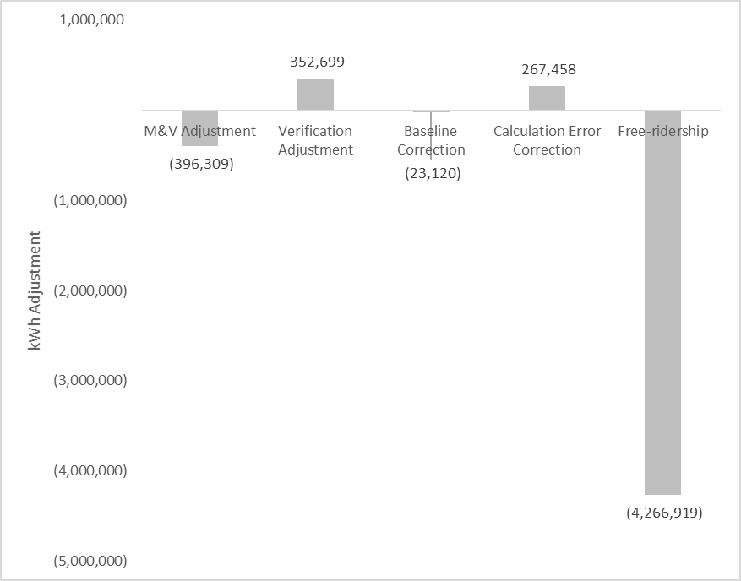

Figure 1‑1 Savings Adjustments – New Orleans

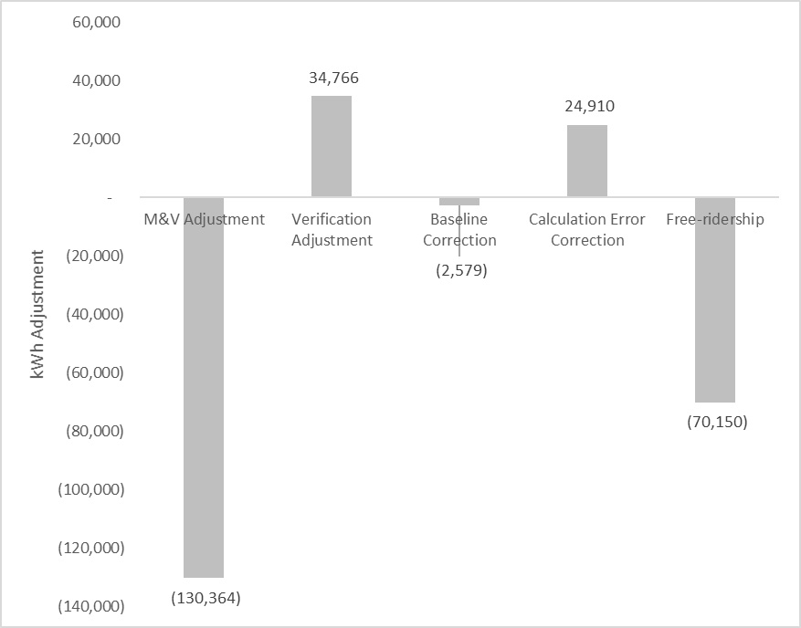

Figure 1‑2 kWh Savings Adjustments - Algiers

### Cost-Benefit Results

Table 1‑8 and Table 1‑9 present cost-benefit summary results. The portfolios overall passed TRC and UCT screening. Energy Smart School Kits passed TRC for both ENO and Algiers, after having failed screening in for both operating companies in PY5. The administration cost ratio declined significantly for the program, resulting in improved TRC results even as participation declined.

Most programs passed. The exceptions are as follows:

* **Algiers Large C&I:** As in PY5, this program only had one participant. Based on the performance of the ENO Large C&I Program, the Evaluators find it likely that the Algiers program would pass TRC if program participation goals were met.

*Table 1‑8 Cost-Effectiveness by Program – New Orleans*

|  |  |  |  |  |  |
| --- | --- | --- | --- | --- | --- |
| ***Program*** | ***Verified Peak Demand Reduction (kW)*** | ***Verified Annual Energy Savings (kWh)*** | ***Total Program Expenditures*** | ***TRC (b/c ratio)*** | ***UCT (b/c ratio)*** |
| HPwES | 1,079.11 | 4,078,177 | $1,729,749 | 2.45 | 2.44 |
| aHPwES | 631.3 | 1,822,693 |
| Green Light New Orleans | 23.97 | 139,102 |
| Consumer Products | 121.37 | 543,467 | $286,169 | 1.02 | .80 |
| Residential Heating & Cooling | 555.66 | 1,638,233 | $547,060 | 2.15 | 2.39 |
| Energy Smart School Kits | 80.11 | 555,312 | $129,813 | 2.01 | 1.51 |
| Small Business Solutions | 290.91 | 3,374,304 | $748,548 | 1.82 | 2.16 |
| Large C&I | 1,446.74 | 8,347,050 | $1,628,517 | 2.15 | 2.80 |
| DLC Pilot | 257.35 | 0 | $455,360 | .02 | .01 |
| **Total** | **4,486.52** | **20,498,338** | **$5,525,216** | **1.99** | **2.20** |

*Table 1‑9 Cost-Effectiveness by Program - Algiers*

|  |  |  |  |  |  |
| --- | --- | --- | --- | --- | --- |
| ***Program*** | ***Verified Peak Demand Reduction (kW)*** | ***Verified Annual Energy Savings (kWh)*** | ***Total Program Expenditures*** | ***TRC (b/c ratio)*** | ***UCT (b/c ratio)*** |
| HPwES | 69.01 | 281,428 | $141,060 | 2.85 | 2.82 |
| aHPwES | 36.25 | 98,896 |
| Green Light New Orleans | 3.43 | 19,905 |
| Consumer Products | 4.41 | 19,759 | $11,665 | 1.90 | .47 |
| Residential Heating & Cooling | 64.83 | 231,850 | $78,116 | 1.58 | 3.19 |
| Energy Smart School Kits | 11.63 | 83,252 | $25,437 | 1.54 | 1.17 |
| Small Business Solutions | 10.25 | 244,485 | $61,601 | 1.53 | 1.81 |
| Large C&I | 37.32 | 148,219 | $94,383 | .81 | .94 |
| DLC Pilot | 0 | 0 | 0 | NA | NA |
| **Total** | **237.13** | **1,127,794** | **$412,262** | **1.75** | **2.14** |

## Process Findings

### Portfolio Findings

#### Performance Benchmarking

Table 1‑10 below summarizes the performance of the Companies’ residential and non-residential portfolios in relation to programs operated by four other utilities programs. Results are presented for the Companies PY5 and PY6 programs.

Comparisons made to other utility programs should be interpreted with caution. It is difficult to make direct comparisons across programs because of differences in markets served, histories of the portfolios, policy environments, and level of funding available. Additionally, these metrics do not comprehensively reflect all dimensions of portfolio performance. For example, the evaluator intended to also provide information on the share of program savings resulting from different measure types and the average savings achieved per participant but was precluded from doing so because of limitations in the available data.

Some key aspects of the comparison programs that may affect differences in the metrics displayed are listed below.

* SWEPCO AR: the metrics displayed are for the 2014 program year which was the seventh year programs were offered.
* Oklahoma Gas & Electric (OG&E): the metrics displayed are for the 2014 program year which was the sixth year programs were offered.
* SWEPCO LA and Entergy LA: the programs offered are highly similar to the Energy Smart programs but do not include the CFL direct install component. The metrics displayed are for the first year programs were offered in these regions.

Table 1‑10 Program Performance Comparison

|  |  |  |  |  |  |  |
| --- | --- | --- | --- | --- | --- | --- |
| ***Performance Indicators*** | ***PY6 Algiers and ENO*** | ***PY5 Algiers and ENO*** | ***SWEPCO AR*** | ***OG&E*** | ***SWEPCO LA*** | ***Entergy LA*** |
| **Residential** |  |  |  |  |  |  |
| Market Penetration |  |  |  |  |  |  |
| Energy savings reduction as percent of total sales | 0.38% | 0.39% | 0.18% | 0.54% | 0.10% | 0.09% |
| Financial Performance |  |  |  |  |  |  |
| % of program expenditures used for incentives and inducements | 47% | 47% | 59% | 47% | 48% | 52% |
| Incentive and inducement dollars per kWh saved | $0.18 | $0.33 | $0.15 | $0.40 | $0.10 | $0.10 |
| **Non-Residential** |  |  |  |  |  |  |
| Market Penetration |  |  |  |  |  |  |
| Energy savings reduction as percent of total sales | 0.52% | 0.35% | 0.05% | 0.25% | 0.12% | 0.04% |
| Financial Performance |  |  |  |  |  |  |
| % of program expenditures used for incentives and inducements | 48% | 50% | 59% | 47% | 48% | 52% |
| Incentive and inducement dollars per kWh saved | $.10 | $0.24 | $0.15 | $0.40 | $0.10 | $0.10 |
| Portfolio TRC | 1.99 | 1.95 | 2.33 | 1.69 | 1.98 | 1.71 |

#### Summary of Customer Satisfaction

Figure 1‑3 summarizes overall program satisfaction for PY5 and PY6 by program. As shown, levels of satisfaction remained consistently high for most programs. The share of participants that were satisfied with the Large C&I program was lower in PY6, however, this difference is likely due to sampling error given the range of possible values that fall within the 90% confidence interval.

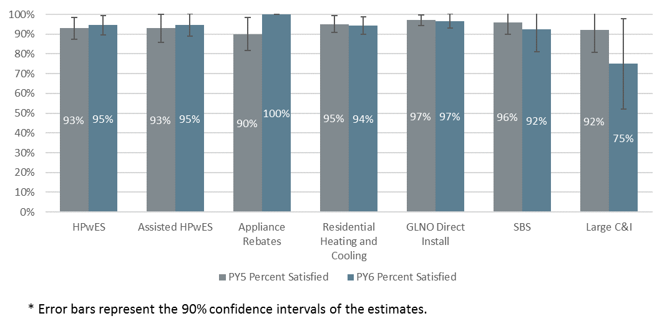

Figure 1‑3 Percent of Participants Satisfied with the Program, PY5 and PY6

For most of the Energy Smart programs, a majority of PY6 participants reported that their participation increased their satisfaction with the Energy Smart Programs. The two exceptions to this trend were the GLNO Direct Install Program and the SBS Program. For the Residential Heating and Cooling, GLNO Direct install, and the SBS programs, the decrease from PY5 in the estimated share of participants whose participation increased their satisfaction with Entergy was large enough that the change may not have been due to sampling error. Future evaluations should continue to monitor these findings for evidence of a trend that suggests the programs’ effectiveness for improving customer satisfaction is declining.

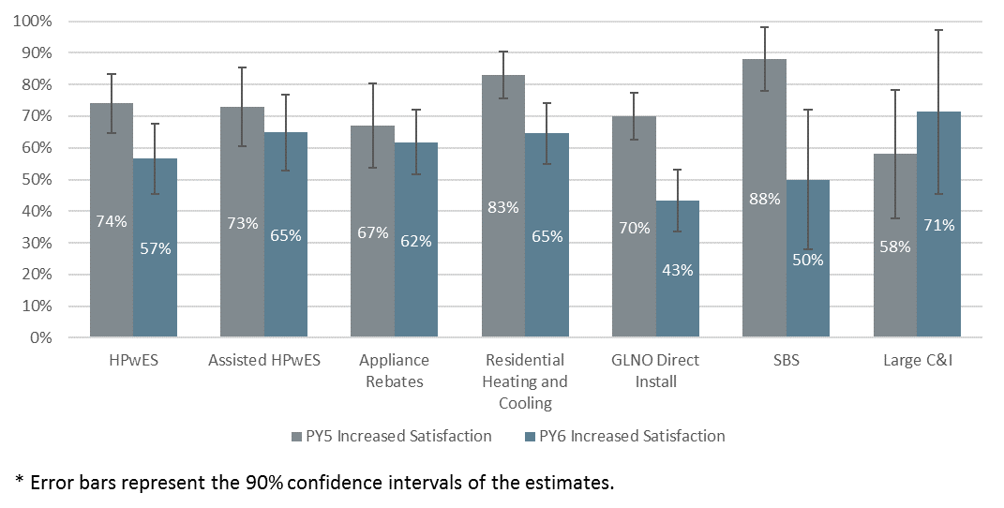

Figure 1‑4 Percent of Participants for whom Participation Increased their Satisfaction with the Companies PY5 and PY6

### Home Performance with Energy Star

* PY6 program measures and incentive levels remained the same as in PY5. In the PY6 evaluation, the Evaluators recommended that staff consider adding low-flow direct install measures to the program for homes with electric water heating. Staff stated that this was discussed but these measures have not been added. The evaluators also suggested capping incentives for duct sealing measures. The PY7 incentive is capped at $200.
* The Evaluators recommended in the PY5 evaluation that staff develop strategies to improve the quality of program data. The tracking data was considerably improved with notably fewer incidents of missing or invalid information identified.
* The number of multiple-measure projects completed increased during PY6. Specifically, the number of projects involving two or more measures increased from 44% in PY5 to 76% in PY6. This shift may be a result of the program allocating a set number of houses to contractors rather than a set dollar amount.
* As was the case in PY5, duct sealing accounted for the largest share of program savings but the share of savings from air sealing increased by nine percentage points.
* The share of expected savings was concentrated in fewer program contractors in PY6 than in PY5. In PY6, 99% of energy savings was delivered by two key contractors, as compared to PY5 when the two most active contractors accounted for 56% of program savings.
* Participants remain satisfied with the program and reported satisfaction was consistent with findings from PY5.

### Assisted Home Performance with Energy Star

* PY6 program measures and incentive levels remained the same as in PY5. In the PY5 evaluation it was noted that some participants stated that participation was not free for them. No customers noted this issue in the PY6 survey.
* The program data was largely complete and contained valid data. However, one issue identified was that 12% of projects listed multiple space heating types for different measures installed at the same location.
* The number of completed projects increased from 220 in PY5 to 272 in PY6. Additionally, the number of participating contractors increased from two in PY5 to five in PY6.
* There was an increase in the share of projects that involved single measures. In PY5 8% of completed projects were single measure projects, which increased to 18% in PY6.
* As was the case in PY5, duct sealing accounted for the largest share of program savings but the share of savings from air sealing and insulation increased in PY6.
* Reported satisfaction was consistent with findings from PY5. Ninety-five percent were somewhat or very satisfied with the program.

### Green Lights Direct Install

* The types of light bulbs remained largely the same as in PY5, although 6% of the light bulbs installed in PY6 were LED. The total number of installed lamps in PY6 was fewer than in PY5.
* Participant satisfaction with the program overall, the installation process, and the CFLs remains high.

### Consumer Products

* Rebates for pool pumps and advanced power strips changed in PY6:
  + The PY5 pool pump rebate was $200 and changed to $200 for multi-speed pool pumps and $250 for variable speed pool pumps.
  + The PY5 advanced power strip rebate was $15 and decreased to $10 in PY6.
* The program began offering lighting discounts at a Dollar Chain location and did not offer discounts through one of the two Home Improvement retailers that participated in PY5. Nevertheless, the total of eight participating locations remained the same as in PY5.
* The diversity of LED lamp types increased to include higher 75-100 W equivalent lamps and more diverse shape types such as PAR38, BR40, and candelabra lamps.
* LED sales accounted for a larger share of PY6 lighting discounts than in PY5. LED sales accounted for large share of lighting discounts and for the majority of discounts at the Home Improvement and Big Box retailer location. Additionally, the LED discounts were as low as $1 per light bulb. The shift towards LED lighting and lower discount amounts in PY6 is consistent with the broader rapid market transition to LED lighting and the decline in LED prices.
* Downstream participant satisfaction remains high. All program participants were somewhat or very satisfied with the program overall and nearly all were satisfied with the program participation process (98%), the energy efficiency improvements (94%), and the rebate amount (90%).

### Residential Heating & Cooling

* Quality control improved for the AC replacement component of the program. In PY5, the Evaluators identified non-qualified systems that had been rebated through the program, resulting in 43.8% gross realization for ENO. This issue was improved upon, and this measure channel had realization of 83% in PY6.

### School Kits and Education

* Program staff modified the kit contents in 2017 in response to changes in ENERGY STAR lamp qualification requirements under version 2.0. Two LED lamps were added to the kit contents. The kits continued to include the six CFLs although the implementation contractor stopped counting savings from these measures. The non-ENERGY STAR qualified CFLs will not be included in future program years.
* Although a limited number of parents or guardians responded to the survey, nearly all that did respond were satisfied with the kits contents and the education provided through the program.

### Small Business Solutions

* The program fell short of the PY6 savings goals. The program achieved 91% of its ENO kWh savings goal and 72% of its Algiers kWh goal. The program did not meet its goal because market response was less than needed to achieve the goal and not a function of factors such as poor realization rates. Program staff noted that achieving the savings goal in Algiers has been difficult, but indicated that there was more small business potential in Algiers than large business potential.
* The majority of program savings (98%) resulted from the installation of lighting measures during PY6, as compared to PY5 when lighting was 86% of program activity and refrigeration and hot water measures comprised the other 14 % of program activity.
* There was a spike in program activity during the last three months of the program year when participants submitted project applications which accounted for nearly half of total expected energy savings.
* Similar to last year, 16 contractors completed projects during PY6. However, activity was more evenly dispersed as 4 contractors were responsible for more than 85% of expected kWh energy savings and 33% of expected savings were associated with one contractor. In comparison, one contractor was responsible for more than half of program expected savings in PY5.
* Consistent with PY5 findings and the program design, most participants (87%) reported that they learned of the program from the contractor that they worked with. Two customers reported that participation in the program took longer than they expected.
* Customers remain satisfied with the program overall. Ninety-two percent rated their satisfaction as a 4 or 5, indicating that they were somewhat or very satisfied with it.
* A smaller share of customers reported that the program increased their satisfaction with Entergy than was the case in PY5 (50% in PY6 vs 88% in PY5).
* Several issues that affected project-level realization rates and listed in section 9.3.1.8 were identified in the analysis of gross.

### Large Commercial & Industrial Program

* The net-to-gross ratio was much lower in PY6 than in PY5. The decrease was due to a large project with a 33% NTGR that accounted for a significant share of gross program savings. The incentive of this project was capped at $50,000 and as a result, the acquisition cost of the kWh savings was low ( approximately $0.01 per expected kWh).
* As was the case in PY5, the evaluators found sites that used non-EISA compliant baselines and incorrect non-daylight hours.
* Six of the eight survey respondents were satisfied with the program overall and two respondents were very dissatisfied with it. The reasons for their dissatisfaction differed for these two respondents. One respondent was dissatisfied with the contractor, while the other stated that the participation processes was unclear.

## Report Organization

This report is organized with one chapter providing the full impact and process summary of a specified program. The report is organized as follows:

* Chapter 2 provides general methodologies;
* Chapter 3 Home Performance with Energy Star (HPwES)
* Chapter 4 provides results for the Assisted Home Performance with Energy Star (aHPwES);
* Chapter 5 provides results for the Green Lights New Orleans Program;
* Chapter 6 provides results for the Residential Heating & Cooling Program;
* Chapter 7 provides results for the Consumer Products Program (CP);
* Chapter 8 provides results for the School Kits and Education (SK&E);
* Chapter 9 provides results for the Small Business Solutions Program (SBS)
* Chapter 10 provides results for the Large Commercial and Industrial Solutions Program (C&I);
* Chapter 11 provides results for the Direct Load Control Pilot;
* Appendix A provides the site-level custom reports for the SBS and C&I Solutions Program;
* Appendix B provides the survey instruments and interview guides used in this evaluation; and
* Appendix C presents cost-benefit results.

# General Methodology

This section details general impact evaluation methodologies by program-type as well as data collection methods applied. This section will present full descriptions of:

* Gross Savings Estimation;
* Sampling Methodologies;
* Process Evaluation Methodologies; and
* Data Collection Procedures.

## Glossary of Terminology

As a first step to detailing the evaluation methodologies, the Evaluators provide a glossary of terms to follow[1]:

* *Ex Ante –* Forecasted savings used for program and portfolio planning purposes (from the Latin for “beforehand”)
* *Ex Post –* Savings estimates reported by an evaluator after the energy impact evaluation has been completed (From the Latin for “from something done afterward”)
* *Deemed Savings –* An estimate of an energy savings or demand savings outcome (savings) for a single unit of an installed energy efficiency measure. This estimate (a) has been developed from data sources and analytical methods that are widely accepted for the measure and purpose and (b) is applicable to the situation being evaluated (e.g., assuming 112 kWh savings for a residential advanced power strip)
* *Savings* – The change in energy consumption and/or demand that results directly from program-related actions taken by participants in an efficiency program
* *Realization Rate* – Ratio of Ex Post Savings / Ex Ante Savings (e.g., if the Evaluators verify 105 kWh per showerhead, Realization Rate = 105/112= 93.8% realization rate

## Overview of Methodology

The proposed methodology for the evaluation of the PY5 ENO Portfolio is intended to provide:

* Impact results; and
* Program feedback and recommendations via process evaluation

In doing so, this evaluation will provide the verified gross savings results, provide the recommendations for program improvement, and ensure cost-effective use of ratepayer funds. Leveraging experience and lessons learned from impact evaluation can provide greater guidance as to methods by which program and portfolio performance could be improved.

### Sampling

Programs are evaluated on one of three bases:

* Census of all participants;
* Simple Random Sample; and
* Stratified Random Sample.

#### Census

A census of participant data was used for select programs where such review is feasible. All program measures were evaluated. Programs that received analysis of a census of participants include:

* Home Performance with ENERGY STAR
* Assisted Home Performance with ENERGY STAR
* Residential Heating & Cooling
* Energy Smart Lighting and Appliances
* Energy Smart School Kits

#### Simple Random Sampling

For programs with relatively homogenous measures (largely in the residential portfolio), the Evaluators conducted a simple random sample of participants. The sample size for verification surveys is calculated to meet 90% confidence and 10% precision (90/10). The sample size to meet 90/10 requirements is calculated based on the coefficient of variation of savings for program participants. Coefficient of Variation (CV) is defined as:

Where x is the average kWh savings per participant. Without data to use as a basis for a higher value, it is typical to apply a CV of .5 in residential program evaluations. The resulting sample size is estimated at:

Where,

1.645 = Z Score for 90% confidence interval in a normal distribution

CV = Coefficient of Variation

RP = Required Precision, 10% in this evaluation

#### Stratified Sampling

For the ENO SBS and Large C&I programs, Simple Random Sampling is not an effective sampling methodology as the CV values observed in business programs are typically very high because the distributions of savings are generally positively skewed. Often, a relatively small number of projects account for a high percentage of the estimated savings for the program.

To address this situation, we use a sample design for selecting projects for the M&V sample that takes such skewness into account. With this approach, we select a number of sites with large savings for the sample with certainty and take a random sample of the remaining sites. To further improve the precision, non-certainty sites are selected for the sample through systematic random sampling. That is, a random sample of sites remaining after the certainty sites have been selected is selected by ordering them according to the magnitude of their savings and using systematic random sampling. Sampling systematically from a list that is ordered according to the magnitude of savings ensures that any sample selected will have some units with high savings, some with moderate savings, and some with low savings. Samples cannot result that have concentrations of sites with atypically high savings or atypically low savings. As a result of this methodology, the required sample for the SBS and Large C&I Programs were reduced to the following strata:

Table 2‑1 Stratified Sampling Summary

|  |  |  |
| --- | --- | --- |
| ***Program*** | ***Strata*** | ***Sites Sampled*** |
| Small Business Solutions | 4, plus 1 certainty | 18 |
| Large Commercial and Industrial | 4, plus 1 certainty | 11 |

### Impact Calculations

The general approach for calculation of verified kWh and kW savings was to start with deemed savings and refine estimates with primary data collection. Further detail can be found in each program chapter.

### Process Evaluation

The Evaluator’s general approach to process evaluation begins with a review of the tests for timing and appropriateness of process. Because an in-depth process evaluation was completed during PY5, few changes were made to the programs during PY6, and a new portfolio of programs will be offered beginning in PY7 with a new implementation contractor, the Evaluators completed a limited process evaluation during PY6. The limited process evaluation focused on analysis of participating customer survey responses, review of program tracking data, and an interview with the Companies program manager.

The data collection procedures for process evaluations typically included:

* *Participant Surveying*. The Evaluators surveyed statistically significant samples of participants in each program in order to provide feedback for the program and provide an assessment of participant satisfaction. Surveys cover topics including:
  + Source of program awareness;
  + Their decision to participate and complete an efficiency project;
  + Experience with the participation process; and
  + Satisfaction with various elements of the program and the program overall
* *Program Staff Interviews*. The Evaluators conducted in-depth interviews with the Companies program manager. This interview focused on program changes and any notable successes or challenges.
* *Review of Program Application Materials*. The Evaluators reviewed program application forms for any notable changes in design and incentive levels.

# Home Performance with ENERGY STAR®

## Program Description

The Home Performance with ENERGY STAR® (HPwES) is designed to promoted energy efficiency by offering home energy walkthrough assessments and/or deeper energy assessments to its residential customers through a participating trade ally. The HPwES provides residential customers with access to qualified vendors and installation trade allies (trade allies) within the Companies’ service areas. The participating trade allies are to help the residential customer analyze their energy use and identify energy efficiency improvements. The trade ally inspection includes a visual inspection of the living space, attic, and crawl space/basement, and exterior of the home, as well as discussion of lifestyle and customer behaviors that impact energy use. Following the assessment, the trade ally recommends home improvements to increase energy efficiency. The HPwES Programs provides incentives for installing ceiling insulation, duct sealing, and air infiltration sealing in the form of a discount to the customer.

A total of 1,215[2] households participated in HPwES, Table 3‑1 summarizes the total number of homes a measure was installed in and/or performed at, total measures installed/performed and the expected kWh and peak kW savings by measure.

Table 3‑1 Summary of Measures and Expected Savings – New Orleans

|  |  |  |  |
| --- | --- | --- | --- |
| ***Measure*** | ***Number of Homes*** | ***Expected kWh Savings*** | ***Expected kW Savings*** |
| Air Sealing | 647 | 686,838 | 307.28 |
| Duct Sealing | 814 | 3,164,898 | 515.21 |
| Ceiling Insulation | 33 | 110,707 | 30.01 |
| **Total:** | **1,494** | **3,962,443** | **852.50** |

Table 3‑2 Summary of Measures and Expected Savings – Algiers

|  |  |  |  |
| --- | --- | --- | --- |
| ***Measure*** | ***Number of Homes*** | ***Expected kWh Savings*** | ***Expected kW Savings*** |
| Air Sealing | 47 | 49,017 | 19.28 |
| Duct Sealing | 57 | 208,475 | 32.17 |
| Ceiling Insulation | 2 | 7,418 | 1.61 |
| **Total:** | **106** | **264,910** | **53.06** |

The program goals and achievement of the goals is summarized below.

Table 3‑3 Summary of Program Goals

|  |  |  |  |
| --- | --- | --- | --- |
| ***Operating Company*** | ***Participation*** | ***MWh*** | ***MW*** |
| Algiers | 70 | 60 | 0.02 |
| ENO | 858 | 733 | 0.3 |

Table 3‑4 HPwES Summary of kWh Goal Achievement

|  |  |  |  |  |  |  |
| --- | --- | --- | --- | --- | --- | --- |
| ***Operating Company*** | ***Verified Net kWh*** | ***kWh Goal*** | ***% of Goal Attained*** | ***Verified kW*** | ***kW Goal*** | ***% of Goal Attained*** |
| ENO | 4,078,177 | 733,000 | 556.4% | 1,079.11 | 300 | 359.7% |
| Algiers | 281,428 | 60,000 | 469.0% | 69.01 | 20 | 345.1% |

The program exceeded goal by a wide margin. Program staff attributed this to the following factors:

* **High prevalence of electric space heating.** Program staff anticipated lower levels of electric space heating. Homes with electric space heating accounted for over 75% of PY5 program savings.
* **Reallocation of budget from Residential Heating & Cooling.** The Residential Heating & Cooling Program underperformed relative to program goals. Program staff reallocated budget mid-year in order to maintain consistent program participation in HPwES.

## Impact Savings Calculation Methodology

### Air Infiltration Reduction Savings Calculations

The deemed savings values for air infiltration reduction were developed through EnergyGauge, a simulation software program. Multiple equipment configurations were simulated in in developing savings values denominated in deemed savings per CFM50 of air leakage rate reduction. Table 3‑5 summarizes the deemed savings values for New Orleans.

Table 3‑5 Deemed Savings Values for Air Infiltration Reduction

|  |  |
| --- | --- |
| ***Equipment Type*** | ***kWh/CFM Savings*** |
| Electric AC with Gas Heat | .3267 |
| Elec. Resistance w/ AC | .9334 |
| Heat Pump | .6376 |

For example, consider a residence with electric AC and gas heat located. If the residence had a leakage rate of 7,200 CFM50 before air infiltration reduction and a leakage rate of 3,500 CFM50 after, then the residence would have an annual savings of:

### Duct Sealing Savings Calculations

Duct sealing savings was calculated using the following savings algorithms from the TRM.

#### Cooling Savings (Electric):

Where:

= Pre-improvement duct leakage at 25 Pa (ft3/min)

= Post-improvement duct leakage at 25 Pa (ft3/min)

*ΔDSE* = Assumed improvement in distribution system efficiency = 5% = 0.05

= Equivalent Full Load Hours. See Table 7‑6

= Outdoor design specific enthalpy (Btu/lb) See Table 3‑7

= Indoor design specific enthalpy (Btu/lb.) See Table 3‑7

Table 3‑6 Deemed Savings Values for Duct Sealing Calculations

|  |  |
| --- | --- |
| ***Parameter*** | ***Value*** |
| EFLHC | 1,637 |
| HDD | 1,349 |
| hout | 40 |
| hin | 30 |
| ρin | .076 |
| Ρout | .074 |
| SEER | 11.5 |

= Density of outdoor air at 95°F = 0.0740 (lb/ft3)[3]

= Density of conditioned air at 75°F = 0.0756 (lb./ft3)4

= Constant to convert from minutes to hours

= Cooling capacity (Btu/hr)

=Constant to convert from W to kW

=Seasonal Energy Efficiency Ratio of existing system (Btu/W·hr)

Default value for SEER = 11.5[4]

In PY5 a deemed of EFLHc was used for duct sealing ex post calculations. This value was adapted from the AR TRM V3.0 using TYM3 weather data for New Orleans. During PY6, ADM conducted an analysis of a pilot load control program, which involved logging residential air conditioner and heat pump operation in New Orleans. This monitoring data was analyzed via regression, which produced EFLHc of 1,637 based upon direct metering for a sample of New Orleans residential air conditioners.

As an example, assume the duct leakage before sealing was measured at 360 CFM and the leakage after sealing was 90 CFM. Using the SEER value of 11.5, the annual savings would be:

kWh per year = (360-90) x 1,637 x (40x0.076 – 30x0.074) x 60 / (1000 x 11.5) = 1,891 kWh per year.

#### Heating Savings (Heat Pump):

Where:

= Pre-improvement duct leakage at 25 Pa (ft3/min)

= Post-improvement duct leakage at 25 Pa (ft3/min)

*ΔDSE* = Assumed improvement in distribution system efficiency = 5% = 0.05

= Equivalent full load heating hours

= Constant to convert from minutes to hours

= Heating degree days (see Table 7‑6)

= Constant to convert from days to hours

= Volumetric heat capacity of air (Btu/ft3°F)

= Heating capacity (Btu/hr)

=Constant to convert from W to kW

= Heating Seasonal Performance Factor of existing system (Btu/W·hr)

Default value for HSPF = 7.30.[5]

#### Heating Savings (Electric Resistance):

Where:

= Pre-improvement duct leakage at 25 Pa (ft3/min)

= Post-improvement duct leakage at 25 Pa (ft3/min)

*ΔDSE* = Assumed improvement in distribution system efficiency = 5% = 0.05

*60* = Constant to convert from minutes to hours

*HDD* = Heating degree days (see Table 7‑6)

*24* = Constant to convert from days to hours

*0.018* = Volumetric heat capacity of air (Btu/ft3°F)

*EFLHH* = Equivalent full load heating hours

*CAP* = Heating capacity (Btu/hr)

*3,412* =Constant to convert from Btu to kWh

#### Heating Savings (Gas Furnace):

Where:

*DLpre* = Pre-improvement duct leakage at 25 Pa (ft3/min)

*DLpost* = Post-improvement duct leakage at 25 Pa (ft3/min)

*ΔDSE* = Assumed improvement in distribution system efficiency = 5% = 0.05

*60* = Constant to convert from minutes to hours

*HDD* = Heating degree days (see Table 7‑6)

*24* = Constant to convert from days to hours

*0.018* = Volumetric heat capacity of air (Btu/ft3°F)

*EFLHH* = Equivalent full load heating hours

*CAP* = Heating capacity (Btuh or Btu/hr)

*100,000* =Constant to convert from Btu to therms

*AFUE* =Annual Fuel Utilization Efficiency of existing system

Default value for AFUE = 0.8.

#### Demand Savings (Cooling):

Where:

kWhsavings,C = Calculated kWh savings for cooling

*EFLHC* = Equivalent full load cooling hours

*CF* = Coincidence factor = 0.77[6]

### Incorporating Onsite findings

Data from onsite verification and measurements performed by the Evaluators was incorporated into deemed savings calculations where necessary. Details of this are described in subsequent sections. Table 3‑7 below displays measurement

Table 3‑7 Summary of Measures and Expected Savings – New Orleans

|  |  |
| --- | --- |
| ***Measure*** | ***Number of Homes Tested*** |
| Air Sealing | 62 |
| Duct Sealing | 80 |
| Ceiling Insulation | 20 |
| **Total of Site Visits:[7]** | **81** |

## Verified Savings by Measure – HPwES

After reviewing the tracking data and inputs for savings calculations, the Evaluators provided verified savings using deemed values developed for New Orleans combined with in-field testing results.

### Infiltration/Air Sealing

#### Field Data Collection

The Evaluators conducted on-site testing at a sample of 62 residencies that received air sealing. This sample was comprised of 40 homes in HPwES and 22 homes in Assisted HPwES. During these site visits, the Evaluators’ field staff conducted blower door testing in an effort to validate post-retrofit leakage estimates indicated in program tracking data.

The results of the Evaluators’ field testing are summarized in Figure 3‑1. In this figure, results are organized such that homes with verified leakage that is lower than shown in tracking data (i.e., homes with realization greater than 100%) are at the left end of the graph and homes with verified leakage higher than shown in tracking data (i.e., homes with realization less than 100%) are on the right. The Evaluators found that 46.8% of tested homes had higher leakage than shown in program tracking, while 53.2% had lower leakage.

Figure 3‑1 Air Infiltration Field Testing Results

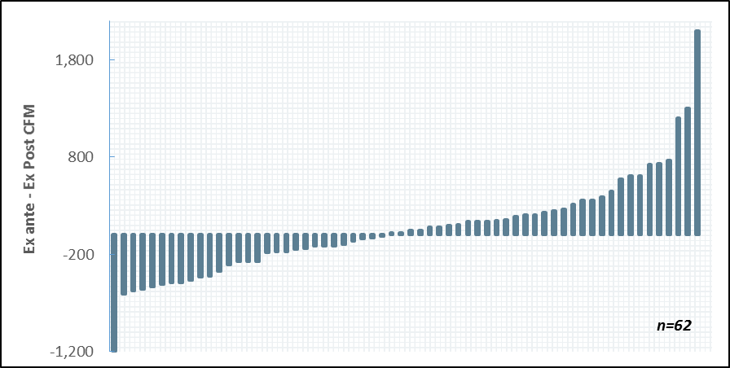

The Evaluators’ field testing found that average post-retrofit leakage was 8.4% lower than indicated in program tracking data. Summary statistics of the Evaluators’ field measurements are as follows:

* Mean difference of -62.3 CFM50, 8.4% below expected.
* Median difference of -31.5 CFM50, 1.4% below expected.

Most homes were within reasonable range of *ex ante* estimates. However, there were two outlier homes result in an average *ex post* leakage measurement that is 59.4% higher than expected, which raises savings for this measure, but not enough to offset the lower-than-expected leakage measured on other sites. A single outlier home with *ex post* leakage measurement that is 44.9% lower than expected was also identified, further increasing savings for this measure.

#### Deemed Savings Revision

Deemed savings parameters were revised significantly for this measure. The Evaluators found that deemed savings used by program staff were not within reasonable range for this measure. “Leakage Results” refers to the average percentage difference between Ex Ante claimed CFM50 post values are, and those measured by the Evaluators onsite. The -8.2% was used to deflate the post CFM50 readings reported by the IC, increasing measure savings.

Table 3‑8 Air Infiltration Savings Multipliers

|  |  |  |  |  |
| --- | --- | --- | --- | --- |
| ***Heating Type*** | ***Ex Ante Value*** | ***Ex Post Value*** | ***% Change in Multiplier*** | ***Independent effect on kWh Savings[8]*** |
| Natural Gas Furnace | 0.2694 | 0.2694 | 0.0% | 0.0% |
| Electric Resistance | 0.7945 | 0.7945 | 0.0% | 0.0% |
| Air Source Heat Pump | 0.4438 | 0.4438 | 0.0% | 0.0% |
| Leakage Results[9] | 100.0% | 91.6% | -8.4% | 13.7% |
| **Total** | | | | **134.3%** |

#### Air Sealing Savings Results

The savings resulting from this revision to deemed parameters and application of field results are summarized in Table 3‑9 and Table 3‑11.

Table 3‑9 Expected and Realized Air Sealing Savings – New Orleans

|  |  |  |  |  |  |  |
| --- | --- | --- | --- | --- | --- | --- |
| ***Heating Type*** | ***Expected kWh Savings*** | ***Realized kWh Savings*** | ***kWh Realization Rate*** | ***Expected Peak kW Savings*** | ***Realized Peak kW Savings*** | ***Peak kW Realization Rate*** |
| Natural Gas Furnace | 129,356 | 172,895 | 133.7% | 124.84 | 147.67 | 118.3% |
| Electric Resistance | 557,482 | 750,376 | 134.6% | 182.44 | 225.01 | 123.3% |
| Air Source Heat Pump | - | - | N/A | - | - | N/A |
| **Total** | **686,838** | **923,271** | **134.4%** | **307.28** | **372.68** | **121.3%** |

Table 3‑10 Expected and Realized Air Sealing Savings - Algiers

|  |  |  |  |  |  |  |
| --- | --- | --- | --- | --- | --- | --- |
| ***Heating Type*** | ***Expected kWh Savings*** | ***Realized kWh Savings*** | ***kWh Realization Rate*** | ***Expected Peak kW Savings*** | ***Realized Peak kW Savings*** | ***Peak kW Realization Rate*** |
| Natural Gas Furnace | 5,085 | 7,138 | 140.4% | 4.91 | 6.08 | 123.8% |
| Electric Resistance | 43,932 | 58,115 | 132.3% | 14.38 | 17.43 | 121.2% |
| Air Source Heat Pump | - | - | N/A | - | - | N/A |
| **Total** | **49,017** | **65,253** | **133.1%** | **19.29** | **23.51** | **121.9%** |

### Duct Sealing

#### Field Data Collection

The Evaluators conducted on-site testing at a sample of 80 residencies that received duct sealing. This sample was comprised of 56 HPwES sites and 24 Assisted HPwES sites. During these site visits, the Evaluators’ field staff conducted blower door testing in an effort to validate post-retrofit leakage estimates indicated in program tracking data. The Evaluators did not make any changes to pre-retrofit data; the evaluation began with three months remaining in PY5 and as such it was not feasible to conduct baseline testing.

The results of the Evaluators’ field testing are summarized in Figure 3‑2. In this figure, results are organized such that homes with verified leakage that is lower than shown in tracking data (i.e., homes with realization greater than 100%) are at the left end of the graph and homes with verified leakage higher than shown in tracking data (i.e., homes with realization less than 100%) are on the right. The Evaluators found that 70.0% of tested homes had higher leakage than shown in program tracking, while 30.0% had lower leakage.

Figure 3‑2 Dust Sealing Field Testing Results

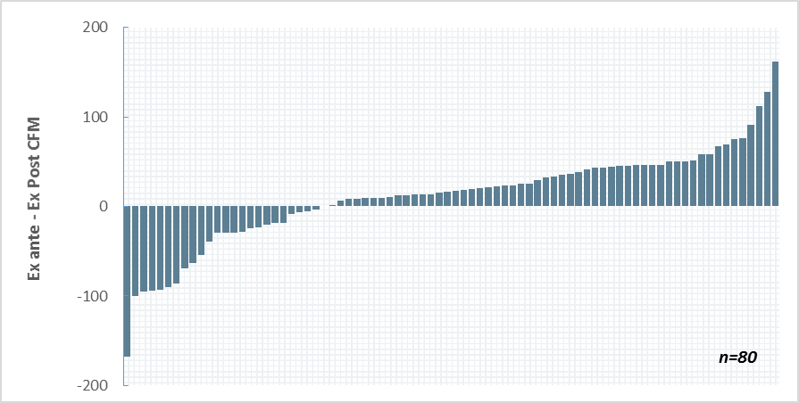

The Evaluators’ field testing found that average post-retrofit leakage was lower than indicated in program tracking data. Summary statistics of differences between the Evaluators’ field measurements and values listed in tracking data are as follows:

* Mean: -11.7 (8.4%)
* Median: -17.0 (13.0%)

Most homes were within reasonable range of ex ante estimates. However, there were two low outlier homes which result in an average ex post leakage measurement that is 121.8% lower. These findings increased savings for this measure accordingly.

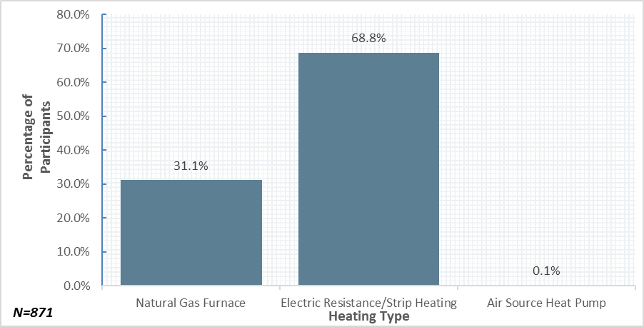

Figure 3‑3 Percentage of Homes by Heating Type (Ex Ante)

#### Deemed Savings Revision

Table 3‑15 compares *ex ante* savings multipliers with those used by the Evaluators in the *ex post* analysis. *ex ante* multipliers came from IECC 2009 LA Zone 2. EFLHC and HDD values were developed via regression as explain in Section 3.2.2. The outdoor design specific enthalpy (*hout)* was adapted specifically for New Orleans using TMY3 data. Table 3‑11 below details the effect of changes in each of the savings parameters.

Table 3‑11 Savings Parameter Differences by Parameter

|  |  |  |  |  |
| --- | --- | --- | --- | --- |
| ***Parameter*** | ***Ex Ante Value*** | ***Ex Post Value*** | ***% Change in Multiplier*** | ***Independent Effect on kWh Savings[10]*** |
| EFLHC | 2,388 | 1,637 | -31.4% | -14.0% |
| HDD | 1,417 | 1,349 | 4.8% | -2.7% |
| *hout* | 37 | 40 | 8.1% | 21.0% |
| Leakage Results[11] | 100.0% | 91.6% | -8.4% | 4.3% |
| **Total** | | | | 101.2% |

While decreased EFLHc hours decreased, the effect was not enough to overcome the leakage results and the enthalpy update, the latter of which is the main driver of savings for this measure.

#### Duct Sealing Savings Results

The savings resulting from this revision to deemed parameters and application of field results are summarized in Table 3‑12 and Table 3‑13.

Table 3‑12 Expected and Realized Duct Sealing Savings – New Orleans

|  |  |  |  |  |  |  |
| --- | --- | --- | --- | --- | --- | --- |
| ***Heating Type*** | ***Expected kWh Savings*** | ***Realized kWh Savings*** | ***kWh Realization Rate*** | ***Expected Peak kW Savings*** | ***Realized Peak kW Savings*** | ***Peak kW Realization Rate*** |
| Natural Gas Furnace | 460,699 | 477,551 | 103.7% | 167.84 | 224.63 | 133.8% |
| Electric Resistance | 2,700,356 | 2,719,635 | 100.7% | 346.62 | 462.74 | 133.5% |
| Air Source Heat Pump | 3,843 | 3,846 | 100.1% | 0.75 | 0.99 | 132.2% |
| **Total** | **3,164,898** | **3,201,032** | **101.1%** | **515.21** | **688.36** | **133.6%** |

Table 3‑13 Expected and Realized Duct Sealing Savings - Algiers

|  |  |  |  |  |  |  |
| --- | --- | --- | --- | --- | --- | --- |
| ***Heating Type*** | ***Expected kWh Savings*** | ***Realized kWh Savings*** | ***kWh Realization Rate*** | ***Expected Peak kW Savings*** | ***Realized Peak kW Savings*** | ***Peak kW Realization Rate*** |
| Natural Gas Furnace | 22,925 | 23,656 | 103.2% | 8.35 | 11.13 | 133.3% |
| Electric Resistance | 185,549 | 188,170 | 101.4% | 23.82 | 32.02 | 134.4% |
| Air Source Heat Pump | - | - | N/A | - | - | N/A |
| **Total** | **208,474** | **211,826** | **101.6%** | **32.17** | **43.14** | **134.1%** |

### Attic Insulation

#### Field Data Collection

The Evaluators conducted on-site inspection at a sample of 20 residencies that received attic insulation. Seventeen of these homes had R-30 insulation installed, and three with R-38. Rebates were premised on R-30 or greater for qualification, with no additional savings calculated beyond R-30. The verified gross savings analysis for this measure also omits these savings.

In addition to verifying program-related installations, the Evaluators also recorded existing insulation levels in 75 homes visited. Figure 3‑4 summarizes the baseline R-values recorded from these sites (note that these are homes that did not receive insulation through the program).

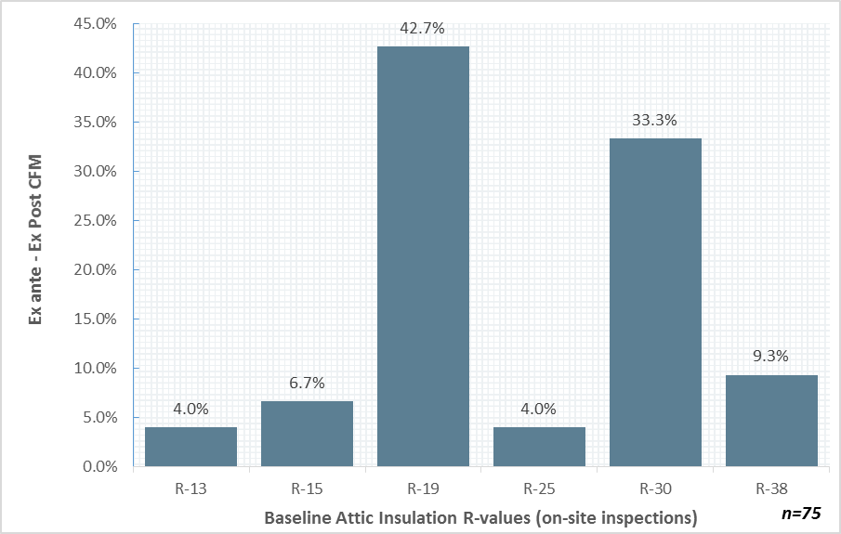

Figure 3‑4 Baseline R-Value for Inspected Attic Insulation (Non-Project Homes)

For attic insulation projects it is not uncommon for preexisting insulation to be left in place, with new insulation installed over it. The Evaluators found a total of four baselines:

Table 3‑14 Program Tracking Baseline R-Values

|  |  |  |
| --- | --- | --- |
| ***Baseline R-Value (Ex Ante)*** | ***Count (Ex Ante)*** | ***% of Total (Ex Ante)*** |
| R-00 | 30 | 85.7% |
| R-02 | 1 | 2.9% |
| R-04 | 2 | 5.7% |
| R-08 | 2 | 5.7% |

When compared with the Evaluator’s on-site findings, presented in Figure 3‑4 it would suggest that the HPwES® ceiling insulation measures are effectively reaching the homes in greater need (e.g. less preexisting insulation) than the general housing stock.

#### Deemed Savings Revision

Table 3‑15 compares Ex Ante savings multipliers with those used by the Evaluators in the Ex Post Analysis. Ex Ante multipliers came from IECC 2009 LA Zone 2. The change to use savings multipliers adapted specifically for New Orleans is the sole driver of the high measure realization rate.

Table 3‑15 Savings Multiplier Changes by Heating Type

|  |  |  |  |  |  |
| --- | --- | --- | --- | --- | --- |
| ***Heating Type*** | ***Percentage of Projects*** | ***Ex Ante Multiplier*** | ***Ex Post Multiplier*** | ***% Change in Multiplier*** | ***Independent effect on program measure-level kWh Realization Rate[12]*** |
| Natural Gas Furnace | 29.4% | 0.640 | 1.389 | 117.1% | 8.4% |
| Electric Resistance | 73.5% | 2.810 | 3.401 | 21.0% | 19.0% |
| Air Source Heat Pump | 0.00% | 1.400 | 2.101 | 50.1% | N/A |
| **Total** | | | | | **127.3%** |

#### Ceiling Insulation Savings Results

Verified savings for this measure are provided in Table 3‑16 and Table 3‑17.

Table 3‑16 Expected and Realized Attic Insulation Savings – New Orleans

|  |  |  |  |  |  |  |
| --- | --- | --- | --- | --- | --- | --- |
| ***Heating Type*** | ***Expected kWh Savings*** | ***Realized kWh Savings*** | ***kWh Realization Rate*** | ***Expected Peak kW Savings*** | ***Realized Peak kW Savings*** | ***Peak kW Realization Rate*** |
| Natural Gas Furnace | 11,276 | 19,361 | 171.7% | 8.50 | 19.13 | 225.1% |
| Electric Resistance | 99,431 | 122,982 | 123.7% | 21.51 | 46.92 | 218.1% |
| Air Source Heat Pump | - | - | N/A | - | - | N/A |
| **Total** | **110,707** | **142,343** | **128.6%** | **30.01** | **66.05** | **220.1%** |

Table 3‑17 Expected and Realized Attic Insulation Savings - Algiers

|  |  |  |  |  |  |  |
| --- | --- | --- | --- | --- | --- | --- |
| ***Heating Type*** | ***Expected kWh Savings*** | ***Realized kWh Savings*** | ***kWh Realization Rate*** | ***Expected Peak kW Savings*** | ***Realized Peak kW Savings*** | ***Peak kW Realization Rate*** |
| Natural Gas Furnace | - | - | N/A | - | - | N/A |
| Electric Resistance | 14,050 | 17,006 | 121.0% | 3.04 | 6.33 | 208.2% |
| Air Source Heat Pump | - | - | N/A | - | - | N/A |
| **Total** | **14,050** | **17,006** | **121.0%** | **3.04** | **6.33** | **208.2%** |

## Verified Gross Savings

Realized savings is presented by program channel in Table 3‑18 through Table 3‑19.

Table 3‑18 Gross Realization Summary – New Orleans

|  |  |  |  |  |  |  |  |
| --- | --- | --- | --- | --- | --- | --- | --- |
| ***Measure*** | ***Number Homes*** | ***Expected kWh Savings*** | ***Expected kW Savings*** | ***Verified kWh Savings*** | ***Verified kW Savings*** | ***Realization*** | |
| ***kWh*** | ***kW*** |
| Air Sealing | 647 | 686,838 | 307.28 | 923,271 | 372.68 | 134.42% | 121.28% |
| Duct Sealing | 814 | 3,164,898 | 515.21 | 3,201,032 | 688.36 | 101.14% | 133.61% |
| Ceiling Insulation | 33 | 110,707 | 30.01 | 142,343 | 66.05 | 128.58% | 220.09% |
| **Total** | **1,494** | **3,962,443** | **852.50** | **4,266,646** | **1,127.09** | **107.68%** | **132.21%** |

Table 3‑19 Gross Realization Summary – Algiers

|  |  |  |  |  |  |  |  |
| --- | --- | --- | --- | --- | --- | --- | --- |
| ***Measure*** | ***Number Homes*** | ***Expected kWh Savings*** | ***Expected kW Savings*** | ***Verified kWh Savings*** | ***Verified kW Savings*** | ***Realization*** | |
| ***kWh*** | ***kW*** |
| Air Sealing | 47 | 49,017 | 19.28 | 65,253 | 23.51 | 133.12% | 121.94% |
| Duct Sealing | 57 | 208,475 | 32.17 | 211,826 | 43.14 | 101.61% | 134.11% |
| Ceiling Insulation | 2 | 7,418 | 1.61 | 17,006 | 6.33 | 229.25% | 393.17% |
| **Total** | **106** | **264,910** | **53.06** | **294,085** | **72.98** | **111.01%** | **137.55%** |

## Estimation of Net Savings

Participant survey responses were used to estimate the net energy impacts of the program. The program net savings are equal to gross savings, less savings associated with free ridership, plus participant spillover savings.

In total, 58 program participants completed the survey. Two responses were removed from the net savings analysis because of errors that occurred during the administration of the survey. Thus, the final number of survey respondents used in the analysis was 56.

### Estimation of Free Ridership

The objective of the free ridership analysis is to estimate the share of program activity would have occurred in the absence of the program. To accomplish this, the Evaluators administered a survey to program participants that contained questions regarding the participants’ plans to implement the incentivized measures and the likelihood of implementing those measures in the absence of program incentives and informational support. Program participants were asked questions regarding:

* Whether or not they had plans to complete the project and if they could afford to complete it without the program discount;
* The likelihood of completing the project without the discount or the incentivized assessment;
* The timing of the project in the absence of the program.

Participant responses to these questions were used to calculate three scores corresponding to the presence of prior plans, the likelihood of completing the project in the absence of the program, and the timing of that project if it had been completed.

#### Prior Plans Score

Respondents were scored as 1 on the prior plans score if both of the following were true:

* The participant had plans to complete the project prior to learning about the program.
* The participant indicated that they would have been financially able to complete the project had a discount or rebate not been provided.

Respondents that did not have prior plans and could afford the measures were not deemed to be free riders.

#### Likelihood of Project Completion Score

The score reflecting the likelihood of completing the project in the absence of the program was based on the following questions:

* Prior to learning about the program, did you have plans to have an energy assessment of your home performed?
* How likely is it that you would have completed the same < MEASURE> project that you completed through the program if the rebate was not available?
* How likely is it that you would completed the same < MEASURE> project had it not been recommended through the energy assessment of your home?

The first question assesses the existence of prior plans to have the assessment performed while the second and third questions assess the likelihood of the customer implementing the project in the absence of the rebate and energy assessment. A score was assigned to each response for the second and third questions as follows:

* Very likely: 1
* Somewhat likely: .75
* Neither particularly likely or unlikely: .5
* Somewhat unlikely: .25
* Very unlikely: 0

The likelihood score is equal to either:

* If the participant did not have an assessment performed, or had prior plans to have an assessment performed, the score based on the rating for the likelihood of completing the project without the discount.
* If the participant had an assessment and did not have prior plans to have an assessment, the score is based on the minimum of the following two scores:
  + The likelihood of completing the project without the assessment; and
  + The likelihood of completing the project without the discount.

#### Timing Score

To account for the impact the program may have had on project timing, the likelihood score was multiplied by a timing score. The timing score was developed from responses to a question on when the participant might have completed a project in the absence of the program. Specifically, timing was scored as follows:

* Project would have been completed in 0 to 6 months: 1
* Project would have been completed in 6 months to a year: .67
* Project would have been completed in 1 to 2 years: .33
* Project would have been completed in more than 2 years: 0

#### Final Free Ridership Score

The final free ridership score is equal to the following:

*Free Ridership = Average (Plans Score + Likelihood Score * Timing Score)*

The procedures used to estimate free ridership are summarized below in Figure 6‑1.

Figure 3‑5 Summary of Free Ridership Scoring Algorithm

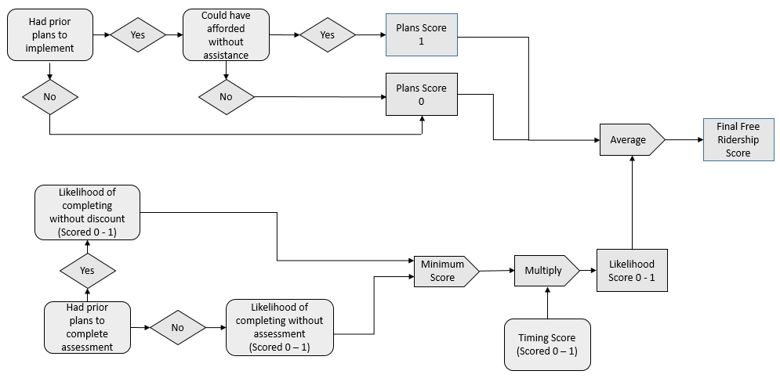

### Estimation of Participant Spillover

To estimate participant spillover impacts, participant survey respondents were asked if they had purchased any additional items because of their experience with the program without receiving an incentive.

Participants that indicated one or more energy efficiency purchases were asked additional questions about what was purchased and the number of units purchased to estimate the savings impact. Additionally, the following two questions were asked to determine whether the energy savings resulting from measures that were attributable to the program:

* On a scale of 0 to 10, where 0 represents “not at all important” and 10 represents “extremely important”, how important was the experience with the program in your decision to purchase the items you just mentioned?
* On a scale of 0 to 10, where 0 represents “not at all likely” and 10 represents “extremely likely,” how likely would you have been to purchase those items if you had not participated in the program?

If the average of the first response and 10 – the second response is 5 or greater, the savings associated with the measures were attributed to the program.

Six respondents reported additional measures that met the attribution criteria. The kWh and peak kW estimates are summarized in Table 3‑20.

Table 3‑20 Participant Reported Spillover Impacts

|  |  |  |  |  |
| --- | --- | --- | --- | --- |
| ***Measure1*** | ***Per Unit kWh Estimate*** | ***Per Unit Peak kW Estimate*** | ***Total kWh*** | ***Total Peak kW*** |
| CFLs2 | 22.60 | 0.00 | 271.24 | 0.04 |
| LEDs3 | 25.62 | 0.00 | 102.47 | 0.02 |
| Energy Efficient Clothes Washer and Dryer4 | 119.00 | 0.03 | 119.00 | 0.03 |
| Dishwasher | 12.00 | 0.00 | 12.00 | 0.00 |
| Refrigerator | 28.49 | 0.00 | 28.49 | 0.00 |
| Window Air Conditioner | 70.81 | 0.09 | 141.62 | 0.18 |
| **Total** |  |  | **674.82** | **0.27** |
| 1. All values based on deemed values from Arkansas Technical Resource Manual, version 6.0. | | | | |
| 2. Assumed 13 W CFL, 793 annual operating hours, 1.25 demand factor, .97 energy factor, and .10 coincidence factor. | | | | |
| 3. Assumed 9 W LED, 793 annual operating hours, 1.25 demand factor, .97 energy factor, and .10 coincidence factor. | | | | |
| 4. Assumed electric water and space heating. | | | | |

### Net Savings Results

Free ridership for the program was estimated by weighting each participant’s response by the associated verified gross kWh savings or peak kW reductions for the measure. Program level spillover was estimated by applying a ratio of the survey respondent reported spillover savings to the total verified gross savings for survey respondents to the program gross savings values.[13] Table 3‑21 and Table 3‑22summarize the program net kWh savings and peak kW demand reduction impacts of the HPwES Program.

Table 3‑21 HPwES Summary of Verified Net Savings

|  |  |  |  |  |  |  |
| --- | --- | --- | --- | --- | --- | --- |
| ***Utility*** | ***Expected kWh Savings*** | ***Verified Gross kWh Savings*** | ***Free Ridership*** | ***Spillover*** | ***Verified Net kWh Savings*** | ***Net to Gross Ratio*** |
| ENO | 3,962,443 | 4,266,646 | 193,250 | 4,781 | 4,078,177 | 96% |
| Algiers | 271,542 | 294,086 | 12,987 | 330 | 281,428 | 96% |
| **Total** | **4,233,985** | **4,560,732** | **206,237** | **5,110** | **4,359,605** | **96%** |

Table 3‑22 HPwES Summary of Verified Net Peak Demand Reductions

|  |  |  |  |  |  |  |
| --- | --- | --- | --- | --- | --- | --- |
| ***Utility*** | ***Expected Peak kW Reductions*** | ***Verified Gross Peak kW Reductions*** | ***Free Ridership*** | ***Spillover*** | ***Verified Net Peak kW Reductions*** | ***Net to Gross Ratio*** |
| ENO | 852.50 | 1,127.09 | 49.89 | 1.91 | 1,079.11 | 96% |
| Algiers | 54.49 | 71.98 | 3.09 | 0.12 | 69.01 | 96% |
| **Total** | **906.99** | **1,199.07** | **52.98** | **2.04** | **1,148.12** | **96%** |

#### Measure Level Free Ridership Results

Table 3‑23 summarizes the average free ridership scores by measure. The results presented show similar levels of free ridership across measure types.

Table 3‑23 HPwES Average Free Ridership by Measure

|  |  |  |
| --- | --- | --- |
| ***Measure*** | ***n*** | ***Free Ridership*** |
| Air sealing | 40 | 5% |
| Attic insulation | 3 | 0% |
| Duct sealing | 52 | 5% |

## Process Findings

This chapter presents the results of the limited process evaluation of the HPwES Program. The process evaluation focuses on aspects of program policies and organization, as well as the program delivery framework.

The process chapter begins with an overview of the program. This is followed by a discussion of the methodological approach used in the evaluation. A summary of findings and recommendations for program improvement follow the discussion of the methodology. This discussion is followed by detailed findings of the evaluation activities.

### Data Collection Activities

The process of evaluation of the HPwES Program included the following data collection activities:

* *The Companies Program Staff* *Interviews*. The Evaluators interviewed the Companies’ Energy Smart Program manager. The purpose of the interview was to understand any program changes made for PY6 or new developments.
* *Participant Surveying*. The Evaluators surveyed a sample of program participants. These surveys addressed issues including participant satisfaction with the program offerings, demographics, and other contextual issues regarding the participation process.

The quantities completed are summarized in Table 3‑24.

Table 3‑24 HPwES Process Evaluation – Summary of Data Collection

|  |  |
| --- | --- |
| ***Activity*** | ***Sample Size*** |
|
| The Companies Staff | 1 |
| Participant Survey | 58 |

### Program Overview

The HPwES Program provides financial incentives for home energy assessments and energy efficiency measures to reduce energy consumption among residential customers. The program is available to any of the Companies’ residential customer who lives in an existing single-family home, duplex, triplex, or fourplex with an account in good standing.

PY6 incentives were unchanged from PY5. The Companies’ customers are provided $75 discount on the cost of an approved contractor provided home energy assessment. The discount amount is intended to cover the full cost of the walkthrough assessment of the residence. Based on the walkthrough assessment, customers are provided recommendations for improving the efficiency of their home. Customers may also elect to have blower door testing and duct leakage testing performed. These tests are required to qualify for discounts on building envelope and duct sealing, respectively.

Upon completion of the energy assessment, customers have up to six months to receive incentives for energy saving home improvements. Incentives are summarized in Table 3‑25.

Table 3‑25 HPwES Incentives

|  |  |
| --- | --- |
| ***Measure*** | ***Incentive Amount*** |
|
| Duct sealing | Up to $1.50 per CFM 25 reduced |
| Air sealing | Up to $0.13 per CFM 50 reduced |
| Ceiling insulation | Up to $.35 / ft.2 |

#### Comparison to National HPwES Guidelines

The program is based on the Department of Energy whole-house program model. The HPwES program model includes the following key components[14]:

* **Whole-house energy assessments**, entailing visual and diagnostic assessments of attics, exterior walls, infiltration, windows, assessments, HVAC and DHW systems. The national program guidelines do not require but encourage assessment of lighting, appliances, and renewables.
* **Development of a qualified contractor network** to support the program, which includes any recruitment and training activities needed.
* **Verification inspection**, in which the contractor conducts post-retrofit diagnostic testing to validate the performance of the work completed.
* **Independent review of contractor work** by an unaffiliated third party.

Table 3‑26 Assessment of ENO HPwES against National Guidelines

|  |  |
| --- | --- |
| ***National Requirement*** | ***ENO Program*** |
|
| Whole-house energy assessment | The program’s whole-house assessment reviews the envelope and mechanical systems. Certain recommended envelope measures are not included in the program due to low cost-effectiveness. |
| Development of a qualified contractor network | The ENO program has developed a qualified contractor network that conducts the diagnostic testing and completes the retrofits. This network has been provided technical and program-specific training by program implementation staff. |
| Verification inspection | Participating contractors are required to submit post-retrofit diagnostic testing results and have consistently complied with this requirement. |
| Independent review of contractor work | HPwES recommends that a minimum of 5% of homes are inspected and reviewed by an independent third party. CLEAResult’s program plan entails inspecting a minimum of 10%, two times the DOE requirement. In addition, 6.5% of homes were sampled by ADM as part of the independent evaluation. |

Across all program requirements, ENO’s HPwES has either met or exceeded national program guidelines.

#### Use of HPwES Program Support

The program is based on the Department of Energy whole-house program model. This model includes multiple sources of potential program support. Two of these sources which may have some possible usefulness to the ENO program include the case studies for successful contractors and the Energy Yardstick tool.

The case studies section of the Home Performance with Energy Star website[15] provides examples of businesses that have had increased success due to the program. ENO should consider working with one of their larger trade allies to demonstrate this success more publicly.

The Home Energy Yardstick[16] is the EPA’s assessment of the efficiency of an individual’s home. An individual provides their zip code, square footage, number of occupants, fuel types, and last 12 months usage, and with this the Yardstick tool provides a summary score of their home efficiency.

Sample output is shown in Figure 3‑6 below.

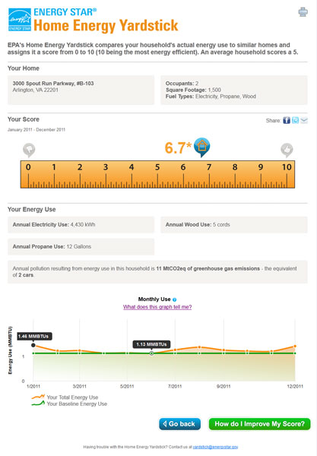

Figure 3‑6 Home Energy Yardstick Sample Output

ENO should consider the addition of this to the program website as a marketing tool for the program.

### Detailed Findings

#### Analysis of Participation Data

Table 3‑27 displays PY6 program activity by measure type. As shown, 80% of the expected energy savings resulted from duct sealing, which is slightly lower than in the previous program year when duct sealing comprised 85% of total program expected savings. More notable in 2016 was the increase in expected savings from air sealing measures which increased from 8% of total program activity in 2015 to 17% of totally program activity in 2016. Savings from insulation measures declined from 7% in 2015, to 3% of total expected program savings in 2016. In terms of expected savings, duct sealing is the measure with the lowest expected savings acquisition cost -- $0.10 per kWh saved. In comparison, the acquisition cost of expected savings for air sealing and insulation were $0.17 and $0.13, respectively.

Table 3‑27 Program Activity by Measure Type

|  |  |  |  |
| --- | --- | --- | --- |
| ***Measure Type*** | ***Expected Savings (kWh)*** | ***Share of Program Savings*** | ***$ per kWh in Expected Savings*** |
| Air sealing | 735,855 | 17% | $0.17 |
| Duct sealing | 3,373,373 | 80% | $0.10 |
| Insulation | 115,810 | 3% | $0.13 |

Figure 3‑7 summarizes program activity by number of measures implemented in PY6 as compared to PY5. The data indicates that customers implemented more measures per project in PY6 than in PY5. In PY5, fifty-six percent of projects were single measure projects, however in PY6 that percentage decreased to 24%. The percent of projects that implemented two or three measures increased from 43% to 67%, and from 1% to 9%, respectively. This shift may be due to the PY6 strategy of allocating a set number of homes to participating contractors instead of a set budget.

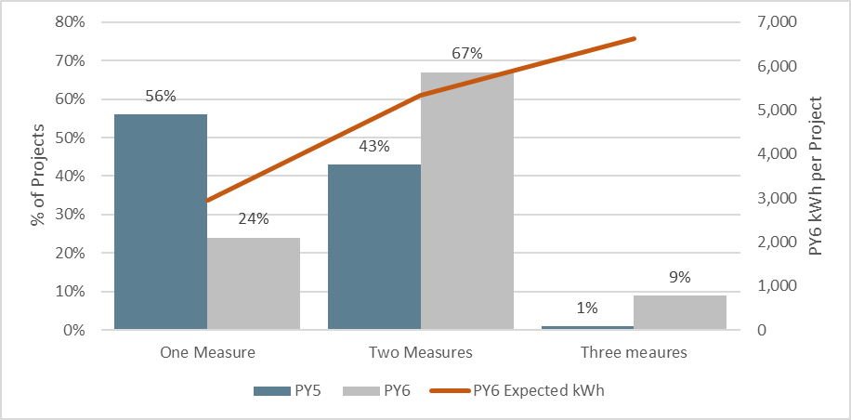

Figure 3‑7 Activity and Average Expected Savings by Number of Measures Implemented per Project

How the customer engaged with the program, that is, whether or not an assessment was performed, was also related to the number of measures implemented and the expected savings. The values provided in Table 3‑28 demonstrates that most customers (98%) that received and energy assessment through the program do implement more measures and as a result produce greater energy savings, on average. These values are up slightly from PY5 when 85% of customers that installed measures received an energy assessment. Average expected kWh savings per project also increased from PY5. Customers that had an energy assessment were expected to save an average of 4,908 kwh per project, which represents an increase of 1,400 kWh per project from PY5. Customers that did not receive an energy assessment were expected to save an average of 3,628 kWh per project, which represents an increase of 500 kWh per project from PY5.

Table 3‑28 Number of Measures and Expected Savings by Engagement Type

|  |  |  |  |
| --- | --- | --- | --- |
| ***Engagement Type*** | ***Percent of Projects\**** | ***Average Number of Measures*** | ***Average Expected kWh Savings*** |
| Had Assessment | 98% | 1.9 | 4,908 |
| Did Not Have an Assessment | 2% | 1.4 | 3,628 |

*The values represent projects that installed air sealing, duct sealing or insulation. Projects that received and assessment but did not install measures were not included in the analysis.

Seven contractors completed projects through the program during PY6. The Evaluators summarized the number and share of energy saving projects completed by these firms. Most program savings (99%) resulted from projects completed by two firms. In terms of contractor participation, the program data indicates that in PY6 fewer firms were responsible for greater portions of program activity as compared to PY5, when the two most active contractors accounted for 56% of program savings.

Table 3‑29 Program Activity by Participating HPwES Contractor

|  |  |  |  |
| --- | --- | --- | --- |
| ***Contractor*** | ***Number of Energy Savings Projects*** | ***Total Energy Savings*** | ***Percent of Savings*** |
| Contractor 1 | 466 | 2,559,324 | 61% |
| Contractor 2 | 374 | 1,601,849 | 38% |
| Contractor 3 | 12 | 24,785 | 1% |
| Contractor 4 | 7 | 13,991 | <1% |
| Contractor 5 | 3 | 19,069 | <1% |
| Contractor 6 | 2 | 3,727 | <1% |
| Contractor 7 | 1 | 2,294 | <1% |

During PY6, four of the seven active contractors had projects that were comprised mostly of duct sealing measures, while the other three contractors focused on insulation measures. Figure 3‑8 displays the measure mix by contractor. This represents a slight change from the previous program year when there were several additional contractors installing mainly insulation measures.

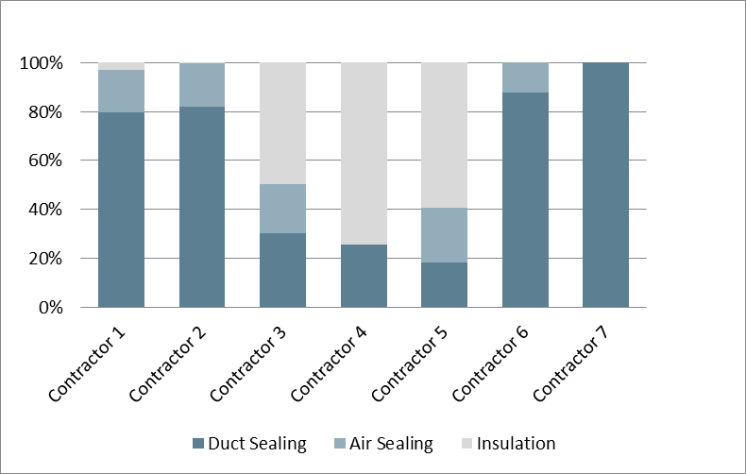

Figure 3‑8 Measure Mix by HPwES Contractor

#### Program Design, Operations and Activities

The program design and operations was discussed in detail in PY5. The program design and operations remained largely the same in PY6. No changes were made to the incentives or measures offered, the contractor network, or the program marketing approach.

#### Participant Survey Results

A total of 58 participants responded to the survey. Figure 3‑9 summarizes the measures implemented through the program by the survey respondents. Ninety-four percent of participants received duct sealing through the program, 76% received air sealing, and 4% received attic insulation.

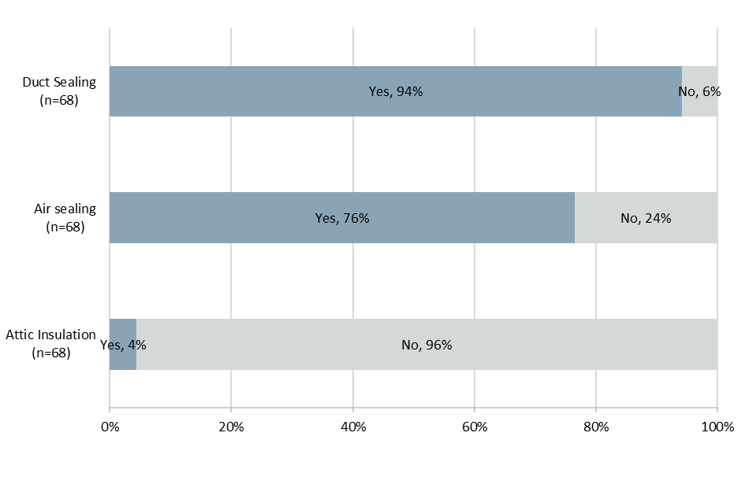

Figure 3‑9 Measures Implemented by HPwES Participants

#### Participant and Residential Demographics

Overall, program participants tended to own their homes, had relatively few household members, and a significant share reported household annual income of less than $50,000. Compared to last year, participants reported an average of .8 more household members, and fewer respondents reported an income of $25,000 and under. The change in the reported income levels may have resulted from the large number of respondents who refused to answer the income question (n = 26) or said “don’t know (n = 6). As such, the differences between PY5 and PY6 should be interpreted with caution.

Table 3‑30 Participant Home Demographics

|  |  |  |
| --- | --- | --- |
| ***Demographic Characteristic*** | ***PY5***  ***(n = 55)*** | ***PY6***  ***(n = 58)*** |
| Average number of home residents | 1.95 | 2.76 |
| Percent with income of:1 |  |  |
| Less than $25,000 per year | 35% | 17% |
| $25,000 to less than $50,000 | 16% | 14% |
| $50,000 to less than $75,000 | 13% | 2% |
| $75,000 or more | 9% | 12% |
| Percent own home | 89% | 78% |
| 1. Total does not equal 100% because some respondents did not know their income or declined to state it. | | |

Table 3‑31 displays participant household characteristics. Most participants (83%) lived in single family homes, half of participants resided in an older (pre-1990) home, and three-quarters of homes were larger than 1,500 square feet. The type of heating fuel was split, with slightly more than half of participants using electric space heating, and about one-half using electric water heating. In comparison to PY5, the household age and size increased.

Table 3‑31 Average Household size

|  |  |  |
| --- | --- | --- |
| ***Residence Characteristic*** | ***PY5***  ***(n = 55)*** | ***PY6***  ***(n = 58)*** |
| Percent Single Family Home1 | 82% | 83% |
| Percent electric space heating | 72% | 59% |
| Percent electric water heating | 56% | 59% |
| Percent of households built before 1990 | 68% | 50% |
| Percent with home size of:2 |  |  |
| Less than 1,000 ft.2 | 5% | 12% |
| 1,001-1,500 ft.2 | 18% | 22% |
| 1,501-2,000 ft.2 | 23% | 7% |
| Greater than 2,000 ft.2 | 23% | 45% |
| 1.Consistent with program rules, none of the respondents reported living in a multifamily property of more than 4 units  2. Total does not equal 100% because some respondents did not know the size of their home or declined to state it. | | |

#### Program Awareness and Participation

As shown in Figure 3‑10, the most common way that participants heard of the program was through friends of colleagues (56%). Bill inserts or mailers were reported as the main source of awareness by 15% of program participants, and 13% reported hearing of the program through a program representative. Less common ways participants heard about the program included through a retailer, a print advertisement, a contractor, Entergy’s website, a radio or television advertisement, or from another source. As was the case in PY5, word of mouth through social networks remained an important source of program awareness. The role of contractors in informing customers of the program diminished in PY6 – 4% of customers reported learning of the program from a program contractor as opposed to 19% in PY5.

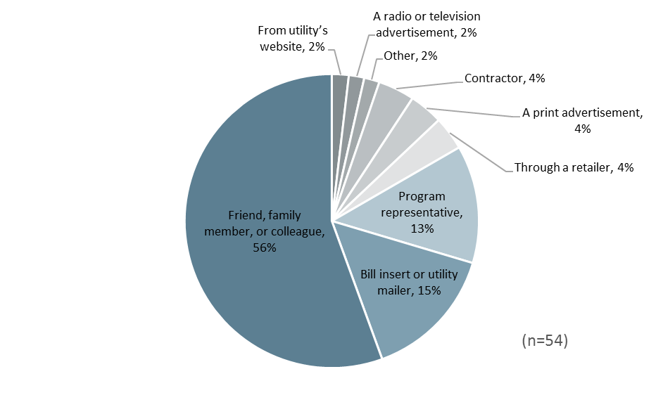

Figure 3‑10 HPwES Source of Program Awareness

Participants provided up to three reasons for why they participated in the program. As seen in Figure 3‑11, participants most often stated that they were motivated to save money or energy on electric bills, with 82% of participants giving this answer. Improving home comfort was reported by 28% of respondents. Eighteen percent of participants reported conserving energy and/or becoming as energy efficient as their friends or neighbors. This indicates that the main motivation for participating in the program is to save money on energy bills, followed by home comfort.

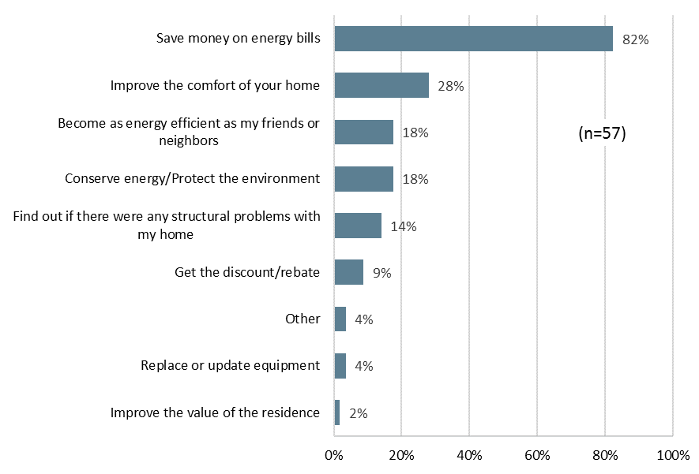

Figure 3‑11 HPwES Reasons for Participation

Twenty respondents reported that they had realized benefits other than energy and cost savings as a result of the measures implemented through the program. Of these twenty, 85% stated that their home was more comfortable, half stated that it was easier to maintain a comfortable temperature, four stated the home is less drafty and one each stated that they noticed reduced outside noise, they saw environmental benefits and their air conditioning or heater runs less often. These results are displayed below in Figure 3‑12.

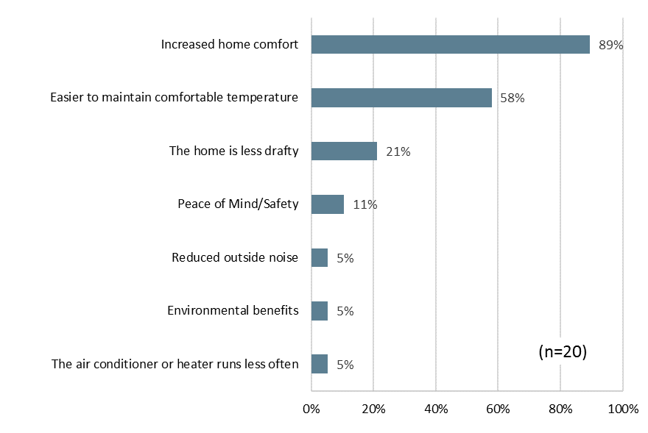

Figure 3‑12 HPwES Non-Energy Benefits

#### Participation Process

Ratings of agreement that the contractor was courteous and professional, that project scheduling was completed in a reasonable amount of time, and that the work was completed in a reasonable amount of time were made by respondents using a five-point scale where one meant “strongly disagree” and five meant “strongly agree.”

As was the case in PY5, most program participants were satisfied with the contractors that installed the energy efficiency measures. Almost all participants thought that the work was scheduled and completed in a reasonable amount of time and that the contractor was courteous and professional. Two participants disagreed that the time it took to complete the work was reasonable, and one disagreed the work was scheduled in a reasonable amount of time.

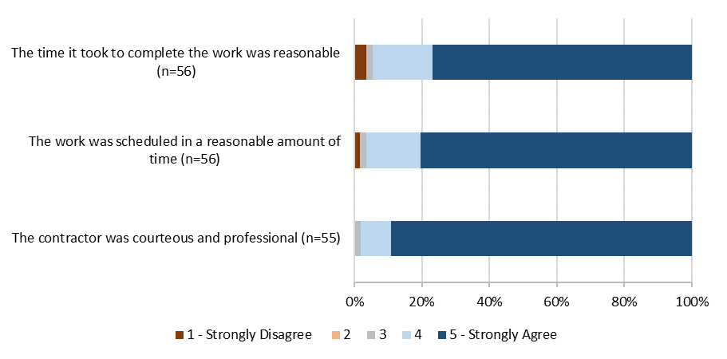

Figure 3‑13 Experience with Program Contractor

Figure 3‑14 summarizes average ratings of agreement for each contractor on the aspects of contractor performance discussed above. Ratings are shown for the two contractors that completed all but one of the respondent projects. As shown respondents provided similar ratings of the contractors’ professionalism and the time to schedule and complete the work. None of the differences in means presented below were statistically significant which means that any apparent differences are due to sampling error rather than performance differences between the two firms.

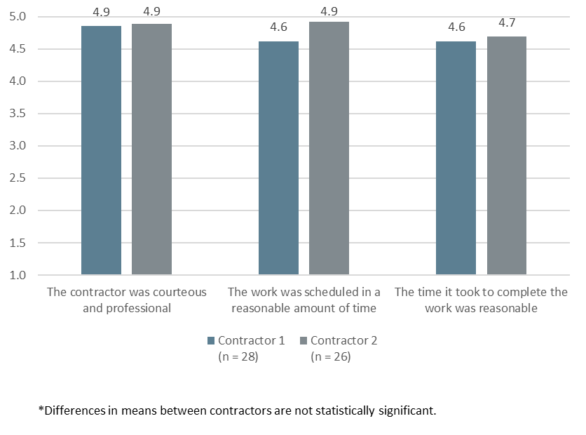

Figure 3‑14 Average Agreement Ratings for Contractors

Almost all participants (96%) stated that it was easy or very easy to find participating contractors, with 92% stating that it was very easy, and two participants stated that it was neither easy nor difficult to find a contractor. No participants stated that it was difficult to find a contractor.

#### Program Satisfaction and Additional Benefits

Participants rated their satisfaction with elements of the program very highly. Satisfaction ratings were provided using a scale where one meant very dissatisfied and five meant very satisfied. As shown in Figure 3‑15, 95% of program participants stated that they were either satisfied or very satisfied with the program overall. Aspects of the program that were more highly rated in terms of satisfaction were the:

* Quality of work performed by contractors (96% satisfied); and
* The participation process (94% satisfied).

Aspects of the program that were less highly rated in terms of satisfaction were the:

* Amount of the rebate or discount (87% satisfied); and
* The realized savings on the utility bill (71% satisfied, 8% were dissatisfied and 21% were neither particularly satisfied nor dissatisfied).

All four participants who had contacted staff with questions were satisfied or very satisfied with how long it took staff to address their questions. Three of the participants stated they were very satisfied with how thoroughly program staff addressed their questions, and one participant was neutral about how well their questions were addressed.

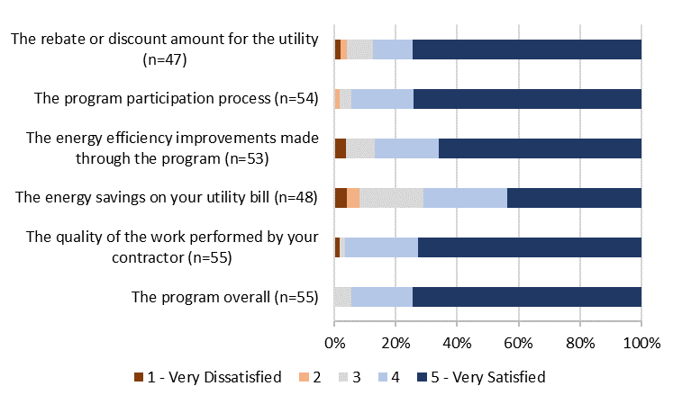

Figure 3‑15 HPwES Satisfaction with Program Components

Figure 3‑16 displays satisfaction ratings of the quality of work performed by the two contractor firms that completed all but one of the respondent projects. As shown, the rated levels of satisfaction were similar for the two firms and the differences in means were not statistically significant.

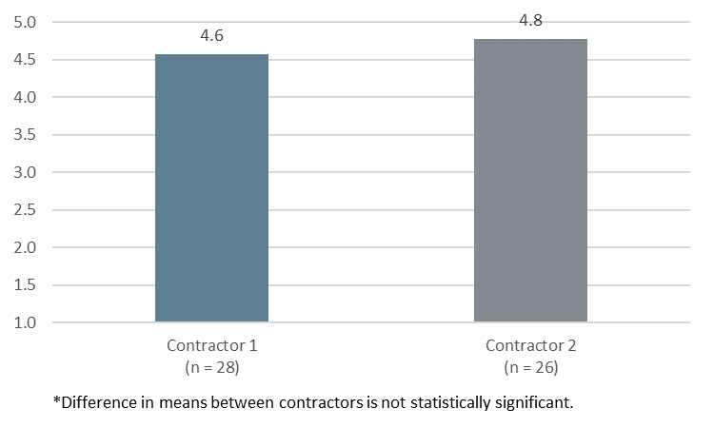

Figure 3‑16 HPwES Satisfaction with Quality of Work Performed by Contractors

Participants that stated some dissatisfaction with one or more aspects of the program were asked to describe why they were dissatisfied. Seven participants gave explanations as to why they were dissatisfied. Four participants stated that they had not seen the desired effect on reducing their electricity bill. These comments were as follows:

*“Light bill is very high and was not decreased by the work that was done.”*

*“Everything made my bill higher and the rebate did not offset the cost of the project.*

*“I haven’t saved anything yet.”*

*“No change in utility bill.”*

Two respondents noted dissatisfaction with the contractor who installed the energy efficiency improvements.

When asked about their overall satisfaction with Entergy as their electrical service provider, more than half (66%) of participants stated they were either somewhat or very satisfied with Entergy, with a third (31%) stating they were ‘very satisfied’. Five percent indicated dissatisfaction.

Table 3‑32 HPwES Participant Satisfaction with Entergy

|  |  |
| --- | --- |
| ***Satisfaction with Entergy*** | ***Percent of Respondents***  ***(n=58)*** |
| 5 - Very satisfied | 31% |
| 4 | 34% |
| 3 - Neither satisfied nor dissatisfied | 22% |
| 2 | 5% |
| 1 - Very dissatisfied | 0% |
| Don’t know | 3% |
| Refused | 3% |

More than half of participants (52%) stated that their participation in the program somewhat or greatly increased their satisfaction with Entergy, a share that is comparable to the 61% who stated this in PY5. An additional 31% stated that the program did not affect their satisfaction with Entergy. Nine percent of participants stated that participation in the program somewhat decreased their satisfaction with Entergy.

Table 3‑33 Effect of Program on Satisfaction with Entergy

|  |  |
| --- | --- |
| ***Effect of Program on Satisfaction with Entergy*** | ***Percent of Respondents  (n = 58)*** |
| Greatly increased your satisfaction with ENO | 16% |
| Somewhat increased your satisfaction with ENO | 36% |
| Did not affect your satisfaction with ENO | 31% |
| Somewhat decreased your satisfaction with ENO | 9% |
| Greatly decreased your satisfaction with ENO | 0% |
| Don’t know | 5% |
| Refused | 3% |

### Conclusions

The Evaluators’ conclusions are summarized below:

* PY6 program measures and incentive levels remained the same as in PY5. In the PY6 evaluation, the Evaluators recommended that staff consider adding low-flow direct install measures to the program for homes with electric water heating. Staff stated that this was discussed but these measures have not been added. The evaluators also suggested capping incentives for duct sealing measures. The PY7 incentive is capped at $200.
* The Evaluators recommended in the PY5 evaluation that staff develop strategies to improve the quality of program data. The tracking data was considerably improved with notably fewer incidents of missing or invalid information identified.
* The number of multiple-measure projects completed increased during PY6. Specifically, the number of projects involving two or more measures increased from 44% in PY5 to 76% in PY6. This shift may be a result of the program allocating a set number of houses to contractors rather than a set dollar amount.
* As was the case in PY5, duct sealing accounted for the largest share of program savings but the share of savings from air sealing increased by nine percentage points.
* The share of expected savings was concentrated in fewer program contractors in PY6 than in PY5. In PY6, 99% of energy savings was delivered by two key contractors, as compared to PY5 when the two most active contractors accounted for 56% of program savings.
* Participants remain satisfied with the program and reported satisfaction was consistent with findings from PY5.

### Recommendations

The Evaluators’ recommendations for the HPwES Program are summarized below:

* **Develop a case study with a successful trade ally for the Energy Star website.** This could increase visibility and recognition of the program’s success.
* **Incorporate the Home Energy Yardstick into program marketing.** The Yardstick provides a quick assessment to a customer as to the overall efficiency of their home and may encourage further participation.
* **Work to develop a case study to recognize one or more of the top-performing trade allies.** The Home Performance with Energy Star national program posts case studies where contractors have had significant success with the program. Working to get an ENO trade ally recognized in this manner could enhance the program reputation.

**Sampling and Surveying**

# Assisted Home Performance with ENERGY STAR

## Program Description

The Assisted Home Performance with Energy Star Program (aHPwES) targets and offers comprehensive weatherization services to qualified low-income, single-family homes and low-rise, multi-family dwellings of four or fewer units. The aHPwES program is intended to be primarily implemented through local participating trade allies who provide energy efficiency upgrades available to income qualifying customers. The Program’s objective is to educate customers on how they are using energy, identify opportunities for energy savings specific to their home, and prioritize a wide range of energy conservation measures that will allow them to save energy immediately.

The aHPwES program provides customers with household incomes at or below 60% of the estimated State’s median income with home energy upgrades at low or no cost.[17] The Program offers these customers a free home energy assessment through a qualified and participating trade ally.

## Expected Savings and Program Participation

The contractor-installed measures are:

* Air sealing;
* Duct sealing; and
* Ceiling insulation.

A total of 220 households participated in the program. Table 4‑1 and Table 4‑2 summarizes the total number of homes a measure was installed in/performed at, total measures installed/performed and the expected kWh and peak kW savings by measure.

Table 4‑1 aHPwES Summary of Measures and Expected Savings – New Orleans

|  |  |  |  |
| --- | --- | --- | --- |
| ***Measure*** | ***Quantity*** | ***Total Expected kWh Savings*** | ***Total Expected kW Savings*** |
| Duct Sealing | 188 | 154,914 | 71.51 |
| Air Sealing | 248 | 987,827 | 171.59 |
| Ceiling Insulation | 158 | 435,279 | 147.70 |
| **Total** | **594** | **1,578,020** | **390.79** |

Table 4‑2 aHPwES Summary of Measures and Expected Savings – Algiers

|  |  |  |  |
| --- | --- | --- | --- |
| ***Measure*** | ***Quantity*** | ***Total Expected kWh Savings*** | ***Total Expected kW Savings*** |
| Duct Sealing | 14 | 12,837 | 14 |
| Air Sealing | 19 | 55,799 | 19 |
| Ceiling Insulation | 6 | 19,112 | 6 |
| **Total** | **39** | **87,749** | **39** |

The program goals and achievement of the goals is summarized below.

Table 4‑3 Summary of Program Goals

|  |  |  |  |
| --- | --- | --- | --- |
| ***Operating Company*** | ***Participation*** | ***MWh*** | ***MW*** |
| Algiers | 70 | 60 | 0.02 |
| ENO | 858 | 733 | 0.3 |

Table 4‑4 aHPwES Summary of Goal Achievement

|  |  |  |  |  |  |  |
| --- | --- | --- | --- | --- | --- | --- |
| ***Operating Company*** | ***Verified Net kWh*** | ***kWh Goal*** | ***% of Goal Attained*** | ***Verified kW*** | ***kW Goal*** | ***% of Goal Attained*** |
| Algiers | 98,896 | 46,000 | 215.0% | 36.25 | 20 | 181.3% |
| ENO | 1,822,693 | 519,000 | 351.2% | 631.3 | 200 | 315.7% |

## Impact Savings Calculation Methodology

Impact methodologies for aHPwES Air Infiltration are the same as described for HPwES, described in sections 3.3 and 3.6.

## Verified Savings by Measure – aHPwES

### Infiltration/Air Sealing

Details about M&V Impact methodologies for aHPwES Air Infiltration are the same as described for HPwES, described in section 3.2.1.

#### Air Sealing Savings Results

Table 4‑5 Expected and Realized Air Sealing Savings – New Orleans

|  |  |  |  |  |  |  |
| --- | --- | --- | --- | --- | --- | --- |
| ***Heating Type*** | ***Expected kWh Savings*** | ***Realized kWh Savings*** | ***kWh Realization Rate*** | ***Expected Peak kW Savings*** | ***Realized Peak kW Savings*** | ***Peak kW Realization Rate*** |
| Natural Gas Furnace | 31,830 | 44,318 | 139.2% | 30.72 | 37.85 | 123.2% |
| Electric Resistance | 121,102 | 162,938 | 134.5% | 39.63 | 48.84 | 123.2% |
| Air Source Heat Pump | 1,983 | 3,099 | 156.3% | 1.16 | 1.36 | 117.2% |
| **Total** | **154,915** | **210,355** | **135.8%** | **71.51** | **88.05** | **123.1%** |

Table 4‑6 Expected and Realized Air Sealing Savings - Algiers

|  |  |  |  |  |  |  |
| --- | --- | --- | --- | --- | --- | --- |
| ***Heating Type*** | ***Expected kWh Savings*** | ***Realized kWh Savings*** | ***kWh Realization Rate*** | ***Expected Peak kW Savings*** | ***Realized Peak kW Savings*** | ***Peak kW Realization Rate*** |
| Natural Gas Furnace | 4,636 | 6,567 | 141.7% | 4.47 | 5.62 | 125.7% |
| Electric Resistance | 8,201 | 10,758 | 131.2% | 2.68 | 3.24 | 120.9% |
| Air Source Heat Pump | - | - | N/A | - | - | N/A |
| **Total** | **12,837** | **17,325** | **135.0%** | **7.15** | **8.86** | **123.9%** |

### Duct Sealing

Details about M&V Impact methodologies for aHPwES Air Infiltration are the same as described for HPwES, described in section 3.2.2.

#### Duct Sealing Savings Results

The savings resulting from this revision to deemed parameters and application of field results are summarized in Table 4‑7 and Table 4‑9.

Table 4‑7 Expected and Realized Duct Sealing Savings – New Orleans

|  |  |  |  |  |  |  |
| --- | --- | --- | --- | --- | --- | --- |
| ***Heating Type*** | ***Expected kWh Savings*** | ***Realized kWh Savings*** | ***kWh Realization Rate*** | ***Expected Peak kW Savings*** | ***Realized Peak kW Savings*** | ***Peak kW Realization Rate*** |
| Natural Gas Furnace | 185,201 | 190,753 | 103.0% | 67.47 | 89.67 | 132.9% |
| Electric Resistance | 795,680 | 800,180 | 100.6% | 102.75 | 136.10 | 132.5% |
| Air Source Heat Pump | 6,946 | 7,126 | 102.6% | 1.36 | 1.84 | 135.3% |
| **Total** | **987,827** | **998,059** | **101.0%** | **171.58** | **227.61** | **132.7%** |

Table 4‑8 Expected and Realized Duct Sealing Savings - Algiers

|  |  |  |  |  |  |  |
| --- | --- | --- | --- | --- | --- | --- |
| ***Heating Type*** | ***Expected kWh Savings*** | ***Realized kWh Savings*** | ***kWh Realization Rate*** | ***Expected Peak kW Savings*** | ***Realized Peak kW Savings*** | ***Peak kW Realization Rate*** |
| Natural Gas Furnace | 19,716 | 20,352 | 103.2% | 7.18 | 9.57 | 133.3% |
| Electric Resistance | 36,083 | 36,171 | 100.2% | 4.63 | 6.16 | 133.0% |
| Air Source Heat Pump | - | - | N/A | - | - | N/A |
| **Total** | **55,799** | **56,523** | **101.3%** | **11.81** | **15.73** | **133.2%** |

### Attic Insulation

#### Attic Insulation Savings Results

Verified savings for this measure are provided in Table 4‑9 and Table 4‑10.

Table 4‑9 Expected and Realized Attic Insulation Savings – New Orleans

|  |  |  |  |  |  |  |
| --- | --- | --- | --- | --- | --- | --- |
| ***Heating Type*** | ***Expected kWh Savings*** | ***Realized kWh Savings*** | ***kWh Realization Rate*** | ***Expected Peak kW Savings*** | ***Realized Peak kW Savings*** | ***Peak kW Realization Rate*** |
| Natural Gas Furnace | 72,995 | 161,159 | 220.8% | 69.32 | 146.92 | 211.9% |
| Electric Resistance | 362,284 | 453,120 | 125.1% | 78.38 | 168.72 | 215.3% |
| Air Source Heat Pump | - | - | N/A | - | - | N/A |
| **Total** | **435,279** | **614,279** | **141.1%** | **147.70** | **315.64** | **213.7%** |

Table 4‑10 Expected and Realized Attic Insulation Savings - Algiers

|  |  |  |  |  |  |  |
| --- | --- | --- | --- | --- | --- | --- |
| ***Heating Type*** | ***Expected kWh Savings*** | ***Realized kWh Savings*** | ***kWh Realization Rate*** | ***Expected Peak kW Savings*** | ***Realized Peak kW Savings*** | ***Peak kW Realization Rate*** |
| Natural Gas Furnace | 1,994 | 4,328 | 217.1% | 1.89 | 3.95 | 209.0% |
| Electric Resistance | 17,119 | 20,720 | 121.0% | 3.70 | 7.71 | 208.4% |
| Air Source Heat Pump | - | - | N/A | - | - | N/A |
| **Total** | **19,113** | **25,048** | **131.1%** | **5.59** | **11.66** | **208.6%** |

## Verified Gross Savings

Realized savings is presented by program channel in Table 4‑11 through Table 4‑12.

Table 4‑11 Gross Realization Summary – New Orleans

|  |  |  |  |  |  |  |  |
| --- | --- | --- | --- | --- | --- | --- | --- |
| ***Measure*** | ***Number Homes*** | ***Expected kWh Savings*** | ***Expected kW Savings*** | ***Verified kWh Savings*** | ***Verified kW Savings*** | ***Realization*** | |
| ***kWh*** | ***kW*** |
| Air Sealing | 188 | 154,914 | 71.51 | 210,355 | 88.05 | 135.79% | 123.13% |
| Duct Sealing | 248 | 987,827 | 171.59 | 998,059 | 227.61 | 101.04% | 132.65% |
| Ceiling Insulation | 158 | 435,279 | 147.70 | 614,279 | 315.64 | 141.12% | 213.71% |
| **Total** | **594** | **1,578,020** | **390.79** | **1,822,693** | **631.30** | **115.51%** | **161.54%** |

Table 4‑12 Gross Realization Summary – Algiers

|  |  |  |  |  |  |  |  |
| --- | --- | --- | --- | --- | --- | --- | --- |
| ***Measure*** | ***Number Homes*** | ***Expected kWh Savings*** | ***Expected kW Savings*** | ***Verified kWh Savings*** | ***Verified kW Savings*** | ***Realization*** | |
| ***kWh*** | ***kW*** |
| Air Sealing | 14 | 12,837 | 7.16 | 17,325 | 8.86 | 134.96% | 123.77% |
| Duct Sealing | 19 | 55,799 | 11.81 | 56,523 | 15.73 | 101.30% | 133.14% |
| Ceiling Insulation | 6 | 19,112 | 5.60 | 25,048 | 11.66 | 131.06% | 208.29% |
| **Total** | **39** | **87,749** | **24.57** | **98,896** | **36.25** | **112.70%** | **147.53%** |

## Verified Net Savings

Due to the income qualification requirements to participate in the program, NTGR for the aHPwES is stipulated at 100%.

## Process Evaluation

This chapter presents the results of the process evaluation of the aHPwES Program. The process evaluation focuses on aspects of program policies and organization, as well as the program delivery framework.

The process chapter begins with an overview of the program. This is followed by a discussion of the methodological approach used in the evaluation. A summary of findings and recommendations for program improvement follow the discussion of the methodology. This discussion is followed by detailed findings of the evaluation activities.

### Data Collection Activities

The limited process evaluation of the aHPwES Program included the following data collection activities:

* *Entergy Program Staff* *Interview*. The Evaluators interviewed the Energy Smart Program manager. This interview was to collect information from program staff on program design, objectives, and operations.
* *Participant Surveying*. The Evaluators surveyed a sample of program participants. These surveys addressed issues including participant satisfaction with the program offerings, demographics, and other contextual issues regarding the participation process.

The quantities completed are summarized in Table 4‑14.

Table 4‑13 aHPwES Process Evaluation – Summary of Data Collection

|  |  |
| --- | --- |
| ***Activity*** | ***Sample Size*** |
|
| The Companies Staff | 1 |
| Participant Survey | 38 |

### Program Overview

The aHPwES provides energy efficiency home upgrades at low or no cost to customers with household incomes at or below 60% of Louisiana State’s median income. These income limits for 2016 are summarized in Table 4‑15. The 60% of state median income standard is the same standard used in PY5 but the dollar values increased slightly.

Table 4‑14 Income Limits for Participation in aHPwES

|  |  |
| --- | --- |
| ***Number in Household*** | ***Maximum Annual Income*** |
| 1 | $22,313 |
| 2 | $29,179 |
| 3 | $36,044 |
| 4 | $42,910 |
| 5 | $49,776 |
| 6 | $56,641 |
| * For households with more than six (6) people add 3 percentage points to the percentage for a six-person household (132%) and multiplying the new percentage by 60 percent of the median income for a four-person family. | |

The program is designed to help qualifying customers save money on their home energy bills by analyzing their energy use and identifying energy efficiency improvement projects. The home energy assessments involve a walkthrough inspection of the customer’s home including an inspection of the ceiling walls, doors, windows, and ventilation. Duct leakage testing and blower door testing may be performed if the customer is a good candidate for duct and envelope sealing measures. Following the assessment, the contractor the installation of home improvements to increase its energy efficiency.

Table 4‑16 summarizes the program incentives. The measures included and incentive amounts remained unchanged from PY5. The discounts for the assessments and measures are intended to cover the full cost of the measures for income qualified participants.

Table 4‑15 Incentives for Assessments and Measures

|  |  |
| --- | --- |
| ***Measure/Service*** | ***Rebate Amount*** |
|
| Air Sealing | $.14/CFM50 reduction |
| Duct Sealing | $4.50/CFM25 reduction |
| Ceiling insulation | Up to $0.60 per ft.2 (depending on heating fuel type) |
| Energy Assessment | $75 |

### Detailed Findings

#### Analysis of Participation Data

Table 4‑1 displays program activity by measure type. As shown, most of the expected energy savings (63%) resulted from duct sealing. Sixty-three percent is slightly lower than last year when duct sealing represented 72% of expected savings. Expected savings from both air sealing and insulation increased from 8% to 10%, and 20% to 27%, respectively.

Table 4‑16 Program Activity by Measure Implemented

|  |  |  |  |
| --- | --- | --- | --- |
| ***Measure Type*** | ***Expected Savings (kWh)*** | ***Share of Program Savings*** | ***$ per kWh in Expected Savings*** |
| Air sealing | 167,752 | 10% | $0.25 |
| Duct sealing | 1,043,626 | 63% | $0.24 |
| Insulation | 454,391 | 27% | $0.33 |

Figure 4‑1 summarizes program activity by number of measures implemented. As shown, most projects involved multiple measures, although instances of projects with a single measure increased from 8% in PY5 to 18% in PY6. From an expected savings perspective, the average savings per project increased in PY6, regardless of how many measures participants installed.

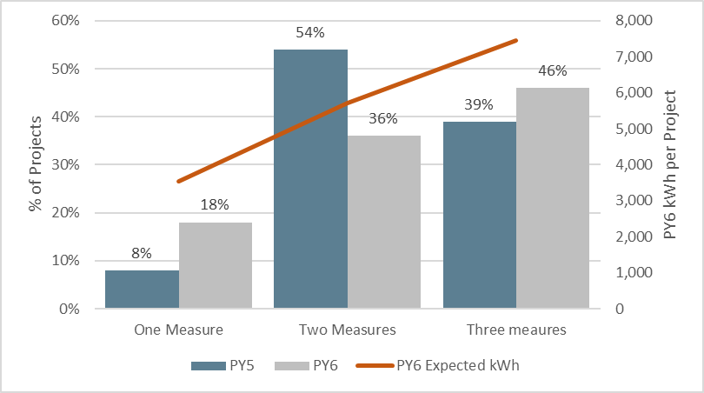

Figure 4‑1 aHPwES: Average Expected Savings by Number of Measures Implemented

Five contractors completed projects through the aHPwES Program during PY6, two of which accounted for the majority (87%) of total expected energy savings. The data reflects an increase in the number of participating contractors; during PY5 just two contractors, in total, completed projects through the aHPwES Program.

Table 4‑17 Program Activity by Participating Contractor

|  |  |  |  |
| --- | --- | --- | --- |
| ***Contractor*** | ***Total Project Count*** | ***Total Expected Energy Savings*** | ***Percent of Expected Energy Savings*** |
| Contractor 1 | 319 | 953,732 | 57% |
| Contractor 2 | 225 | 500,704 | 30% |
| Contractor 3 | 47 | 120,073 | 7% |
| Contractor 4 | 33 | 78,298 | 5% |
| Contractor 5 | 9 | 12,962 | 1% |

Figure 4‑2 below displays the measure mix by contractor. Three of the five participating contractors had approximately 50% or more of their expected energy savings come from the installation of duct sealing. The other two contractors focused solely on insulation. This measure mix contrasts with the measure mix, by contractor, in PY5 when the two participating firms focused primarily on duct sealing.

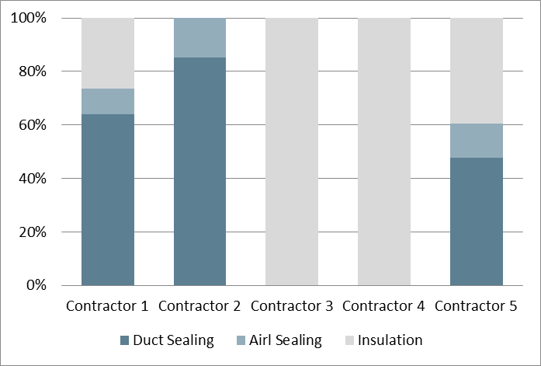

Figure 4‑2 aHPwES Measure Mix by Contractor

#### Program Design, Operations and Activities

The program design and operations was discussed in detail in PY5. The program design and operations remained largely the same in PY6. No changes were made to the incentives or measures offered or the contractor network. Staff stated that they pushed the income qualified component of the HPwES to a greater extent in PY6, and this may explain the increase in expected program savings.

#### Participant Survey Results

A total of thirty-nine participants responded to the survey. Figure 4‑3 summarizes the program measures implemented by the survey respondents. All participants received duct sealing through the program, and 80% received air sealing.

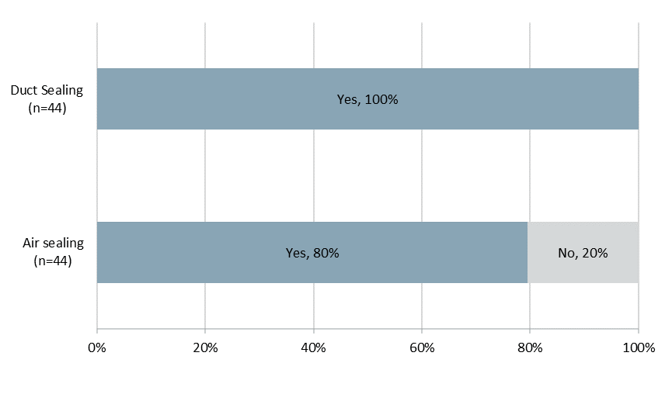

Figure 4‑3 aHPwES Measures Installed through Program

Overall, program participants tended to own their homes, have relatively few household members, and slightly less than one-half of program participants reported household annual income of less than $25,000. The Evaluators cross-tabulated income and occupancy responses and concluded that all surveyed participants were program-eligible.

Table 4‑18 Participant Demographics

|  |  |  |
| --- | --- | --- |
| ***Demographic Characteristic*** | ***PY5***  ***(n=30)*** | ***PY6***  ***(n=38)*** |
| Average number of home residents | 1.53 | 2.53 |
| Percent with income of:1 |  |  |
| Less than $25,000 per year | 53% | 45% |
| $25,000 to less than $50,000 | 23% | 13% |
| $50,000 to less than $75,000 | 3% | 0% |
| $75,000 or more | 0% | 0% |
| Percent own home | 83% | 84% |
| 1. Total does not equal 100% because some respondents did not know their income or declined to state it. | | |

Table 4‑20 displays participant household characteristics. The majority of participants resided in a single-family home with electric space heating. About one-half of homes had electric water heating and most were smaller than 1,500 square feet. Of the 26 respondents that knew the age of their home, 65% stated that they resided in homes that were built before 1990, indicating that program participants generally live in older homes.

Table 4‑19 Household Demographics

|  |  |  |
| --- | --- | --- |
| ***Residence Characteristic*** | ***PY5***  ***(n=30)*** | ***PY6***  ***(n=38)*** |
| Percent Single Family Home1 | 93% | 89% |
| Percent electric space heating | 83% | 68% |
| Percent electric water heating | 63% | 50% |
| Percent of households built before 1990 | 70% | 65% |
| Percent with home size of:2 |  |  |
| Less than 1,000 ft.2 | 3% | 21% |
| 1,001-1,500 ft.2 | 17% | 26% |
| 1,501-2,000 ft.2 | 20% | 13% |
| Greater than 2,000 ft.2 | 17% | 34% |
| 1.Consistent with program rules, none of the respondents reported living in a multifamily property of more than 4 units  2.  Total does not equal 100% because some respondents did not know the size of their home or declined to state it. | | |

#### Program Awareness and Participation

As shown in Figure 4‑4, the most common source of awareness of the program was through friends, family, or colleagues (61%). Bill inserts or mailers were stated as the source of initial awareness by 22% of program participants, and 11% of respondents indicated that that they learned of the program through a print advertisement. Participants also heard of the program through an internet advertisement (3%) and through a program representative (3%). In comparison, to PY5, the sources of program awareness were largely similar. A notable difference in participant sources of program awareness is that none of the participants in PY6 reported that they learned of the program from a contractor or home energy consultant. In comparison, 14% of participants learned of the program from contractors or energy consultants in PY5.

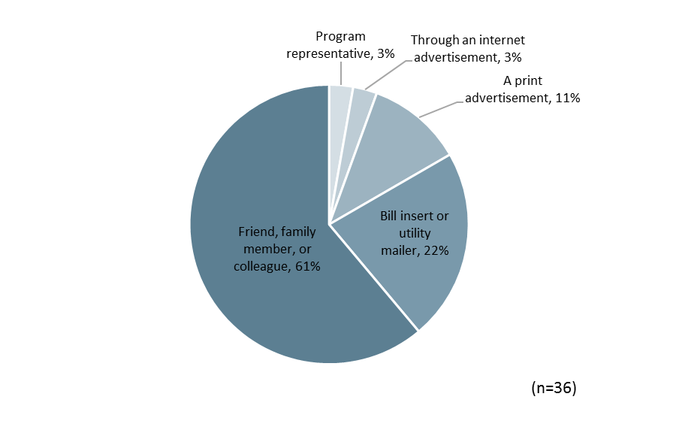

Figure 4‑4 aHPwES Source of Program Awareness

Participants were asked to explain why they participated in the program. As displayed in Figure 4‑5, the majority of participants reported that saving money on their energy bills was a reason for participating. Slightly more than a fifth of participants (21%) stated that they participated to be as energy efficient as their neighbors, and 18% stated that they were interested in improved home comfort. Other reasons that participants reported include receiving the rebate, learning of structural issues to their homes, and conserving energy. The responses indicated that while multiple factors motivate participation, energy conservation is a less compelling motivator than saving money on energy bills for participating in the program. The most commonly stated motivator related to energy conservation was related to comparison to other people’s energy use rather than conservation as a goal in of itself.

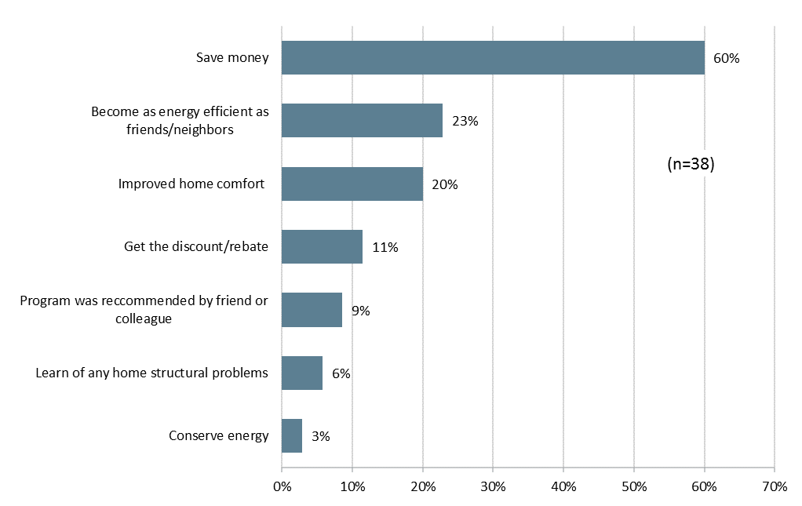

Figure 4‑5 aHPwES Reasons for Participation

#### Participation Process

Overall, program participants were very satisfied with the contractors that installed the energy efficiency measures. All but two respondents agreed that the work was scheduled and completed in a reasonable amount of time and that the contractor was courteous and professional (Figure 4‑6). None of the respondents disagreed that this was the case.

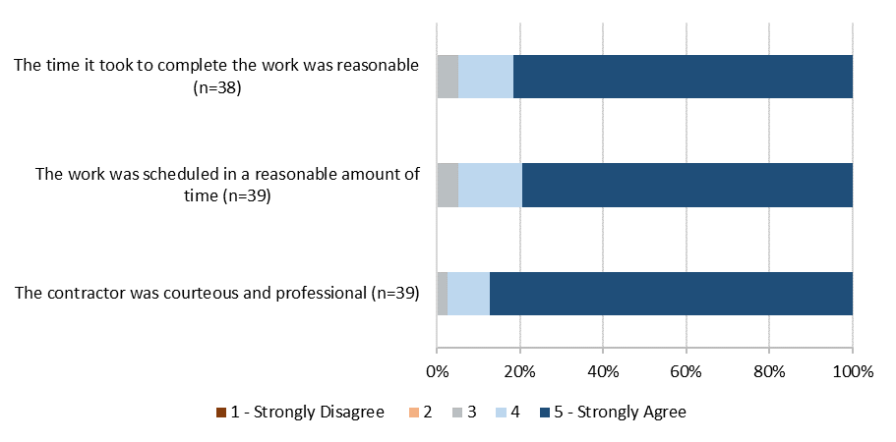

Figure 4‑6 aHPwES Satisfaction with Contractor

Figure 4‑7 summarizes average ratings of agreement for each contractor on the aspects of contractor performance discussed above. Ratings are shown for the two contractors that completed respondent projects. As shown respondents provided similar ratings of the contractors’ professionalism and the time to schedule and complete the work. None of the differences in means presented below were statistically significant which means that any apparent differences are due to sampling error rather than performance differences between the two firms.

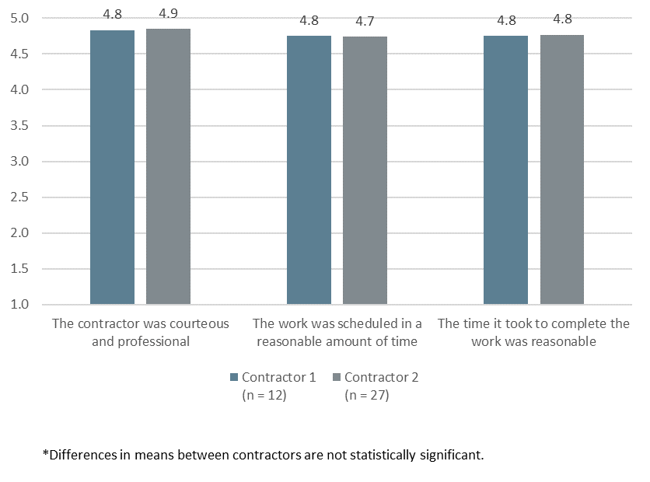

Figure 4‑7 aHPwES Average Agreement Ratings for Contractors

Ninety-three percent of participants stated that it was easy or very easy to find participating contractors, with 75% stating that it was very easy. One participant stated that it was very difficult to find a contractor.

#### Program Satisfaction

Overall, program participants were satisfied with the program. Ninety-five percent of respondents rated their satisfaction with the program overall as a four or a five, indicating that they were somewhat or very satisfied with the program. The highest rated elements were the energy efficiency improvements made through the program, the program participation process, and the overall program. As shown in Figure 4‑8, 95% of program participants stated that they were either satisfied or very satisfied with each of these elements. Participants were also satisfied with the quality of work performed by the contractor – 92% stated that they were satisfied or very satisfied with this aspect of the project. Like last year, participants were least satisfied with the energy savings on their utility bill – in PY6, 70% of participants were satisfied or very satisfied with their energy savings but 6% were dissatisfied with this aspect of the project.

Seven participants contacted program staff with questions. Six of the seven participants were satisfied or very satisfied with the time it took program staff to address their questions or concerns, and how thoroughly they addressed their questions. The remaining participant was neither satisfied or dissatisfied.

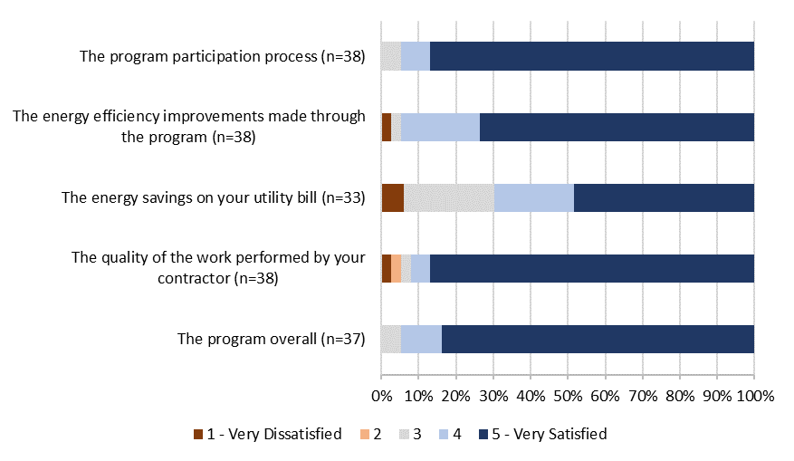

Figure 4‑8 aHPwES Satisfaction with Program Components

Figure 4‑9 displays satisfaction ratings of the quality of work performed by the two contractor firms that completed respondent projects. As shown, the rated levels of satisfaction were similar for the two firms and the differences in means were not statistically significant.

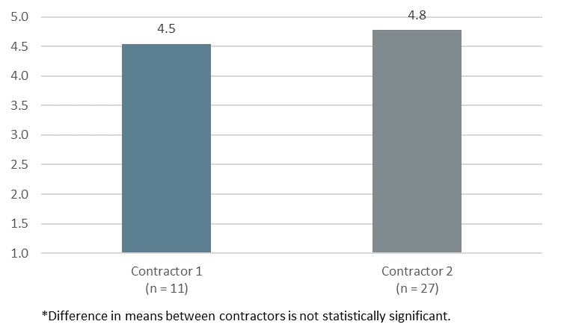

Figure 4‑9 aHPwES Satisfaction with Quality of Work Performed by Contractors

Participants that were dissatisfied with one or more aspects of the program were asked to explain why they were dissatisfied. A total of three respondents indicated dissatisfaction with at least one program element. Two of these respondents stated that they have not seen lower energy costs because of the program. The third respondent, reported that a fuse blew after completion of the duct and air sealing project.

One-quarter of the program participants indicated that they had experienced benefits from participation in addition to the cost and energy savings. Of the ten respondents that stated they had experienced additional benefits 60% stated their home is more comfortable, 50% stated that their home is less drafty, 30% stated that it was easier to maintain a comfortable temperature, 20% gave general statements of satisfaction, and 10% stated that their air conditioner or heater runs less often.

Table 4‑20 Non-Energy Benefits of the Program

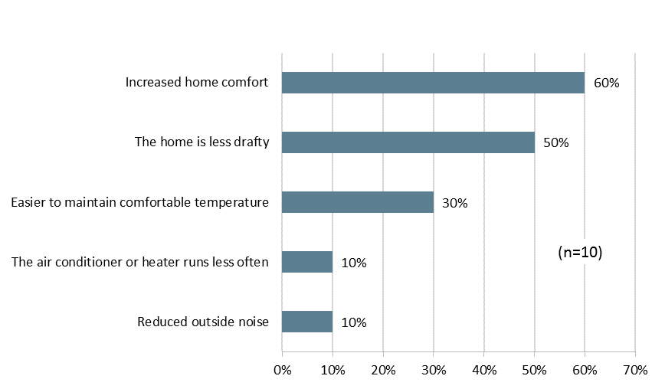

Participants were also asked about their overall satisfaction with Entergy as their electrical service provider. Three-quarters (77%) of participants stated they were either somewhat or very satisfied with Entergy, with more than half (60%) stating they were ‘very satisfied’. No participants reported dissatisfaction with Entergy. These results are similar to the PY5 evaluation findings.

Table 4‑21 Overall Satisfaction with Entergy

|  |  |
| --- | --- |
| ***Satisfaction with Entergy*** | ***Percent of Respondents*** |
| ***(n=35)*** |
| 5 - Very satisfied | 60% |
| 4 | 17% |
| 3 - Neither satisfied nor dissatisfied | 23% |
| 2 | 0% |
| 1 - Very dissatisfied | 0% |

Participants rated the impact of participating in the program on their satisfaction with Entergy as their electrical service provider, most participants (65%) stated that their participation in the program somewhat or greatly increased their satisfaction with Entergy (Table 4‑23). An additional 30% stated that the program did not affect their satisfaction with Entergy. Five percent of participants stated that participation in the program either somewhat or greatly decreased their satisfaction with Entergy. These results were also similar to findings from the PY5 evaluation.

Table 4‑22 Effect of Program on Satisfaction with Entergy

|  |  |
| --- | --- |
| ***Effect of Program on Satisfaction with Entergy*** | ***Percent of Respondents*** |
| ***(n=37)*** |
| Greatly increased your satisfaction with ENO | 30% |
| Somewhat increased your satisfaction with ENO | 35% |
| Did not affect your satisfaction with ENO | 30% |
| Somewhat decreased your satisfaction with ENO | 5% |
| Greatly decreased your satisfaction with ENO | 0% |

Overall, participants are generally satisfied with the program and ENO as their electrical service provider.

### Conclusions

The Evaluators’ conclusions are summarized below:

* PY6 program measures and incentive levels remained the same as in PY5. In the PY5 evaluation it was noted that some participants stated that participation was not free for them. No customers noted this issue in the PY6 survey.
* The program data was largely complete and contained valid data. However, one issue identified was that 12% of projects listed multiple space heating types for different measures installed at the same location.
* The number of completed projects increased from 220 in PY5 to 272 in PY6. Additionally, the number of participating contractors increased from two in PY5 to five in PY6.
* There was an increase in the share of projects that involved single measures. In PY5 8% of completed projects were single measure projects, which increased to 18% in PY6.
* As was the case in PY5, duct sealing accounted for the largest share of program savings but the share of savings from air sealing and insulation increased in PY6.
* Reported satisfaction was consistent with findings from PY5. Ninety-five percent were somewhat or very satisfied with the program.

### Recommendations

The Evaluators’ recommendations for the aHPwES Program are as follows:

* **Review Data Management Procedures to Reduce Incidents of Multiple Space Heating Types Reported for a Location.** Twelve percent of sites listed multiple space heating types for different measures installed at the same location. Future program implementers should consider strategies such as implementing data validity checks or storing premise information in a premise-level table to prevent such errors. If there is a differing fuel type between a primary and secondary heating system, then savings should be calculated using the primary system only.

# Green Light Direct install

## Program Description

The Green Light Direct Install (GLDI) Program provides direct installation of compact fluorescent lamps (CFLs) and light emitting diodes (LEDs) in participating residences. The GLDI Program is intended to reduce residential energy use through the one-for-one replacement of incandescent lamps with energy efficient CFLs and LEDs.

Residential customers in New Orleans Parish are eligible for the program. There is not limit on the number of bulbs that can be installed in a residence so long as they replace incandescent lamps.

## Expected Savings and Program Participation

A total of 385 households participated in the program. The tables below summarize the total measures installed and the expected kWh and kW savings.

Table 5‑1 Summary of Measures and Expected Savings – New Orleans

|  |  |  |  |
| --- | --- | --- | --- |
| ***Measure*** | ***Total Quantity of Measures*** | ***Total Expected kWh Savings*** | ***Total Expected kW Savings*** |
| 13W CFL | 4,484 | 82,819 | 17.94 |
| 20W CFL | 169 | 3,642 | 0.79 |
| 23W CFL | 111 | 3,212 | 0.699 |
| 9W CFL | 1,636 | 19,141 | 4.09 |
| 14W CFL | 290 | 5,356 | 1.16 |
| 8.5W CFL | 439 | 5,136 | 1.097 |
| 10W CFL | 22 | 257 | 0.06 |
| 16W CFL | 11 | 237 | 0.05 |
| **Total:** | **7,162** | **119,802** | **25.89** |

Table 5‑2 Summary of Measures and Expected Savings - Algiers

|  |  |  |  |
| --- | --- | --- | --- |
| ***Measure*** | ***Total Quantity of Measures*** | ***Total Expected kWh Savings*** | ***Total Expected kW Savings*** |
| 13W CFL | 616 | 11,377.52 | 2.46 |
| 20W CFL | 12 | 258.6 | 0.06 |
| 23W CFL | 39 | 1,128.66 | 0.25 |
| 9W CFL | 244 | 2,854.8 | 0.61 |
| 14W CFL | 50 | 923.5 | 0.2 |
| 10W CFL | 55 | 643.5 | 0.14 |
| **Total:** | **1,016** | **17,187** | **3.71** |

Total verified savings and percentage of goals for the GLDI Program are summarized in Table 5‑3. For this program, the Evaluators did not receive disaggregate goals. As such, the results are presented as an aggregation of ENO and Algiers

Table 5‑3 GLDI Savings Goals & Attainment by Utility

|  |  |  |  |  |  |  |
| --- | --- | --- | --- | --- | --- | --- |
| ***Utility*** | ***kWh goal*** | ***Net Realized kWh*** | ***Percentage of kWh goal realized*** | ***kW goal*** | ***Net Realized kW*** | ***Percentage of kW goal realized*** |
| Algiers + ENO | 518,216 | 159,007 | 30.68% | 109 | 34.85 | 31.97% |

## Gross Impact Savings Calculation Methodology

For equipment and retrofits rebated through the PY6 GLDI Program, calculation methodologies were performed using existing literature pertaining to the usage of residential CFLs and LEDs.

### Savings Calculations

The energy savings calculations used to analyze the program are described in this section.

#### Energy Savings Calculation

Per unit energy savings for lighting is calculated as follows:

Where,

* Wbase = Baseline watts (Based on EISA standard, see Table 5‑3 and Table 5‑4)
* Wpost = Installed watts
* Hours = Annual hours of use, 819.43[18]
* IEFE = Energy Interactive Factor (See Table 1‑5),
* ISR = In Service Rate, the percentage of CFLs installed, 0.96[19]
* 1000 = W/kW conversion
* Baseline Penalty: 8.73%. This value is derived from survey responses where participants indicated some lighting that was replaced were existing CFLs.

Per unit peak demand is calculated as follows:

Where,

* Wbase = Baseline watts (Based on EISA standard see Table 1‑3 and Table 1‑4)
* Wpost = Installed watts
* 1000 = W/kW conversion
* CF = Summer Peak Coincidence Factor, 12.72%18
* ISR = In Service Rate, the percentage of CFLs installed, 0.96
* IEFD = Interactive Effects Factor (See Table 5‑6)

Table 5‑4 EISA Baseline Assumptions (Standard Lamps)

|  |  |  |  |
| --- | --- | --- | --- |
| ***Minimum Lumens*** | ***Maximum Lumens*** | ***Baseline (Exempt Bulbs)*** | ***Baseline (Post-EISA)*** |
| 2,000 | 2,600 | 150 | 72 |
| 1,600 | 1,999 | 100 | 72 |
| 1,100 | 1,599 | 75 | 53 |
| 800 | 1,099 | 60 | 43 |
| 450 | 799 | 40 | 29 |
| 310 | 449 | 25 | 25 |
| 2,000 | 2,600 | 150 | 72 |

Table 5‑5 EISA Baseline Assumptions (Specialty Lamps)

|  |  |  |  |  |  |
| --- | --- | --- | --- | --- | --- |
| ***Decorative Shape Min Lumens*** | ***Decorative Shape Max Lumens*** | ***Globe Shape Min Lumens*** | ***Globe Shape Max Lumens*** | ***Baseline (Exempt Bulbs)*** | ***Baseline (Post-EISA)*** |
| - | - | 1,100 | 1,300 | 150 | 72 |
| - | - | 650 | 1099 | 100 | 72 |
| - | - | 575 | 649 | 75 | 53 |
| 500 | 699 | 500 | 574 | 60 | 43 |
| 300 | 499 | 350 | 499 | 40 | 29 |
| 150 | 299 | 250 | 349 | 25 | 25 |
| 90 | 149 | - | - | 15 | 15 |
| 70 | 89 | - | - | 10 | 10 |

Table 5‑6 IEFE Assumptions

|  |  |
| --- | --- |
| ***Heating/Cooling Type*** | ***IEF***E |
| Gas heat with AC | 1.10 |
| Gas heat without AC | 1.00 |
| Electric heal with AC | 0.83 |
| Electric heat without AC | 0.73 |
| Heat pump | 0.96 |
| Unknown | 0.97 |

Table 5‑7 IEFD Assumptions

|  |  |
| --- | --- |
| ***Heating/Cooling Type*** | ***IEF***D |
| Gas heat with AC | 1.29 |
| Gas heat without AC | 1.00 |
| Electric heal with AC | 1.29 |
| Electric heat without AC | 1.00 |
| Heat pump | 1.29 |
| Unknown | 1.25 |

## Verified Savings

Realized savings are presented by utility and measure type in tables Table 5‑8 and Table 5‑9.

Table 5‑8 Verified Gross Savings – New Orleans

| ***Measure*** | ***Ex Ante kWh Savings*** | ***Ex Post kWh Savings*** | ***kWh Realization Rate*** | ***Ex Ante kW Savings*** | ***Ex Post kW Savings*** | ***Peak kW Realization Rate*** |
| --- | --- | --- | --- | --- | --- | --- |
| 13W CFL | 82,819 | 93,656 | 113.08% | 17.94 | 20.53 | 114.45% |
| 20W CFL | 3642 | 3,883 | 106.61% | 0.79 | 0.85 | 107.14% |
| 23W CFL | 3212 | 3,787 | 117.88% | 0.70 | 0.83 | 118.68% |
| 9W CFL | 19,141 | 35,310 | 184.47% | 4.09 | 7.74 | 189.22% |
| 14W CFL | 5,356 | 5,855 | 109.32% | 1.16 | 1.28 | 110.63% |
| 8.5W CFL | 5,136 | 10,545 | 205.30% | 1.10 | 2.31 | 210.58% |
| 10W LED | 257 | 505 | 196.37% | 0.06 | 0.11 | 201.42% |
| 16W LED | 237 | 283 | 119.54% | 0.05 | 0.06 | 120.13% |
| **Total** | **119,802** | **153,825** | **128.40%** | **25.88** | **33.71** | **130.25%** |

Table 5‑9 Verified Gross Savings – Algiers

| ***Measure*** | ***Ex Ante kWh Savings*** | ***Ex Post kWh Savings*** | ***kWh Realization Rate*** | ***Ex Ante kW Savings*** | ***Ex Post kW Saving*** | ***Peak kW Realization Rate*** |
| --- | --- | --- | --- | --- | --- | --- |
| 13W CFL | 11,378 | 12,866 | 113.08% | 2.46 | 2.82 | 114.45% |
| 20W CFL | 259 | 276 | 106.61% | 0.06 | 0.06 | 107.14% |
| 23W CFL | 1,129 | 1,330 | 117.88% | 0.25 | 0.29 | 118.68% |
| 9W CFL | 2,855 | 5,266 | 184.47% | 0.61 | 1.15 | 189.22% |
| 14W CFL | 924 | 1,010 | 109.32% | 0.20 | 0.22 | 110.63% |
| 10W LED | 644 | 1,264 | 196.37% | 0.14 | 0.28 | 201.42% |
| **Total** | **17,187** | **22,012** | **128.08%** | **3.71** | **4.82** | **129.91%** |

## Estimation of Net Savings

The objective of free ridership analysis is to estimate the portion of program activity would have occurred in the absence of the program. To estimate free ridership for the GLDI Program, the Evaluators administered a survey to program participants that contained questions regarding the participant’s plans to replace the CFLs in the absence of the program. Program participants were asked questions regarding:

* Whether or not they had plans to replace the CFLs prior to requesting them;
* The number of CFLs they were planning to replace; and
* The timing of those planned purchases.

Respondents that indicated that they did not have plans to install CFLs were deemed to not be free riders. For those respondents that did have plans to install the CFLs, quantity and timing adjustments were applied to account for partial and deferred free ridership. Specifically, the quantity free ridership adjustment was calculated as:

Quantity Adjustment = Quantity of Planned CFLs Installations / Total Number of CFLs Installed

A timing adjustment was calculated based on the when the participants planned on purchasing those CFLs. The scoring adjustment applied is as follows.

Table 5‑10 Timing Adjustment Score

|  |  |
| --- | --- |
| ***Timing*** | ***Timing Adjustment Score*** |
| Within 6 months of when you received them | 1 |
| Between 6 and 12 months | 0.5 |
| In more than a year | 0 |

### Net Savings Results

Table 5‑11 and Table 5‑12 summarize the ex post net kWh and kW achieved through the GLDI Program.

Table 5‑11 GLDI Summary of Ex Post Net kWh Savings

|  |  |  |  |  |  |
| --- | --- | --- | --- | --- | --- |
| ***Utility*** | ***Expected kWh Savings*** | ***Realized Gross kWh Savings*** | ***Free Ridership*** | ***Realized Net kWh Savings*** | ***Net to Gross Ratio*** |
| ENO | 119,802 | 153,825 | 14,723 | 139,102 | 90% |
| Algiers | 17,187 | 22,012 | 2,107 | 19,905 | 90% |
| **Total** | **136,989** | **175,837** | **16,829** | **159,008** | **90%** |

Table 5‑12 GLDI Summary of Ex Post Net Peak kW Reductions

|  |  |  |  |  |  |
| --- | --- | --- | --- | --- | --- |
| ***Utility*** | ***Expected kW Reductions*** | ***Realized Gross kW Reductions*** | ***Free Ridership*** | ***Realized Net kW Reductions*** | ***Net to Gross Ratio*** |
| ENO | 25.88 | 33.71 | 3.23 | 30.49 | 90% |
| Algiers | 3.71 | 4.82 | 0.46 | 4.36 | 90% |
| **Total** | **29.59** | **38.54** | **3.69** | **34.85** | **90%** |

## Process Evaluation

This chapter presents the results of the process evaluation of the GLDI Program. The process evaluation focuses on aspects of program policies and organization, as well as the program delivery framework.

The process chapter begins with an overview of the program. This is followed by a discussion of the methodological approach used in the evaluation. A summary of findings and recommendations for program improvement follow the discussion of the methodology. This discussion is followed by detailed findings of the evaluation activities.

### Data Collection Activities

The limited process of evaluation of the GLDI Program included the following data collection activities:

* *The Companies’ Program Staff* *Interview*. The Evaluators interviewed staff the Companies program manager who administers the Energy Smart Programs. The interview focused on any notable changes made to the program.
* *Participant Surveying*. The Evaluators surveyed a sample of program participants. These surveys addressed issues including participant satisfaction with the program offerings, demographics, and other contextual issues regarding the participation process.

The quantities completed are summarized in Table 5‑13.

Table 5‑13 GLDI Process Evaluation – Summary of Data Collection

|  |  |
| --- | --- |
| ***Activity*** | ***Sample Size*** |
|
| The Companies Staff | 1 |
| Participant Survey | 60 |

### Program Overview

The GLDI Program provides direct installation of compact fluorescent lamps (CFLs) in participating residences. In PY6, the program installed a limited number of LEDs. In total these, LEDs equaled 6% of the bulbs installed through the program. The GLDI Program is intended to reduce residential energy use through the replacement of incandescent lamps with energy efficient CFLs.

Through the program, participants may request to have some or all of the incandescent light bulbs in their home replaced with CFLs or LEDs.

### Detailed Findings

#### Analysis of Participation Data

Figure 5‑1 displays the number of bulbs distributed in participant residences. Seventy-eight percent of participants received fewer than 30 bulbs, 22% received between 30 and 75 bulbs, and less than 1% received more than 75 bulbs.

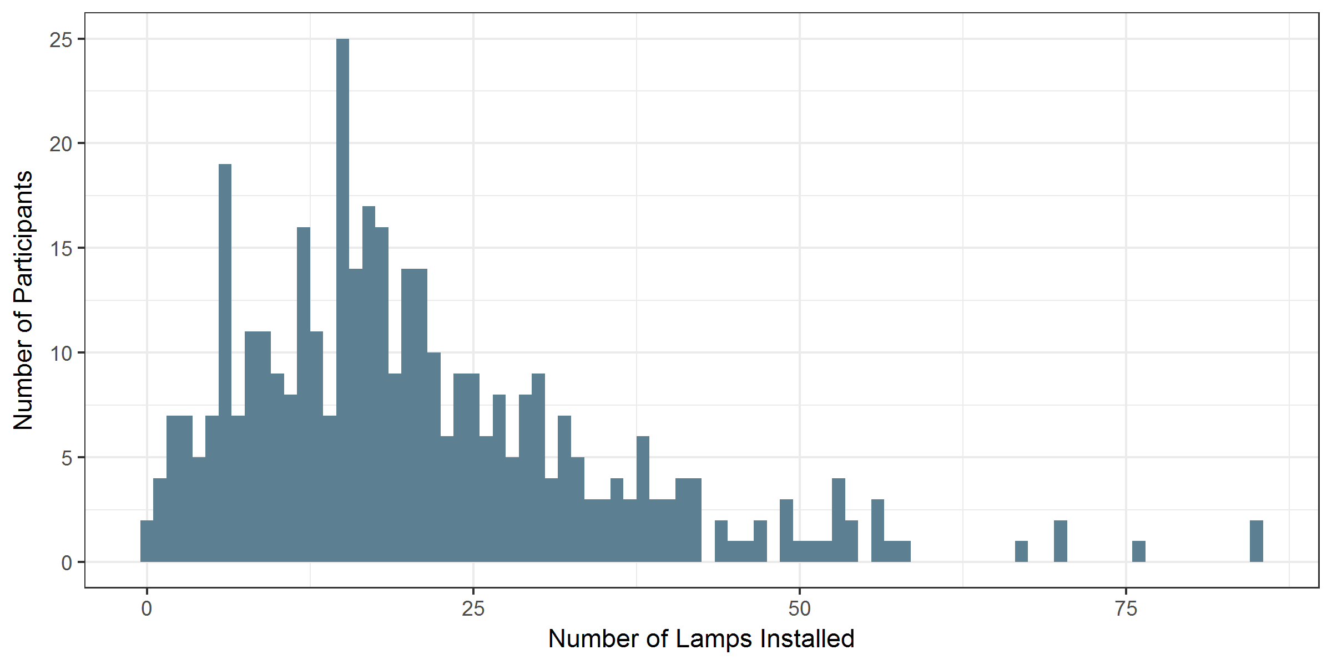

Figure 5‑1 GLDI Distribution of Number of CFLs Installed in Participant Residences

#### Program Design, Operations and Activities

The program design and operations was discussed in detail in PY5. Staff reported that the program design and operations remained largely the same in PY6. The measures installed through the program remained the same, although LED bulbs were added and accounted for 6% of the number bulbs installed through the program.

The number of directly installed lamps decreased substantially in PY6 from PY5. Staff speculated that this was due to disinterest in CFLs as the market transitions to LEDs.

#### Participant Survey Results

The Green Light New Orleans participant survey included topics such as motivation for participating, the participation process, cross-program awareness, and program satisfaction. A total of 60 participants completed the survey.

#### Participant Demographics and Residence Characteristics

Compared to PY5, survey participants had a similar number of household members on average, and a similar percent owned their homes. In PY6, a larger percentage of participants had incomes under $25,000 indicating that the program may be satisfying the goal of reaching more low-income households.

Table 5‑14 Participant Demographics

|  |  |  |
| --- | --- | --- |
| ***Demographic Characteristic*** | ***PY5***  ***(n = 95)*** | ***PY6***  ***(n=60)*** |
| Average number of home residents | 2.8 | 2.4 |
| Percent with income of:1 |  |  |
| Less than $25,000 per year | 34% | 50% |
| $25,000 to less than $50,000 | 13% | 15% |
| $50,000 to less than $75,000 | 15% | 7% |
| $75,000 or more | 9% | 8% |
| Percent own home | 58% | 53% |
| 1. Total does not equal 100% because some respondents did not know their income or declined to state it. | | |

Similar to PY5, slightly less than two-thirds of participants lived in single family homes. Forty-five percent of participants had electric space heating in their homes and 45% had electric water heating. The reported size of participant homes was similar to PY5. However, in both years the majority of participants did not know the size of their homes.

Table 5‑15 Participant Residence Characteristics

|  |  |  |
| --- | --- | --- |
| ***Residence Characteristic*** | ***PY5***  ***(n = 95)*** | ***PY6***  ***(n=60)*** |
| Percent single family home | 68% | 68% |
| Percent electric space heating | 45% | 45% |
| Percent electric water heating | 34% | 45% |
| Percent of households built before 1990 | 60% | 17% |
| Percent with home size of:1 |  |  |
| Less than 1,000 ft.2 | 4% | 0% |
| 1,001-1,500 ft.2 | 16% | 15% |
| 1,501-2,000 ft.2 | 21% | 15% |
| Greater than 2,000 ft.2 | 6% | 12% |
| 1. Total does not equal 100% because some respondents did not know the size of their home or declined to state it. | | |

#### Sources of Program Awareness

As was the case in PY5, participants most commonly learned of the free light bulbs through a friend, family member, or a colleague. As shown in Figure 5‑2, respondents most frequently learned of the program from friends, family members, or colleagues (65%). Other sources of program awareness were varied and included internet advertisements (9%), print advertisements (9%), and through a retailer (7%).

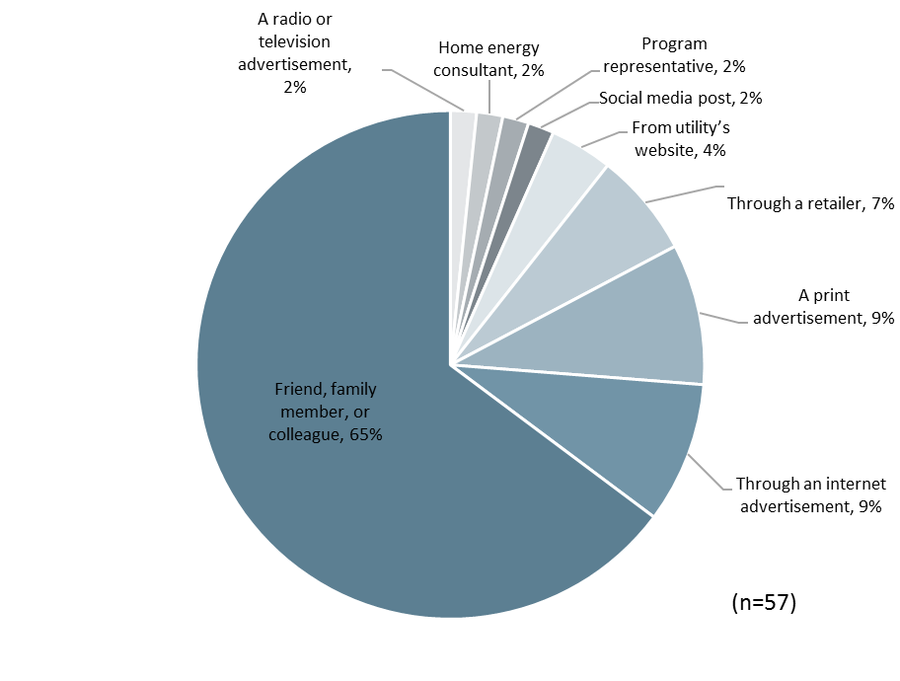

Figure 5‑2 GLDI Source of Program Awareness

#### Motivations for Participation

As seen in Figure 5‑3, most participants (68%) stated that they participated in the program because they were interested in becoming as energy efficient as friends or neighbors. A majority were also motivated by a desire to save money (57%). Slightly more than a third of respondents (38%) were interested in the free CFLs, 12% were interested in saving energy, and 2% were interested in improving their home value. The share of participants that stated they participated to be as efficient as friends and neighbors is significantly larger than in PY5, when 1% of respondents stated that becoming as efficient as family member or friends was a reason for participating. The share of respondents stating that they participated to save money and get the free light bulbs was similar to the PY5 findings.

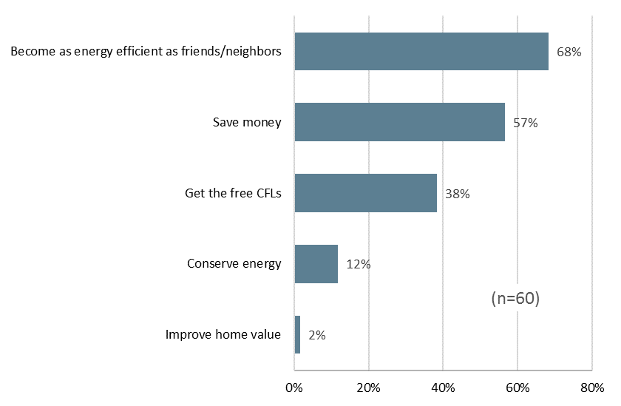

Figure 5‑3 GLDI Reasons for Participating in the Program

#### Participation Process

On average, respondents experienced a wait time of 1.7 weeks for their CFLs to be installed after they requested installation. The shortest reported wait time was one day and the longest was nine weeks. Most participants (81%) had the CFLs installed within two weeks of requesting them.

No participants reported dissatisfaction with the process of having the CFLs installed.

#### Cross Program Awareness

Seventeen percent of participants were aware that Entergy offered lighting discounts at retail locations. Most of these participants – a total of 14% of program participants – were aware of these discounts prior to participating in the program. These results suggest that few participants are opting for free CFLs over purchasing discounted LED light bulbs. However, because the LED light bulbs are point-of-purchase discounts, some of the GLNO participants may have purchased discounted light bulbs even though they were not aware of the discounts.

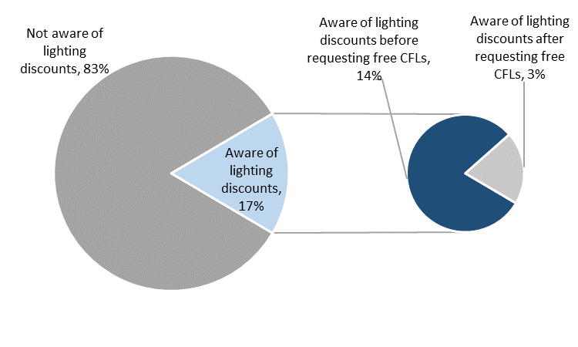

Figure 5‑4 GLDI Awareness of ENO POS Lighting Discounts

Twenty percent of GLNO participants stated that they were aware of the Companies rebates and discounts for home efficiency improvements and appliances.

#### Program Satisfaction

As shown in Figure 5‑5, participants rated various elements of the program on a scale of 1 to 5, where 1 represented “very dissatisfied” and 5 represented “very satisfied.” Overall participants rated each of the program elements and the program highly. Ninety-two percent of participants were very satisfied with the program overall and 5% were somewhat satisfied with it.

Program participants were most satisfied with the process of having the CFLs installed, with 98% stating they were satisfied or very satisfied with the program element. Participants were also satisfied with the program participation process, with 97% stating they were satisfied or very satisfied. Participants were also satisfied with the light bulbs, with 95% stating they were satisfied or very satisfied with the CFLs that were installed in their home.

Participants were least likely to report satisfaction with the energy savings on their utility bill – 78% were satisfied for very satisfied with this aspect of the program and 2% were some dissatisfied with it.

Those that rated dissatisfaction with one or more elements of the program provided additional explanation for why they were dissatisfied with the program. One participant stated the they had not seen any cost savings since the installation of the light bulbs, and two participants had issues with the light bulbs not working in their homes.

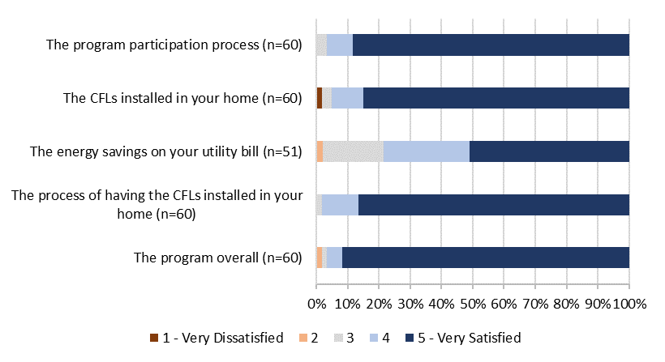

Figure 5‑5 GLDI Participant Satisfaction

As displayed in Table 5‑16, Seventy-eight percent reported that they were satisfied or very satisfied with Entergy as their electrical service provider. Ten percent of participants stated that they were dissatisfied or very dissatisfied.

Table 5‑16 GLDI Satisfaction with Entergy as an Electrical Service Provider

|  |  |
| --- | --- |
| ***Satisfaction Score*** | ***Percent of Respondents***  ***(n=60)*** |
| 5 (Very satisfied) | 53% |
| 4 | 25% |
| 3 | 10% |
| 2 | 7% |
| 1 (Very dissatisfied) | 3% |

Participants were also asked how their participation in the program had influenced their satisfaction with Entergy. More than half of respondents’ opinions of Entergy were unchanged by the program, and slightly less than half (43%) reported that their program experience had at least somewhat increased their satisfaction with Entergy. Only two percent of respondents stated that participation of the program had decreased their satisfaction with Entergy. Responses are summarized in the table below.

Table 5‑17 GLDI Change in Satisfaction with Entergy as a Result of Program Participation

|  |  |
| --- | --- |
| ***Impact on Satisfaction*** | ***Percent of Respondents***  ***(n=60)*** |
| Greatly increased satisfaction with Entergy | 5% |
| Somewhat increased satisfaction with Entergy | 38% |
| Did not affect satisfaction with Entergy | 55% |
| Somewhat decreased satisfaction with Entergy | 2% |
| Greatly decreased satisfaction with Entergy | 0% |
| Don’t know | 0% |

### Conclusions

The Evaluators’ conclusions are summarized below:

* The types of light bulbs remained largely the same as in PY5, although 6% of the light bulbs installed in PY6 were LED. The total number of installed lamps in PY6 was fewer than in PY5.
* Participant satisfaction with the program overall, the installation process, and the CFLs remains high.

### Recommendations

The Evaluators’ recommendation for the GLDI Program are as follows:

* **Consider additional measures to increase per participant savings.** Staff should consider additional program measures to increase per participant savings. As was recommended in PY5, the addition of 150W equivalent A-type lamps and PAR 30/38 flood lamps present opportunities for additional savings from exterior lighting. During PY5 interviews, program staff stated that they were looking to add low-flow shower heads and aerators to homes with electric water heating. Neither of these measures were implemented during PY6 and staff should continue to pursue these low-cost measures. PY5 and PY6 survey data suggest that approximately one-third to one-half of program participants have electric water heating. Lastly, staff should consider installing advanced power strips through the program. This measure is currently rebated through the program but the limited volume of rebated units and feedback provided by staff suggest that downstream rebates are not effective for driving uptake of this measure.
* **Transition to LED lighting.** LED lighting costs have declined as the market matured and with the relaxation of the longevity standards under ENERGY STAR 2.0 guidelines. Additionally, ENERGY STAR certified lighting has largely transitioned to CFLs.[20]

# Consumer Products

## Program Description

The Consumer Products (CP) Program provides Point of purchase discounts are provided for compact fluorescent lamps (CFLs) and light emitting diodes (LEDs) through participating retailers, as well as mail-in rebates (downstream rebates) for Room ACs, Pool Pumps, and Advanced Power Strips. A complete list of eligible items is listed below:

* 13W – 23W compact fluorescent light bulbs (CFLs);
* 5W – 18.2W light emitting diodes (LEDs);
* Advanced Power Strips;
* Pool Pumps; and
* Room ACs.

The tables below summarize the total number of measures distributed through the program and expected savings.

Table 6‑1 Summary of Measures and Expected Savings - Total

|  |  |  |  |
| --- | --- | --- | --- |
| ***Measure*** | ***Total Quantity of Measures*** | ***Total Expected kWh Savings*** | ***Total Expected kW Savings*** |
| Lighting | 4,802 | 686,668 | 148.94 |
| Power Strips | 3 | 336 | 0.03 |
| Pool Pumps | 7 | 14,917 | 2.29 |
| Room ACs | 209 | 56,482 | 62.36 |
| **Total** | **5,021** | **758,402** | **213.62** |

Table 6‑2 Summary of Measures and Expected Savings – New Orleans

|  |  |  |  |
| --- | --- | --- | --- |
| ***Measure*** | ***Total Quantity of Measures*** | ***Total Expected kWh Savings*** | ***Total Expected kW Savings*** |
| Lighting | 4,800 | 665,178 | 144.28 |
| Power Strips | 2 | 224 | 0.02 |
| Pool Pumps | 6 | 12,786 | 1.96 |
| Room ACs | 201 | 54,225 | 59.86 |
| **Total** | **5,009** | **732,413** | **206.13** |

Table 6‑3 Summary of Measures and Expected Savings - Algiers

|  |  |  |  |
| --- | --- | --- | --- |
| ***Measure*** | ***Total Quantity of Measures*** | ***Total Expected kWh Savings*** | ***Total Expected kW Savings*** |
| Lighting | 2 | 21,489 | 4.66 |
| Power Strips | 1 | 112 | 0.01 |
| Pool Pumps | 1 | 2,131 | 0.33 |
| Room ACs | 8 | 2,257 | 2.49 |
| **Total** | **12** | **25,989** | **7.49** |

Total verified savings and percentage of goals for the CP Program are detailed in Table 6‑4.

Table 6‑4 Savings Goals by Utility

|  |  |  |  |  |  |  |
| --- | --- | --- | --- | --- | --- | --- |
| ***Utility*** | ***kWh goal*** | ***Net Realized kWh*** | ***Percentage of kWh goal realized*** | ***kW goal*** | ***Net Realized kW*** | ***Percentage of kW goal realized*** |
| ENO | 942,765 | 543,467 | 57.65% | 290.00 | 121.37 | 41.85% |
| Algiers | 75,368 | 19,759 | 26.22% | 23.00 | 4.41 | 19.18% |

## M&V Methodology

Evaluation of the CP Program included the following:

* Updating hours of use (HOU) assumptions based on a residential lighting metering study;
* Updating pool pump calculations to reflect ENERGY STAR parameters by drive type and horsepower;
* Review of program tracking and recreation of deemed savings calculations;
* Interviews with program staff; and
* Review of program Memoranda of Understanding (MOU).

For equipment and retrofits rebated through the PY6 CP Program, calculation methodologies were performed as described in the Arkansas TRM (AR TRM). Measure inputs came from the AR TRM, EISA lumen table and groundwater data specific to the New Orleans area.

Table 6‑5 CPP Data Sources by Measure

|  |  |  |
| --- | --- | --- |
| ***Measure*** | ***Input*** | ***Source*** |
| Lighting | Baseline wattages | EISA lumen equivalence table |
| Lighting | Operating hours, energy factor, demand factor, CF | AR TRM Section 2.5.1 |
| Room ACs | CA, RAF, EHLFC, CF | Simulation modeling |
| Pool Pumps | See Section 6.2.5 below | ENERGY STAR Pool Pump Calculator[21] |

Three measures accounted for the majority of the gross savings for the CP Program: lighting, room ACs and pool pumps. The calculation methodologies for these measures are detailed in the following sections.

### Lighting Savings Calculations

#### Energy Savings Calculations

Upstream rebates were provided in-store for 14W CFLs and 9W LEDs.

Per unit energy savings for lighting is calculated as follows:

Where,

* Hours = Annual hours of use
* Wbase = Baseline watts
* Wpost = Installed watts
* IEFE = Energy Interactive Factor, 0.97
* ISR = In Service Rate, 0.98
* 1000 = W/kW conversion

Table 6‑6 Deemed Savings Values for Lighting Calculations

|  |  |
| --- | --- |
| ***Parameter*** | ***Deemed Value*** |
| Hours | 819.43[22] |
| EF | 0.97 |
| DF | 1.25 |
| ISR | 98[23]% |

Table 6‑7 Baseline Wattages by Lamp Type

|  |  |  |
| --- | --- | --- |
| ***Lamp Type*** | ***Wattage*** | ***Baseline*** |
| CFL | 9W Spiral | 29W |
| 13W Spiral | 43W |
| 14W Spiral | 43W |
| 19W Spiral | 53W |
| 23W Spiral | 72W |
| LED | 3.1W Candelabra | 25W |
| 5W Candelabra | 40W |
| 5W A-lamp | 29 |
| 5.5W A-lamp | 29 |
| 6W A-lamp | 29 |
| 6.2W A-lamp | 29 |
| 7W A-lamp | 29-72[24] |
| 7.4W A-lamp | 29 |
| 8.5W A-lamp | 43 |
| 9W A-lamp | 29-4316 |
| 9.5W A-lamp | 43 |
| 9.7W A-lamp | 43 |
| 10W A-lamp | 43 |
| 10.2W A-lamp | 43-5316 |
| 11W A-lamp | 43 |
| 11.2W A-lamp | 53 |
| 12W A-lamp | 53 |
| 13W A-lamp | 53 |
| 13.5W A-lamp | 53 |
| 15W A-lamp | 72 |
| 16W A-lamp | 72 |
| 16.4W A-lamp | 72 |
| 16.5W A-lamp | 72 |
| 18W A-lamp | 72 |
| 18.2W A-lamp | 72 |
| 7W BR30 | 65 |
| 8W BR30 | 65 |
| 9W BR30 | 65 |
| 9.9W BR30 | 65 |
| 10W BR30 | 65 |
| 12W BR40 | 85 |
| 12.5W BR40 | 85 |

### Lighting Hours of Use (HOU) Metering

Hours of use were estimated through direct monitoring of lighting in the on-site sample homes. Each logger was extrapolated to full annual usage by using a linear model with day length as the predictor, where day length varies inversely with the number of hours of use. Latitude and longitude coordinates for New Orleans, Louisiana were used in the computation of day length (29.9511, -90.0715). The regression used to extrapolate the meter data to a full year is shown in the equation below.

Where:

Hd = hours of use on day d

Day Length = Number of daylight hours on day d

α and β are coefficients determined by the regression

εd = residual error.

A similar model was run which added room type as an explanatory variable in order to estimate hours of use for each room type.

#### Hours of Use Results

Results of the regressed logger data provided ADM with overall efficient lighting hours of use, as well as breakdowns of hours of use by room type as shown in Table 3‑3. In total 176 lighting loggers were used, and all results were found to meet precision requirements. Overall daily HOU are 2.25, which corresponds to 819 annual HOU. In addition, ADM calculated the coincident factor (CF) based on actual lighting logger data in June between the hours of 3 and 6 pm as 12.74%. The coefficients from the overall model and the model which adds room type are also shown below.

Table 6‑8. Hours of Use by Area

|  |  |  |  |  |
| --- | --- | --- | --- | --- |
| ***Area/Room*** | ***HOU Annual*** | ***HOU Daily*** | ***# Loggers*** | ***Precision*** |
| Kitchen | 761 | 2.08 | 39 | 0.06 |
| Living Room | 669 | 1.83 | 39 | 0.06 |
| Bedroom | 775 | 2.12 | 28 | 0.08 |
| Bath | 1,143 | 3.13 | 34 | 0.05 |
| Dining Room | 790 | 2.17 | 36 | 0.06 |
| **Overall** | **819** | **2.25** | **176** | **0.03** |

Table 6‑9 Overall Model Coefficients

|  |  |  |  |  |
| --- | --- | --- | --- | --- |
| ***Coefficient*** | ***Estimate*** | ***SE*** | ***T-Stat*** | ***P-value*** |
| Intercept | 2.526 | 0.694 | 3.640 | 0.000 |
| Day Length | -0.023 | 0.053 | -0.437 | 0.662 |

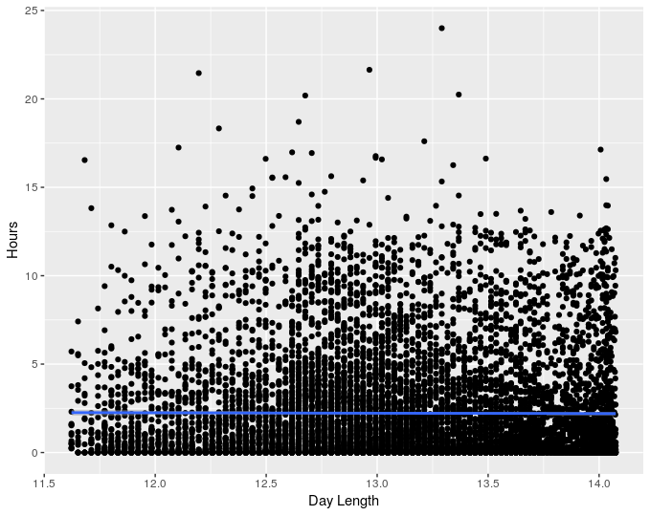Table 6‑10 Room Model Coefficients

Figure 6‑1 Average Logger Hours vs. Day Length

|  |  |  |  |  |
| --- | --- | --- | --- | --- |
| ***Coefficient*** | ***Estimate*** | ***SE*** | ***T-Stat*** | ***P-value*** |
| Intercept | 2.607 | 0.690 | 3.777 | 0.000 |
| Day Length | -0.043 | 0.052 | -0.818 | 0.413 |
| Bedroom | -0.250 | 0.097 | -2.572 | 0.010 |
| Dining Room | 0.038 | 0.104 | 0.362 | 0.718 |
| Kitchen | 1.048 | 0.099 | 10.600 | 0.000 |
| Living Room | 0.081 | 0.097 | 0.828 | 0.408 |

The graph below is a scatterplot showing average hours of use for all of the loggers in the M&V sample and the corresponding day length (based on New Orleans, LA). The fitted line shows a slightly negative relationship between average daily hours and day length, which is the pattern one would expect ex-ante. The day length coefficients for both models also confirm this relationship, as they are both negative, although neither is statistically significant.

Finally, the map below shows the location of homes involved in the lighting logger M&V sample in the New Orleans, LA area.

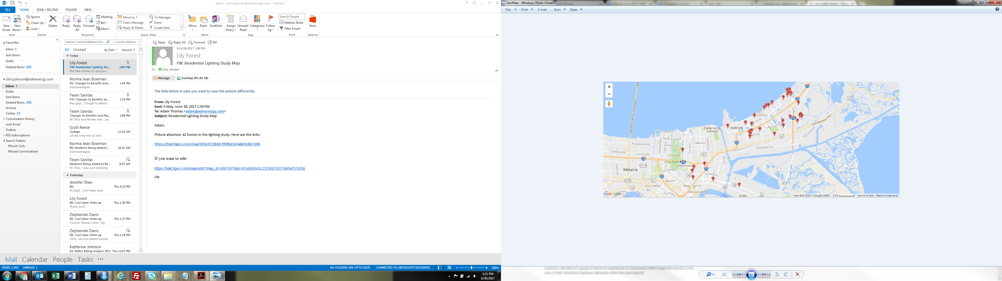

Figure 6‑2 Lighting Logger Home Locations

### Room Air Conditioner Calculations

#### Energy Savings Calculations

The CP Program energy savings room air conditioners were calculated as follows.

Where,

* CAP = Rated equipment cooling capacity of the new unit (Btu/hr)
* 𝑅𝐴𝐹 = Room AC adjustment factor
* 𝐸𝐹𝐿𝐻𝐶 = Equivalent full-load cooling hours
* 𝜂𝑏𝑎𝑠𝑒 = Energy efficiency rating (EER) of the baseline cooling equipment (Table 6‑11)
* 𝜂𝑝𝑜𝑠𝑡= Energy efficiency rating (EER) of the installed cooling equipment (at least equal to value from Table 6‑11)

Table 6‑11. Window AC Replacement – Baseline and Efficiency Standards[25]

| ***Reverse Cycle*** | ***Louvered*** |  | ***Capacity (Btu/hr)*** | ***Capacity (Btu/hr)*** | ***Baseline*** | ***Efficiency*** |
| --- | --- | --- | --- | --- | --- | --- |
| ***(Yes/No)*** | ***Sides*** | ***Efficiency*** | ***Standard*** |
|  | ***(Yes/No)*** | ***(EER)*** | ***(EER)*** |
| No | Yes | NY | < 8,000 | 0 | 9.7 | 10.7 |
| > 8,000 and < 14,000 | 8000 | 9.7 | 10.7 |
| > 14,000 and < 20,000 | 14000 | 9.7 | 10.7 |
| > 20,000 | 20000 | 8.5 | 9.4 |
| No | No | NN | < 8,000 | 0 | 9 | 9.9 |
| > 8,000 | 8000 | 8.5 | 9.4 |
| Yes | Yes | YY | < 20,000 | 0 | 9 | 9.9 |
| > 20,000 | 20000 | 8.5 | 9.4 |
| Yes | No | YN | < 14,000 | 0 | 8.5 | 9.4 |
| > 14,000 | 14000 | 8 | 8.8 |

Table 6‑12 Deemed Savings Values for Room Air Conditioner Calculations

|  |  |
| --- | --- |
| ***Parameter*** | ***Deemed Value*** |
| RAF | 0.49 |
| EFLHC[26] | 1,637 |

### ENERGY STAR® Pool Pump Calculations

#### Energy Savings Calculations

The CP Program energy savings for ENERGY STAR Pool Pumps were derived using as follows.

Where,

* 𝑘𝑊ℎ𝑐𝑜𝑛𝑣 = Conventional single-speed pool pump energy
* 𝑘𝑊ℎES = ENERGY STAR® variable speed pool pump energy

Algorithms to calculate the above parameters are defined as:

Table 6‑13 Parameters for kWh usage of conventional and ENERGY STAR® Pool Pump

|  |  |
| --- | --- |
| 𝑘𝑊ℎ𝐻𝑆 | ENERGY STAR® variable speed pool pump energy at high speed |
| 𝑘𝑊ℎ𝐿𝑆 | ENERGY STAR® variable speed pool pump energy at low speed |
| ℎ𝑜𝑢𝑟𝑠𝑐𝑜𝑛𝑣 | Conventional single-speed pump daily operating hours |
| ℎ𝑜𝑢𝑟𝑠𝐻𝑆,𝑉𝑆 | ENERGY STAR® variable speed pump high speed daily operating hours = 2 hours |
| ℎ𝑜𝑢𝑟𝑠𝐿𝑆,𝑉𝑆 | ENERGY STAR® variable speed pump low speed daily operating hours = 10 hours |
| ℎ𝑜𝑢𝑟𝑠𝐻𝑆,𝑀𝑆 | ENERGY STAR® multi-speed pump high speed daily operating hours = 2 hours |
| ℎ𝑜𝑢𝑟𝑠𝐿𝑆,𝑉𝑆 | ENERGY STAR® multi-speed pump low speed daily operating hours |
| 𝑑𝑎𝑦𝑠 | Operating days per year = 212.8 days |
| 𝑃𝐹𝑅𝑐𝑜𝑛v | Conventional single-speed pump flow rate (gal/min) |
| 𝑃𝐹𝑅𝐻𝑆,𝑉𝑆 | ENERGY STAR® variable speed pump high speed flow rate = 50 gal/min |
| 𝑃𝐹𝑅𝐿𝑆,𝑉𝑆 | ENERGY STAR® variable speed pump low speed flow rate (gal/min) = 30.6 |
| 𝑃𝐹𝑅𝐻𝑆,𝑀𝑆 | ENERGY STAR® multi-speed pump high speed flow rate (gal/min) |
| 𝑃𝐹𝑅𝐿𝑆,𝑀𝑆 | ENERGY STAR® multi-speed pump low speed flow rate (gal/min) |
| 𝐸𝐹𝑐𝑜𝑛𝑣 | Conventional single-speed pump energy factor (gal/W·hr) |
| 𝐸𝐹𝐻𝑆,𝑉𝑆 | ENERGY STAR® variable speed pump high speed energy factor = 3.75 gal/W·hr |
| 𝐸𝐹𝐿𝑆,𝑉S | ENERGY STAR® variable speed pump low speed energy factor = 7.26 gal/W·hr |
| 𝐸𝐹𝐻𝑆,𝑀𝑆 | = ENERGY STAR® multi-speed pump high speed energy factor (gal/W·hr) |
| 𝐸𝐹𝐿𝑆,𝑀𝑆 | ENERGY STAR® multi-speed pump low speed energy factor (gal/W·hr) |
| 𝑉𝑝𝑜𝑜𝑙 | Pool volume = 22,000 gal |
| *PT* | Pool turnovers per day = 1.5 |
| 𝑡𝑡𝑢𝑟𝑛𝑜𝑣𝑒𝑟,𝑉𝑆 | Variable speed pump time to complete 1 turnover = 12 hours |
| 𝑡𝑡𝑢𝑟𝑛𝑜𝑣𝑒𝑟,𝑀𝑆 | Multi-speed pump time to complete 1 turnover |

Table 6‑14 Conventional Pool Pumps Assumptions

|  |  |  |  |
| --- | --- | --- | --- |
| ***Pump***  ***HP*** | ***hoursconv*** | ***PFRconv***  ***(gal/min)*** | ***EFconv***  ***(gal/W·h)*** |
| 0.5 | 11.0 | 50.0 | 2.71 |
| 0.75 | 10.4 | 53.0 | 2.57 |
| 1 | 9.2 | 60.1 | 2.40 |
| 1.5 | 8.6 | 64.4 | 2.09 |
| 2 | 8.5 | 65.4 | 1.95 |
| 2.5 | 8.1 | 68.4 | 1.88 |
| 3 | 7.5 | 73.1 | 1.65 |

Table 6‑15 ENERGY STAR® Multi-Speed Pool Pumps Assumptions

|  |  |  |  |  |  |  |
| --- | --- | --- | --- | --- | --- | --- |
| ***Pump***  ***HP*** | ***tturnover,MS*** | ***hoursMS,LS*** | ***PFRHS,MS***  ***(gal/min)*** | ***EFHS,MS***  ***(gal/W·h)*** | ***PFRLS,MS***  ***(gal/min)*** | ***EFLS,MS***  ***(gal/W·h)*** |
| 1 | 11.8 | 9.8 | 56.0 | 2.40 | 31.0 | 5.41 |
| 1.5 | 11.5 | 9.5 | 61.0 | 2.27 | 31.9 | 5.43 |
| 2 | 11.0 | 9.0 | 66.4 | 1.95 | 33.3 | 5.22 |
| 2.5 | 10.8 | 8.8 | 66.0 | 2.02 | 34.0 | 4.80 |
| 3 | 9.9 | 7.9 | 74.0 | 1.62 | 37.0 | 4.76 |

Demand savings calculations are as follows:

CF = Coincidence Factor = .31

Deemed kWh and kW savings are summarized in Table 6‑16 and Table 6‑17.

Table 6‑16 ENERGY STAR® Variable Speed Pool Pumps – Deemed Savings Values

|  |  |  |
| --- | --- | --- |
| ***Pump HP*** | ***kW***  ***Savings*** | ***kWh***  ***Savings*** |
| 0.5 | 0.24 | 1,713 |
| 0.75 | 0.28 | 1,860 |
| 1 | 0.36 | 2,063 |
| 1.5 | 0.47 | 2,465 |
| 2 | 0.52 | 2,718 |
| 2.5 | 0.57 | 2,838 |
| 3 | 0.72 | 3,364 |

Table 6‑17 ENERGY STAR® Multi-Speed Pool Pumps – Deemed Savings Values

|  |  |  |
| --- | --- | --- |
| ***Pump******HP*** | ***kW***  ***Savings*** | ***kWh***  ***Savings*** |
| 1 | 0.30 | 1,629 |
| 1.5 | 0.40 | 1,945 |
| 2 | 0.41 | 1,994 |
| 2.5 | 0.46 | 2,086 |
| 3 | 0.54 | 2,292 |

## Verified Savings by Measure

After reviewing the tracking data and inputs for savings calculations, the Evaluators provided verified gross savings according to TRM protocols. Savings figures provided by CLEAResult for the following measures were verified:

* CFL and LED lighting;
* Advanced Power Strips;
* Pool Pumps; and
* Room ACs.

### Lighting

Table 6‑18 Expected and Realized Lighting Savings – New Orleans

|  |  |  |  |  |  |  |
| --- | --- | --- | --- | --- | --- | --- |
| ***Measure*** | ***Expected kWh Savings*** | ***Realized kWh Savings*** | ***kWh Realization Rate*** | ***Expected Peak kW Savings*** | ***Realized Peak kW Savings*** | ***kW Realization Rate*** |
| CFL-9 | 874 | 1,094 | 125.2% | 0.19 | 0.22 | 115.5% |
| CFL-13 | 174,895 | 218,974 | 125.2% | 37.94 | 43.80 | 115.5% |
| CFL-14 | 11,273 | 14,114 | 125.2% | 2.45 | 2.82 | 115.5% |
| CFL-19 | 297 | 372 | 125.2% | 0.06 | 0.07 | 115.5% |
| CFL-23 | 1,284 | 1,608 | 125.2% | 0.28 | 0.32 | 115.5% |
| LED-3.1 | 132 | 150 | 113.3% | 0.03 | 0.03 | 104.5% |
| LED-5 | 7,790 | 8,077 | 103.7% | 1.69 | 1.62 | 95.6% |
| LED-5.5 | 7,511 | 8,032 | 106.9% | 1.63 | 1.61 | 98.6% |
| LED-6 | 55 | 63 | 113.3% | 0.01 | 0.01 | 104.5% |
| LED-6.2 | 10,231 | 11,596 | 113.3% | 2.22 | 2.32 | 104.5% |
| LED-7 | 18,070 | 20,524 | 113.6% | 3.92 | 4.11 | 104.7% |
| LED-7.4 | 610 | 694 | 113.7% | 0.13 | 0.14 | 104.9% |
| LED-8 | 13,923 | 15,780 | 113.3% | 3.02 | 3.16 | 104.5% |
| LED-8.5 | 18,528 | 18,583 | 100.3% | 4.02 | 3.72 | 92.5% |
| LED-9 | 231,528 | 262,419 | 113.3% | 50.22 | 52.49 | 104.5% |
| LED-9.5 | 43,146 | 46,532 | 107.8% | 9.36 | 9.31 | 99.5% |
| LED-9.7 | 3,253 | 3,688 | 113.3% | 0.71 | 0.74 | 104.5% |
| LED-9.9 | - |  |  | - |  |  |
| LED-10 | 25,196 | 29,032 | 115.2% | 5.47 | 5.81 | 106.3% |
| LED-10.2 | 1,826 | 1,814 | 99.3% | 0.40 | 0.36 | 91.6% |
| LED-11 | 60,925 | 68,794 | 112.9% | 13.21 | 13.76 | 104.1% |
| LED-11.2 | 2,743 | 2,943 | 107.3% | 0.59 | 0.59 | 99.0% |
| LED-12 | 1,039 | 1,176 | 113.1% | 0.23 | 0.24 | 104.3% |
| LED-12.5 | 2,798 | 3,172 | 113.3% | 0.61 | 0.63 | 104.5% |
| LED-13 | 2,566 | 2,898 | 112.9% | 0.56 | 0.58 | 104.2% |
| LED-13.5 | 262 | 297 | 113.3% | 0.06 | 0.06 | 104.5% |
| LED-15 | 5,509 | 5,728 | 104.0% | 1.19 | 1.15 | 95.9% |
| LED-16 | 835 | 957 | 114.6% | 0.18 | 0.19 | 105.7% |
| LED-16.4 | 1,369 | 1,520 | 111.1% | 0.30 | 0.30 | 102.4% |
| LED-16.5 | 3,651 | 3,832 | 105.0% | 0.79 | 0.77 | 96.8% |
| LED-17 | 9,574 | 9,347 | 97.6% | 2.08 | 1.87 | 90.0% |
| LED-18 | 3,517 | 3,987 | 113.3% | 0.76 | 0.80 | 104.5% |
| LED-18.2 | -32.45 | -36.78 | 113.3% | -0.01 | -0.01 | 104.5% |
| **Total** | **665,178** | **767,759** | **115.4%** | **144.28** | **153.58** | **106.4%** |

Table 6‑19 Expected and Realized Lighting Savings - Algiers

|  |  |  |  |  |  |  |
| --- | --- | --- | --- | --- | --- | --- |
| ***Measure*** | ***Expected kWh Savings*** | ***Realized kWh Savings*** | ***kWh Realization Rate*** | ***Expected Peak kW Savings*** | ***Realized Peak kW Savings*** | ***kW Realization Rate*** |
| CFL-13 | 21,489 | 26,905 | 125.2% | 4.66 | 5.38 | 115.5% |
| **Total** | **21,489** | **26,905** | **125.2%** | **4.66** | **5.38** | **115.5%** |

Lighting savings inputs for ex ante calculations were not available in program documents, nor were the Evaluators were able to find a set of inputs which satisfied ex ante savings figures.

### Advanced Power Strips

Table 6‑20 Expected and Realized Power Strip Savings – New Orleans

|  |  |  |  |  |  |
| --- | --- | --- | --- | --- | --- |
| ***Expected kWh Savings*** | ***Realized kWh Savings*** | ***kWh Realization Rate*** | ***Expected Peak kW Savings*** | ***Realized Peak kW Savings*** | ***kW Realization Rate*** |
| **224** | **224** | **100.0%** | **0.02** | **0.03** | **140.0%** |

Table 6‑21 Expected and Realized Power Strip Savings – Algiers

|  |  |  |  |  |  |
| --- | --- | --- | --- | --- | --- |
| ***Expected kWh Savings*** | ***Realized kWh Savings*** | ***kWh Realization Rate*** | ***Expected Peak kW Savings*** | ***Realized Peak kW Savings*** | ***kW Realization Rate*** |
| **112** | **112** | **100.0%** | **0.01** | **0.01** | **140.0%** |

Peak kW differences are due to an omitted significant figure in ex ante savings calculations.

### ENEGRY STAR® Pool Pumps

Table 6‑22 Expected and Realized Pool Pump Savings – New Orleans

|  |  |  |  |  |  |
| --- | --- | --- | --- | --- | --- |
| ***Expected kWh Savings*** | ***Realized kWh Savings*** | ***kWh Realization Rate*** | ***Expected Peak kW Savings*** | ***Realized Peak kW Savings*** | ***kW Realization Rate*** |
| **12,786** | **17,094** | **133.7%** | **1.96** | **3.42** | **174.3%** |

Table 6‑23 Expected and Realized Pool Pump Savings - Algiers

|  |  |  |  |  |  |
| --- | --- | --- | --- | --- | --- |
| ***Expected kWh Savings*** | ***Realized kWh Savings*** | ***kWh Realization Rate*** | ***Expected Peak kW Savings*** | ***Realized Peak kW Savings*** | ***kW Realization Rate*** |
| **2,131** | **2,063** | **96.8%** | **0.33** | **0.36** | **110.1%** |

Ex ante calculations used deemed savings figures of 2,131 kWh and 0.327 kW, whereas the Evaluators calculated savings based on the horsepower of the given unit.

### Room Air Conditioners

Table 6‑24 Expected and Realized Room AC Savings – New Orleans

|  |  |  |  |  |  |
| --- | --- | --- | --- | --- | --- |
| ***Expected kWh Savings*** | ***Realized kWh Savings*** | ***kWh Realization Rate*** | ***Expected Peak kW Savings*** | ***Realized Peak kW Savings*** | ***kW Realization Rate*** |
| **54,225** | **33,514** | **61.8%** | **59.86** | **36.35** | **60.7%** |

Table 6‑25 Expected and Realized Room AC Savings - Algiers

|  |  |  |  |  |  |
| --- | --- | --- | --- | --- | --- |
| ***Expected kWh Savings*** | ***Realized kWh Savings*** | ***kWh Realization Rate*** | ***Expected Peak kW Savings*** | ***Realized Peak kW Savings*** | ***kW Realization Rate*** |
| **2,257** | **1,304** | **57.8%** | **2.49** | **1.41** | **56.8%** |

### Gross Savings Summary

Table 6‑26 and Table 6‑27 summarize the gross savings from the CP Program.

Table 6‑26 kWh and Peak kW Realization Summary – New Orleans

|  |  |  |  |  |  |  |
| --- | --- | --- | --- | --- | --- | --- |
| ***Measure*** | ***Expected kWh Savings*** | ***Realized kWh Savings*** | ***kWh Realization Rate*** | ***Expected Peak kW Savings*** | ***Realized Peak kW Savings*** | ***kW Realization Rate*** |
| Lighting | 665,178 | 767,759 | 115.42% | 144.27 | 153.58 | 106.45% |
| Power Strips | 224 | 224 | 100.00% | 0.02 | 0.03 | 140.00% |
| Pool Pumps | 12,786 | 17,094 | 133.69% | 1.96 | 3.42 | 174.31% |
| Room ACs | 54,225 | 33,514 | 61.81% | 59.86 | 36.35 | 60.72% |
| **Total** | **732,413** | **818,591** | **111.77%** | **206.12** | **193.38** | **93.82%** |

Table 6‑27 kWh and Peak kW Realization Summary - Algiers

|  |  |  |  |  |  |  |
| --- | --- | --- | --- | --- | --- | --- |
| ***Measure*** | ***Expected kWh Savings*** | ***Realized kWh Savings*** | ***kWh Realization Rate*** | ***Expected Peak kW Savings*** | ***Realized Peak kW Savings*** | ***kW Realization Rate*** |
| Lighting | 21,489 | 26,905 | 125.2% | 4.66 | 5.38 | 115.47% |
| Power Strips | 112 | 112 | 100.0% | 0.01 | 0.01 | 140.00% |
| Pool Pumps | 2,131 | 2,063 | 96.8% | 0.33 | 0.36 | 110.09% |
| Room ACs | 2,257 | 1,304 | 57.8% | 2.49 | 1.41 | 56.78% |
| **Total** | **25,989** | **30,385** | **116.9%** | **7.49** | **7.17** | **95.74%** |

## Estimation of Net Savings

The following sections describe the approach used to estimate net savings for the lighting and appliance components of the CP Program.

### Lighting Component

Free ridership for the lighting component was estimated using the Revenue Neutral Sales Model (RNSM).[27] The logic of the RNSM is that retailers will not participate unless they feel they can do so without reducing revenue. The model relies on this assumption to calculate the number of bulbs sold under normal retail pricing required to meet the same level of revenues the retailers have implicitly agreed to by participating in the program. As such, the estimate of free ridership represents a maximum free ridership value. It relies on the idea that retailers are concerned with top-line sales for each discounted lamp, and that they are able to accurately forecast sales under program and non-program conditions. The sales required to meet the same level of revenues as are expected through program sales sets the baseline sales condition for what would have been sold in the absence of the program.

Under this model free ridership is equal to:

The quantity without the program is estimated by divided the total revenue for the program discounted product by the sales price without the program discount.

### Appliance Component

Participant survey responses were used to estimate the net energy impacts of appliance component of the CP Program. The program net savings are equal to gross savings, less savings associated with free ridership, plus participant spillover savings.

Fifty-five customers that received an appliance rebate responded to the survey. Two respondents were dropped from the analysis because they could not answer key free ridership questions. In total, 53 responses were used in the analysis of net savings.

#### Estimation of Free Ridership

The objective of the free ridership analysis is to estimate the share of program activity would have occurred in the absence of the program. To accomplish this, the Evaluators administered a survey to program participants that contained questions regarding the participants’ plans to implement the incentivized measures and the likelihood of implementing those measures in the absence of program incentives and informational support. Program participants were asked questions regarding:

* Whether or not they had plans to complete the project and if they could afford to complete it without the program discount;
* The likelihood of completing the project without the discount or the incentivized assessment;
* The timing of the project in the absence of the program.

Participant responses to these questions were used to calculate three scores corresponding to the presence of prior plans, the likelihood of completing the project in the absence of the program, and the timing of that project if it had been completed.

#### Prior Plans Score

Respondents were scored as 1 on the prior plans score if all of the following were true:

* The participant had plans to complete the project prior to learning about the program.
* The participant confirms that they were planning to install an efficient unit as opposed to a standard efficiency unit.
* The participant indicated that they would have been financially able to complete the project had a discount or rebate not been provided.

Respondents that did not have prior plans and could afford the measures were not deemed to be free riders.

#### Likelihood of Project Completion Score

The score reflecting the likelihood of completing the project in the absence of the program was based on the following questions:

* Prior to learning about the program, did you have plans to have an energy assessment of your home performed?
* How likely is it that you would have completed the same < MEASURE> project that you completed through the program if the rebate was not available?

A likelihood score was assigned to each response for this question as follows:

* Very likely: 1
* Somewhat likely: .75
* Neither particularly likely or unlikely: .5
* Somewhat unlikely: .25
* Very unlikely: 0

#### Timing Score

To account for the impact the program may have had on project timing, the likelihood score was multiplied by a timing score. The timing score was developed from responses to a question on when the participant might have completed a project in the absence of the program. Specifically, timing was scored as follows:

* Project would have been completed in 0 to 6 months: 1
* Project would have been completed in 6 months to a year: .67
* Project would have been completed in 1 to 2 years: .33
* Project would have been completed in more than 2 years: 0

#### Final Free Ridership Score

The final free ridership score is equal to the following:

*Free Ridership = Average (Plans Score + Likelihood Score * Timing Score)*

The procedures used to estimate free ridership are summarized below in Figure 6‑1.

Figure 6‑3 Summary of Free Ridership Scoring Algorithm

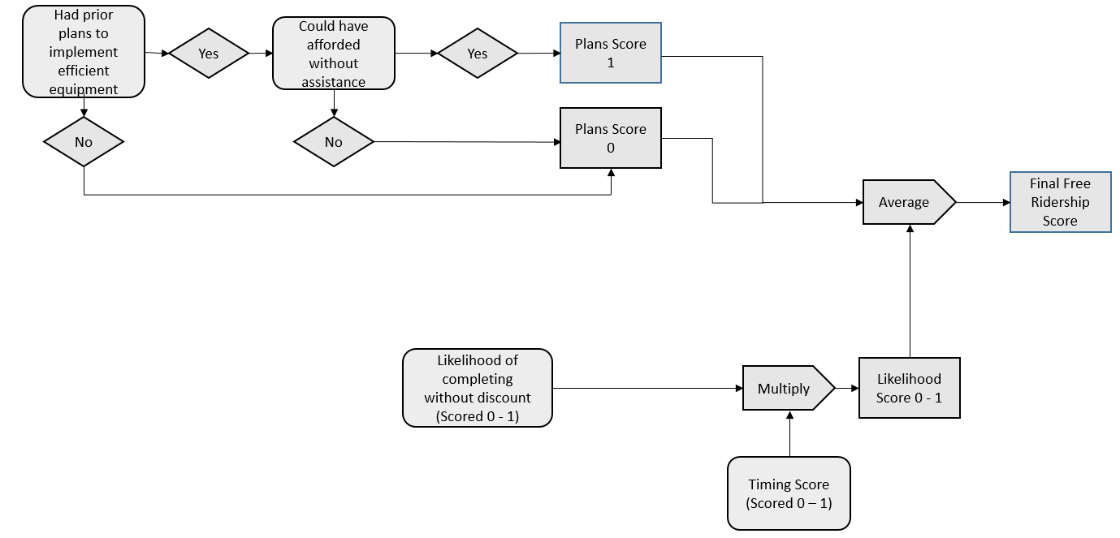

#### Estimation of Participant Spillover

To estimate participant spillover impacts, participant survey respondents were asked if they had purchased any additional items because of their experience with the program without receiving an incentive.

Participants that indicated one or more energy efficiency purchases were asked additional questions about what was purchased and the number of units purchased to estimate the savings impact. Additionally, the following two questions were asked to determine whether the energy savings resulting from measures that were attributable to the program:

* On a scale of 0 to 10, where 0 represents “not at all important” and 10 represents “extremely important”, how important was the experience with the program in your decision to purchase the items you just mentioned?
* On a scale of 0 to 10, where 0 represents “not at all likely” and 10 represents “extremely likely,” how likely would you have been to purchase those items if you had not participated in the program?

If the average of the first response and 10 – the second response is 7 or greater, the savings associated with the measures were attributed to the program.

One respondent reported installing LED light bulbs that met the attribution criteria. The kWh and peak kW estimates are summarized in Table 6‑28.

Table 6‑28 Participant Reported Spillover Impacts

|  |  |  |  |  |
| --- | --- | --- | --- | --- |
| ***Measure1*** | ***Per Unit kWh Estimate*** | ***Per Unit Peak kW Estimate*** | ***Total kWh*** | ***Total Peak kW*** |
| LEDs2 | 25.62 | 0.00 | 102.47 | 0.02 |
| **Total** |  |  | **102.47** | **0.02** |
| 1. All values based on deemed values from Arkansas Technical Resource Manual, version 6.0. | | | | |
| 2. Assumed 9 W LED, 793 annual operating hours, 1.25 demand factor, .97 energy factor, and .10 coincidence factor. | | | | |

### Net Savings Results

#### Lighting Component

The free ridership rates are presented below in Table 6‑29 by bulb type. The rate of free ridership was similar for LEDs and CFLs.

Table 6‑29 Net to Gross Ratios for CFLs and LEDs

|  |  |
| --- | --- |
| ***Bulb type*** | ***Free Ridership*** |
| CFL | 32% |
| LED | 33% |

The verified net kWh savings of the lighting component are displayed in Table 6‑27 followed by verified net peak kW reductions in Table 6‑31. The net-to-gross ratio is equal to 68% for both kWh savings and peak kW reductions.

Table 6‑30 Summary of Verified Net Savings – Lighting Component

|  |  |  |  |  |  |
| --- | --- | --- | --- | --- | --- |
| ***Utility*** | ***Expected kWh Savings*** | ***Verified Gross kWh Savings*** | ***Free Ridership*** | ***Verified Net kWh Savings*** | ***Net to Gross Ratio*** |
| ENO | 665,178 | 767,759 | 245,683 | 522,076 | 68% |
| Algiers | 21,489 | 26,905 | 8,610 | 18,295 | 68% |
| **Total** | **686,668** | **794,664** | **254,292** | **540,372** | **68%** |

Table 6‑31 Summary of Verified Net Peak Demand Reductions – Lighting Component

|  |  |  |  |  |  |
| --- | --- | --- | --- | --- | --- |
| ***Utility*** | ***Expected Peak kW Reductions*** | ***Verified Gross Peak kW Reductions*** | ***Free Ridership*** | ***Verified Net Peak kW Reductions*** | ***Net to Gross Ratio*** |
| ENO | 144.27 | 153.58 | 49.15 | 104.43 | 68% |
| Algiers | 4.66 | 5.38 | 1.72 | 3.66 | 68% |
| **Total** | **148.93** | **158.96** | **50.87** | **108.09** | **68%** |

#### Appliance Component

Free ridership for the appliance component of the program was estimated by applying the measure level net to gross ratios to the measure savings. Program level spillover was estimated by applying a ratio of the survey respondent reported spillover savings to the total verified gross savings for survey respondents to the program gross savings. values.[28] Table 6‑32 and Table 6‑33 summarize the program net kWh savings and peak kW demand reduction impacts of the CP Program.

Table 6‑32 Summary of Verified Net Savings – Appliance Component

|  |  |  |  |  |  |  |
| --- | --- | --- | --- | --- | --- | --- |
| ***Utility*** | ***Expected kWh Savings*** | ***Verified Gross kWh Savings*** | ***Free Ridership*** | ***Spillover*** | ***Verified Net kWh Savings*** | ***Net to Gross Ratio*** |
| ENO | 67,235 | 50,832 | 29,648 | 208 | 21,391 | 42% |
| Algiers | 4,500 | 3,479 | 2,030 | 14 | 1,463 | 42% |
| **Total** | **71,735** | **54,311** | **31,678** | **222** | **22,855** | **42%** |

Table 6‑33 Summary of Verified Net Peak Demand Reductions – Appliance Component

|  |  |  |  |  |  |  |
| --- | --- | --- | --- | --- | --- | --- |
| ***Utility*** | ***Expected Peak kW Reductions*** | ***Verified Gross Peak kW Reductions*** | ***Free Ridership*** | ***Spillover*** | ***Verified Net Peak kW Reductions*** | ***Net to Gross Ratio*** |
| ENO | 61.84 | 39.80 | 22.91 | 0.04 | 16.93 | 43% |
| Algiers | 2.83 | 1.78 | 1.03 | 0.00 | 0.75 | 42% |
| **Total** | **64.67** | **41.58** | **23.94** | **0.04** | 17.68 | 43% |

#### Measure Level Free Ridership Results

Table 6‑34 summarizes the average free ridership scores by measure. The results presented show higher levels of free ridership for room air conditioners than for pool pumps.

Table 6‑34 Average Free Ridership by Measure

|  |  |  |
| --- | --- | --- |
| ***Measure*** | ***Number of Responses*** | ***Average Free Ridership*** |
| energy efficient pool pump | 5 | 61% |
| energy efficient room air conditioner | 47 | 57% |
| energy saving power strip | 1 | 25% |

#### Final Net Savings

Table 6‑35 Verified Net Savings – New Orleans

|  |  |  |  |  |  |  |
| --- | --- | --- | --- | --- | --- | --- |
| ***Measure Category*** | ***Expected Gross kWh*** | ***Verified Gross kWh*** | ***Verified Net kWh*** | ***Expected Gross kW*** | ***Verified Gross kW*** | ***Verified Net kW*** |
| Lighting | 665,178 | 767,759 | 522,076 | 144.27 | 104.43 | 104.43 |
| Appliances | 67,235 | 50,832 | 21,391 | 61.84 | 16.93 | 16.93 |
| **Total** | **732,413** | **818,591** | **543,467** | **206.11** | **121.37** | **121.37** |

Table 6‑36 Verified Net Savings – Algiers

|  |  |  |  |  |  |  |
| --- | --- | --- | --- | --- | --- | --- |
| ***Measure Category*** | ***Expected Gross kWh*** | ***Verified Gross kWh*** | ***Verified Net kWh*** | ***Expected Gross kW*** | ***Verified Gross kW*** | ***Verified Net kW*** |
| Lighting | 21,489 | 26,905 | 18,295 | 4.66 | 5.38 | 3.66 |
| Appliances | 4,500 | 3,479 | 1,463 | 2.83 | 1.78 | 0.75 |
| **Total** | **25,989** | **30,384** | **19,759** | **7.49** | **7.16** | **4.41** |

## Process Evaluation

This chapter presents the results of the process evaluation of the CP Program. The process evaluation focuses on aspects of program policies and organization, as well as the program delivery framework.

The process chapter begins with an overview of the program. This is followed by a discussion of the methodological approach used in the evaluation. A summary of findings and recommendations for program improvement follow the discussion of the methodology. This discussion is followed by detailed findings of the evaluation activities.

### Data Collection Activities

The limited process of evaluation of the CP Program included the following data collection activities:

* *The Companies’ Program Staff* *Interview*. The Evaluators interviewed staff the Companies program manager who administers the Energy Smart Programs. The interview focused on any notable changes made to the program.
* *Participant Surveying*. The Evaluators surveyed a sample of program participants that received downstream rebates for room air conditioners, advanced power strips, or efficient pool pumps. These surveys addressed issues including participant satisfaction with the program offerings, demographics, and other contextual issues regarding the participation process.

The quantities completed are summarized in Table 6‑37.

Table 6‑37 CP Process Evaluation – Summary of Data Collection

|  |  |
| --- | --- |
| ***Activity*** | ***Sample Size*** |
|
| The Companies Staff | 1 |
| Participant Survey | 60 |

### Program Overview

The CP Program provides mail-in rebates (downstream rebates) for window ACs, Pool Pumps, and Advanced Power Strips. Point of purchase discounts are provided for compact fluorescent lamps (CFLs) and light emitting diodes (LEDs) through participating retailers.

#### Lighting Component

Entergy provides point-of-sale discounts on standard CFLs and LEDs three retail chains. CFLs received a discount of $0.83 - $1.25 per bulb and LEDs receive a discount of $1 - $10 per bulb. Table 6‑38 summarizes the number of retail locations offering discounted bulbs in the Entergy New Orleans service area. Dollar Chain locations only sold discounted CFLs – the Home Improvement and Big Box Locations all sold both LED and CFLs

Table 6‑38 Number of Participating Retailers

|  |  |
| --- | --- |
| ***Retailer*** | ***Number of Participating Locations*** |
| Home Improvement #1 | 2 |
| Big Box #1 | 3 |
| Dollar Chain #1 | 5 |
| Total | 8 |

#### Appliance Component

Mail-in rebates are offered for ENERGY STAR Room AC units, ENERGY STAR Pool Pumps installed in an in-ground pool, and Advanced Power Strips. The rebates available for these products are summarized in Table 6‑39. These rebate amounts for pool pumps and advanced power strips changed in PY6.

* The PY5 pool pump rebate was $200 and changed to $200 for multi-speed pool pumps and $250 for variable speed pool pumps.
* The PY5 advanced power strip rebate was $15 and decreased to $10 in PY6.

Table 6‑39 Appliance Rebates

|  |  |
| --- | --- |
| ***Appliance*** | ***Rebate Amount*** |
| Window AC units | $40 |
| Pool Pumps | $200 Multi-Speed / $250 Variable Speed |
| Advanced Power Strips | $10 |

### Detailed Findings

#### Analysis of Program Tracking Data

Table 6‑40 provides a summary of program activity during PY6. As shown, lighting accounted for 91% of the program expected energy savings. Room ACs accounted for the largest share of appliance savings, followed by pool pumps.

Table 6‑40 Summary of CP Program Activity

|  |  |  |  |  |  |
| --- | --- | --- | --- | --- | --- |
| ***Measure Type*** | ***Per Unit Incentive Amount*** | ***Number of Units Purchased*** | ***Expected Savings (kWh)*** | ***Share of Program Savings*** | ***$ per kWh in Expected Savings*** |
| CFL | $0.83 - $1.50 | 12,846 | 210,112 | 28% | $0.07 |
| LED | $1.00 - $10.00 | 21,781 | 476,556 | 63% | $0.10 |
| Power strip | $10.00 | 3 | 336 | <1% | $0.12 |
| Pool pump | $200 Multi-Speed / $250 Variable Speed | 7 | 14,917 | 2% | $0.10 |
| Room AC | $40.00 | 209 | 56,482 | 7% | $0.15 |

.

Three retailers participated in the lighting component of the Consumer Products Program during PY6. Two retailers accounted for the majority of program lighting sales which were largely comprised of LED sales.

One PY5 Home Improvement retailer was not active in PY6 and a Dollar Chain retailer was added. The Dollar Chain retailer was responsible for 17% of total program sales – all sales by this retailer were CFLs.

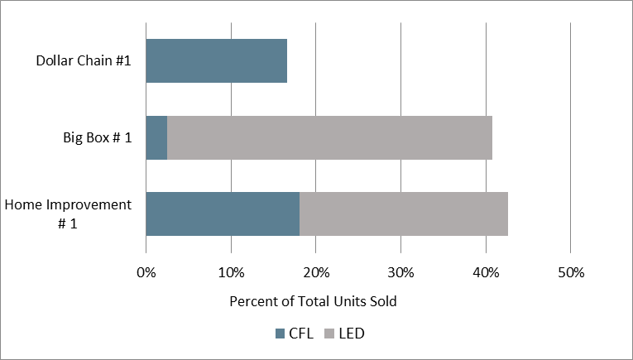

Figure 6‑4 CP Program Lighting Sales by Retailer

Figure 6‑5 displays monthly and cumulative lighting sales for the Consumer Products Program. The data shows that program lighting sales picked up in March and April of 2016 and remained consistent throughout the program year.

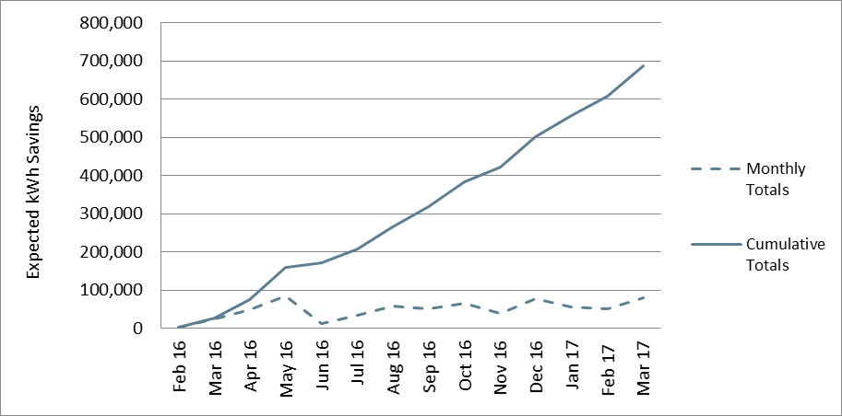

Figure 6‑5 CPP Monthly and Cumulative Accrual of Lighting kWh Savings

Figure 6‑6 displays monthly and cumulative appliance rebates for the Consumer Products Program. The data shows that appliance rebates were greatest during the first five months of the program, during which time 62% of total expected kWh was achieved. After August, monthly sales slowly declined throughout the rest of the program year. Considering the majority of program activity was associated with room ACs, it can be inferred that the spike in program activity correlates with warmer summer temperatures.

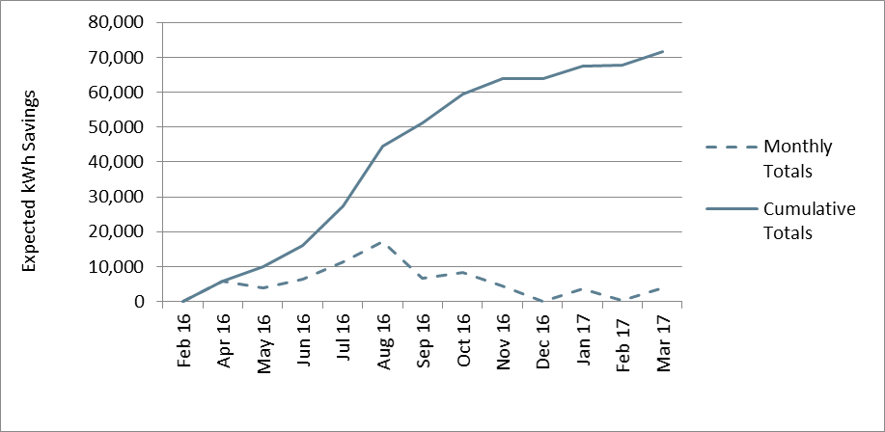

Figure 6‑6 CP Program Monthly and Cumulative Accrual of Appliance kWh Savings

#### Program Design, Operations and Activities

The program design and operations was discussed in detail in PY5. The program design and operations remained largely the same in PY6. As noted in 6.4.2 (appliances) the downstream rebates for pool pumps and advanced power strips changed in PY6. Program marketing and outreach activities remained unchanged.

#### Participant Survey Results

A total of 55 participants responded to the survey. Table 6‑5 summarizes the measures implemented by survey respondents. Eighty-nine percent of participants received rebates for air conditioning units through the program, 9% received pool pump rebates, and 2% received power strip rebates.

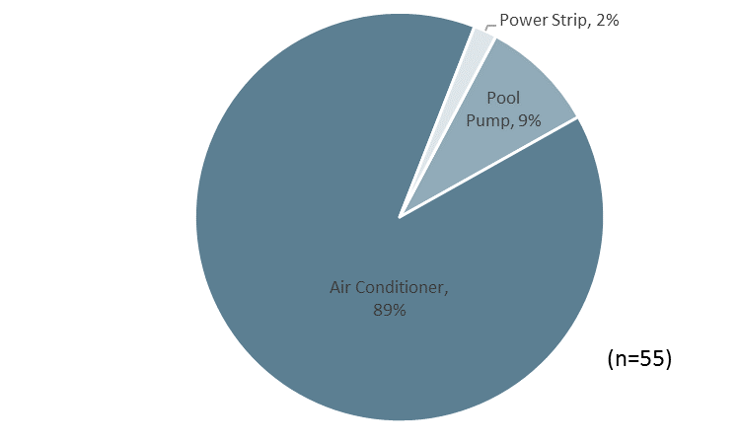

Figure 6‑7 CPP Measures Implemented by Survey Respondents

#### Participant Demographics and Residence Characteristics

Compared to PY5, survey participants had a similar number of household members on average, and a similar percent owned their homes. In PY6, a smaller percentage of participants reported incomes of under $25,000, however it is unclear whether this is due to a decrease in lower income participants in the program because a larger share of participants declined to state their income as compared to last year.

Table 6‑41 CPP Participant Demographics

|  |  |  |
| --- | --- | --- |
| ***Demographic Characteristic*** | ***2015***  ***(n=30)*** | ***2016***  ***(n=55)*** |
| Average number of home residents | 2.9 | 2.3 |
| Percent with income of:1 |  |  |
| Less than $25,000 per year | 13% | 4% |
| $25,000 to less than $50,000 | 23% | 15% |
| $50,000 to less than $75,000 | 17% | 15% |
| $75,000 or more | 33% | 18% |
| Percent own home | 53% | 53% |
| 1. Total does not equal 100% because some respondents did not know their income or declined to state it. | | |

Table 6‑42 summarizes the participant household characteristics. Similar to last year, most participants (75%) resided in an older (pre-1990) home, slightly more than half lived in a single-family home, 16% of participants used electric space heating, and 15% used electric water heating. More than a third lived in a home that was at least 2,000 square feet. Compared to last year, fewer participants had electric space or water heating.

Table 6‑42 CPP Residence Characteristics

|  |  |  |
| --- | --- | --- |
| ***Residence Characteristic*** | ***2015***  ***(n=30)*** | ***2016***  ***(n=55)*** |
| Percent Single Family Home1 | 57% | 56% |
| Percent electric space heating | 37% | 16% |
| Percent electric water heating | 23% | 15% |
| Percent of households built before 1990 | 97% | 75% |
| Percent with home size of:2 |  |  |
| Less than 1,000 ft.2 | 20% | 2% |
| 1,001-1,500 ft.2 | 20% | 25% |
| 1,501-2,000 ft.2 | 10% | 16% |
| Greater than 2,000 ft.2 | 47% | 36% |
| 1.Consistent with program rules, none of the respondents reported living in a multifamily property of more than 4 units | | |
| 2.  Total does not equal 100% because some respondents did not know the size of their home or declined to state it. | | |

#### Program Awareness and Participation

The ways in which participants learned of the rebates was similar to the findings for PY5. As shown in Figure 6‑6, three-quarters of PY6 participants learned of the program through a retailer. As in PY5, this was the most common source of program awareness. An additional ten percent heard of the program through word-of-mouth. Other sources of awareness included from a contractor, from an internet search, from a bill insert, and from an internet advertisement.

None of the five participants that installed pool pumps learned of the program from a retailer or contractor. These participants learned of the program from an internet search (n =2), family member, friend, or colleague (n = 1), or either learned of the program through some other means (n = 1) or did not recall how they learned of the program (n = 1).

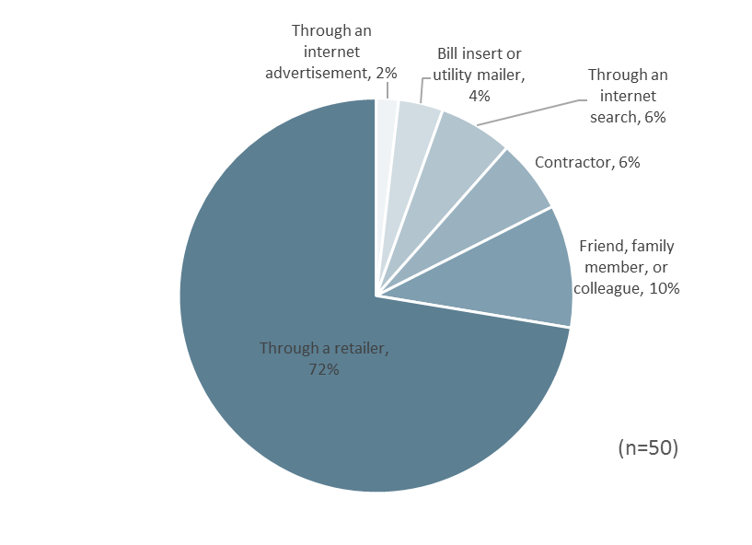

Figure 6‑8 CPP Source of Program Awareness

As seen in Figure 6‑9, most participants (73%) stated they participated in the program to receive the program discount or rebate. Almost a third (29%) were interested in conserving energy, and saving money was stated by 15%. Participants also listed becoming as efficient as friends and neighbors, improved home comfort, and other reasons among the reasons for participating.

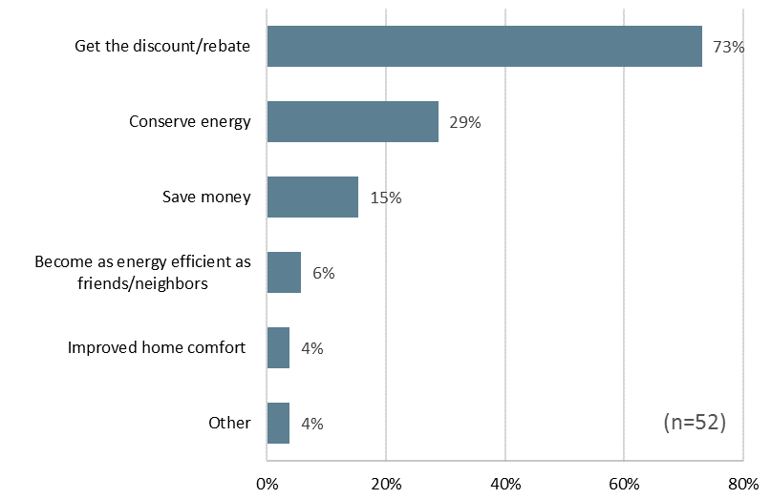

Figure 6‑9 CPP Reasons for Participation

#### Program Satisfaction

Participants rated various elements of the program on a scale of 1 to 5, where 1 represented “very dissatisfied” and 5 represented “very satisfied.” As shown in Figure 6‑10**.**, participants rated each of the program elements and the program overall highly. All program participants stated that they were either satisfied or very satisfied with the program overall. Most participants stated they were satisfied or very satisfied with the program participation process (98%), the energy efficiency improvements (94%), and the rebate amount (90%).

The aspect of the program that the fewest participants indicated satisfaction with was the savings on their utility bill with 78% of participants stating they were satisfied or very satisfied with this aspect of the program.

The one participant that had interactions with the staff was very satisfied with how long it took program staff to address their questions and how thoroughly staff addressed their questions or concerns.

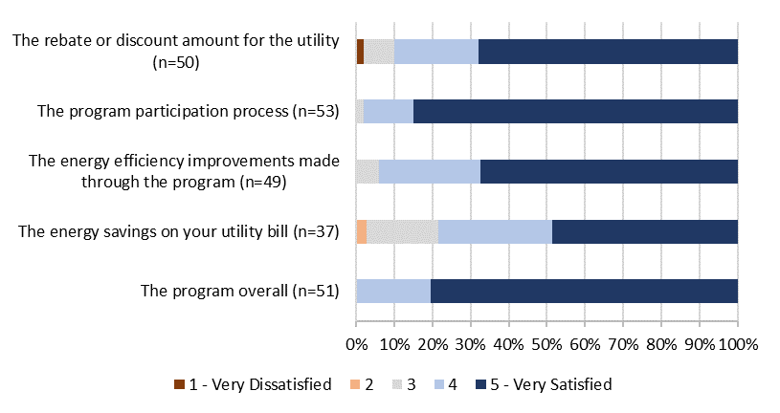

Figure 6‑10 Satisfaction with Program Components

Thirty-five percent of participants (n = 19) stated that they perceived one or more non-energy benefits from installing the discounted measure. As seen in Figure 6‑11, most of these participants reported an increase in home comfort, a third noted that their air conditioner or heater runs less often, one-fifth found it easier to maintain a comfortable temperature. Other benefits mentioned included reduced outside noise, environmental benefits, and other benefits.

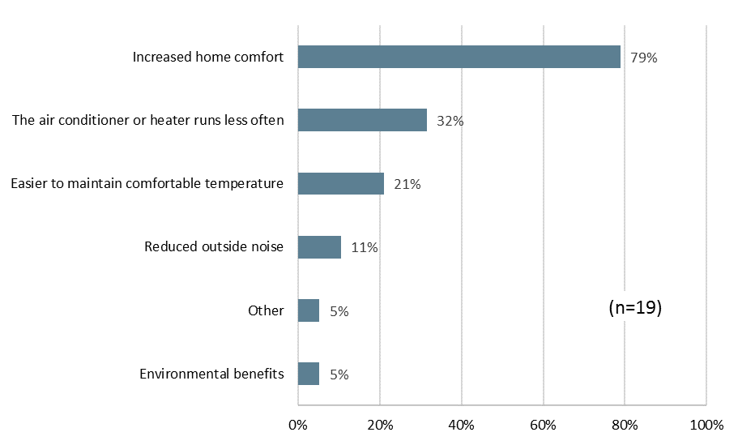

Figure 6‑11 CPP Non-Energy Benefits

As displayed in Table 6‑43, Seventy-five percent reported that they were satisfied or very satisfied with Entergy as their electrical service provider. Nine percent of participants stated that they were dissatisfied or very dissatisfied.

Table 6‑43 CPP Overall Satisfaction with Entergy

|  |  |
| --- | --- |
| ***Satisfaction with Entergy*** | ***Percent of Respondents***  ***(n=55)*** |
| 5 - Very satisfied | 60% |
| 4 | 15% |
| 3 - Neither satisfied nor dissatisfied | 11% |
| 2 | 5% |
| 1 - Very dissatisfied | 4% |

Participants that indicated dissatisfaction with Entergy provided additional explanations for their dissatisfaction. Of the five participants that gave additional comments, two were dissatisfied due to power surges, two were unsatisfied with the cost of their bill, and one gave general comments of dissatisfaction.

Fifty-two percent of respondents’ opinions of Entergy improved at least somewhat because they received the rebate through the program. An additional 31% stated that their opinion did not change, and two percent of respondents stated that participation of the program had decreased their satisfaction with Entergy.

Table 6‑44 CPP Effect of Program on Satisfaction with Entergy

|  |  |
| --- | --- |
| ***Effect of Program on Satisfaction with Entergy*** | ***Percent of Respondents***  ***(n=55)*** |
| Greatly increased your satisfaction with ENO | 27% |
| Somewhat increased your satisfaction with ENO | 25% |
| Did not affect your satisfaction with ENO | 31% |
| Somewhat decreased your satisfaction with ENO | 0% |
| Greatly decreased your satisfaction with ENO | 2% |

### Conclusions

The Evaluators’ conclusions are summarized below:

* Rebates for pool pumps and advanced power strips changed in PY6:
  + The PY5 pool pump rebate was $200 and changed to $200 for multi-speed pool pumps and $250 for variable speed pool pumps.
  + The PY5 advanced power strip rebate was $15 and decreased to $10 in PY6.
* The program began offering lighting discounts at a Dollar Chain location and did not offer discounts through one of the two Home Improvement retailers that participated in PY5. Nevertheless, the total of eight participating locations remained the same as in PY5.
* The diversity of LED lamp types increased to include higher 75-100 W equivalent lamps and more diverse shape types such as PAR38, BR40, and candelabra lamps.
* LED sales accounted for a larger share of PY6 lighting discounts than in PY5. LED sales accounted for large share of lighting discounts and for the majority of discounts at the Home Improvement and Big Box retailer location. Additionally, the LED discounts were as low as $1 per light bulb. The shift towards LED lighting and lower discount amounts in PY6 is consistent with the broader rapid market transition to LED lighting and the decline in LED prices.
* Downstream participant satisfaction remains high. All program participants were somewhat or very satisfied with the program overall and nearly all were satisfied with the program participation process (98%), the energy efficiency improvements (94%), and the rebate amount (90%).

### Recommendations

The Evaluators’ recommendations for the Consumer Products Program are as follows:

* **Discontinue downstream rebates for power strips.** The downstream rebate delivery approach has been ineffective for this measure and only three units were rebated during PY6. As recommended in PY5, direct install deliver approaches are more appropriate for this measure type given the challenges in educating customers of its value and the likelihood of incorrect use of the technology.
* **Consider moving room ACs to a point-of-sale rebate.** The rebate amount is modest ($40) and as such the program should consider a delivery channel that lessens the administrative burden on the part of participating customers.
* **Consider adding rebates for ENERGY STAR air purifiers.** To increase the diversity of measures offered through the program, staff should consider offering rebates for ENERGY STAR air purifiers. $50 is a typical rebate amount for this measure.
* **Prepare for potential impacts of ENERGY STAR 2.1 lamp specifications on directional lamp pricing and market potential.** Version 2.1 of the lamp specifications, slated to go into effect in October 2017, will decrease the LED lifetime hours of operation to 15,000, as version 2.0 did for omnidirectional LED lamps. This change may decrease the cost of directional LEDs, as version 2.0 appears to have done for omnidirectional lamps. As a result, staff should continue monitoring of incentive levels for directional lamps to ensure that they are appropriate for the cost of the lamps. Additionally, there may be additional opportunity to promote this lamp type because declining prices, in conjunction with program discount, may lead to increase interest in them.

# Residential Heating & Cooling

## Program Description

The Residential Heating & Cooling (RH&C) Program provides financial incentives to encourage residential customers to improve the efficiency of their HVAC systems. Incentives are provided for a tune-up of the system and for HVAC system replacements.

Tune-ups are provided by a qualified technician and involve testing the performance of the unit before and after measures are implemented. Typical measures implemented as part of the tune-up procedure include air flow correction; cleaning of the indoor blower, evaporator coils, condenser coils; and correction of refrigerant charge.

Incentives are provided for replacement of air conditioning systems and heat pump systems. Incentives for air conditioner replacements range from $75 to $550, depending on the size and SEER of the new unit. Incentives for ducted heat pumps range from $100 to $650, depending on size and SEER of the new unit. Ductless heat pumps may receive incentives ranging from $225 to $700 depending on the size of the unit.

A total of 1,191 customers participated in the Residential Heating & Cooling Program; 804 tune-ups, 391 duct sealings, and 75 replacements. Below, Table 7‑1 summarizes the total number of measures conducted and distributed through the program and overall expected savings:

Table 7‑1 RH&C Summary of Measures and Expected Savings

|  |  |  |  |
| --- | --- | --- | --- |
| ***Measure*** | ***Total Quantity of Measures*** | ***Total Expected kWh Savings*** | ***Total Expected peak kW Savings*** |
| Tune-ups | 804 | 1,045,989 | 371.74 |
| Replacements | 38 | 114,204 | 33.31 |
| Duct Sealing | 391 | 1,486,214 | 340.22 |
| **Total** | **1,191** | **2,646,407** | **745.27** |

Total verified savings and percentage of goals for the Residential Heating & Cooling Program are summarized in Table 7‑2.

Table 7‑2 RH&C Savings Goals & Attainment by Utility

|  |  |  |  |  |  |  |
| --- | --- | --- | --- | --- | --- | --- |
| ***Utility*** | ***kWh goal*** | ***Net Realized kWh*** | ***Percentage of kWh goal realized*** | ***kW goal*** | ***Net Realized kW*** | ***Percentage of kW goal realized*** |
| Algiers | 131,000 | 190,151 | 145.15% | 50 | 49.93 | 99.86% |
| ENO | 1,458,000 | 1,281,909 | 87.92% | 600 | 436.84 | 72.81% |

## M&V Methodology

Evaluation of the Residential Heating & Cooling Program included the following:

* Surveys with tune-up participants;
* Interviews with program trade allies; and
* Collection and analysis of participant billing data.

The Evaluators examined the Excel workbook distributed to trade allies to assess savings by measure. The workbook includes a section on heat pump replacement which utilizes deemed savings algorithms with trade ally inputs to calculate savings based on the input parameters. The Evaluators examined the calculator and factor tables, however were unable to recreate savings figures found in tracking data. Savings from AC and heat pump replacements used stipulated equivalent full-load hours along with unit-specific capacity and efficiency inputs. Finally, to evaluate savings from the tune-up portion of the program the Evaluators used regression modeling with participant billing data.

### Central Air Conditioner Tune-Up Savings Calculations

The Evaluators were provided test-in and test-out data for a sample of 62 air conditioners. This test data provided the EER before and after the tune-up. These values were applied in the following formula:

Where,

Capacity = Tons * 12,000 BTU/Ton

EERbase = Test-in EER

EERpost = Test-out EER

1,000 W/kW = Watts – kilowatts conversion

The improvement in EER is summarized in Figure 7‑1.

Figure 7‑1 EER Gain for M&V Sites

The mean tonnage for air conditioners that received tune-ups was 3.29. With this value, the average cooling-season kWh savings was calculated as:

This kWh savings per-unit was then multiplied by the total units in the program. This resulted in 70.49% realization for AC tune-ups.

To calculate heating season savings for heat pumps, the evaluators scaled the heating season ex ante savings by the same realization rate as developed for cooling savings. There were no heat pumps in the test-in M&V sample so there was no further validation of HSPF for heat pumps.

Verified AC tune-up savings are summarized in Table 7‑3 and Table 7‑4.

Table 7‑3 RH&C CAC/HP Tune-up Savings Summary – New Orleans

|  |  |  |  |  |  |  |
| --- | --- | --- | --- | --- | --- | --- |
| ***Measure*** | ***Expected kWh*** | ***Realized kWh*** | ***kWh Realization Rate*** | ***Expected kW*** | ***Realized kW*** | ***Peak kW Realization Rate*** |
| Central AC | 929,657 | 640,190 | 68.86% | 333.39 | 227.52 | 68.24% |
| Heat Pump | 26,829 | 18,475 | 68.86% | 6.26 | 6.57 | 68.24% |
| **Total** | **956,486** | **658,665** | **68.86%** | **340** | **234** | **68.92%** |

Table 7‑4 RH&C CAC/HP Tune-up Savings Summary – Algiers

|  |  |  |  |  |  |  |
| --- | --- | --- | --- | --- | --- | --- |
| ***Measure*** | ***Expected kWh*** | ***Realized kWh*** | ***kWh Realization Rate*** | ***Expected kW*** | ***Realized kW*** | ***Peak kW Realization Rate*** |
| Central AC | 89,503 | 83,463 | 93.25% | 32.09 | 29.66 | 92.44% |
| Heat Pump | 0 | 0 | NA | 0 | 0 | NA |
| **Total** | **89,503** | **83,463** | **93.25%** | **32.09** | **29.66** | **92.44%** |

### Central AC/Heat Pump Replacement

The PY6 Residential Heating & Cooling Program rebated 34 central air conditioners and 4 heat pumps. The Evaluators calculated savings for all replacements were as Replacement-on-Burnout (“ROB”), using current minimum code as baseline.

#### Central AC

Where,

* CAP = Rated equipment cooling capacity of the new unit (Btu/hr.)
* 𝐸𝐹𝐿𝐻𝐶 = Equivalent full-load cooling hours
* 𝜂𝑏𝑎𝑠𝑒 = Energy efficiency rating of the baseline cooling equipment (SEER for kWh and EER for kW)
* 𝜂𝑝𝑜𝑠𝑡 = Energy efficiency rating of the installed cooling equipment (SEER for kWh and EER for kW)
* CF = Coincidence factor = 0.77[29]

#### Heat Pump

Where,

* CAP = Rated equipment cooling capacity of the new unit (Btu/hr)
* 𝐸𝐹𝐿𝐻H = Equivalent full-load heating hours
* 𝜂𝑏𝑎𝑠𝑒 = Energy efficiency rating of the baseline cooling equipment
  + SEER for cooling kWh
  + HSPF for heating kWh
  + EER for cooling kW
* 𝜂𝑝𝑜𝑠𝑡= Energy efficiency rating of the installed cooling equipment
* CF = Coincidence factor = 0.77

New codes took effect on January 1, 2015 for residential HVAC systems. The effects of this code change are as follows:

* Minimum required Seasonal Energy Efficiency Ratio (SEER) increased from 13 to 14 for new construction or replacement-on-burnout packaged units;
* Minimum required Heating Season Performance Factor (HSPF) increased from 7.7 to 8.0 (for packaged systems) and 8.2 (for split systems)[30].

This code change barred the manufacturing of equipment at older efficiency levels, but did not bar the sale of equipment already on the market. The Evaluators allowed for a six-month sell-through period for back-stock of old equipment when calculating savings for HVAC systems rebated trough the Residential Heating & Cooling Program. As a result, 13 SEER/7.7 HSPF baselines were applied to all systems rebated before July 1, 2015, with the new code being applied to units rebated on or after that date. For the Southern Region as-defined in this code change, EER was not affected by this update.

#### Savings Results

The Evaluators had difficulty in creating unit-specific calculations for a significant number of participants. There were erroneous entries for model numbers for a large share of units. In such occurrences, the model number field was instead populated by a statement of “CAC_” along with the premise address. This issue as present in:

* 15.4% of heat pumps; and
* 41.9% of central air conditioners.

For units with model numbers present, the evaluator did not find any issues in terms of unit eligibility (i.e., all units shown had eligible SEER and HSPF ratings). As a result, the Evaluators did not disqualify these units. However, they were credited at a conservative savings level. For such units, the Evaluators assumed:

* 16 SEER; and
* 9 HSPF (heat pumps only).
* Resulting gross savings are summarized in Table 7‑5 and
* Table 7‑6.

Table 7‑5 RH&C CAC/HP Savings Summary – New Orleans

|  |  |  |  |  |  |  |
| --- | --- | --- | --- | --- | --- | --- |
| ***Measure*** | ***Expected kWh*** | ***Realized kWh*** | ***kWh Realization Rate*** | ***Expected kW*** | ***Realized kW*** | ***Peak kW Realization Rate*** |
| Central AC | 97,835 | 80,525 | 82.31% | 28.56 | 7.15 | 25.05% |
| Heat Pump | 10,554 | 10,432 | 98.84% | 3.04 | 0.29 | 9.38% |
| **Total** | **108,389** | **90,957** | **83.92%** | **31.60** | **7.44** | **23.54%** |

Table 7‑6 RH&C CAC/HP Savings Summary - Algiers

|  |  |  |  |  |  |  |
| --- | --- | --- | --- | --- | --- | --- |
| ***Measure*** | ***Expected kWh*** | ***Realized kWh*** | ***kWh Realization Rate*** | ***Expected kW*** | ***Realized kW*** | ***Peak kW Realization Rate*** |
| Central AC | 5,815 | 4,716 | 81.10% | 1.71 | 0.51 | 29.59% |
| Heat Pump | - | - | - | - | - | - |
| **Total** | **5,815** | **4,716** | **81.10%** | **1.71** | **0.51** | **29.59%** |

Overall kWh realization for HVAC replacements was 83.8% and overall kW realization was 27.0%.

### Duct Sealing

Duct sealing savings was calculated using the following savings algorithms from the TRM.

## Cooling Savings (Electric):

Where:

= Pre-improvement duct leakage at 25 Pa (ft3/min)

= Post-improvement duct leakage at 25 Pa (ft3/min)

*ΔDSE* = Assumed improvement in distribution system efficiency = 5% = 0.05

= Equivalent Full Load Hours.

= Outdoor design specific enthalpy (Btu/lb)

= Indoor design specific enthalpy (Btu/lb.)

Table 7‑7 Deemed Savings Values for Duct Sealing Calculations

|  |  |
| --- | --- |
| ***Parameter*** | ***Value*** |
| EFLHC | 1,637 |
| HDD | 1,349 |
| hout | 40 |
| hin | 30 |
| ρin | 0.076 |
| Ρout | 0.074 |
| SEER | 11.5 |
| CF | 0.77 |

= Density of outdoor air at 95°F = 0.0740 (lb/ft3)[31]

= Density of conditioned air at 75°F = 0.0756 (lb./ft3)4

= Constant to convert from minutes to hours

= Cooling capacity (Btu/hr)

=Constant to convert from W to kW

=Seasonal Energy Efficiency Ratio of existing system (Btu/W·hr)

Default value for SEER = 11.5[32]

## Heating Savings (Heat Pump):

Where:

= Pre-improvement duct leakage at 25 Pa (ft3/min)

= Post-improvement duct leakage at 25 Pa (ft3/min)

*ΔDSE* = Assumed improvement in distribution system efficiency = 5% = 0.05

= Equivalent full load heating hours

= Constant to convert from minutes to hours

= Heating degree days

= Constant to convert from days to hours

= Volumetric heat capacity of air (Btu/ft3°F)

= Heating capacity (Btu/hr)

=Constant to convert from W to kW

= Heating Seasonal Performance Factor of existing system (Btu/W·hr)

Default value for HSPF = 7.30.[33]

## Heating Savings (Electric Resistance):

Where:

= Pre-improvement duct leakage at 25 Pa (ft3/min)

= Post-improvement duct leakage at 25 Pa (ft3/min)

*ΔDSE* = Assumed improvement in distribution system efficiency = 5% = 0.05

*60* = Constant to convert from minutes to hours

*HDD* = Heating degree days

*24* = Constant to convert from days to hours

*0.018* = Volumetric heat capacity of air (Btu/ft3°F)

*EFLHH* = Equivalent full load heating hours

*CAP* = Heating capacity (Btu/hr)

*3,412* =Constant to convert from Btu to kWh

## Demand Savings (Cooling):

Where:

kWhsavings,C = Calculated kWh savings for cooling

*EFLHC* = Equivalent full load cooling hours

*CF* = Coincidence factor = 0.77

The savings resulting from this revision to deemed parameters and application of field results are summarized in Table 7‑8 and Table 7‑9.

Table 7‑8 Expected and Realized Duct Sealing Savings – New Orleans

|  |  |  |  |  |  |  |
| --- | --- | --- | --- | --- | --- | --- |
| ***Heating Type*** | ***Expected kWh Savings*** | ***Realized kWh Savings*** | ***kWh Realization Rate*** | ***Expected Peak kW Savings*** | ***Realized Peak kW Savings*** | ***Peak kW Realization Rate*** |
| Natural Gas Furnace | 483,091 | 303,117 | 62.7% | 167.57 | 184.60 | 110.2% |
| Electric Resistance | 791,290 | 665,941 | 84.2% | 132.61 | 146.02 | 110.1% |
| Air Source Heat Pump | 27,980 | 20,095 | 71.8% | 6.07 | 6.69 | 110.2% |
| **Total** | **1,302,361** | **989,153** | **76.0%** | **306.25** | **337.31** | **110.1%** |

Table 7‑9 Expected and Realized Duct Sealing Savings - Algiers

|  |  |  |  |  |  |  |
| --- | --- | --- | --- | --- | --- | --- |
| ***Heating Type*** | ***Expected kWh Savings*** | ***Realized kWh Savings*** | ***kWh Realization Rate*** | ***Expected Peak kW Savings*** | ***Realized Peak kW Savings*** | ***Peak kW Realization Rate*** |
| Natural Gas Furnace | 18,684 | 12,218 | 65.4% | 6.70 | 7.42 | 110.7% |
| Electric Resistance | 165,169 | 145,508 | 88.1% | 27.27 | 32.82 | 120.4% |
| Air Source Heat Pump | - | - | N/A | - | - | N/A |
| **Total** | **183,853** | **157,726** | **85.8%** | **33.97** | **40.24** | **118.5%** |

## Savings Results

Verified savings are summarized in Table 7‑10 and Table 7‑11.

Table 7‑10 Realization Summary – New Orleans

|  |  |  |  |  |  |  |
| --- | --- | --- | --- | --- | --- | --- |
| ***Measure*** | ***Expected kWh*** | ***Realized kWh*** | ***kWh Realization Rate*** | ***Expected kW*** | ***Realized kW*** | ***Peak kW Realization Rate*** |
| Tune-ups | 956,486 | 658,665 | 68.86% | 340.00 | 234.00 | 68.92% |
| Replacements | 108,389 | 90,957 | 83.92% | 31.60 | 7.44 | 23.54% |
| Duct Sealing | 1,302,361 | 989,153 | 75.95% | 306.25 | 337.31 | 110.14% |
| **Total** | **2,367,236** | **1,738,775** | **73.45%** | **677.85** | **578.75** | **85.38%** |

Table 7‑11 Realization Summary - Algiers

|  |  |  |  |  |  |  |
| --- | --- | --- | --- | --- | --- | --- |
| ***Measure*** | ***Expected kWh*** | ***Realized kWh*** | ***kWh Realization Rate*** | ***Expected kW*** | ***Realized kW*** | ***Peak kW Realization Rate*** |
| Tune-ups | 89,503 | 83,463 | 93.25% | 32.09 | 29.66 | 92.44% |
| Replacements | 5,815 | 4,716 | 81.10% | 1.71 | 0.51 | 29.59% |
| Duct Sealing | 183,853 | 157,726 | 85.79% | 33.97 | 40.24 | 118.46% |
| **Total** | **279,171** | **245,905** | **88.08%** | **67.77** | **70.41** | **103.90%** |

## Estimation of Net Savings

Participant survey responses were used to estimate the net energy impacts of appliance component of the Residential Heating & Cooling Program. The program net savings are equal to gross savings, less savings associated with free ridership, plus participant spillover savings.

In total, 64 program participants that completed tune-ups or duct sealing projects completed the survey. One respondent was removed from the analysis because responses because the respondent did not answer he net-to-gross questions. Eleven customers that replace air conditioners or heat pumps also completed the survey.

#### Estimation of Free Ridership

The objective of the free ridership analysis is to estimate the share of program activity would have occurred in the absence of the program. To accomplish this, the Evaluators administered a survey to program participants that contained questions regarding the participants’ plans to implement the incentivized measures and the likelihood of implementing those measures in the absence of program incentives and informational support. Program participants were asked questions regarding:

* Whether or not they had plans to complete the project and if they could afford to complete it without the program discount;
* The likelihood of completing the project without the discount or the incentivized assessment;
* The timing of the project in the absence of the program.

Participant responses to these questions were used to calculate three scores corresponding to the presence of prior plans, the likelihood of completing the project in the absence of the program, and the timing of that project if it had been completed.

#### Prior Plans Score

Respondents were scored as 1 on the prior plans score if all of the following were true:

* The participant had plans to complete the project prior to learning about the program.
* The participant indicated that they would have been financially able to complete the project had a discount or rebate not been provided.

Respondents that did not have prior plans and could afford the measures were not deemed to be free riders.

#### Likelihood of Project Completion Score

The score reflecting the likelihood of completing the project in the absence of the program was based on the following questions:

* Prior to learning about the program, did you have plans to have an energy assessment of your home performed?
* How likely is it that you would have completed the same < MEASURE> project that you completed through the program if the rebate was not available?

A likelihood score was assigned to each response for this question as follows:

* Very likely: 1
* Somewhat likely: .75
* Neither particularly likely or unlikely: .5
* Somewhat unlikely: .25
* Very unlikely: 0

#### Timing Score

To account for the impact the program may have had on project timing, the likelihood score was multiplied by a timing score. The timing score was developed from responses to a question on when the participant might have completed a project in the absence of the program. Specifically, timing was scored as follows:

* Project would have been completed in 0 to 6 months: 1
* Project would have been completed in 6 months to a year: .67
* Project would have been completed in 1 to 2 years: .33
* Project would have been completed in more than 2 years: 0

#### Final Free Ridership Score

The final free ridership score is equal to the following:

*Free Ridership = Average (Plans Score + Likelihood Score * Timing Score)*

The procedures used to estimate free ridership are summarized below in Figure 7‑2.

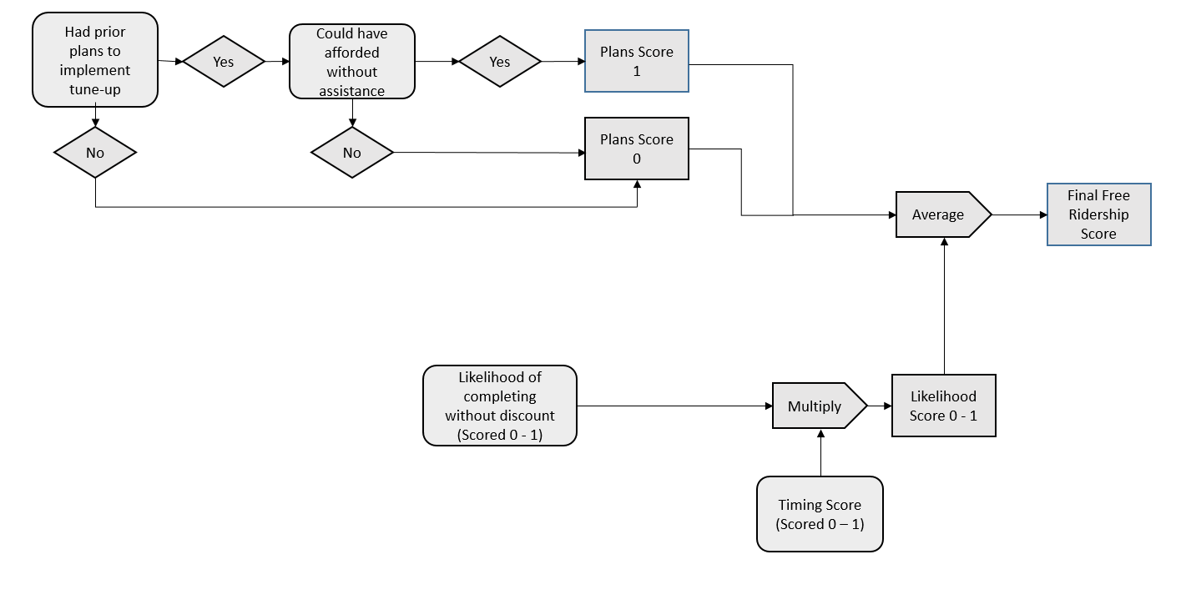

Figure 7‑2 RH&C Free Ridership Scoring Algorithm

#### Free-Ridership Modification – AC Tune-Up

The Evaluators found that the tune-up service provided through Residential Heating & Cooling included additional benefits compared to prior tune-up practices performed in the Companies’ service areas. Program plan savings for AC tune-ups were listed at 615 kWh prior to the introduction of the iManifold system. This was increased to 1,060 kWh per unit subsequent to this program improvement. Survey responses for AC tune-ups found a free-ridership rate of 21%. The Evaluators are adjusting this to reflect the added savings from the iManifold tune-up as follows:

#### Estimation of Participant Spillover

To estimate participant spillover impacts, participant survey respondents were asked if they had purchased any additional items because of their experience with the program without receiving an incentive.

Participants that indicated one or more energy efficiency purchases were asked additional questions about what was purchased and the number of units purchased to estimate the savings impact. Additionally, the following two questions were asked to determine whether the energy savings resulting from measures that were attributable to the program:

* On a scale of 0 to 10, where 0 represents “not at all important” and 10 represents “extremely important”, how important was the experience with the program in your decision to purchase the items you just mentioned?
* On a scale of 0 to 10, where 0 represents “not at all likely” and 10 represents “extremely likely,” how likely would you have been to purchase those items if you had not participated in the program?

If the average of the first response and 10 – the second response is 7 or greater, the savings associated with the measures were attributed to the program.

Four respondents reported installing CFLs and LED light bulbs that were influenced by the program. The kWh and peak kW estimates are summarized in Table 7‑12.

Table 7‑12 Participant Reported Spillover Impacts

|  |  |  |  |  |
| --- | --- | --- | --- | --- |
| ***Measure1*** | ***Per Unit kWh Estimate*** | ***Per Unit Peak kW Estimate*** | ***Total kWh*** | ***Total Peak kW*** |
| CFLs2 | 22.60 | 0.00 | 678.10 | 0.11 |
| LEDs3 | 25.62 | 0.00 | 307.41 | 0.05 |
| **Total** |  |  | **985.51** | **0.16** |
| 1. All values based on deemed values from Arkansas Technical Resource Manual, version 6.0. | | | | |
| 2. Assumed 13 W CFL, 793 annual operating hours, 1.25 demand factor, .97 energy factor, and .10 coincidence factor. | | | | |
| 3. Assumed 9 W LED, 793 annual operating hours, 1.25 demand factor, .97 energy factor, and .10 coincidence factor. | | | | |

### Net Savings Results

The results of the net savings analysis are presented below in Table 7‑13 and Table 7‑15. As shown the net-to-gross ratios for kWh savings and peak kW reductions are both equal to 79%.

Table 7‑13 RH&C Summary of Verified Net Savings

|  |  |  |  |  |  |  |
| --- | --- | --- | --- | --- | --- | --- |
| ***Utility*** | ***Expected kWh Savings*** | ***Verified Gross kWh Savings*** | ***Free Ridership*** | ***Spillover*** | ***Verified Net kWh Savings*** | ***Net to Gross Ratio*** |
| ENO | 2,367,236 | 1,738,775 | 137,875 | 37,333 | 1,638,233 | 94.22% |
| Algiers | 279,171 | 245,905 | 19,499 | 5,444 | 231,850 | 94.28% |
| **Total** | **2,646,407** | **1,548,876** | **157,374** | **42,776** | **1,434,278** | **92.60%** |

Table 7‑15 RH&C Summary of Verified Net Peak Demand Reductions

|  |  |  |  |  |  |  |
| --- | --- | --- | --- | --- | --- | --- |
| ***Utility*** | ***Expected Peak kW Reductions*** | ***Verified Gross Peak kW Reductions*** | ***Free Ridership*** | ***Spillover*** | ***Verified Net Peak kW Reductions*** | ***Net to Gross Ratio*** |
| ENO | 677.22 | 578.75 | 45.89 | 22.80 | 555.66 | 96.01% |
| Algiers | 68.05 | 70.41 | 5.58 | 0.00 | 64.83 | 92.07% |
| **Total** | **745.27** | **649.16** | **51.47** | **22.80** | **620.49** | **95.58%** |

#### Measure Level Free Ridership Results

Table 7‑16 summarizes the average free ridership scores by measure.

Table 7‑16 Average Free Ridership by Measure

|  |  |  |
| --- | --- | --- |
| ***Measure*** | ***Number of Responses*** | ***Free Ridership*** |
| Air conditioner | 10 | 45% |
| Heat pump | 1 | 25% |
| Tune-up | 52 | 10% |
| Duct sealing | 24 | 5% |

## Process Evaluation

This chapter presents the results of the process evaluation of the Residential Heating & Cooling Program. The process evaluation focuses on aspects of program policies and organization, as well as the program delivery framework.

The process chapter begins with an overview of the program. This is followed by a discussion of the methodological approach used in the evaluation. A summary of findings and recommendations for program improvement follow the discussion of the methodology. This discussion is followed by detailed findings of the evaluation activities.

### Data Collection Activities

The process evaluation of the Residential Heating & Cooling Program included the following data collection activities:

Table 7‑17 Residential Heating & Cooling Process Evaluation – Summary of Data Collection

|  |  |
| --- | --- |
| ***Activity*** | ***Sample Size*** |
|
| The Companies Staff | 1 |
| Participant Survey – AC Tune-up | 64 |
| Participant Survey – HVAC Replacement | 11 |

### Program Overview

The Residential Heating & Cooling Program provides financial incentives to encourage residential customers to improve the efficiency of their HVAC systems or replace their systems with more efficient units.

### Detailed Findings

#### Analysis of Participation Data

Table 7‑18 displays the number of projects and the expected kWh savings by measure type. During PY6 the total expected savings for the Residential Heating and Cooling Program more than doubled from PY5. As shown, tune-ups and duct sealing accounted for 40% and 56% of the program expected kWh savings. AC and heat pump replacements accounted for, a combined, 5% of total savings.

In terms of expected savings, the savings acquisition cost for program measures ranged from a low of $0.08 per kWh saved for duct sealing and $0.16 per kWh saved for heat pump replacements.

Table 7‑17 Program Activity by Measure Implemented

|  |  |  |  |  |
| --- | --- | --- | --- | --- |
| ***Measure Type*** | ***Expected Savings (kWh)*** | ***Share of Total Program Savings*** | ***Share of Total Projects*** | ***$ per kWh in Expected Savings*** |
| Tune Up | 1,045,989 | 40% | 65% | $0.11 |
| Duct Sealing | 1,486,214 | 56% | 32% | $0.08 |
| AC Replacement | 103,650 | 4% | 3% | $0.14 |
| Heat Pump Replacement | 10,554 | <1% | <1% | $0.16 |

As shown in Table 7‑18, tune-ups and duct sealing accounted for 96% of total expected energy savings, 98% of which was associated with AC units ranging from 1.5 to 5 tons. The remaining 2% of savings was associated with heat pump units ranging from 2 to 5 tons.

Three and four-ton AC units accounted for 63% of the duct sealing and tune up projects.

Table 7‑18 AC Tune Up Activity by Unit Size the Type

|  |  |  |  |  |
| --- | --- | --- | --- | --- |
| ***Unit Tonnage by Cooling Source*** | ***Expected Savings (kWh)*** | ***Share of Tune Up / Duct Sealing Savings*** | ***Project Count*** | ***Average Savings per Project*** |
| AC Tonnage |  |  |  |  |
| 1.5 | 5,567 | 0% | 5 | 1,113.40 |
| 2 | 183,497 | 7% | 140 | 1,310.69 |
| 2.5 | 333,429 | 13% | 182 | 1,832.03 |
| 3 | 653,417 | 26% | 333 | 1,962.21 |
| 3.5 | 318,438 | 13% | 148 | 2,151.61 |
| 4 | 724,467 | 29% | 279 | 2,596.66 |
| 5 | 258,579 | 10% | 86 | 3,006.73 |
| AC Totals | **2,477,394** | **98%** | **1173** | **2,112** |
| Heat Pump Tonnage |  |  |  |  |
| 2 | 4,664 | 9% | 3 | 1,554.67 |
| 2.5 | 10,775 | 20% | 5 | 2,155.00 |
| 3 | 3,245 | 6% | 2 | 1,622.50 |
| 3.5 | 9,919 | 18% | 3 | 3,306.33 |
| 4 | 23,758 | 43% | 8 | 2,969.75 |
| 5 | 2,448 | 4% | 1 | 2,448.00 |
| Heat Pump Totals | **54,809** | **2%** | **22** | **2,491** |

Figure 7‑3 through Figure 7‑5 display monthly and cumulative expected kWh by program component. Both program components experienced higher levels of activity during the warmer months, then a slow down during fall, and a resurgence in spring towards the end of the program year. These seasonal shifts in program activity align with when customers are more likely to discover issues with their AC units and to be more motivated to fix or replace them. Additionally, temperatures are more likely to be warm enough to put sufficient load on the cooling system to get accurate measurements.

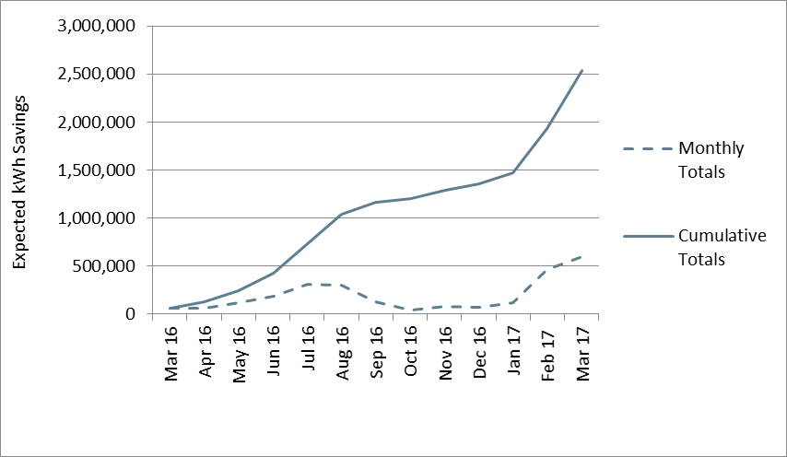

Figure 7‑3 Monthly and Cumulative HVAC Tune Up Expected kWh Savings

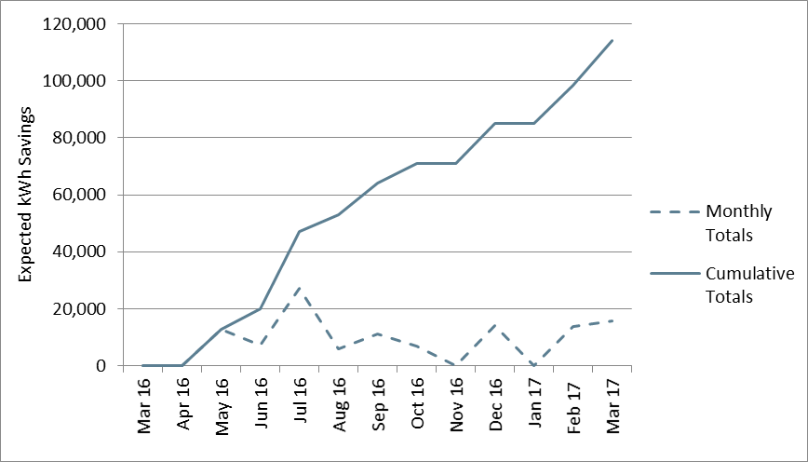

Figure 7‑4 Monthly and Cumulative AC Replacement Expected Savings

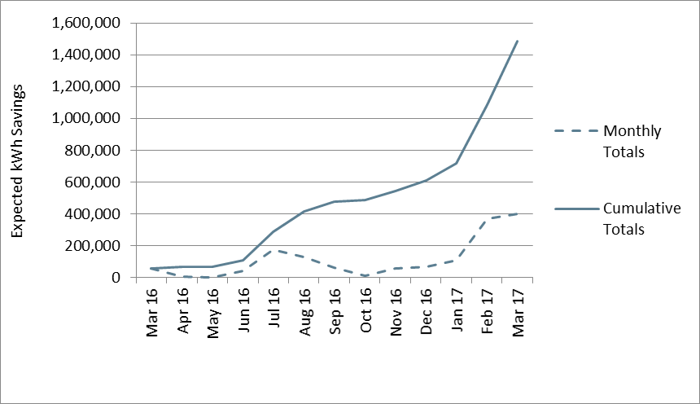

*Figure 7‑5 Monthly and Cumulative Duct Sealing Expected Savings*

Figure 7‑6 provides a summary of tune-up and duct sealing projects completed by contractor. The data is further disaggregated to show which contractors installed duct sealing in addition to performing a general tune-up, and which contractors provided only one of those services.

Fourteen contractors participated in the tune-up/duct sealing component of the Residential Heating and Cooling Program in PY6. Most of the contractor projects involved a single measure, either duct sealing or a system tune-up. However, the majority (71%) of projects completed by the most active contractor (Contractor 1) involved both duct sealing and a tune-up. While project specific factors may account for some of the differences in the types of measures implemented by different contractors, other factors such as contractor knowledge or access to necessary diagnostic equipment may lead them to complete single measure projects.

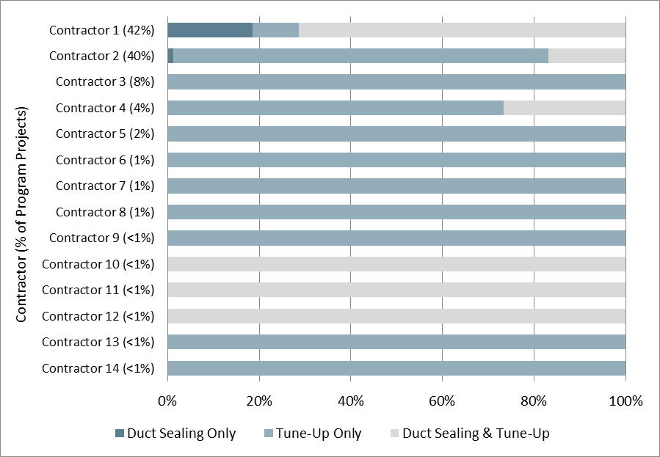

*Figure 7‑6 Tune-Up Savings by Program Contractor[34]*

Five contractors completed AC or heat pump replacements through the program in PY6; Figure 7‑7 summarizes replacement activity by contractor. Contractor 2 was the only contractor that installed replacement units in addition to performing tune-ups. As show, the majority of program activity and participating contractors installed AC units as replacements as compared to heat pumps. Only one contractor installed both.

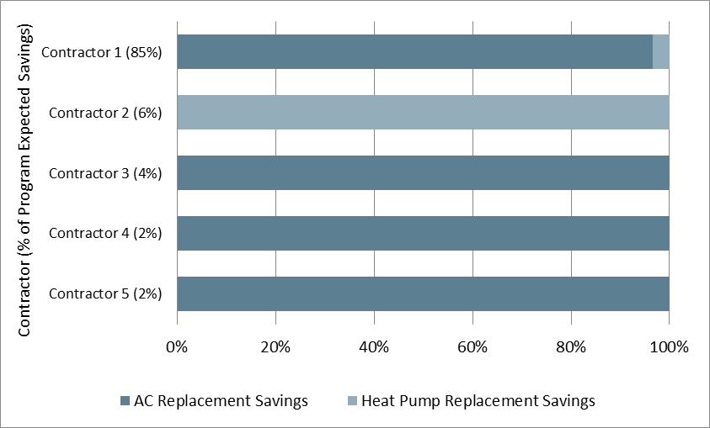

*Figure 7‑7 Replacement Savings by Program Contractor*

#### Program Design, Operations and Activities

The program design and operations was discussed in detail in PY5. The program design and operations remained largely the same in PY6.

#### Participant Survey Results

In total, 75 participants completed the participant survey. Sixty-four of these participants received tune-ups or duct sealing measures, and 11 received HVAC replacements.

#### Characteristics of Tuned-Up AC Systems

Figure 7‑8 summarizes the reported age of the units that were tuned-up through the program separated by type. As seen below, most units that were tuned-up were between five and fifteen years old, and the average age of all AC units tuned up through the program was 8.8 years.

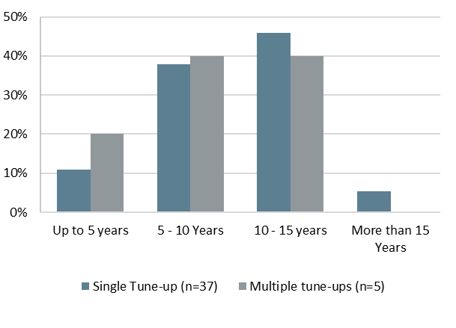

Figure 7‑8 RH&C Age of Tuned-Up Units

Fifteen of the 53 tune-up participants (28%) reported that they had had a tune-up at some point before they participated in the program. The average amount of time since a tune-up had been performed at the location was approximately two-years and nine of the fifteen participants reported that a tune-up had been completed in the past two years. ADM compared expected kWh per ton reductions for customers that reported that their unit had received a tune-up in the past three years with customers that had not had a tune-up or whose most recent tune up was more than five years ago but found little difference between these groups (420 kWh per ton vs. 422 kWh per ton).

#### Participant Demographics

Table 7‑19 displays participant demographics broken out by participants that received a tune-up or HVAC replacement. The average number of home residents and percent of participants that owned their homes were similar between the two populations. The data suggests that there are income differences between the two populations, with the participants receiving HVAC replacement having higher incomes. However, due to the large number of participants (n = 37) that did not report their income, this may not be a substantive difference.

Table 7‑19 RH&C Participant Demographics

|  |  |  |
| --- | --- | --- |
| ***Demographic Characteristic*** | ***Tune-Up***  ***(n=64)*** | ***HVAC Replacement (n=10)*** |
| Average number of home residents | 2.66 | 2.67 |
| Percent with income of:1 |  |  |
| Less than $25,000 per year | 22% | 0% |
| $25,000 to less than $50,000 | 13% | 0% |
| $50,000 to less than $75,000 | 5% | 10% |
| $75,000 or more | 9% | 60% |
| Percent own home | 83% | 80% |
| 1. Total does not equal 100% because some respondents did not know their income or declined to state it. | | |

Table 7‑20 summarizes participant household characteristics broken out by participant type. A similar percent of both populations lived in single family homes, and lived in older homes. Those receiving HVAC replacement were more likely to live in a home over 1,500 square feet and less likely to have electric space heating.

Table 7‑20 RH&C Residential Demographics

|  |  |  |
| --- | --- | --- |
| ***Residence Characteristic*** | ***Tune-Up***  ***(n=64)*** | ***HVAC Replacement (n=10)*** |
| Percent Single Family Home | 83% | 80% |
| Percent electric space heating | 41% | 20% |
| Percent electric water heating | 34% | 40% |
| Percent of households built before 1990 | 61% | 70% |
| Percent with home size of:2 |  |  |
| Less than 1,000 sqft | 2% | 0% |
| 1,001-1,500 sqft | 13% | 0% |
| 1,501-2,000 sqft | 22% | 20% |
| Greater than 2,000 sqft | 16% | 70% |
| 1.  Total does not equal 100% because some respondents did not know the size of their home or declined to state it. | | |

#### 

#### Program Awareness and Participation

As shown in Table 7‑21, participants in each of the two program components heard of the program through different means. Half of participants who completed HVAC replacements through the program learned of the program from a contractor, 36% heard of the program through a retailer, and 9% heard of the program through a home energy consultant. The participants who completed tune-ups/duct sealing were most likely to hear of the program through word-of-mouth (60%). An additional thirteen percent heard of the program through a bill insert or utility mailer, 8% heard of the program through a contractor or program representative. Other sources of awareness included through a home energy consultant, through a program representative, email, print advertisement, or through the program website.

Table 7‑21 RH&C Source of Program Awareness

|  |  |  |
| --- | --- | --- |
| ***How did you first learn of the program*** | ***Tune-Up/Duct Sealing***  ***(n=60)*** | ***HVAC Replacement (n=11)*** |
| Contractor | 8% | 55% |
| Home energy consultant | 2% | 9% |
| Program representative | 8% | 0% |
| Program website | 3% | 0% |
| Friend, family member, or colleague | 60% | 0% |
| Bill insert or utility mailer | 13% | 0% |
| Email from utility | 2% | 0% |
| From utility’s website | 2% | 0% |
| A print advertisement | 2% | 0% |
| Through a retailer | 0% | 36% |

As seen in Figure 7‑9, reasons for participating in the program were similar for both types of participants with a few key differences. For both types of participants, the most common reason for participating in the program was to save money on electric bills. Over a third of tune-up/duct sealing participants (39%) and 11% of HVAC replacement participants stated they participated to receive the discount offered through the program. While these differences may be a function of sampling error due to the small number of HVAC replacement respondents, they could be due to the larger share of project cost covered by the tune-up/duct sealing incentives. Similar percentages of both types of participants stated they participated to see increased home comfort and conserve energy. HVAC recipients also noted they participated to replace or update equipment (22%). Reasons only given by tune-up/duct sealing recipients included to be as efficient as friends or neighbors, or to improve home value.

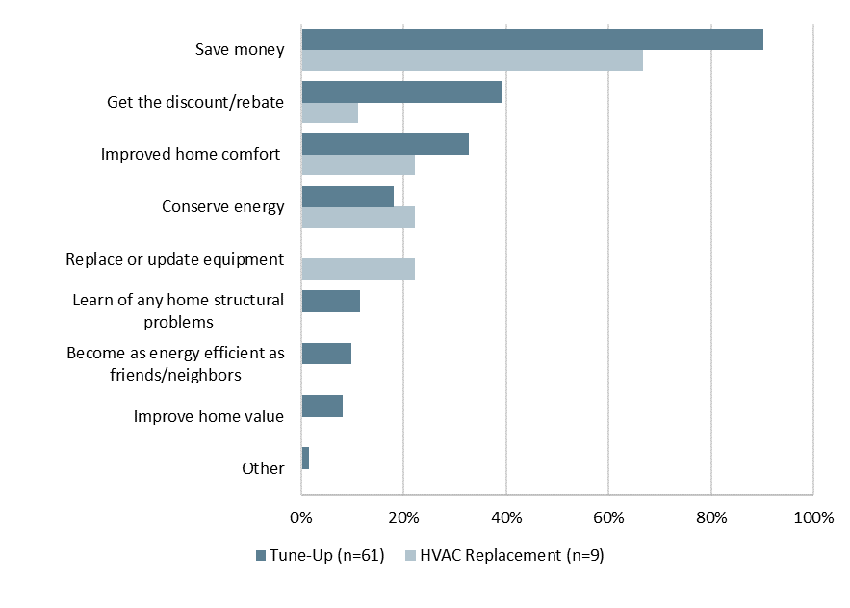

Figure 7‑9 RH&C Reasons for Participation

#### Participation Process

Overall, program participants were satisfied with the contractors that completed the tune-ups/duct sealing. As displayed in Figure 7‑10, most participants strongly agreed that the contractor was courteous and professional (95%), the work was scheduled in a reasonable amount of time (92%), and the time it took to complete the tune-up was reasonable (88%).

A small number indicated disagreement with these statements. Six percent of respondents were dissatisfied with the amount of time it took to complete the work, four percent were dissatisfied with the amount of time it took to schedule the work, and three percent were dissatisfied with the contractor’s professional courtesy.

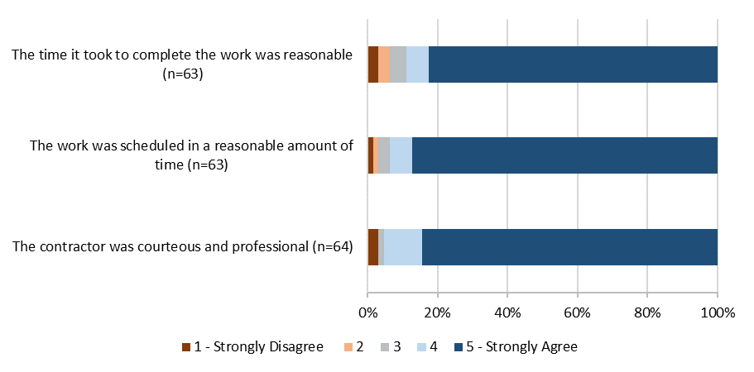

Figure 7‑10 RH&C Tune-Up/Duct Sealing Satisfaction with Contractor

Figure 7‑11 summarizes average ratings of agreement for each contractor on the aspects of contractor performance discussed above. Ratings are shown for the two contractors that completed 49 of the respondent projects and a group of six other contractors that completed the remaining 15 projects. As shown respondents provided lower average ratings of the contractors’ professionalism and the time to schedule and complete the work for the group of “other” contractors than for the contractors that completed most respondent projects. Moreover, the lower average rating of the reasonableness of the time required to complete the project was a statistically significant difference. Review of the average ratings for the six individual contractor firms comprising the group of other contractors found that ratings for four of the six contractors were generally lower than for Contractor 1 and Contractor 2, which indicates that the difference in rated performance is a function of multiple contractor firms rather than a single firm with particularly low ratings.

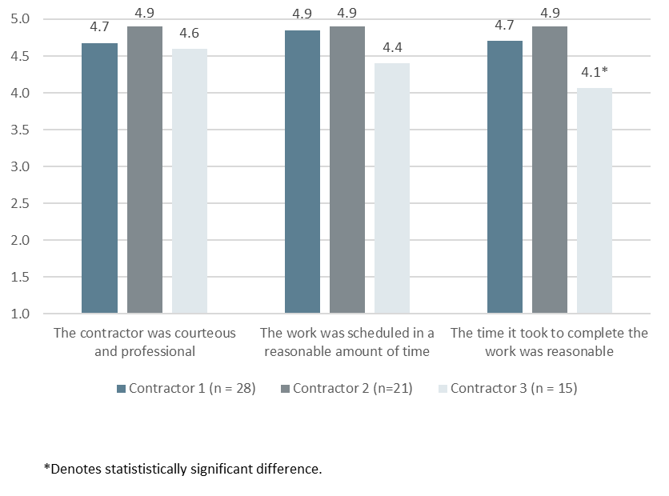

Figure 7‑11 RH&C Average Agreement Ratings for Contractors

All but two participants who completed tune-ups through the program stated that it was easy or very easy to find a contractor, with 94% stating that it was very easy.

Of the eleven participants that received HVAC replacement, 10 agreed or strongly agreed that the contractor was courteous and professional, and the work was scheduled in a reasonable amount of time. Nine agreed or strongly agreed that the time it took to complete the work was reasonable.

All but one participant who received an HVAC replacement stated that it was easy or very easy to find a contractor for the project. The other participant stated it was neither easy nor difficult.

#### Program Satisfaction

Participants rated various elements of the program on a scale of 1 to 5, where 1 represented “very dissatisfied” and 5 represented “very satisfied.”

As shown in Figure 7‑12, participants who completed tune-ups/duct sealing through the program rated each of the program elements and the program overall highly. Almost all program participants (97%) stated that they were either satisfied or very satisfied with the program overall. The majority of participants stated they were satisfied or very satisfied with the program participation process (97%), the energy efficiency improvements (92%), the quality of the work performed (92%), and the rebate or discount amount (95%).

The aspect of the program that the fewest participants indicated satisfaction with was the savings on their utility bill with 72% of participants stating they were satisfied or very satisfied with this aspect of the program.

Tune-up/duct sealing participants that scored any element as ‘neither satisfied or dissatisfied’ or less were asked to explain in their own words what the sources of their dissatisfaction was. Two participants were dissatisfied with the work performed by the contractor, and three participants were dissatisfied with their utility bill amount.

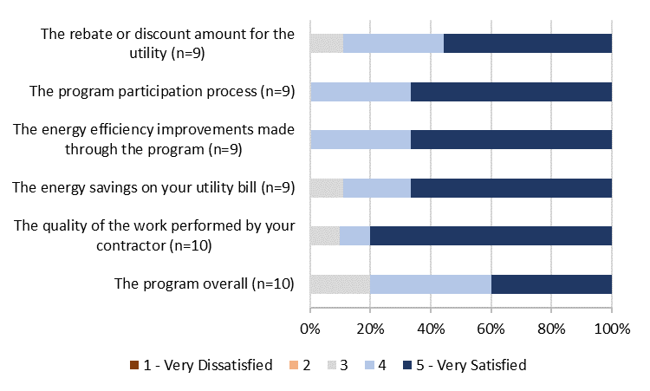

Figure 7‑12 Tune-Up Satisfaction with Program Components

Figure 7‑13 displays ratings of satisfaction with the quality of work performed by contractors completing HVAC tune-ups and duct sealing. As shown, the average rating for the group of “other” contractors was lower than the average ratings for the two contractors that completed most respondent projects. The lower average rating for these six contractors was a statistically significant difference. Review of the average ratings for each of these individual six contractor firms found that four of the contractors received lower average ratings than the two most active contractors, which indicates that this difference in rated performance is a function of multiple contractor firms rather than a single firm with particularly low ratings.

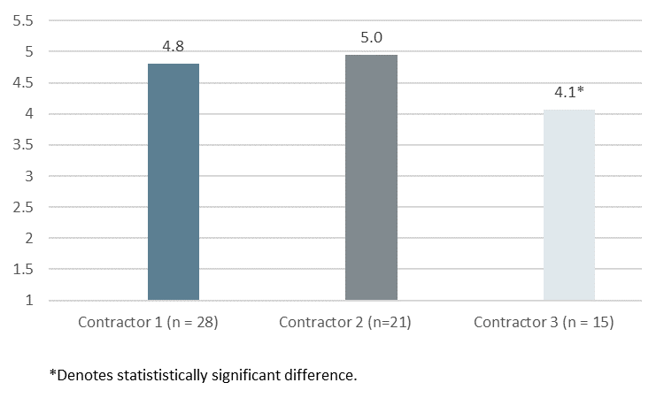

Figure 7‑13 RH&C Satisfaction with Quality of Work Performed by Contractors

All HVAC replacement recipients stated they were satisfied or very satisfied with the energy efficiency improvements and the participation process. Nine of ten stated they were satisfied or very satisfied with the quality of work performed, and the rebate or discount amount. Eight stated they were satisfied or very satisfied with the program overall.

Participants that experienced non-energy benefits because of the measures implemented through the program listed up to three benefits that they realized. As seen in Figure 7‑14, the most common benefit seen by both type of participant was an increase in home comfort. Both types of participant also noticed that it was easier to maintain a comfortable temperature. Tune-up recipients noted that the air conditioner or heater ran less often, and HVAC replacement recipients noticed environmental benefits, and a less drafty home.

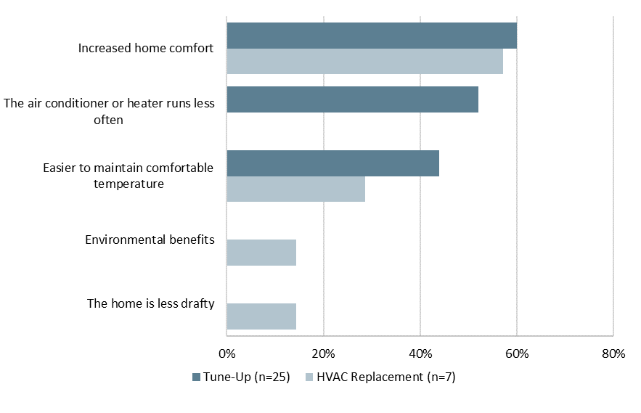

Figure 7‑14 RH&C Non-Energy Benefits

As displayed in Table 7‑22, the majority of participants were satisfied or very satisfied with Entergy. Two percent of tune-up participants reported dissatisfaction.

Table 7‑22 RH&C Overall Satisfaction with Entergy

|  |  |  |
| --- | --- | --- |
| ***Satisfaction with Entergy*** | ***Tune-Up***  ***(n=61)*** | ***HVAC Replacement (n=10)*** |
| 5 - Very satisfied | 36% | 40% |
| 4 | 39% | 40% |
| 3 - Neither satisfied nor dissatisfied | 23% | 20% |
| 2 | 0% | 0% |
| 1 - Very dissatisfied | 2% | 0% |

The two types of program participants had different opinions on how the program influenced their satisfaction with Entergy. The majority of participants who received HVAC replacements (90%) saw an increase in their satisfaction with Entergy, and ten percent saw no change. Participants who received tune-ups saw a smaller increase in satisfaction. The majority (64%) of respondents’ opinions of Entergy were increased at least somewhat by the program. An additional 32% stated that their satisfaction did not change, and three percent of respondents stated that participation in the program had decreased their satisfaction with Entergy.

Table 7‑23 RH&C Effect of Program on Satisfaction with Entergy

|  |  |  |
| --- | --- | --- |
| ***Effect of Program on Satisfaction with Entergy*** | ***Tune-Up***  ***(n=62)*** | ***HVAC Replacement (n=10)*** |
| Greatly increased your satisfaction with ENO | 6% | 10% |
| Somewhat increased your satisfaction with ENO | 58% | 80% |
| Did not affect your satisfaction with ENO | 32% | 10% |
| Somewhat decreased your satisfaction with ENO | 3% | 0% |
| Greatly decreased your satisfaction with ENO | 0% | 0% |

Overall, participants are generally satisfied with the program and ENO as their electrical service provider.

### Conclusions

* **The AC Tune-up component faced similar realization rate issues as in PY5.**  In PY5, the Evaluators conducted a billing analysis that yielded realization rates of 43% and 24% for ENO and Algiers (respectively) for AC tune-ups. Program implementation staff did not adjust their savings calculation methodology in response to this, and as a result the tune-ups have a low realization rate in PY6 as well (39% and 29% for ENO and Algiers, respectively).
* **Quality control improved for the AC replacement component of the program.** In PY5, the Evaluators identified non-qualified systems that had been rebated through the program, resulting in 43.8% gross realization for ENO. This issue was improved upon, and this measure channel had realization of 83% in PY6.

### Recommendations

The Evaluators’ recommendations for the Residential Heating & Cooling Program are as follows:

* **Discuss barriers contractors may face in completing multiple measure projects and develop approaches to mitigate any barriers present.**  A large number of contractors are completing single measure projects. Staff should discuss with these contractors any barriers they face in completing multi-measure projects and consider approaches to mitigate these barriers such as additional training to address knowledge gaps and potential payoffs in terms of increased business for contractors that need to purchase the required diagnostic equipment.
* **Investigate differences in performance between contractors.** The Evaluators found a statistically significant difference in survey respondents’’ assessment as to the promptness of the completion of their tune up or duct sealing between contractors. ENO should investigate this performance issue with the lower-rated contractor and identify areas to redress this.

# Energy Smart School Kits & Education

## Program Description

The Energy Smart School Kits and Education (SK&E) Program provides classroom education on energy use and saving energy, energy efficiency kits to students, and adult outreach activities to promote energy efficiency and the rebates and discounts offered by Entergy through the Energy Smart Programs.

The School Kits component of the program includes a 45 to 90-minute presentation given by program staff to 5th, 6th, or 7th grade students. The presentation focuses on energy use the importance of conservation. Students also receive an energy efficiency kit that contains the following items:

* Either,
  + six compact fluorescent light bulbs (CFLs) – four 13W and two 18W (during 2016), or
  + six compact fluorescent light bulbs (CFLs) – four 13W and two 18W and two 9W LEDs (during 2017);
* One LED nightlight;
* Two low-flow faucet aerators;
* One low-flow showerhead;
* A flow-rate bag for measuring the flow rate of faucets and showers; and
* A flyer included in the kit that describes the kit items and their benefits.

The adult outreach activities are intended to educate the Companies’ customers about energy efficiency and the Entergy Energy Smart efficiency programs. The outreach activities include:

* Presentations at neighborhood groups and churches;
* Attendance at fairs and festivals; and
* Hosting tables at public events and public buildings.

The adult outreach component also provides energy efficiency retrofits to nonprofits. The primary goal of the retrofits is to inform the membership of energy saving opportunities by demonstrating the benefits of efficient technologies.

A total of 3,527 kits were distributed through the program during Program Year 6. Below, Table 1‑1 summarizes the total number of measures distributed through the program and overall expected savings[35]:

Table 8‑1 SK&E Summary of Measures and Expected Savings

|  |  |
| --- | --- |
| ***Measure*** | ***Total Quantity of Measures*** |
| 13 W CFL Bulb | 14,108 |
| 18 W CFL Bulb | 7,054 |
| Bathroom Aerator | 3,527 |
| Kitchen Aerator | 3,527 |
| Showerhead | 3,527 |
| Nightlight | 3,527 |
| 9W LED Bulb | 4,420 |

Total verified savings and percentage of goals for the SK&E Program are summarized in Table 8‑2.

Table 8‑2 SK&E Savings Goals by Utility

|  |  |  |  |  |  |  |
| --- | --- | --- | --- | --- | --- | --- |
| ***Utility*** | ***kWh goal*** | ***Realized Net kWh*** | ***Percentage of kWh goal realized*** | ***kW goal*** | ***Realized kW*** | ***Percentage of kW goal realized*** |
| ENO | 487,273 | 555,312 | 114.0% | 57.6 | 80.11 | 139.1% |
| Algiers | 79,844 | 83,252 | 104.3% | 9.53 | 11.63 | 122.1% |

## Impact Calculation Methodology

Electricity savings and peak demand reductions of the PY6 SK&E Program were estimated using the engineering calculations described in the Arkansas TRM 6.0 (AR TRM). Measure inputs came from the AR TRM, The Pennsylvania TRM (PA TRM), EISA lumen table, groundwater data specific to the New Orleans area, and from a lighting hours of use metering study completed by the evaluator in the New Orleans area.

Table 8‑3 summarizes the source of the inputs used for the verification of measure-level savings under the SK&E.

The evaluator used data collected by the implementation contractor on in-service rates and the prevalence of electric water heating. This data was collected through forms submitted by students. In total, the implementation collected this data from 1,512 students. The Evaluator chose to utilize this data over the data it collected through an email survey because of the low response rate to the email survey (the survey was completed by 10 parents or guardians.

Table 8‑3 SK&E Savings Inputs

|  |  |  |
| --- | --- | --- |
| ***Measure*** | ***Input*** | ***Source*** |
| CFLs/LEDs | Baseline wattages | EISA lumen equivalence table |
| Annual operating hours | New Orleans lighting hours metering study |
| Energy factor, demand factor, CF | AR TRM 6.0, Section 2.5.1.1 |
| Space heating type | Participant survey administered by evaluator |
| Faucet Aerators, Low Flow Showerheads | Percent with electric water heating | Participant survey administered by program implementation contractor. |
| Groundwater and mixed water temperatures | Calculated based on New Orleans groundwater temperatures |
| Gallons of water saved per year | AR TRM 6.0, Section 2.3.4 (aerators), & Section 2.3.5 (shower heads) |
| LEDs nightlights | Delta watts, annual operating hours | PA TRM 5.0, Section 2.1.4 |
| Energy factor, demand factor, CF | AR TRM 6.0, Section 2.5.1 |
| All | In-Service Rates | Participant survey administered by program implementation contractor. |

### CFL/LED Bulb Savings Calculations

Each kit distributed included four 13 watt CFLs and two 18 watts CFLs. After January 1st, 2017, each kit included two 9W LEDs.

#### Energy Savings Calculation

Per unit energy savings for CFLs were calculated as follows:

Where:

*Watts Base* = Assumed wattage of baseline equipment based on lumen range of the lamp and the EISA baseline standard.

*Watts Post* = Actual watts of the installed CFL/LED.

*ISR* = In Service Rate. The percentage of CFLs distributed that are installed.

*Hours of Use* = Average hours of use per year, 819.43[36]

*IEFE* = Interactive Effects Factor to account for cooling energy savings and heating energy penalties.

Peak demand impacts were calculated via the following formula:

Where:

*CF* = Summer Peak Coincidence Factor, 12.72%36

*IEFD*= Interactive Effects Factor to account for cooling energy savings and heating energy penalties.

Table 8‑4 SK&E Savings Parameters for CFL/LEDs

|  |  |
| --- | --- |
| ***Parameter*** | ***Deemed Value*** |
| Watts Base | EISA baseline – dependent on luminous output of installed lamp |
| Watts Post | Rated wattage of newly-installed lamp |
| ISR | 9W LED – 68%  13W CFL – 60%  18W CFL – 62% |
| Hours | 819.43 |
| IEFe | Dependent on space heating/cooling type |
| CF | 10% |
| IEFd | Dependent on space heating/cooling type |

### LED Nightlight Savings Calculations

Each kit distributed included one LED nightlight.

#### Energy Savings Calculation

Per unit energy savings for LED nightlight is calculated as follows:

Where:

*Watts Base* = Assumed wattage of baseline equipment.

*Watts Post* = Assumed wattage of installed equipment.

*ISR* = In Service Rate. The percentage of LED Nightlights distributed that are installed.

*Hours of Use* = Average hours of use per year.

*IEFE* = Interactive Effects Factor to account for cooling energy savings and heating energy penalties.

There are no peak demand reductions for LED nightlights.

Table 8‑5 SK&E Savings Parameters for Nightlights

|  |  |
| --- | --- |
| ***Parameter*** | ***Deemed Value*** |
| Watts Base | 7W |
| Watts Post | 1W |
| ISR | 86% |
| Hours | 4,380 |
| IEFe | Dependent on space heating/cooling type |

### Faucet Aerator Savings Calculations

Each kit distributed included one 1.5 gpm kitchen faucet aerator and one 1.5 gpm bathroom faucet aerator.

#### Energy Savings Calculation

Per unit energy savings for faucet aerators is calculated as follows:

Where,

𝜌 = Water density

𝐶𝑃= Specific heat of water

𝑉= gallons of water saved per year per faucet

𝑇𝑀𝑖𝑥𝑒𝑑 = Mixed water temperature

𝑇𝑆𝑢𝑝𝑝𝑙𝑦 = Average supply water temperature

𝑅𝐸 = Recovery Efficiency

*Conversion Factor* = Btu/kWh conversion factor.

*ISR* = In Service Rate. The percentage of distributed aerators that are installed.

*%Elec* = Percent of participants with electric water heating.

Peak demand impacts will be calculated via the following formula, adjusting peak demand impacts for the percentage of indoor and outdoor bulbs based on the survey results:

Where:

*Ratio Peak kW annual kWh* = Ratio of peak share to annual kWh use

Table 8‑6 SK&E Savings Parameters for Faucet Aerators

|  |  |
| --- | --- |
| ***Parameter*** | ***Deemed Value*** |
| 𝜌 | 8.33 lb/gal |
| 𝐶𝑃 | 1 BTU/lb·°F |
| V | 381 gallons saved per year, per faucet |
| 𝑇𝑀𝑖𝑥𝑒𝑑 | 106.5°F |
| 𝑇𝑆𝑢𝑝𝑝𝑙𝑦 | 74.80°F |
| RE | 0.98 for electric resistance water heaters and 0.79 for natural gas water heaters |
| Conversion factor | 3,412 Btu/kWh for electric water heating or 100,000 Btu/Therm for gas water heating |
| ISR | Bathroom – 34%, Kitchen – 41% |
| %Elec | 55% |
| Ratio Peak kW annual kWh | 0.000104 |

### Low Flow Showerhead Savings Calculations

#### Energy Savings Calculation

Per unit energy savings for low flow showerheads are calculated as follows:

Where;

𝜌 = Water density

𝐶𝑃= Specific heat of water

𝑉= gallons of water saved per year, per showerhead

𝑇𝑀𝑖𝑥𝑒𝑑 = Mixed water temperature

𝑇𝑆𝑢𝑝𝑝𝑙𝑦 = Average supply water temperature

𝑅𝐸 = Recovery Efficiency

*ISR =* In Service Rate. The percentage of distributed aerators that are installed.

*% Elec =* Percent of participants with electric water heating.

*Conversion Factor* = 3,412 Btu/kWh for electric water heating or 100,000 Btu/Therm for gas water heating

Peak demand impacts will be calculated via the following formula, adjusting peak demand impacts for the percentage of indoor and outdoor bulbs based on the survey results:

Where:

*Ratio Peak kW annual kWh* = Ratio of peak share to annual use (0.000104).

Table 8‑7 SK&E Savings Parameters for Low Flow Showerheads

|  |  |
| --- | --- |
| ***Parameter*** | ***Deemed Value*** |
| 𝜌 | 8.33 lb/gal |
| CP | 1 BTU/lb·°F |
| V | 3,246 gallons saved per year per showerhead |
| 𝑇𝑀𝑖𝑥𝑒𝑑 | 106.5°F |
| 𝑇𝑆𝑢𝑝𝑝𝑙𝑦 | 74.80°F |
| RE | 0.98 for electric resistance water heaters and 0.79 for natural gas water heaters |
| ISR | 58% |
| %Elec | 55% |
| Conversion factor | 3,412 Btu/kWh for electric water heating or 100,000 Btu/Therm for gas water heating |
| Ratio Peak kW annual kWh | 0.000104 |

## Verified Savings by Measure

After reviewing the tracking data and inputs for savings calculations, the Evaluators provided verified gross savings which applied in-service rates developed through surveying of program participants. Savings were verified for the following measures:

* CFL Bulbs;
* LED Bulbs;
* Faucet Aerators;
* Low Flow Showerheads;
* LED Nightlights.

### Savings Findings

The Evaluators verified measure-level savings according to TRM guidelines.

Table 8‑8 and Table 8‑9 present the energy savings (kWh) and peak demand reductions (kW) results of the evaluation of the PY6 SK&E Program, by utility by measure. The total expected savings for the program equaled 567,117 kWh. Verified savings totaled 790,023 kWh and the overall kWh realization rate for the program was 139.3%.

Table 8‑8 SK&E Verified Savings by Measure Type – New Orleans

| ***Measure*** | ***Count*** | ***Expected kWh Savings*** | ***Verified kWh Savings*** | ***kWh Realization Rate*** | ***Expected Peak kW Savings*** | ***Verified Peak kW Savings*** | ***Peak kW Realization Rate*** |
| --- | --- | --- | --- | --- | --- | --- | --- |
| 13 W CFL | 12,160 |  | 168,766 |  |  | 35.53 |  |
| 18 W CFL | 6,080 |  | 101,729 |  |  | 21.42 |  |
| Bathroom Aerator | 3,040 |  | 17,104 |  |  | 1.78 |  |
| Kitchen Aerator | 3,040 |  | 21,129 |  |  | 2.20 |  |
| Showerhead | 3,040 |  | 248,589 |  |  | 25.85 |  |
| Nightlight | 3,040 |  | 64,649 |  |  | 0.00 |  |
| 9W LED Bulb | 3,722 |  | 66,350 |  |  | 13.97 |  |
| **Total** | **34,122** | **487,273** | **688,317** | **141.3%** | **57.60** | **100.75** | **174.9%** |

Table 8‑9 SK&E Verified Savings by Measure Type - Algiers

| ***Measure*** | ***Count*** | ***Ex Ante kWh Savings*** | ***Ex Post kWh Savings*** | ***kWh Realization Rate*** | ***Ex Ante Peak kW Savings*** | ***Ex Post Peak kW Savings*** | ***Peak kW Realization Rate*** |
| --- | --- | --- | --- | --- | --- | --- | --- |
| 13 W CFL | 1,948 |  | 27,036 |  |  | 5.69 |  |
| 18 W CFL | 974 |  | 16,297 |  |  | 3.43 |  |
| Bathroom Aerator | 487 |  | 2,740 |  |  | 0.28 |  |
| Kitchen Aerator | 487 |  | 3,385 |  |  | 0.35 |  |
| Showerhead | 487 |  | 39,823 |  |  | 4.14 |  |
| Nightlight | 487 |  | 10,357 |  |  | 0.00 |  |
| 9W LED Bulb | 698 |  | 2,068 |  |  | 0.44 |  |
| **Total** | **5,568** | **79,844** | **101,705** | **127.4%** | **9.53** | **14.34** | **150.4%** |

A key explanatory factor for the high realization rate was that expected savings for 2017 did not include savings from the four CFLs distributed with the kits after January 1st, 2017. The implementation contractor did not include these savings because under the ENERGY STAR Lamp Specification Version 2.0, the distributed CFLs were no longer ENERGY STAR certified.

The Evaluator counted the CFL savings because under a provision of the AR TRM, a grace period is allowed when codes or standards change before that change impacts the estimation of measure energy savings.[37]

## Estimation of Net Savings

Participant survey responses were used to estimate the net energy impacts of the program. The program net savings are equal to gross savings, less savings associated with free ridership, plus participant spillover savings. Because of a low survey response rate in 2016, results from both the 2015 and 2016 evaluations were used to calculate free ridership for 2016.

In total, 43 program participants completed the survey for the 2015 and 2016 evaluations. Respondents were asked questions related to the impact of the program on the installation of each measure that they installed.

### Estimation of Free Ridership

The objective of the free ridership analysis is to estimate the share of program activity would have occurred in the absence of the program. To accomplish this, the Evaluators administered a survey to program participants that contained questions regarding the participants’ plans to implement the kit items and the likelihood of implementing those measures had they not been provided through the program. Program participants were asked questions regarding:

* Whether or not they had plans to purchase and install the kit item;
* When would they have implemented the kit item in the absence of the program;
* The likelihood of purchasing and installing the kit item had they not received it for free.

Participant responses to these questions were used to calculate two scores corresponding to the presence of prior plans and the likelihood of installing the items in the absence of the program.

#### Prior Plans Score

The prior plans score was calculated as follows:

* Respondents who indicated that they did not have plans to install the kit item were scored as 0.
* Respondents who indicated that they did have plans to install the kit item were scored as 1. This score was adjusted based on the quantity of the number of items the participant planned to install and the timing of that planned installation. The quantity adjustment was based on the share of items sent that the respondent planned to install. That is, if the respondent indicated that they would have installed three of the six CFLs, the score of 1 was multiplied by .5. The timing adjustment was based on when they would have likely installed the items. For respondents that said they would have likely installed the items in the next six months, no timing adjustment was made. Respondents who indicated that they would have installed the item in the next 6 – 12 months, the plans score was multiplied by .5. For those that would have installed in more than 12 months, the plans score was set to 0.

#### Likelihood of Project Completion Score

The score reflecting the likelihood of completing the project in the absence of the program was based on the following question:

* How likely or unlikely would you have been to purchase and install the kit items if you had not received them for free?

A score was assigned to each response for this question as follows:

* Very likely: 1
* Somewhat likely: .75
* Neither particularly likely or unlikely: .5
* Somewhat unlikely: .25
* Very unlikely: 0

#### Final Free Ridership Score

The final free ridership score is equal to the following:

*Free Ridership = Average (Plans Score, Likelihood Score) * Previous experience adjustment*

The previous experience adjustment was based on a question about if the respondent had similar items currently installed in the home. The free ridership score for those that answered “No” to this question was multiplied by .5.

### Estimation of Net Savings

Free ridership for the program was estimated by applying measure level free ridership to verified gross kWh savings and peak kW reductions. As seen in Table 8‑10, the overall Net-to-Gross ratio for this program was 81%.

Table 8‑10 SK&E Summary of Verified Net Savings

|  |  |  |  |  |  |
| --- | --- | --- | --- | --- | --- |
| ***Utility*** | ***Expected kWh Savings*** | ***Verified Gross kWh Savings*** | ***Free Ridership*** | ***Verified Net kWh Savings*** | ***Net to Gross Ratio*** |
| ENO | 487,273 | 688,317 | 133,005 | 555,312 | 81% |
| Algiers | 79,844 | 101,705 | 18,453 | 83,252 | 82% |
| **Total** | **567,117** | **790,023** | **151,458** | **638,564** | **81%** |

Table 8‑11 SK&E Summary of Verified Net Peak Demand Reductions

|  |  |  |  |  |  |
| --- | --- | --- | --- | --- | --- |
| ***Utility*** | ***Expected Peak kW Reductions*** | ***Verified Gross Peak kW Reductions*** | ***Free Ridership*** | ***Verified Net Peak kW Reductions*** | ***Net to Gross Ratio*** |
| ENO | 57.60 | 100.75 | 20.63 | 80.11 | 80% |
| Algiers | 9.53 | 14.34 | 2.70 | 11.63 | 81% |
| **Total** | **67.13** | **115.08** | **23.34** | **91.75** | **80%** |

#### Measure Level Free Ridership Results

Table 8‑12 summarizes the average free ridership scores by measure. The results presented show higher free ridership for the lighting measures, and was highest for LEDs. This indicates that a higher percentage of participants are more familiar with energy efficient lighting measures.

Table 8‑12 SK&E Average Free Ridership by Measure

|  |  |  |
| --- | --- | --- |
| ***Measure*** | ***Number of Responses*** | ***Average Free Ridership*** |
| CFL 13 W | 38 | 22% |
| CFL 18 W | 38 | 22% |
| Bathroom Aerator 1.5 gpm | 32 | 13% |
| Kitchen Aerator 1.5 gpm | 32 | 13% |
| Showerhead | 26 | 11% |
| Nightlight | 38 | 28% |
| 9W LED | 6 | 33% |

## Process Findings

This chapter presents the results of the process evaluation of the Energy Wise Alliance School Kits and Education Program (SK&E) Program, which is comprised of two components: a school kits program that provides energy efficiency kits and education to students and outreach activities intended to inform the Companies’ customers about the Energy Smart programs and how they can be used to help them manage their electricity costs. The process evaluation focuses on aspects of program policies and organization, as well as the program delivery framework.

The process chapter begins with an overview of data collection activities followed by presentation of detailed program findings. This discussion is followed by a summary of findings and recommendations for program improvement.

### Data Collection Activities

The process of evaluation of the SK&E Program included the following data collection activities:

* *ENO Program Staff* *Interviews*. The Evaluators interviewed staff at ENO involved in the administration of the Energy Smart Programs. The interview focused on higher-level issues related to the administration of the portfolio of programs and included discussion of the process of setting energy saving goals, communications processes, implementation contractor management, the utilities role in marketing the programs, and quality control processes.
* *Parent or Guardian Survey*. The Evaluators surveyed a sample of parents or guardians that received efficiency kits and provided their contact information to program staff members. The survey addressed issues including participant satisfaction with the program offerings, demographics, and other reasons for not installing kit items.

Table 8‑15 summarizes data collection activities for the SK&E Program process evaluation.

Table 8‑13 SK&E Data Collection Activities

|  |  |
| --- | --- |
| ***Activity*** | ***n*** |
| Entergy staff interviews | 1 |
| Parent/guardian survey | 10 |

### Detailed Findings

The Evaluators reviewed the activity tracked in the document and summarized it below.

#### School Kits Participation

Table 8‑16 summarizes participation in the Energy Smart School Kits and Education Program by utility. During PY6, the program distributed a total of 3,527 kits to students at 42 schools. The number of kits distributed during PY6 was slightly less than the 3,683 kits distributed in PY5.

Kits distributed in the ENO service territory made up 86% of total expected program savings with 3,040 kits distributed. Algiers accounted for 14% of program activity with 487 kits distributed.

Table 8‑14 SK&E Program Activity by Utility

|  |  |  |  |
| --- | --- | --- | --- |
| ***Utility*** | ***Expected Savings (kWh)*** | ***Share of Expected Savings*** | ***Number of Kits Distributed*** |
| ENO | 487,273 | 86% | 3,040 |
| Algiers | 79,844 | 14% | 487 |

Figure 8‑1 displays monthly and cumulative expected savings for the program. The evaluation team utilized the program tracking data variable labeled “Submitted Date” to assess program activity by program month. The data shows that the program distributed relatively few kits in the early months of the program; activity decreased during the summer months and picked back up again in the fall. The trend in program activity is to be expected considering it correlates with the end and beginning of the school year.

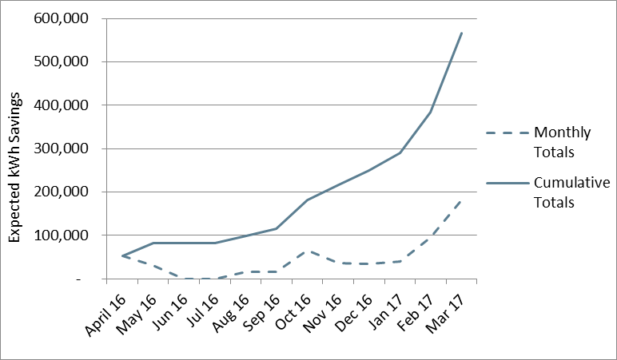

Figure 8‑1 SK&E Monthly and Cumulative Expected Savings

#### Program Design, Operations and Activities

The program design and operations was discussed in detail in PY5. In January 2017, staff added two LED lightbulbs to the kit content and no longer counted savings from the CFLs in their ex ante saving estimates. These changes were made because under the new ENERGY STAR lamp guidelines, the CFLs no longer met the ENERGY STAR requirements.

#### Parent/Guardian Survey Results

The Evaluator administered an online survey to parents or guardians of students that received an efficiency kit through the SK&E Program. The Evaluator received a list of 246 contact email addresses, however, 77 of the email addresses were incomplete, missing or bounced when the survey invitation was sent. Thus, the effective population consisted of 169 email addresses. These customers were contacted up to three times to complete the survey. In total, 10 responded to the survey and the overall response rate was 5.9%.

Table 8‑18 and Table 8‑19 present demographic characteristics and participant home characteristics for PY5 and PY6. It is important to note that differences between PY5 and PY6 may be a function of sampling error due to the small number of PY6 survey responses, differences between the results found this year and for PY5 may be a result of sampling error and are not discussed here.

Overall, survey respondents tended to own their homes, have approximately four household members, and the modal income bracket was between $25,000 and $50,000 (Table 8‑18).

Table 8‑15 SK&E Participant Demographics

|  |  |  |
| --- | --- | --- |
| ***Demographic Characteristic*** | ***PY5***  ***(n = 55)*** | ***PY6***  ***(n = 10)*** |
| Average number of home residents | 4.2 | 3.9 |
| Percent with income of:1 |  |  |
| Less than $25,000 per year | 13% | 30% |
| $25,000 to less than $50,000 | 44% | 40% |
| $50,000 to less than $75,000 | 6% | 0% |
| $75,000 or more | 19% | 20% |
| Percent own home | 66% | 80% |
| 1. Total does not equal 100% because some respondents did not know their income or declined to state it. | | | |

Table 8‑19 displays the respondent household characteristics. Fifty percent of participants resided in an older (pre-1990) single family home and 60% reported that they had electric space heating.

Table 8‑16 SK&E Participant Home Characteristics

|  |  |  |
| --- | --- | --- |
| ***Residence Characteristic*** | ***PY5***  ***(n = 55)*** | ***PY6***  ***(n = 10)*** |
| Percent Single Family Home | 88% | 90% |
| Percent electric space heating | 56% | 50% |
| Percent electric water heating | 34% | 60% |
| Percent of households built before 1990 | 66% | 50% |
| Percent with home size of:1 |  |  |
| Less than 1,000 ft.2 | 9% | 10% |
| 1,001-1,500 ft.2 | 16% | 10% |
| 1,501-2,000 ft.2 | 19% | 40% |
| Greater than 2,000 ft.2 | 41% | 40% |
| 1. Total does not equal 100% because some respondents did not know the size of their home or declined to state it. | | |

#### Kit Usage

Six respondents reported that they had not installed all of the CFLs included in the kit. The reasons for this were that they were waiting for bulbs to burn out (67%) or the bulbs would not fit their fixtures (33%).

Table 8‑17 SK&E Barriers to Installing CFLs

|  |  |
| --- | --- |
| ***Installation Barrier*** | ***Percent of Respondents***  ***(n = 6)*** |
| Waiting until currently installed light bulbs burn out | 67% |
| The CFLs don’t fit in the fixtures where they would have been installed | 33% |

Four respondents reported that they did not install the faucet When asked why some of the aerators were not installed, the reasons give where that that the aerators did not fit the faucet or the water supply pressure was too low.

Table 8‑18 SK&E Barriers to Installing Faucet Aerators

|  |  |
| --- | --- |
| ***Installation Barrier*** | ***Percent of Respondents***  ***(n = 4)*** |
| They did not fit the faucet | 50% |
| The water supply pressure is too low | 25% |
| Don't recall | 25% |

Four respondents did not install the shower head because they already had low flow shower heads installed, the water supply pressure was too low, they dislike them, or for another reason.

Table 8‑19 SK&E Barriers to Installing Shower Heads

|  |  |
| --- | --- |
| ***Installation Barrier*** | ***Percent of Respondents***  ***(n = 4)*** |
| You already have low-flow showerheads installed | 25% |
| The water supply pressure is too low | 25% |
| You dislike low-flow showerheads | 25% |
| Other | 25% |

All respondents reported that the LED nightlight was installed.

Respondents were asked which of the kit items they found to be most useful. The most popular items were the CFL bulbs; 50% of respondents stated these were the most useful items. Responses are summarized in the table below.

Figure 8‑2 Which Kit Item was Most Useful

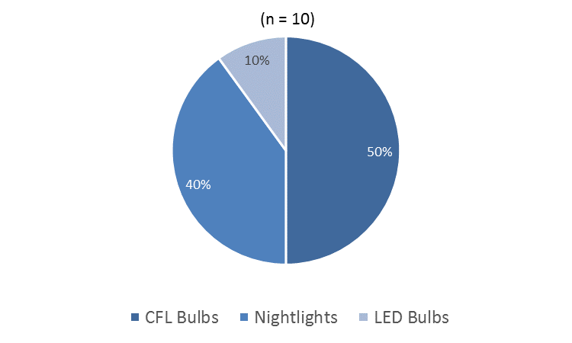

None of the respondents reported that one or more of the kit items was broken when they received them.

#### Program Satisfaction

Survey respondents were asked to rate their level of satisfaction with the energy efficiency education provided through the program and the items included in the kits. The results are summarized below in Figure 8‑2. Ninety-four percent of respondents reported that they were satisfied with each of these aspects of the program. Respondents were largely satisfied with the kit items and the education provided through program. One of the respondents who indicated dissatisfaction doubted the usefulness of the program.

Figure 8‑3 Satisfaction with the Energy Education and Kits Contents

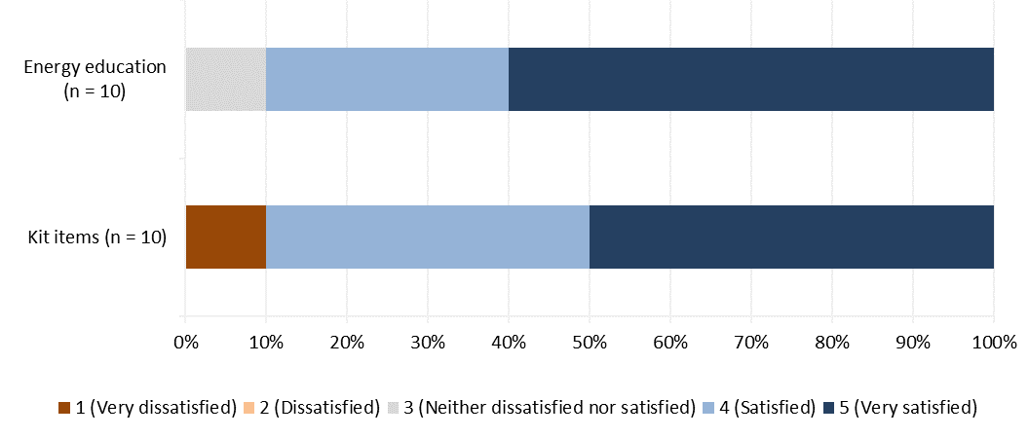

#### Satisfaction with Entergy

Respondents were also asked about their satisfaction with the Companies as their electrical services provider and how their participation in the program has changed their satisfaction with Entergy. Responses are summarized in the table below.

Table 8‑20 SK&E Satisfaction with Entergy

|  |  |
| --- | --- |
| ***Satisfaction with Entergy*** | ***Percent of Respondents***  ***(n = 10)*** |
| 5 - Very satisfied | 60% |
| 4 | 40% |
| 3 - Neither satisfied nor dissatisfied | 0% |
| 2 | 0% |
| 1 - Very dissatisfied | 0% |

When asked how the program has influenced their satisfaction with Entergy as a utility, most (80%) responded positively, saying that their participation in the program has somewhat or greatly increased their satisfaction with Entergy. Responses are summarized in the table below.

Table 8‑21 SK&E Effect of Program on Satisfaction with Entergy

|  |  |
| --- | --- |
| ***Effect of Program on Satisfaction with Entergy*** | ***Percent of Respondents (n = 10)*** |
| Greatly increased your satisfaction with ENO | 30% |
| Somewhat increased your satisfaction with ENO | 50% |
| Did not affect your satisfaction with ENO | 20% |
| Somewhat decreased your satisfaction with ENO | 0% |
| Greatly decreased your satisfaction with ENO | 0% |

#### Cross-Program Awareness

Ten percent of respondents reported awareness of the other Energy Smart efficiency programs.

### Conclusions

The Evaluators’ conclusions are summarized below:

* Program staff modified the kit contents in 2017 in response to changes in ENERGY STAR lamp qualification requirements under version 2.0. Two LED lamps were added to the kit contents. The kits continued to include the six CFLs although the implementation contractor stopped counting savings from these measures. The non-ENERGY STAR qualified CFLs will not be included in future program years.
* Although a limited number of parents or guardians responded to the survey, nearly all that did respond were satisfied with the kits contents and the education provided through the program.

### Recommendations

The Evaluators’ recommendation for the SK&E Program is as follows:

* **Consider collecting data on space heating type through student forms.** Collection of this data from a larger sample of participants than has been achieved through the evaluator survey will improve the estimation of heating and cooling interactive factors in the calculation of evaluated program impacts.
* **Include “Act Now” messaging as it pertains to installation of CFLs or LEDs.** Two thirds of respondents that did not install the CFLs stated that they are waiting for the old bulbs to burn out before installing. Program messaging should discuss the lost savings associated with waiting to discourage this behavior.

# Small Business Solutions

## Program Description

The ENO and Algiers Small Business Solutions Program (SBS) offers enhanced incentives to small business owners to help overcome the first-cost barrier unique to the small business market which interferes with small business adoption of energy efficiency measures. By offering enhanced financial incentives, the program generates significant cost-effective energy savings for small businesses using added market-segmented strategies that encourage the adoption of diverse efficiency measures in target sub-sectors.

The Program is designed to provide small business owners with energy efficiency information and develop awareness of energy/non-energy benefits of energy efficiency. The information helps small business customers invest in energy efficient technologies and help overcome high “first costs.” It is intended to increase the awareness of the latest energy efficient technologies available to ENO and Algiers small business customers. Through the SBS Program, a network of contractors was developed that work with small business customers. The Program provides the tools and training for contractors to quantify the energy savings and incentives for small business customers.

The Program offers technical assistance effective in removing market barriers for small business customers. This includes providing free walk through facility assessments to educate the business owner on the value of energy efficiency. Incentives are offered for energy efficiency measures utilizing a streamlined approach for enrollment, installation, and savings verification. The Program develops and maintains a network of contractors to provide additional outreach and customer participation. PY6 is the first year to include commercial duct sealing and AC tune-ups in claimed savings.

Table 9‑1 Savings Expectations by Program Component ENO

|  |  |  |  |
| --- | --- | --- | --- |
| ***Program Component*** | ***Count of Projects*** | ***Expected kWh Savings*** | ***Expected kW Savings*** |
| Lighting | 138 | 2,896,751 | 245.82 |
| Duct Sealing | 9 | 29,683 | 21.03 |
| AC Tune-Ups | 6 | 6,564 | 2.67 |
| **Total** | **153** | **2,932,998** | **269.52** |

Table 9‑2 Savings Expectations by Program Component Algiers

|  |  |  |  |
| --- | --- | --- | --- |
| ***Program Component*** | ***Count of Projects*** | ***Expected kWh Savings*** | ***Expected kW Savings*** |
| Lighting | 2 | 196,447 | 0.00 |
| Duct Sealing | 1 | 17,409 | 13.11 |
| AC Tune-Ups | 0 | 5,429 | 2.02 |
| **Total** | **3** | **219,285** | **15.13** |

Total verified savings and percentage of goals for the SBS Program are summarized in Table 9‑3.

Table 9‑3 SBS Savings Goals by Utility

|  |  |  |  |  |  |  |
| --- | --- | --- | --- | --- | --- | --- |
| ***Utility*** | ***kWh goal*** | ***Realized Net kWh*** | ***Percentage of kWh goal realized*** | ***kW goal*** | ***Realized Net kW*** | ***Percentage of kW goal realized*** |
| Algiers | 340,000 | 244,485 | 71.9% | 100 | 10.25 | 10.3% |
| ENO | 3,692,000 | 3,374,304 | 91.4% | 900 | 290.91 | 32.3% |

## M&V Methodology

### Lighting and Controls

Evaluation of the SBS Program Lighting and Controls component requires the following:

* Stratified Random Sampling of lighting and controls projects, selecting large saving sites with certainty (as detailed in Section 2.2.1.3);
* Review of deemed savings parameters for prescriptive projects;
* On-site verification;
* On-site metering
* Interviewing of program participants and trade allies.

The main features of the approach used for the impact evaluation are as follows:

* Data for the study have been collected through review of program materials, on-site inspections, and end-use metering. Based on data provided by CLEAResult, sample designs were developed for on-site data collection for the impact evaluation. Sample sizes were determined that provide savings estimates for the program with ±10% precision at the 90% confidence level. Actual sampling precision was 8.47% at 90% confidence.
* On-site visits were used to collect data for savings impacts calculations. The on-site visits were used to verify installations and to determine any changes to the operating parameters since the measures were first installed. Facility staff were interviewed to determine the operating hours of the installed system and to locate any additional benefits or shortcomings with the installed system. Finally, lighting loggers were left on site to record at least two weeks’ worth of data from the newly-installed lighting. This data was later extrapolated to annual operating hours.
* Commercial duct sealing and air conditioner tune-up savings were calculated using the methods describes in the AR TRM 6.0, Section 3.1.11 and Section 3.1.7, respectively, with EFLHc adapted to the New Orleans weather zone using TMY3 weather data. A census of each was evaluated.

Parameters required for evaluation of the SBS program are presented in Table 9‑4below.

Table 9‑4 Data Sources for Gross Impact Parameters – SBS program

|  |  |
| --- | --- |
| ***Parameter*** | ***Source*** |
| Project Details | Program Tracking Data |
| Energy Efficient Equipment Specifications | Manufacturer’s Literature |
| Lighting Hours of Operation | Deemed hours from secondary research, assignment of new values based upon facility operating hours should deemed values not provide accurate estimates NOAA data-based non-daylight hours. |
| HVAC Interactive Factors | Simulations of archetypical buildings using local weather data |
| Lighting Peak Coincident Factor | Review of deemed values, assignment of new values based upon facility operating hours should deemed values not provide accurate estimates |
| Duct Savings EFLHc, HDD and CF | AR TRM 6.0, Section 3.1.11 adapted to the New Orleans weather zone using TMY3 weather data |

#### Lighting and Controls Savings Calculations

Using values from the table above, the Evaluators calculated annual kWh savings as follows:

*Parameters for kWh Savings Calculation of Lighting Retrofit Measures*

|  |  |
| --- | --- |
| kWbase | Total Baseline fixtures x W/Fixturebase / 1000 W/kW |
| kWpost | Total Installed fixtures x W/Fixturepost / 1000 W/kW |
| AOHbase | Annual Operating Hours of Baseline Fixtures |
| AOHpost | Annual Operating Hours of Installed Fixtures |
| IEFE | Heating/Cooling Energy Interactive Effects Factor |
| PAF | Power Adjusted Control Factor |

Following this, the Evaluators calculated peak kW savings. This is based upon Louisiana defined peak hours during summer weekdays. Peak kW savings are calculated as:

*Parameters for Peak Demand (kW) Savings Calculation of Lighting Retrofit Measures*

|  |  |
| --- | --- |
| kWbase | Total Baseline fixtures x W/Fixturebase / 1000 W/kW |
| kWpost | Total Installed fixtures x W/Fixturepost / 1000 W/kW |
| CF | Peak Demand Coincident Factor, % Time During the Peak Period in Which Lighting is Operating |
| IEFD | Heating/Cooling Demand Interactive Effects Factor |

### Commercial Duct Sealing

Evaluation of duct sealing measures was completed using methods described the AR TRM 6.0 section 3.1.11 and EFLHc hours developed using TMY3 weather data for the New Orleans area. Table 9‑5 below shows EFLHc hours by building type for New Orleans:

Table 9‑5 Commercial EFLHc

|  |  |  |  |  |  |  |  |  |  |  |
| --- | --- | --- | --- | --- | --- | --- | --- | --- | --- | --- |
| **Facility Type** | **Fast Food** | **Grocery** | **Health Clinic** | **Large Office** | **Lodging** | **Full Menu Restaurant** | **Retail** | **School** | **Small Office** | **University** |
| EFLHc | 1,526 | 1,483 | 2,095 | 3,191 | 1,997 | 1,989 | 2,060 | 1,510 | 2,329 | 2,375 |

### Commercial AC Tune-Ups

Evaluation of air condition tune-up measures was completed using methods described the AR TRM 6.0 section 3.1.7 with EFHLc hours from Table 9‑5.

## Gross Impact Findings

Energy savings were estimated using proven techniques, including engineering calculations using industry standards to determine energy savings. Table 9‑6 summarizes the total participation in the PY6 Small Business Program.

Table 9‑6 PY6 Small Business Program Participation Summary

|  |  |  |  |
| --- | --- | --- | --- |
| ***Utility*** | ***# Projects*** | ***Expected kWh*** | ***Expected Peak kW*** |
| ENO | 153 | 2,932,998 | 269.52 |
| Algiers | 3 | 219,285 | 15.13 |
| **Total** | **156** | **3,152,284** | **284.65** |

Data provided by CLEAResult showed that during PY6, there were 153 and 3 projects for ENO and Algiers respectively, for a combined total of 156 projects. These projects were expected to provide a combined savings of 3,152,248 kWh and 284.65 kW.

#### Small Business - Lighting Measures Sample Design

Table 9‑7 Small Business Sample Summary

|  |  |  |  |
| --- | --- | --- | --- |
| ***Utility*** | ***# Sites in Population*** | ***Site Visit Sample Size*** | ***# Surveys*** |
| ENO | 153 | 17 | 15 |
| Algiers | 3 | 1 | 0 |
| **Total** | **156** | **18** | **15** |

Sampling for evaluation of ENO and Algiers’ SBS program was developed using the Stratified Random Sampling procedure detailed in Section 2.2.1.3). This procedure provides 90% confidence and +/- 10% precision with a significantly reduced sample than simple random sampling would require by selecting the highest saving facilities with certainty, thereby minimizing the variance that non-sampled sites can contribute to the overall results. Actual sampling precision was 8.47% at 90%. The population and sample include both utilities pooled however, savings in this report are presented for each utility as well as combined.

The Lighting participant population for the SBS was divided into five strata. Table 9‑8 summarizes the strata boundaries and sample frames for the SBS and Table 9‑9 summarizes expected savings for of both the sample and population.

Table 9‑8 Small Business Program Lighting Sample Design (Pooled)

|  |  |  |  |  |  |  |
| --- | --- | --- | --- | --- | --- | --- |
|  | ***Stratum 1*** | ***Stratum 2*** | ***Stratum3*** | ***Stratum 4*** | ***Stratum 5*** | ***Totals*** |
| Strata boundaries (kWh) | < 12,000 | 12,001 - 45,000 | 45,001 - 80,000 | 80,001 - 140,000 | <140,001 |  |
| Number of projects | 19 | 30 | 8 | 6 | 6 | 69 |
| Total kWh savings | 131,903 | 795,121 | 468,782 | 586,269 | 1,111,123 | 3,093,198 |
| Average kWh Savings | 6,942 | 26,504 | 58,598 | 97,712 | 185,187 | 8,977 |
| Standard deviation of kWh savings | 2,960 | 10,250 | 9,847 | 20,785 | 41,041 | 52,624 |
| Coefficient of variation | 0.41 | 0.37 | 0.16 | 0.19 | 0.21 | 8.10 |
| Final design sample | 4 | 4 | 2 | 3 | 5 | 18 |

Table 9‑9 SBS Expected Savings for Sampled and Non-Sampled Lighting Projects by Stratum

|  |  |  |
| --- | --- | --- |
| ***Stratum*** | ***Sample Expected Savings*** | ***Total Expected Savings*** |
| 1 | 27,870 | 131,903 |
| 2 | 128,867 | 795,121 |
| 3 | 125,974 | 468,782 |
| 4 | 288,023 | 586,269 |
| 5 | 968,678 | 1,111,123 |
| **Total** | **1,539,412** | **3,093,198** |

#### Small Business Lighting - Site-Level Realization

Sites chosen within each stratum were visited in order to verify installation of rebated measures and to collect data needed for calculation of ex post verified savings. The realization rates for sites within each stratum were then applied to the non-sampled sites within their respective stratum. Table 9‑10 presents realization at the stratum level, with Table 9‑11 presenting results at the site level.

Table 9‑10 SBS Summary of Lighting kWh Savings for Small Business Program by Sample Stratum (Pooled)

|  |  |  |  |
| --- | --- | --- | --- |
| ***Stratum*** | ***Sample Expected kWh Savings*** | ***Sample Realized kWh Savings*** | ***Realization Rate*** |
| 1 | 27,870 | 38,473 | 138.04% |
| 2 | 128,867 | 154,660 | 120.02% |
| 3 | 125,974 | 134,618 | 106.86% |
| 4 | 288,023 | 311,305 | 108.08% |
| 5 | 968,678 | 1,060,391 | 109.47% |

Table 9‑11 shows the expected and realized energy savings for the program by project.

Table 9‑11 SBS Expected and Realized Savings by Sampled Project

| ***Project ID(s)*** | ***Facility Type*** | ***Expected kWh Savings*** | ***Realized kWh Savings*** | ***Realization Rate*** |
| --- | --- | --- | --- | --- |
| PRJ-854410 | Retail | 5,218 | 12,139 | 232.64% |
| PRJ-1017239 | Restaurant | 5,865 | 5,483 | 93.49% |
| PRJ-787045 | Restaurant | 8,016 | 8,859 | 110.51% |
| PRJ-820455 | Restaurant | 8,771 | 11,992 | 136.72% |
| PRJ-787080 | Restaurant/Bar | 18,648 | 18,824 | 100.94% |
| PRJ-1029612 | Discount Grocery | 31,898 | 48,289 | 151.39% |
| PRJ-818611 | Advertising Billboard | 36,571 | 39,527 | 108.08% |
| PRJ-837114 | Discount Grocery | 41,750 | 48,019 | 115.02% |
| PRJ-843756 | Gas Station | 62,482 | 69,834 | 111.77% |
| PRJ-805977 | Grocery | 63,492 | 64,784 | 102.03% |
| PRJ-1308246 | Parking Lot | 84,715 | 91,563 | 108.08% |
| PRJ-1127711 | Parking Lot | 94,873 | 102,542 | 108.08% |
| PRJ-1308374 | Parking Lot | 108,435 | 117,200 | 108.08% |
| PRJ-786342 | Parking Garage | 152,579 | 169,532 | 111.11% |
| PRJ-1308333 | Parking Lot | 155,876 | 168,476 | 108.08% |
| PRJ-784549 | Retail | 196,447 | 196,447 | 100.00% |
| PRJ-785859 | Parking Garage | 222,305 | 247,006 | 111.11% |
| PRJ-786000 | Parking Garage | 241,471 | 278,931 | 115.51% |
| **Total** |  | **1,539,412** | **1,699,447** | **110.40%** |

#### Small Business Lighting - Component-Level Realization

The Evaluators extrapolated results from sampled sites to non-sampled sites in developing program-level savings estimates. Table 9‑12 presents results by stratum.

Table 9‑12 Small Business - Lighting Realization by Stratum

|  |  |  |  |  |  |  |  |
| --- | --- | --- | --- | --- | --- | --- | --- |
| ***Stratum*** | ***# Sites*** | ***Expected kWh Savings*** | ***Realized kWh Savings*** | ***kWh Realization Rate*** | ***Expected kW Savings*** | ***Realized kW Savings*** | ***kW Realization Rate*** |
| 1 | 19 | 131,903 | 182,084 | 138.04% | 33.14 | 42.64 | 128.67% |
| 2 | 30 | 795,121 | 954,265 | 120.02% | 88.78 | 104.67 | 117.90% |
| 3 | 8 | 468,782 | 500,949 | 106.86% | 45.72 | 47.82 | 104.59% |
| 4 | 6 | 586,269 | 633,659 | 108.08% | 0.00 | 0.00 | N/A |
| 5 | 6 | 1,111,123 | 1,216,323 | 109.47% | 78.18 | 79.51 | 101.71% |
| **Total** | **69** | **3,093,198** | **3,487,279** | **112.74%** | **245.82** | **274.64** | **111.72%** |

#### Small Business Lighting - Realization by Contractor

The Evaluator extrapolated results from the program into savings by project contractor trade ally. The results are presented below in Table 9‑13.

Table 9‑13 SBS Lighting Savings by Contractor

|  |  |  |  |  |  |  |
| --- | --- | --- | --- | --- | --- | --- |
| ***Contractor*** | ***Expected kWh*** | ***Realized kWh*** | ***kWh Realization Rate*** | ***Expected Peak kW*** | ***Realized Peak kW*** | ***Peak kW Realization Rate*** |
| Lighting Contractor 1 | 947,723 | 1,062,248 | 112.08% | 64.69 | 67.20 | 103.87% |
| Lighting Contractor 2 | 624,518 | 677,143 | 108.43% | 26.95 | 29.07 | 107.85% |
| Lighting Contractor 3 | 1,520,957 | 1,747,888 | 114.92% | 59.66 | 73.62 | 123.39% |
| **Total** | **3,093,198** | **3,487,279** | **112.74%** | **151.31** | **169.88** | **112.28%** |

#### Small Business Lighting – Causes of Savings Deviations

The Evaluators have summarized these adjustments and others in Table 9‑14 for illustrative purposes.

Table 9‑14 Small Business – Causes of Variance in Savings

| ***Project ID*** | ***Expected kWh*** | ***Realized kWh*** | ***Realization Rate*** | ***Causes of Variance in Savings*** |
| --- | --- | --- | --- | --- |
| PRJ-854410 | 5,218 | 12,139 | 232.64% | Retail. Logger data verified lamps operated 8,534 hours annually; ex ante calculation estimated 3,668 AOH. The hours logged matched hours reported through on-site interviews. |
| PRJ-1017239 | 5,865 | 5,483 | 93.49% | Restaurant. Logger data verified 3,346 AOH in the showroom. The Ex Ante estimates 3,668 AOH. |
| PRJ-787045 | 8,016 | 8,859 | 110.51% | Restaurant. Logger data verified 4,899 AOH; ex ante calculation estimated 4,368 AOH. Exterior hours changed from 3,996 to 4,319. |
| PRJ-820455 | 8,771 | 11,992 | 136.72% | Restaurant. Logger data verified between 4,646 and 4,667 AOH, depending on space type; ex ante calculation estimated 3,406 AOH. |
| PRJ-787080 | 18,648 | 18,824 | 100.94% | Restaurant/Bar. Logger data verified 8,760 AOH. CF increase from 0.81 to 1.00. The increase in CF is due to AOH increased from 6,188 to 8,760. |
| PRJ-1029612 | 31,898 | 48,289 | 151.39% | Discount Grocery. Logger data verified between 5,471 and 8,760 AOH, depending on space type; ex ante calculation estimated 3,668 AOH. |
| PRJ-818611 | 36,571 | 39,527 | 108.08% | Advertising Billboard. Exterior hours changed from 3,996 to 4,319. |
| PRJ-837114 | 41,750 | 48,019 | 115.02% | Discount Grocery. Several of the base wattages in ex ante calculations did not comply with EISA baselines. Logger data verified higher operating hours. Exterior hours changed from 3,996 to 4,319. |
| PRJ-843756 | 62,482 | 69,834 | 111.77% | Gas Station. Logger data verified 8,760 AOH; ex ante calculations estimated 6,900 AOH. Exterior hours changed from 3,996 to 4,319. Some fixtures were not verified on site. |
| PRJ-805977 | 63,492 | 64,784 | 102.03% | Grocery. Logger data verified between 4,494 and 4,809 AOH, depending on space type; ex ante calculation estimated 4,706 AOH. |
| PRJ-1308246 | 84,715 | 91,563 | 108.08% | Parking Lot. Exterior hours changed from 3,996 to 4,319. |
| PRJ-1127711 | 94,873 | 102,542 | 108.08% | Parking Lot. Exterior hours changed from 3,996 to 4,319. |
| PRJ-1308374 | 108,435 | 117,200 | 108.08% | Parking Lot. Exterior hours changed from 3,996 to 4,319. |
| PRJ-786342 | 152,579 | 169,532 | 111.11% | Parking Garage. Logger data verified between 8,760 AOH; ex ante calculation estimated 7,884 AOH. |
| PRJ-1308333 | 155,876 | 168,476 | 108.08% | Parking Lot. The kWh savings is high because operating hours used in ex ante savings did not take into account daylight hours in this region; hours were updated from 3,996 to 4,319 to better reflect use. This resulted in an 8.1% increase in savings. The kW savings are not applicable because the lights are outdoors and do not operate during peak hours. |
| PRJ-784549 | 196,447 | 196,447 | 100.00% | Retail. Exterior hours changed from 3,996 to 4,319. Some fixtures were not verified on site. |
| PRJ-785859 | 222,305 | 247,006 | 111.11% | Parking Garage. Logger data verified between 8,760 AOH; ex ante calculation estimated 7,884 AOH. |
| PRJ-786000 | 241,471 | 278,931 | 115.51% | Parking Garage. Logger data verified between 2,340 and 8,760 AOH, depending on space type; ex ante calculation estimated 7,884 AOH for all space types. Office space CF increased from 1.00 to 0.77 |

#### Small Business - Duct Sealing Realized Savings

The results of the commercial duct sealing program component are summarized in Table 9‑15 below.

Table 9‑15 SBS Duct Sealing Realized Savings

|  |  |  |  |  |  |  |
| --- | --- | --- | --- | --- | --- | --- |
| ***Utility*** | ***Expected kWh Savings*** | ***Verified kWh Savings*** | ***kWh Realization Rate*** | ***Expected Peak kW Savings*** | ***Verified Peak kW Savings*** | ***Peak kW Realization Rate*** |
| ENO | 29,683 | 77,770 | 262.00% | 21.03 | 14.26 | 67.83% |
| Algiers | 17,409 | 43,334 | 248.91% | 13.11 | 8.82 | 67.23% |
| **Total** | **47,093** | **121,104** | **257.16%** | **34.14** | **23.08** | **67.60%** |

Not all input variables to ex ante calculations were made available to the Evaluators, preventing discussion of specific causes of the 257.16% kWh and 67.60% realization rates. In ex post calculations, the Evaluators used EFLHc, HDD and CF values developed from the AR TRM 6.0 using New Orleans TMY3 weather data. Savings differences are likely due to ex ante calculations using data from weather zones other than New Orleans whose EFLHc hours are lower, but the peak CF is higher.

#### Small Business - HVAC Tune-Up Realized Savings

The results of the commercial duct sealing program component are summarized in Table 9‑16 below.

Table 9‑16 SBS Tune-Ups Realized Savings

|  |  |  |  |  |  |  |
| --- | --- | --- | --- | --- | --- | --- |
| ***Utility*** | ***Expected kWh Savings*** | ***Verified kWh Savings*** | ***kWh Realization Rate*** | ***Expected Peak kW Savings*** | ***Verified Peak kW Savings*** | ***Peak kW Realization Rate*** |
| ENO | 6,564 | 5,702 | 86.86% | 2.67 | 2.01 | 75.31% |
| Algiers | 5,429 | 4,704 | 86.64% | 2.02 | 1.43 | 71.00% |
| **Total** | **11,993** | **10,405** | **86.76%** | **4.69** | **3.45** | **73.46%** |

Not all input variables to ex ante calculations were made available to the Evaluators, preventing discussion of specific causes of the 86.76% kWh and 73.46% realization rates. In ex ante calculations, the Evaluators used EFLHc, HDD and CF values developed from the AR TRM 6.0 using New Orleans TMY3 weather data. Savings differences are likely due to ex ante calculations using data from weather zones other than New Orleans.

#### Small Business – Program-Level Realized Savings

Table 9‑17 SBS Program-Level Realized Savings - ENO

|  |  |  |  |  |  |  |
| --- | --- | --- | --- | --- | --- | --- |
| ***Program Component*** | ***Expected kWh Savings*** | ***Verified kWh Savings*** | ***kWh Realization Rate*** | ***Expected Peak kW Savings*** | ***Verified Peak kW Savings*** | ***Peak kW Realization Rate*** |
| Lighting | 2,896,751 | 3,290,832 | 113.60% | 245.82 | 274.64 | 111.72% |
| Duct Sealing | 29,683 | 77,770 | 262.00% | 21.03 | 14.26 | 67.83% |
| AC Tune-Ups | 6,564 | 5,702 | 86.86% | 2.67 | 2.01 | 75.31% |
| **Total** | **2,932,998** | **3,374,304** | **115.05%** | **269.52** | **290.91** | **107.94%** |

Table 9‑18 SBS Program-Level Realized Savings - Algiers

|  |  |  |  |  |  |  |
| --- | --- | --- | --- | --- | --- | --- |
| ***Program Component*** | ***Expected kWh Savings*** | ***Verified kWh Savings*** | ***kWh Realization Rate*** | ***Expected Peak kW Savings*** | ***Verified Peak kW Savings*** | ***Peak kW Realization Rate*** |
| Lighting | 196,447 | 196,447 | 100.00% | 0.00 | 0.00 | N/A |
| Duct Sealing | 17,409 | 43,334 | 248.91% | 13.11 | 8.82 | 67.23% |
| AC Tune-Ups | 5,429 | 4,704 | 86.64% | 2.02 | 1.43 | 71.00% |
| **Total** | **219,285** | **244,485** | **111.49%** | **15.13** | **10.25** | **67.73%** |

Key issues identified in site-level analyses include:

* **Incorrect non-daylight hours**. Ex ante calculations involving ‘Outdoor’ lighting used the Arkansas TRM-deemed 3,996 as an annual hours of operation input. The Evaluators used New Orleans annual sunrise and sunset times, downloaded from the National Oceanic and Atmospheric Administration (NOAA), to calculate latitude-specific 4,319 non-daylight hours which were used as annual operating hours for dusk-to-dawn lighting
* **Facility type assignment for nonconforming business types.** Other significant corrections occurred when the program staff was required to make a judgement call in assigning a facility type from the list of Arkansas TRM facilities. The Evaluators made numerous corrections on projects of this type.
* **Incomplete retrofits**. At some sites the Evaluators found partially incomplete retrofits. Savings cannot be attributed to lamps/fixtures which have not been retrofitted.
* **Use of weather-sensitive inputs for areas other than New Orleans.** During review of the Duct Sealing and AC Tune-up program components, the Evaluators were unable to determine the values of weather-sensitive inputs which had been used to calculate ex ante savings. The magnitude of difference in savings figures suggests that ex ante inputs were not appropriate for the New Orleans climate.

## Net Impact Findings

Participant survey responses were used to estimate the net energy impacts of the program. The program net savings are equal to gross savings, less savings associated with free ridership, plus participant spillover savings.

In total, 15 program participants completed the survey.

### Estimating Free Ridership

Several criteria were used for determining what portion of a customer’s savings for a particular project should be attributed to free ridership. The first criterion was based on the response to the question: “Would you have been financially able to install energy efficient [Measure/Equipment] at the location without the financial incentive from the Program?” Customers that answer “No” to this question are then asked to rate how certain they are that their organization could not have afforded the measure. If a customer indicated that their organization could not have afforded the measure and indicates that they were very certain of this, the customer was not deemed a free rider.

For decision makers that indicated that they were able to undertake energy efficiency projects without financial assistance from the program, three factors were analyzed to determine what percentage of savings may be attributed to free ridership. The three factors were:

* Plans and intentions of firm to install a measure even without support from the program;
* Influence that the program had on the decision to install a measure; and
* A firm’s previous experience with a measure installed under the program.

For each of these factors, rules were applied to develop binary variables indicating whether or not a participant’s behavior showed free ridership.

The first factor requires determining if a participant stated that his or her intention was to install an energy efficiency measure even without the program. The answers to a combination of several questions were used with a set of rules to determine whether a participant’s behavior indicates likely free ridership. Two binary variables were constructed to account for customer plans and intentions: one, based on a more restrictive set of criteria that may describe a high likelihood of free ridership, and a second, based on a less restrictive set of criteria that may describe a relatively lower likelihood of free ridership.

The first, more restrictive criteria indicating customer plans and intentions that likely signify free ridership are as follows (Definition 1):

* The respondent answers “yes” to the following two questions: “Did you have plans to install energy efficient [Measure/Equipment] at the location before participating in the program?” and “Would you have gone ahead with this planned installation even if you had not participated in the program?”
* The respondent answers “definitely would have installed” to the following question: “If the financial incentive from the program had not been available, how likely is it that you would have installed energy efficient [Measure/Equipment] at the location anyway?”
* The respondent answers “no, program did not affect timing of purchase and installation” to the following question: “Did you purchase and install energy efficient [Measure/Equipment] earlier than you otherwise would have without the program?”
* The respondent answers “no, program did not affect level of efficiency chosen for equipment” in response to the following question: “Did you choose equipment that was more energy efficient than you would have chosen had you not participated in the program?”

The second, less restrictive criteria indicating customer plans and intentions that likely signify free ridership are as follows (Definition 2):

* The respondent answers “yes” to the following two questions: “Did you have plans to install energy efficient [Measure/Equipment] at the location before participating in the program?” and “Would you have gone ahead with this planned installation even if you had not participated in the program?”
* Either the respondent answers “definitely would have installed” or “probably would have installed” to the following question: “If the financial incentive from the program not been available, how likely is it that you would have installed energy efficient [Measure/Equipment] at the location anyway?”
* Either the respondent answers “no, program did not affect timing of purchase and installation” to the following question: “Did you purchase and install energy efficient [Measure/Equipment] earlier than you otherwise would have without the program?” or the respondent indicates that while program information and financial incentives did affect the timing of equipment purchase and installation, in the absence of the program they would have purchased and installed the equipment within the next two years.
* The respondent answers “no, program did not affect level of efficiency chosen for equipment” in response to the following question: “Did you choose equipment that was more energy efficient than you would have chosen had you not participated in the program?”

The second factor requires determining if a customer reported that a recommendation from a program representative or past experience with the program was influential in the decision to install a particular piece of equipment or measure.

The criterion indicating that program influence may signify a lower likelihood of free ridership is that either of the following conditions is true:

* The respondent answers “very important” to the following question: “How important was previous experience with the program in making your decision to install energy efficient [Measure/Equipment] at the location?”
* The respondent answers “probably would not have” or “definitely would not have” to the following question: “If the program representative that provided the energy assessment of your facility had not recommended [Measure/Equipment], how likely is it that you would have installed it anyway?”

The third factor requires determining if a participant in the program indicates that he or she had previously installed an energy efficiency measure similar to one that they installed under the program without an energy efficiency program incentive during the last three years. A participant indicating that he or she had installed a similar measure is considered to have a likelihood of free ridership.

The criteria indicating that previous experience may signify a higher likelihood of free ridership are as follows:

* The respondent answers “yes” to the following question: “Before participating in the Program, had you installed any equipment or measure similar to energy efficient [Measure/Equipment] at the location?”
* The respondent answers “yes” to the following question: “Has your organization purchased any significant energy efficient equipment in the last three years at the location?” and answered “yes” to the question: “Did you install any of that equipment without applying for a financial incentive through an energy efficiency program?”

The four sets of rules described above were used to construct four different indicator variables that address free ridership behavior. For each customer, a free ridership value was assigned based on the combination of variables. With the four indicator variables, there are 11 applicable combinations for assigning free ridership scores for each respondent, depending on the combination of answers to the questions creating the indicator variables. Table 9‑19 shows these values.

*Table 9‑19 Free Ridership Scores for Combinations of Indicator Variable Responses*

| ***Indicator Variables*** | | | | ***Free Ridership Score*** |
| --- | --- | --- | --- | --- |
| ***Had Plans and Intentions to Install Measure without Program? (Definition 1)*** | ***Had Plans and Intentions to Install Measure without Program? (Definition 2)*** | ***Program had influence on Decision to Install Measure?*** | ***Had Previous Experience with Measure?*** |
| Y | N/A | Y | Y | 100% |
| Y | N/A | N | N | 100% |
| Y | N/A | N | Y | 100% |
| Y | N/A | Y | N | 67% |
| N | Y | N | Y | 67% |
| N | N | N | Y | 33% |
| N | Y | N | N | 33% |
| N | Y | Y | N | 0% |
| N | N | N | N | 0% |
| N | N | Y | N | 0% |
| N | N | Y | Y | 0% |

### Estimating Spillover

Program participants may implement additional energy saving measures without receiving a program incentive because of their participation in the program. The energy savings resulting from these additional measures constitute program participant spillover effects.

To assess participant spillover savings, survey respondents were asked whether or not they implemented any additional energy saving measures for which they did not receive a program incentive. Respondents that indicated that they did install additional measures were asked two questions to assess whether or not the savings are attributable to the program. Specifically, respondents were asked:

* “How important was your experience with the <PROGRAM> in your decision to implement this Measure, using a scale of 0 to 10, where 0 is not at all important and 10 is extremely important?”
* “If you had not participated in the <PROGRAM>, how likely is it that your organization would still have implemented this measure, using a 0 to 10 scale, where 0 means you definitely WOULD NOT have implemented this measure and 10 means you definitely WOULD have implemented this measure?”

The energy savings associated with the measure are considered attributable to the program if the average of the rating for the first question, and 10 – the rating for the second question, is greater than seven, the savings are counted as attributable to the program.

None of the survey respondents indicated that they had implemented additional measures that met the criterion for attributing the savings to the program.

### Net Savings Results

Table 9‑20 summarizes the results of the free ridership scoring. Free ridership for the program was estimated by weighting each participant’s response by the associated verified gross kWh savings or peak kW reductions for the measure. Free ridership was low for the program because most participants indicated that they could not have implemented the measures without the program’s financial assistance (24%) or that they did not have prior plans to implement the measures (76%). These reasons for the lack of program free ridership are consistent with the theory underlying the SBS program – small businesses face financial and informational barriers that program incentives and the network of program contractors seek to mitigate.

Table 9‑20 Free-Ridership Scoring Results

|  |  |  |  |  |  |
| --- | --- | --- | --- | --- | --- |
| ***Had Plans and Intentions to Install Measure without C&I Program? (Definition 1)*** | ***Had Plans and Intentions to Install Measure without C&I Program? (Definition 2)*** | ***C&I Program had influence on Decision to Install Measure?*** | ***Had Previous Experience with Measure?*** | ***Percentage of Total Ex Post Gross kWh Savings*** | ***Free Ridership Score*** |
| N | N | N | N | 40% | 0% |
| N | N | Y | N | 16% | 0% |
| N | N | Y | Y | 20% | 0% |
| Required program to implement measures. | | | | 24% | 0% |
| Total | | | | 100% | 0% |

Table 9‑21 and Table 9‑22 summarize the verified net kWh savings and peak kW demand reduction 100% of gross program savings. Net kW reductions totaled 301.16 kW and equaled 100% of verified gross program savings.

Table 9‑21 Summary of Net Ex Post kWh Savings

|  |  |  |  |  |  |  |
| --- | --- | --- | --- | --- | --- | --- |
| ***Utility*** | ***Expected kWh Savings*** | ***Verified Gross kWh Savings*** | ***Free Ridership*** | ***Spillover*** | ***Verified Net kWh Savings*** | ***Net to Gross Ratio*** |
| ENO | 2,932,998 | 3,374,304 | 0 | 0 | 3,374,304 | 100% |
| Algiers | 219,285 | 244,485 | 0 | 0 | 244,485 | 100% |
| Total | 3,152,284 | 3,618,789 | 0 | 0 | 3,618,789 | 100% |

Table 9‑22 Summary of Ex Post Net Peak kW Reductions

|  |  |  |  |  |  |  |
| --- | --- | --- | --- | --- | --- | --- |
| ***Utility*** | ***Expected Peak kW Reductions*** | ***Verified Gross Peak kW Reductions*** | ***Free Ridership*** | ***Spillover*** | ***Verified Net kW Savings*** | ***Net to Gross Ratio*** |
| ENO | 269.52 | 290.91 | 0.00 | 0.00 | 290.91 | 100% |
| Algiers | 15.13 | 10.25 | 0.00 | 0.00 | 10.25 | 100% |
| Total | 284.65 | 301.16 | 0.00 | 0.00 | 301.16 | 100% |

## Process Findings

This chapter presents the results of the process evaluation of the Small Business Program. The process evaluation focuses on aspects of program policies and organization, as well as the program delivery framework.

### Data Collection Activities

The limited process of evaluation of the SBS included the following data collection activities:

Table 9‑23 Small Business Program Process Evaluation – Summary of Data Collection

|  |  |
| --- | --- |
| ***Activity*** | ***Sample Size*** |
|
| The Companies Staff | 1 |
| Participant Survey | 15 |

### Program Overview

The Small Business Program provides energy education to trade allies and customers, and financial incentives to customers, to encourage small businesses to implement energy efficiency projects that reduce their facilities electricity consumption. The program utilizes a network of participating trade allies to assist customers in identifying energy saving opportunities and to promote the incentives available.

Financial incentives are based on expected savings for the measure implemented. Incentives are $0.12 per kWh saved and may cover up to 100% of the project cost. Incentives are paid directly to the trade ally implementing the project to reduce or eliminate the initial cost of the equipment to the customer. Incentives are capped at $25,000.

Energy savings are calculated based on procedures outlined in the Arkansas Technical Resource Manual.

The primary measures offered through the program are the efficient lighting and refrigeration equipment listed below:

* Linear fluorescent lamp and ballast replacement;
* High-intensity discharge (HID) fixture replacement;
* Compact fluorescent lamps (CFLs);
* Interior and exterior light emitting diodes (LEDs);
* Solid and glass door reach in units;
* Electronically commutated motors (ECM) for evaporator fans;
* Door heater controls; and
* Vending misers.

Small business customers may also elect to install additional measures offered through the Large Commercial and Industrial Solutions Program and receive incentives of $0.16 per kWh saved for that equipment.

To mitigate barriers to small business participation, such as lack of program awareness and energy saving opportunities, the program relies upon a network of participating trade allies to perform direct customer outreach. The program provides trade allies with training and software used to perform on-site assessments and estimate energy savings associated with measures.

Any non-residential ENO customer with maximum peak demand of less than 100 kW is eligible for the program.

### Detailed Findings

#### Analysis of Participation Data

Table 9‑24 summarizes the Small Business Solutions Program activity by measure type. As shown, lighting comprised 98% of total expected savings during PY6. HVAC tune-ups and duct sealing each accounted for 1%, or less, of program savings. In PY5, lighting comprised 86% of program savings, the other 14% of savings resulted from refrigeration and hot water measures, neither of which were installed in PY6.

Table 9‑24 Program Savings and Cost per kWh Saved by Measure Type

|  |  |  |  |
| --- | --- | --- | --- |
| ***Measure Type*** | ***Expected Savings (kWh)*** | ***Share of Program Savings*** | ***$ per kWh in Expected Savings*** |
| Lighting | 2,896,751 | 99% | $0.12 |
| HVAC Tune-Ups | 6,564 | <1% | $0.11 |
| Duct Sealing | 29,683 | 1% | $0.12 |

Figure 9‑1 provides a graphic representation of monthly and cumulative expected energy savings throughout PY6. The evaluation team based the following analysis on the date the project was completed and the participant submitted the program application, using the variables “Submitted Date,” “Date Created” and “Created On” in the program tracking data.

The beginning of the program year got off to a slow start. By December of 2016, expected energy savings from completed projects totaled approximately 1M kWh, just over 33% of total program savings. Approximately two-thirds of program activity occurred after January of 2017, when total expected energy savings steeply increased from approximately 1M kWh to 2.9M kWh by the end of April 2017.

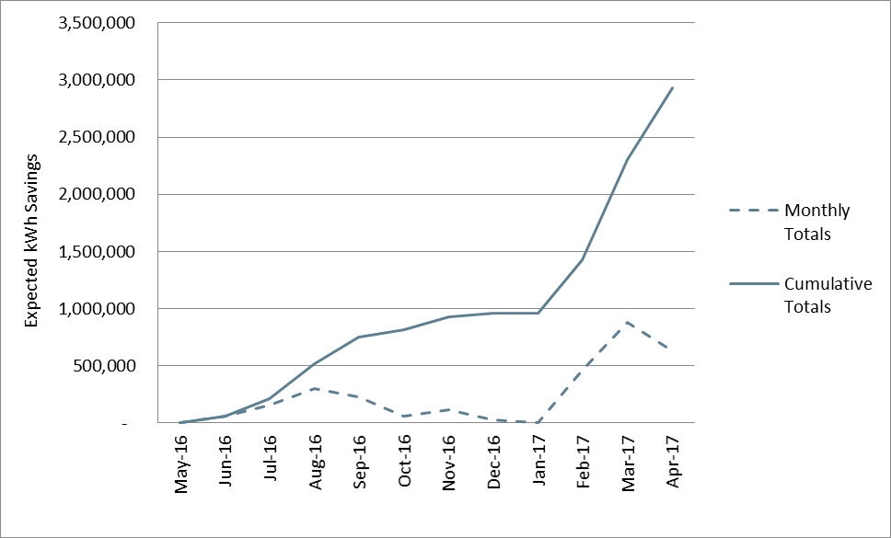

Figure 9‑1 SBS Accrual of Expected kWh Savings during PY6

As shown in Table 9‑25, 16 contractors completed projects through the Small Business Solutions Program during PY6. Four contractor firms accounted for more than 85% of total program expected savings. The quantity of expected kWh savings resulting from projects completed by each contractor was more evenly dispersed during PY6, as compared to PY5 when just one firm was responsible for more than half of expected kWh savings. During PY6, the majority of contractors implemented one measure type, lighting. Two contractors performed HVAC tune-ups in addition to installing duct sealing.

Table 9‑25 Share of Expected Energy Savings by Contractor

| ***Contractor*** | ***Lighting kWh*** | ***HVAC Tune Up kWh*** | ***Duct Sealing kWh*** | ***Total kWh*** | ***Share of Total Expected kWh Savings*** |
| --- | --- | --- | --- | --- | --- |
| Contractor 1 | 947,723 |  |  | 947,723 | 33% |
| Contractor 2 | 624,518 |  |  | 624,518 | 22% |
| Contractor 3 | 527,065 |  |  | 527,065 | 18 % |
| Contractor 4 | 345,995 |  |  | 345,995 | 12% |
| Contractor 5 | 144,333 |  |  | 144,333 | 5% |
| Contractor 6 | 126,071 |  |  | 126,071 | 4% |
| Contractor 7 | 38,613 |  |  | 38,613 | 1% |
| Contractor 8 | 27,776 |  |  | 27,776 | 1% |
| Contractor 9 | 26,436 |  |  | 26,436 | 1% |
| Contractor 10 |  |  | 26,143 | 26,143 | 1% |
| Contractor 11 | 10,557 |  |  | 10,557 | <1% |
| Contractor 12 | 5,218 |  |  | 5,218 | <1% |
| Contractor 13 |  | 2,468 | 2,238 | 4,706 | <1% |
| Contractor 14 |  | 889 | 1,302 | 2,191 | <1% |
| Contractor 15 |  | 2,102 |  | 2,102 | <1% |
| Contractor 16 |  | 1,105 |  | 1,105 | <1% |
| Unidentified Contractor | 72,446 |  |  |  | 2% |

#### Program Design, Operations, and Activities

The SBS program remained largely unchanged from PY5. Staff stated that the contractor network, the program marketing materials and outreach approaches, and incentives and requirements remained unchanged.

One change that was made was that a spiff was offered to contractors for efficiency projects. Staff stated that the effect of the spiff was limited.

On ongoing challenge that staff noted is the development of projects in the Entergy Algiers service territory. Staff noted that while that there is limited opportunity for Large CI projects, there is more opportunity for SBS projects.

#### Participant Survey Results

ADM contacted 42 program participants to complete a telephone survey about their experience with the SBS program. Up to five attempts were made to complete the survey with each contact. In total 15 participants in the SBS Program responded to the survey.

#### Firmographics

The facility types reported by survey respondents were typical of small business establishments. Twenty-seven percent of surveyed small businesses were retail facilities, followed by gas stations and multifamily facilities (13% each). Responses are summarized below in Figure 9‑2.

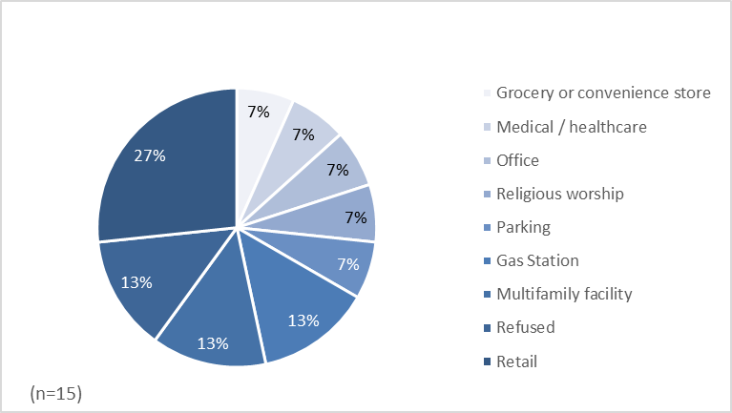

Figure 9‑2 SBS Survey Respondent Facility Type

Nearly one-half of surveyed customers (47%) reported that the location which participated in the program was their company’s only location (Figure 9‑3).

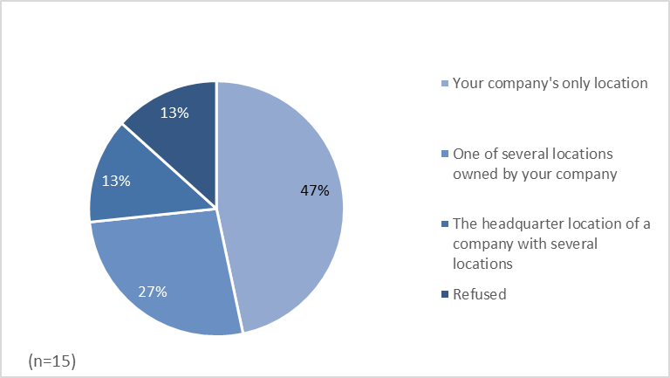

Figure 9‑3 SBS Respondents’ Number of Business Locations

Fifty-three percent of respondents reported owning and occupying their facilities. Twenty percent rent their facilities. All responses are summarized in the figure below.

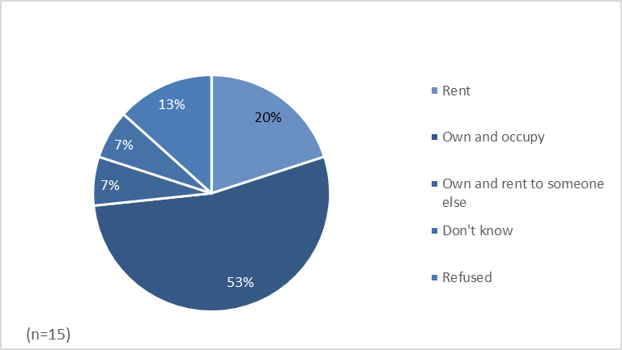

Figure 9‑4 SBS Ownership Status

Forty percent of respondents reporting having electric water heating and 47% reported having electric space heating.

Table 9‑26 Water and Space Heating Fuel Types

|  |  |  |
| --- | --- | --- |
| ***Fuel Type*** | ***Water Heating***  ***(n = 15)*** | ***Space Heating***  ***(n = 15)*** |
| Natural Gas | 20% | 27% |
| Electricity | 40% | 47% |
| Other | 20% | 0% |
| Don’t Know | 7% | 13% |
| Refused | 13% | 13% |

#### Source of Initial Awareness

Most respondents (87%) initially learned of the program from a program contractor that offered to perform an assessment of their business energy use. Two customers reported learning of the program from another source: one learned of the program from another contractor and one learned of the program on Entergy’s website.

These results are similar to those found for PY5, for which 97% of respondents reported learning of the program from the contractor that offered to perform the energy assessment.

#### Decision to Participate

Twenty-seven percent of survey respondents reported that they initially had concerns about participating when first approached about the program, which is nearly the same as in PY5. The initial concerns participants raised during PY6 were also consistent with those raised during PY5. When asked to identify their initial concerns, one customer said that they were concerned about the legitimacy of the program, one said that they were concerned about the quality of the insulation, one expressed concern about the return on investment of the project, and another said that they did not like the quote they received from their first two contractors. These respondents were also asked why they chose to participate in the program despite their concerns. The first said that they were motivated to participate by the desire for rebated LEDs and the quality of the customer service. The respondent who had had concerns about the quality of the insulation also said that talking to a program representative made them feel more comfortable in their decision to participate. The third respondent was motivated by the tax credits, and the final respondent said that they eventually received a quote that they found reasonable.

Forty percent of respondents said that they viewed program marketing materials when they were learning about the program. One third of the customers who saw these materials said that they were somewhat or very influential in their decision to participate in the program.

#### Experience with Contractor

Customers rated their satisfaction with various aspects of the service provided by the contractor they worked with on a scale of 1 to 5, where 1 represents “Very Dissatisfied” and 5 represents “Very Satisfied.” As was the case in PY5, most customers were satisfied with all aspects of their work with their contractor. One respondent was dissatisfied with the overall professionalism of the contractor and the proposal received. When asked to elaborate on why they were dissatisfied, this customer said that their contractor did not seem to be that knowledgeable and seemed to be adding to the cost of the project without explaining why. The satisfaction responses are summarized below in Figure 9‑5.

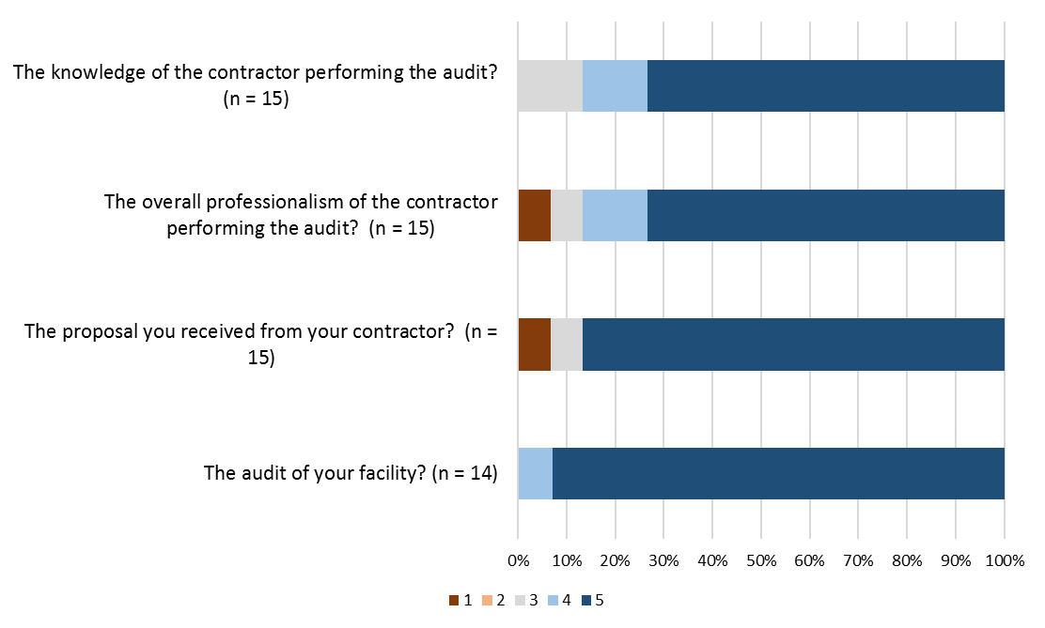

Figure 9‑5 SBS Satisfaction with Contractor

Participants were also asked to provide open-ended commentary regarding their audit experience. Most respondents provided positive feedback; all but one customer who provided commentary said that they had a positive experience with their contractors. Below is a sample of the comments representative of the positive feedback provided:

*“I found them to be very professional and engaging and [they] were able to answer all my questions.”*

*“They did a very good job and led the project. They managed the job very well and made sure equipment was put in properly.”*

*“They were very knowledgeable, they were able to convey the savings and benefits in layman’s terms.”*

#### Equipment Installation

Survey respondents were asked to rate their satisfaction with the range of energy saving equipment available and how well this range of equipment fit their needs. Ratings were provided on a scale of 1 to 5, where 1 represents “Not at all satisfied” and 5 represents “Completely satisfied.” Most respondents (87%) gave a satisfaction score of 4 or 5. Two respondents indicated some degree of satisfaction. When asked to elaborate on the ways in which the range of energy saving equipment offered did not meet their needs, one customer said that they have yet to see energy savings related to the equipment that they installed.

Two survey respondents reported that they had not installed all of the equipment recommended by their contractor. Both reported not installing all of the recommended interior lighting. When asked why they did not install these measures, one respondent cited financial reasons and the other said that they preferred to install new fixtures over the retrofit fixtures that were recommended.

#### Program Satisfaction

Survey respondents were asked to rate their satisfaction with various aspects of the program experience on a scale of 1 to 5, where 1 represents “Very Dissatisfied” and 5 represents “Very Satisfied.” Ninety-two percent for respondents were satisfied or very satisfied with the program overall, and one participant was dissatisfied with it. All customers reported that they were satisfied with the quality of the installation and non-were dissatisfied with range of the equipment that qualifies for the program or the installed equipment. One customer was dissatisfied with the time between when the audit was completed and when the equipment was installed. Overall, these responses are consistent with PY5 participant satisfaction results

Survey responses are summarized below in Figure 9‑6.

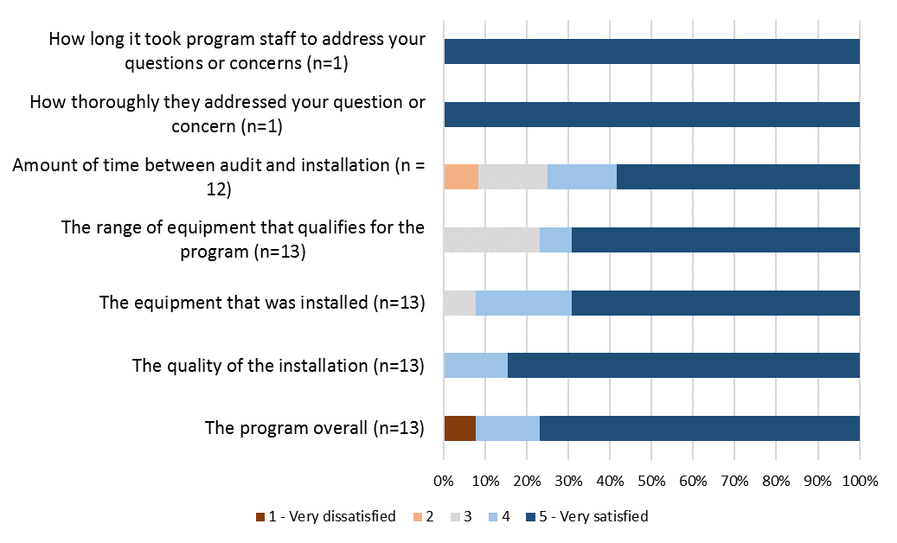

Figure 9‑6 Program Satisfaction

Respondents who reported that they were not satisfied or very satisfied with the program were given the opportunity to comment on their reasons for not being satisfied with the program. Two participants noted issues the amount of time it took to complete the project. The respondents stated:

*“It took a little longer than expected.”*

*“The timing seemed past the point of being professional.”*

The remaining comments referenced a variety of issues, but each related to the contractor the customer worked with in some way – either communication issues or the materials cost offered by the contractor.

*“I would have been more satisfied if the material was able to be bought at wholesale prices. The program was too expensive.”*

*“The lightbulbs flickered although they were replaced. We were hoping for more high-quality bulbs.”*

*“There was some miscommunication on the fact that we wanted to move forward. Ultimately we wanted LED with a narrower lighting range.”*

Survey respondents were also asked about their satisfaction with the Companies and how their participation in the Small Business program has changed their perception of the utility.

First, respondents were asked to score their satisfaction with the Companies as their electrical service provider on a scale of 1 to 5, where 1 represents “Very Dissatisfied” and 5 represents “Very Satisfied.” Most respondents are satisfied with the Companies (93%) and gave a satisfaction score of 4 or 5. No respondents indicated dissatisfaction.

Table 9‑27 Satisfaction with Entergy as Electrical Service Provider

|  |  |
| --- | --- |
| ***Satisfaction with Entergy*** | ***Percent of Respondents***  ***(n=13)*** |
| 5 - Very satisfied | 62% |
| 4 | 31% |
| 3 - Neither satisfied nor dissatisfied | 8% |
| 2 | 0% |
| 1 - Very dissatisfied | 0% |

Respondents were also asked whether their participation in the program has increased or decreased their satisfaction with Entergy. Fifty percent of respondents reported that the program has at least somewhat increased their satisfaction with Entergy. The share of customers reporting that their participation was less than the 88% that said their participation increased their satisfaction with Entergy in PY5.

Responses are summarized in the table below.

Table9‑28 Effect of Program on Satisfaction with Entergy

|  |  |
| --- | --- |
| ***Effect of participation on satisfaction with Entergy*** | ***Percent of Respondents***  ***(n = 12)*** |
| Greatly increased satisfaction with Entergy | 33% |
| Somewhat increased satisfaction with Entergy | 17% |
| Did not affect satisfaction with Entergy | 50% |
| Somewhat decreased satisfaction with Entergy | 0% |
| Greatly decreased satisfaction with Entergy | 0% |

### Conclusions

The Evaluators’ conclusions are summarized below:

* The program fell short of the PY6 savings goals. The program achieved 91% of its ENO kWh savings goal and 72% of its Algiers kWh goal. The program did not meet its goal because market response was less than needed to achieve the goal and not a function of factors such as poor realization rates. Program staff noted that achieving the savings goal in Algiers has been difficult, but indicated that there was more small business potential in Algiers than large business potential.
* The majority of program savings (98%) resulted from the installation of lighting measures during PY6, as compared to PY5 when lighting was 86% of program activity and refrigeration and hot water measures comprised the other 14 % of program activity.
* There was a spike in program activity during the last three months of the program year when participants submitted project applications which accounted for nearly half of total expected energy savings.
* Similar to last year, 16 contractors completed projects during PY6. However, activity was more evenly dispersed as 4 contractors were responsible for more than 85% of expected kWh energy savings and 33% of expected savings were associated with one contractor. In comparison, one contractor was responsible for more than half of program expected savings in PY5.
* Consistent with PY5 findings and the program design, most participants (87%) reported that they learned of the program from the contractor that they worked with. Two customers reported that participation in the program took longer than they expected.
* Customers remain satisfied with the program overall. Ninety-two percent rated their satisfaction as a 4 or 5, indicating that they were somewhat or very satisfied with it.
* A smaller share of customers reported that the program increased their satisfaction with Entergy than was the case in PY5 (50% in PY6 vs 88% in PY5).
* Several issues that affected project-level realization rates and listed in section 9.3.1.8 were identified in the analysis of gross.

### Recommendations

The Evaluators’ recommendations for the Small Business Solutions Program are summarized in the following categories:

* **Update non-daylight hours**. As was the case in PY5, multiple sites did not use hours of daylight appropriate for New Orleans latitude. Non-daylight hours should be updated to reflect the New Orleans latitude.
* **Develop protocols for assigning facility types and provide training to contractors on these protocols.** The Evaluators corrected several project building types, suggesting the need for improved procedures for contractor assignment of building types. Providing contractors with a list and definition of TRM facility types may reduce errors of assignment.
* **Add a checkbox to the project final application form to certify that all measures listed in the application are currently installed.** The Evaluator found that several sites had incomplete retrofits. Adding a checkbox to certify that all measures listed have been installed should clarify for installing contractors that incentives are to only be paid on installed measures. Contractors that falsely certify measures as installed should be removed from the program.
* **Consider approaches to address project duration noted by participants**. Two program participants noted that the project took longer than anticipated. Staff should consider approaches such as modification to guidelines or additional contractor training to encourage a reduction in the time between project initiation and completion. Future evaluations should assess if contractors have difficulty sourcing program equipment.
* **PY7 evaluation should focus on potential barriers to participation in the small business program and market response**. Specific research activities should include interviews of trade allies to assess barriers to participation and reviews of best practices for targeting small business customers.

# Large Commercial & Industrial

## Program Description

The Large Commercial & Industrial Solutions Program (Large C&I) provides financial incentives and technical services to encourage nonresidential customers with greater than 100 kW peak demand to implement energy saving measures. The C&I Program is designed to help this customer segment overcome barriers to energy improvement, such as higher first-cost of efficiency equipment and a lack of technical knowledge or resources.

The incentives provided are summarized below in Table 10‑1.

Table 10‑1 Large C&I Summary of Program Incentives

|  |  |
| --- | --- |
| ***Measure*** | ***Incentive*** |
| Lighting | $0.10 per kWh Saved |
| Non-Lighting | $0.12 per kWh Saved |

Total realized savings and percentage of goals for the Large C&I program are summarized in Table 10‑2.

Table 10‑2 Large C&I Savings Goals by Utility

|  |  |  |  |  |  |  |
| --- | --- | --- | --- | --- | --- | --- |
| ***Utility*** | ***kWh goal*** | ***Net Realized kWh*** | ***Percentage of kWh goal realized*** | ***kW goal*** | ***Net Realized kW*** | ***Percentage of kW goal realized*** |
| Algiers | 645,000 | 170,614 | 26.5% | 100 | 40.59 | 40.6% |
| ENO | 7,562,000 | 8,036,275 | 106.3% | 1,300 | 1205.78 | 92.8% |

The M&V methodology for the Large C&I program is the same as-described for the Small Business Program in Section 9.2.

## Gross Impact Findings

Energy savings was estimated using proven techniques, including engineering calculations using industry standards to determine energy savings. Table 10‑3 summarizes the total participation in the PY6 Large C&I program.

Table 10‑3 PY6 Large C&I program Participation Summary

|  |  |  |  |
| --- | --- | --- | --- |
| ***# Applicants*** | ***# Projects*** | ***Expected kWh*** | ***Expected kW*** |
| ENO | 40 | 11,989,882 | 2,424.43 |
| Algiers | 1 | 292,428 | 40.27 |
| **Total** | **41** | **12,282,310** | **2,464.70** |

Data provided by CLEAResult showed that during PY6, there were 40 and 1 projects for ENO and Algiers respectively, for a combined total of 41 projects. These projects were expected to provide a combined savings of 12,282,310 kWh and 2,646.70 kW.

Table 10‑4 Large C&I program Sample Summary

|  |  |  |  |
| --- | --- | --- | --- |
| ***Utility*** | ***# Sites in Population*** | ***Site Visit Sample Size*** | ***# Surveys*** |
| ENO | 38 | 11 | 7 |
| Algiers | 1 | 1 | 1 |
| **Total** | **39** | **12** | **8** |

Sampling for evaluation of ENO’s Large C&I program was developed using the Stratified Random Sampling procedure detailed in Section 2.2.1.3. This procedure provides 90% confidence and ±10% precision with a significantly reduced sample than random sampling would require, by selecting the highest saving facilities with certainty, thereby minimizing the variance that non-sampled sites can contribute to the overall results. Actual precision is 6.79%.

#### Large C&I Sample Design

The participant population for the Large C&I program was divided into four strata. Table 10‑5 summarizes the strata boundaries and sample frames for the Large C&I program.

Table 10‑5 Large C&I program Sample Design

|  |  |  |  |  |  |  |
| --- | --- | --- | --- | --- | --- | --- |
|  | ***Stratum 1*** | ***Stratum 2*** | ***Stratum3*** | ***Stratum 4*** | ***Stratum 5*** | ***Totals*** |
| Strata boundaries (kWh) | < 70,000 | 70,001 - 140,000 | 140,001 - 280,000 | 280,001 - 700,000 | 700,001 - 5,000,000 |  |
| Number of sites | 9 | 11 | 10 | 10 | 1 | **41** |
| Total kWh savings | 317,410 | 1,162,932 | 1,879,043 | 4,453,415 | 4,469,510 | **12,282,310** |
| Average kWh | 35,268 | 105,721 | 187,904 | 445,342 | 4,469,510 | **299,569** |
| Standard deviation of kWh savings | 22,031 | 21,248 | 41,108 | 109,536 | N/A | **1,001,948** |
| Coefficient of variation | 0.625 | 0.201 | 0.219 | 0.246 | 0.000 | **2.206** |
| Final sample | 2 | 2 | 3 | 4 | 1 | **12** |

#### Certainty Site

As seen in s Stratum 5 in Table 10‑5, a single project in the program was responsible for 4,469,510 kWh savings, or 36.4% of the overall expected program savings. The evaluators performed QA/QC and sampled this certainty project, though due to its size the Evaluators also drew a second with this project removed from the population. Using the sample other samples sites, the Evaluators verified their subsample met 90% confidence and ±10% precision. Actual precision is 6.77%.

Table 10‑6 Large C&I program Sample Design Sans Certainty Site

|  |  |  |  |  |  |  |
| --- | --- | --- | --- | --- | --- | --- |
|  | ***Stratum 1*** | ***Stratum 2*** | ***Stratum3*** | ***Stratum 4*** | ***Stratum 5*** | ***Totals*** |
| Strata boundaries (kWh) | < 80,000 | 80,001 - 140,000 | 140,001 - 250,000 | 250,001 - 400,000 | 400,001 - 650,000 |  |
| Number of projects | 11 | 9 | 9 | 5 | 6 | **40** |
| Total kWh savings | 462,866 | 1,017,476 | 1,614,572 | 1,583,364 | 3,134,522 | **7,812,800** |
| Average kWh Savings | 42,079 | 113,053 | 179,397 | 316,673 | 522,420 | **195,320** |
| Standard deviation of kWh savings | 24,863 | 15,213 | 32,968 | 40,573 | 56,015 | **166,110** |
| Coefficient of variation | 0.591 | 0.135 | 0.184 | 0.128 | 0.107 | **77,574.433** |
| Final design sample | 2 | 2 | 2 | 2 | 3 | **11** |

The remainder of this chapter leaves said project in the program population.

Table 10‑7 Expected Savings for Sampled and Non-Sampled Projects by Stratum

|  |  |  |  |
| --- | --- | --- | --- |
| ***Stratum*** | ***Sample Expected Savings*** | ***Total Expected Savings*** | ***Percent of Total Expected kWh*** |
| 1 | 57,643 | 317,410 | 18.2% |
| 2 | 216,731 | 1,162,932 | 18.6% |
| 3 | 595,046 | 1,879,043 | 31.7% |
| 4 | 1,964,139 | 4,453,415 | 44.1% |
| 5 | 4,469,510 | 4,469,510 | 100.0% |
| **Total** | **7,303,069** | **12,282,310** | **59.5%** |

#### Large C&I Site-Level Realization

Sites chosen within each stratum are visited in order to verify installation of rebated measures and to collect data needed for calculation of ex post verified savings. The realization rates for sites within each stratum are then applied to the non-sampled sites within their respective stratum. Table 10‑8 presents realization at the stratum level, with Table 10‑9 presenting results at the site level.

Table 10‑8 Summary of kWh Savings for Large C&I by Sample Stratum

|  |  |  |  |
| --- | --- | --- | --- |
| ***Stratum*** | ***Expected kWh Savings*** | ***Realized kWh Savings*** | ***Realization Rate*** |
| 1 | 317,410 | 303,239 | 95.54% |
| 2 | 1,162,932 | 1,131,528 | 97.30% |
| 3 | 1,879,043 | 1,935,645 | 103.01% |
| 4 | 4,453,415 | 4,215,029 | 94.65% |
| 5 | 4,469,510 | 4,469,510 | 100.00% |
| **Total** | **12,282,310** | **12,054,952** | **98.15%** |

Table 10‑9 Expected and Realized Savings by Project

|  |  |  |  |  |
| --- | --- | --- | --- | --- |
| ***Project ID(s)*** | ***Facility Type*** | ***Expected kWh Savings*** | ***Realized kWh Savings*** | ***Realization Rate*** |
| PRJ-947277 | Retail Store | 11,249 | 6,174 | 54.88% |
| PRJ-785239 | Parking Garage | 46,394 | 50,144 | 108.08% |
| PRJ-929765 | Hotel | 102,230 | 78,528 | 76.81% |
| PRJ-785536 | Public Event Center | 114,501 | 132,351 | 115.59% |
| PRJ-784348 | High-Rise | 162,979 | 181,458 | 111.34% |
| PRJ-783989 | Printing Facility | 167,596 | 153,379 | 91.52% |
| PRJ-828297 | Retail Store | 264,471 | 278,134 | 105.17% |
| PRJ-845108 | Condominium Association | 292,428 | 160,295 | 54.82% |
| PRJ-1270487 | High-Rise | 503,908 | 579,047 | 114.91% |
| PRJ-785774 | Hotel | 549,684 | 563,639 | 102.54% |
| PRJ-784311 | High-Rise | 618,119 | 556,020 | 89.95% |
| PRJ-892642 | Sports Arena | 4,469,510 | 4,469,510 | 100.00% |

#### Large C&I Program-Level Realization

Using the realization rates presented in Table 10‑8, the Evaluators extrapolated results from sampled sites to non-sampled sites in developing program-level savings estimates. Table 10‑10 presents results by stratum.

Table 10‑10 Large C&I Program-Level Realization by Stratum

|  |  |  |  |  |  |  |  |
| --- | --- | --- | --- | --- | --- | --- | --- |
| ***Stratum*** | ***# Sites*** | ***Expected kWh Savings*** | ***Realized kWh Savings*** | ***kWh Realization Rate*** | ***Expected kW Savings*** | ***Realized kW Savings*** | ***kW Realization Rate*** |
| 1 | 9 | 317,410 | 310,111 | 97.70% | 43.19 | 40.98 | 94.88% |
| 2 | 11 | 1,162,932 | 1,131,528 | 97.30% | 199.10 | 196.04 | 98.46% |
| 3 | 10 | 1,879,043 | 1,935,645 | 103.01% | 252.82 | 253.69 | 100.34% |
| 4 | 10 | 4,453,415 | 4,215,029 | 94.65% | 660.94 | 644.67 | 97.54% |
| 5 | 1 | 4,469,510 | 4,469,510 | 100.00% | 1,308.65 | 1,308.65 | 100.00% |
| **Totals** | **41** | **12,282,310** | **12,061,824** | **98.20%** | **2,464.70** | **2,444.03** | **99.16%** |

Table 10‑11 summarizes expected and realized savings estimates by measure category for the Large C&I program.

Table 10‑11 Large C&I program Savings by Measure Category

|  |  |  |  |  |  |  |
| --- | --- | --- | --- | --- | --- | --- |
| ***Measure Category*** | ***Expected kWh Savings*** | ***Realized kWh Savings*** | ***kWh Realization Rate*** | ***Expected kW Savings*** | ***Realized kW Savings*** | ***kW Realization Rate*** |
| HVAC | 1,298,837 | 1,218,573 | 93.82% | 159.03 | 155.19 | 97.59% |
| Lighting | 10,673,718 | 10,666,027 | 99.93% | 2,262.10 | 2,245.35 | 99.26% |
| Controls | 292,428 | 160,295 | 54.82% | 40.27 | 40.27 | 100.00% |
| Other/Custom | 17,327 | 16,929 | 97.70% | 3.30 | 3.22 | 97.70% |
| **Total** | **12,282,310** | **12,061,824** | **98.20%** | **2,464.70** | **2,444.03** | **99.16%** |

Table 10‑12 Large C&I Program Savings by Utility

|  |  |  |  |  |  |  |
| --- | --- | --- | --- | --- | --- | --- |
| ***Utility*** | ***Expected kWh Savings*** | ***Realized kWh Savings*** | ***kWh Realization Rate*** | ***Expected kW Savings*** | ***Realized kW Savings*** | ***kW Realization Rate*** |
| ENO | 11,989,882 | 11,901,529 | 99.26% | 2,424.43 | 2,403.76 | 99.15% |
| Algiers | 292,428 | 160,295 | 54.82% | 40.27 | 40.27 | 100.00% |
| **Total** | **12,282,310** | **12,061,824** | **98.20%** | **2,464.70** | **2,444.03** | **99.16%** |

#### Large C&I – Causes of Low Realization

The Evaluators have summarized these adjustments and others in Table 10‑13 for illustrative purposes.

Table 10‑13 Large C&I – Causes of Deviation in Savings Estimates

|  |  |  |  |  |
| --- | --- | --- | --- | --- |
| ***Project ID(s)*** | ***Expected kWh Savings*** | ***Realized kWh Savings*** | ***Realization Rate*** | ***Causes of Deviation in Savings Estimates*** |
| PRJ-947277 | 11,249 | 4,926 | 43.8% | Retail Store. Eight missing fixtures, facility-specific hours (3,623) instead of deemed hours (3,737). |
| PRJ-785239 | 46,394 | 50,144 | 108.1% | Parking Garage. Non-daylight hours (4,315) were used instead of deemed hours (3,737) were used in ex post calculations. |
| PRJ-929765 | 102,230 | 78,528 | 76.8% | Hotel. (60) missing fixtures and facility-specific hours (various) instead of deemed hours (various) were used in ex post calculations. |
| PRJ-785536 | 114,501 | 132,351 | 115.6% | Public Event Center. Facility-specific hours (8,760) were used instead of deemed hours (6,630) were used in ex post calculations. |
| PRJ-784348 | 162,979 | 181,458 | 111.3% | High-Rise. Ex ante calculations assumed interior lighting HOA to be either (6,630) or (4,271). |
| PRJ-783989 | 167,596 | 153,379 | 91.5% | Printing Facility. Facility-specific hours (various) instead of deemed hours (various) were used in ex post calculations. |
| PRJ-828297 | 264,471 | 278,134 | 105.2% | Retail Store. Facility-specific hours (8,568, 3,297 and 4,315) instead of deemed hours (3,668 and 3,737) were used in ex post calculations. |
| PRJ-845108 | 292,428 | 160,295 | 54.8% | Condominium Association. Facility-specific hours (various) instead of deemed hours (various) were used in ex post calculations. |
| PRJ-1270487 | 503,908 | 579,047 | 114.9% | High-Rise. Facility-specific hours (8,760, 3,774 and 4,174) instead of deemed hours (3,737) were used in ex post calculations. |
| PRJ-785774 | 549,684 | 563,639 | 102.5% | Hotel. Facility-specific hours (5,614) instead of deemed hours (5,475) were used in ex post calculations. |
| PRJ-784311 | 618,119 | 556,020 | 90.0% | High-Rise. New Orleans-specific EFLHc hours (1,997) instead of deemed hours (2,200) were used in ex post calculations. |
| PRJ-892642 | 4,469,510 | 4,469,510 | 100.0% | Sports Arena. The kWh realization rate for project PRJ-892642 is 100% and the kW realization rate is 100%. |

## Net Impact Findings

Participant survey responses were used to estimate the net energy impacts of the program. The program net savings are equal to gross savings, less savings associated with free ridership, plus participant spillover savings.

In total, eight program participants completed the survey.

### Estimating Free Ridership

Several criteria were used for determining what portion of a customer’s savings for a particular project should be attributed to free ridership. The first criterion was based on the response to the question: “Would you have been financially able to install energy efficient [Measure/Equipment] at the location without the financial incentive from the Program?” Customers that answer “No” to this question are asked to rate how certain they are that their organization could not have afforded the measure. If a customer indicated that their organization could not have afforded the measure and indicates that they were very certain of this, the customer was not deemed a free rider.

For decision makers that indicated that they were able to undertake energy efficiency projects without financial assistance from the program, three factors were analyzed to determine what percentage of savings may be attributed to free ridership. The three factors were:

* Plans and intentions of firm to install a measure even without support from the program;
* Influence that the program had on the decision to install a measure; and
* A firm’s previous experience with a measure installed under the program.

For each of these factors, rules were applied to develop binary variables indicating whether or not a participant’s behavior showed free ridership.

The first factor requires determining if a participant stated that his or her intention was to install an energy efficiency measure even without the program. The answers to a combination of several questions were used with a set of rules to determine whether a participant’s behavior indicates likely free ridership. Two binary variables were constructed to account for customer plans and intentions: one, based on a more restrictive set of criteria that may describe a high likelihood of free ridership, and a second, based on a less restrictive set of criteria that may describe a relatively lower likelihood of free ridership.

The first, more restrictive criteria indicating customer plans and intentions that likely signify free ridership are as follows (Definition 1):

* The respondent answers “yes” to the following two questions: “Did you have plans to install energy efficient [Measure/Equipment] at the location before deciding to participate in the program?” and “Would you have gone ahead with this planned project if the you had not received the rebate through the program?”
* The respondent answers “definitely would have installed” to the following question: “If the rebates from the program had not been available, how likely is it that you would have installed energy efficient [Measure/Equipment] at the location anyway?”
* The respondent answers “no, program did not affect timing of purchase and installation” to the following question: “Did you purchase and install energy efficient [Measure/Equipment] earlier than you otherwise would have without the program?”
* The respondent answers “no, program did not affect level of efficiency chosen for equipment” in response to the following question: “Did you choose equipment that was more energy efficient than you would have chosen had you not participated in the program?”

The second, less restrictive criteria indicating customer plans and intentions that likely signify free ridership are as follows (Definition 2):

* The respondent answers “yes” to the following two questions: “Did you have plans to install energy efficient [Measure/Equipment] at the location before participating in the program?” and “Would you have gone ahead with this planned installation even if you had not participated in the program?”
* Either the respondent answers “definitely would have installed” or “probably would have installed” to the following question: “If the rebates from the program had not been available, how likely is it that you would have installed energy efficient [Measure/Equipment] at the location anyway?”
* Either the respondent answers “no, program did not affect timing of purchase and installation” to the following question: “Did you purchase and install energy efficient [Measure/Equipment] earlier than you otherwise would have without the program?” or the respondent indicates that while program information and financial incentives did affect the timing of equipment purchase and installation, in the absence of the program they would have purchased and installed the equipment within the next two years.
* The respondent answers “no, program did not affect level of efficiency chosen for equipment” in response to the following question: “Did you choose equipment that was more energy efficient than you would have chosen had you not participated in the program?”

The second factor requires determining if a customer reported that a recommendation from a program representative or past experience with the program was influential in the decision to install a particular piece of equipment or measure.

The criterion indicating that program influence may signify a lower likelihood of free ridership is that either of the following conditions is true:

* The respondent answers “very important” to the following question: “How important was previous experience with the program in making your decision to install energy efficient [Measure/Equipment] at the location?”
* The respondent answers “probably would not have” or “definitely would not have” to the following question: “If the program representative had not recommended [Measure/Equipment], how likely is it that you would have installed it anyway?”

The third factor requires determining if a participant in the program indicates that he or she had previously installed an energy efficiency measure similar to one that they installed under the program without an energy efficiency program incentive during the last three years. A participant indicating that he or she had installed a similar measure is considered to have a likelihood of free ridership.

The criteria indicating that previous experience may signify a higher likelihood of free ridership are as follows:

* The respondent answers “yes” to the following question: “Before participating in the Program, had you installed any equipment or measure similar to energy efficient [Measure/Equipment] at the location?”
* The respondent answers “yes” to the following question: “Has your organization purchased any significant energy efficient equipment in the last three years at the location?” and answered “yes” to the question: “Did you install any of that equipment without applying for a financial incentive through an energy efficiency program?”

The four sets of rules described above were used to construct four different indicator variables that address free ridership behavior. For each customer, a free ridership value was assigned based on the combination of variables. With the four indicator variables, there are 11 applicable combinations for assigning free ridership scores for each respondent, depending on the combination of answers to the questions creating the indicator variables. Table 10‑12 shows these values.

*Table 10‑14.Free Ridership Scores for Combinations of Indicator Variable Responses*

| ***Indicator Variables*** | | | | ***Free Ridership Score*** |
| --- | --- | --- | --- | --- |
| ***Had Plans and Intentions to Install Measure without Program? (Definition 1)*** | ***Had Plans and Intentions to Install Measure without Program? (Definition 2)*** | ***Program had influence on Decision to Install Measure?*** | ***Had Previous Experience with Measure?*** |
| Y | N/A | Y | Y | 100% |
| Y | N/A | N | N | 100% |
| Y | N/A | N | Y | 67% |
| Y | N/A | Y | N | 67% |
| N | Y | N | Y | 67% |
| N | N | N | Y | 33% |
| N | Y | N | N | 33% |
| N | Y | Y | N | 0% |
| N | N | N | N | 0% |
| N | N | Y | N | 0% |
| N | N | Y | Y | 0% |

### Estimating Spillover

Program participants may implement additional energy saving measures without receiving a program incentive because of their participation in the program. The energy savings resulting from these additional measures constitute program participant spillover effects.

To assess participant spillover savings, survey respondents were asked whether or not they implemented any additional energy saving measures for which they did not receive a program incentive. Respondents that indicated that they did install additional measures were asked two questions to assess whether or not the savings are attributable to the program. Specifically, respondents were asked:

* “How important was your experience with the <PROGRAM> in your decision to implement this Measure, using a scale of 0 to 10, where 0 is not at all important and 10 is extremely important?”
* “If you had not participated in the <PROGRAM>, how likely is it that your organization would still have implemented this measure, using a 0 to 10 scale, where 0 means you definitely WOULD NOT have implemented this measure and 10 means you definitely WOULD have implemented this measure?”

The energy savings associated with the measure are considered attributable to the program if the average of the rating for the first question, and 10 – the rating for the second question, is greater than seven, the savings are counted as attributable to the program.

None of the survey respondents indicated that they had implemented additional measures that met the criterion for attributing the savings to the program.

### Net Savings Results

Review of expected savings of the Large C&I projects found that one large project accounted for 40% of program savings. Because of the size of this project, the project was assigned to a certainty stratum and all other projects were assigned to a second stratum.

Table 10‑13 summarizes the results of the free ridership scoring. Free ridership for the program was estimated by weighting each participant’s scored responses by the associated realized gross kWh savings or peak kW reductions for the measure. Thirty-eight percent of gross kWh savings were associated with a respondent that met the criteria for the most restrictive definition of prior plans but did not meet the criteria for previous experience with the measure or program influence. Another 14% of kWh savings was associated with responses that met the criteria for the less restrictive prior plans definition.

Table 10‑15 Free-Ridership Scoring Results

|  |  |  |  |  |  |
| --- | --- | --- | --- | --- | --- |
| ***Had Plans and Intentions to Install Measure without C&I Program? (Definition 1)*** | ***Had Plans and Intentions to Install Measure without C&I Program? (Definition 2)*** | ***C&I Program had influence on Decision to Install Measure?*** | ***Had Previous Experience with Measure?*** | ***Percentage of Total Ex Post Gross kWh Savings*** | ***Free Ridership Score*** |
| Y | Y | N | Y | 38% | 67% |
| N | Y | N | N | 14% | 33% |
| N | N | N | N | 17% | 0% |
| Required program to implement measures. | | | | 31% | 0% |
| Total | | | | 100% | 43% |

Table 10‑3 and Table 10‑4 summarize the realized net kWh savings and peak kW demand reductions of the program. Net kWh savings totaled to 6,731,951 kWh and equal 57% of gross program savings. Net kW reductions totaled 814.52 kW and equal 37% of realized gross program savings.

Table 10‑16 Summary of Net Ex Post kWh Savings

|  |  |  |  |  |  |  |
| --- | --- | --- | --- | --- | --- | --- |
| ***Utility*** | ***Expected Gross kWh Savings*** | ***Realized Gross kWh Savings*** | ***Free Ridership*** | ***Spillover*** | ***Realized Net kWh Savings*** | ***Net to Gross Ratio*** |
| Algiers | 292,428 | 160,295 | 12,076 | 0 | 148,219 | 92% |
| ENO | 11,989,882 | 11,901,529 | 3,554,479 | 0 | 8,347,050 | 70% |
| **Total** | **12,282,310** | **12,061,824** | **3,566,555** | **0** | **8,495,269** | **70%** |

Table 10‑17 Summary of Ex Post Net Peak kW Reductions

|  |  |  |  |  |  |  |
| --- | --- | --- | --- | --- | --- | --- |
| ***Utility*** | ***Expected Gross Peak kW Reductions*** | ***Realized Gross Peak kW Reductions*** | ***Free Ridership*** | ***Spillover*** | ***Realized Net kW Savings*** | ***Net to Gross Ratio*** |
| Algiers | 40.27 | 40.27 | 2.95 | 0.00 | 37.32 | 93% |
| ENO | 2,424.43 | 2,403.76 | 957.02 | 0.00 | 1,446.74 | 60% |
| **Total** | **2,464.70** | **2,444.03** | **959.97** | **0.00** | **1,484.07** | **61%** |

Program free ridership was considerably higher in PY6 than in PY5. The high level of free ridership was largely a function of the finding that the largest project completed through the program was found to have 67% free-ridership. This project was part of a larger ESCO funded energy efficiency improvement project completed at the facility. Review of project documentation submitted by the program implementation contractor found that this project would have had a payback period of 49 days without the program incentive – a finding that corroborates the likelihood that the project would have happened in the absence of the program. The project was assigned 33% NTGR based on evaluation survey results.

ADM took steps in addition to review of the customer’s survey responses to validate the free ridership score, but these steps provided little additional information on the project. The steps taken were:

* Discussions with the program implementation contractor to better understand how the project developed;
* A request for the ESCO contact for completing an interview with that individual – this information was unavailable;
* A request for an interview with a second facility contact for the project location – the request was denied by the contact; and
* A request for email or other documentation such as energy assessments that may provide additional information that may have corroborated or contradicted the decision maker responses or otherwise provided additional information on the development of the project – only the application materials were available.

## Process Findings

This chapter presents the results of the process evaluation of the Large C&I program. The process evaluation focuses on aspects of program policies and organization, as well as the program delivery framework.

### Data Collection Activities

The process of evaluation of the C&I Program included the following data collection activities:

Table 10‑18 Large Commercial & Industrial Solutions Process Evaluation – Summary of Data Collection

|  |  |
| --- | --- |
| ***Activity*** | ***Sample Size*** |
|
| The Companies Staff | 1 |
| Participant Survey | 8 |

### Program Overview

The C&I Program provides financial incentives and technical services to encourage nonresidential customers with greater than 100 kW peak demand to implement energy saving measures. The C&I Program is designed to help this customer segment overcome barriers to energy improvement, such as higher first-cost of efficiency equipment and a lack of technical knowledge or resources.

In addition to encouraging the adoption of energy efficiency measures, the program also intends to transform the energy efficiency market in the Companies’ service area through training, education, and program implementation.

The program offers incentives for efficiency measures as well as technical assistance to help customer identify and develop energy efficiency projects.

Financial incentives are based on expected savings for the measure implemented and vary by end–use. The targeted incentive amounts for different end-uses are summarized in Table 10‑19.

Table 10‑19 Incentive Amount by End-Use for the C&I Program

|  |  |
| --- | --- |
| ***End-Use*** | ***Incentive Amount*** |
| Lighting | $0.10 / kWh Saved |
| Non-Lighting | $0.12 / kWh saved |

The incentive amounts may be based on one of three calculation methodologies described below.

* Deemed or Stipulated Savings: This approach is the most typical and utilized for projects for which savings can be reasonably estimated using previously collected data on operating hours and energy consumption of pre-existing equipment. This approach does not require the participant to perform any measurement and verification (M&V) activities.
* Simplified Measurement and Verification: This approach is for projects which require short-term metering and utilizes this data in simple engineering calculations to estimate energy savings. Participants are required to submit an M&V plan before beginning the project.
* Full Measurement and Verification: Projects requiring full M&V estimate savings utilizing procedures based on the International Performance Measurement and Verification Protocol and may utilize metering, statistical analysis of billing data, or energy modeling. Participants are required to submit an M&V plan before beginning the project.

### Detailed Findings

#### Analysis of Participation Data

Table 10‑20 summarizes program expected savings by measure type. As shown, the expected savings resulted from two primary measure types, lighting and HVAC, which accounted for 89% and 11% respectively. Table 10‑20 also presents the dollar per kWh saved acquisition costs. The cost per kWh saved for was $0.06 lighting, $0.10 for HVAC, and $0.12 for custom measures. One kWh of savings from lighting measures costs the program $0.06, in incentive dollars. HVAC measures cost $0.10, in incentive dollars, per expected kWh saved. Costs per kWh saved are less than the incentive rate because five projects reached the $50,000 incentive cap.

Table 10‑20 Expected kWh Savings by Measure Type

|  |  |  |  |
| --- | --- | --- | --- |
| ***Measure Type*** | ***Expected Savings (kWh)*** | ***Share of Program Savings*** | ***$ per kWh in Expected Savings*** |
| Lighting | 10,673,718 | 89% | $0.06 |
| HVAC | 1,298,837 | 11% | $0.10 |
| Other/Custom | 17,327 | <1% | $0.12 |

Figure 10‑1, displays the monthly and cumulative accrual of expected program savings. The analysis is based on the project submission date. The figure below shows a spike in program activity occurring in February. The spike is largely because of a single large project with savings that totaled 4,469,510 kWh (37% of program savings).

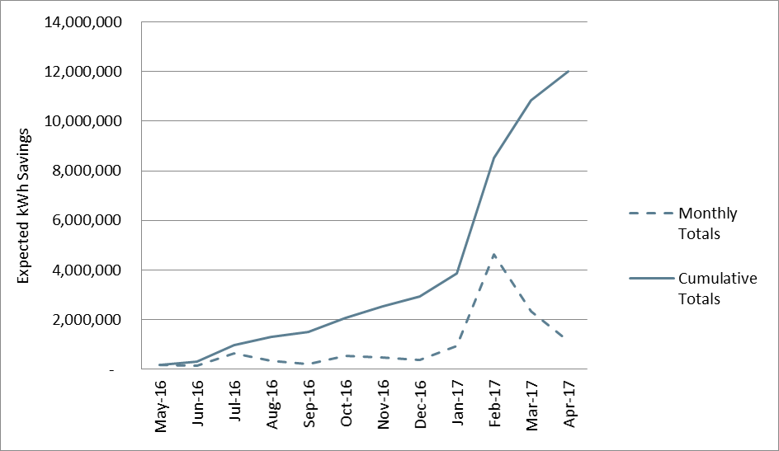

Figure 10‑1 Monthly and Cumulative Accrual of Expected kWh Savings

#### Program Design, Operations, and Activities

The Large C&I Program remained largely unchanged from PY5. Staff stated that the contractor network, the program marketing materials and outreach approaches, and incentives and requirements remained unchanged. As was the case in PY5, the incentive budget was largely reserved early in the program year.

#### Participant Survey Results

Eight decision makers completed a survey that contained questions pertaining to their experiences with the Large C&I Program.

#### Firmographics

The business types with the highest representation in the survey were offices and retail locations, each of which represent 25% of survey respondents. The complete makeup of survey respondents is summarized in the figure below.

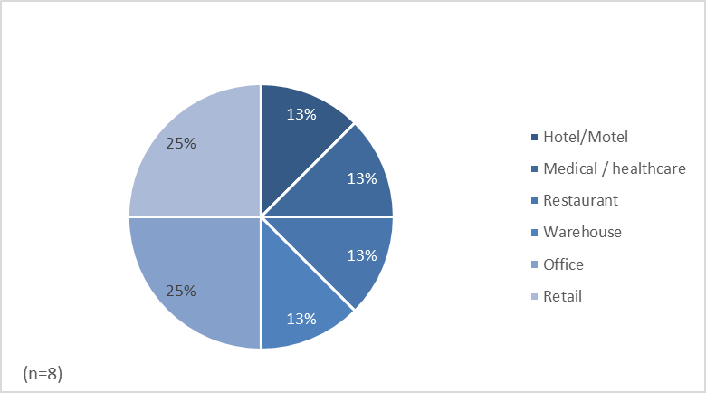

Figure 10‑2 Large C&I Participating Business Types

The majority of surveyed businesses (75%) own several locations.

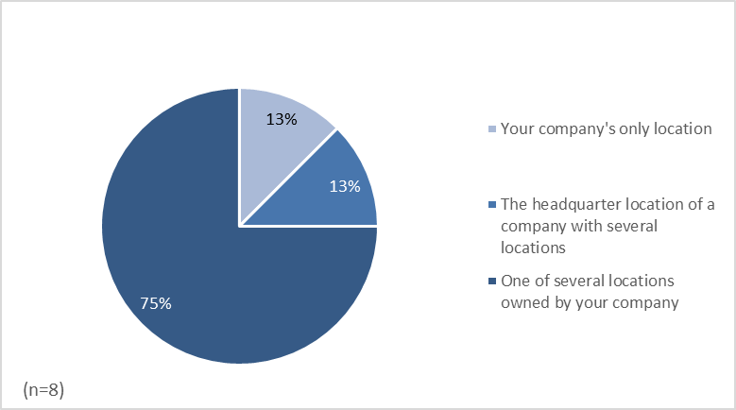

Figure 10‑3 Large C&I Number of Business Locations

In addition, most surveyed businesses (63%) own and occupy the location where renovations took place.

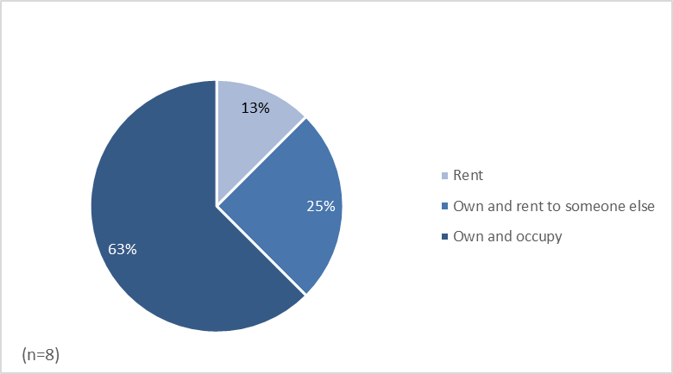

Figure 10‑4 Large C&I Site Ownership

#### Source of Initial Awareness

Thirty-seven percent of participants first heard about the incentives for efficient equipment upgrades from a contractor. One participant heard about the program via word-of-mouth and industry connections, and one participant learned of the program while doing research on energy efficiency programs in Louisiana. One participant learned of the program from a utility representative.

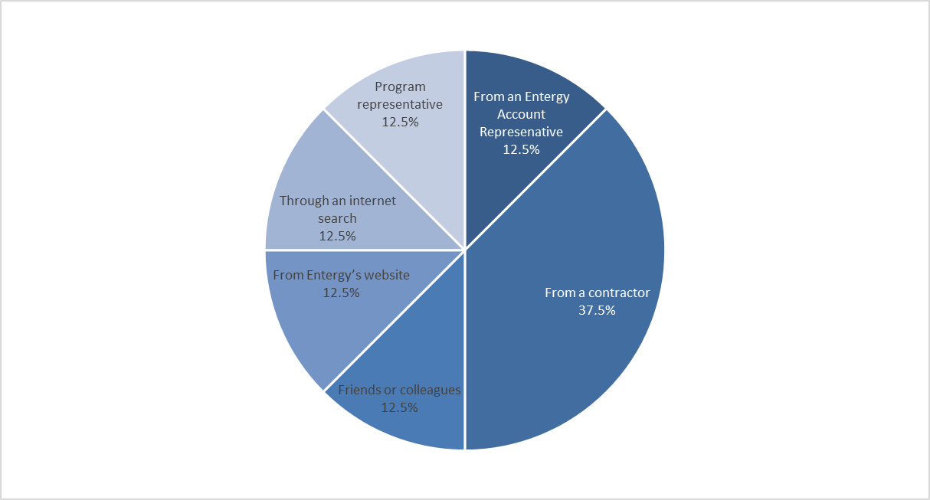

Figure 10‑5 Large C&I Sources of Program Awareness

#### Reasons for Participation

Respondents were asked if they had had any concerns when they were first approached about participating in the program. Eighty-eight percent reported that they had not had any concerns. The one respondent who said that they had had concerns about participating in the program did not elaborate on their source of their concern or why they chose to participate in the program despite their concerns.

No respondents reported viewing program marketing materials when they were learning about the program.

Survey respondents also identified their reasons for participating in the program. The most frequently mentioned motivating factor was to replace old or outdated equipment, which all respondents identified as an important motivating factor. Other common motivations included improving equipment performance and reducing energy costs, each cited by 50% of respondents. All responses are summarized in the figure below. Percentages exceed 100% because respondents were permitted to provide more than one response.

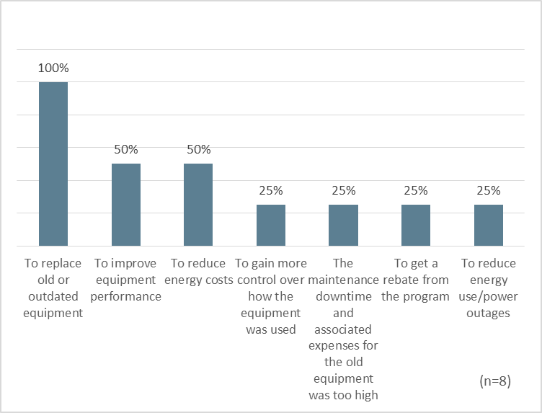

Figure 10‑6 Large C&I Reasons for Participation

#### Participation Process

Half of survey respondents said that they worked on the application for program themselves. As shown below in Table 10‑21, contractors assisted 38% of participants with the application. All responses are summarized in the table below.

Table 10‑21 Contributors to the Incentive Application

|  |  |
| --- | --- |
| ***Application Contributor*** | ***Percent of Respondents***  ***(n = 8)\**** |
| Yourself | 50% |
| A Contractor | 38% |
| Another member of your company | 13% |
| An equipment vendor | 13% |
| A designer or architect | 13% |
| A program representative | 13% |
| * The percentages total more than 100% because some respondents provided more than one response. | |

Most respondents who worked on the application themselves (75%) reported that the information about how to complete the application was clear or completely clear, giving it a score of 4 or 5 out of 5 for overall clarity. One respondent gave the clarity of information a score of 1 out of 5. When asked what part of the application process was unclear, the respondent replied, “The process was never fully defined and handled in a piecemeal basis.”

Seventy-five percent of respondents who worked on the application themselves said they had a clear idea of who to go to for assistance with the application process.

Most respondents (63%) did not know how long they had to wait to receive their incentive payment. Twenty-five percent received their payment in less than 2 weeks, and 1 respondent waited more than 8 weeks.

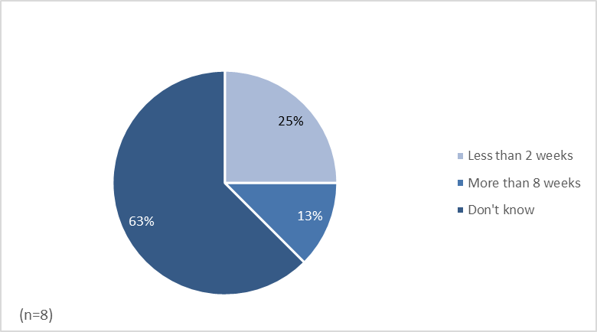

Figure 10‑7 Large C&I Time until Incentive Payment was Received

Most respondents (88%) felt that the incentive they received met their expectation (see Figure 10‑8). One respondent said that the incentive payment was much less than what they had been expecting.

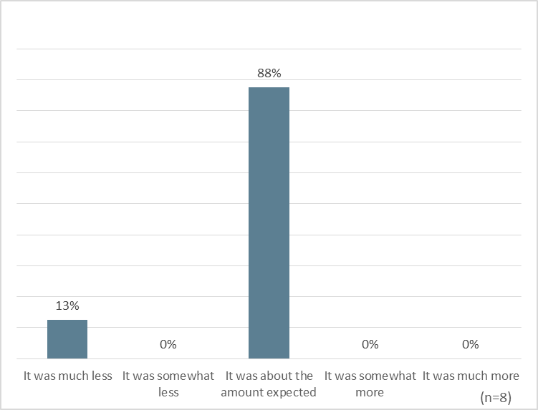

Figure 10‑8 Comparison of Actual and Expected Incentive Size

#### Program Satisfaction

Survey respondents were asked to rate their satisfaction with various components of the program on a scale of 1 to 5, where 1 means “very dissatisfied” and 5 means “very satisfied.” Satisfaction ratings were somewhat mixed, and lower than they were in PY5. Two program participants reported that they are dissatisfied with each aspect of the program that they rated, while the remaining six are satisfied with each aspect of the program they rated.

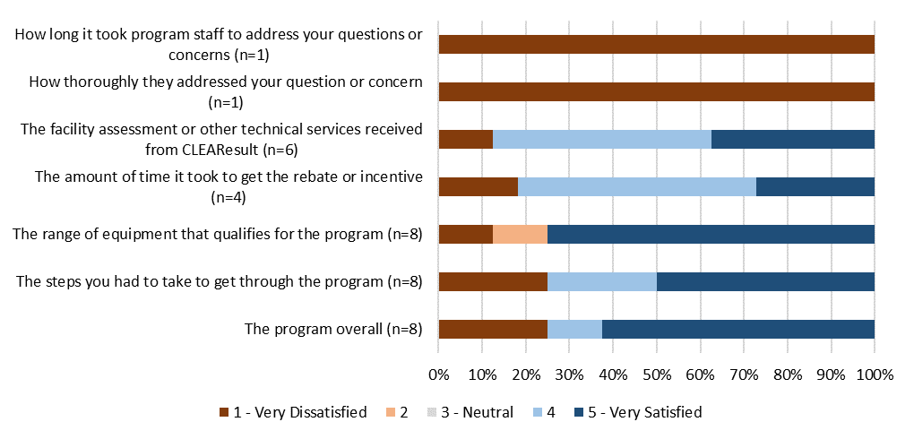

Figure 10‑9 Large C&I Satisfaction with Program Components

The two program participants who are dissatisfied with the program provided differing reasons for their dissatisfaction. One respondent stated that the “process was never fully defined and handled in a piecemeal basis.” This respondent stated that the information on how to complete the application was not at all clear and that they did not have a clear sense of whom to go to for assistance with the application. Additionally, the customer reported that it took more than eight weeks to receive the incentive payment.

The other respondent cited an issue with the contractors as the primary source of their dissatisfaction:

*“Very dissatisfied with the contractor. Did not position the lights correctly. Did not remove and recycle old light bulbs. Never received a list of what was installed and where. Lots of replacements on the new equipment. Ended up being charged $12,000 after contractor sent them a letter stating the project would be no-cost.”*

#### Satisfaction with Entergy

Respondents were also asked about their satisfaction with the Companies and how their participation in the program has influenced their opinion of the utility. Sixty-three percent of respondents report that they are satisfied or very satisfied with Entergy as an electrical services provider. All responses are summarized in the table below.

Table 10‑22 Satisfaction with Entergy as Electrical Service Provider

|  |  |
| --- | --- |
| ***Satisfaction Score*** | ***Percent of Respondents***  ***(n=8)*** |
| 5 (Very Satisfied) | 13% |
| 4 | 50% |
| 3 | 0% |
| 2 | 0% |
| 1 (Very Dissatisfied) | 25% |

Sixty-three percent of respondents said that their participation in the program somewhat or greatly increased their satisfaction with Entergy. One respondent said that their participation in the program somewhat decreased their satisfaction with Entergy. All responses are summarized in the table below.

Table 10‑23 Effect of Program on Satisfaction with Entergy

|  |  |
| --- | --- |
| ***Effect of Program Participation on Satisfaction with Entergy*** | ***Percent of Respondents***  ***(n=8)*** |
| Greatly increased satisfaction with Entergy | 25% |
| Somewhat increased satisfaction with Entergy | 38% |
| Did not affect satisfaction with Entergy | 13% |
| Somewhat decreased satisfaction with Entergy | 13% |
| Greatly decreased satisfaction with Entergy | 0% |

### Conclusions

The Evaluators’ conclusions are summarized below:

* The net-to-gross ratio was much lower in PY6 than in PY5. The decrease was due to a large project with a 33% NTGR that accounted for a significant share of gross program savings. The incentive of this project was capped at $50,000 and as a result, the acquisition cost of the kWh savings was low ( approximately $0.01 per expected kWh).
* As was the case in PY5, the evaluators found sites that used non-EISA compliant baselines and incorrect non-daylight hours.
* Six of the eight survey respondents were satisfied with the program overall and two respondents were very dissatisfied with it. The reasons for their dissatisfaction differed for these two respondents. One respondent was dissatisfied with the contractor, while the other stated that the participation processes was unclear.

### Recommendations

The Evaluators’ recommendations for the Large C&I Program are summarized in the following categories:

* **Update non-daylight hours**. As was the case in PY5, multiple sites did not use hours of daylight appropriate for New Orleans latitude. Non-daylight hours should be updated to reflect the New Orleans latitude.
* **Correct the spreadsheet calculators to account for EISA baseline wattages.** When installing screw-in LEDs and CFLs, ex ante calculations used listed wattage (40W, 60W, 75W, and 100W) as the baseline. The baseline values need to account for the Energy Independence and Security Act (EISA) baseline values (29W, 43W, 53W, 72W), as the remaining useful life of incandescent lighting is too short to use as the baseline for the life cycle savings of a lighting retrofit.
* **Consider strategies for mitigating free ridership risk.** The Evaluator recognizes that many factors are considered when designing program incentives, but suggests consideration of the following changes to the incentive caps. These suggestions are indented to reduce evaluation risk stemming from high free ridership on projects that have a small share of the project cost covered because of the current incentive cap or because the project payback is sufficiently short that participants are likely to implement projects without a program incentive.
  + Institute a cap on program claimed savings that is consistent with the incentive cap (e.g., limit claimed project savings to 500,000 kWh). Because the budget is unspent and this program has been budget limited, this cap should not adversely affect the achievement of program goals.
  + Institute a lower cap (e.g., $25,000) for lighting projects, which have quick payback periods for participating entities. The cap should be based on tax identification number to prevent skirting the cap by implementing multiple projects at the same location.
  + Cap the incentive such that the incentive payment does not lower the payback period to less than one-year.

In addition to consideration of alternative incentive caps, staff should consider requiring that a documented energy assessment be completed for any large customer project. This may provide a non-financial inducement for the project.

# Direct Load Control Pilot

The Direct Load Control (“DLC”) Pilot Program (“the Pilot”) was administered by CLEAResult Consulting (“CLEAResult”) on behalf of Entergy New Orleans (“ENO”) under the direction of the New Orleans City Council. The Pilot is designed to assess the potential for administering a full-scale DLC program in future program years.

The Pilot recruited 307 residential customers comprising 316 air conditioners. Control switches were installed on these units in order to run test events. The control strategies employed were fixed cycling. In such a strategy, a duty cycle is selected *a priori* and all participants have their air conditioner limited to a maximum of this duty cycle[38].

The goals of this evaluation of the Pilot are to:

* **Assess the effectiveness of varying control strategies.** The Pilot used both 50% and 33% cycling strategies. This evaluation summarizes the impacts of both strategies.
* **Evaluate the sensitivity to baseline specification.** We analyzed events according to four baseline schemes:
  + Three of five days;
  + Three of eight days;
  + Three of 10 days; and
  + Five of 10 days.

## M&V Methodology

### Household Recruitment

Where possible, ADM would install monitoring equipment while Pilot staff were installing the load control switches. However, we were not able to do this for all households. ADM was provided participation lists by CLEAResult, from which we recruited households to participate in the metering component of the study. Recruited households were compensated with a $50 Visa gift card upon completion of the metering and successful collection of the equipment.

The timing of the installations was such that ADM was not able to have the full metering sample deployed for all events. The first two events (August 24 and August 26) had 38% and 48%meter deployment. The subsequent seven events had full meter deployment.

### Data Collection

The assessment of load reductions was based on data collected for a sample of 63 central air conditioning units. ADM field staff took one-time power measurements of the CAC unit’s compressor and air handler to determine its kW load and installed loggers to monitor indoor temperature and run time of the CAC compressor.

Information collected on the characteristics of each monitored unit included the following:

* Btu/hr. cooling capacity
* Rated unit efficiency, size, make and model
* Number of AC zones

Data on the power performance of sample unit was supplemented by also taking one-time readings of the following:

* Electrical input
* Dry bulb temperatures
* Relative humidity

Monitoring equipment was installed to measure the run time of the air conditioning system. A time-of-use motor logger was installed either in the condensing unit control compartment or in the disconnect switch box feeding the unit. By sensing the AC field generated by the current draw of the compressor, the logger could record the dates and times of each event when the compressor was turned on or off. Indoor temperature and humidity loggers were used to collect data on ambient and indoor air conditions

### Calculation Methodology

Our approach in analyzing the demand reductions from the DLC events was to calculate baseline load based on prior-day averaging. This approach is as follows:

* First, the average load from the baseline days specified is collected for each hour of the event. For example, in a 3-of-5 baseline, we would examine the load data from the last five non-event, non-holiday weekdays and take the mean values of the three highest loads.
* Second, we then compare loads for the hour prior to the event. This is used to create a prior-hour adjustment factor. This corrects the baseline to align with the weather and load demonstrated on the event day.

The events were analyzed using the following baseline criteria:

* 3-of-5
* 3-of-10
* 5-of-10
* 3-of-8

The reductions are calculated in terms of kW per ton of cooling capacity.

### Event Summary

Table 11‑1 summaries the dates and times of events as well as the control strategy applied.

Table 11‑1 Event Summary

|  |  |  |
| --- | --- | --- |
| ***Date*** | ***Event Time*** | ***Control Strategy*** |
| 8/24/2016 | 4:00 PM – 6:00 PM | 50% Cycling |
| 8/26/2016 | 4:00 PM – 6:00 PM | 50% Cycling |
| 9/1/2016 | 4:00 PM – 6:00 PM | 50% Cycling |
| 9/8/2016 | 4:00 PM – 6:00 PM | 33% Cycling |
| 9/12/2016 | 4:00 PM – 6:00 PM | 50% Cycling |
| 9/20/2016 | 4:00 PM – 6:00 PM | 50% Cycling |
| 9/21/2016 | 4:00 PM – 6:00 PM | 33% Cycling |
| 9/28/2016 | 4:00 PM – 6:00 PM | 50% Cycling |
| 9/29/2016 | 4:00 PM – 6:00 PM | 50% Cycling |

### Event Results

Table 11‑2 and Table 11‑3summarize the event load reductions in terms of kW/Ton and kW/Unit (respectively). Many of the events were at moderate temperature; 9/1 and 9/20 are more typical of a summer peak event.

Table 11‑2 Event Performance (kW/ton)

|  |  |  |
| --- | --- | --- |
| ***Date*** | ***Hour 1*** | ***Hour 2*** |
| 9/1/2016 | .238 | .249 |
| 9/8/2016 | .159 | .116 |
| 9/12/2016 | .158 | .131 |
| 9/20/2016 | .239 | .244 |
| 9/21/2016 | .128 | .114 |
| 9/28/2016 | .167 | .133 |
| 9/29/2016 | .139 | .093 |

Table 11‑3 Event Performance (kW/Unit)

|  |  |  |
| --- | --- | --- |
| ***Date*** | ***Hour 1*** | ***Hour 2*** |
| 9/1/2016 | .809 | .847 |
| 9/8/2016 | .541 | .394 |
| 9/12/2016 | .537 | .445 |
| 9/20/2016 | .813 | .830 |
| 9/21/2016 | .435 | .388 |
| 9/28/2016 | .568 | .452 |
| 9/29/2016 | .473 | .316 |

Table 11‑4 through Table 11‑7 summarize the event load reductions for each baseline specification.

Table 11‑4 Event Performance – 3-of-5 Baseline

|  |  |  |
| --- | --- | --- |
| ***Date*** | ***Hour 1*** | ***Hour 2*** |
| 9/1/2016 | .238 | .249 |
| 9/8/2016 | .159 | .116 |
| 9/12/2016 | .158 | .131 |
| 9/20/2016 | .239 | .244 |
| 9/21/2016 | .128 | .114 |
| 9/28/2016 | .167 | .133 |
| 9/29/2016 | .139 | .093 |

Table 11‑5 Event Performance – 3-of-10 Baseline

|  |  |  |
| --- | --- | --- |
| ***Date*** | ***Hour 1*** | ***Hour 2*** |
| 9/1/2016 | .249 | .264 |
| 9/8/2016 | .144 | .080 |
| 9/12/2016 | .120 | .066 |
| 9/20/2016 | .254 | .254 |
| 9/21/2016 | .124 | .101 |
| 9/28/2016 | .167 | .133 |
| 9/29/2016 | .139 | .093 |

Table 11‑6 Event Performance – 5-of-10 Baseline

|  |  |  |
| --- | --- | --- |
| ***Date*** | ***Hour 1*** | ***Hour 2*** |
| 9/1/2016 | .236 | .246 |
| 9/8/2016 | .128 | .084 |
| 9/12/2016 | .106 | .070 |
| 9/20/2016 | .255 | .253 |
| 9/21/2016 | .141 | .119 |
| 9/28/2016 | .172 | .145 |
| 9/29/2016 | .143 | .103 |

Table 11‑7 Event Performance – 3-of-8 Baseline

|  |  |  |
| --- | --- | --- |
| ***Date*** | ***Hour 1*** | ***Hour 2*** |
| 9/1/2016 | .255 | .227 |
| 9/8/2016 | .159 | .116 |
| 9/12/2016 | .133 | .098 |
| 9/20/2016 | .256 | .268 |
| 9/21/2016 | .159 | .142 |
| 9/28/2016 | .167 | .133 |
| 9/29/2016 | .139 | .093 |

Figure 11‑1 summarizes the spread of load reductions in each event when comparing all four baseline specifications. Load reductions vary significantly for lower-performing events, while variation reduces sharply for the higher-performing events.

Figure 11‑1 Variation in Load Reduction from Baseline Specification

### Event Load Profiles

Figure 11‑2 through Figure 11‑8 present the kW/ton load profiles for the analyzed events. These are provided for illustrative purposes, and use the three-of-five baseline data.

Figure 11‑2 September 1st Load Profile

Figure 11‑3 September 8th Load Profile

Figure 11‑4 September 12th Load Profile

Figure 11‑5 September 20th Load Profile

Figure 11‑6 September 21st Load Profile

Figure 11‑7 September 28th Load Profile

Figure 11‑8 September 29th Load Profile

### Indoor Temperature

The Evaluators monitored indoor temperature in the sampled residences in order to assess the effects of the program on home comfort. The temperature increases are presented in Figure 11‑9. The average temperature increase in a residence during a system event was .66 degrees Fahrenheit. This is a very low temperature increase; in programs that use a thermostat setback method, the home thermostat would typically be set back 4-6 degrees Fahrenheit.

The average temperature increase was .273 degrees during 33% cycling and .808 degrees during 50% cycling events.

*Figure 11‑9 Temperature Increase During DLC Events*

### Savings Summary

The Evaluators applied the 3-of-5 baseline in assessing final kW demand reductions from the DLC pilot. With 307 respondents an average per-unit savings of .847 kW, total demand reduction is 257.35 kW.

## Process Evaluation

The Evaluators conducted an abbreviated process evaluation of the DLC pilot. The main goals of this effort were to:

* Obtain participant feedback on their program experience;
* Compare methods to other DLC programs;
* Compare results to other DLC programs; and
* Provide recommendations for program improvement.

### Data Collection Activities

The process of evaluation of the DLC Program included the following data collection activities:

* *ENO Program Staff* *Interviews*. The Evaluators interviewed staff at ENO involved in the administration of DLC Pilot. The interview focused on higher-level issues related to the launch of the pilot as well as to obtain a better understanding of how the Pilot was administered.
* *Participant Survey*. The Evaluators surveyed a sample of program participants. This sample was stratified by DLC switch installer in order to ensure that feedback on their program experience was representative of the program trade allies.
* *Benchmarking*. The Evaluators completed a literature of other similar DLC programs to compare cycling strategies and event performance.

Table 11‑6 summarizes data collection activities for the DLC Pilot Program process evaluation.

Table 11‑6 DLC Pilot Data Collection Activities

|  |  |
| --- | --- |
| ***Activity*** | ***n*** |
| Entergy staff interviews | 1 |
| CLEAResult staff interviews | 1 |
| Participant surveys | 60 |

### Program Comparison

The Evaluators compared the DLC Pilot to three other programs to see differences in cycling strategies and kW reductions. These comparisons are provided in Table 11‑7.

Table 11‑7 Benchmark Program Cycling Strategies

|  |  |  |  |  |
| --- | --- | --- | --- | --- |
| ***Metric*** | ***ENO DLC Pilot*** | ***Entergy Arkansas DLC*** | ***Public Service of New Mexico***  ***Power Saver*** | ***PG&E Smart AC*** |
| Cycling | 33% or 50% | 50% or 75% | 50% | Dynamic |
| kW Reduction | .847 | 1.51 | .92 | .56 |

### Program Features

In our literature review of other DLC programs, we identified the following program features:

* **Dynamic/adaptive cycling:** this feature normalizes the cycling strategy to ensure that all participant homes face the same indoor temperature increase. This varies the cycling in order to account for factors such as over- and under-sizing, poor refrigerant charging, and distribution losses.
* **Two-way communication:** DLC programs with this feature use devices that provide communication back to program implementers, providing:
  + Runtime
  + Temperature
  + Signal test results for non-operating devices
* **Variable cycling options:** Entergy Arkansas allows for participants to sign up for 50% or 75% cycling, with a higher incentive for the higher cycling option.

### Survey Responses

The Evaluators conducted a brief survey with program participants. The survey addressed how respondents became involved in the program and obtained feedback on their program experience.

#### Program Awareness

The sources of program awareness are detailed in Figure 11‑10. Most respondents learned of the program via an email from Entergy (30.0%) or an Entergy bill insert (26.7%).

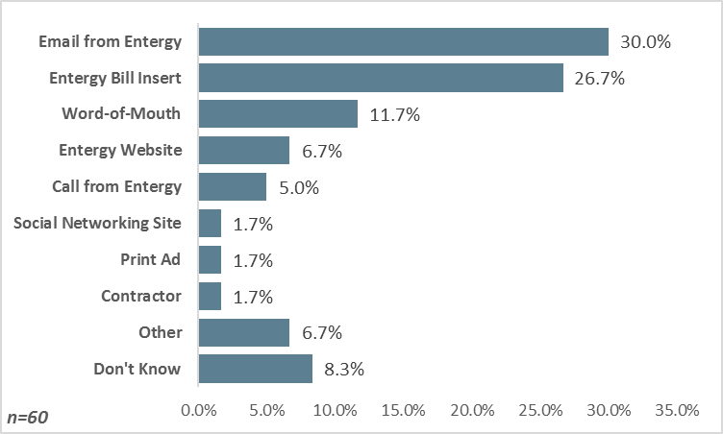

Figure 11‑10 DLC Sources of Program Awareness

### Customer Program Experience

Respondents were asked if they had any concerns about participating in the DLC Pilot. Ninety percent of respondents stated that they had no concerns. Of the 10% that indicated concerns, the issues raised included concerns over whether it was actually Entergy running the program, concerns about scheduling difficulty, and concerns over whether the cycling device would damage the air conditioner. Fifty percent of respondents with concerns stated that their concerns were adequately handled by program staff.

Respondents were then asked to identify the extent to which they noticed the events occurring.

Figure 11‑11 Customer Occupancy During DLC Events

Those that were home during events were asked to identify how long the events lasted. Only 19% of this group could provide an estimate, and all respondents that noticed an event thought it did not last longer than one hour.

Figure 11‑12 summarizes the extent to which respondents noticed any effects on home comfort as a result of the event.

Figure 11‑12 Extent of Noticing Home Comfort Impacts

Figure 11‑13 aggregates the findings of whether customers noticed an event, and whether the event affected their comfort. Only 6.7% of respondents indicated a large effect on home comfort.

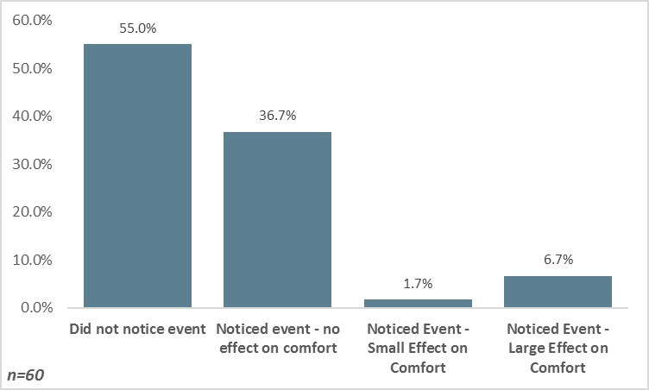

Figure 11‑13 Effect of Events on Home Comfort

Respondents were also asked about prenotification procedures. Figure 11‑14 summarizes the self-reported importance of pre-notification, and Figure 11‑15 summarizes the preferred communication method. Seventy percent of respondents place some importance on prenotification.

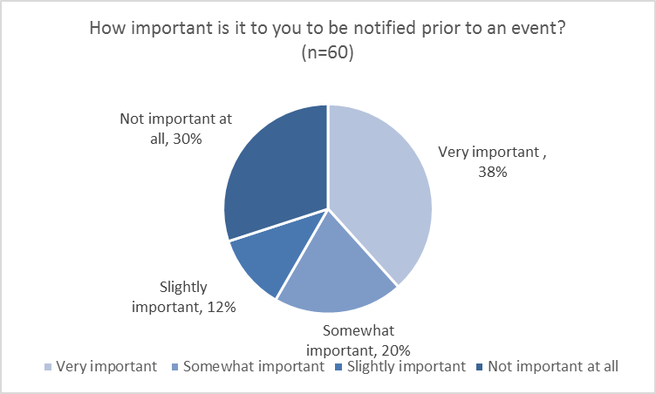

Figure 11‑14 Importance of Pre-notification for DLC Events

.

Figure 11‑15 Respondent Preferences for Prenotification

Respondents indicated a preference for text message and email communication to notify them about pending events.

The Evaluators subset the data to identify the communication preferences of respondents that indicated that prenotification is “very important”. These values are presented in Figure 11‑16. Though there is a slightly increased preference for text message communication, the difference is not statistically significant from the overall survey sample.

Figure 11‑16 Preferences for Prenotification Among Respondents that State Prenotification is “Very Important”

#### Participant Satisfaction

Satisfaction results are presented in Figure 11‑17.

Figure 11‑17 Participant Satisfaction

Common issues identified by respondents:

1. **Belief that the program would result in a reduced energy bill.** 5% of respondents stated unprompted in an open-ended question that they were disappointed that their bill didn’t go down; the program is not designed to do this.
2. **Uncertainty as to how the equipment works.** Similar to Point #1, respondents indicated needing a more thorough explanation of how the equipment works and what they can expect.
3. **Respondents want feedback.** In an open-ended question asking for comments about the program, 10% gave an unsolicited response stating that they would like to be told how they performed after an event.
4. **5% of respondents do not recall receiving an incentive for participating.**

Respondents were then asked to identify their interest in participating in the program in the future, and their likelihood of referring a friend or relative. These are presented in Figure 11‑18 and Figure 11‑19.

Figure 11‑18 Interest in Future Participation

Figure 11‑19 Likelihood of Referral

### Program Recommendations

The Evaluators recommendations are as follows:

* **Run more aggressive curtailment events.** Only 6.7% of respondents noticed any discomfort, and in most events the mean indoor temperature increase was less than .5 degrees Fahrenheit. There is room to run a more aggressive curtailment strategy.
* **Ensure that all outreach strategies specifically mention Entergy.** Of the 10% of respondents that indicated concerns about participating, half of the concerns pertained to program legitimacy.
* **Conduct prenotifications with text and email, with telephone as an opt-in back up.** These are the preferred modes of communication among most respondents and are low-cost methods. However, 11.7% of respondents (13.0% of those that stated that prenotification is “very important”) indicated a preference for a phone call for prenotification. The Evaluators recommend having a checkbox option in the program application to be notified by telephone, with text and/or email communication as the default.
* **Offer a $25 incentive for customer referral to expand the program if round two recruitment efforts stall.** 35% of respondents stated that the “probably will” and 33.3% stated that they “definitely will” refer a friend or relative to the program. If program implementation contractors face difficulties in recruiting then current participants should be contacted with a referral offer (limit one per customer).
* **Include an automated thank-you message after an event has concluded.** Respondents indicated an interest in knowing how they performed. A thank-you message with a demand reduction estimation (denominated in percent of use reduction) could be used to further encourage enthusiasm among program participants.

# Appendix A: Site Reports

## Small Business Program

|  |  |
| --- | --- |
| **Project Number** | PRJ-854410 |
| **Program** | Small Business |

# **Project Background**

The participant is a retail store that received incentives from Entergy New Orleans for implementing energy efficient lighting. On-site, the evaluators verified the participant had installed:

|  |
| --- |
| * (15) 11W LED fixtures replaced (15) 120W incandescent fixtures. |

In addition to verifying the installation and operation of these measures, the Evaluators also left light-monitoring equipment on site to monitor a portion of the newly-installed lighting for two or more weeks.

# **Calculation Parameters**

Savings calculations were performed using savings methodology described in Section 9.2.1.1 Lighting and Controls Savings Calculations. Savings parameters used are shown in Table A below:

*Table A, Savings Parameters*

|  |  |  |  |  |  |
| --- | --- | --- | --- | --- | --- |
| ***Building Type*** | ***Heating Type*** | ***Annual Hours*** | ***IEFE*** | ***IEFD*** | ***CF*** |
| Retail | Electric Resistance | 8,534 | 0.87 | 1.20 | 90% |

# **Savings Calculations**

*Table B, Lighting Retrofit kWh Savings Calculations*

|  |  |  |  |  |  |  |  |  |  |
| --- | --- | --- | --- | --- | --- | --- | --- | --- | --- |
| Measure | *Quantity (Fixtures)* | | *Wattage* | | *AOH* | *Expected kWh Savings* | *Realized kWh Savings* | *IEFE* | *Realization Rate* |
| *Base* | *Post* | *Base* | *Post* |
| I120 to LEDINT11W | 15 | 15 | 120 | 11 | 8,534 | 5,218 | 12,139 | 0.87 | 232.6% |
| **Total** | | | | | | **5,218** | **12,139** |  | **232.6%** |

*Table C, Lighting Retrofit kW Savings Calculations*

|  |  |  |  |  |  |  |  |  |  |
| --- | --- | --- | --- | --- | --- | --- | --- | --- | --- |
| ***Measure*** | ***Quantity (Fixtures)*** | | ***Wattage*** | | ***CF*** | ***Expected kW Savings*** | ***Realized kW Savings*** | ***IEFD*** | ***Realization Rate*** |
| ***Base*** | ***Post*** | ***Base*** | ***Post*** |
| I120 to LEDINT11W | 15 | 15 | 120 | 11 | 0.90 | 1.77 | 1.77 | 1.20 | 100.0% |
| **Total** | | | | | | **1.77** | **1.77** |  | **100.0%** |

# **Results**

The kWh realization rate for project PRJ-854410 is 232.6% and the kW realization rate is 100%.

The kWh realization rate is high the evaluators determine, through monitoring, that the lamps operated 8,534 hours annually; the ex ante calculation estimated that these hours were 3,668 annually. The hours logged matched hours reported through on-site interviews.

*Table D, Verified Gross Savings & Realization Rates*

|  |  |  |  |  |
| --- | --- | --- | --- | --- |
| ***Measure*** | ***Verified*** | | | |
| ***kWh Savings*** | ***kW Savings*** | ***kWh Realization Rate*** | ***kW Realization Rate*** |
| I120 to LEDINT11W | 12,139 | 1.77 | 232.6% | 100.0% |
| **Total** | **12,139** | **1.77** | **232.6%** | **100.0%** |

|  |  |
| --- | --- |
| **Project Number** | PRJ-1017239 |
| **Program** | Small Business |

# **Project Background**

The participant is a retail location that received incentives from Entergy New Orleans for implementing energy efficient lighting in the parking lot. On-site, the evaluators verified the participant had installed:

|  |
| --- |
| * (10) 10W LED fixtures replaced (10) 90W 1-Lamp Halogen fixtures; * (8) 8W LED fixtures replaced (8) 50W 1-Lamp Halogen fixtures; * (8) 76W LED fixtures replaced (8) 4’ 3-Lamp T12ES fixtures; * (2) 38W LED fixtures replaced (2) 4’ 2-Lamp T12ES fixtures; * (2) 38W LED fixtures replaced (2) 4’ 4-Lamp T8 fixtures; * (1) 10W LED fixtures replaced (1) 75W 1-Lamp Halogen fixtures; * (4) 5W LED fixtures replaced (4) 60W Incandescent lamps; and * (1) 5W LED fixtures replaced (1) 14W CFLs lamps. |

# **Calculation** **Parameters**

Savings calculations were performed using savings methodology described in Section 9.2.1.1 Lighting and Controls Savings Calculations. Savings parameters used are shown in Table A below:

*Table A, Savings Parameters*

|  |  |  |  |  |  |
| --- | --- | --- | --- | --- | --- |
| ***Building Type*** | ***Heating Type*** | ***Annual Hours*** | ***IEFE*** | ***IEFD*** | ***CF*** |
| Showroom | Electric Resistance | 3,346 | 0.87 | 1.20 | 0.90 |
| Office | Electric Resistance | 3,713 | 0.87 | 1.20 | 0.90 |

# **Savings Calculations**

*Table B, Lighting Retrofit kWh Savings Calculations*

|  |  |  |  |  |  |  |  |  |  |
| --- | --- | --- | --- | --- | --- | --- | --- | --- | --- |
| Measure | *Quantity (Fixtures)* | | *Wattage* | | *AOH* | *Expected kWh Savings* | *Realized kWh Savings* | *IEFE* | *Realization Rate* |
| *Base* | *Post* | *Base* | *Post* |
| H90 to LEDINT10W | 10 | 10 | 90 | 10 | 3,346 | 2,553 | 2,329 | 0.87 | 91.2% |
| H50 to LEDINT18W | 8 | 8 | 50 | 8 | 3,346 | 1,072 | 978 | 0.87 | 91.2% |
| F40T12/ES to LED76W | 8 | 8 | 112 | 76 | 3,346 | 919 | 838 | 0.87 | 91.2% |
| F40T12/ES to LED38W | 2 | 2 | 58 | 38 | 3,713 | 128 | 129 | 0.87 | 100.9% |
| F32T8 to LED38W | 2 | 2 | 112 | 38 | 3,713 | 472 | 478 | 0.87 | 101.3% |
| H75 to LEDINT10W | 1 | 1 | 75 | 10 | 3,713 | 207 | 210 | 0.87 | 101.4% |
| I60 to LEDINT5W | 4 | 4 | 43 | 5 | 3,713 | 485 | 491 | 0.87 | 101.2% |
| CF14W to LEDINT5W | 1 | 1 | 14 | 5 | 3,713 | 29 | 29 | 0.87 | 100.3% |
| **Total** | | | | | | **5,865** | **5,483** |  | **93.5%** |

*Table C, Lighting Retrofit kW Savings Calculations*

|  |  |  |  |  |  |  |  |  |  |
| --- | --- | --- | --- | --- | --- | --- | --- | --- | --- |
| ***Measure*** | ***Quantity (Fixtures)*** | | ***Wattage*** | | ***CF*** | ***Expected kW Savings*** | ***Realized kW Savings*** | ***IEFD*** | ***Realization Rate*** |
| ***Base*** | ***Post*** | ***Base*** | ***Post*** |
| H90 to LEDINT10W | 10 | 10 | 90 | 10 | 0.90 | 0.86 | 0.86 | 1.20 | 100.0% |
| H50 to LEDINT18W | 8 | 8 | 50 | 8 | 0.90 | 0.36 | 0.36 | 1.20 | 100.0% |
| F40T12/ES to LED76W | 8 | 8 | 112 | 76 | 0.90 | 0.31 | 0.31 | 1.20 | 100.0% |
| F40T12/ES to LED38W | 2 | 2 | 58 | 38 | 0.90 | 0.04 | 0.04 | 1.20 | 100.0% |
| F32T8 to LED38W | 2 | 2 | 112 | 38 | 0.90 | 0.16 | 0.16 | 1.20 | 100.0% |
| H75 to LEDINT10W | 1 | 1 | 75 | 10 | 0.90 | 0.07 | 0.07 | 1.20 | 100.0% |
| I60 to LEDINT5W | 4 | 4 | 43 | 5 | 0.90 | 0.16 | 0.16 | 1.20 | 100.0% |
| CF14W to LEDINT5W | 1 | 1 | 14 | 5 | 0.90 | 0.01 | 0.01 | 1.20 | 100.0% |
| **Total** | | | | | | **1.97** | **1.97** |  | **100.0%** |

# **Results**

The kWh realization rate for project PRJ-1017239 is 93.5% and the kW realization rate is 100%.

The kWh realization rate is low because the evaluators, through monitoring, verified lower hour of use (3,346) in the showroom. The Ex Ante estimates used 3,668 hours for this space type.

*Table D, Verified Gross Savings & Realization Rates*

|  |  |  |  |  |
| --- | --- | --- | --- | --- |
| ***Measure*** | ***Verified*** | | | |
| ***kWh Savings*** | ***kW Savings*** | ***kWh Realization Rate*** | ***kW Realization Rate*** |
| H90 to LEDINT10W | 2,329 | 0.86 | 91.2% | 100.0% |
| H50 to LEDINT18W | 978 | 0.36 | 91.2% | 100.0% |
| F40T12/ES to LED76W | 838 | 0.31 | 91.2% | 100.0% |
| F40T12/ES to LED38W | 129 | 0.04 | 100.9% | 100.0% |
| F32T8 to LED38W | 478 | 0.16 | 101.3% | 100.0% |
| H75 to LEDINT10W | 210 | 0.07 | 101.4% | 100.0% |
| I60 to LEDINT5W | 491 | 0.16 | 101.2% | 100.0% |
| CF14W to LEDINT5W | 29 | 0.01 | 100.3% | 100.0% |
| **Total** | **5,483** | **1.97** | **93.5%** | **100.0%** |

|  |  |
| --- | --- |
| **Project Number** | PRJ-787045 |
| **Program** | Small Business |

# **Project Background**

The participant is a bar that received incentives from Entergy New Orleans for implementing energy efficient lighting throughout the facility. On-site, the evaluators verified the participant had installed:

|  |
| --- |
| * (3) 15W LED fixtures replaced (3) 150w 1-lamp halogen fixtures; * (14) 10W LED lamps replaced (14) 60w incandescent lamps; * (19) 9W LED fixtures replaced (19) 65w 1-lamp halogen fixtures; and * (4) 6W LED lamps replaced (4) 40w incandescent lamps. |

In addition to verifying the installation and operation of these measures, the Evaluators also left light-monitoring equipment on site to monitor a portion of the newly-installed lighting for two or more weeks.

# **Calculation Parameters**

Savings calculations were performed using savings methodology described in Section 9.2.1.1 Lighting and Controls Savings Calculations. Savings parameters used are shown in Table A below:

*Table A, Savings Parameters*

|  |  |  |  |  |  |
| --- | --- | --- | --- | --- | --- |
| ***Building Type*** | ***Heating Type*** | ***Annual Hours*** | ***IEFE*** | ***IEFD*** | ***CF*** |
| Outdoor | None | 4,319 | 1.00 | 1.00 | 0% |
| Restaurant / Bar Area | Electric Resistance | 4,899 | 0.87 | 1.20 | 81% |

# **Savings Calculations**

*Table B, Lighting Retrofit kWh Savings Calculations*

|  |  |  |  |  |  |  |  |  |  |
| --- | --- | --- | --- | --- | --- | --- | --- | --- | --- |
| Measure | *Quantity (Fixtures)* | | *Wattage* | | *AOH* | *Expected kWh Savings* | *Realized kWh Savings* | *IEFE* | *Realization Rate* |
| *Base* | *Post* | *Base* | *Post* |
| H150 to LEDINT15W | 3 | 3 | 150 | 15 | 4,319 | 1,618 | 1,749 | 1.00 | 108.1% |
| I60/ES to LEDINT10W | 14 | 14 | 43 | 10 | 4,319 | 1,846 | 1,995 | 1.00 | 108.1% |
| H65 to LEDINT9W | 19 | 19 | 65 | 9 | 4,899 | 4,043 | 4,534 | 0.87 | 112.2% |
| I40 to LEDINT6W | 4 | 4 | 40 | 6 | 4,899 | 517 | 580 | 0.87 | 112.1% |
| **Total** | | | | | | **8,024** | **8,859** |  | **110.4%** |

*Table C, Lighting Retrofit kW Savings Calculations*

|  |  |  |  |  |  |  |  |  |  |
| --- | --- | --- | --- | --- | --- | --- | --- | --- | --- |
| ***Measure*** | ***Quantity (Fixtures)*** | | ***Wattage*** | | ***CF*** | ***Expected kW Savings*** | ***Realized kW Savings*** | ***IEFD*** | ***Realization Rate*** |
| ***Base*** | ***Post*** | ***Base*** | ***Post*** |
| H150 to LEDINT15W | 3 | 3 | 150 | 15 | 0.00 | 0.00 | 0.00 | 1.00 | N/A |
| I60/ES to LEDINT10W | 14 | 14 | 43 | 10 | 0.00 | 0.00 | 0.00 | 1.00 | N/A |
| H65 to LEDINT9W | 19 | 19 | 65 | 9 | 0.81 | 1.03 | 1.03 | 1.20 | 100.0% |
| I40 to LEDINT6W | 4 | 4 | 40 | 6 | 0.81 | 0.13 | 0.13 | 1.20 | 100.0% |
| **Total** | | | | | | **1.16** | **1.16** |  | **100.0%** |

# **Results**

The kWh realization rate for project PRJ-787045 is 110.4% and the kW realization rate is 100%.

The interior hours changed from 4,368 hours to 4,899, due to onsite monitoring, resulted in an increase in kWh savings of 554 kWh. The exterior hours changed from 3,996 to 4,319.

*Table D, Verified Gross Savings & Realization Rates*

|  |  |  |  |  |
| --- | --- | --- | --- | --- |
| ***Measure*** | ***Verified*** | | | |
| ***kWh Savings*** | ***kW Savings*** | ***kWh Realization Rate*** | ***kW Realization Rate*** |
| H150 to LEDINT15W | 1,749 | 0.00 | 108.1% | N/A |
| I60/ES to LEDINT10W | 1,995 | 0.00 | 108.1% | N/A |
| H65 to LEDINT9W | 4,534 | 1.03 | 112.2% | 100.0% |
| I40 to LEDINT6W | 580 | 0.13 | 112.1% | 100.0% |
| **Total** | **8,859** | **1.16** | **110.4%** | **100.0%** |

|  |  |
| --- | --- |
| **Project Number** | PRJ-820455 |
| **Program** | Small Business |

# **Project Background**

The participant is a restaurant that received incentives from Entergy New Orleans for implementing energy efficient lighting in the parking lot. On-site, the evaluators verified the participant had installed:

|  |
| --- |
| * (32) 13W LED fixtures replaced (32) 23W CFL lamps; * (5) 9W LED fixtures replaced (5) 23W CFL lamps; * (19) 9W LED fixtures replaced (19) 23W CFL lamps; * (6) 7W LED fixtures replaced (6) 60w incandescent lamps; * (2) 7W LED fixtures replaced (2) 50w 1-lamp halogen fixtures; * (1) 36W LED fixtures replaced (1) 4' 2-lamp T12 fixtures; * (2) 72W LED fixtures replaced (2) 4' 4-lamp T8 fixtures; * (4) 72W LED fixtures replaced (4) 4' 4-lamp T8 fixtures; * (20) 72W LED fixtures replaced (20) 4' 3-lamp T12 fixtures; * (1) 36W LED fixtures replaced (1) 4' 3-lamp T12 fixtures; and * (1) 36W LED fixtures replaced (1) 4' 4-lamp T8 fixtures. |

In addition to verifying the installation and operation of these measures, the Evaluators also left light-monitoring equipment on site to monitor a portion of the newly-installed lighting for two or more weeks.

# **Calculation Parameters**

Savings calculations were performed using savings methodology described in Section 9.2.1.1 Lighting and Controls Savings Calculations. Savings parameters used are shown in Table A below:

*Table A, Savings Parameters*

|  |  |  |  |  |  |
| --- | --- | --- | --- | --- | --- |
| ***Building Type*** | ***Heating Type*** | ***Annual Hours*** | ***IEFE*** | ***IEFD*** | ***CF*** |
| Dining Area | Electric Resistance | 4,667 | 0.87 | 1.20 | 90% |
| Kitchen | Electric Resistance | 4,701 | 0.87 | 1.20 | 90% |

# **Savings Calculations**

*Table B, Lighting Retrofit kWh Savings Calculations*

|  |  |  |  |  |  |  |  |  |  |
| --- | --- | --- | --- | --- | --- | --- | --- | --- | --- |
| Measure | *Quantity (Fixtures)* | | *Wattage* | | *AOH* | *Expected kWh Savings* | *Realized kWh Savings* | *IEFE* | *Realization Rate* |
| *Base* | *Post* | *Base* | *Post* |
| CF23W to LEDINT13W | 32 | 32 | 23 | 13 | 4,646 | 948 | 1,294 | 0.87 | 136.5% |
| CF23W to LEDINT9W | 5 | 5 | 23 | 9 | 4,646 | 207 | 283 | 0.87 | 136.7% |
| CF23W to LEDINT9W | 19 | 19 | 23 | 9 | 4,646 | 788 | 1,075 | 0.87 | 136.4% |
| I60 to LEDINT7W | 6 | 6 | 60 | 7 | 4,646 | 942 | 1,285 | 0.87 | 136.4% |
| H50 to LEDINT7W | 2 | 2 | 50 | 7 | 4,646 | 255 | 348 | 0.87 | 136.5% |
| F40T12/ES to LED36W | 1 | 1 | 72 | 36 | 4,646 | 107 | 146 | 0.87 | 136.4% |
| F32T8 to LED72W | 2 | 2 | 112 | 72 | 4,646 | 237 | 323 | 0.87 | 136.3% |
| F32T8 to LED72W | 4 | 4 | 112 | 72 | 4,646 | 474 | 647 | 0.87 | 136.5% |
| F40T12/ES to LED72W | 20 | 20 | 144 | 72 | 4,667 | 4,267 | 5,846 | 0.87 | 137.0% |
| F40T12/ES to LED36W | 1 | 1 | 144 | 36 | 4,667 | 320 | 438 | 0.87 | 136.9% |
| F32T8 to LED36W | 1 | 1 | 112 | 36 | 4,646 | 225 | 307 | 0.87 | 136.4% |
| **Total** | | | | | | **8,771** | **11,992** |  | **136.7%** |

*Table C, Lighting Retrofit kW Savings Calculations*

|  |  |  |  |  |  |  |  |  |  |
| --- | --- | --- | --- | --- | --- | --- | --- | --- | --- |
| ***Measure*** | ***Quantity (Fixtures)*** | | ***Wattage*** | | ***CF*** | ***Expected kW Savings*** | ***Realized kW Savings*** | ***IEFD*** | ***Realization Rate*** |
| ***Base*** | ***Post*** | ***Base*** | ***Post*** |
| CF23W to LEDINT13W | 32 | 32 | 23 | 13 | 0.90 | 0.35 | 0.35 | 1.20 | 100.0% |
| CF23W to LEDINT9W | 5 | 5 | 23 | 9 | 0.90 | 0.08 | 0.08 | 1.20 | 100.0% |
| CF23W to LEDINT9W | 19 | 19 | 23 | 9 | 0.90 | 0.29 | 0.29 | 1.20 | 100.0% |
| I60 to LEDINT7W | 6 | 6 | 60 | 7 | 0.90 | 0.34 | 0.34 | 1.20 | 100.0% |
| H50 to LEDINT7W | 2 | 2 | 50 | 7 | 0.90 | 0.09 | 0.09 | 1.20 | 100.0% |
| F40T12/ES to LED36W | 1 | 1 | 72 | 36 | 0.90 | 0.04 | 0.04 | 1.20 | 100.0% |
| F32T8 to LED72W | 2 | 2 | 112 | 72 | 0.90 | 0.09 | 0.09 | 1.20 | 100.0% |
| F32T8 to LED72W | 4 | 4 | 112 | 72 | 0.90 | 0.17 | 0.17 | 1.20 | 100.0% |
| F40T12/ES to LED72W | 20 | 20 | 144 | 72 | 0.90 | 1.56 | 1.56 | 1.20 | 100.0% |
| F40T12/ES to LED36W | 1 | 1 | 144 | 36 | 0.90 | 0.12 | 0.12 | 1.20 | 100.0% |
| F32T8 to LED36W | 1 | 1 | 112 | 36 | 0.90 | 0.08 | 0.08 | 1.20 | 100.0% |
| **Total** | | | | | | **3.20** | **3.20** |  | **100.0%** |

# **Results**

The kWh realization rate for project PRJ-820455 is 136.7% and the kW realization rate is 100%.

The high kWh realization rate is due to updated annual operating hours that were obtained from monitoring equipment installed on site. The ex ante calculation estimated that operating hours were 3,406, while monitoring showed lighting being used between 4,646 and 4,667 hours annually, depending on space type.

*Table D, Verified Gross Savings & Realization Rates*

|  |  |  |  |  |
| --- | --- | --- | --- | --- |
| ***Measure*** | ***Verified*** | | | |
| ***kWh Savings*** | ***kW Savings*** | ***kWh Realization Rate*** | ***kW Realization Rate*** |
| CF23W to LEDINT13W | 1,294 | 0.35 | 136.5% | 100.0% |
| CF23W to LEDINT9W | 283 | 0.08 | 136.7% | 100.0% |
| CF23W to LEDINT9W | 1,075 | 0.29 | 136.4% | 100.0% |
| I60 to LEDINT7W | 1,285 | 0.34 | 136.4% | 100.0% |
| H50 to LEDINT7W | 348 | 0.09 | 136.5% | 100.0% |
| F40T12/ES to LED36W | 146 | 0.04 | 136.4% | 100.0% |
| F32T8 to LED72W | 323 | 0.09 | 136.3% | 100.0% |
| F32T8 to LED72W | 647 | 0.17 | 136.5% | 100.0% |
| F40T12/ES to LED72W | 5,846 | 1.56 | 137.0% | 100.0% |
| F40T12/ES to LED36W | 438 | 0.12 | 136.9% | 100.0% |
| F32T8 to LED36W | 307 | 0.08 | 136.4% | 100.0% |
| **Total** | **11,992** | **3.20** | **136.7%** | **100.0%** |

|  |  |
| --- | --- |
| **Project Number** | PRJ-787080 |
| **Program** | Small Business |

# **Project Background**

The participant is a restaurant that received incentives from Entergy New Orleans for implementing energy efficient lighting. On-site, the evaluators verified the participant had installed:

|  |
| --- |
| * (3) 15W LED fixtures replaced (3) 150W 1-lamp halogen fixtures; * (3) 6W LED lamps replaced (3) 45W incandescent lamps; * (2) 56W LED fixtures replaced (2) 4' 4-lamp T8 fixtures; * (1) 56W LED fixtures replaced (1) 4' 3-lamp T12 fixtures; * (22) 8W LED fixtures replaced (22) 45W 1-lamp halogen fixtures; * (2) 28W LED fixtures replaced (2) 4' 2-lamp T8 fixtures; * (3) 28W LED fixtures replaced (3) 4' 2-lamp T8 fixtures * (3) 15W LED replaced (3) 150W 1-lamp halogens fixtures; * (4) 9W LED fixtures replaced (4) 65W 1-lamp halogen fixtures; * (1) 28W LED fixtures replaced (1) 4' 2-lamp T8 fixtures; * (2) 10W LED lamps replaced (2) 60W incandescent lamps; * (5) 15W LED fixtures replaced (5) 150W 1-lamp halogen fixtures; and * (4) 9W LED fixtures replaced (4) 65W 1-lamp halogen fixtures. |

On Site, the evaluators were not able to verify

* (20) 10W LED lamps.

In addition to verifying the installation and operation of these measures, the Evaluators also left light-monitoring equipment on site to monitor a portion of the newly-installed lighting for two or more weeks.

# **Calculation Parameters**

Savings calculations were performed using savings methodology described in Section 9.2.1.1 Lighting and Controls Savings Calculations. Savings parameters used are shown in Table A below:

*Table A, Savings Parameters*

|  |  |  |  |  |  |
| --- | --- | --- | --- | --- | --- |
| ***Building Type*** | ***Heating Type*** | ***Annual Hours*** | ***IEFE*** | ***IEFD*** | ***CF*** |
| Outdoor | None | 4,319 | 1.00 | 1.00 | 0% |
| Outdoor | None | 1,274 | 1.00 | 1.00 | 0% |
| Restaurant | Electric Resistance | 8,760 | 0.87 | 1.20 | 95% |
| Restaurant Restroom | Electric Resistance | 8,448 | 0.87 | 1.20 | 95% |

# **Savings Calculations**

*Table B, Lighting Retrofit kWh Savings Calculations*

|  |  |  |  |  |  |  |  |  |  |
| --- | --- | --- | --- | --- | --- | --- | --- | --- | --- |
| Measure | *Quantity (Fixtures)* | | *Wattage* | | *AOH* | *Expected kWh Savings* | *Realized kWh Savings* | *IEFE* | *Realization Rate* |
| *Base* | *Post* | *Base* | *Post* |
| H150 to LEDINT15W | 3 | 3 | 150 | 15 | 4,319 | 1,618 | 1,749 | 1.00 | 108.1% |
| I60 to LEDINT10W | 0 | 0 | 43 | 10 | 4,319 | 2,637 | 0 | 1.00 | 0.0% |
| I45 to LEDINT6W | 3 | 3 | 45 | 6 | 8,760 | 630 | 892 | 0.87 | 141.5% |
| F32T8 to LED56W | 2 | 2 | 112 | 56 | 8,760 | 603 | 854 | 0.87 | 141.6% |
| F40T12/ES to LED56W | 1 | 1 | 144 | 56 | 8,760 | 474 | 671 | 0.87 | 141.5% |
| H45 to LEDINT8W | 22 | 22 | 45 | 8 | 8,760 | 4,382 | 6,204 | 0.87 | 141.6% |
| F32T8 to LED28W | 2 | 2 | 58 | 28 | 8,448 | 323 | 441 | 0.87 | 136.5% |
| F32T8 to LED28W | 3 | 3 | 58 | 28 | 8,448 | 485 | 661 | 0.87 | 136.4% |
| H150 to LEDINT15W | 3 | 3 | 150 | 15 | 8,760 | 2,180 | 3,087 | 0.87 | 141.6% |
| H65 to LEDINT9W | 4 | 4 | 65 | 9 | 8,760 | 1,206 | 1,707 | 0.87 | 141.6% |
| F32T8 to LED28W | 1 | 1 | 58 | 28 | 8,760 | 162 | 229 | 0.87 | 141.1% |
| I60 to LEDINT10W | 2 | 2 | 43 | 10 | 8,760 | 355 | 503 | 0.87 | 141.7% |
| H150 to LEDINT15W | 5 | 5 | 150 | 15 | 1,274 | 2,697 | 860 | 1.00 | 31.9% |
| H65 to LEDINT9W | 4 | 4 | 65 | 9 | 4,319 | 895 | 967 | 1.00 | 108.1% |
| **Total** | | | | | | **18,647** | **18,824** |  | **100.9%** |

*Table C, Lighting Retrofit kW Savings Calculations*

|  |  |  |  |  |  |  |  |  |  |
| --- | --- | --- | --- | --- | --- | --- | --- | --- | --- |
| ***Measure*** | ***Quantity (Fixtures)*** | | ***Wattage*** | | ***CF*** | ***Expected kW Savings*** | ***Realized kW Savings*** | ***IEFD*** | ***Realization Rate*** |
| ***Base*** | ***Post*** | ***Base*** | ***Post*** |
| H150 to LEDINT15W | 3 | 3 | 150 | 15 | 0.00 | 0.00 | 0.00 | 1.00 | N/A |
| I60 to LEDINT10W | 0 | 0 | 43 | 10 | 0.00 | 0.00 | 0.00 | 1.00 | N/A |
| I45 to LEDINT6W | 3 | 3 | 45 | 6 | 1.00 | 0.11 | 0.14 | 1.20 | 127.3% |
| F32T8 to LED56W | 2 | 2 | 112 | 56 | 1.00 | 0.11 | 0.13 | 1.20 | 118.2% |
| F40T12/ES to LED56W | 1 | 1 | 144 | 56 | 1.00 | 0.09 | 0.11 | 1.20 | 122.2% |
| H45 to LEDINT8W | 22 | 22 | 45 | 8 | 1.00 | 0.79 | 0.98 | 1.20 | 124.1% |
| F32T8 to LED28W | 2 | 2 | 58 | 28 | 1.00 | 0.06 | 0.07 | 1.20 | 116.7% |
| F32T8 to LED28W | 3 | 3 | 58 | 28 | 1.00 | 0.09 | 0.11 | 1.20 | 122.2% |
| H150 to LEDINT15W | 3 | 3 | 150 | 15 | 1.00 | 0.39 | 0.49 | 1.20 | 125.6% |
| H65 to LEDINT9W | 4 | 4 | 65 | 9 | 1.00 | 0.22 | 0.27 | 1.20 | 122.7% |
| F32T8 to LED28W | 1 | 1 | 58 | 28 | 1.00 | 0.03 | 0.04 | 1.20 | 133.3% |
| I60 to LEDINT10W | 2 | 2 | 43 | 10 | 1.00 | 0.06 | 0.08 | 1.20 | 133.3% |
| H150 to LEDINT15W | 5 | 5 | 150 | 15 | 0.00 | 0.00 | 0.00 | 1.00 | N/A |
| H65 to LEDINT9W | 4 | 4 | 65 | 9 | 0.00 | 0.00 | 0.00 | 1.00 | N/A |
| **Total** | | | | | | **1.95** | **2.42** |  | **124.1%** |

# **Results**

The kWh realization rate for project PRJ-787080 is 100.9% and the kW realization rate is 124.1%.

The high kWh savings is due to the higher annual hours used in the ex post calculations. The evaluators monitored lighting in the kitchen, dining room, and restrooms in this facility. Logging data verified on-site interviews that the site is open 8,760 hours annually.

The high kW savings is due to the increase in CF from 0.81 to 1.00. The increase in CF is due to the lighting being on for 8,760 hours annually instead of 6,188 hours annually.

*Table D, Verified Gross Savings & Realization Rates*

|  |  |  |  |  |
| --- | --- | --- | --- | --- |
| ***Measure*** | ***Verified*** | | | |
| ***kWh Savings*** | ***kW Savings*** | ***kWh Realization Rate*** | ***kW Realization Rate*** |
| H150 to LEDINT15W | 1,749 | 0.00 | 108.1% | N/A |
| I60 to LEDINT10W | 0 | 0.00 | 0.0% | N/A |
| I45 to LEDINT6W | 892 | 0.14 | 141.5% | 127.3% |
| F32T8 to LED56W | 854 | 0.13 | 141.6% | 118.2% |
| F40T12/ES to LED56W | 671 | 0.11 | 141.5% | 122.2% |
| H45 to LEDINT8W | 6,204 | 0.98 | 141.6% | 124.1% |
| F32T8 to LED28W | 441 | 0.07 | 136.5% | 116.7% |
| F32T8 to LED28W | 661 | 0.11 | 136.4% | 122.2% |
| H150 to LEDINT15W | 3,087 | 0.49 | 141.6% | 125.6% |
| H65 to LEDINT9W | 1,707 | 0.27 | 141.6% | 122.7% |
| F32T8 to LED28W | 229 | 0.04 | 141.1% | 133.3% |
| I60 to LEDINT10W | 503 | 0.08 | 141.7% | 133.3% |
| H150 to LEDINT15W | 860 | 0.00 | 31.9% | N/A |
| H65 to LEDINT9W | 967 | 0.00 | 108.1% | N/A |
| **Total** | **18,824** | **2.42** | **100.9%** | **124.1%** |

|  |  |
| --- | --- |
| **Project Number** | PRJ-1029612 |
| **Program** | Small Business |

# **Project Background**

The participant is a retail store that received incentives from Entergy New Orleans for implementing energy efficient lighting. On-site, the evaluators verified the participant had installed:

|  |
| --- |
| * (317) 21W LED fixtures, replacing (317) 28W 2L Linear Fluorescents; * (22) 21W LED fixtures, replacing (22) 28W 1L Linear Fluorescents; and * (2) 43W LED fixtures, replacing (2) 28W 2L Linear Fluorescents. |

In addition to verifying the installation and operation of these measures, the Evaluators also left light-monitoring equipment on site to monitor a portion of the newly-installed lighting for two or more weeks.

# **Calculation Parameters**

Savings calculations were performed using savings methodology described in Section 9.2.1.1 Lighting and Controls Savings Calculations. Savings parameters used are shown in Table A below:

*Table A, Savings Parameters*

|  |  |  |  |  |  |
| --- | --- | --- | --- | --- | --- |
| ***Building Type*** | ***Heating Type*** | ***Annual Hours*** | ***IEFE*** | ***IEFD*** | ***CF*** |
| Retail: Stock Room | Electric Resistance | 5,471 | 0.87 | 1.20 | 90% |
| Retail: Main Area | Electric Resistance | 8,568 | 0.87 | 1.20 | 90% |
| Security Lighting | Electric Resistance | 8,760 | 0.87 | 1.20 | 90% |

# **Savings Calculations**

*Table B, Lighting Retrofit kWh Savings Calculations*

|  |  |  |  |  |  |  |  |  |  |
| --- | --- | --- | --- | --- | --- | --- | --- | --- | --- |
| **Measure** | ***Quantity (Fixtures)*** | | ***Wattage*** | | ***AOH*** | ***Expected kWh Savings*** | ***Realized kWh Savings*** | ***IEFE*** | ***Realization Rate*** |
| ***Base*** | ***Post*** | ***Base*** | ***Post*** |
| F42IRLL to LED021-FIXT | 309 | 309 | 52 | 21 | 5,471 | 30,568 | 45,593 | 0.87 | 149% |
| F42IRLL to LED021-FIXT | 4 | 4 | 52 | 21 | 8,760 | 396 | 945.03 | 0.87 | 239% |
| F41IRLL to LED021-FIXT | 11 | 11 | 27 | 21 | 8,568 | 211 | 492 | 0.87 | 234% |
| F42IRLL to LED043-FIXT | 2 | 2 | 52 | 43 | 5,471 | 57 | 86 | 0.87 | 149% |
| F42IRLL to LED021-FIXT | 1 | 1 | 52 | 21 | 5,471 | 99 | 148 | 0.87 | 149% |
| F42IRLL to LED021-FIXT | 2 | 2 | 52 | 21 | 5,471 | 198 | 295 | 0.87 | 149% |
| F42IRLL to LED021-FIXT | 1 | 1 | 52 | 21 | 5,471 | 99 | 148 | 0.87 | 149% |
| F41IRLL to LED021-FIXT | 11 | 11 | 27 | 21 | 8,568 | 211 | 492 | 0.87 | 234% |
| **Total:** | | | | | | **31,838** | **48,199** | **-** | **151%** |

*Table C, Occupancy Sensor kWh Savings Calculations*

|  |  |  |  |  |  |  |  |  |
| --- | --- | --- | --- | --- | --- | --- | --- | --- |
| **Measure** | ***Quantity (Fixtures)*** | ***Wattage*** | ***AOH*** | ***Controls Reduction*** | ***Expected kWh Savings*** | ***Realized kWh Savings*** | ***IEFE*** | ***Realization Rate*** |
| Occupancy Sensor on LED21W | 1 | 21 | 5,471 | 70% | 20 | 30 | 0.87 | 149% |
| Occupancy Sensor on LED21W | 2 | 21 | 5,471 | 70% | 40 | 60 | 0.87 | 149% |
| **Total:** | | | | | **60** | **90** |  | **149%** |

*Table 11‑1, Lighting Retrofit kW Savings Calculations*

|  |  |  |  |  |  |  |  |  |  |
| --- | --- | --- | --- | --- | --- | --- | --- | --- | --- |
| ***Measure*** | ***Quantity (Fixtures)*** | | ***Wattage*** | | ***CF*** | ***Expected kW Savings*** | ***Realized kW Savings*** | ***IEFD*** | ***Realization Rate*** |
| ***Base*** | ***Post*** | ***Base*** | ***Post*** |
| F42IRLL to LED021-FIXT | 309 | 309 | 52 | 21 | 0.9 | 10.35 | 10.35 | 1.2 | 100% |
| F42IRLL to LED021-FIXT | 4 | 4 | 52 | 21 | 0.9 | 0.13 | 0.13 | 1.2 | 100% |
| F41IRLL to LED021-FIXT | 11 | 11 | 27 | 21 | 0.9 | 0.07 | 0.07 | 1.2 | 100% |
| F42IRLL to LED043-FIXT | 2 | 2 | 52 | 43 | 0.9 | 0.02 | 0.02 | 1.2 | 100% |
| F42IRLL to LED021-FIXT | 1 | 1 | 52 | 21 | 0.9 | 0.03 | 0.03 | 1.2 | 100% |
| F42IRLL to LED021-FIXT | 2 | 2 | 52 | 21 | 0.9 | 0.07 | 0.07 | 1.2 | 100% |
| F42IRLL to LED021-FIXT | 1 | 1 | 52 | 21 | 0.9 | 0.03 | 0.03 | 1.2 | 100% |
| F41IRLL to LED021-FIXT | 11 | 11 | 27 | 21 | 0.9 | 0.07 | 0.07 | 1.2 | 100% |
| **Total:** | | | | | | **10.78** | **10.78** | **-** | **100%** |

*Table E, Occupancy Sensor kW Savings Calculations*

|  |  |  |  |  |  |  |  |  |  |
| --- | --- | --- | --- | --- | --- | --- | --- | --- | --- |
| **Measure** | ***Quantity (Fixtures)*** | ***Wattage*** | ***AOH*** | ***Peak Reduction*** | ***CF*** | ***Expected kWh Savings*** | ***Realized kWh Savings*** | ***IEFE*** | ***Realization Rate*** |
| Occupancy Sensor on LED21W | 1 | 21 | 5,471 | 0.26 | 0.90 | 0.01 | 0.01 | 1.20 | 100% |
| Occupancy Sensor on LED21W | 2 | 21 | 5,471 | 0.26 | 0.90 | 0.01 | 0.01 | 1.20 | 100% |
| **Total:** | | | | | | **0.02** | **0.02** | **2.40** | **100%** |

# **Results**

The kWh realization rate for project PRJ-1029612 is 152% and the kW realization rate is 100%.

The high kWh realization rate is due to updated annual operating hours that were obtained from monitoring equipment installed on site. The ex ante calculation estimated that operating hours were 3,668, while monitoring showed lighting being used between 5,471 and 8,760 hours annually, depending on space type.

*Table F, Verified Gross Savings & Realization Rates*

|  |  |  |  |  |
| --- | --- | --- | --- | --- |
| ***Measure*** | ***Verified*** | | | |
| ***kWh Savings*** | ***kW Savings*** | ***kWh Realization Rate*** | ***kW Realization Rate*** |
| F42IRLL to LED021-FIXT | 45,593 | 10.35 | 149% | 100% |
| F42IRLL to LED021-FIXT | 945.03 | 0.13 | 239% | 100% |
| F41IRLL to LED021-FIXT | 492 | 0.07 | 234% | 100% |
| F42IRLL to LED043-FIXT | 86 | 0.02 | 149% | 100% |
| F42IRLL to LED021-FIXT | 148 | 0.03 | 149% | 100% |
| F42IRLL to LED021-FIXT | 295 | 0.07 | 149% | 100% |
| F42IRLL to LED021-FIXT | 148 | 0.03 | 149% | 100% |
| F41IRLL to LED021-FIXT | 492 | 0.07 | 234% | 100% |
| Occupancy Sensor(s) | 30 | 0.01 | 149% | 100% |
| Occupancy Sensor(s) | 60 | 0.01 | 149% | 100% |
| **Total:** | **48,289** | **10.79** | **152%** | **100%** |

|  |  |
| --- | --- |
| **Project Number** | PRJ-818611 |
| **Program** | Small Business |

# **Project Background**

The participant is a billboard that received incentives from Entergy New Orleans for implementing energy efficient lighting in the parking lot. On-site, the evaluators verified the participant had installed:

|  |
| --- |
| * (8) 323W LED fixtures replaced (8) 1000W Metal Halide fixtures; and * (4) 300W LED fixtures replaced (4) 1000W Metal Halides. |

# **Calculation Parameters**

Savings calculations were performed using savings methodology described in Section 9.2.1.1 Lighting and Controls Savings Calculations. Savings parameters used are shown in Table A below:

*Table A, Savings Parameters*

|  |  |  |  |  |  |
| --- | --- | --- | --- | --- | --- |
| ***Building Type*** | ***Heating Type*** | ***Annual Hours*** | ***IEFE*** | ***IEFD*** | ***CF*** |
| Outdoor | None | 4,319 | 1.00 | 1.00 | 0.00 |

# **Savings Calculations**

*Table B, Lighting Retrofit kWh Savings Calculations*

|  |  |  |  |  |  |  |  |  |  |
| --- | --- | --- | --- | --- | --- | --- | --- | --- | --- |
| Measure | *Quantity (Fixtures)* | | *Wattage* | | *AOH* | *Expected kWh Savings* | *Realized kWh Savings* | *IEFE* | *Realization Rate* |
| *Base* | *Post* | *Base* | *Post* |
| MH1000 to LED323W | 8 | 8 | 1,078 | 323 | 4,319 | 24,136 | 26,087 | 1.00 | 108.1% |
| MH1000 to LED300W | 4 | 4 | 1,078 | 300 | 4,319 | 12,436 | 13,441 | 1.00 | 108.1% |
| **Total** | | | | | | **36,572** | **39,527** |  | **108.1%** |

*Table C, Lighting Retrofit kW Savings Calculations*

|  |  |  |  |  |  |  |  |  |  |
| --- | --- | --- | --- | --- | --- | --- | --- | --- | --- |
| ***Measure*** | ***Quantity (Fixtures)*** | | ***Wattage*** | | ***CF*** | ***Expected kW Savings*** | ***Realized kW Savings*** | ***IEFD*** | ***Realization Rate*** |
| ***Base*** | ***Post*** | ***Base*** | ***Post*** |
| MH1000 to LED323W | 8 | 8 | 1,078 | 323 | 0.00 | 0.00 | 0.00 | 1.00 | N/A |
| MH1000 to LED300W | 4 | 4 | 1,078 | 300 | 0.00 | 0.00 | 0.00 | 1.00 | N/A |
| **Total** | | | | | | **0.00** | **0.00** | **-** | **N/A** |

# **Results**

The kWh realization rate for project PRJ-818611 is 108.1% and the kW realization rate is not applicable.

The kWh savings are high because ex-ante calculation used 3,996 hours annually; our analyst calculated non daylight hours to be 4,319 hours. This increase resulted in an increased savings of 2,955 or 8.1%. The kW savings are not applicable because the lights are outdoors and do not operate during peak hours.

*Table D, Verified Gross Savings & Realization Rates*

|  |  |  |  |  |
| --- | --- | --- | --- | --- |
| ***Measure*** | ***Verified*** | | | |
| ***kWh Savings*** | ***kW Savings*** | ***kWh Realization Rate*** | ***kW Realization Rate*** |
| MH1000 to LED323W | 26,087 | 0.00 | 108.1% | N/A |
| MH1000 to LED300W | 13,441 | 0.00 | 108.1% | N/A |
| **Total** | **39,527** | **0.00** | **108.1%** | **N/A** |

|  |  |
| --- | --- |
| **Project Number** | PRJ-837114 |
| **Program** | Small Business |

# **Project Background**

The participant is a gas station food store that received incentives from Entergy New Orleans for implementing energy efficient lighting. On-site, the evaluators verified the participant had installed:

|  |
| --- |
| * (20) 114W LED fixtures replaced (20) 320W metal halide fixtures; * (1) 50W LED fixtures replaced (1) 175W mercury vapor fixture; * (2) 156W LED fixtures replaced (1) 400W metal halide fixtures; * (2) 45W LED fixtures replaced (2) 150W metal halide fixtures; * (1) 80W LED fixtures replaced (1) 400W metal halide fixtures; * (18) 35W LED fixtures replaced (18) 4' 3-lamp T12 fixtures; * (4) 35W LED fixtures replaced (4) 4' 2-lamp T12 fixtures; * (4) 10W LED fixtures replaced (4) 60w incandescent lamps; * (1) 35W LED fixtures replaced (1) 4' 3-lamp T12 fixtures; * (11) 22W LED fixtures replaced (11) 6' 1-lamp high bay T12 fixtures; * (1) 35W LED fixtures replaced (1) 4' 2-lamp T12 fixtures; * (3) 35W LED fixtures replaced (3) 4' 3-lamp T12 fixtures; * (2) 35W LED fixtures replaced (2) 4' 3-lamp T12 fixtures; * (4) 10W LED fixtures replaced (4) 75w incandescent lamps; * (2) 10W LED fixtures replaced (2) 75w incandescent lamps; * (2) 35W LED fixtures replaced (2) 4' 2-lamp T12 fixtures; and * (1) 35W LED fixtures replaced (1) 4' 3-lamp T12 fixtures. |

In addition to verifying the installation and operation of these measures, the Evaluators also left light-monitoring equipment on site to monitor a portion of the newly-installed lighting for two or more weeks.

# **Calculation Parameters**

Savings calculations were performed using savings methodology described in Section 9.2.1.1 Lighting and Controls Savings Calculations. Savings parameters used are shown in Table A below:

*Table A, Savings Parameters*

|  |  |  |  |  |  |
| --- | --- | --- | --- | --- | --- |
| ***Building Type*** | ***Heating Type*** | ***Annual Hours*** | ***IEFE*** | ***IEFD*** | ***CF*** |
| Gas Station Food Store: Office | Electric Resistance | 4,581 | 0.87 | 1.20 | 95% |
| Gas Station Food Store: Kitchen | Electric Resistance | 3,999 | 0.87 | 1.20 | 95% |
| Gas Station Food Store: Main Area | Electric Resistance | 5,935 | 0.87 | 1.20 | 95% |
| Gas Station Food Store: Walk-In Cooler | Electric Resistance | 3,566 | 1.00 | 1.25 | 95% |
| Outdoor | None | 4,319 | 1.00 | 1.00 | 0% |

# **Savings Calculations**

*Table B, Lighting Retrofit kWh Savings Calculations*

|  |  |  |  |  |  |  |  |  |  |
| --- | --- | --- | --- | --- | --- | --- | --- | --- | --- |
| Measure | *Quantity (Fixtures)* | | *Wattage* | | *AOH* | *Expected kWh Savings* | *Realized kWh Savings* | *IEFE* | *Realization Rate* |
| *Base* | *Post* | *Base* | *Post* |
| MH320 to LED114W | 20 | 20 | 362 | 114 | 4,319 | 19,820 | 21,422 | 1.00 | 108.1% |
| MV175 to LED50W | 1 | 1 | 205 | 50 | 4,319 | 619 | 669 | 1.00 | 108.1% |
| MH400 to LED156W | 2 | 1 | 453 | 156 | 4,319 | 2,997 | 3,239 | 1.00 | 108.1% |
| MH150 to LED45W | 2 | 2 | 183 | 45 | 4,319 | 1,103 | 1,192 | 1.00 | 108.1% |
| MH400 to LED80W | 1 | 1 | 453 | 80 | 4,319 | 1,491 | 1,611 | 1.00 | 108.0% |
| F40T12/ES to LED35W | 18 | 18 | 144 | 35 | 5,935 | 5,675 | 10,131 | 0.87 | 178.5% |
| F40T12/ES to LED35W | 4 | 4 | 72 | 35 | 3,999 | 377 | 515 | 0.87 | 136.6% |
| I60/ES to LEDINT10W | 4 | 4 | 43 | 10 | 3,999 | 540 | 459 | 0.87 | 85.0% |
| F40T12/ES to LED35W | 1 | 1 | 144 | 35 | 4,581 | 315 | 434 | 0.87 | 137.9% |
| F72T12/HO to LED22W | 11 | 11 | 106 | 22 | 3,566 | 5,435 | 3,295 | 1.00 | 60.6% |
| F40T12/ES to LED35W | 1 | 1 | 72 | 35 | 4,319 | 92 | 160 | 1.00 | 173.7% |
| F40T12/ES to LED35W | 3 | 3 | 144 | 35 | 5,935 | 946 | 1,688 | 0.87 | 178.5% |
| F40T12/ES to LED35W | 2 | 2 | 144 | 35 | 5,935 | 631 | 1,126 | 0.87 | 178.4% |
| I75/ES to LEDINT10W | 4 | 4 | 53 | 10 | 5,935 | 704 | 888 | 0.87 | 126.2% |
| I75/ES to LEDINT10W | 2 | 2 | 53 | 10 | 3,566 | 506 | 307 | 1.00 | 60.6% |
| F40T12/ES to LED35W | 2 | 2 | 72 | 35 | 4,319 | 184 | 320 | 1.00 | 173.7% |
| F40T12/ES to LED35W | 1 | 1 | 144 | 35 | 5,935 | 315 | 563 | 0.87 | 178.7% |
| **Total** | | | | | | **41,750** | **48,019** |  | **115.0%** |

*Table C, Lighting Retrofit kW Savings Calculations*

|  |  |  |  |  |  |  |  |  |  |
| --- | --- | --- | --- | --- | --- | --- | --- | --- | --- |
| ***Measure*** | ***Quantity (Fixtures)*** | | ***Wattage*** | | ***CF*** | ***Expected kW Savings*** | ***Realized kW Savings*** | ***IEFD*** | ***Realization Rate*** |
| ***Base*** | ***Post*** | ***Base*** | ***Post*** |
| MH320 to LED114W | 20 | 20 | 362 | 114 | 0.00 | 0.00 | 0.00 | 1.00 | N/A |
| MV175 to LED50W | 1 | 1 | 205 | 50 | 0.00 | 0.00 | 0.00 | 1.00 | N/A |
| MH400 to LED156W | 2 | 1 | 453 | 156 | 0.00 | 0.00 | 0.00 | 1.00 | N/A |
| MH150 to LED45W | 2 | 2 | 183 | 45 | 0.00 | 0.00 | 0.00 | 1.00 | N/A |
| MH400 to LED80W | 1 | 1 | 453 | 80 | 0.00 | 0.00 | 0.00 | 1.00 | N/A |
| F40T12/ES to LED35W | 18 | 18 | 144 | 35 | 0.95 | 1.58 | 2.24 | 1.20 | 141.8% |
| F40T12/ES to LED35W | 4 | 4 | 72 | 35 | 0.95 | 0.11 | 0.17 | 1.20 | 154.5% |
| I60/ES to LEDINT10W | 4 | 4 | 43 | 10 | 0.95 | 0.15 | 0.15 | 1.20 | 100.0% |
| F40T12/ES to LED35W | 1 | 1 | 144 | 35 | 0.95 | 0.09 | 0.12 | 1.20 | 133.3% |
| F72T12/HO to LED22W | 11 | 11 | 106 | 22 | 0.95 | 1.10 | 1.10 | 1.25 | 100.0% |
| F40T12/ES to LED35W | 1 | 1 | 72 | 35 | 0.00 | 0.00 | 0.00 | 1.00 | N/A |
| F40T12/ES to LED35W | 3 | 3 | 144 | 35 | 0.95 | 0.26 | 0.37 | 1.20 | 142.3% |
| F40T12/ES to LED35W | 2 | 2 | 144 | 35 | 0.95 | 0.18 | 0.25 | 1.20 | 138.9% |
| I75/ES to LEDINT10W | 4 | 4 | 53 | 10 | 0.95 | 0.20 | 0.20 | 1.20 | 100.0% |
| I75/ES to LEDINT10W | 2 | 2 | 53 | 10 | 0.95 | 0.10 | 0.10 | 1.25 | 100.0% |
| F40T12/ES to LED35W | 2 | 2 | 72 | 35 | 0.00 | 0.00 | 0.00 | 1.00 | N/A |
| F40T12/ES to LED35W | 1 | 1 | 144 | 35 | 0.95 | 0.09 | 0.12 | 1.20 | 133.3% |
| **Total** | | | | | | **3.86** | **4.82** |  | **124.9%** |

# **Results**

The kWh realization rate for project PRJ-837114 is 115% and the kW realization rate is 124.9%. The kWh and kW realization rates are high because several of the base wattages were estimated incorrectly in the ex ante. Using the Arkansas TRM, the wattages were updated, resulting in higher savings.

The realization rates are also high because after installing monitoring equipment at this facility, we found that several areas operate lights at much higher annual hours than deemed hours used in ex ante calculations. Exterior lights were calculated at 4,319, while ex ante savings estimated lights were only in use 3,996 hours annually.

*Table D, Verified Gross Savings & Realization Rates*

|  |  |  |  |  |
| --- | --- | --- | --- | --- |
| ***Measure*** | ***Verified*** | | | |
| ***kWh Savings*** | ***kW Savings*** | ***kWh Realization Rate*** | ***kW Realization Rate*** |
| MH320 to LED114W | 21,422 | 0.00 | 108.1% | N/A |
| MV175 to LED50W | 669 | 0.00 | 108.1% | N/A |
| MH400 to LED156W | 3,239 | 0.00 | 108.1% | N/A |
| MH150 to LED45W | 1,192 | 0.00 | 108.1% | N/A |
| MH400 to LED80W | 1,611 | 0.00 | 108.0% | N/A |
| F40T12/ES to LED35W | 10,131 | 2.24 | 178.5% | 141.8% |
| F40T12/ES to LED35W | 515 | 0.17 | 136.6% | 154.5% |
| I60/ES to LEDINT10W | 459 | 0.15 | 85.0% | 100.0% |
| F40T12/ES to LED35W | 434 | 0.12 | 137.9% | 133.3% |
| F72T12/HO to LED22W | 3,295 | 1.10 | 60.6% | 100.0% |
| F40T12/ES to LED35W | 160 | 0.00 | 173.7% | N/A |
| F40T12/ES to LED35W | 1,688 | 0.37 | 178.5% | 142.3% |
| F40T12/ES to LED35W | 1,126 | 0.25 | 178.4% | 138.9% |
| I75/ES to LEDINT10W | 888 | 0.20 | 126.2% | 100.0% |
| I75/ES to LEDINT10W | 307 | 0.10 | 60.6% | 100.0% |
| F40T12/ES to LED35W | 320 | 0.00 | 173.7% | N/A |
| F40T12/ES to LED35W | 563 | 0.12 | 178.7% | 133.3% |
| **Total** | **48,019** | **4.82** | **115.0%** | **124.9%** |

|  |  |
| --- | --- |
| **Project Number** | PRJ-843756 |
| **Program** | Small Business |

# **Project Background**

The participant is a gas station food store that received incentives from Entergy New Orleans for implementing energy efficient lighting. On-site, the evaluators verified the participant had installed:

|  |
| --- |
| * (33) 130W LED fixtures replaced (33) 320W metal halide fixtures; * (12) 22W LED fixtures replaced (12) 6' 1-lamp high bay T12 fixtures; * (2) 18W LED fixtures replaced (1) 4' 2-lamp T8 fixtures; * (68) 18W LED fixtures replaced (39) 4' 4-lamp T8 fixtures; * (2) 18W LED fixtures replaced (2) 8' 2-lamp T12 fixtures; * (1) 7W LED lamp replaced (1) 150W incandescent lamp; * (2) 7W LED lamps replaced (2) 23W CFL lamps; * (1) 7W LED lamps replaced (1) 23W CFL lamp; * (2) 18W LED fixtures replaced (2) 4' 4-lamp T8 fixtures; * (2) 18W LED fixtures replaced (2) 4' 1-lamp T8 fixtures; and * (1) 14W LED fixture replaced (1) 4' 2-lamp T8 fixture. |

In addition to verifying the installation and operation of these measures, the Evaluators also left light-monitoring equipment on site to monitor a portion of the newly-installed lighting for two or more weeks.

# **Calculation Parameters**

Savings calculations were performed using savings methodology described in Section 9.2.1.1 Lighting and Controls Savings Calculations. Savings parameters used are shown in Table A below:

*Table A, Savings Parameters*

|  |  |  |  |  |  |
| --- | --- | --- | --- | --- | --- |
| ***Building Type*** | ***Heating Type*** | ***Annual Hours*** | ***IEFE*** | ***IEFD*** | ***CF*** |
| Sales Area | Electric Resistance | 8,568 | 0.87 | 1.20 | 95% |
| Walk-In Cooler | Electric Restistance | 7,761 | 1.00 | 1.25 | 95% |
| Walk-In Freezer | Electric Resistance | 7,761 | 1.00 | 1.30 | 95% |
| Outdoor | None | 3,996 | 1.00 | 1.00 | 100% |

# **Savings Calculations**

*Table B, Lighting Retrofit kWh Savings Calculations*

|  |  |  |  |  |  |  |  |  |  |
| --- | --- | --- | --- | --- | --- | --- | --- | --- | --- |
| Measure | *Quantity (Fixtures)* | | *Wattage* | | *AOH* | *Expected kWh Savings* | *Realized kWh Savings* | *IEFE* | *Realization Rate* |
| *Base* | *Post* | *Base* | *Post* |
| MH320 to LED130W | 33 | 33 | 362 | 130 | 4,319 | 30,593 | 33,066 | 1.00 | 108.1% |
| F72T12/HO to LEDINT22W | 12 | 12 | 106 | 22 | 7,761 | 8,694 | 7,823 | 1.00 | 90.0% |
| F32T8 to LEDINT18W | 1 | 2 | 58 | 18 | 8,568 | 132 | 164 | 0.87 | 124.2% |
| F32T8 to LEDINT18W | 39 | 68 | 112 | 18 | 8,568 | 17,793 | 23,436 | 0.87 | 131.7% |
| F96T12/ES to LEDINT18W | 2 | 2 | 123 | 18 | 8,568 | 1,261 | 1,565 | 0.87 | 124.1% |
| I150 to LEDINT7W | 1 | 1 | 150 | 7 | 7,761 | 1,233 | 1,110 | 1.00 | 90.0% |
| CF23W to LEDINT7W | 2 | 2 | 23 | 7 | 8,568 | 192 | 239 | 0.87 | 124.2% |
| CF23W to LEDINT7W | 1 | 1 | 23 | 7 | 7,761 | 138 | 124 | 1.00 | 90.0% |
| F32T8 to LEDINT18W | 2 | 2 | 112 | 18 | 8,568 | 1,686 | 1,611 | 1.00 | 95.5% |
| F32T8 to LEDINT18W | 2 | 2 | 31 | 18 | 8,568 | 233 | 223 | 1.00 | 95.6% |
| F32T8 to LEDINT14W | 1 | 1 | 31 | 14 | 7,761 | 147 | 132 | 1.00 | 89.8% |
| F32T8 to LEDINT14W | 1 | 1 | 58 | 14 | 7,761 | 380 | 341 | 1.00 | 89.9% |
| **Total** | | | | | | **62,482** | **69,834** |  | **111.8%** |

*Table C, Lighting Retrofit kW Savings Calculations*

|  |  |  |  |  |  |  |  |  |  |
| --- | --- | --- | --- | --- | --- | --- | --- | --- | --- |
| ***Measure*** | ***Quantity (Fixtures)*** | | ***Wattage*** | | ***CF*** | ***Expected kW Savings*** | ***Realized kW Savings*** | ***IEFD*** | ***Realization Rate*** |
| ***Base*** | ***Post*** | ***Base*** | ***Post*** |
| MH320 to LED130W | 33 | 33 | 362 | 130 | 0.00 | 0.00 | 0.00 | 1.00 | NA |
| F72T12/HO to LEDINT22W | 12 | 12 | 106 | 22 | 0.95 | 1.20 | 1.20 | 1.25 | 100.0% |
| F32T8 to LEDINT18W | 1 | 2 | 58 | 18 | 0.95 | 0.03 | 0.03 | 1.20 | 100.0% |
| F32T8 to LEDINT18W | 39 | 68 | 112 | 18 | 0.95 | 3.38 | 3.58 | 1.20 | 105.9% |
| F96T12/ES to LEDINT18W | 2 | 2 | 123 | 18 | 0.95 | 0.24 | 0.24 | 1.20 | 100.0% |
| I150 to LEDINT7W | 1 | 1 | 150 | 7 | 0.95 | 0.17 | 0.17 | 1.25 | 100.0% |
| CF23W to LEDINT7W | 2 | 2 | 23 | 7 | 0.95 | 0.04 | 0.04 | 1.20 | 100.0% |
| CF23W to LEDINT7W | 1 | 1 | 23 | 7 | 0.95 | 0.02 | 0.02 | 1.25 | 100.0% |
| F32T8 to LEDINT18W | 2 | 2 | 112 | 18 | 0.95 | 0.23 | 0.23 | 1.30 | 100.0% |
| F32T8 to LEDINT18W | 2 | 2 | 31 | 18 | 0.95 | 0.03 | 0.03 | 1.30 | 100.0% |
| F32T8 to LEDINT14W | 1 | 1 | 31 | 14 | 0.95 | 0.02 | 0.02 | 1.25 | 100.0% |
| F32T8 to LEDINT14W | 1 | 1 | 58 | 14 | 0.95 | 0.05 | 0.05 | 1.25 | 100.0% |
| **Total** | | | | | | **5.41** | **5.61** |  | **103.7%** |

# **Results**

The kWh realization rate for project PRJ-843756 is 107.8% and the kW realization rate is 103.7%.

The kWh and kW savings are high because monitoring on site showed that lights are used close to 24/7 rather than 6,900 annual hours used in ex ante calculations. Exterior lighting was updated from 3,996 hours annually to 4,319 to better reflect actual nighttime areas in this region. Some fixtures were not verified on site.

*Table D, Verified Gross Savings & Realization Rates*

|  |  |  |  |  |
| --- | --- | --- | --- | --- |
| ***Measure*** | ***Verified*** | | | |
| ***kWh Savings*** | ***kW Savings*** | ***kWh Realization Rate*** | ***kW Realization Rate*** |
| MH320 to LED130W | 33,066 | 0.00 | 108.1% | NA |
| F72T12/HO to LEDINT22W | 7,823 | 1.20 | 90.0% | 100.0% |
| F32T8 to LEDINT18W | 164 | 0.03 | 124.2% | 100.0% |
| F32T8 to LEDINT18W | 23,436 | 3.58 | 131.7% | 105.9% |
| F96T12/ES to LEDINT18W | 1,565 | 0.24 | 124.1% | 100.0% |
| I150 to LEDINT7W | 1,110 | 0.17 | 90.0% | 100.0% |
| CF23W to LEDINT7W | 239 | 0.04 | 124.2% | 100.0% |
| CF23W to LEDINT7W | 124 | 0.02 | 90.0% | 100.0% |
| F32T8 to LEDINT18W | 1,611 | 0.23 | 95.5% | 100.0% |
| F32T8 to LEDINT18W | 223 | 0.03 | 95.6% | 100.0% |
| F32T8 to LEDINT14W | 132 | 0.02 | 89.8% | 100.0% |
| F32T8 to LEDINT14W | 341 | 0.05 | 89.9% | 100.0% |
| **Total** | **69,834** | **5.61** | **111.8%** | **103.7%** |

|  |  |
| --- | --- |
| **Project Number** | PRJ-805977 |
| **Program** | Small Business |

# **Project Background**

The participant is a grocery store that received incentives from Entergy New Orleans for implementing energy efficient lighting in the parking lot. On-site, the evaluators verified the participant had installed:

|  |
| --- |
| * (38) 72W LED fixtures replaced (38) 8' 2-lamp high Bay T12 fixtures; * (3) 36W LED fixtures replaced (3) 6' 2-lamp T12 fixtures; * (3) 10W LED fixtures replaced (3) 65w 1-lamp halogen fixtures; * (4) 72W LED fixtures replaced (4) 8' 2-lamp T12 fixtures; * (2) 43W LED fixtures replaced (2) 4' 2-lamp T12 fixtures; * (2) 72W LED fixtures replaced (2) 8' 2-lamp T12 fixtures; * (5) 72W LED fixtures replaced (5) 8' 2-lamp T12 fixtures; * (2) 43W LED fixtures replaced (2) 4' 2-lamp T12 fixtures; * (1) 36W LED fixtures replaced (1) 6' 2-lamp T12 fixtures; * (12) 18W LED fixtures replaced (12) 4' 1-lamp T8 fixtures; * (6) 18W LED fixtures replaced (6) 4' 1-lamp T8 fixtures; * (14) 18W LED fixtures replaced (10) 4' 1-lamp T8 fixtures; * (21) 18W LED fixtures replaced (21) 4' 1-lamp T8 fixtures; * (14) 18W LED fixtures replaced (14) 4' 1-lamp T8 fixtures; * (1) 18W LED fixtures replaced (1) 4' 1-lamp T8 fixtures; * (11) 18W LED fixtures replaced (11) 4' 1-lamp T12 fixtures; * (18) 18W LED fixtures replaced (18) 4' 1-lamp T12 fixtures; * (12) 17W LED fixtures replaced (7) 6' 1-lamp t12hos; * (2) 17W LED fixtures replaced (2) 4' 1-lamp T12 fixtures; * (2) 17W LED fixtures replaced (2) 6' 1-lamp high bay T12 fixtures; * (1) 43W LED fixtures replaced (1) 300W 1-lamp halogen fixtures; * (3) 43W LED fixtures replaced (3) 100W high pressure sodium fixtures; * (2) 15W LED fixtures replaced (2) 75W incandescent lamps; * (1) 36W LED fixtures replaced (1) 100W incandescent lamps; * (1) 10W LED fixtures replaced (1) 100W incandescent lamps; * (1) 50W LED fixtures replaced (1) 400W high pressure sodium fixtures; and * (25) 12W LED fixtures replaced (17) 3' 1-lamp T12 fixtures. |

In addition to verifying the installation and operation of these measures, the Evaluators also left light-monitoring equipment on site to monitor a portion of the newly-installed lighting for two or more weeks.

# **Calculation Parameters**

Savings calculations were performed using savings methodology described in Section 9.2.1.1 Lighting and Controls Savings Calculations. Savings parameters used are shown in Table A below:

*Table A, Savings Parameters*

|  |  |  |  |  |  |
| --- | --- | --- | --- | --- | --- |
| ***Building Type*** | ***Heating Type*** | ***Annual Hours*** | ***IEFE*** | ***IEFD*** | ***CF*** |
| Outdoor | None | 4,319 | 1.00 | 1.00 | 0.00 |
| Non-24 hr Grocery | Gas | 4,794 | 1.09 | 1.20 | 0.95 |
| Non-24 hr Grocery | Electric Resistance | 4,794 | 1.09 | 1.20 | 0.95 |
| Non-24 hr Grocery | Gas | 4,809 | 1.25 | 1.25 | 0.95 |
| Non-24 hr Grocery | Gas | 4,809 | 1.30 | 1.30 | 0.95 |

# **Savings Calculations**

*Table B, Lighting Retrofit kWh Savings Calculations*

|  |  |  |  |  |  |  |  |  |  |
| --- | --- | --- | --- | --- | --- | --- | --- | --- | --- |
| Measure | *Quantity (Fixtures)* | | *Wattage* | | *AOH* | *Expected kWh Savings* | *Realized kWh Savings* | *IEFE* | *Realization Rate* |
| *Base* | *Post* | *Base* | *Post* |
| F96T12/HO/ES to LED72W | 38 | 38 | 207 | 72 | 4,794 | 26,315 | 26,807 | 1.09 | 101.9% |
| F72T12 to LED36W | 3 | 3 | 122 | 36 | 4,794 | 1,323 | 1,348 | 1.09 | 101.9% |
| H65 to LEDINT10W | 3 | 3 | 65 | 10 | 4,794 | 846 | 862 | 1.09 | 101.9% |
| F96T12/ES to LED72W | 4 | 4 | 123 | 72 | 4,588 | 1,046 | 1,020 | 1.09 | 97.5% |
| F48T12/ES to LED43W | 2 | 2 | 82 | 43 | 4,588 | 400 | 390 | 1.09 | 97.5% |
| F96T12/ES to LED72W | 2 | 2 | 123 | 72 | 4,588 | 523 | 510 | 1.09 | 97.5% |
| F96T12/ES to LED72W | 5 | 5 | 123 | 72 | 4,494 | 1,308 | 1,249 | 1.09 | 95.5% |
| F48T12/ES to LED43W | 2 | 2 | 82 | 43 | 4,494 | 400 | 382 | 1.09 | 95.5% |
| F72T12 to LED36W | 1 | 1 | 122 | 36 | 4,494 | 441 | 421 | 1.09 | 95.5% |
| F32T8 to LEDINT18W | 12 | 12 | 31 | 18 | 4,809 | 918 | 938 | 1.25 | 102.2% |
| F32T8 to LEDINT18W | 6 | 6 | 31 | 18 | 4,809 | 459 | 469 | 1.25 | 102.2% |
| F32T8 to LEDINT18W | 14 | 10 | 31 | 18 | 4,809 | 1,494 | 1,527 | 1.25 | 102.2% |
| F32T8 to LEDINT18W | 21 | 21 | 31 | 18 | 4,809 | 1,606 | 1,641 | 1.25 | 102.2% |
| F32T8 to LEDINT18W | 14 | 14 | 31 | 18 | 4,809 | 1,071 | 1,094 | 1.25 | 102.2% |
| F32T8 to LEDINT18W | 1 | 1 | 31 | 18 | 4,809 | 76 | 78 | 1.25 | 102.8% |
| F48T12/ES to LEDINT18W | 11 | 11 | 51 | 18 | 4,809 | 2,135 | 2,182 | 1.25 | 102.2% |
| F48T12/ES to LEDINT18W | 18 | 18 | 51 | 18 | 4,809 | 3,494 | 3,571 | 1.25 | 102.2% |
| F72T12/HO to LED17W | 12 | 7 | 106 | 17 | 4,809 | 7,054 | 7,208 | 1.30 | 102.2% |
| F48T12/ES to LED17W | 2 | 2 | 51 | 17 | 4,809 | 416 | 425 | 1.30 | 102.2% |
| F72T12/VHO to LED17W | 2 | 2 | 180 | 17 | 4,809 | 1,994 | 2,038 | 1.30 | 102.2% |
| H300 to LED43W | 1 | 1 | 300 | 43 | 4,319 | 1,027 | 1,110 | 1.00 | 108.1% |
| HPS100 to LED43W | 3 | 3 | 138 | 43 | 4,319 | 1,139 | 1,231 | 1.00 | 108.1% |
| I75 to LEDINT15W | 2 | 2 | 53 | 15 | 4,588 | 390 | 380 | 1.09 | 97.5% |
| I100 to LED36W | 1 | 1 | 72 | 36 | 4,319 | 144 | 155 | 1.00 | 108.0% |
| I100 to LEDINT10W | 1 | 1 | 72 | 10 | 4,319 | 248 | 268 | 1.00 | 108.0% |
| HPS400 to LED50W | 1 | 1 | 465 | 50 | 4,319 | 1,658 | 1,792 | 1.00 | 108.1% |
| F30T12 to LED12W | 25 | 17 | 46 | 12 | 4,809 | 5,565 | 5,687 | 1.25 | 102.2% |
| **Total** | | | | | | **63,490** | **64,784** |  | **102.0%** |

*Table C, Lighting Retrofit kW Savings Calculations*

|  |  |  |  |  |  |  |  |  |  |
| --- | --- | --- | --- | --- | --- | --- | --- | --- | --- |
| ***Measure*** | ***Quantity (Fixtures)*** | | ***Wattage*** | | ***CF*** | ***Expected kW Savings*** | ***Realized kW Savings*** | ***IEFD*** | ***Realization Rate*** |
| ***Base*** | ***Post*** | ***Base*** | ***Post*** |
| F96T12/HO/ES to LED72W | 38 | 38 | 207 | 72 | 0.95 | 5.85 | 5.85 | 1.20 | 100.0% |
| F72T12 to LED36W | 3 | 3 | 122 | 36 | 0.95 | 0.29 | 0.29 | 1.20 | 100.0% |
| H65 to LEDINT10W | 3 | 3 | 65 | 10 | 0.95 | 0.19 | 0.19 | 1.20 | 100.0% |
| F96T12/ES to LED72W | 4 | 4 | 123 | 72 | 0.95 | 0.23 | 0.23 | 1.20 | 100.0% |
| F48T12/ES to LED43W | 2 | 2 | 82 | 43 | 0.95 | 0.09 | 0.09 | 1.20 | 100.0% |
| F96T12/ES to LED72W | 2 | 2 | 123 | 72 | 0.95 | 0.12 | 0.12 | 1.20 | 100.0% |
| F96T12/ES to LED72W | 5 | 5 | 123 | 72 | 0.95 | 0.29 | 0.29 | 1.20 | 100.0% |
| F48T12/ES to LED43W | 2 | 2 | 82 | 43 | 0.95 | 0.09 | 0.09 | 1.20 | 100.0% |
| F72T12 to LED36W | 1 | 1 | 122 | 36 | 0.95 | 0.10 | 0.10 | 1.20 | 100.0% |
| F32T8 to LEDINT18W | 12 | 12 | 31 | 18 | 0.95 | 0.19 | 0.19 | 1.25 | 100.0% |
| F32T8 to LEDINT18W | 6 | 6 | 31 | 18 | 0.95 | 0.09 | 0.09 | 1.25 | 100.0% |
| F32T8 to LEDINT18W | 14 | 10 | 31 | 18 | 0.95 | 0.30 | 0.30 | 1.25 | 100.0% |
| F32T8 to LEDINT18W | 21 | 21 | 31 | 18 | 0.95 | 0.32 | 0.32 | 1.25 | 100.0% |
| F32T8 to LEDINT18W | 14 | 14 | 31 | 18 | 0.95 | 0.22 | 0.22 | 1.25 | 100.0% |
| F32T8 to LEDINT18W | 1 | 1 | 31 | 18 | 0.95 | 0.02 | 0.02 | 1.25 | 100.0% |
| F48T12/ES to LEDINT18W | 11 | 11 | 51 | 18 | 0.95 | 0.43 | 0.43 | 1.25 | 100.0% |
| F48T12/ES to LEDINT18W | 18 | 18 | 51 | 18 | 0.95 | 0.71 | 0.71 | 1.25 | 100.0% |
| F72T12/HO to LED17W | 12 | 7 | 106 | 17 | 0.95 | 1.42 | 1.42 | 1.30 | 100.0% |
| F48T12/ES to LED17W | 2 | 2 | 51 | 17 | 0.95 | 0.08 | 0.08 | 1.30 | 100.0% |
| F72T12/VHO to LED17W | 2 | 2 | 180 | 17 | 0.95 | 0.40 | 0.40 | 1.30 | 100.0% |
| H300 to LED43W | 1 | 1 | 300 | 43 | 0.00 | 0.00 | 0.00 | 1.00 | N/A |
| HPS100 to LED43W | 3 | 3 | 138 | 43 | 0.00 | 0.00 | 0.00 | 1.00 | N/A |
| I75 to LEDINT15W | 2 | 2 | 53 | 15 | 0.95 | 0.09 | 0.09 | 1.20 | 100.0% |
| I100 to LED36W | 1 | 1 | 72 | 36 | 0.00 | 0.00 | 0.00 | 1.00 | N/A |
| I100 to LEDINT10W | 1 | 1 | 72 | 10 | 0.00 | 0.00 | 0.00 | 1.00 | N/A |
| HPS400 to LED50W | 1 | 1 | 465 | 50 | 0.00 | 0.00 | 0.00 | 1.00 | N/A |
| F30T12 to LED12W | 25 | 17 | 46 | 12 | 0.95 | 1.12 | 1.12 | 1.25 | 100.0% |
| **Total** | | | | | | **12.64** | **12.64** |  | **100.0%** |

# **Results**

The kWh realization rate for project PRJ-805977 is 102.0% and the kW realization rate is 100%.

The kWh realization rate is slightly high because after monitoring the interior of this facility, it was found that several areas use lighting more often than was expected in the ex-ante calculation. All fixtures were verified on site.

*Table D, Verified Gross Savings & Realization Rates*

|  |  |  |  |  |
| --- | --- | --- | --- | --- |
| ***Measure*** | ***Verified*** | | | |
| ***kWh Savings*** | ***kW Savings*** | ***kWh Realization Rate*** | ***kW Realization Rate*** |
| F96T12/HO/ES to LED72W | 26,807 | 5.85 | 101.9% | 100.0% |
| F72T12 to LED36W | 1,348 | 0.29 | 101.9% | 100.0% |
| H65 to LEDINT10W | 862 | 0.19 | 101.9% | 100.0% |
| F96T12/ES to LED72W | 1,020 | 0.23 | 97.5% | 100.0% |
| F48T12/ES to LED43W | 390 | 0.09 | 97.5% | 100.0% |
| F96T12/ES to LED72W | 510 | 0.12 | 97.5% | 100.0% |
| F96T12/ES to LED72W | 1,249 | 0.29 | 95.5% | 100.0% |
| F48T12/ES to LED43W | 382 | 0.09 | 95.5% | 100.0% |
| F72T12 to LED36W | 421 | 0.10 | 95.5% | 100.0% |
| F32T8 to LEDINT18W | 938 | 0.19 | 102.2% | 100.0% |
| F32T8 to LEDINT18W | 469 | 0.09 | 102.2% | 100.0% |
| F32T8 to LEDINT18W | 1,527 | 0.30 | 102.2% | 100.0% |
| F32T8 to LEDINT18W | 1,641 | 0.32 | 102.2% | 100.0% |
| F32T8 to LEDINT18W | 1,094 | 0.22 | 102.2% | 100.0% |
| F32T8 to LEDINT18W | 78 | 0.02 | 102.8% | 100.0% |
| F48T12/ES to LEDINT18W | 2,182 | 0.43 | 102.2% | 100.0% |
| F48T12/ES to LEDINT18W | 3,571 | 0.71 | 102.2% | 100.0% |
| F72T12/HO to LED17W | 7,208 | 1.42 | 102.2% | 100.0% |
| F48T12/ES to LED17W | 425 | 0.08 | 102.2% | 100.0% |
| F72T12/VHO to LED17W | 2,038 | 0.40 | 102.2% | 100.0% |
| H300 to LED43W | 1,110 | 0.00 | 108.1% | N/A |
| HPS100 to LED43W | 1,231 | 0.00 | 108.1% | N/A |
| I75 to LEDINT15W | 380 | 0.09 | 97.5% | 100.0% |
| I100 to LED36W | 155 | 0.00 | 108.0% | N/A |
| I100 to LEDINT10W | 268 | 0.00 | 108.0% | N/A |
| HPS400 to LED50W | 1,792 | 0.00 | 108.1% | N/A |
| F30T12 to LED12W | 5,687 | 1.12 | 102.2% | 100.0% |
| **Total** | **64,784** | **12.64** | **102.0%** | **100.0%** |

|  |  |
| --- | --- |
| **Project Number** | PRJ-1308246 |
| **Program** | Small Business |

# **Project Background**

The participant is a parking lot that received incentives from Entergy New Orleans for implementing energy efficient lighting. On-site, the evaluators verified the participant had installed:

|  |
| --- |
| * (25) 230W LED fixtures replaced (25) 1000W metal halides fixtures. |

# **Calculation Parameters**

Savings calculations were performed using savings methodology described in Section 9.2.1.1 Lighting and Controls Savings Calculations. Savings parameters used are shown in Table A below:

*Table A, Savings Parameters*

|  |  |  |  |  |
| --- | --- | --- | --- | --- |
| ***Building Type*** | ***Heating Type*** | ***Annual Hours*** | ***IEFE*** | ***IEFD*** |
| Outdoor | None | 4,319 | 1.00 | 1.00 |

# **Savings Calculations**

*Table B, Lighting Retrofit kWh Savings Calculations*

|  |  |  |  |  |  |  |  |  |  |
| --- | --- | --- | --- | --- | --- | --- | --- | --- | --- |
| Measure | *Quantity (Fixtures)* | | *Wattage* | | *AOH* | *Expected kWh Savings* | *Realized kWh Savings* | *IEFE* | *Realization Rate* |
| *Base* | *Post* | *Base* | *Post* |
| MH1000 to LED230W | 25 | 25 | 1,078 | 230 | 4,319 | 84,715 | 91,563 | 1.00 | 108.1% |
| **Total** | | | | | | **84,715** | **91,563** |  | **108.1%** |

# **Results**

The kWh realization rate for project PRJ-1308246 is 108.1% while the kW realization rate is not applicable.

The kWh savings is high because operating hours used in ex ante savings did not take into account daylight hours in this region; hours were updated from 3,996 to 4,319 to better reflect use. This resulted in an 8.1% increase in savings. The kW savings are not applicable because the lights are outdoors and do not operate during peak hours.

*Table C, Verified Gross Savings & Realization Rates*

|  |  |  |  |  |
| --- | --- | --- | --- | --- |
| ***Measure*** | ***Verified*** | | | |
| ***kWh Savings*** | ***kW Savings*** | ***kWh Realization Rate*** | ***kW Realization Rate*** |
| MH1000 to LED230W | 91,563 | 0.00 | 108.1% | N/A |
| **Total** | **91,563** | **0.00** | **108.1%** | **N/A** |

|  |  |
| --- | --- |
| **Project Number** | PRJ-1127711 |
| **Program** | Small Business |

# **Project Background**

The participant is an exterior site that received incentives from Entergy New Orleans for implementing energy efficient lighting. On-site, the evaluators verified the participant had installed:

|  |
| --- |
| * (27) 558W LED fixtures, replacing (36) 1000W Metal Halide fixtures. |

# **Calculation Parameters**

Savings calculations were performed using savings methodology described in Section 9.2.1.1 Lighting and Controls Savings Calculations. Savings parameters used are shown in Table A below:

*Table A, Savings Parameters*

|  |  |  |  |  |  |
| --- | --- | --- | --- | --- | --- |
| ***Building Type*** | ***Heating Type*** | ***Annual Hours*** | ***IEFE*** | ***IEFD*** | ***CF*** |
| Outdoor | None | 4,319 | 1.00 | 1.00 | 0% |

# **Savings Calculations**

*Table B, Lighting Retrofit kWh Savings Calculations*

|  |  |  |  |  |  |  |  |  |  |
| --- | --- | --- | --- | --- | --- | --- | --- | --- | --- |
| Measure | *Quantity (Fixtures)* | | *Wattage* | | *AOH* | *Expected kWh Savings* | *Realized kWh Savings* | *IEFE* | *Realization Rate* |
| *Base* | *Post* | *Base* | *Post* |
| MH1000 to LED558 | 18 | 9 | 1,078 | 558 | 4,319 | 57,470 | 62,116 | 1.00 | 108.1% |
| MH1000 to LED558 | 4 | 6 | 1,078 | 558 | 4,319 | 3,852 | 4,164 | 1.00 | 108.1% |
| MH1000 to LED558 | 14 | 12 | 1,078 | 558 | 4,319 | 33,550 | 36,262 | 1.00 | 108.1% |
| **Total** | | | | | | **94,872** | **102,542** |  | **108.1%** |

# **Results**

The kWh realization rate for project PRJ-1127711 is 108.1% and the kW realization rate is not applicable. Ex ante calculations used (3,996) non-daylight hours, however ex post calculations used (4,319), which are NDH at the New Orleans Latitude.

*Table C, Verified Gross Savings & Realization Rates*

|  |  |  |  |  |
| --- | --- | --- | --- | --- |
| ***Measure*** | ***Verified*** | | | |
| ***kWh Savings*** | ***kW Savings*** | ***kWh Realization Rate*** | ***kW Realization Rate*** |
| MH1000 to LED558 | 62,116 | 0.00 | 108.1% | N/A |
| MH1000 to LED558 | 4,164 | 0.00 | 108.1% | N/A |
| MH1000 to LED558 | 36,262 | 0.00 | 108.1% | N/A |
| **Total** | **102,542** | **0.00** | **108.1%** | **N/A** |

|  |  |
| --- | --- |
| **Project Number** | PRJ-1308374 |
| **Program** | Small Business |

# **Project Background**

The participant is a parking lot that received incentives from Entergy New Orleans for implementing energy efficient lighting. On-site, the evaluators verified the participant had installed:

|  |
| --- |
| * (32) 230W LED fixtures replaced (32) 1000W metal halide fixtures. |

# **Calculation Parameters**

Savings calculations were performed using savings methodology described in Section 9.2.1.1 Lighting and Controls Savings Calculations. Savings parameters used are shown in Table A below:

*Table A, Savings Parameters*

|  |  |  |  |  |  |
| --- | --- | --- | --- | --- | --- |
| ***Building Type*** | ***Heating Type*** | ***Annual Hours*** | ***IEFE*** | ***IEFD*** | ***CF*** |
| Outdoor | None | 4,319 | 1.00 | 1.00 | 0% |

# **Savings Calculations**

*Table B, Lighting Retrofit kWh Savings Calculations*

|  |  |  |  |  |  |  |  |  |  |
| --- | --- | --- | --- | --- | --- | --- | --- | --- | --- |
| Measure | *Quantity (Fixtures)* | | *Wattage* | | *AOH* | *Expected kWh Savings* | *Realized kWh Savings* | *IEFE* | *Realization Rate* |
| *Base* | *Post* | *Base* | *Post* |
| MH1000 to LED230W | 32 | 32 | 1,078 | 230 | 4,319 | 108,435 | 117,200 | 1.00 | 108.1% |
| **Total** | | | | | | **108,435** | **117,200** |  | **108.1%** |

# **Results**

The kWh realization rate for project PRJ-1308374 is 108.1% and the kW realization rate is not applicable.

The kWh savings is high because operating hours used in ex ante savings did not take into account daylight hours in this region; hours were updated from 3,996 to 4,319 to better reflect use. This resulted in an 8.1% increase in savings. The kW savings are not applicable because the lights are outdoors and do not operate during peak hours.

*Table C, Verified Gross Savings & Realization Rates*

|  |  |  |  |  |
| --- | --- | --- | --- | --- |
| ***Measure*** | ***Verified*** | | | |
| ***kWh Savings*** | ***kW Savings*** | ***kWh Realization Rate*** | ***kW Realization Rate*** |
| MH1000 to LED230W | 117,200 | 0.00 | 108.1% | N/A |
| **Total** | **117,200** | **0.00** | **108.1%** | **N/A** |

|  |  |
| --- | --- |
| **Project Number** | PRJ-7846342 |
| **Program** | Small Business |

# **Project Background**

The participant is a parking garage that received incentives from Entergy New Orleans for implementing energy efficient lighting. On-site, the evaluators verified the participant had installed:

|  |
| --- |
| * (20) 18W LED fixtures replaced (40) 4' 2-lamp T8 fixtures; * (11) 64W LED fixtures replaced (11) 175W metal halide fixtures; * (19) 18W LED fixtures replaced (76) 4' 4-lamp high bay T5 fixtures; and * (252) 18W LED fixtures replaced (752) 4' 4-lamp T8 fixtures. |

# **Calculation Parameters**

Savings calculations were performed using savings methodology described in Section 9.2.1.1 Lighting and Controls Savings Calculations. Savings parameters used are shown in Table A below:

*Table A, Savings Parameters*

|  |  |  |  |  |  |
| --- | --- | --- | --- | --- | --- |
| ***Building Type*** | ***Heating Type*** | ***Annual Hours*** | ***IEFE*** | ***IEFD*** | ***CF*** |
| Outdoor | None | 8,760 | 1.00 | 1.00 | 100% |

# **Savings Calculations**

*Table B, Lighting Retrofit kWh Savings Calculations*

|  |  |  |  |  |  |  |  |  |  |
| --- | --- | --- | --- | --- | --- | --- | --- | --- | --- |
| Measure | *Quantity (Fixtures)* | | *Wattage* | | *AOH* | *Expected kWh Savings* | *Realized kWh Savings* | *IEFE* | *Realization Rate* |
| *Base* | *Post* | *Base* | *Post* |
| MH175 to LED64W | 11 | 11 | 208 | 64 | 8,760 | 12,488 | 13,876 | 1.00 | 111.1% |
| F54T5/HO-RW to LED18W | 19 | 76 | 211 | 18 | 8,760 | 20,822 | 23,135 | 1.00 | 111.1% |
| F32T8 to LED18W | 2 | 2 | 112 | 18 | 8,760 | 1,482 | 1,647 | 1.00 | 111.1% |
| F32T8 to LED18W | 1 | 2 | 58 | 18 | 8,760 | 173 | 193 | 1.00 | 111.1% |
| F32T8 to LED18W | 4 | 16 | 112 | 18 | 8,760 | 1,261 | 1,402 | 1.00 | 111.1% |
| F32T8 to LED18W | 2 | 4 | 58 | 18 | 8,760 | 347 | 385 | 1.00 | 111.1% |
| F32T8 to LED18W | 2 | 8 | 112 | 18 | 8,760 | 631 | 701 | 1.00 | 111.1% |
| F32T8 to LED18W | 6 | 24 | 112 | 18 | 8,760 | 1,892 | 2,102 | 1.00 | 111.1% |
| F32T8 to LED18W | 2 | 8 | 112 | 18 | 8,760 | 631 | 701 | 1.00 | 111.1% |
| F32T8 to LED18W | 4 | 16 | 112 | 18 | 8,760 | 1,261 | 1,402 | 1.00 | 111.1% |
| F32T8 to LED18W | 1 | 2 | 58 | 18 | 8,760 | 173 | 193 | 1.00 | 111.1% |
| F32T8 to LED18W | 2 | 8 | 112 | 18 | 8,760 | 631 | 701 | 1.00 | 111.1% |
| F32T8 to LED18W | 6 | 24 | 112 | 18 | 8,760 | 1,892 | 2,102 | 1.00 | 111.1% |
| F32T8 to LED18W | 2 | 8 | 112 | 18 | 8,760 | 631 | 701 | 1.00 | 111.1% |
| F32T8 to LED18W | 4 | 16 | 112 | 18 | 8,760 | 1,261 | 1,402 | 1.00 | 111.1% |
| F32T8 to LED18W | 4 | 8 | 58 | 18 | 8,760 | 694 | 771 | 1.00 | 111.1% |
| F32T8 to LED18W | 2 | 4 | 112 | 18 | 8,760 | 1,198 | 1,332 | 1.00 | 111.1% |
| F32T8 to LED18W | 6 | 24 | 112 | 18 | 8,760 | 1,892 | 2,102 | 1.00 | 111.1% |
| F32T8 to LED18W | 2 | 4 | 112 | 18 | 8,760 | 1,198 | 1,332 | 1.00 | 111.1% |
| F32T8 to LED18W | 12 | 24 | 58 | 18 | 8,760 | 2,081 | 2,313 | 1.00 | 111.1% |
| F32T8 to LED18W | 2 | 8 | 112 | 18 | 8,760 | 631 | 701 | 1.00 | 111.1% |
| F32T8 to LED18W | 8 | 32 | 112 | 18 | 8,760 | 2,523 | 2,803 | 1.00 | 111.1% |
| F32T8 to LED18W | 2 | 8 | 112 | 18 | 8,760 | 631 | 701 | 1.00 | 111.1% |
| F32T8 to LED18W | 12 | 48 | 112 | 18 | 8,760 | 3,784 | 4,205 | 1.00 | 111.1% |
| F32T8 to LED18W | 2 | 8 | 112 | 18 | 8,760 | 631 | 701 | 1.00 | 111.1% |
| F32T8 to LED18W | 12 | 48 | 112 | 18 | 8,760 | 3,784 | 4,205 | 1.00 | 111.1% |
| F32T8 to LED18W | 2 | 8 | 112 | 18 | 8,760 | 631 | 701 | 1.00 | 111.1% |
| F32T8 to LED18W | 12 | 48 | 112 | 18 | 8,760 | 3,784 | 4,205 | 1.00 | 111.1% |
| F32T8 to LED18W | 2 | 8 | 112 | 18 | 8,760 | 631 | 701 | 1.00 | 111.1% |
| F32T8 to LED18W | 11 | 44 | 112 | 18 | 8,760 | 3,469 | 3,854 | 1.00 | 111.1% |
| F32T8 to LED18W | 10 | 40 | 112 | 18 | 8,760 | 3,154 | 3,504 | 1.00 | 111.1% |
| F32T8 to LED18W | 12 | 48 | 112 | 18 | 8,760 | 3,784 | 4,205 | 1.00 | 111.1% |
| F32T8 to LED18W | 9 | 18 | 112 | 18 | 8,760 | 5,393 | 5,992 | 1.00 | 111.1% |
| F32T8 to LED18W | 14 | 28 | 112 | 18 | 8,760 | 8,389 | 9,321 | 1.00 | 111.1% |
| F32T8 to LED18W | 12 | 24 | 112 | 18 | 8,760 | 7,190 | 7,989 | 1.00 | 111.1% |
| F32T8 to LED18W | 12 | 24 | 112 | 18 | 8,760 | 7,190 | 7,989 | 1.00 | 111.1% |
| F32T8 to LED18W | 13 | 26 | 112 | 18 | 8,760 | 7,789 | 8,655 | 1.00 | 111.1% |
| F32T8 to LED18W | 15 | 30 | 112 | 18 | 8,760 | 8,988 | 9,986 | 1.00 | 111.1% |
| F32T8 to LED18W | 11 | 22 | 112 | 18 | 8,760 | 6,591 | 7,323 | 1.00 | 111.1% |
| F32T8 to LED18W | 4 | 8 | 112 | 18 | 8,760 | 2,397 | 2,663 | 1.00 | 111.1% |
| F32T8 to LED18W | 10 | 20 | 112 | 18 | 8,760 | 5,992 | 6,658 | 1.00 | 111.1% |
| F32T8 to LED18W | 7 | 14 | 112 | 18 | 8,760 | 4,194 | 4,660 | 1.00 | 111.1% |
| F32T8 to LED18W | 10 | 20 | 112 | 18 | 8,760 | 5,992 | 6,658 | 1.00 | 111.1% |
| F32T8 to LED18W | 4 | 8 | 112 | 18 | 8,760 | 2,397 | 2,663 | 1.00 | 111.1% |
| **Total** | | | | | | **152,579** | **169,532** |  | **111.1%** |

*Table C, Lighting Retrofit kW Savings Calculations*

|  |  |  |  |  |  |  |  |  |  |
| --- | --- | --- | --- | --- | --- | --- | --- | --- | --- |
| ***Measure*** | ***Quantity (Fixtures)*** | | ***Wattage*** | | ***CF*** | ***Expected kW Savings*** | ***Realized kW Savings*** | ***IEFD*** | ***Realization Rate*** |
| ***Base*** | ***Post*** | ***Base*** | ***Post*** |
| MH175 to LED64W | 11 | 11 | 208 | 64 | 1.00 | 1.58 | 1.58 | 1.00 | 100.0% |
| F54T5/HO-RW to LED18W | 19 | 76 | 211 | 18 | 1.00 | 2.64 | 2.64 | 1.00 | 100.0% |
| F32T8 to LED18W | 2 | 2 | 112 | 18 | 1.00 | 0.19 | 0.19 | 1.00 | 100.0% |
| F32T8 to LED18W | 1 | 2 | 58 | 18 | 1.00 | 0.02 | 0.02 | 1.00 | 100.0% |
| F32T8 to LED18W | 4 | 16 | 112 | 18 | 1.00 | 0.16 | 0.16 | 1.00 | 100.0% |
| F32T8 to LED18W | 2 | 4 | 58 | 18 | 1.00 | 0.04 | 0.04 | 1.00 | 100.0% |
| F32T8 to LED18W | 2 | 8 | 112 | 18 | 1.00 | 0.08 | 0.08 | 1.00 | 100.0% |
| F32T8 to LED18W | 6 | 24 | 112 | 18 | 1.00 | 0.24 | 0.24 | 1.00 | 100.0% |
| F32T8 to LED18W | 2 | 8 | 112 | 18 | 1.00 | 0.08 | 0.08 | 1.00 | 100.0% |
| F32T8 to LED18W | 4 | 16 | 112 | 18 | 1.00 | 0.16 | 0.16 | 1.00 | 100.0% |
| F32T8 to LED18W | 1 | 2 | 58 | 18 | 1.00 | 0.02 | 0.02 | 1.00 | 100.0% |
| F32T8 to LED18W | 2 | 8 | 112 | 18 | 1.00 | 0.08 | 0.08 | 1.00 | 100.0% |
| F32T8 to LED18W | 6 | 24 | 112 | 18 | 1.00 | 0.24 | 0.24 | 1.00 | 100.0% |
| F32T8 to LED18W | 2 | 8 | 112 | 18 | 1.00 | 0.08 | 0.08 | 1.00 | 100.0% |
| F32T8 to LED18W | 4 | 16 | 112 | 18 | 1.00 | 0.16 | 0.16 | 1.00 | 100.0% |
| F32T8 to LED18W | 4 | 8 | 58 | 18 | 1.00 | 0.09 | 0.09 | 1.00 | 100.0% |
| F32T8 to LED18W | 2 | 4 | 112 | 18 | 1.00 | 0.15 | 0.15 | 1.00 | 100.0% |
| F32T8 to LED18W | 6 | 24 | 112 | 18 | 1.00 | 0.24 | 0.24 | 1.00 | 100.0% |
| F32T8 to LED18W | 2 | 4 | 112 | 18 | 1.00 | 0.15 | 0.15 | 1.00 | 100.0% |
| F32T8 to LED18W | 12 | 24 | 58 | 18 | 1.00 | 0.26 | 0.26 | 1.00 | 100.0% |
| F32T8 to LED18W | 2 | 8 | 112 | 18 | 1.00 | 0.08 | 0.08 | 1.00 | 100.0% |
| F32T8 to LED18W | 8 | 32 | 112 | 18 | 1.00 | 0.32 | 0.32 | 1.00 | 100.0% |
| F32T8 to LED18W | 2 | 8 | 112 | 18 | 1.00 | 0.08 | 0.08 | 1.00 | 100.0% |
| F32T8 to LED18W | 12 | 48 | 112 | 18 | 1.00 | 0.48 | 0.48 | 1.00 | 100.0% |
| F32T8 to LED18W | 2 | 8 | 112 | 18 | 1.00 | 0.08 | 0.08 | 1.00 | 100.0% |
| F32T8 to LED18W | 12 | 48 | 112 | 18 | 1.00 | 0.48 | 0.48 | 1.00 | 100.0% |
| F32T8 to LED18W | 2 | 8 | 112 | 18 | 1.00 | 0.08 | 0.08 | 1.00 | 100.0% |
| F32T8 to LED18W | 12 | 48 | 112 | 18 | 1.00 | 0.48 | 0.48 | 1.00 | 100.0% |
| F32T8 to LED18W | 2 | 8 | 112 | 18 | 1.00 | 0.08 | 0.08 | 1.00 | 100.0% |
| F32T8 to LED18W | 11 | 44 | 112 | 18 | 1.00 | 0.44 | 0.44 | 1.00 | 100.0% |
| F32T8 to LED18W | 10 | 40 | 112 | 18 | 1.00 | 0.40 | 0.40 | 1.00 | 100.0% |
| F32T8 to LED18W | 12 | 48 | 112 | 18 | 1.00 | 0.48 | 0.48 | 1.00 | 100.0% |
| F32T8 to LED18W | 9 | 18 | 112 | 18 | 1.00 | 0.68 | 0.68 | 1.00 | 100.0% |
| F32T8 to LED18W | 14 | 28 | 112 | 18 | 1.00 | 1.06 | 1.06 | 1.00 | 100.0% |
| F32T8 to LED18W | 12 | 24 | 112 | 18 | 1.00 | 0.91 | 0.91 | 1.00 | 100.0% |
| F32T8 to LED18W | 12 | 24 | 112 | 18 | 1.00 | 0.91 | 0.91 | 1.00 | 100.0% |
| F32T8 to LED18W | 13 | 26 | 112 | 18 | 1.00 | 0.99 | 0.99 | 1.00 | 100.0% |
| F32T8 to LED18W | 15 | 30 | 112 | 18 | 1.00 | 1.14 | 1.14 | 1.00 | 100.0% |
| F32T8 to LED18W | 11 | 22 | 112 | 18 | 1.00 | 0.84 | 0.84 | 1.00 | 100.0% |
| F32T8 to LED18W | 4 | 8 | 112 | 18 | 1.00 | 0.30 | 0.30 | 1.00 | 100.0% |
| F32T8 to LED18W | 10 | 20 | 112 | 18 | 1.00 | 0.76 | 0.76 | 1.00 | 100.0% |
| F32T8 to LED18W | 7 | 14 | 112 | 18 | 1.00 | 0.53 | 0.53 | 1.00 | 100.0% |
| F32T8 to LED18W | 10 | 20 | 112 | 18 | 1.00 | 0.76 | 0.76 | 1.00 | 100.0% |
| F32T8 to LED18W | 4 | 8 | 112 | 18 | 1.00 | 0.30 | 0.30 | 1.00 | 100.0% |
| **Total** | | | | | | **19.32** | **19.32** |  | **100.0%** |

# **Results**

The kWh realization rate for project PRJ-7846342 is 111.1% and the kW realization rate is 100%.

The kW savings increased by 16,953 because the evaluators confirmed on site that these lights operate 24/7. Ex-ante calculations estimated lights were operating at 7,884 hours annually. All fixtures were confirmed on site.

*Table D, Verified Gross Savings & Realization Rates*

|  |  |  |  |  |
| --- | --- | --- | --- | --- |
| ***Measure*** | ***Verified*** | | | |
| ***kWh Savings*** | ***kW Savings*** | ***kWh Realization Rate*** | ***kW Realization Rate*** |
| Lighting | 169,532 | 19.35 | 111.1% | 100.0% |
| **Total** | **169,532** | **19.35** | **111.1%** | **100.0%** |

|  |  |
| --- | --- |
| **Project Number** | PRJ-1308333 |
| **Program** | Small Business |

# **Project Background**

The participant is a parking lot that received incentives from Entergy New Orleans for implementing energy efficient lighting. On-site, the evaluators verified the participant had installed:

|  |
| --- |
| * (46) 230W LED fixtures replaced (46) 1000w metal halide fixtures. |

# **Calculation Parameters**

Savings calculations were performed using savings methodology described in Section 9.2.1.1 Lighting and Controls Savings Calculations. Savings parameters used are shown in Table A below:

*Table A, Savings Parameters*

|  |  |  |  |  |  |
| --- | --- | --- | --- | --- | --- |
| ***Building Type*** | ***Heating Type*** | ***Annual Hours*** | ***IEFE*** | ***IEFD*** | ***CF*** |
| Outdoor | None | 4,319 | 1.00 | 1.00 | 0% |

# **Savings Calculations**

*Table B, Lighting Retrofit kWh Savings Calculations*

|  |  |  |  |  |  |  |  |  |  |
| --- | --- | --- | --- | --- | --- | --- | --- | --- | --- |
| Measure | *Quantity (Fixtures)* | | *Wattage* | | *AOH* | *Expected kWh Savings* | *Realized kWh Savings* | *IEFE* | *Realization Rate* |
| *Base* | *Post* | *Base* | *Post* |
| MH1000 to LED230W | 46 | 46 | 1,078 | 230 | 4,319 | 155,876 | 168,476 | 1.00 | 108.1% |
| **Total** | | | | | | **155,876** | **168,476** |  | **108.1%** |

# **Results**

The kWh realization rate for project PRJ-1308333 is 108.1% and the kW realization rate is not applicable.

The kWh savings is high because operating hours used in ex ante savings did not take into account daylight hours in this region; hours were updated from 3,996 to 4,319 to better reflect use. This resulted in an 8.1% increase in savings. The kW savings are not applicable because the lights are outdoors and do not operate during peak hours.

*Table C, Verified Gross Savings & Realization Rates*

|  |  |  |  |  |
| --- | --- | --- | --- | --- |
| ***Measure*** | ***Verified*** | | | |
| ***kWh Savings*** | ***kW Savings*** | ***kWh Realization Rate*** | ***kW Realization Rate*** |
| MH1000 to LED230W | 168,476 | 0.00 | 108.1% | N/A |
| **Total** | **168,476** | **0.00** | **108.1%** | **N/A** |

|  |  |
| --- | --- |
| **Project Number** | PRJ-784579 |
| **Program** | Small Business |

# **Project Background**

The participant is a parking lot that received incentives from Entergy New Orleans for implementing energy efficient lighting in the parking lot. On-site, the evaluators verified the following fixtures were installed:

|  |
| --- |
| * (4) 147W LED fixtures replaced (4) 400W metal halide fixtures; * (7) 147W LED fixtures replaced (7) 1000W metal halide fixtures; * (9) 147W LED fixtures replaced (9) 1000W metal halide fixtures; * (9) 147W LED fixtures replaced (9) 1000W metal halide fixtures; * (8) 147W LED fixtures replaced (8) 1000W metal halide fixtures; * (3) 84W LED fixtures replaced (3) 400W metal halide fixtures; * (6) 147W LED fixtures replaced (6) 400W metal halide fixtures; and * (15) 147W LED fixtures replaced (15) 1000W metal halide fixtures. |

# Calculation **Parameters**

Savings calculations were performed using savings methodology described in Section 9.2.1.1 Lighting and Controls Savings Calculations. Savings parameters used are shown in Table A below:

*Table A, Savings Parameters*

|  |  |  |  |  |  |
| --- | --- | --- | --- | --- | --- |
| ***Building Type*** | ***Heating Type*** | ***Annual Hours*** | ***IEFE*** | ***IEFD*** | ***CF*** |
| Outdoor | None | 4,319 | 1.00 | 1.00 | 0.00 |

# **Savings Calculations**

*Table B, Lighting Retrofit kWh Savings Calculations*

|  |  |  |  |  |  |  |  |  |  |
| --- | --- | --- | --- | --- | --- | --- | --- | --- | --- |
| Measure | *Quantity (Fixtures)* | | *Wattage* | | *AOH* | *Expected kWh Savings* | *Realized kWh Savings* | *IEFE* | *Realization Rate* |
| *Base* | *Post* | *Base* | *Post* |
| MH400 to LED147W | 4 | 4 | 453 | 147 | 4,319 | 6,114 | 5,286 | 1.00 | 86.5% |
| MH1000 to LED147W | 7 | 7 | 1,078 | 147 | 4,319 | 26,042 | 28,147 | 1.00 | 108.1% |
| MH1000 to LED147W | 9 | 9 | 1,078 | 147 | 4,319 | 33,482 | 36,189 | 1.00 | 108.1% |
| MH1000 to LED147W | 9 | 9 | 1,078 | 147 | 4,319 | 33,482 | 36,189 | 1.00 | 108.1% |
| MH1000 to LED147W | 8 | 8 | 1,078 | 147 | 4,319 | 29,762 | 32,168 | 1.00 | 108.1% |
| MH400 to LED84W | 3 | 3 | 453 | 84 | 4,319 | 4,424 | 4,781 | 1.00 | 108.1% |
| MH400 to LED147W | 6 | 6 | 453 | 147 | 4,319 | 7,337 | 7,930 | 1.00 | 108.1% |
| MH1000 to LED147W | 15 | 15 | 1,078 | 147 | 4,319 | 55,804 | 60,314 | 1.00 | 108.1% |
| **Total** | | | | | | **196,447** | **211,003** |  | **107.4%** |

*Table C, Lighting Retrofit kW Savings Calculations*

|  |  |  |  |  |  |  |  |  |  |
| --- | --- | --- | --- | --- | --- | --- | --- | --- | --- |
| ***Measure*** | ***Quantity (Fixtures)*** | | ***Wattage*** | | ***CF*** | ***Expected kW Savings*** | ***Realized kW Savings*** | ***IEFD*** | ***Realization Rate*** |
| ***Base*** | ***Post*** | ***Base*** | ***Post*** |
| MH400 to LED147W | 4 | 4 | 453 | 147 | 0.00 | 0.00 | 0.00 | 1.00 | N/A |
| MH1000 to LED147W | 7 | 7 | 1,078 | 147 | 0.00 | 0.00 | 0.00 | 1.00 | N/A |
| MH1000 to LED147W | 9 | 9 | 1,078 | 147 | 0.00 | 0.00 | 0.00 | 1.00 | N/A |
| MH1000 to LED147W | 9 | 9 | 1,078 | 147 | 0.00 | 0.00 | 0.00 | 1.00 | N/A |
| MH1000 to LED147W | 8 | 8 | 1,078 | 147 | 0.00 | 0.00 | 0.00 | 1.00 | N/A |
| MH400 to LED84W | 3 | 3 | 453 | 84 | 0.00 | 0.00 | 0.00 | 1.00 | N/A |
| MH400 to LED147W | 6 | 6 | 453 | 147 | 0.00 | 0.00 | 0.00 | 1.00 | N/A |
| MH1000 to LED147W | 15 | 15 | 1,078 | 147 | 0.00 | 0.00 | 0.00 | 1.00 | N/A |
| **Total** | | | | | | **0.00** | **0.00** |  | **N/A** |

# **Results**

The kWh realization rate for project PRJ-784549 is 107.4% and the kW realization rate is not applicable, as these lights do not operate during peak hours.

Hours were updated for this site to better reflect daylight in this region; hours used in ex-ante were 3,996, whereas new hours were 4,319. Updating these hours resulted in an overall increase in savings by 4.2%. Not all fixtures were confirmed on site, resulting in an 827 loss in kWh savings or 13.5% drop in savings for a single line item.

*Table D, Verified Gross Savings & Realization Rates*

|  |  |  |  |  |
| --- | --- | --- | --- | --- |
| ***Measure*** | ***Verified*** | | | |
| ***kWh Savings*** | ***kW Savings*** | ***kWh Realization Rate*** | ***kW Realization Rate*** |
| MH400 to LED147W | 5,286 | 0.00 | 86.5% | N/A |
| MH1000 to LED147W | 28,147 | 0.00 | 108.1% | N/A |
| MH1000 to LED147W | 36,189 | 0.00 | 108.1% | N/A |
| MH1000 to LED147W | 36,189 | 0.00 | 108.1% | N/A |
| MH1000 to LED147W | 32,168 | 0.00 | 108.1% | N/A |
| MH400 to LED84W | 4,781 | 0.00 | 108.1% | N/A |
| MH400 to LED147W | 7,930 | 0.00 | 108.1% | N/A |
| MH1000 to LED147W | 60,314 | 0.00 | 108.1% | N/A |
| **Total** | **211,003** | **0.00** | **107.4%** | **N/A** |

|  |  |
| --- | --- |
| **Project Number** | PRJ-785859 |
| **Program** | Small Business |

# **Project Background**

The participant is a parking structure that received incentives from Entergy New Orleans for implementing energy efficient lighting. On-site, the evaluators verified the participant had installed:

|  |
| --- |
| * (7) 49W LED fixtures replaced (5) 175W metal halide fixtures; * (5) 49W LED fixtures replaced (4) 175W metal halide fixtures; * (3) 49W LED fixtures replaced (3) 175W metal halide fixtures; * (3) 49W LED fixtures replaced (2) 175W metal halide fixtures; * (4) 48W LED fixtures replaced (4) 100W high pressure sodium fixtures; * (7) 49W LED fixtures replaced (7) 175W metal halide fixtures; * (4) 49W LED fixtures replaced (4) 175W metal halide fixtures; * (1) 49W LED fixtures replaced (1) 175W metal halide fixtures; * (13) 49W LED fixtures replaced (13) 175W metal halide fixtures; * (15) 49W LED fixtures replaced (15) 175W metal halide fixtures; * (2) 46W LED fixtures replaced (2) 175W metal halide fixtures; * (2) 129W LED fixtures replaced (2) 250W metal halide fixtures; * (10) 49W LED fixtures replaced (10) 175W metal halide fixtures; * (6) 49W LED fixtures replaced (6) 175W metal halide fixtures; * (15) 49W LED fixtures replaced (15) 175W metal halide fixtures; * (15) 49W LED fixtures replaced (15) 175W metal halide fixtures; * (12) 49W LED fixtures replaced (12) 175W metal halide fixtures; * (1) 30W LED fixtures replaced (1) 4' 2-lamp T8 fixtures; * (16) 49W LED fixtures replaced (16) 175W metal halide fixtures; * (2) 49W LED fixtures replaced (2) 175W metal halide fixtures; * (10) 49W LED fixtures replaced (10) 175W metal halide fixtures; * (6) 49W LED fixtures replaced (6) 175W metal halide fixtures; * (3) 46W LED fixtures replaced (3) 175W metal halide fixtures; * (2) 129W LED fixtures replaced (2) 250W metal halide fixtures; * (2) 129W LED fixtures replaced (2) 400W metal halide fixtures; * (2) 86W LED fixtures replaced (2) 250W metal halide fixtures; * (12) 30W LED fixtures replaced (12) 4' 2-lamp T8 fixtures; * (1) 30W LED fixtures replaced (1) 4' 2-lamp T8 fixtures; * (2) 30W LED fixtures replaced (2) 4' 4-lamp T8 fixtures; * (3) 15W LED fixtures replaced (3) 4' 2-lamp T8 fixtures; * (3) 15W LED fixtures replaced (3) 4' 2-lamp T8 fixtures; * (3) 45W LED fixtures replaced (3) 4' 3-lamp T8 fixtures; * (3) 30W LED fixtures replaced (3) 4' 2-lamp T8 fixtures; * (2) 46W LED fixtures replaced (2) 175W metal halide fixtures; and * (1) 49W LED fixtures. |

# **Calculation Parameters**

Savings calculations were performed using savings methodology described in Section 9.2.1.1 Lighting and Controls Savings Calculations. Savings parameters used are shown in Table A below:

*Table A, Savings Parameters*

|  |  |  |  |  |  |
| --- | --- | --- | --- | --- | --- |
| ***Building Type*** | ***Heating Type*** | ***Annual Hours*** | ***IEFE*** | ***IEFD*** | ***CF*** |
| Outdoor | None | 8,760 | 1.00 | 1.00 | 100% |

# **Savings Calculations**

*Table B, Lighting Retrofit kWh Savings Calculations*

|  |  |  |  |  |  |  |  |  |  |
| --- | --- | --- | --- | --- | --- | --- | --- | --- | --- |
| Measure | *Quantity (Fixtures)* | | *Wattage* | | *AOH* | *Expected kWh Savings* | *Realized kWh Savings* | *IEFE* | *Realization Rate* |
| *Base* | *Post* | *Base* | *Post* |
| MH175 to LED49W | 7 | 5 | 208 | 49 | 8,760 | 9,548 | 10,608 | 1.00 | 111.1% |
| MH175 to LED49W | 5 | 4 | 208 | 49 | 8,760 | 6,654 | 7,393 | 1.00 | 111.1% |
| MH175 to LED49W | 3 | 3 | 208 | 49 | 8,760 | 3,761 | 4,179 | 1.00 | 111.1% |
| MH175 to LED49W | 3 | 2 | 208 | 49 | 8,760 | 4,147 | 4,608 | 1.00 | 111.1% |
| HPS100 to LED48W | 4 | 4 | 138 | 48 | 8,760 | 2,838 | 3,154 | 1.00 | 111.1% |
| MH175 to LED49W | 7 | 7 | 208 | 49 | 8,760 | 8,775 | 9,750 | 1.00 | 111.1% |
| MH175 to LED49W | 4 | 4 | 208 | 49 | 8,760 | 5,014 | 5,571 | 1.00 | 111.1% |
| MH175 to LED49W | 1 | 1 | 208 | 49 | 8,760 | 1,254 | 1,393 | 1.00 | 111.1% |
| MH175 to LED49W | 13 | 13 | 208 | 49 | 8,760 | 16,296 | 18,107 | 1.00 | 111.1% |
| MH175 to LED49W | 15 | 15 | 208 | 49 | 8,760 | 18,803 | 20,893 | 1.00 | 111.1% |
| MH175 to LED46W | 2 | 2 | 208 | 46 | 8,760 | 2,554 | 2,838 | 1.00 | 111.1% |
| MH250 to LED129W | 2 | 2 | 288 | 129 | 8,760 | 2,507 | 2,786 | 1.00 | 111.1% |
| MH175 to LED49W | 10 | 10 | 208 | 49 | 8,760 | 12,536 | 13,928 | 1.00 | 111.1% |
| MH175 to LED49W | 6 | 6 | 208 | 49 | 8,760 | 7,521 | 8,357 | 1.00 | 111.1% |
| MH175 to LED49W | 15 | 15 | 208 | 49 | 8,760 | 18,803 | 20,893 | 1.00 | 111.1% |
| MH175 to LED49W | 15 | 15 | 208 | 49 | 8,760 | 18,803 | 20,893 | 1.00 | 111.1% |
| MH175 to LED49W | 12 | 12 | 208 | 49 | 8,760 | 15,043 | 16,714 | 1.00 | 111.1% |
| F32T8 to LED30W | 1 | 1 | 58 | 30 | 8,760 | 221 | 245 | 1.00 | 111.0% |
| LED49W | 1 | 1 | 0 | 49 | 8,760 | -386 | -429 | 1.00 | 111.2% |
| MH175 to LED49W | 16 | 16 | 208 | 49 | 8,760 | 20,057 | 22,285 | 1.00 | 111.1% |
| MH175 to LED49W | 2 | 2 | 208 | 49 | 8,760 | 2,507 | 2,786 | 1.00 | 111.1% |
| MH175 to LED49W | 10 | 10 | 208 | 49 | 8,760 | 12,536 | 13,928 | 1.00 | 111.1% |
| MH175 to LED49W | 6 | 6 | 208 | 49 | 8,760 | 7,521 | 8,357 | 1.00 | 111.1% |
| MH175 to LED46W | 3 | 3 | 208 | 46 | 8,760 | 3,832 | 4,257 | 1.00 | 111.1% |
| MH250 to LED129W | 2 | 2 | 288 | 129 | 8,760 | 2,507 | 2,786 | 1.00 | 111.1% |
| MH400 to LED129W | 2 | 2 | 453 | 129 | 8,760 | 5,109 | 5,676 | 1.00 | 111.1% |
| MH250 to LED86W | 2 | 2 | 288 | 86 | 8,760 | 3,185 | 3,539 | 1.00 | 111.1% |
| F32T8 to LED30W | 12 | 12 | 58 | 30 | 8,760 | 2,649 | 2,943 | 1.00 | 111.1% |
| F32T8 to LED30W | 1 | 1 | 58 | 30 | 8,760 | 221 | 245 | 1.00 | 111.0% |
| F32T8 to LED30W | 2 | 2 | 112 | 30 | 8,760 | 1,293 | 1,437 | 1.00 | 111.1% |
| F32T8 to LED15W | 3 | 3 | 58 | 15 | 8,760 | 1,017 | 1,130 | 1.00 | 111.1% |
| F32T8 to LED15W | 3 | 3 | 58 | 15 | 8,760 | 1,017 | 1,130 | 1.00 | 111.1% |
| F32T8 to LED45W | 3 | 3 | 85 | 45 | 8,760 | 946 | 1,051 | 1.00 | 111.1% |
| F32T8 to LED30W | 3 | 3 | 58 | 30 | 8,760 | 662 | 736 | 1.00 | 111.2% |
| MH175 to LED46W | 2 | 2 | 208 | 46 | 8,760 | 2,554 | 2,838 | 1.00 | 111.1% |
| **Total** | | | | | | **222,305** | **247,006** |  | **111.1%** |

*Table C, Lighting Retrofit kW Savings Calculations*

|  |  |  |  |  |  |  |  |  |  |
| --- | --- | --- | --- | --- | --- | --- | --- | --- | --- |
| ***Measure*** | ***Quantity (Fixtures)*** | | ***Wattage*** | | ***CF*** | ***Expected kW Savings*** | ***Realized kW Savings*** | ***IEFD*** | ***Realization Rate*** |
| ***Base*** | ***Post*** | ***Base*** | ***Post*** |
| MH175 to LED49W | 7 | 5 | 208 | 49 | 1.00 | 1.21 | 1.21 | 1.00 | 100.0% |
| MH175 to LED49W | 5 | 4 | 208 | 49 | 1.00 | 0.84 | 0.84 | 1.00 | 100.0% |
| MH175 to LED49W | 3 | 3 | 208 | 49 | 1.00 | 0.48 | 0.48 | 1.00 | 100.0% |
| MH175 to LED49W | 3 | 2 | 208 | 49 | 1.00 | 0.53 | 0.53 | 1.00 | 100.0% |
| HPS100 to LED48W | 4 | 4 | 138 | 48 | 1.00 | 0.36 | 0.36 | 1.00 | 100.0% |
| MH175 to LED49W | 7 | 7 | 208 | 49 | 1.00 | 1.11 | 1.11 | 1.00 | 100.0% |
| MH175 to LED49W | 4 | 4 | 208 | 49 | 1.00 | 0.64 | 0.64 | 1.00 | 100.0% |
| MH175 to LED49W | 1 | 1 | 208 | 49 | 1.00 | 0.16 | 0.16 | 1.00 | 100.0% |
| MH175 to LED49W | 13 | 13 | 208 | 49 | 1.00 | 2.07 | 2.07 | 1.00 | 100.0% |
| MH175 to LED49W | 15 | 15 | 208 | 49 | 1.00 | 2.39 | 2.39 | 1.00 | 100.0% |
| MH175 to LED46W | 2 | 2 | 208 | 46 | 1.00 | 0.32 | 0.32 | 1.00 | 100.0% |
| MH250 to LED129W | 2 | 2 | 288 | 129 | 1.00 | 0.32 | 0.32 | 1.00 | 100.0% |
| MH175 to LED49W | 10 | 10 | 208 | 49 | 1.00 | 1.59 | 1.59 | 1.00 | 100.0% |
| MH175 to LED49W | 6 | 6 | 208 | 49 | 1.00 | 0.95 | 0.95 | 1.00 | 100.0% |
| MH175 to LED49W | 15 | 15 | 208 | 49 | 1.00 | 2.39 | 2.39 | 1.00 | 100.0% |
| MH175 to LED49W | 15 | 15 | 208 | 49 | 1.00 | 2.39 | 2.39 | 1.00 | 100.0% |
| MH175 to LED49W | 12 | 12 | 208 | 49 | 1.00 | 1.91 | 1.91 | 1.00 | 100.0% |
| F32T8 to LED30W | 1 | 1 | 58 | 30 | 1.00 | 0.03 | 0.03 | 1.00 | 100.0% |
| LED49W | 1 | 1 | 0 | 49 | 1.00 | -0.05 | -0.05 | 1.00 | 100.0% |
| MH175 to LED49W | 16 | 16 | 208 | 49 | 1.00 | 2.54 | 2.54 | 1.00 | 100.0% |
| MH175 to LED49W | 2 | 2 | 208 | 49 | 1.00 | 0.32 | 0.32 | 1.00 | 100.0% |
| MH175 to LED49W | 10 | 10 | 208 | 49 | 1.00 | 1.59 | 1.59 | 1.00 | 100.0% |
| MH175 to LED49W | 6 | 6 | 208 | 49 | 1.00 | 0.95 | 0.95 | 1.00 | 100.0% |
| MH175 to LED46W | 3 | 3 | 208 | 46 | 1.00 | 0.49 | 0.49 | 1.00 | 100.0% |
| MH250 to LED129W | 2 | 2 | 288 | 129 | 1.00 | 0.32 | 0.32 | 1.00 | 100.0% |
| MH400 to LED129W | 2 | 2 | 453 | 129 | 1.00 | 0.65 | 0.65 | 1.00 | 100.0% |
| MH250 to LED86W | 2 | 2 | 288 | 86 | 1.00 | 0.40 | 0.40 | 1.00 | 100.0% |
| F32T8 to LED30W | 12 | 12 | 58 | 30 | 1.00 | 0.34 | 0.34 | 1.00 | 100.0% |
| F32T8 to LED30W | 1 | 1 | 58 | 30 | 1.00 | 0.03 | 0.03 | 1.00 | 100.0% |
| F32T8 to LED30W | 2 | 2 | 112 | 30 | 1.00 | 0.16 | 0.16 | 1.00 | 100.0% |
| F32T8 to LED15W | 3 | 3 | 58 | 15 | 1.00 | 0.13 | 0.13 | 1.00 | 100.0% |
| F32T8 to LED15W | 3 | 3 | 58 | 15 | 1.00 | 0.13 | 0.13 | 1.00 | 100.0% |
| F32T8 to LED45W | 3 | 3 | 85 | 45 | 1.00 | 0.12 | 0.12 | 1.00 | 100.0% |
| F32T8 to LED30W | 3 | 3 | 58 | 30 | 1.00 | 0.08 | 0.08 | 1.00 | 100.0% |
| MH175 to LED46W | 2 | 2 | 208 | 46 | 1.00 | 0.32 | 0.32 | 1.00 | 100.0% |
| **Total** | | | | | | **28.21** | **28.21** |  | **100.0%** |

# **Results**

The kWh realization rate for project PRJ-785859 is 111.1% and the kW realization rate is 100%.

The kWh savings increased by 24,701 (or 11.1%) due to hour changes. Our field tech confirmed on site that these parking lot lights are operated 24/7; ex ante calculations estimated lights were operating 7,884 hours annually.

*Table D, Verified Gross Savings & Realization Rates*

|  |  |  |  |  |
| --- | --- | --- | --- | --- |
| ***Measure*** | ***Verified*** | | | |
| ***kWh Savings*** | ***kW Savings*** | ***kWh Realization Rate*** | ***kW Realization Rate*** |
| Lighting | **247,006** | **28.21** | **111.1%** | **100.0%** |
| **Total** | **247,006** | **28.21** | **111.1%** | **100.0%** |

|  |  |
| --- | --- |
| **Project Number** | PRJ-786000 |
| **Program** | Small Business |

# **Project Background**

The participant is a parking garage that received incentives from Entergy New Orleans for implementing energy efficient lighting. On-site, the evaluators verified the participant had installed:

|  |
| --- |
| * (4) 15W LED fixtures replaced (4) 4' 2-lamp T12 fixtures; * (1) 28W LED fixtures replaced (1) 175W metal halide fixtures; * (2) 62W LED fixtures replaced (2) 150W high pressure sodium fixtures; * (92) 15W LED fixtures replaced (92) 4' 1-lamp T12 fixtures; * (22) 30W LED fixtures replaced (22) 4' 2-lamp T8 fixtures; * (52) 30W LED fixtures replaced (46) 4' 2-lamp T12 fixtures; * (20) 86W LED fixtures replaced (20) 150W high pressure sodium fixtures; * (4) 15W LED fixtures replaced (4) 4' 1-lamp T8 fixtures; * (69) 15W LED fixtures replaced (69) 4' 2-lamp T8 fixtures; * (5) 19W LED fixtures replaced (5) 70W high pressure sodium fixtures; * (5) 28W LED fixtures replaced (5) 150W high pressure sodium fixtures; * (17) 15W LED fixtures replaced (17) 4' 1-lamp T8 fixtures; and * (148) 49W LED fixtures replaced (148) 150W high pressure sodium fixtures. |

# **Calculation Parameters**

Savings calculations were performed using savings methodology described in Section 9.2.1.1 Lighting and Controls Savings Calculations. Savings parameters used are shown in Table A below:

*Table A, Savings Parameters*

|  |  |  |  |  |  |
| --- | --- | --- | --- | --- | --- |
| ***Building Type*** | ***Heating Type*** | ***Annual Hours*** | ***IEFE*** | ***IEFD*** | ***CF*** |
| Parking Garage | None | 8,760 | 1.00 | 1.00 | 1.00 |
| Parking Garage | None | 7,884 | 1.00 | 1.00 | 1.00 |
| Office | None | 2,340 | 1.00 | 1.00 | 0.77 |

# **Savings Calculations**

*Table B, Lighting Retrofit kWh Savings Calculations*

|  |  |  |  |  |  |  |  |  |  |
| --- | --- | --- | --- | --- | --- | --- | --- | --- | --- |
| Measure | *Quantity (Fixtures)* | | *Wattage* | | *AOH* | *Expected kWh Savings* | *Realized kWh Savings* | *IEFE* | *Realization Rate* |
| *Base* | *Post* | *Base* | *Post* |
| HPS150 to LED49W | 8 | 8 | 188 | 49 | 8,760 | 8,767 | 9,741 | 1.00 | 111.1% |
| F32T8 to LED30W | 2 | 2 | 58 | 30 | 8,760 | 442 | 491 | 1.00 | 111.0% |
| F40T12/ES to LED15W | 1 | 1 | 72 | 15 | 7,884 | 449 | 449 | 1.00 | 100.1% |
| F40T12/ES to LED30W | 4 | 4 | 72 | 30 | 2,340 | 1,325 | 393 | 1.00 | 29.7% |
| F40T12/ES to LED15W | 1 | 1 | 72 | 15 | 2,340 | 449 | 133 | 1.00 | 29.7% |
| HPS150 to LED28W | 5 | 5 | 188 | 28 | 8,760 | 6,307 | 7,008 | 1.00 | 111.1% |
| MH175 to LED28W | 1 | 1 | 208 | 28 | 8,760 | 1,419 | 1,577 | 1.00 | 111.1% |
| HPS70 to LED19W | 5 | 5 | 95 | 19 | 8,760 | 2,996 | 3,329 | 1.00 | 111.1% |
| HPS150 to LED62W | 1 | 1 | 188 | 62 | 8,760 | 993 | 1,104 | 1.00 | 111.2% |
| F32T8 to LED30W | 16 | 16 | 58 | 30 | 8,760 | 3,532 | 3,924 | 1.00 | 111.1% |
| HPS150 to LED62W | 1 | 1 | 188 | 62 | 8,760 | 993 | 1,104 | 1.00 | 111.2% |
| F40T12/ES to LED30W | 4 | 2 | 72 | 30 | 8,760 | 1,798 | 1,997 | 1.00 | 111.1% |
| F32T8 to LED15W | 6 | 6 | 58 | 15 | 8,760 | 2,034 | 2,260 | 1.00 | 111.1% |
| F40T12/ES to LED15W | 8 | 8 | 43 | 15 | 8,760 | 1,766 | 1,962 | 1.00 | 111.1% |
| F32T8 to LED15W | 4 | 4 | 31 | 15 | 8,760 | 505 | 561 | 1.00 | 111.0% |
| F32T8 to LED15W | 9 | 9 | 31 | 15 | 8,760 | 1,135 | 1,261 | 1.00 | 111.1% |
| HPS150 to LED49W | 7 | 7 | 188 | 49 | 8,760 | 7,671 | 8,523 | 1.00 | 111.1% |
| HPS150 to LED49W | 9 | 9 | 188 | 49 | 8,760 | 9,863 | 10,959 | 1.00 | 111.1% |
| F32T8 to LED30W | 8 | 8 | 58 | 30 | 8,760 | 1,766 | 1,962 | 1.00 | 111.1% |
| F40T12/ES to LED30W | 4 | 4 | 72 | 30 | 8,760 | 1,325 | 1,472 | 1.00 | 111.1% |
| F32T8 to LED15W | 12 | 12 | 31 | 15 | 8,760 | 1,514 | 1,682 | 1.00 | 111.1% |
| HPS150 to LED49W | 13 | 13 | 188 | 49 | 8,760 | 14,246 | 15,829 | 1.00 | 111.1% |
| F32T8 to LED30W | 4 | 4 | 58 | 30 | 8,760 | 883 | 981 | 1.00 | 111.1% |
| F40T12/ES to LED30W | 2 | 2 | 72 | 30 | 8,760 | 662 | 736 | 1.00 | 111.2% |
| F40T12/ES to LED30W | 2 | 1 | 72 | 30 | 8,760 | 899 | 999 | 1.00 | 111.1% |
| F32T8 to LED15W | 8 | 8 | 31 | 15 | 8,760 | 1,009 | 1,121 | 1.00 | 111.1% |
| F40T12/ES to LED15W | 4 | 4 | 43 | 15 | 8,760 | 883 | 981 | 1.00 | 111.1% |
| HPS150 to LED49W | 12 | 12 | 188 | 49 | 8,760 | 13,151 | 14,612 | 1.00 | 111.1% |
| F32T8 to LED30W | 7 | 7 | 58 | 30 | 8,760 | 1,545 | 1,717 | 1.00 | 111.1% |
| F32T8 to LED15W | 12 | 12 | 31 | 15 | 8,760 | 1,514 | 1,682 | 1.00 | 111.1% |
| HPS150 to LED49W | 12 | 12 | 188 | 49 | 8,760 | 13,151 | 14,612 | 1.00 | 111.1% |
| F32T8 to LED30W | 8 | 8 | 58 | 30 | 8,760 | 1,766 | 1,962 | 1.00 | 111.1% |
| F40T12/ES to LED30W | 4 | 4 | 72 | 30 | 8,760 | 1,325 | 1,472 | 1.00 | 111.1% |
| F40T12/ES to LED30W | 2 | 1 | 72 | 30 | 8,760 | 899 | 999 | 1.00 | 111.1% |
| F32T8 to LED15W | 12 | 12 | 31 | 15 | 8,760 | 1,514 | 1,682 | 1.00 | 111.1% |
| HPS150 to LED49W | 11 | 11 | 188 | 49 | 8,760 | 12,055 | 13,394 | 1.00 | 111.1% |
| F32T8 to LED30W | 4 | 4 | 58 | 30 | 8,760 | 883 | 981 | 1.00 | 111.1% |
| F40T12/ES to LED30W | 4 | 4 | 72 | 30 | 8,760 | 1,325 | 1,472 | 1.00 | 111.1% |
| F32T8 to LED15W | 6 | 6 | 31 | 15 | 8,760 | 757 | 841 | 1.00 | 111.1% |
| F40T12/ES to LED15W | 6 | 6 | 43 | 15 | 8,760 | 1,325 | 1,472 | 1.00 | 111.1% |
| HPS150 to LED49W | 7 | 7 | 188 | 49 | 8,760 | 7,671 | 8,523 | 1.00 | 111.1% |
| F32T8 to LED30W | 4 | 4 | 58 | 30 | 8,760 | 883 | 981 | 1.00 | 111.1% |
| F40T12/ES to LED15W | 12 | 12 | 43 | 15 | 8,760 | 2,649 | 2,943 | 1.00 | 111.1% |
| HPS150 to LED86W | 20 | 20 | 188 | 86 | 8,760 | 16,083 | 17,870 | 1.00 | 111.1% |
| HPS150 to LED49W | 6 | 6 | 188 | 49 | 8,760 | 6,575 | 7,306 | 1.00 | 111.1% |
| F32T8 to LED30W | 4 | 4 | 58 | 30 | 8,760 | 883 | 981 | 1.00 | 111.1% |
| F40T12/ES to LED30W | 4 | 4 | 72 | 30 | 8,760 | 1,325 | 1,472 | 1.00 | 111.1% |
| F40T12/ES to LED30W | 2 | 1 | 72 | 30 | 8,760 | 899 | 999 | 1.00 | 111.1% |
| HPS150 to LED49W | 11 | 11 | 188 | 49 | 8,760 | 12,055 | 13,394 | 1.00 | 111.1% |
| F32T8 to LED30W | 2 | 2 | 58 | 30 | 8,760 | 442 | 491 | 1.00 | 111.0% |
| F40T12/ES to LED30W | 4 | 4 | 72 | 30 | 8,760 | 1,325 | 1,472 | 1.00 | 111.1% |
| HPS150 to LED49W | 11 | 11 | 188 | 49 | 8,760 | 12,055 | 13,394 | 1.00 | 111.1% |
| F32T8 to LED30W | 6 | 6 | 58 | 30 | 8,760 | 1,325 | 1,472 | 1.00 | 111.1% |
| F40T12/ES to LED30W | 2 | 2 | 72 | 30 | 8,760 | 662 | 736 | 1.00 | 111.2% |
| HPS150 to LED49W | 11 | 11 | 188 | 49 | 8,760 | 12,055 | 13,394 | 1.00 | 111.1% |
| F32T8 to LED30W | 2 | 2 | 58 | 30 | 8,760 | 442 | 491 | 1.00 | 111.0% |
| F40T12/ES to LED30W | 4 | 4 | 72 | 30 | 8,760 | 1,325 | 1,472 | 1.00 | 111.1% |
| F40T12/ES to LED30W | 2 | 1 | 72 | 30 | 8,760 | 899 | 999 | 1.00 | 111.1% |
| HPS150 to LED49W | 7 | 7 | 188 | 49 | 8,760 | 7,671 | 8,523 | 1.00 | 111.1% |
| F40T12/ES to LED30W | 4 | 4 | 72 | 30 | 8,760 | 1,325 | 1,472 | 1.00 | 111.1% |
| HPS150 to LED49W | 11 | 11 | 188 | 49 | 8,760 | 12,055 | 13,394 | 1.00 | 111.1% |
| F32T8 to LED30W | 4 | 4 | 58 | 30 | 8,760 | 883 | 981 | 1.00 | 111.1% |
| F40T12/ES to LED30W | 4 | 4 | 72 | 30 | 8,760 | 1,325 | 1,472 | 1.00 | 111.1% |
| HPS150 to LED49W | 12 | 12 | 188 | 49 | 8,760 | 13,151 | 14,612 | 1.00 | 111.1% |
| F32T8 to LED30W | 4 | 4 | 58 | 30 | 8,760 | 883 | 981 | 1.00 | 111.1% |
| F32T8 to LED15W | 4 | 4 | 58 | 15 | 8,760 | 1,356 | 1,507 | 1.00 | 111.1% |
| F40T12/ES to LED15W | 8 | 8 | 43 | 15 | 8,760 | 1,766 | 1,962 | 1.00 | 111.1% |
| F40T12/ES to LED15W | 1 | 1 | 72 | 15 | 8,760 | 449 | 499 | 1.00 | 111.2% |
| F32T8 to LED15W | 6 | 6 | 58 | 15 | 8,760 | 2,034 | 2,260 | 1.00 | 111.1% |
| F40T12/ES to LED15W | 12 | 12 | 43 | 15 | 8,760 | 2,649 | 2,943 | 1.00 | 111.1% |
| F40T12/ES to LED15W | 1 | 1 | 72 | 15 | 8,760 | 449 | 499 | 1.00 | 111.2% |
| **Total** | | | | | | **252,390** | **278,931** |  | **110.5%** |

*Table C, Lighting Retrofit kW Savings Calculations*

|  |  |  |  |  |  |  |  |  |  |
| --- | --- | --- | --- | --- | --- | --- | --- | --- | --- |
| ***Measure*** | ***Quantity (Fixtures)*** | | ***Wattage*** | | ***CF*** | ***Expected kW Savings*** | ***Realized kW Savings*** | ***IEFD*** | ***Realization Rate*** |
| ***Base*** | ***Post*** | ***Base*** | ***Post*** |
| HPS150 to LED49W | 8 | 8 | 188 | 49 | 1.00 | 1.11 | 1.11 | 1.00 | 100.0% |
| F32T8 to LED30W | 2 | 2 | 58 | 30 | 1.00 | 0.06 | 0.06 | 1.00 | 100.0% |
| F40T12/ES to LED15W | 1 | 1 | 72 | 15 | 1.00 | 0.06 | 0.06 | 1.00 | 100.0% |
| F40T12/ES to LED30W | 4 | 4 | 72 | 30 | 0.77 | 0.17 | 0.13 | 1.00 | 77.0% |
| F40T12/ES to LED15W | 1 | 1 | 72 | 15 | 0.77 | 0.06 | 0.04 | 1.00 | 77.0% |
| HPS150 to LED28W | 5 | 5 | 188 | 28 | 1.00 | 0.80 | 0.80 | 1.00 | 100.0% |
| MH175 to LED28W | 1 | 1 | 208 | 28 | 1.00 | 0.18 | 0.18 | 1.00 | 100.0% |
| HPS70 to LED19W | 5 | 5 | 95 | 19 | 1.00 | 0.38 | 0.38 | 1.00 | 100.0% |
| HPS150 to LED62W | 1 | 1 | 188 | 62 | 1.00 | 0.13 | 0.13 | 1.00 | 100.0% |
| F32T8 to LED30W | 16 | 16 | 58 | 30 | 1.00 | 0.45 | 0.45 | 1.00 | 100.0% |
| HPS150 to LED62W | 1 | 1 | 188 | 62 | 1.00 | 0.13 | 0.13 | 1.00 | 100.0% |
| F40T12/ES to LED30W | 4 | 2 | 72 | 30 | 1.00 | 0.23 | 0.23 | 1.00 | 100.0% |
| F32T8 to LED15W | 6 | 6 | 58 | 15 | 1.00 | 0.26 | 0.26 | 1.00 | 100.0% |
| F40T12/ES to LED15W | 8 | 8 | 43 | 15 | 1.00 | 0.22 | 0.22 | 1.00 | 100.0% |
| F32T8 to LED15W | 4 | 4 | 31 | 15 | 1.00 | 0.06 | 0.06 | 1.00 | 100.0% |
| F32T8 to LED15W | 9 | 9 | 31 | 15 | 1.00 | 0.14 | 0.14 | 1.00 | 100.0% |
| HPS150 to LED49W | 7 | 7 | 188 | 49 | 1.00 | 0.97 | 0.97 | 1.00 | 100.0% |
| HPS150 to LED49W | 9 | 9 | 188 | 49 | 1.00 | 1.25 | 1.25 | 1.00 | 100.0% |
| F32T8 to LED30W | 8 | 8 | 58 | 30 | 1.00 | 0.22 | 0.22 | 1.00 | 100.0% |
| F40T12/ES to LED30W | 4 | 4 | 72 | 30 | 1.00 | 0.17 | 0.17 | 1.00 | 100.0% |
| F32T8 to LED15W | 12 | 12 | 31 | 15 | 1.00 | 0.19 | 0.19 | 1.00 | 100.0% |
| HPS150 to LED49W | 13 | 13 | 188 | 49 | 1.00 | 1.81 | 1.81 | 1.00 | 100.0% |
| F32T8 to LED30W | 4 | 4 | 58 | 30 | 1.00 | 0.11 | 0.11 | 1.00 | 100.0% |
| F40T12/ES to LED30W | 2 | 2 | 72 | 30 | 1.00 | 0.08 | 0.08 | 1.00 | 100.0% |
| F40T12/ES to LED30W | 2 | 1 | 72 | 30 | 1.00 | 0.11 | 0.11 | 1.00 | 100.0% |
| F32T8 to LED15W | 8 | 8 | 31 | 15 | 1.00 | 0.13 | 0.13 | 1.00 | 100.0% |
| F40T12/ES to LED15W | 4 | 4 | 43 | 15 | 1.00 | 0.11 | 0.11 | 1.00 | 100.0% |
| HPS150 to LED49W | 12 | 12 | 188 | 49 | 1.00 | 1.67 | 1.67 | 1.00 | 100.0% |
| F32T8 to LED30W | 7 | 7 | 58 | 30 | 1.00 | 0.20 | 0.20 | 1.00 | 100.0% |
| F32T8 to LED15W | 12 | 12 | 31 | 15 | 1.00 | 0.19 | 0.19 | 1.00 | 100.0% |
| HPS150 to LED49W | 12 | 12 | 188 | 49 | 1.00 | 1.67 | 1.67 | 1.00 | 100.0% |
| F32T8 to LED30W | 8 | 8 | 58 | 30 | 1.00 | 0.22 | 0.22 | 1.00 | 100.0% |
| F40T12/ES to LED30W | 4 | 4 | 72 | 30 | 1.00 | 0.17 | 0.17 | 1.00 | 100.0% |
| F40T12/ES to LED30W | 2 | 1 | 72 | 30 | 1.00 | 0.11 | 0.11 | 1.00 | 100.0% |
| F32T8 to LED15W | 12 | 12 | 31 | 15 | 1.00 | 0.19 | 0.19 | 1.00 | 100.0% |
| HPS150 to LED49W | 11 | 11 | 188 | 49 | 1.00 | 1.53 | 1.53 | 1.00 | 100.0% |
| F32T8 to LED30W | 4 | 4 | 58 | 30 | 1.00 | 0.11 | 0.11 | 1.00 | 100.0% |
| F40T12/ES to LED30W | 4 | 4 | 72 | 30 | 1.00 | 0.17 | 0.17 | 1.00 | 100.0% |
| F32T8 to LED15W | 6 | 6 | 31 | 15 | 1.00 | 0.10 | 0.10 | 1.00 | 100.0% |
| F40T12/ES to LED15W | 6 | 6 | 43 | 15 | 1.00 | 0.17 | 0.17 | 1.00 | 100.0% |
| HPS150 to LED49W | 7 | 7 | 188 | 49 | 1.00 | 0.97 | 0.97 | 1.00 | 100.0% |
| F32T8 to LED30W | 4 | 4 | 58 | 30 | 1.00 | 0.11 | 0.11 | 1.00 | 100.0% |
| F40T12/ES to LED15W | 12 | 12 | 43 | 15 | 1.00 | 0.34 | 0.34 | 1.00 | 100.0% |
| HPS150 to LED86W | 20 | 20 | 188 | 86 | 1.00 | 2.04 | 2.04 | 1.00 | 100.0% |
| HPS150 to LED49W | 6 | 6 | 188 | 49 | 1.00 | 0.83 | 0.83 | 1.00 | 100.0% |
| F32T8 to LED30W | 4 | 4 | 58 | 30 | 1.00 | 0.11 | 0.11 | 1.00 | 100.0% |
| F40T12/ES to LED30W | 4 | 4 | 72 | 30 | 1.00 | 0.17 | 0.17 | 1.00 | 100.0% |
| F40T12/ES to LED30W | 2 | 1 | 72 | 30 | 1.00 | 0.11 | 0.11 | 1.00 | 100.0% |
| HPS150 to LED49W | 11 | 11 | 188 | 49 | 1.00 | 1.53 | 1.53 | 1.00 | 100.0% |
| F32T8 to LED30W | 2 | 2 | 58 | 30 | 1.00 | 0.06 | 0.06 | 1.00 | 100.0% |
| F40T12/ES to LED30W | 4 | 4 | 72 | 30 | 1.00 | 0.17 | 0.17 | 1.00 | 100.0% |
| HPS150 to LED49W | 11 | 11 | 188 | 49 | 1.00 | 1.53 | 1.53 | 1.00 | 100.0% |
| F32T8 to LED30W | 6 | 6 | 58 | 30 | 1.00 | 0.17 | 0.17 | 1.00 | 100.0% |
| F40T12/ES to LED30W | 2 | 2 | 72 | 30 | 1.00 | 0.08 | 0.08 | 1.00 | 100.0% |
| HPS150 to LED49W | 11 | 11 | 188 | 49 | 1.00 | 1.53 | 1.53 | 1.00 | 100.0% |
| F32T8 to LED30W | 2 | 2 | 58 | 30 | 1.00 | 0.06 | 0.06 | 1.00 | 100.0% |
| F40T12/ES to LED30W | 4 | 4 | 72 | 30 | 1.00 | 0.17 | 0.17 | 1.00 | 100.0% |
| F40T12/ES to LED30W | 2 | 1 | 72 | 30 | 1.00 | 0.11 | 0.11 | 1.00 | 100.0% |
| HPS150 to LED49W | 7 | 7 | 188 | 49 | 1.00 | 0.97 | 0.97 | 1.00 | 100.0% |
| F40T12/ES to LED30W | 4 | 4 | 72 | 30 | 1.00 | 0.17 | 0.17 | 1.00 | 100.0% |
| HPS150 to LED49W | 11 | 11 | 188 | 49 | 1.00 | 1.53 | 1.53 | 1.00 | 100.0% |
| F32T8 to LED30W | 4 | 4 | 58 | 30 | 1.00 | 0.11 | 0.11 | 1.00 | 100.0% |
| F40T12/ES to LED30W | 4 | 4 | 72 | 30 | 1.00 | 0.17 | 0.17 | 1.00 | 100.0% |
| HPS150 to LED49W | 12 | 12 | 188 | 49 | 1.00 | 1.67 | 1.67 | 1.00 | 100.0% |
| F32T8 to LED30W | 4 | 4 | 58 | 30 | 1.00 | 0.11 | 0.11 | 1.00 | 100.0% |
| F32T8 to LED15W | 4 | 4 | 58 | 15 | 1.00 | 0.17 | 0.17 | 1.00 | 100.0% |
| F40T12/ES to LED15W | 8 | 8 | 43 | 15 | 1.00 | 0.22 | 0.22 | 1.00 | 100.0% |
| F40T12/ES to LED15W | 1 | 1 | 72 | 15 | 1.00 | 0.06 | 0.06 | 1.00 | 100.0% |
| F32T8 to LED15W | 6 | 6 | 58 | 15 | 1.00 | 0.26 | 0.26 | 1.00 | 100.0% |
| F40T12/ES to LED15W | 12 | 12 | 43 | 15 | 1.00 | 0.34 | 0.34 | 1.00 | 100.0% |
| F40T12/ES to LED15W | 1 | 1 | 72 | 15 | 1.00 | 0.06 | 0.06 | 1.00 | 100.0% |
| **Total** | | | | | | **32.02** | **31.96** |  | 99.8% |

# **Results**

The kWh realization rate for project PRJ-786000 is 110.5% and the kW realization rate is 99.8%.

The high kWh realization rate is due to a change in hours after on site verification. Most areas area operating 24/7, whereas the ex ante estimated that these sites were operating at 7,884 hours annually. This resulted in an increased savings of 27,795. Offices were found to only operate annually at 2,340 hours annually, which resulted in lost savings of 1,247.

The low kW is due to the office space has a CF of 0.77 instead of 1.00.

*Table D, Verified Gross Savings & Realization Rates*

|  |  |  |  |  |
| --- | --- | --- | --- | --- |
| ***Measure*** | ***Verified*** | | | |
| ***kWh Savings*** | ***kW Savings*** | ***kWh Realization Rate*** | ***kW Realization Rate*** |
| Lighting | 278,931 | 31.96 | 110.5% | 99.8% |
| **Total** | **278,931** | **31.96** | **110.5%** | **99.8%** |

## Large Commercial and Industrial Program

|  |  |
| --- | --- |
| **Project Number** | PRJ-947277 |
| **Program** | Large C&I |

# **Project Background**

The participant is a restaurant that received incentives from Entergy New Orleans for implementing energy efficient lighting in the dining area.

On site, the Evaluators verified the installation and operation of these measures, as well as recorded their operating schedule.

# **Calculation Parameters**

Savings calculations were performed using savings methodology described in Section 9.2.1.1 Lighting and Controls Savings Calculations. Savings parameters used are shown in Table A below:

*Table A, Savings Parameters*

|  |  |  |  |  |  |
| --- | --- | --- | --- | --- | --- |
| ***Building Type*** | ***Heating Type*** | ***Annual Hours*** | ***IEFE*** | ***IEFD*** | ***CF*** |
| Sit Down Restaurant | Electric Resistance | 3,623[39] | 0.87 | 1.20 | 0.81 |

# **Savings Calculations**

*Table B, Lighting Retrofit kWh Savings Calculations*

|  |  |  |  |  |  |  |  |  |  |
| --- | --- | --- | --- | --- | --- | --- | --- | --- | --- |
| Measure | *Quantity (Fixtures)* | | *Wattage* | | *AOH* | *Expected kWh Savings* | *Realized kWh Savings* | *IEFE* | *Realization Rate* |
| *Base* | *Post* | *Base* | *Post* |
| I65 to LEDINT10W | 18 | 18 | 43 | 10 | 3,623 | 3,219 | 1,872 | 0.87 | 58.2% |
| I50 to LEDINT12W | 57 | 57 | 29 | 12 | 3,623 | 8,030 | 3,054 | 0.87 | 38.0% |
| **Total** | | | | | | **11,249** | **4,926** |  | **43.8%** |

*Table C, Lighting Retrofit kW Savings Calculations*

|  |  |  |  |  |  |  |  |  |  |
| --- | --- | --- | --- | --- | --- | --- | --- | --- | --- |
| ***Measure*** | ***Quantity (Fixtures)*** | | ***Wattage*** | | ***CF*** | ***Expected kW Savings*** | ***Realized kW Savings*** | ***IEFD*** | ***Realization Rate*** |
| ***Base*** | ***Post*** | ***Base*** | ***Post*** |
| I65 to LEDINT10W | 18 | 18 | 43 | 10 | 0.81 | 0.92 | 0.58 | 1.20 | 63.0% |
| I50 to LEDINT12W | 57 | 57 | 29 | 12 | 0.81 | 2.28 | 0.94 | 1.20 | 41.2% |
| **Total** | | | | | | **3.20** | **1.52** |  | **47.5%** |

# **Results**

The kWh and peak kW realization rates for project PRJ-947277 are 43.8% and 47.5%, respectively.

On site, the Evaluators found that (8) incandescent lamps had not yet been retrofitted to LED lamps yet, which reduced kWh and peak kW savings by 8.5% and 9.3%, respectively. Ex ante savings calculations used baseline wattages which were not compliant with EISA guidelines. Ex post calculations used baselines determined by EISA, reducing both kWh and peak kW savings by approximately 50%. Additionally, ex ante calculations for the lights used AR TRM 3.0-deemed 'Office' lighting hours (3,737), however a lighting profile based upon interviews with facility staff confirms that the lighting AOH are slightly lower (3,623), resulting in decreased verified kWh savings.

*Table D, Verified Gross Savings & Realization Rates*

|  |  |  |  |  |
| --- | --- | --- | --- | --- |
| ***Measure*** | ***Verified*** | | | |
| ***kWh Savings*** | ***kW Savings*** | ***kWh Realization Rate*** | ***kW Realization Rate*** |
| I65 to LEDINT10W | 1,872 | 0.58 | 58.2% | 63.0% |
| I50 to LEDINT12W | 3,054 | 0.94 | 38.0% | 41.2% |
| **Total** | **4,926** | **1.52** | **43.8%** | **47.5%** |

|  |  |
| --- | --- |
| **Project Number** | PRJ-785239 |
| **Program** | Large C&I |

# **Project Background**

The participant is a parking garage that received incentives from Entergy New Orleans for implementing energy efficient lighting.

|  |
| --- |
| * (15) 304w led - non-int. ballasts replaced (15) 1000w metal halides |

# **Calculation Parameters**

Savings calculations were performed using savings methodology described in Section 9.2.1.1 Lighting and Controls Savings Calculations. Savings parameters used are shown in *Table A* below:

*Table A, Savings Parameters*

|  |  |  |  |  |  |
| --- | --- | --- | --- | --- | --- |
| ***Building Type*** | ***Heating Type*** | ***Annual Hours*** | ***IEFE*** | ***IEFD*** | ***CF*** |
| Outdoor | None | 4,319 | 1.00 | 1.00 | 0.00% |

# **Savings Calculations**

*Table B, Lighting Retrofit kWh Savings Calculations*

|  |  |  |  |  |  |  |  |  |  |
| --- | --- | --- | --- | --- | --- | --- | --- | --- | --- |
| **Measure** | ***Quantity (Fixtures)*** | | ***Wattage*** | | ***AOH*** | ***Expected kWh Savings*** | ***Realized kWh Savings*** | ***IEFE*** | ***Realization Rate*** |
| *Base* | *Post* | *Base* | *Post* |
| MH1000 to LED304W | 15 | 15 | 1,078 | 304 | 4,319 | 46,394 | 50,144 | 1.00 | 108.1% |
| **Total:** | | | | | | **46,394** | **46,394** |  | **100.0%** |

*Table C, Lighting Retrofit kW Savings Calculations*

|  |  |  |  |  |  |  |  |  |  |
| --- | --- | --- | --- | --- | --- | --- | --- | --- | --- |
| ***Measure*** | ***Quantity (Fixtures)*** | | ***Wattage*** | | ***CF*** | ***Expected kW Savings*** | ***Realized kW Savings*** | ***IEFD*** | ***Realization Rate*** |
| ***Base*** | ***Post*** | ***Base*** | ***Post*** |
| MH1000 to LED304W | 15 | 15 | 1,078 | 304 | 0.00 | 0.00 | 0.00 | 1.00 | N/A |
| **Total:** | | | | | | **0.00** | **0.00** |  | **N/A** |

# **Results**

The kWh realization rate for project PRJ-785239 is 108.1% and the kW realization rate is not applicable. All fixtures were verified on site and operating hours were confirmed. Ex ante calculations for the lights used AR TRM3.0-deemed ‘Exterior’ lighting hours (3,996), however ex post calculations used (4,319) to reflect the difference in latitude between Little Rock and New Orleans, resulting in higher lighting HOA for non-daylight fixtures and more kWh savings.

*Table D, Verified Gross Savings & Realization Rates*

|  |  |  |  |  |
| --- | --- | --- | --- | --- |
| ***Measure*** | ***Verified*** | | | |
| ***kWh Savings*** | ***kW Savings*** | ***kWh Realization Rate*** | ***kW Realization Rate*** |
| MH1000 to LED304W | 50,144 | 0.00 | 108.1% | N/A |
| **Total** | **50,144** | **0.00** | **108.1%** | **N/A** |

|  |  |
| --- | --- |
| **Project Number** | PRJ-929765 |
| **Program** | Large C&I |

# **Project Background**

The participant is a hotel that received incentives from Entergy New Orleans for implementing energy efficient lighting. On-site, the evaluators verified the participant had installed:

|  |
| --- |
| * (497) 10w led - int. ballasts replaced (497) 60w incandescent fixtures; * (2) 10w led - int. ballasts replaced (6) 150w incandescent fixtures; * (6) 10w led - int. ballasts replaced (6) 40w incandescent fixtures; * (164) 5w led - int. ballasts replaced (164) 40w incandescent fixtures; * (28) 7w led - int. ballasts replaced (28) 45w 1-lamp halogens; * (10) 17w led - int. ballasts replaced (10) 45w 1-lamp halogens; and * (42) 18w led - non-int. ballasts replaced (78) 4' 2-lamp t8s. |

On-site, the evaluators found that a specific lamp in each room had not been retrofitted, totaling (60) missing 10W led lamps.

# **Calculation Parameters**

Savings calculations were performed using savings methodology described in Section 9.2.1.1 Lighting and Controls Savings Calculations. Savings parameters used are shown in Table A below:

*Table A, Savings Parameters*

|  |  |  |  |  |  |
| --- | --- | --- | --- | --- | --- |
| ***Building Type*** | ***Heating Type*** | ***Annual Hours*** | ***IEFE*** | ***IEFD*** | ***CF*** |
| Lodging (Common) | Electric Resistance | 8,760 | 1.20 | 0.87 | 0.82 |
| Lodging (Rooms) | Electric Resistance | 1,972 | 1.20 | 0.87 | 0.25 |
| Outdoor | None | 4,319 | 1.00 | 1.00 | 0.00 |
| Sit Down Restaurant | Electric Resistance | 1,644 | 1.20 | 0.87 | 0.81 |

# Savings Calculations

*Table B, Lighting Retrofit kWh Savings Calculations*

|  |  |  |  |  |  |  |  |  |  |
| --- | --- | --- | --- | --- | --- | --- | --- | --- | --- |
| Measure | *Quantity (Fixtures)* | | *Wattage* | | *AOH* | *Expected kWh Savings* | *Realized kWh Savings* | *IEFE* | *Realization Rate* |
| *Base* | *Post* | *Base* | *Post* |
| I40 to LEDINT10W | 6 | 6 | 29 | 10 | 8,760 | 658 | 869 | 0.87 | 132.1% |
| I60 to LEDINT10W | 9 | 9 | 43 | 10 | 8,760 | 1,713 | 2,263 | 0.87 | 132.1% |
| I60 to LEDINT10W | 1 | 1 | 43 | 10 | 8,760 | 190 | 251 | 0.87 | 132.1% |
| I40 to LEDINT5W | 24 | 24 | 40 | 5 | 8,760 | 3,322 | 4,390 | 0.87 | 132.1% |
| I60 to LEDINT10W | 4 | 4 | 43 | 10 | 8,760 | 761 | 1,006 | 0.87 | 132.1% |
| I60 to LEDINT10W | 12 | 12 | 43 | 10 | 8,760 | 2,284 | 3,018 | 0.87 | 132.1% |
| I60 to LEDINT10W | 42 | 42 | 43 | 10 | 4,319 | 5,538 | 5,986 | 1.00 | 108.1% |
| I60 to LEDINT10W | 2 | 2 | 43 | 10 | 8,760 | 381 | 503 | 0.87 | 132.1% |
| I60 to LEDINT10W | 3 | 3 | 43 | 10 | 8,760 | 571 | 754 | 0.87 | 132.1% |
| F32T8 to LED18W | 2 | 4 | 58 | 18 | 8,760 | 254 | 335 | 0.87 | 132.1% |
| F32T8 to LED18W | 2 | 4 | 58 | 18 | 8,760 | 254 | 335 | 0.87 | 132.1% |
| I60 to LEDINT10W | 3 | 3 | 43 | 10 | 8,760 | 571 | 754 | 0.87 | 132.1% |
| I60 to LEDINT10W | 5 | 5 | 43 | 10 | 8,760 | 952 | 1,257 | 0.87 | 132.1% |
| I60 to LEDINT10W | 2 | 2 | 43 | 10 | 8,760 | 381 | 503 | 0.87 | 132.1% |
| F32T8 to LED18W | 1 | 2 | 58 | 18 | 8,760 | 127 | 168 | 0.87 | 132.1% |
| I60 to LEDINT10W | 7 | 7 | 43 | 10 | 8,760 | 1,332 | 1,760 | 0.87 | 132.1% |
| I60 to LEDINT10W | 7 | 7 | 43 | 10 | 8,760 | 1,332 | 1,760 | 0.87 | 132.1% |
| F32T8 to LED18W | 6 | 24 | 112 | 18 | 8,760 | 1,384 | 1,829 | 0.87 | 132.1% |
| I60 to LEDINT10W | 2 | 2 | 43 | 10 | 8,760 | 381 | 503 | 0.87 | 132.1% |
| F32T8 to LED18W | 4 | 4 | 58 | 18 | 8,760 | 923 | 1,219 | 0.87 | 132.1% |
| F32T8 to LED18W | 7 | 14 | 58 | 18 | 4,319 | 615 | 665 | 1.00 | 108.1% |
| F32T8 to LED18W | 2 | 2 | 31 | 18 | 8,760 | 150 | 198 | 0.87 | 132.1% |
| F32T8 to LED18W | 1 | 2 | 58 | 18 | 8,760 | 127 | 168 | 0.87 | 132.1% |
| F32T8 to LED18W | 12 | 12 | 31 | 18 | 8,760 | 900 | 1,189 | 0.87 | 132.1% |
| I60 to LEDINT10W | 1 | 1 | 43 | 10 | 1,972 | 88 | 57 | 0.87 | 64.5% |
| I60 to LEDINT10W | 4 | 4 | 43 | 10 | 1,972 | 351 | 226 | 0.87 | 64.5% |
| I60 to LEDINT10W | 0 | 0 | 43 | 10 | 1,972 | 88 | - | 0.87 | 0.0% |
| I40 to LEDINT5W | 2 | 2 | 40 | 5 | 1,972 | 128 | 82 | 0.87 | 64.5% |
| I60 to LEDINT10W | 2 | 2 | 43 | 10 | 1,972 | 175 | 113 | 0.87 | 64.5% |
| I60 to LEDINT10W | 2 | 2 | 43 | 10 | 1,972 | 175 | 113 | 0.87 | 64.5% |
| I60 to LEDINT10W | 2 | 2 | 43 | 10 | 1,972 | 175 | 113 | 0.87 | 64.5% |
| I60 to LEDINT10W | 1 | 1 | 43 | 10 | 1,972 | 88 | 57 | 0.87 | 64.5% |
| I60 to LEDINT10W | 2 | 2 | 43 | 10 | 1,972 | 175 | 113 | 0.87 | 64.5% |
| I60 to LEDINT10W | 0 | 0 | 43 | 10 | 1,972 | 88 | - | 0.87 | 0.0% |
| I60 to LEDINT10W | 4 | 4 | 43 | 10 | 1,972 | 351 | 226 | 0.87 | 64.5% |
| I60 to LEDINT10W | 3 | 3 | 43 | 10 | 1,972 | 263 | 170 | 0.87 | 64.5% |
| I60 to LEDINT10W | 3 | 3 | 43 | 10 | 1,972 | 263 | 170 | 0.87 | 64.5% |
| I60 to LEDINT10W | 0 | 0 | 43 | 10 | 1,972 | 88 | - | 0.87 | 0.0% |
| I40 to LEDINT5W | 2 | 2 | 40 | 5 | 1,972 | 128 | 82 | 0.87 | 64.5% |
| I60 to LEDINT10W | 1 | 1 | 43 | 10 | 1,972 | 88 | 57 | 0.87 | 64.5% |
| I60 to LEDINT10W | 3 | 3 | 43 | 10 | 1,972 | 263 | 170 | 0.87 | 64.5% |
| I60 to LEDINT10W | 0 | 0 | 43 | 10 | 1,972 | 88 | - | 0.87 | 0.0% |
| I40 to LEDINT5W | 4 | 4 | 40 | 5 | 1,972 | 255 | 165 | 0.87 | 64.5% |
| I60 to LEDINT10W | 3 | 3 | 43 | 10 | 1,972 | 263 | 170 | 0.87 | 64.5% |
| I60 to LEDINT10W | 3 | 3 | 43 | 10 | 1,972 | 263 | 170 | 0.87 | 64.5% |
| I60 to LEDINT10W | 0 | 0 | 43 | 10 | 1,972 | 88 | - | 0.87 | 0.0% |
| I40 to LEDINT5W | 2 | 2 | 40 | 5 | 1,972 | 128 | 82 | 0.87 | 64.5% |
| I60 to LEDINT10W | 1 | 1 | 43 | 10 | 1,972 | 88 | 57 | 0.87 | 64.5% |
| I60 to LEDINT10W | 4 | 4 | 43 | 10 | 1,972 | 351 | 226 | 0.87 | 64.5% |
| I60 to LEDINT10W | 0 | 0 | 43 | 10 | 1,972 | 88 | - | 0.87 | 0.0% |
| I40 to LEDINT5W | 2 | 2 | 40 | 5 | 1,972 | 128 | 82 | 0.87 | 64.5% |
| I60 to LEDINT10W | 1 | 1 | 43 | 10 | 1,972 | 88 | 57 | 0.87 | 64.5% |
| I60 to LEDINT10W | 4 | 4 | 43 | 10 | 1,972 | 351 | 226 | 0.87 | 64.5% |
| I60 to LEDINT10W | 0 | 0 | 43 | 10 | 1,972 | 88 | - | 0.87 | 0.0% |
| I40 to LEDINT5W | 2 | 2 | 40 | 5 | 1,972 | 128 | 82 | 0.87 | 64.5% |
| I60 to LEDINT10W | 3 | 3 | 43 | 10 | 1,972 | 263 | 170 | 0.87 | 64.5% |
| I60 to LEDINT10W | 3 | 3 | 43 | 10 | 1,972 | 263 | 170 | 0.87 | 64.5% |
| I60 to LEDINT10W | 0 | 0 | 43 | 10 | 1,972 | 88 | - | 0.87 | 0.0% |
| I40 to LEDINT5W | 2 | 2 | 40 | 5 | 1,972 | 128 | 82 | 0.87 | 64.5% |
| I60 to LEDINT10W | 1 | 1 | 43 | 10 | 1,972 | 88 | 57 | 0.87 | 64.5% |
| I60 to LEDINT10W | 3 | 3 | 43 | 10 | 1,972 | 263 | 170 | 0.87 | 64.5% |
| I60 to LEDINT10W | 0 | 0 | 43 | 10 | 1,972 | 88 | - | 0.87 | 0.0% |
| I40 to LEDINT5W | 4 | 4 | 40 | 5 | 1,972 | 255 | 165 | 0.87 | 64.5% |
| I60 to LEDINT10W | 3 | 3 | 43 | 10 | 1,972 | 263 | 170 | 0.87 | 64.5% |
| I60 to LEDINT10W | 3 | 3 | 43 | 10 | 1,972 | 263 | 170 | 0.87 | 64.5% |
| I60 to LEDINT10W | 0 | 0 | 43 | 10 | 1,972 | 88 | - | 0.87 | 0.0% |
| I40 to LEDINT5W | 2 | 2 | 40 | 5 | 1,972 | 128 | 82 | 0.87 | 64.5% |
| I60 to LEDINT10W | 2 | 2 | 43 | 10 | 1,972 | 175 | 113 | 0.87 | 64.5% |
| I60 to LEDINT10W | 2 | 2 | 43 | 10 | 1,972 | 175 | 113 | 0.87 | 64.5% |
| I60 to LEDINT10W | 2 | 2 | 43 | 10 | 1,972 | 175 | 113 | 0.87 | 64.5% |
| I60 to LEDINT10W | 1 | 1 | 43 | 10 | 1,972 | 88 | 57 | 0.87 | 64.5% |
| I60 to LEDINT10W | 2 | 2 | 43 | 10 | 1,972 | 175 | 113 | 0.87 | 64.5% |
| I60 to LEDINT10W | 0 | 0 | 43 | 10 | 1,972 | 88 | - | 0.87 | 0.0% |
| I60 to LEDINT10W | 4 | 4 | 43 | 10 | 1,972 | 351 | 226 | 0.87 | 64.5% |
| I60 to LEDINT10W | 3 | 3 | 43 | 10 | 1,972 | 263 | 170 | 0.87 | 64.5% |
| I60 to LEDINT10W | 2 | 2 | 43 | 10 | 1,972 | 175 | 113 | 0.87 | 64.5% |
| I60 to LEDINT10W | 0 | 0 | 43 | 10 | 1,972 | 88 | - | 0.87 | 0.0% |
| I40 to LEDINT5W | 2 | 2 | 40 | 5 | 1,972 | 128 | 82 | 0.87 | 64.5% |
| I60 to LEDINT10W | 3 | 3 | 43 | 10 | 1,972 | 263 | 170 | 0.87 | 64.5% |
| I60 to LEDINT10W | 3 | 3 | 43 | 10 | 1,972 | 263 | 170 | 0.87 | 64.5% |
| I40 to LEDINT5W | 2 | 2 | 40 | 5 | 1,972 | 128 | 82 | 0.87 | 64.5% |
| I60 to LEDINT10W | 0 | 0 | 43 | 10 | 1,972 | 88 | - | 0.87 | 0.0% |
| I60 to LEDINT10W | 3 | 3 | 43 | 10 | 1,972 | 263 | 170 | 0.87 | 64.5% |
| I60 to LEDINT10W | 3 | 3 | 43 | 10 | 1,972 | 263 | 170 | 0.87 | 64.5% |
| I60 to LEDINT10W | 0 | 0 | 43 | 10 | 1,972 | 88 | - | 0.87 | 0.0% |
| I40 to LEDINT5W | 2 | 2 | 40 | 5 | 1,972 | 128 | 82 | 0.87 | 64.5% |
| I60 to LEDINT10W | 1 | 1 | 43 | 10 | 1,972 | 88 | 57 | 0.87 | 64.5% |
| I60 to LEDINT10W | 4 | 4 | 43 | 10 | 1,972 | 351 | 226 | 0.87 | 64.5% |
| I60 to LEDINT10W | 0 | 0 | 43 | 10 | 1,972 | 88 | - | 0.87 | 0.0% |
| I40 to LEDINT5W | 2 | 2 | 40 | 5 | 1,972 | 128 | 82 | 0.87 | 64.5% |
| I60 to LEDINT10W | 1 | 1 | 43 | 10 | 1,972 | 88 | 57 | 0.87 | 64.5% |
| I60 to LEDINT10W | 4 | 4 | 43 | 10 | 1,972 | 351 | 226 | 0.87 | 64.5% |
| I60 to LEDINT10W | 0 | 0 | 43 | 10 | 1,972 | 88 | - | 0.87 | 0.0% |
| I40 to LEDINT5W | 2 | 2 | 40 | 5 | 1,972 | 128 | 82 | 0.87 | 64.5% |
| I60 to LEDINT10W | 1 | 1 | 43 | 10 | 1,972 | 88 | 57 | 0.87 | 64.5% |
| I60 to LEDINT10W | 4 | 4 | 43 | 10 | 1,972 | 351 | 226 | 0.87 | 64.5% |
| I60 to LEDINT10W | 0 | 0 | 43 | 10 | 1,972 | 88 | - | 0.87 | 0.0% |
| I40 to LEDINT5W | 2 | 2 | 40 | 5 | 1,972 | 128 | 82 | 0.87 | 64.5% |
| I60 to LEDINT10W | 2 | 2 | 43 | 10 | 1,972 | 175 | 113 | 0.87 | 64.5% |
| I60 to LEDINT10W | 2 | 2 | 43 | 10 | 1,972 | 175 | 113 | 0.87 | 64.5% |
| I60 to LEDINT10W | 2 | 2 | 43 | 10 | 1,972 | 175 | 113 | 0.87 | 64.5% |
| I60 to LEDINT10W | 1 | 1 | 43 | 10 | 1,972 | 88 | 57 | 0.87 | 64.5% |
| I60 to LEDINT10W | 2 | 2 | 43 | 10 | 1,972 | 175 | 113 | 0.87 | 64.5% |
| I60 to LEDINT10W | 0 | 0 | 43 | 10 | 1,972 | 88 | - | 0.87 | 0.0% |
| I60 to LEDINT10W | 4 | 4 | 43 | 10 | 1,972 | 351 | 226 | 0.87 | 64.5% |
| I60 to LEDINT10W | 3 | 3 | 43 | 10 | 1,972 | 263 | 170 | 0.87 | 64.5% |
| I60 to LEDINT10W | 3 | 3 | 43 | 10 | 1,972 | 263 | 170 | 0.87 | 64.5% |
| I60 to LEDINT10W | 0 | 0 | 43 | 10 | 1,972 | 88 | - | 0.87 | 0.0% |
| I40 to LEDINT5W | 2 | 2 | 40 | 5 | 1,972 | 128 | 82 | 0.87 | 64.5% |
| I60 to LEDINT10W | 1 | 1 | 43 | 10 | 1,972 | 88 | 57 | 0.87 | 64.5% |
| I60 to LEDINT10W | 3 | 3 | 43 | 10 | 1,972 | 263 | 170 | 0.87 | 64.5% |
| I60 to LEDINT10W | 0 | 0 | 43 | 10 | 1,972 | 88 | - | 0.87 | 0.0% |
| I40 to LEDINT5W | 4 | 4 | 40 | 5 | 1,972 | 255 | 165 | 0.87 | 64.5% |
| I60 to LEDINT10W | 3 | 3 | 43 | 10 | 1,972 | 263 | 170 | 0.87 | 64.5% |
| I60 to LEDINT10W | 3 | 3 | 43 | 10 | 1,972 | 263 | 170 | 0.87 | 64.5% |
| I60 to LEDINT10W | 0 | 0 | 43 | 10 | 1,972 | 88 | - | 0.87 | 0.0% |
| I40 to LEDINT5W | 2 | 2 | 40 | 5 | 1,972 | 128 | 82 | 0.87 | 64.5% |
| I60 to LEDINT10W | 3 | 3 | 43 | 10 | 1,972 | 263 | 170 | 0.87 | 64.5% |
| I60 to LEDINT10W | 3 | 3 | 43 | 10 | 1,972 | 263 | 170 | 0.87 | 64.5% |
| I60 to LEDINT10W | 0 | 0 | 43 | 10 | 1,972 | 88 | - | 0.87 | 0.0% |
| I40 to LEDINT5W | 2 | 2 | 40 | 5 | 1,972 | 128 | 82 | 0.87 | 64.5% |
| I60 to LEDINT10W | 1 | 1 | 43 | 10 | 1,972 | 88 | 57 | 0.87 | 64.5% |
| I60 to LEDINT10W | 3 | 3 | 43 | 10 | 1,972 | 263 | 170 | 0.87 | 64.5% |
| I60 to LEDINT10W | 0 | 0 | 43 | 10 | 1,972 | 88 | - | 0.87 | 0.0% |
| I40 to LEDINT5W | 4 | 4 | 40 | 5 | 1,972 | 255 | 165 | 0.87 | 64.5% |
| I60 to LEDINT10W | 3 | 3 | 43 | 10 | 1,972 | 263 | 170 | 0.87 | 64.5% |
| I60 to LEDINT10W | 3 | 3 | 43 | 10 | 1,972 | 263 | 170 | 0.87 | 64.5% |
| I60 to LEDINT10W | 0 | 0 | 43 | 10 | 1,972 | 88 | - | 0.87 | 0.0% |
| I40 to LEDINT5W | 2 | 2 | 40 | 5 | 1,972 | 128 | 82 | 0.87 | 64.5% |
| I60 to LEDINT10W | 2 | 2 | 43 | 10 | 1,972 | 175 | 113 | 0.87 | 64.5% |
| I60 to LEDINT10W | 2 | 2 | 43 | 10 | 1,972 | 175 | 113 | 0.87 | 64.5% |
| I60 to LEDINT10W | 2 | 2 | 43 | 10 | 1,972 | 175 | 113 | 0.87 | 64.5% |
| I60 to LEDINT10W | 1 | 1 | 43 | 10 | 1,972 | 88 | 57 | 0.87 | 64.5% |
| I60 to LEDINT10W | 2 | 2 | 43 | 10 | 1,972 | 175 | 113 | 0.87 | 64.5% |
| I60 to LEDINT10W | 0 | 0 | 43 | 10 | 1,972 | 88 | - | 0.87 | 0.0% |
| I60 to LEDINT10W | 4 | 4 | 43 | 10 | 1,972 | 351 | 226 | 0.87 | 64.5% |
| I60 to LEDINT10W | 3 | 3 | 43 | 10 | 1,972 | 263 | 170 | 0.87 | 64.5% |
| I60 to LEDINT10W | 2 | 2 | 43 | 10 | 1,972 | 175 | 113 | 0.87 | 64.5% |
| I60 to LEDINT10W | 0 | 0 | 43 | 10 | 1,972 | 88 | - | 0.87 | 0.0% |
| I60 to LEDINT10W | 3 | 3 | 43 | 10 | 1,972 | 263 | 170 | 0.87 | 64.5% |
| I60 to LEDINT10W | 3 | 3 | 43 | 10 | 1,972 | 263 | 170 | 0.87 | 64.5% |
| I60 to LEDINT10W | 0 | 0 | 43 | 10 | 1,972 | 88 | - | 0.87 | 0.0% |
| I40 to LEDINT5W | 2 | 2 | 40 | 5 | 1,972 | 128 | 82 | 0.87 | 64.5% |
| I60 to LEDINT10W | 3 | 3 | 43 | 10 | 1,972 | 263 | 170 | 0.87 | 64.5% |
| I60 to LEDINT10W | 3 | 3 | 43 | 10 | 1,972 | 263 | 170 | 0.87 | 64.5% |
| I60 to LEDINT10W | 0 | 0 | 43 | 10 | 1,972 | 88 | - | 0.87 | 0.0% |
| I40 to LEDINT5W | 2 | 2 | 40 | 5 | 1,972 | 128 | 82 | 0.87 | 64.5% |
| I60 to LEDINT10W | 2 | 2 | 43 | 10 | 1,972 | 175 | 113 | 0.87 | 64.5% |
| I60 to LEDINT10W | 2 | 2 | 43 | 10 | 1,972 | 175 | 113 | 0.87 | 64.5% |
| I60 to LEDINT10W | 1 | 1 | 43 | 10 | 1,972 | 88 | 57 | 0.87 | 64.5% |
| I60 to LEDINT10W | 4 | 4 | 43 | 10 | 1,972 | 351 | 226 | 0.87 | 64.5% |
| I60 to LEDINT10W | 0 | 0 | 43 | 10 | 1,972 | 88 | - | 0.87 | 0.0% |
| I40 to LEDINT5W | 2 | 2 | 40 | 5 | 1,972 | 128 | 82 | 0.87 | 64.5% |
| I60 to LEDINT10W | 1 | 1 | 43 | 10 | 1,972 | 88 | 57 | 0.87 | 64.5% |
| I60 to LEDINT10W | 4 | 4 | 43 | 10 | 1,972 | 351 | 226 | 0.87 | 64.5% |
| I60 to LEDINT10W | 0 | 0 | 43 | 10 | 1,972 | 88 | - | 0.87 | 0.0% |
| I40 to LEDINT5W | 2 | 2 | 40 | 5 | 1,972 | 128 | 82 | 0.87 | 64.5% |
| I60 to LEDINT10W | 1 | 1 | 43 | 10 | 1,972 | 88 | 57 | 0.87 | 64.5% |
| I60 to LEDINT10W | 4 | 4 | 43 | 10 | 1,972 | 351 | 226 | 0.87 | 64.5% |
| I60 to LEDINT10W | 0 | 0 | 43 | 10 | 1,972 | 88 | - | 0.87 | 0.0% |
| I40 to LEDINT5W | 2 | 2 | 40 | 5 | 1,972 | 128 | 82 | 0.87 | 64.5% |
| I60 to LEDINT10W | 2 | 2 | 43 | 10 | 1,972 | 175 | 113 | 0.87 | 64.5% |
| I60 to LEDINT10W | 2 | 2 | 43 | 10 | 1,972 | 175 | 113 | 0.87 | 64.5% |
| I60 to LEDINT10W | 2 | 2 | 43 | 10 | 1,972 | 175 | 113 | 0.87 | 64.5% |
| I60 to LEDINT10W | 1 | 1 | 43 | 10 | 1,972 | 88 | 57 | 0.87 | 64.5% |
| I60 to LEDINT10W | 2 | 2 | 43 | 10 | 1,972 | 175 | 113 | 0.87 | 64.5% |
| I60 to LEDINT10W | 0 | 0 | 43 | 10 | 1,972 | 88 | - | 0.87 | 0.0% |
| I60 to LEDINT10W | 4 | 4 | 43 | 10 | 1,972 | 351 | 226 | 0.87 | 64.5% |
| I60 to LEDINT10W | 3 | 3 | 43 | 10 | 1,972 | 263 | 170 | 0.87 | 64.5% |
| I60 to LEDINT10W | 3 | 3 | 43 | 10 | 1,972 | 263 | 170 | 0.87 | 64.5% |
| I60 to LEDINT10W | 0 | 0 | 43 | 10 | 1,972 | 88 | - | 0.87 | 0.0% |
| I40 to LEDINT5W | 2 | 2 | 40 | 5 | 1,972 | 128 | 82 | 0.87 | 64.5% |
| I60 to LEDINT10W | 1 | 1 | 43 | 10 | 1,972 | 88 | 57 | 0.87 | 64.5% |
| I60 to LEDINT10W | 3 | 3 | 43 | 10 | 1,972 | 263 | 170 | 0.87 | 64.5% |
| I60 to LEDINT10W | 0 | 0 | 43 | 10 | 1,972 | 88 | - | 0.87 | 0.0% |
| I40 to LEDINT5W | 4 | 4 | 40 | 5 | 1,972 | 255 | 165 | 0.87 | 64.5% |
| I60 to LEDINT10W | 3 | 3 | 43 | 10 | 1,972 | 263 | 170 | 0.87 | 64.5% |
| I60 to LEDINT10W | 3 | 3 | 43 | 10 | 1,972 | 263 | 170 | 0.87 | 64.5% |
| I60 to LEDINT10W | 0 | 0 | 43 | 10 | 1,972 | 88 | - | 0.87 | 0.0% |
| I40 to LEDINT5W | 2 | 2 | 40 | 5 | 1,972 | 128 | 82 | 0.87 | 64.5% |
| I60 to LEDINT10W | 3 | 3 | 43 | 10 | 1,972 | 263 | 170 | 0.87 | 64.5% |
| I60 to LEDINT10W | 3 | 3 | 43 | 10 | 1,972 | 263 | 170 | 0.87 | 64.5% |
| I60 to LEDINT10W | 0 | 0 | 43 | 10 | 1,972 | 88 | - | 0.87 | 0.0% |
| I40 to LEDINT5W | 2 | 2 | 40 | 5 | 1,972 | 128 | 82 | 0.87 | 64.5% |
| I60 to LEDINT10W | 1 | 1 | 43 | 10 | 1,972 | 88 | 57 | 0.87 | 64.5% |
| I60 to LEDINT10W | 3 | 3 | 43 | 10 | 1,972 | 263 | 170 | 0.87 | 64.5% |
| I60 to LEDINT10W | 0 | 0 | 43 | 10 | 1,972 | 88 | - | 0.87 | 0.0% |
| I40 to LEDINT5W | 4 | 4 | 40 | 5 | 1,972 | 255 | 165 | 0.87 | 64.5% |
| I60 to LEDINT10W | 3 | 3 | 43 | 10 | 1,972 | 263 | 170 | 0.87 | 64.5% |
| I60 to LEDINT10W | 3 | 3 | 43 | 10 | 1,972 | 263 | 170 | 0.87 | 64.5% |
| I60 to LEDINT10W | 0 | 0 | 43 | 10 | 1,972 | 88 | - | 0.87 | 0.0% |
| I40 to LEDINT5W | 2 | 2 | 40 | 5 | 1,972 | 128 | 82 | 0.87 | 64.5% |
| I60 to LEDINT10W | 2 | 2 | 43 | 10 | 1,972 | 175 | 113 | 0.87 | 64.5% |
| I60 to LEDINT10W | 2 | 2 | 43 | 10 | 1,972 | 175 | 113 | 0.87 | 64.5% |
| I60 to LEDINT10W | 5 | 5 | 43 | 10 | 1,972 | 439 | 283 | 0.87 | 64.5% |
| I60 to LEDINT10W | 0 | 0 | 43 | 10 | 1,972 | 88 | - | 0.87 | 0.0% |
| I60 to LEDINT10W | 4 | 4 | 43 | 10 | 1,972 | 351 | 226 | 0.87 | 64.5% |
| I60 to LEDINT10W | 3 | 3 | 43 | 10 | 1,972 | 263 | 170 | 0.87 | 64.5% |
| I60 to LEDINT10W | 2 | 2 | 43 | 10 | 1,972 | 175 | 113 | 0.87 | 64.5% |
| I60 to LEDINT10W | 0 | 0 | 43 | 10 | 1,972 | 88 | - | 0.87 | 0.0% |
| I60 to LEDINT10W | 3 | 3 | 43 | 10 | 1,972 | 263 | 170 | 0.87 | 64.5% |
| I60 to LEDINT10W | 3 | 3 | 43 | 10 | 1,972 | 263 | 170 | 0.87 | 64.5% |
| I60 to LEDINT10W | 0 | 0 | 43 | 10 | 1,972 | 88 | - | 0.87 | 0.0% |
| I40 to LEDINT5W | 2 | 2 | 40 | 5 | 1,972 | 128 | 82 | 0.87 | 64.5% |
| I60 to LEDINT10W | 3 | 3 | 43 | 10 | 1,972 | 263 | 170 | 0.87 | 64.5% |
| I60 to LEDINT10W | 3 | 3 | 43 | 10 | 1,972 | 263 | 170 | 0.87 | 64.5% |
| I60 to LEDINT10W | 0 | 0 | 43 | 10 | 1,972 | 88 | - | 0.87 | 0.0% |
| I40 to LEDINT5W | 2 | 2 | 40 | 5 | 1,972 | 128 | 82 | 0.87 | 64.5% |
| I40 to LEDINT5W | 4 | 4 | 40 | 5 | 1,972 | 554 | 165 | 0.87 | 29.7% |
| I60 to LEDINT10W | 6 | 6 | 43 | 10 | 1,972 | 1,142 | 340 | 0.87 | 29.7% |
| I60 to LEDINT10W | 3 | 3 | 43 | 10 | 1,972 | 571 | 170 | 0.87 | 29.7% |
| I60 to LEDINT10W | 1 | 1 | 43 | 10 | 1,972 | 88 | 57 | 0.87 | 64.5% |
| I60 to LEDINT10W | 4 | 4 | 43 | 10 | 1,972 | 351 | 226 | 0.87 | 64.5% |
| I60 to LEDINT10W | 0 | 0 | 43 | 10 | 1,972 | 88 | - | 0.87 | 0.0% |
| I40 to LEDINT5W | 2 | 2 | 40 | 5 | 1,972 | 128 | 82 | 0.87 | 64.5% |
| I60 to LEDINT10W | 1 | 1 | 43 | 10 | 1,972 | 88 | 57 | 0.87 | 64.5% |
| I60 to LEDINT10W | 4 | 4 | 43 | 10 | 1,972 | 351 | 226 | 0.87 | 64.5% |
| I60 to LEDINT10W | 0 | 0 | 43 | 10 | 1,972 | 88 | - | 0.87 | 0.0% |
| I40 to LEDINT5W | 2 | 2 | 40 | 5 | 1,972 | 128 | 82 | 0.87 | 64.5% |
| I60 to LEDINT10W | 1 | 1 | 43 | 10 | 1,972 | 88 | 57 | 0.87 | 64.5% |
| I60 to LEDINT10W | 4 | 4 | 43 | 10 | 1,972 | 351 | 226 | 0.87 | 64.5% |
| I60 to LEDINT10W | 0 | 0 | 43 | 10 | 1,972 | 88 | - | 0.87 | 0.0% |
| I40 to LEDINT5W | 2 | 2 | 40 | 5 | 1,972 | 128 | 82 | 0.87 | 64.5% |
| I60 to LEDINT10W | 2 | 2 | 43 | 10 | 1,972 | 175 | 113 | 0.87 | 64.5% |
| I60 to LEDINT10W | 2 | 2 | 43 | 10 | 1,972 | 175 | 113 | 0.87 | 64.5% |
| I60 to LEDINT10W | 2 | 2 | 43 | 10 | 1,972 | 175 | 113 | 0.87 | 64.5% |
| I60 to LEDINT10W | 1 | 1 | 43 | 10 | 1,972 | 88 | 57 | 0.87 | 64.5% |
| I60 to LEDINT10W | 2 | 2 | 43 | 10 | 1,972 | 175 | 113 | 0.87 | 64.5% |
| I60 to LEDINT10W | 0 | 0 | 43 | 10 | 1,972 | 88 | - | 0.87 | 0.0% |
| I60 to LEDINT10W | 4 | 4 | 43 | 10 | 1,972 | 351 | 226 | 0.87 | 64.5% |
| I60 to LEDINT10W | 3 | 3 | 43 | 10 | 1,972 | 263 | 170 | 0.87 | 64.5% |
| I60 to LEDINT10W | 3 | 3 | 43 | 10 | 1,972 | 263 | 170 | 0.87 | 64.5% |
| I60 to LEDINT10W | 0 | 0 | 43 | 10 | 1,972 | 88 | - | 0.87 | 0.0% |
| I40 to LEDINT5W | 2 | 2 | 40 | 5 | 1,972 | 128 | 82 | 0.87 | 64.5% |
| I60 to LEDINT10W | 1 | 1 | 43 | 10 | 1,972 | 88 | 57 | 0.87 | 64.5% |
| I60 to LEDINT10W | 3 | 3 | 43 | 10 | 1,972 | 263 | 170 | 0.87 | 64.5% |
| I60 to LEDINT10W | 0 | 0 | 43 | 10 | 1,972 | 88 | - | 0.87 | 0.0% |
| I40 to LEDINT5W | 4 | 4 | 40 | 5 | 1,972 | 255 | 165 | 0.87 | 64.5% |
| I60 to LEDINT10W | 3 | 3 | 43 | 10 | 1,972 | 263 | 170 | 0.87 | 64.5% |
| I60 to LEDINT10W | 3 | 3 | 43 | 10 | 1,972 | 263 | 170 | 0.87 | 64.5% |
| I60 to LEDINT10W | 0 | 0 | 43 | 10 | 1,972 | 88 | - | 0.87 | 0.0% |
| I40 to LEDINT5W | 2 | 2 | 40 | 5 | 1,972 | 128 | 82 | 0.87 | 64.5% |
| I60 to LEDINT10W | 3 | 3 | 43 | 10 | 1,972 | 263 | 170 | 0.87 | 64.5% |
| I60 to LEDINT10W | 3 | 3 | 43 | 10 | 1,972 | 263 | 170 | 0.87 | 64.5% |
| I60 to LEDINT10W | 0 | 0 | 43 | 10 | 1,972 | 88 | - | 0.87 | 0.0% |
| I40 to LEDINT5W | 2 | 2 | 40 | 5 | 1,972 | 128 | 82 | 0.87 | 64.5% |
| I60 to LEDINT10W | 1 | 1 | 43 | 10 | 1,972 | 88 | 57 | 0.87 | 64.5% |
| I60 to LEDINT10W | 3 | 3 | 43 | 10 | 1,972 | 263 | 170 | 0.87 | 64.5% |
| I60 to LEDINT10W | 0 | 0 | 43 | 10 | 1,972 | 88 | - | 0.87 | 0.0% |
| I40 to LEDINT5W | 4 | 4 | 40 | 5 | 1,972 | 255 | 165 | 0.87 | 64.5% |
| I60 to LEDINT10W | 3 | 3 | 43 | 10 | 1,972 | 263 | 170 | 0.87 | 64.5% |
| I60 to LEDINT10W | 3 | 3 | 43 | 10 | 1,972 | 263 | 170 | 0.87 | 64.5% |
| I60 to LEDINT10W | 0 | 0 | 43 | 10 | 1,972 | 88 | - | 0.87 | 0.0% |
| I40 to LEDINT5W | 2 | 2 | 40 | 5 | 1,972 | 128 | 82 | 0.87 | 64.5% |
| I60 to LEDINT10W | 2 | 2 | 43 | 10 | 1,972 | 175 | 113 | 0.87 | 64.5% |
| I60 to LEDINT10W | 2 | 2 | 43 | 10 | 1,972 | 175 | 113 | 0.87 | 64.5% |
| I60 to LEDINT10W | 2 | 2 | 43 | 10 | 1,972 | 175 | 113 | 0.87 | 64.5% |
| I60 to LEDINT10W | 1 | 1 | 43 | 10 | 1,972 | 88 | 57 | 0.87 | 64.5% |
| I60 to LEDINT10W | 4 | 4 | 43 | 10 | 1,972 | 351 | 226 | 0.87 | 64.5% |
| I60 to LEDINT10W | 0 | 0 | 43 | 10 | 1,972 | 88 | - | 0.87 | 0.0% |
| I60 to LEDINT10W | 4 | 4 | 43 | 10 | 1,972 | 351 | 226 | 0.87 | 64.5% |
| I60 to LEDINT10W | 3 | 3 | 43 | 10 | 1,972 | 263 | 170 | 0.87 | 64.5% |
| I60 to LEDINT10W | 2 | 2 | 43 | 10 | 1,972 | 175 | 113 | 0.87 | 64.5% |
| I60 to LEDINT10W | 0 | 0 | 43 | 10 | 1,972 | 88 | - | 0.87 | 0.0% |
| I60 to LEDINT10W | 2 | 2 | 43 | 10 | 1,972 | 175 | 113 | 0.87 | 64.5% |
| I60 to LEDINT10W | 3 | 3 | 43 | 10 | 1,972 | 263 | 170 | 0.87 | 64.5% |
| I60 to LEDINT10W | 2 | 2 | 43 | 10 | 1,972 | 175 | 113 | 0.87 | 64.5% |
| I60 to LEDINT10W | 1 | 1 | 43 | 10 | 1,972 | 88 | 57 | 0.87 | 64.5% |
| I60 to LEDINT10W | 2 | 2 | 43 | 10 | 1,972 | 175 | 113 | 0.87 | 64.5% |
| I60 to LEDINT10W | 0 | 0 | 43 | 10 | 1,972 | 88 | - | 0.87 | 0.0% |
| I60 to LEDINT10W | 4 | 4 | 43 | 10 | 1,972 | 351 | 226 | 0.87 | 64.5% |
| I60 to LEDINT10W | 3 | 3 | 43 | 10 | 8,760 | 571 | 754 | 0.87 | 132.1% |
| I40 to LEDINT5W | 4 | 4 | 40 | 5 | 8,760 | 554 | 732 | 0.87 | 132.1% |
| I60 to LEDINT10W | 4 | 4 | 43 | 10 | 8,760 | 761 | 1,006 | 0.87 | 132.1% |
| I60 to LEDINT10W | 4 | 4 | 43 | 10 | 1,972 | 351 | 226 | 0.87 | 64.5% |
| I60 to LEDINT10W | 4 | 4 | 43 | 10 | 1,972 | 351 | 226 | 0.87 | 64.5% |
| I60 to LEDINT10W | 0 | 0 | 43 | 10 | 1,972 | 88 | - | 0.87 | 0.0% |
| I40 to LEDINT5W | 2 | 2 | 40 | 5 | 1,972 | 128 | 82 | 0.87 | 64.5% |
| I60 to LEDINT10W | 1 | 1 | 43 | 10 | 1,972 | 88 | 57 | 0.87 | 64.5% |
| I60 to LEDINT10W | 4 | 4 | 43 | 10 | 1,972 | 351 | 226 | 0.87 | 64.5% |
| I60 to LEDINT10W | 4 | 4 | 43 | 10 | 1,972 | 351 | 226 | 0.87 | 64.5% |
| I60 to LEDINT10W | 0 | 0 | 43 | 10 | 1,972 | 88 | - | 0.87 | 0.0% |
| I40 to LEDINT5W | 2 | 2 | 40 | 5 | 1,972 | 128 | 82 | 0.87 | 64.5% |
| I60 to LEDINT10W | 2 | 2 | 43 | 10 | 1,972 | 175 | 113 | 0.87 | 64.5% |
| I60 to LEDINT10W | 4 | 4 | 43 | 10 | 1,972 | 351 | 226 | 0.87 | 64.5% |
| I60 to LEDINT10W | 0 | 0 | 43 | 10 | 1,972 | 88 | - | 0.87 | 0.0% |
| I40 to LEDINT5W | 2 | 2 | 40 | 5 | 1,972 | 128 | 82 | 0.87 | 64.5% |
| I60 to LEDINT10W | 0 | 0 | 43 | 10 | 1,972 | 263 | 170 | 0.87 | 64.5% |
| I60 to LEDINT10W | 3 | 3 | 43 | 10 | 1,972 | 351 | 226 | 0.87 | 64.5% |
| I60 to LEDINT10W | 4 | 4 | 43 | 10 | 1,972 | 88 | - | 0.87 | 0.0% |
| I60 to LEDINT10W | 0 | 0 | 43 | 10 | 1,972 | 128 | 82 | 0.87 | 64.5% |
| I40 to LEDINT5W | 2 | 2 | 40 | 5 | 1,972 | 88 | 57 | 0.87 | 64.5% |
| I60 to LEDINT10W | 1 | 1 | 43 | 10 | 1,972 | 263 | 170 | 0.87 | 64.5% |
| I60 to LEDINT10W | 3 | 3 | 43 | 10 | 1,972 | 351 | 226 | 0.87 | 64.5% |
| I60 to LEDINT10W | 4 | 4 | 43 | 10 | 1,972 | 88 | - | 0.87 | 0.0% |
| I60 to LEDINT10W | 0 | 0 | 43 | 10 | 1,972 | 128 | 82 | 0.87 | 64.5% |
| I40 to LEDINT5W | 2 | 2 | 40 | 5 | 1,972 | 190 | 251 | 0.87 | 132.1% |
| I60 to LEDINT10W | 1 | 1 | 43 | 10 | 8,760 | 952 | 1,257 | 0.87 | 132.1% |
| I60 to LEDINT10W | 5 | 5 | 43 | 10 | 8,760 | 75 | 99 | 0.87 | 132.1% |
| F32T8 to LED18W | 1 | 1 | 31 | 18 | 8,760 | 2,077 | 2,744 | 0.87 | 132.1% |
| I40 to LEDINT5W | 15 | 15 | 40 | 5 | 8,760 | 176 | 190 | 0.87 | 108.1% |
| F32T8 to LED18W | 2 | 4 | 58 | 18 | 4,319 | 104 | 112 | 1.00 | 108.1% |
| F32T8 to LED18W | 2 | 5 | 58 | 18 | 4,319 | 959 | 1,037 | 1.00 | 108.1% |
| I150 to LEDINT10W | 2 | 6 | 150 | 10 | 4,319 | 2,855 | 3,772 | 1.00 | 132.1% |
| I60 to LEDINT10W | 15 | 15 | 43 | 10 | 8,760 | 866 | 326 | 0.87 | 37.6% |
| H45 to LEDINT7W | 6 | 6 | 45 | 7 | 1,644 | 752 | 283 | 0.87 | 37.6% |
| I60 to LEDINT10W | 6 | 6 | 43 | 10 | 1,644 | 456 | 172 | 0.87 | 37.6% |
| I40 to LEDINT5W | 5 | 5 | 40 | 5 | 1,644 | 2,048 | 771 | 0.87 | 37.6% |
| H60 to LEDINT11W | 11 | 11 | 60 | 11 | 1,644 | 752 | 283 | 0.87 | 37.6% |
| I60 to LEDINT10W | 6 | 6 | 43 | 10 | 1,644 | 426 | 160 | 0.87 | 37.6% |
| H45 to LEDINT17W | 4 | 4 | 45 | 17 | 1,644 | 1,155 | 435 | 0.87 | 37.6% |
| H45 to LEDINT7W | 8 | 8 | 45 | 7 | 1,644 | 8,300 | 3,124 | 0.87 | 37.6% |
| H50 to LEDINT11W | 56 | 56 | 50 | 11 | 1,644 | 638 | 240 | 0.87 | 37.6% |
| H45 to LEDINT17W | 6 | 6 | 45 | 17 | 1,644 | 1,733 | 652 | 0.87 | 37.6% |
| H45 to LEDINT7W | 12 | 12 | 45 | 7 | 1,644 | 182 | 69 | 0.87 | 37.6% |
| H45 to LEDINT7W | 2 | 6 | 45 | 7 | 1,644 | 262 | 99 | 0.87 | 37.6% |
| I60 to LEDINT10W | 3 | 6 | 43 | 10 | 1,644 | 658 | 869 | 0.87 | 132.1% |
| **Total** | | | | | | **102,231** | **78,528** |  | **76.8%** |

*Table C, Lighting Retrofit kW Savings Calculations*

|  |  |  |  |  |  |  |  |  |  |
| --- | --- | --- | --- | --- | --- | --- | --- | --- | --- |
| ***Measure*** | ***Quantity (Fixtures)*** | | ***Wattage*** | | ***CF*** | ***Expected kW Savings*** | ***Realized kW Savings*** | ***IEFD*** | ***Realization Rate*** |
| *Base* | *Post* | *Base* | *Post* |
| I40 to LEDINT10W | 6 | 6 | 29 | 10 | 0.82 | 0.11 | 0.11 | 1.20 | 100.0% |
| I60 to LEDINT10W | 9 | 9 | 43 | 10 | 0.82 | 0.29 | 0.29 | 1.20 | 100.0% |
| I60 to LEDINT10W | 1 | 1 | 43 | 10 | 0.82 | 0.03 | 0.03 | 1.20 | 100.0% |
| I40 to LEDINT5W | 24 | 24 | 40 | 5 | 0.82 | 0.57 | 0.57 | 1.20 | 100.0% |
| I60 to LEDINT10W | 4 | 4 | 43 | 10 | 0.82 | 0.13 | 0.13 | 1.20 | 100.0% |
| I60 to LEDINT10W | 12 | 12 | 43 | 10 | 0.82 | 0.39 | 0.39 | 1.20 | 100.0% |
| I60 to LEDINT10W | 42 | 42 | 43 | 10 | 0.00 | - | - | 1.00 | NA |
| I60 to LEDINT10W | 2 | 2 | 43 | 10 | 0.82 | 0.06 | 0.06 | 1.20 | 100.0% |
| I60 to LEDINT10W | 3 | 3 | 43 | 10 | 0.82 | 0.10 | 0.10 | 1.20 | 100.0% |
| F32T8 to LED18W | 2 | 4 | 58 | 18 | 0.82 | 0.04 | 0.04 | 1.20 | 100.0% |
| F32T8 to LED18W | 2 | 4 | 58 | 18 | 0.82 | 0.04 | 0.04 | 1.20 | 100.0% |
| I60 to LEDINT10W | 3 | 3 | 43 | 10 | 0.82 | 0.10 | 0.10 | 1.20 | 100.0% |
| I60 to LEDINT10W | 5 | 5 | 43 | 10 | 0.82 | 0.16 | 0.16 | 1.20 | 100.0% |
| I60 to LEDINT10W | 2 | 2 | 43 | 10 | 0.82 | 0.06 | 0.06 | 1.20 | 100.0% |
| F32T8 to LED18W | 1 | 2 | 58 | 18 | 0.82 | 0.02 | 0.02 | 1.20 | 100.0% |
| I60 to LEDINT10W | 7 | 7 | 43 | 10 | 0.82 | 0.23 | 0.23 | 1.20 | 100.0% |
| I60 to LEDINT10W | 7 | 7 | 43 | 10 | 0.82 | 0.23 | 0.23 | 1.20 | 100.0% |
| F32T8 to LED18W | 6 | 24 | 112 | 18 | 0.82 | 0.24 | 0.24 | 1.20 | 100.0% |
| I60 to LEDINT10W | 2 | 2 | 43 | 10 | 0.82 | 0.06 | 0.06 | 1.20 | 100.0% |
| F32T8 to LED18W | 4 | 4 | 58 | 18 | 0.82 | 0.16 | 0.16 | 1.20 | 100.0% |
| F32T8 to LED18W | 7 | 14 | 58 | 18 | 0.00 | - | - | 1.00 | NA |
| F32T8 to LED18W | 2 | 2 | 31 | 18 | 0.82 | 0.03 | 0.03 | 1.20 | 100.0% |
| F32T8 to LED18W | 1 | 2 | 58 | 18 | 0.82 | 0.02 | 0.02 | 1.20 | 100.0% |
| F32T8 to LED18W | 12 | 12 | 31 | 18 | 0.82 | 0.15 | 0.15 | 1.20 | 100.0% |
| I60 to LEDINT10W | 1 | 1 | 43 | 10 | 0.25 | 0.01 | 0.01 | 1.20 | 100.0% |
| I60 to LEDINT10W | 4 | 4 | 43 | 10 | 0.25 | 0.04 | 0.04 | 1.20 | 100.0% |
| I60 to LEDINT10W | 0 | 0 | 43 | 10 | 0.25 | 0.01 | - | 1.20 | 0.0% |
| I40 to LEDINT5W | 2 | 2 | 40 | 5 | 0.25 | 0.01 | 0.01 | 1.20 | 100.0% |
| I60 to LEDINT10W | 2 | 2 | 43 | 10 | 0.25 | 0.02 | 0.02 | 1.20 | 100.0% |
| I60 to LEDINT10W | 2 | 2 | 43 | 10 | 0.25 | 0.02 | 0.02 | 1.20 | 100.0% |
| I60 to LEDINT10W | 2 | 2 | 43 | 10 | 0.25 | 0.02 | 0.02 | 1.20 | 100.0% |
| I60 to LEDINT10W | 1 | 1 | 43 | 10 | 0.25 | 0.01 | 0.01 | 1.20 | 100.0% |
| I60 to LEDINT10W | 2 | 2 | 43 | 10 | 0.25 | 0.02 | 0.02 | 1.20 | 100.0% |
| I60 to LEDINT10W | 0 | 0 | 43 | 10 | 0.25 | 0.01 | - | 1.20 | 0.0% |
| I60 to LEDINT10W | 4 | 4 | 43 | 10 | 0.25 | 0.04 | 0.04 | 1.20 | 100.0% |
| I60 to LEDINT10W | 3 | 3 | 43 | 10 | 0.25 | 0.03 | 0.03 | 1.20 | 100.0% |
| I60 to LEDINT10W | 3 | 3 | 43 | 10 | 0.25 | 0.03 | 0.03 | 1.20 | 100.0% |
| I60 to LEDINT10W | 0 | 0 | 43 | 10 | 0.25 | 0.01 | - | 1.20 | 0.0% |
| I40 to LEDINT5W | 2 | 2 | 40 | 5 | 0.25 | 0.01 | 0.01 | 1.20 | 100.0% |
| I60 to LEDINT10W | 1 | 1 | 43 | 10 | 0.25 | 0.01 | 0.01 | 1.20 | 100.0% |
| I60 to LEDINT10W | 3 | 3 | 43 | 10 | 0.25 | 0.03 | 0.03 | 1.20 | 100.0% |
| I60 to LEDINT10W | 0 | 0 | 43 | 10 | 0.25 | 0.01 | - | 1.20 | 0.0% |
| I40 to LEDINT5W | 4 | 4 | 40 | 5 | 0.25 | 0.03 | 0.03 | 1.20 | 100.0% |
| I60 to LEDINT10W | 3 | 3 | 43 | 10 | 0.25 | 0.03 | 0.03 | 1.20 | 100.0% |
| I60 to LEDINT10W | 3 | 3 | 43 | 10 | 0.25 | 0.03 | 0.03 | 1.20 | 100.0% |
| I60 to LEDINT10W | 0 | 0 | 43 | 10 | 0.25 | 0.01 | - | 1.20 | 0.0% |
| I40 to LEDINT5W | 2 | 2 | 40 | 5 | 0.25 | 0.01 | 0.01 | 1.20 | 100.0% |
| I60 to LEDINT10W | 1 | 1 | 43 | 10 | 0.25 | 0.01 | 0.01 | 1.20 | 100.0% |
| I60 to LEDINT10W | 4 | 4 | 43 | 10 | 0.25 | 0.04 | 0.04 | 1.20 | 100.0% |
| I60 to LEDINT10W | 0 | 0 | 43 | 10 | 0.25 | 0.01 | - | 1.20 | 0.0% |
| I40 to LEDINT5W | 2 | 2 | 40 | 5 | 0.25 | 0.01 | 0.01 | 1.20 | 100.0% |
| I60 to LEDINT10W | 1 | 1 | 43 | 10 | 0.25 | 0.01 | 0.01 | 1.20 | 100.0% |
| I60 to LEDINT10W | 4 | 4 | 43 | 10 | 0.25 | 0.04 | 0.04 | 1.20 | 100.0% |
| I60 to LEDINT10W | 0 | 0 | 43 | 10 | 0.25 | 0.01 | - | 1.20 | 0.0% |
| I40 to LEDINT5W | 2 | 2 | 40 | 5 | 0.25 | 0.01 | 0.01 | 1.20 | 100.0% |
| I60 to LEDINT10W | 3 | 3 | 43 | 10 | 0.25 | 0.03 | 0.03 | 1.20 | 100.0% |
| I60 to LEDINT10W | 3 | 3 | 43 | 10 | 0.25 | 0.03 | 0.03 | 1.20 | 100.0% |
| I60 to LEDINT10W | 0 | 0 | 43 | 10 | 0.25 | 0.01 | - | 1.20 | 0.0% |
| I40 to LEDINT5W | 2 | 2 | 40 | 5 | 0.25 | 0.01 | 0.01 | 1.20 | 100.0% |
| I60 to LEDINT10W | 1 | 1 | 43 | 10 | 0.25 | 0.01 | 0.01 | 1.20 | 100.0% |
| I60 to LEDINT10W | 3 | 3 | 43 | 10 | 0.25 | 0.03 | 0.03 | 1.20 | 100.0% |
| I60 to LEDINT10W | 0 | 0 | 43 | 10 | 0.25 | 0.01 | - | 1.20 | 0.0% |
| I40 to LEDINT5W | 4 | 4 | 40 | 5 | 0.25 | 0.03 | 0.03 | 1.20 | 100.0% |
| I60 to LEDINT10W | 3 | 3 | 43 | 10 | 0.25 | 0.03 | 0.03 | 1.20 | 100.0% |
| I60 to LEDINT10W | 3 | 3 | 43 | 10 | 0.25 | 0.03 | 0.03 | 1.20 | 100.0% |
| I60 to LEDINT10W | 0 | 0 | 43 | 10 | 0.25 | 0.01 | - | 1.20 | 0.0% |
| I40 to LEDINT5W | 2 | 2 | 40 | 5 | 0.25 | 0.01 | 0.01 | 1.20 | 100.0% |
| I60 to LEDINT10W | 2 | 2 | 43 | 10 | 0.25 | 0.02 | 0.02 | 1.20 | 100.0% |
| I60 to LEDINT10W | 2 | 2 | 43 | 10 | 0.25 | 0.02 | 0.02 | 1.20 | 100.0% |
| I60 to LEDINT10W | 2 | 2 | 43 | 10 | 0.25 | 0.02 | 0.02 | 1.20 | 100.0% |
| I60 to LEDINT10W | 1 | 1 | 43 | 10 | 0.25 | 0.01 | 0.01 | 1.20 | 100.0% |
| I60 to LEDINT10W | 2 | 2 | 43 | 10 | 0.25 | 0.02 | 0.02 | 1.20 | 100.0% |
| I60 to LEDINT10W | 0 | 0 | 43 | 10 | 0.25 | 0.01 | - | 1.20 | 0.0% |
| I60 to LEDINT10W | 4 | 4 | 43 | 10 | 0.25 | 0.04 | 0.04 | 1.20 | 100.0% |
| I60 to LEDINT10W | 3 | 3 | 43 | 10 | 0.25 | 0.03 | 0.03 | 1.20 | 100.0% |
| I60 to LEDINT10W | 2 | 2 | 43 | 10 | 0.25 | 0.02 | 0.02 | 1.20 | 100.0% |
| I60 to LEDINT10W | 0 | 0 | 43 | 10 | 0.25 | 0.01 | - | 1.20 | 0.0% |
| I40 to LEDINT5W | 2 | 2 | 40 | 5 | 0.25 | 0.01 | 0.01 | 1.20 | 100.0% |
| I60 to LEDINT10W | 3 | 3 | 43 | 10 | 0.25 | 0.03 | 0.03 | 1.20 | 100.0% |
| I60 to LEDINT10W | 3 | 3 | 43 | 10 | 0.25 | 0.03 | 0.03 | 1.20 | 100.0% |
| I40 to LEDINT5W | 2 | 2 | 40 | 5 | 0.25 | 0.01 | 0.01 | 1.20 | 100.0% |
| I60 to LEDINT10W | 0 | 0 | 43 | 10 | 0.25 | 0.01 | - | 1.20 | 0.0% |
| I60 to LEDINT10W | 3 | 3 | 43 | 10 | 0.25 | 0.03 | 0.03 | 1.20 | 100.0% |
| I60 to LEDINT10W | 3 | 3 | 43 | 10 | 0.25 | 0.03 | 0.03 | 1.20 | 100.0% |
| I60 to LEDINT10W | 0 | 0 | 43 | 10 | 0.25 | 0.01 | - | 1.20 | 0.0% |
| I40 to LEDINT5W | 2 | 2 | 40 | 5 | 0.25 | 0.01 | 0.01 | 1.20 | 100.0% |
| I60 to LEDINT10W | 1 | 1 | 43 | 10 | 0.25 | 0.01 | 0.01 | 1.20 | 100.0% |
| I60 to LEDINT10W | 4 | 4 | 43 | 10 | 0.25 | 0.04 | 0.04 | 1.20 | 100.0% |
| I60 to LEDINT10W | 0 | 0 | 43 | 10 | 0.25 | 0.01 | - | 1.20 | 0.0% |
| I40 to LEDINT5W | 2 | 2 | 40 | 5 | 0.25 | 0.01 | 0.01 | 1.20 | 100.0% |
| I60 to LEDINT10W | 1 | 1 | 43 | 10 | 0.25 | 0.01 | 0.01 | 1.20 | 100.0% |
| I60 to LEDINT10W | 4 | 4 | 43 | 10 | 0.25 | 0.04 | 0.04 | 1.20 | 100.0% |
| I60 to LEDINT10W | 0 | 0 | 43 | 10 | 0.25 | 0.01 | - | 1.20 | 0.0% |
| I40 to LEDINT5W | 2 | 2 | 40 | 5 | 0.25 | 0.01 | 0.01 | 1.20 | 100.0% |
| I60 to LEDINT10W | 1 | 1 | 43 | 10 | 0.25 | 0.01 | 0.01 | 1.20 | 100.0% |
| I60 to LEDINT10W | 4 | 4 | 43 | 10 | 0.25 | 0.04 | 0.04 | 1.20 | 100.0% |
| I60 to LEDINT10W | 0 | 0 | 43 | 10 | 0.25 | 0.01 | - | 1.20 | 0.0% |
| I40 to LEDINT5W | 2 | 2 | 40 | 5 | 0.25 | 0.01 | 0.01 | 1.20 | 100.0% |
| I60 to LEDINT10W | 2 | 2 | 43 | 10 | 0.25 | 0.02 | 0.02 | 1.20 | 100.0% |
| I60 to LEDINT10W | 2 | 2 | 43 | 10 | 0.25 | 0.02 | 0.02 | 1.20 | 100.0% |
| I60 to LEDINT10W | 2 | 2 | 43 | 10 | 0.25 | 0.02 | 0.02 | 1.20 | 100.0% |
| I60 to LEDINT10W | 1 | 1 | 43 | 10 | 0.25 | 0.01 | 0.01 | 1.20 | 100.0% |
| I60 to LEDINT10W | 2 | 2 | 43 | 10 | 0.25 | 0.02 | 0.02 | 1.20 | 100.0% |
| I60 to LEDINT10W | 0 | 0 | 43 | 10 | 0.25 | 0.01 | - | 1.20 | 0.0% |
| I60 to LEDINT10W | 4 | 4 | 43 | 10 | 0.25 | 0.04 | 0.04 | 1.20 | 100.0% |
| I60 to LEDINT10W | 3 | 3 | 43 | 10 | 0.25 | 0.03 | 0.03 | 1.20 | 100.0% |
| I60 to LEDINT10W | 3 | 3 | 43 | 10 | 0.25 | 0.03 | 0.03 | 1.20 | 100.0% |
| I60 to LEDINT10W | 0 | 0 | 43 | 10 | 0.25 | 0.01 | - | 1.20 | 0.0% |
| I40 to LEDINT5W | 2 | 2 | 40 | 5 | 0.25 | 0.01 | 0.01 | 1.20 | 100.0% |
| I60 to LEDINT10W | 1 | 1 | 43 | 10 | 0.25 | 0.01 | 0.01 | 1.20 | 100.0% |
| I60 to LEDINT10W | 3 | 3 | 43 | 10 | 0.25 | 0.03 | 0.03 | 1.20 | 100.0% |
| I60 to LEDINT10W | 0 | 0 | 43 | 10 | 0.25 | 0.01 | - | 1.20 | 0.0% |
| I40 to LEDINT5W | 4 | 4 | 40 | 5 | 0.25 | 0.03 | 0.03 | 1.20 | 100.0% |
| I60 to LEDINT10W | 3 | 3 | 43 | 10 | 0.25 | 0.03 | 0.03 | 1.20 | 100.0% |
| I60 to LEDINT10W | 3 | 3 | 43 | 10 | 0.25 | 0.03 | 0.03 | 1.20 | 100.0% |
| I60 to LEDINT10W | 0 | 0 | 43 | 10 | 0.25 | 0.01 | - | 1.20 | 0.0% |
| I40 to LEDINT5W | 2 | 2 | 40 | 5 | 0.25 | 0.01 | 0.01 | 1.20 | 100.0% |
| I60 to LEDINT10W | 3 | 3 | 43 | 10 | 0.25 | 0.03 | 0.03 | 1.20 | 100.0% |
| I60 to LEDINT10W | 3 | 3 | 43 | 10 | 0.25 | 0.03 | 0.03 | 1.20 | 100.0% |
| I60 to LEDINT10W | 0 | 0 | 43 | 10 | 0.25 | 0.01 | - | 1.20 | 0.0% |
| I40 to LEDINT5W | 2 | 2 | 40 | 5 | 0.25 | 0.01 | 0.01 | 1.20 | 100.0% |
| I60 to LEDINT10W | 1 | 1 | 43 | 10 | 0.25 | 0.01 | 0.01 | 1.20 | 100.0% |
| I60 to LEDINT10W | 3 | 3 | 43 | 10 | 0.25 | 0.03 | 0.03 | 1.20 | 100.0% |
| I60 to LEDINT10W | 0 | 0 | 43 | 10 | 0.25 | 0.01 | - | 1.20 | 0.0% |
| I40 to LEDINT5W | 4 | 4 | 40 | 5 | 0.25 | 0.03 | 0.03 | 1.20 | 100.0% |
| I60 to LEDINT10W | 3 | 3 | 43 | 10 | 0.25 | 0.03 | 0.03 | 1.20 | 100.0% |
| I60 to LEDINT10W | 3 | 3 | 43 | 10 | 0.25 | 0.03 | 0.03 | 1.20 | 100.0% |
| I60 to LEDINT10W | 0 | 0 | 43 | 10 | 0.25 | 0.01 | - | 1.20 | 0.0% |
| I40 to LEDINT5W | 2 | 2 | 40 | 5 | 0.25 | 0.01 | 0.01 | 1.20 | 100.0% |
| I60 to LEDINT10W | 2 | 2 | 43 | 10 | 0.25 | 0.02 | 0.02 | 1.20 | 100.0% |
| I60 to LEDINT10W | 2 | 2 | 43 | 10 | 0.25 | 0.02 | 0.02 | 1.20 | 100.0% |
| I60 to LEDINT10W | 2 | 2 | 43 | 10 | 0.25 | 0.02 | 0.02 | 1.20 | 100.0% |
| I60 to LEDINT10W | 1 | 1 | 43 | 10 | 0.25 | 0.01 | 0.01 | 1.20 | 100.0% |
| I60 to LEDINT10W | 2 | 2 | 43 | 10 | 0.25 | 0.02 | 0.02 | 1.20 | 100.0% |
| I60 to LEDINT10W | 0 | 0 | 43 | 10 | 0.25 | 0.01 | - | 1.20 | 0.0% |
| I60 to LEDINT10W | 4 | 4 | 43 | 10 | 0.25 | 0.04 | 0.04 | 1.20 | 100.0% |
| I60 to LEDINT10W | 3 | 3 | 43 | 10 | 0.25 | 0.03 | 0.03 | 1.20 | 100.0% |
| I60 to LEDINT10W | 2 | 2 | 43 | 10 | 0.25 | 0.02 | 0.02 | 1.20 | 100.0% |
| I60 to LEDINT10W | 0 | 0 | 43 | 10 | 0.25 | 0.01 | - | 1.20 | 0.0% |
| I60 to LEDINT10W | 3 | 3 | 43 | 10 | 0.25 | 0.03 | 0.03 | 1.20 | 100.0% |
| I60 to LEDINT10W | 3 | 3 | 43 | 10 | 0.25 | 0.03 | 0.03 | 1.20 | 100.0% |
| I60 to LEDINT10W | 0 | 0 | 43 | 10 | 0.25 | 0.01 | - | 1.20 | 0.0% |
| I40 to LEDINT5W | 2 | 2 | 40 | 5 | 0.25 | 0.01 | 0.01 | 1.20 | 100.0% |
| I60 to LEDINT10W | 3 | 3 | 43 | 10 | 0.25 | 0.03 | 0.03 | 1.20 | 100.0% |
| I60 to LEDINT10W | 3 | 3 | 43 | 10 | 0.25 | 0.03 | 0.03 | 1.20 | 100.0% |
| I60 to LEDINT10W | 0 | 0 | 43 | 10 | 0.25 | 0.01 | - | 1.20 | 0.0% |
| I40 to LEDINT5W | 2 | 2 | 40 | 5 | 0.25 | 0.01 | 0.01 | 1.20 | 100.0% |
| I60 to LEDINT10W | 2 | 2 | 43 | 10 | 0.25 | 0.02 | 0.02 | 1.20 | 100.0% |
| I60 to LEDINT10W | 2 | 2 | 43 | 10 | 0.25 | 0.02 | 0.02 | 1.20 | 100.0% |
| I60 to LEDINT10W | 1 | 1 | 43 | 10 | 0.25 | 0.01 | 0.01 | 1.20 | 100.0% |
| I60 to LEDINT10W | 4 | 4 | 43 | 10 | 0.25 | 0.04 | 0.04 | 1.20 | 100.0% |
| I60 to LEDINT10W | 0 | 0 | 43 | 10 | 0.25 | 0.01 | - | 1.20 | 0.0% |
| I40 to LEDINT5W | 2 | 2 | 40 | 5 | 0.25 | 0.01 | 0.01 | 1.20 | 100.0% |
| I60 to LEDINT10W | 1 | 1 | 43 | 10 | 0.25 | 0.01 | 0.01 | 1.20 | 100.0% |
| I60 to LEDINT10W | 4 | 4 | 43 | 10 | 0.25 | 0.04 | 0.04 | 1.20 | 100.0% |
| I60 to LEDINT10W | 0 | 0 | 43 | 10 | 0.25 | 0.01 | - | 1.20 | 0.0% |
| I40 to LEDINT5W | 2 | 2 | 40 | 5 | 0.25 | 0.01 | 0.01 | 1.20 | 100.0% |
| I60 to LEDINT10W | 1 | 1 | 43 | 10 | 0.25 | 0.01 | 0.01 | 1.20 | 100.0% |
| I60 to LEDINT10W | 4 | 4 | 43 | 10 | 0.25 | 0.04 | 0.04 | 1.20 | 100.0% |
| I60 to LEDINT10W | 0 | 0 | 43 | 10 | 0.25 | 0.01 | - | 1.20 | 0.0% |
| I40 to LEDINT5W | 2 | 2 | 40 | 5 | 0.25 | 0.01 | 0.01 | 1.20 | 100.0% |
| I60 to LEDINT10W | 2 | 2 | 43 | 10 | 0.25 | 0.02 | 0.02 | 1.20 | 100.0% |
| I60 to LEDINT10W | 2 | 2 | 43 | 10 | 0.25 | 0.02 | 0.02 | 1.20 | 100.0% |
| I60 to LEDINT10W | 2 | 2 | 43 | 10 | 0.25 | 0.02 | 0.02 | 1.20 | 100.0% |
| I60 to LEDINT10W | 1 | 1 | 43 | 10 | 0.25 | 0.01 | 0.01 | 1.20 | 100.0% |
| I60 to LEDINT10W | 2 | 2 | 43 | 10 | 0.25 | 0.02 | 0.02 | 1.20 | 100.0% |
| I60 to LEDINT10W | 0 | 0 | 43 | 10 | 0.25 | 0.01 | - | 1.20 | 0.0% |
| I60 to LEDINT10W | 4 | 4 | 43 | 10 | 0.25 | 0.04 | 0.04 | 1.20 | 100.0% |
| I60 to LEDINT10W | 3 | 3 | 43 | 10 | 0.25 | 0.03 | 0.03 | 1.20 | 100.0% |
| I60 to LEDINT10W | 3 | 3 | 43 | 10 | 0.25 | 0.03 | 0.03 | 1.20 | 100.0% |
| I60 to LEDINT10W | 0 | 0 | 43 | 10 | 0.25 | 0.01 | - | 1.20 | 0.0% |
| I40 to LEDINT5W | 2 | 2 | 40 | 5 | 0.25 | 0.01 | 0.01 | 1.20 | 100.0% |
| I60 to LEDINT10W | 1 | 1 | 43 | 10 | 0.25 | 0.01 | 0.01 | 1.20 | 100.0% |
| I60 to LEDINT10W | 3 | 3 | 43 | 10 | 0.25 | 0.03 | 0.03 | 1.20 | 100.0% |
| I60 to LEDINT10W | 0 | 0 | 43 | 10 | 0.25 | 0.01 | - | 1.20 | 0.0% |
| I40 to LEDINT5W | 4 | 4 | 40 | 5 | 0.25 | 0.03 | 0.03 | 1.20 | 100.0% |
| I60 to LEDINT10W | 3 | 3 | 43 | 10 | 0.25 | 0.03 | 0.03 | 1.20 | 100.0% |
| I60 to LEDINT10W | 3 | 3 | 43 | 10 | 0.25 | 0.03 | 0.03 | 1.20 | 100.0% |
| I60 to LEDINT10W | 0 | 0 | 43 | 10 | 0.25 | 0.01 | - | 1.20 | 0.0% |
| I40 to LEDINT5W | 2 | 2 | 40 | 5 | 0.25 | 0.01 | 0.01 | 1.20 | 100.0% |
| I60 to LEDINT10W | 3 | 3 | 43 | 10 | 0.25 | 0.03 | 0.03 | 1.20 | 100.0% |
| I60 to LEDINT10W | 3 | 3 | 43 | 10 | 0.25 | 0.03 | 0.03 | 1.20 | 100.0% |
| I60 to LEDINT10W | 0 | 0 | 43 | 10 | 0.25 | 0.01 | - | 1.20 | 0.0% |
| I40 to LEDINT5W | 2 | 2 | 40 | 5 | 0.25 | 0.01 | 0.01 | 1.20 | 100.0% |
| I60 to LEDINT10W | 1 | 1 | 43 | 10 | 0.25 | 0.01 | 0.01 | 1.20 | 100.0% |
| I60 to LEDINT10W | 3 | 3 | 43 | 10 | 0.25 | 0.03 | 0.03 | 1.20 | 100.0% |
| I60 to LEDINT10W | 0 | 0 | 43 | 10 | 0.25 | 0.01 | - | 1.20 | 0.0% |
| I40 to LEDINT5W | 4 | 4 | 40 | 5 | 0.25 | 0.03 | 0.03 | 1.20 | 100.0% |
| I60 to LEDINT10W | 3 | 3 | 43 | 10 | 0.25 | 0.03 | 0.03 | 1.20 | 100.0% |
| I60 to LEDINT10W | 3 | 3 | 43 | 10 | 0.25 | 0.03 | 0.03 | 1.20 | 100.0% |
| I60 to LEDINT10W | 0 | 0 | 43 | 10 | 0.25 | 0.01 | - | 1.20 | 0.0% |
| I40 to LEDINT5W | 2 | 2 | 40 | 5 | 0.25 | 0.01 | 0.01 | 1.20 | 100.0% |
| I60 to LEDINT10W | 2 | 2 | 43 | 10 | 0.25 | 0.02 | 0.02 | 1.20 | 100.0% |
| I60 to LEDINT10W | 2 | 2 | 43 | 10 | 0.25 | 0.02 | 0.02 | 1.20 | 100.0% |
| I60 to LEDINT10W | 5 | 5 | 43 | 10 | 0.25 | 0.05 | 0.05 | 1.20 | 100.0% |
| I60 to LEDINT10W | 0 | 0 | 43 | 10 | 0.25 | 0.01 | - | 1.20 | 0.0% |
| I60 to LEDINT10W | 4 | 4 | 43 | 10 | 0.25 | 0.04 | 0.04 | 1.20 | 100.0% |
| I60 to LEDINT10W | 3 | 3 | 43 | 10 | 0.25 | 0.03 | 0.03 | 1.20 | 100.0% |
| I60 to LEDINT10W | 2 | 2 | 43 | 10 | 0.25 | 0.02 | 0.02 | 1.20 | 100.0% |
| I60 to LEDINT10W | 0 | 0 | 43 | 10 | 0.25 | 0.01 | - | 1.20 | 0.0% |
| I60 to LEDINT10W | 3 | 3 | 43 | 10 | 0.25 | 0.03 | 0.03 | 1.20 | 100.0% |
| I60 to LEDINT10W | 3 | 3 | 43 | 10 | 0.25 | 0.03 | 0.03 | 1.20 | 100.0% |
| I60 to LEDINT10W | 0 | 0 | 43 | 10 | 0.25 | 0.01 | - | 1.20 | 0.0% |
| I40 to LEDINT5W | 2 | 2 | 40 | 5 | 0.25 | 0.01 | 0.01 | 1.20 | 100.0% |
| I60 to LEDINT10W | 3 | 3 | 43 | 10 | 0.25 | 0.03 | 0.03 | 1.20 | 100.0% |
| I60 to LEDINT10W | 3 | 3 | 43 | 10 | 0.25 | 0.03 | 0.03 | 1.20 | 100.0% |
| I60 to LEDINT10W | 0 | 0 | 43 | 10 | 0.25 | 0.01 | - | 1.20 | 0.0% |
| I40 to LEDINT5W | 2 | 2 | 40 | 5 | 0.25 | 0.01 | 0.01 | 1.20 | 100.0% |
| I40 to LEDINT5W | 4 | 4 | 40 | 5 | 0.82 | 0.09 | 0.09 | 1.20 | 100.0% |
| I60 to LEDINT10W | 6 | 6 | 43 | 10 | 0.82 | 0.19 | 0.19 | 1.20 | 100.0% |
| I60 to LEDINT10W | 3 | 3 | 43 | 10 | 0.82 | 0.10 | 0.10 | 1.20 | 100.0% |
| I60 to LEDINT10W | 1 | 1 | 43 | 10 | 0.25 | 0.01 | 0.01 | 1.20 | 100.0% |
| I60 to LEDINT10W | 4 | 4 | 43 | 10 | 0.25 | 0.04 | 0.04 | 1.20 | 100.0% |
| I60 to LEDINT10W | 0 | 0 | 43 | 10 | 0.25 | 0.01 | - | 1.20 | 0.0% |
| I40 to LEDINT5W | 2 | 2 | 40 | 5 | 0.25 | 0.01 | 0.01 | 1.20 | 100.0% |
| I60 to LEDINT10W | 1 | 1 | 43 | 10 | 0.25 | 0.01 | 0.01 | 1.20 | 100.0% |
| I60 to LEDINT10W | 4 | 4 | 43 | 10 | 0.25 | 0.04 | 0.04 | 1.20 | 100.0% |
| I60 to LEDINT10W | 0 | 0 | 43 | 10 | 0.25 | 0.01 | - | 1.20 | 0.0% |
| I40 to LEDINT5W | 2 | 2 | 40 | 5 | 0.25 | 0.01 | 0.01 | 1.20 | 100.0% |
| I60 to LEDINT10W | 1 | 1 | 43 | 10 | 0.25 | 0.01 | 0.01 | 1.20 | 100.0% |
| I60 to LEDINT10W | 4 | 4 | 43 | 10 | 0.25 | 0.04 | 0.04 | 1.20 | 100.0% |
| I60 to LEDINT10W | 0 | 0 | 43 | 10 | 0.25 | 0.01 | - | 1.20 | 0.0% |
| I40 to LEDINT5W | 2 | 2 | 40 | 5 | 0.25 | 0.01 | 0.01 | 1.20 | 100.0% |
| I60 to LEDINT10W | 2 | 2 | 43 | 10 | 0.25 | 0.02 | 0.02 | 1.20 | 100.0% |
| I60 to LEDINT10W | 2 | 2 | 43 | 10 | 0.25 | 0.02 | 0.02 | 1.20 | 100.0% |
| I60 to LEDINT10W | 2 | 2 | 43 | 10 | 0.25 | 0.02 | 0.02 | 1.20 | 100.0% |
| I60 to LEDINT10W | 1 | 1 | 43 | 10 | 0.25 | 0.01 | 0.01 | 1.20 | 100.0% |
| I60 to LEDINT10W | 2 | 2 | 43 | 10 | 0.25 | 0.02 | 0.02 | 1.20 | 100.0% |
| I60 to LEDINT10W | 0 | 0 | 43 | 10 | 0.25 | 0.01 | - | 1.20 | 0.0% |
| I60 to LEDINT10W | 4 | 4 | 43 | 10 | 0.25 | 0.04 | 0.04 | 1.20 | 100.0% |
| I60 to LEDINT10W | 3 | 3 | 43 | 10 | 0.25 | 0.03 | 0.03 | 1.20 | 100.0% |
| I60 to LEDINT10W | 3 | 3 | 43 | 10 | 0.25 | 0.03 | 0.03 | 1.20 | 100.0% |
| I60 to LEDINT10W | 0 | 0 | 43 | 10 | 0.25 | 0.01 | - | 1.20 | 0.0% |
| I40 to LEDINT5W | 2 | 2 | 40 | 5 | 0.25 | 0.01 | 0.01 | 1.20 | 100.0% |
| I60 to LEDINT10W | 1 | 1 | 43 | 10 | 0.25 | 0.01 | 0.01 | 1.20 | 100.0% |
| I60 to LEDINT10W | 3 | 3 | 43 | 10 | 0.25 | 0.03 | 0.03 | 1.20 | 100.0% |
| I60 to LEDINT10W | 0 | 0 | 43 | 10 | 0.25 | 0.01 | - | 1.20 | 0.0% |
| I40 to LEDINT5W | 4 | 4 | 40 | 5 | 0.25 | 0.03 | 0.03 | 1.20 | 100.0% |
| I60 to LEDINT10W | 3 | 3 | 43 | 10 | 0.25 | 0.03 | 0.03 | 1.20 | 100.0% |
| I60 to LEDINT10W | 3 | 3 | 43 | 10 | 0.25 | 0.03 | 0.03 | 1.20 | 100.0% |
| I60 to LEDINT10W | 0 | 0 | 43 | 10 | 0.25 | 0.01 | - | 1.20 | 0.0% |
| I40 to LEDINT5W | 2 | 2 | 40 | 5 | 0.25 | 0.01 | 0.01 | 1.20 | 100.0% |
| I60 to LEDINT10W | 3 | 3 | 43 | 10 | 0.25 | 0.03 | 0.03 | 1.20 | 100.0% |
| I60 to LEDINT10W | 3 | 3 | 43 | 10 | 0.25 | 0.03 | 0.03 | 1.20 | 100.0% |
| I60 to LEDINT10W | 0 | 0 | 43 | 10 | 0.25 | 0.01 | - | 1.20 | 0.0% |
| I40 to LEDINT5W | 2 | 2 | 40 | 5 | 0.25 | 0.01 | 0.01 | 1.20 | 100.0% |
| I60 to LEDINT10W | 1 | 1 | 43 | 10 | 0.25 | 0.01 | 0.01 | 1.20 | 100.0% |
| I60 to LEDINT10W | 3 | 3 | 43 | 10 | 0.25 | 0.03 | 0.03 | 1.20 | 100.0% |
| I60 to LEDINT10W | 0 | 0 | 43 | 10 | 0.25 | 0.01 | - | 1.20 | 0.0% |
| I40 to LEDINT5W | 4 | 4 | 40 | 5 | 0.25 | 0.03 | 0.03 | 1.20 | 100.0% |
| I60 to LEDINT10W | 3 | 3 | 43 | 10 | 0.25 | 0.03 | 0.03 | 1.20 | 100.0% |
| I60 to LEDINT10W | 3 | 3 | 43 | 10 | 0.25 | 0.03 | 0.03 | 1.20 | 100.0% |
| I60 to LEDINT10W | 0 | 0 | 43 | 10 | 0.25 | 0.01 | - | 1.20 | 0.0% |
| I40 to LEDINT5W | 2 | 2 | 40 | 5 | 0.25 | 0.01 | 0.01 | 1.20 | 100.0% |
| I60 to LEDINT10W | 2 | 2 | 43 | 10 | 0.25 | 0.02 | 0.02 | 1.20 | 100.0% |
| I60 to LEDINT10W | 2 | 2 | 43 | 10 | 0.25 | 0.02 | 0.02 | 1.20 | 100.0% |
| I60 to LEDINT10W | 2 | 2 | 43 | 10 | 0.25 | 0.02 | 0.02 | 1.20 | 100.0% |
| I60 to LEDINT10W | 1 | 1 | 43 | 10 | 0.25 | 0.01 | 0.01 | 1.20 | 100.0% |
| I60 to LEDINT10W | 4 | 4 | 43 | 10 | 0.25 | 0.04 | 0.04 | 1.20 | 100.0% |
| I60 to LEDINT10W | 0 | 0 | 43 | 10 | 0.25 | 0.01 | - | 1.20 | 0.0% |
| I60 to LEDINT10W | 4 | 4 | 43 | 10 | 0.25 | 0.04 | 0.04 | 1.20 | 100.0% |
| I60 to LEDINT10W | 3 | 3 | 43 | 10 | 0.25 | 0.03 | 0.03 | 1.20 | 100.0% |
| I60 to LEDINT10W | 2 | 2 | 43 | 10 | 0.25 | 0.02 | 0.02 | 1.20 | 100.0% |
| I60 to LEDINT10W | 0 | 0 | 43 | 10 | 0.25 | 0.01 | - | 1.20 | 0.0% |
| I60 to LEDINT10W | 2 | 2 | 43 | 10 | 0.25 | 0.02 | 0.02 | 1.20 | 100.0% |
| I60 to LEDINT10W | 3 | 3 | 43 | 10 | 0.25 | 0.03 | 0.03 | 1.20 | 100.0% |
| I60 to LEDINT10W | 2 | 2 | 43 | 10 | 0.25 | 0.02 | 0.02 | 1.20 | 100.0% |
| I60 to LEDINT10W | 1 | 1 | 43 | 10 | 0.25 | 0.01 | 0.01 | 1.20 | 100.0% |
| I60 to LEDINT10W | 2 | 2 | 43 | 10 | 0.25 | 0.02 | 0.02 | 1.20 | 100.0% |
| I60 to LEDINT10W | 0 | 0 | 43 | 10 | 0.25 | 0.01 | - | 1.20 | 0.0% |
| I60 to LEDINT10W | 4 | 4 | 43 | 10 | 0.25 | 0.04 | 0.04 | 1.20 | 100.0% |
| I60 to LEDINT10W | 3 | 3 | 43 | 10 | 0.82 | 0.10 | 0.10 | 1.20 | 100.0% |
| I40 to LEDINT5W | 4 | 4 | 40 | 5 | 0.82 | 0.09 | 0.09 | 1.20 | 100.0% |
| I60 to LEDINT10W | 4 | 4 | 43 | 10 | 0.82 | 0.13 | 0.13 | 1.20 | 100.0% |
| I60 to LEDINT10W | 4 | 4 | 43 | 10 | 0.25 | 0.04 | 0.04 | 1.20 | 100.0% |
| I60 to LEDINT10W | 4 | 4 | 43 | 10 | 0.25 | 0.04 | 0.04 | 1.20 | 100.0% |
| I60 to LEDINT10W | 0 | 0 | 43 | 10 | 0.25 | 0.01 | - | 1.20 | 0.0% |
| I40 to LEDINT5W | 2 | 2 | 40 | 5 | 0.25 | 0.01 | 0.01 | 1.20 | 100.0% |
| I60 to LEDINT10W | 1 | 1 | 43 | 10 | 0.25 | 0.01 | 0.01 | 1.20 | 100.0% |
| I60 to LEDINT10W | 4 | 4 | 43 | 10 | 0.25 | 0.04 | 0.04 | 1.20 | 100.0% |
| I60 to LEDINT10W | 4 | 4 | 43 | 10 | 0.25 | 0.04 | 0.04 | 1.20 | 100.0% |
| I60 to LEDINT10W | 0 | 0 | 43 | 10 | 0.25 | 0.01 | - | 1.20 | 0.0% |
| I40 to LEDINT5W | 2 | 2 | 40 | 5 | 0.25 | 0.01 | 0.01 | 1.20 | 100.0% |
| I60 to LEDINT10W | 2 | 2 | 43 | 10 | 0.25 | 0.02 | 0.02 | 1.20 | 100.0% |
| I60 to LEDINT10W | 4 | 4 | 43 | 10 | 0.25 | 0.04 | 0.04 | 1.20 | 100.0% |
| I60 to LEDINT10W | 0 | 0 | 43 | 10 | 0.25 | 0.01 | - | 1.20 | 0.0% |
| I40 to LEDINT5W | 2 | 2 | 40 | 5 | 0.25 | 0.01 | 0.01 | 1.20 | 100.0% |
| I60 to LEDINT10W | 0 | 0 | 43 | 10 | 0.25 | 0.03 | 0.03 | 1.20 | 100.0% |
| I60 to LEDINT10W | 3 | 3 | 43 | 10 | 0.25 | 0.04 | 0.04 | 1.20 | 100.0% |
| I60 to LEDINT10W | 4 | 4 | 43 | 10 | 0.25 | 0.01 | - | 1.20 | 0.0% |
| I60 to LEDINT10W | 0 | 0 | 43 | 10 | 0.25 | 0.01 | 0.01 | 1.20 | 100.0% |
| I40 to LEDINT5W | 2 | 2 | 40 | 5 | 0.25 | 0.01 | 0.01 | 1.20 | 100.0% |
| I60 to LEDINT10W | 1 | 1 | 43 | 10 | 0.25 | 0.03 | 0.03 | 1.20 | 100.0% |
| I60 to LEDINT10W | 3 | 3 | 43 | 10 | 0.25 | 0.04 | 0.04 | 1.20 | 100.0% |
| I60 to LEDINT10W | 4 | 4 | 43 | 10 | 0.25 | 0.01 | - | 1.20 | 0.0% |
| I60 to LEDINT10W | 0 | 0 | 43 | 10 | 0.25 | 0.01 | 0.01 | 1.20 | 100.0% |
| I40 to LEDINT5W | 2 | 2 | 40 | 5 | 0.25 | 0.03 | 0.03 | 1.20 | 100.0% |
| I60 to LEDINT10W | 1 | 1 | 43 | 10 | 0.82 | 0.16 | 0.16 | 1.20 | 100.0% |
| I60 to LEDINT10W | 5 | 5 | 43 | 10 | 0.82 | 0.01 | 0.01 | 1.20 | 100.0% |
| F32T8 to LED18W | 1 | 1 | 31 | 18 | 0.82 | 0.35 | 0.35 | 1.20 | 100.0% |
| I40 to LEDINT5W | 15 | 15 | 40 | 5 | 0.82 | - | - | 1.20 | NA |
| F32T8 to LED18W | 2 | 4 | 58 | 18 | 0.00 | - | - | 1.00 | NA |
| F32T8 to LED18W | 2 | 5 | 58 | 18 | 0.00 | - | - | 1.00 | NA |
| I150 to LEDINT10W | 2 | 6 | 150 | 10 | 0.00 | 0.487 | 0.481 | 1.00 | 98.8% |
| I60 to LEDINT10W | 15 | 15 | 43 | 10 | 0.82 | 0.22 | 0.22 | 1.20 | 100.0% |
| H45 to LEDINT7W | 6 | 6 | 45 | 7 | 0.81 | 0.19 | 0.19 | 1.20 | 100.0% |
| I60 to LEDINT10W | 6 | 6 | 43 | 10 | 0.81 | 0.12 | 0.12 | 1.20 | 100.0% |
| I40 to LEDINT5W | 5 | 5 | 40 | 5 | 0.81 | 0.52 | 0.52 | 1.20 | 100.0% |
| H60 to LEDINT11W | 11 | 11 | 60 | 11 | 0.81 | 0.19 | 0.19 | 1.20 | 100.0% |
| I60 to LEDINT10W | 6 | 6 | 43 | 10 | 0.81 | 0.11 | 0.11 | 1.20 | 100.0% |
| H45 to LEDINT17W | 4 | 4 | 45 | 17 | 0.81 | 0.30 | 0.30 | 1.20 | 100.0% |
| H45 to LEDINT7W | 8 | 8 | 45 | 7 | 0.81 | 2.12 | 2.12 | 1.20 | 100.0% |
| H50 to LEDINT11W | 56 | 56 | 50 | 11 | 0.81 | 0.16 | 0.16 | 1.20 | 100.0% |
| H45 to LEDINT17W | 6 | 6 | 45 | 17 | 0.81 | 0.44 | 0.44 | 1.20 | 100.0% |
| H45 to LEDINT7W | 12 | 12 | 45 | 7 | 0.81 | 0.05 | 0.05 | 1.20 | 100.0% |
| H45 to LEDINT7W | 2 | 6 | 45 | 7 | 0.81 | 0.07 | 0.07 | 1.20 | 100.0% |
| I60 to LEDINT10W | 3 | 6 | 43 | 10 | 0.81 | 0.11 | 0.11 | 1.20 | 100.0% |
| I40 to LEDINT10W | 6 | 6 | 29 | 10 | 0.82 | 0.29 | 0.29 | 1.20 | 100.0% |
| **Total** | | | | | | **14.90** | **14.30** | **-** | **96.0%** |

# **Results**

The kWh realization rate for PRJ-929765 is 76.81% and the kW realization rate is 96.0%.

During the site visit the Evaluators found that one 60W incandescent lamp had not been retrofitted with a 10W LED in each room, totaling (60) missing lamps. This decreased both kWh and kW savings. Additionally, ex ante savings calculations used deemed hours of lighting operation form the ARM TRM 3.0, while the Evaluators used hours based upon logging and staff interviews. The table below shows the changes and the affected expected kWh by percent of project total.

|  |  |  |  |
| --- | --- | --- | --- |
| **Area** | **Ex Ante** | **Ex Post** | **Percentage of expected kWh affected** |
| Lodging (Rooms) | 3,055 | 1,972 | 47.0% |
| Lodging (Common) | 6,630 | 8,760 | 28.6% |
| Outdoor | 3,996 | 4,319 | 7.2% |
| Sit Down Rest. | 4,368 | 1,644 | 17.2% |

*Table D, Verified Gross Savings & Realization Rates*

|  |  |  |  |  |
| --- | --- | --- | --- | --- |
| ***Measure*** | ***Verified*** | | | |
| ***kWh Savings*** | ***kW Savings*** | ***kWh Realization Rate*** | ***kW Realization Rate*** |
| Lighting Savings | 78,528 | 14.30 | 76.8% | 96.0% |
| **Total:** | **78,528** | **14.30** | **76.8%** | **96.0%** |

|  |  |
| --- | --- |
| **Project Number** | PRJ-785536 |
| **Program** | Large C&I |

# **Project Background**

The participant is a hotel that received incentives from Entergy New Orleans for implementing energy efficient lighting in the convention center and rooms.

* (1,655) 16W LED lamps replaced (1,655) 23W CFL lamps;
* (344) 12W LED fixtures (344) 2-lamp 18W CFL Multi 4-pins fixtures; and
* (662) 16W LED lamps replaced (662) 32W CFL lamps.

In addition to verifying the installation and operation of these measures, the Evaluators also left three light-monitoring loggers on site to monitor a portion of the newly-installed lighting for two or more weeks.

# **Calculation Parameters**

Savings calculations were performed using savings methodology described in Section 9.2.1.1 Lighting and Controls Savings Calculations. Savings parameters used are shown in Table A below:

*Table A, Savings Parameters*

|  |  |  |  |  |  |
| --- | --- | --- | --- | --- | --- |
| ***Building Type*** | ***Heating Type*** | ***Annual Hours*** | ***IEFE*** | ***IEFD*** | ***CF*** |
| Lodging (Rooms) | Electric Resistance | 3,055 | 0.87 | 1.20 | 0.25 |
| Lodging (Common) | Electric Resistance | 8,760 | 0.87 | 1.20 | 1.00 |

# **Savings Calculations**

*Table B, Lighting Retrofit kWh Savings Calculations*

|  |  |  |  |  |  |  |  |  |  |
| --- | --- | --- | --- | --- | --- | --- | --- | --- | --- |
| **Measure** | ***Quantity (Fixtures)*** | | ***Wattage*** | | ***AOH*** | ***Expected kWh Savings*** | ***Realized kWh Savings*** | ***IEFE*** | ***Realization Rate*** |
| ***Base*** | ***Post*** | ***Base*** | ***Post*** |
| CF23W to LEDINT16W | 1,655 | 1,655 | 23 | 16 | 3,055 | 30,791 | 30,791 | 0.87 | 100.0% |
| CFM18W to LEDINT12W | 344 | 344 | 40 | 12 | 8,760 | 55,558 | 73,407 | 0.87 | 132.1% |
| CF32W to LEDINT16W | 662 | 662 | 32 | 16 | 3,055 | 28,152 | 28,152 | 0.87 | 100.0% |
| **Total:** | | | | | | **114,501** | **132,351** |  | **115.6%** |

*Table C, Lighting Retrofit kW Savings Calculations*

|  |  |  |  |  |  |  |  |  |  |
| --- | --- | --- | --- | --- | --- | --- | --- | --- | --- |
| ***Measure*** | ***Quantity (Fixtures)*** | | ***Wattage*** | | ***CF*** | ***Expected kW Savings*** | ***Realized kW Savings*** | ***IEFD*** | ***Realization Rate*** |
| ***Base*** | ***Post*** | ***Base*** | ***Post*** |
| CF23W to LEDINT16W | 1,655 | 1,655 | 23 | 16 | 0.25 | 3.48 | 3.48 | 1.20 | 100.0% |
| CFM18W to LEDINT12W | 344 | 344 | 40 | 12 | 1.00 | 9.48 | 11.56 | 1.20 | 121.9% |
| CF32W to LEDINT16W | 662 | 662 | 32 | 16 | 0.25 | 3.18 | 3.18 | 1.20 | 100.0% |
| **Total:** | | | | | | **16.14** | **18.22** |  | **112.9%** |

# **Results**

The kWh realization rate for project PRJ-785536 is 115.6% and the kW realization rate is 112.9%. On-site, through monitoring, the evaluators verified that the lodging common area annual hours are 8,760 hours instead of 6,630 hours, used in the Ex ante estimate. This contributed to the 15.6% increase in kWh savings. Also through on-site monitoring, the evaluators verified the Lodging (Common) CF to be 1.00 instead of 0.82 and for these areas to be operating 8,760 hours annually. This contributed to the 12.9% increase in kW savings.

*Table D, Verified Gross Savings & Realization Rates*

|  |  |  |  |  |
| --- | --- | --- | --- | --- |
| ***Measure*** | ***Verified*** | | | |
| ***kWh Savings*** | ***kW Savings*** | ***kWh Realization Rate*** | ***kW Realization Rate*** |
| CF23W to LEDINT16W | 30,791 | 3.48 | 100.0% | 100.0% |
| CFM18W to LEDINT12W | 73,407 | 11.56 | 132.1% | 121.9% |
| CF32W to LEDINT16W | 28,152 | 3.18 | 100.0% | 100.0% |
| **Total** | **132,351** | **18.22** | **115.6%** | **112.9%** |

|  |  |
| --- | --- |
| **Project Number** | PRJ-784348 |
| **Program** | Small Business |

# **Project Background**

The participant is a parking garage that received incentives from Entergy New Orleans for implementing energy efficient lighting in the parking lot. On-site, the evaluators verified the participant had installed:

|  |
| --- |
| * (700) 30W LED - non-int. ballasts replaced (700) 4' 2-lamp T8s; and * (325) 17W LED - int. ballasts replaced (325) 25w 1-lamp Halogens. |

In addition to verifying the installation and operation of these measures, the Evaluators also left light-monitoring equipment on site to monitor a portion of the newly-installed lighting for two or more weeks.

# **Calculation Parameters**

Savings calculations were performed using savings methodology described in Section 9.2.1.1 Lighting and Controls Savings Calculations. Savings parameters used are shown in Table A below:

*Table A, Savings Parameters*

|  |  |  |  |  |  |
| --- | --- | --- | --- | --- | --- |
| ***Building Type*** | ***Heating Type*** | ***Annual Hours*** | ***IEFE*** | ***IEFD*** | ***CF*** |
| Parking Garage | None | 8,760 | 1.00 | 1.00 | 1.00 |
| Offices | Electric Resistance | 4,315 | 0.87 | 1.20 | 0.77 |

# **Savings Calculations**

*Table B, Lighting Retrofit kWh Savings Calculations*

|  |  |  |  |  |  |  |  |  |  |
| --- | --- | --- | --- | --- | --- | --- | --- | --- | --- |
| Measure | *Quantity (Fixtures)* | | *Wattage* | | *AOH* | *Expected kWh Savings* | *Realized kWh Savings* | *IEFE* | *Realization Rate* |
| *Base* | *Post* | *Base* | *Post* |
| F32T8 to LED30W | 700 | 700 | 58 | 30 | 8,760 | 154,526 | 171,696 | 1.00 | 111.1% |
| H25 to LEDINT17W | 325 | 325 | 25 | 17 | 4,315 | 8,453 | 9,761 | 0.87 | 115.5% |
| **Total** | | | | | | **162,979** | **181,457** |  | **111.3%** |

*Table C, Lighting Retrofit kW Savings Calculations*

|  |  |  |  |  |  |  |  |  |  |
| --- | --- | --- | --- | --- | --- | --- | --- | --- | --- |
| ***Measure*** | ***Quantity (Fixtures)*** | | ***Wattage*** | | ***CF*** | ***Expected kW Savings*** | ***Realized kW Savings*** | ***IEFD*** | ***Realization Rate*** |
| ***Base*** | ***Post*** | ***Base*** | ***Post*** |
| F32T8 to LED30W | 700 | 700 | 58 | 30 | 1.00 | 19.60 | 19.60 | 1.00 | 100.0% |
| H25 to LEDINT17W | 325 | 325 | 25 | 17 | 0.77 | 2.40 | 2.40 | 1.20 | 100.0% |
| **Total** | | | | | | **22.00** | **22.00** |  | **100.0%** |

# **Results**

The kWh realization rate for project PRJ-784348 is 111.3% and the kW realization rate is 100.0%. Ex ante calculations used deemed hours of operation, however ex post calculations used hours developed form on-site logging. The parking lot was estimated to operate 7,884 hours annually but was updated to 8,760; the office areas were updated to match custom hours of operation, from 3,737 to 4,315. This accounts for the 11.3% overall increase in kWh savings. All fixtures were verified on site.

*Table D, Verified Gross Savings & Realization Rates*

|  |  |  |  |  |
| --- | --- | --- | --- | --- |
| ***Measure*** | ***Verified*** | | | |
| ***kWh Savings*** | ***kW Savings*** | ***kWh Realization Rate*** | ***kW Realization Rate*** |
| F32T8 to LED30W | 171,696 | 19.60 | 111.1% | 100.0% |
| H25 to LEDINT17W | 9,761 | 2.40 | 115.5% | 100.0% |
| **Total** | **181,457** | **22.00** | **111.3%** | **100.0%** |

|  |  |
| --- | --- |
| **Project Number** | PRJ-783989 |
| **Program** | Large CI |

# **Project Background**

The participant is an office and warehouse space that received incentives from Entergy New Orleans for implementing energy efficient lighting in the parking lot. On-site, the evaluators verified the participant had installed:

|  |
| --- |
| * (4) 101W LED fixtures, replacing (4) 250W Metal Halide fixtures; * (2) 223W LED fixtures, replacing (2) 1000W Metal Halide fixtures; * (3) 112W LED fixtures, replacing (3) 400W Metal Halide fixtures; * (3) 112W LED fixtures, replacing (3) 1000W Metal Halide fixtures; * (3) 025W LED fixtures, replacing (3) 70W Metal Halide fixtures; * (39) 160W LED fixtures, replacing (39) 8’ 2L 59W T8 fluorescent fixtures; * (13) 160W LED fixtures, replacing (13) 1000W Metal Halide fixtures; * (0) 1W LED fixtures, replacing (1) 45.8” 2L T5 fluorescent with high output fixtures; * (1) 1W LED fixtures, replacing (1) 4’ 2L 32W T8 fluorescent fixtures; * (1) 5W LED fixtures, replacing (5) 45.8” 3L T5 fluorescent with high output fixtures; * (1) 3W LED fixtures, replacing (3) 45.8” 4L T5 fluorescent with high output fixtures; * (7) 044W LED fixtures, replacing (7) 4’ 1L 32W T8 fluorescent fixtures; * (1) 1W LED fixtures, replacing (1) 45.8” 2L T5 fluorescent with high output fixtures; * (2) 044W LED fixtures, replacing (2) 4’ 2L 32W T8 fluorescent fixtures; * (75) 040W LED fixtures, replacing (75) 4’ 4L 32W T8 fluorescent fixtures; * (10) 40W LED fixtures, replacing (10) 4’ 2L 32W T8 fluorescent fixtures with occupancy sensor; * (132) 40W LED fixtures, replacing (133) 4’ 4L 32W T8 fluorescent fixtures with occupancy sensor; * (6) 40W LED fixtures, replacing (6) 4’ 4L 32W T8 fluorescent fixtures with occupancy sensor; * (16) 40W LED fixtures, replacing (13) 2L 32W U-tube fluorescent fixtures with occupancy sensor; and * (1) 40W LED fixtures, replacing (1) 2L 32W U-tube fluorescent with magnetic ballast fixtures with occupancy sensor. |

In addition to verifying the installation and operation of these measures, the Evaluators also left light-monitoring equipment on site to monitor a portion of the newly-installed lighting for two or more weeks.

# **Calculation Parameters**

Savings calculations were performed using savings methodology described in Section 9.2.1.1 Lighting and Controls Savings Calculations. Savings parameters used are shown in *Table A* below:

*Table A, Savings Parameters*

|  |  |  |  |  |  |
| --- | --- | --- | --- | --- | --- |
| ***Building Type*** | ***Heating Type*** | ***Annual Hours*** | ***IEFE*** | ***IEFD*** | ***CF*** |
| Warehouse | Electric Resistance | 4,231 | 0.87 | 1.20 | 0.77 |
| Exterior | None | 4,319 | 1.00 | 1.00 | 0.00 |
| Offices | Electric Resistance | 4,278 | 0.87 | 1.20 | 0.77 |

# **Savings Calculations**

*Table B, Lighting Retrofit kWh Savings Calculations*

|  |  |  |  |  |  |  |  |  |  |
| --- | --- | --- | --- | --- | --- | --- | --- | --- | --- |
| ***Measure*** | ***Quantity (Fixtures)*** | | ***Wattage*** | | ***AOH*** | ***Expected kWh Savings*** | ***Realized kWh Savings*** | ***IEFE*** | ***Realization Rate*** |
| ***Base*** | ***Post*** | ***Base*** | ***Post*** |
| MH250 to LED101W | 1 | 1 | 288 | 101 | 4,231 | 999 | 688 | 0.87 | 69% |
| MH250 to LED101W | 1 | 1 | 288 | 101 | 4,231 | 999 | 688 | 0.87 | 69% |
| MH1000 to LED223W | 2 | 2 | 1,078 | 223 | 4,319 | 6,833 | 7,385 | 1.00 | 108% |
| MH250 to LED101W | 2 | 2 | 288 | 101 | 4,319 | 1,495 | 1,615 | 1.00 | 108% |
| MH400 to LED112W | 3 | 3 | 453 | 112 | 4,319 | 4,088 | 4,418 | 1.00 | 108% |
| MH1000 to LED112W | 3 | 3 | 1,078 | 112 | 4,319 | 11,580 | 12,516 | 1.00 | 108% |
| MH70 to LED25W | 3 | 3 | 91 | 25 | 4,319 | 791 | 855 | 1.00 | 108% |
| F96T8 to LED160W | 39 | 18 | 110 | 160 | 4,231 | 7,532 | 5,190 | 0.87 | 69% |
| MH1000 to LED160W | 13 | 13 | 1,078 | 160 | 4,231 | 63,749 | 43,930 | 0.87 | 69% |
| F54T5/HO to LED1W | 1 | 0 | 117 | 1 | 4,231 | 625 | 431 | 0.87 | 69% |
| F32T8 to LED1W | 1 | 0 | 58 | 1 | 4,231 | 310 | 214 | 0.87 | 69% |
| F54T5/HO to LED160W | 5 | 1 | 181 | 160 | 4,231 | 3,980 | 2,742 | 0.87 | 69% |
| F54T5/HO to LED160W | 3 | 1 | 230 | 160 | 4,231 | 2,831 | 1,951 | 0.87 | 69% |
| F32T8 to LED44W | 1 | 1 | 31 | 44 | 4,231 | -69 | (48) | 0.87 | 69% |
| F32T8 to LED40W | 2 | 2 | 112 | 40 | 4,278 | 468 | 536 | 0.87 | 114% |
| F32T8 to LED40W | 5 | 5 | 112 | 40 | 4,278 | 1,170 | 1,340 | 0.87 | 114% |
| F32T8 to LED41W | 6 | 6 | 112 | 41 | 4,278 | 1,385 | 1,585 | 0.87 | 114% |
| F32T8 to LED40W | 7 | 8 | 112 | 40 | 4,278 | 1,509 | 1,727 | 0.87 | 114% |
| F54T5/HO to LED40W | 1 | 1 | 117 | 40 | 4,278 | 250 | 287 | 0.87 | 114% |
| F32T8 to LED40W | 3 | 3 | 58 | 40 | 4,278 | 176 | 201 | 0.87 | 114% |
| F32T8 to LED44W | 1 | 1 | 58 | 44 | 4,278 | 46 | 52 | 0.87 | 114% |
| F32T8 to LED40W | 12 | 12 | 112 | 40 | 4,278 | 2,809 | 3,215 | 0.87 | 114% |
| F32T8 to LED40W | 6 | 6 | 112 | 40 | 4,278 | 1,405 | 1,608 | 0.87 | 114% |
| F32T8 to LED40W | 75 | 77 | 112 | 40 | 4,278 | 17,296 | 19,798 | 0.87 | 114% |
| FU40T12 to LED33W | 1 | 1 | 60 | 33 | 4,278 | 88 | 100 | 0.87 | 114% |
| F32T8 to LED40W | 1 | 1 | 58 | 40 | 4,278 | 59 | 67 | 0.87 | 114% |
| F32T8 to LED44W | 1 | 1 | 58 | 44 | 4,278 | 46 | 52 | 0.87 | 114% |
| F32T8 to LED44W | 3 | 3 | 31 | 44 | 4,278 | -127 | (145) | 0.87 | 114% |
| F32T8 to LED44W | 3 | 3 | 31 | 44 | 4,278 | -127 | (145) | 0.87 | 114% |
| F32T8 to LED40W | 3 | 5 | 112 | 40 | 4,278 | 442 | 506 | 0.87 | 114% |
| FU31T8/6 to LED40W | 5 | 8 | 60 | 40 | 4,278 | -65 | (74) | 0.87 | 114% |
| F32T8 to LED40W | 8 | 8 | 112 | 40 | 4,278 | 1,873 | 2,144 | 0.87 | 114% |
| F32T8 to LED40W | 6 | 6 | 112 | 40 | 4,278 | 1,405 | 1,608 | 0.87 | 114% |
| F32T8 to LED40W | 10 | 6 | 112 | 40 | 4,278 | 2,861 | 3,275 | 0.87 | 114% |
| F32T8 to LED40W | 12 | 12 | 112 | 40 | 4,278 | 2,809 | 3,215 | 0.87 | 114% |
| F32T8 to LED40W | 6 | 6 | 58 | 40 | 4,278 | 351 | 402 | 0.87 | 114% |
| F32T8 to LED40W | 4 | 4 | 112 | 40 | 4,278 | 936 | 1,072 | 0.87 | 114% |
| F32T8 to LED40W | 4 | 4 | 112 | 40 | 4,278 | 936 | 1,072 | 0.87 | 114% |
| F32T8 to LED40W | 5 | 5 | 112 | 40 | 4,278 | 1,170 | 1,340 | 0.87 | 114% |
| F32T8 to LED40W | 6 | 6 | 112 | 40 | 4,278 | 1,405 | 1,608 | 0.87 | 114% |
| F32T8 to LED40W | 8 | 8 | 112 | 40 | 4,278 | 1,873 | 2,144 | 0.87 | 114% |
| F32T8 to LED40W | 1 | 1 | 112 | 40 | 4,278 | 234 | 268 | 0.87 | 114% |
| F32T8 to LED40W | 2 | 2 | 112 | 40 | 4,278 | 468 | 536 | 0.87 | 114% |
| F32T8 to LED40W | 6 | 6 | 112 | 40 | 4,278 | 1,405 | 1,608 | 0.87 | 114% |
| F32T8 to LED40W | 3 | 3 | 112 | 40 | 4,278 | 702 | 804 | 0.87 | 114% |
| F32T8 to LED40W | 2 | 2 | 112 | 40 | 4,278 | 468 | 536 | 0.87 | 114% |
| F32T8 to LED40W | 3 | 3 | 112 | 40 | 4,278 | 702 | 804 | 0.87 | 114% |
| F32T8 to LED40W | 4 | 4 | 112 | 40 | 4,278 | 936 | 1,072 | 0.87 | 114% |
| F32T8 to LED40W | 2 | 2 | 112 | 40 | 4,278 | 468 | 536 | 0.87 | 114% |
| F32T8 to LED40W | 3 | 3 | 112 | 40 | 4,278 | 702 | 804 | 0.87 | 114% |
| F32T8 to LED40W | 1 | 1 | 112 | 40 | 4,278 | 234 | 268 | 0.87 | 114% |
| F32T8 to LED40W | 2 | 2 | 112 | 40 | 4,278 | 468 | 536 | 0.87 | 114% |
| F32T8 to LED40W | 2 | 2 | 112 | 40 | 4,278 | 468 | 536 | 0.87 | 114% |
| F32T8 to LED40W | 2 | 2 | 112 | 40 | 4,278 | 468 | 536 | 0.87 | 114% |
| F32T8 to LED40W | 2 | 2 | 112 | 40 | 4,278 | 468 | 536 | 0.87 | 114% |
| F32T8 to LED40W | 3 | 3 | 112 | 40 | 4,278 | 702 | 804 | 0.87 | 114% |
| FU31T8/6 to LED33W | 2 | 2 | 60 | 33 | 4,278 | 176 | 201 | 0.87 | 114% |
| F32T8 to LED40W | 2 | 2 | 112 | 40 | 4,278 | 468 | 536 | 0.87 | 114% |
| F32T8 to LED40W | 2 | 2 | 112 | 40 | 4,278 | 468 | 536 | 0.87 | 114% |
| FU31T8/6 to LED33W | 2 | 2 | 60 | 33 | 4,278 | 176 | 201 | 0.87 | 114% |
| FU31T8/6 to LED33W | 2 | 2 | 60 | 33 | 4,278 | 176 | 201 | 0.87 | 114% |
| FU31T8/6 to LED33W | 2 | 2 | 60 | 33 | 4,278 | 176 | 201 | 0.87 | 114% |
| **Total** | | | | | | **158,725** | **143,222** |  | **90.2%** |

*Table C, kWh Control Savings Calculations*

|  |  |  |  |  |  |  |  |  |  |
| --- | --- | --- | --- | --- | --- | --- | --- | --- | --- |
| **Measure** | ***Quantity (Fixtures)*** | | ***AOH*** | | ***Cut %*** | ***Expected kWh Savings*** | ***Realized kWh Savings*** | ***IEFE*** | ***Realization Rate*** |
| ***Base*** | ***Post*** | ***Base*** | ***Post*** |
| F32T8 to LED40W | 2 | 2 | 4,278 | 2,567 | 60% | 104 | 119 | 0.87 | 114% |
| F32T8 to LED40W | 5 | 5 | 4,278 | 2,567 | 60% | 260 | 298 | 0.87 | 114% |
| F32T8 to LED41W | 6 | 6 | 4,278 | 2,567 | 60% | 320 | 366 | 0.87 | 114% |
| F32T8 to LED40W | 7 | 8 | 4,278 | 2,567 | 60% | 416 | 476 | 0.87 | 114% |
| F32T8 to LED40W | 3 | 3 | 4,278 | 2,567 | 60% | 156 | 179 | 0.87 | 114% |
| F32T8 to LED40W | 12 | 12 | 4,278 | 2,567 | 60% | 624 | 715 | 0.87 | 114% |
| F32T8 to LED40W | 6 | 6 | 4,278 | 2,567 | 60% | 312 | 357 | 0.87 | 114% |
| FU40T12 to LED33W | 1 | 1 | 4,278 | 2,567 | 60% | 43 | 49 | 0.87 | 114% |
| F32T8 to LED40W | 1 | 1 | 4,278 | 2,567 | 60% | 52 | 60 | 0.87 | 114% |
| F32T8 to LED40W | 3 | 5 | 4,278 | 2,567 | 60% | 260 | 298 | 0.87 | 114% |
| FU31T8/6 to LED40W | 5 | 8 | 4,278 | 2,567 | 60% | 416 | 476 | 0.87 | 114% |
| F32T8 to LED40W | 8 | 8 | 4,278 | 2,567 | 60% | 416 | 476 | 0.87 | 114% |
| F32T8 to LED40W | 6 | 6 | 4,278 | 2,567 | 60% | 312 | 357 | 0.87 | 114% |
| F32T8 to LED40W | 10 | 6 | 4,278 | 2,567 | 60% | 312 | 357 | 0.87 | 114% |
| F32T8 to LED40W | 12 | 12 | 4,278 | 2,567 | 60% | 624 | 715 | 0.87 | 114% |
| F32T8 to LED40W | 6 | 6 | 4,278 | 2,567 | 60% | 312 | 357 | 0.87 | 114% |
| F32T8 to LED40W | 4 | 4 | 4,278 | 2,567 | 60% | 208 | 238 | 0.87 | 114% |
| F32T8 to LED40W | 4 | 4 | 4,278 | 2,567 | 60% | 208 | 238 | 0.87 | 114% |
| F32T8 to LED40W | 5 | 5 | 4,278 | 2,567 | 60% | 260 | 298 | 0.87 | 114% |
| F32T8 to LED40W | 6 | 6 | 4,278 | 2,567 | 60% | 312 | 357 | 0.87 | 114% |
| F32T8 to LED40W | 8 | 8 | 4,278 | 2,567 | 60% | 416 | 476 | 0.87 | 114% |
| F32T8 to LED40W | 1 | 1 | 4,278 | 2,567 | 60% | 52 | 60 | 0.87 | 114% |
| F32T8 to LED40W | 2 | 2 | 4,278 | 2,567 | 60% | 104 | 119 | 0.87 | 114% |
| F32T8 to LED40W | 6 | 6 | 4,278 | 2,567 | 60% | 312 | 357 | 0.87 | 114% |
| F32T8 to LED40W | 3 | 3 | 4,278 | 2,567 | 60% | 156 | 179 | 0.87 | 114% |
| F32T8 to LED40W | 2 | 2 | 4,278 | 2,567 | 60% | 104 | 119 | 0.87 | 114% |
| F32T8 to LED40W | 3 | 3 | 4,278 | 2,567 | 60% | 156 | 179 | 0.87 | 114% |
| F32T8 to LED40W | 4 | 4 | 4,278 | 2,567 | 60% | 208 | 238 | 0.87 | 114% |
| F32T8 to LED40W | 2 | 2 | 4,278 | 2,567 | 60% | 104 | 119 | 0.87 | 114% |
| F32T8 to LED40W | 3 | 3 | 4,278 | 2,567 | 60% | 156 | 179 | 0.87 | 114% |
| F32T8 to LED40W | 1 | 1 | 4,278 | 2,567 | 60% | 52 | 60 | 0.87 | 114% |
| F32T8 to LED40W | 2 | 2 | 4,278 | 2,567 | 60% | 104 | 119 | 0.87 | 114% |
| F32T8 to LED40W | 2 | 2 | 4,278 | 2,567 | 60% | 104 | 119 | 0.87 | 114% |
| F32T8 to LED40W | 2 | 2 | 4,278 | 2,567 | 60% | 104 | 119 | 0.87 | 114% |
| F32T8 to LED40W | 2 | 2 | 4,278 | 2,567 | 60% | 104 | 119 | 0.87 | 114% |
| F32T8 to LED40W | 3 | 3 | 4,278 | 2,567 | 60% | 156 | 179 | 0.87 | 114% |
| FU31T8/6 to LED33W | 2 | 2 | 4,278 | 2,567 | 60% | 86 | 98 | 0.87 | 114% |
| F32T8 to LED40W | 2 | 2 | 4,278 | 2,567 | 60% | 104 | 119 | 0.87 | 114% |
| F32T8 to LED40W | 2 | 2 | 4,278 | 2,567 | 60% | 104 | 119 | 0.87 | 114% |
| FU31T8/6 to LED33W | 2 | 2 | 4,278 | 2,567 | 60% | 86 | 98 | 0.87 | 114% |
| FU31T8/6 to LED33W | 2 | 2 | 4,278 | 2,567 | 60% | 86 | 98 | 0.87 | 114% |
| FU31T8/6 to LED33W | 2 | 2 | 4,278 | 2,567 | 60% | 86 | 98 | 0.87 | 114% |
| **Total:** | | | | | | **8,873** | **10,157** |  | **114%** |

*Table D, Lighting Retrofit kW Savings Calculations*

|  |  |  |  |  |  |  |  |  |  |
| --- | --- | --- | --- | --- | --- | --- | --- | --- | --- |
| ***Measure*** | ***Quantity (Fixtures)*** | | ***Wattage*** | | ***CF*** | ***Expected kW Savings*** | ***Realized kW Savings*** | ***IEFD*** | ***Realization Rate*** |
| ***Base*** | ***Post*** | ***Base*** | ***Post*** |
| MH250 to LED101W | 1 | 1 | 288 | 101 | 0.77 | 0.17 | 0.17 | 1.20 | 100.0% |
| MH250 to LED101W | 1 | 1 | 288 | 101 | 0.77 | 0.17 | 0.17 | 1.20 | 100.0% |
| MH1000 to LED223W | 2 | 2 | 1,078 | 223 | 0.00 | 0.00 | 0.00 | 1.00 | N/A |
| MH250 to LED101W | 2 | 2 | 288 | 101 | 0.00 | 0.00 | 0.00 | 1.00 | N/A |
| MH400 to LED112W | 3 | 3 | 453 | 112 | 0.00 | 0.00 | 0.00 | 1.00 | N/A |
| MH1000 to LED112W | 3 | 3 | 1,078 | 112 | 0.00 | 0.00 | 0.00 | 1.00 | N/A |
| MH70 to LED25W | 3 | 3 | 91 | 25 | 0.00 | 0.00 | 0.00 | 1.00 | N/A |
| F96T8 to LED160W | 39 | 18 | 110 | 160 | 0.77 | 1.30 | 1.30 | 1.20 | 100.0% |
| MH1000 to LED160W | 13 | 13 | 1,078 | 160 | 0.77 | 11.03 | 11.03 | 1.20 | 100.0% |
| F54T5/HO to LED1W | 1 | 0 | 117 | 1 | 0.77 | 0.11 | 0.11 | 1.20 | 100.0% |
| F32T8 to LED1W | 1 | 0 | 58 | 1 | 0.77 | 0.05 | 0.05 | 1.20 | 100.0% |
| F54T5/HO to LED160W | 5 | 1 | 181 | 160 | 0.77 | 0.69 | 0.69 | 1.20 | 100.0% |
| F54T5/HO to LED160W | 3 | 1 | 230 | 160 | 0.77 | 0.49 | 0.49 | 1.20 | 100.0% |
| F32T8 to LED44W | 1 | 1 | 31 | 44 | 0.77 | -0.01 | -0.01 | 1.20 | 100.0% |
| F32T8 to LED40W | 2 | 2 | 112 | 40 | 0.77 | 0.13 | 0.13 | 1.20 | 100.0% |
| F32T8 to LED40W | 5 | 5 | 112 | 40 | 0.77 | 0.33 | 0.33 | 1.20 | 100.0% |
| F32T8 to LED41W | 6 | 6 | 112 | 41 | 0.77 | 0.39 | 0.39 | 1.20 | 100.0% |
| F32T8 to LED40W | 7 | 8 | 112 | 40 | 0.77 | 0.43 | 0.43 | 1.20 | 100.0% |
| F54T5/HO to LED40W | 1 | 1 | 117 | 40 | 0.77 | 0.07 | 0.07 | 1.20 | 100.0% |
| F32T8 to LED40W | 3 | 3 | 58 | 40 | 0.77 | 0.05 | 0.05 | 1.20 | 100.0% |
| F32T8 to LED44W | 1 | 1 | 58 | 44 | 0.77 | 0.01 | 0.01 | 1.20 | 100.0% |
| F32T8 to LED40W | 12 | 12 | 112 | 40 | 0.77 | 0.80 | 0.80 | 1.20 | 100.0% |
| F32T8 to LED40W | 6 | 6 | 112 | 40 | 0.77 | 0.40 | 0.40 | 1.20 | 100.0% |
| F32T8 to LED40W | 75 | 77 | 112 | 40 | 0.77 | 4.92 | 4.92 | 1.20 | 100.0% |
| FU40T12 to LED33W | 1 | 1 | 60 | 33 | 0.77 | 0.02 | 0.02 | 1.20 | 100.0% |
| F32T8 to LED40W | 1 | 1 | 58 | 40 | 0.77 | 0.02 | 0.02 | 1.20 | 100.0% |
| F32T8 to LED44W | 1 | 1 | 58 | 44 | 0.77 | 0.01 | 0.01 | 1.20 | 100.0% |
| F32T8 to LED44W | 3 | 3 | 31 | 44 | 0.77 | -0.04 | -0.04 | 1.20 | 100.0% |
| F32T8 to LED44W | 3 | 3 | 31 | 44 | 0.77 | -0.04 | -0.04 | 1.20 | 100.0% |
| F32T8 to LED40W | 3 | 5 | 112 | 40 | 0.77 | 0.13 | 0.13 | 1.20 | 100.0% |
| FU31T8/6 to LED40W | 5 | 8 | 60 | 40 | 0.77 | -0.02 | -0.02 | 1.20 | 100.0% |
| F32T8 to LED40W | 8 | 8 | 112 | 40 | 0.77 | 0.53 | 0.53 | 1.20 | 100.0% |
| F32T8 to LED40W | 6 | 6 | 112 | 40 | 0.77 | 0.40 | 0.40 | 1.20 | 100.0% |
| F32T8 to LED40W | 10 | 6 | 112 | 40 | 0.77 | 0.81 | 0.81 | 1.20 | 100.0% |
| F32T8 to LED40W | 12 | 12 | 112 | 40 | 0.77 | 0.80 | 0.80 | 1.20 | 100.0% |
| F32T8 to LED40W | 6 | 6 | 58 | 40 | 0.77 | 0.10 | 0.10 | 1.20 | 100.0% |
| F32T8 to LED40W | 4 | 4 | 112 | 40 | 0.77 | 0.27 | 0.27 | 1.20 | 100.0% |
| F32T8 to LED40W | 4 | 4 | 112 | 40 | 0.77 | 0.27 | 0.27 | 1.20 | 100.0% |
| F32T8 to LED40W | 5 | 5 | 112 | 40 | 0.77 | 0.33 | 0.33 | 1.20 | 100.0% |
| F32T8 to LED40W | 6 | 6 | 112 | 40 | 0.77 | 0.40 | 0.40 | 1.20 | 100.0% |
| F32T8 to LED40W | 8 | 8 | 112 | 40 | 0.77 | 0.53 | 0.53 | 1.20 | 100.0% |
| F32T8 to LED40W | 1 | 1 | 112 | 40 | 0.77 | 0.07 | 0.07 | 1.20 | 100.0% |
| F32T8 to LED40W | 2 | 2 | 112 | 40 | 0.77 | 0.13 | 0.13 | 1.20 | 100.0% |
| F32T8 to LED40W | 6 | 6 | 112 | 40 | 0.77 | 0.40 | 0.40 | 1.20 | 100.0% |
| F32T8 to LED40W | 3 | 3 | 112 | 40 | 0.77 | 0.20 | 0.20 | 1.20 | 100.0% |
| F32T8 to LED40W | 2 | 2 | 112 | 40 | 0.77 | 0.13 | 0.13 | 1.20 | 100.0% |
| F32T8 to LED40W | 3 | 3 | 112 | 40 | 0.77 | 0.20 | 0.20 | 1.20 | 100.0% |
| F32T8 to LED40W | 4 | 4 | 112 | 40 | 0.77 | 0.27 | 0.27 | 1.20 | 100.0% |
| F32T8 to LED40W | 2 | 2 | 112 | 40 | 0.77 | 0.13 | 0.13 | 1.20 | 100.0% |
| F32T8 to LED40W | 3 | 3 | 112 | 40 | 0.77 | 0.20 | 0.20 | 1.20 | 100.0% |
| F32T8 to LED40W | 1 | 1 | 112 | 40 | 0.77 | 0.07 | 0.07 | 1.20 | 100.0% |
| F32T8 to LED40W | 2 | 2 | 112 | 40 | 0.77 | 0.13 | 0.13 | 1.20 | 100.0% |
| F32T8 to LED40W | 2 | 2 | 112 | 40 | 0.77 | 0.13 | 0.13 | 1.20 | 100.0% |
| F32T8 to LED40W | 2 | 2 | 112 | 40 | 0.77 | 0.13 | 0.13 | 1.20 | 100.0% |
| F32T8 to LED40W | 2 | 2 | 112 | 40 | 0.77 | 0.13 | 0.13 | 1.20 | 100.0% |
| F32T8 to LED40W | 3 | 3 | 112 | 40 | 0.77 | 0.20 | 0.20 | 1.20 | 100.0% |
| FU31T8/6 to LED33W | 2 | 2 | 60 | 33 | 0.77 | 0.05 | 0.05 | 1.20 | 100.0% |
| F32T8 to LED40W | 2 | 2 | 112 | 40 | 0.77 | 0.13 | 0.13 | 1.20 | 100.0% |
| F32T8 to LED40W | 2 | 2 | 112 | 40 | 0.77 | 0.13 | 0.13 | 1.20 | 100.0% |
| FU31T8/6 to LED33W | 2 | 2 | 60 | 33 | 0.77 | 0.05 | 0.05 | 1.20 | 100.0% |
| FU31T8/6 to LED33W | 2 | 2 | 60 | 33 | 0.77 | 0.05 | 0.05 | 1.20 | 100.0% |
| FU31T8/6 to LED33W | 2 | 2 | 60 | 33 | 0.77 | 0.05 | 0.05 | 1.20 | 100.0% |
| **Total** | | | | | | **29.06** | **29.06** |  | **100.0%** |

*Table E, kW Control Savings Calculations*

|  |  |  |  |  |  |  |  |  |  |
| --- | --- | --- | --- | --- | --- | --- | --- | --- | --- |
| **Measure** | ***Quantity (Fixtures)*** | | ***AOH*** | | ***% reduction*** | ***Expected kW Savings*** | ***Realized kW Savings*** | ***IEFD*** | ***Realization Rate*** |
| ***Base*** | ***Post*** | ***Base*** | ***Post*** |
| F32T8 to LED40W | 2 | 2 | 4,278 | 2,567 | 60% | 0.03 | 0.03 | 1.20 | 100% |
| F32T8 to LED40W | 5 | 5 | 4,278 | 2,567 | 60% | 0.07 | 0.07 | 1.20 | 100% |
| F32T8 to LED41W | 6 | 6 | 4,278 | 2,567 | 60% | 0.09 | 0.09 | 1.20 | 100% |
| F32T8 to LED40W | 7 | 8 | 4,278 | 2,567 | 60% | 0.12 | 0.12 | 1.20 | 100% |
| F32T8 to LED40W | 3 | 3 | 4,278 | 2,567 | 60% | 0.04 | 0.04 | 1.20 | 100% |
| F32T8 to LED40W | 12 | 12 | 4,278 | 2,567 | 60% | 0.18 | 0.18 | 1.20 | 100% |
| F32T8 to LED40W | 6 | 6 | 4,278 | 2,567 | 60% | 0.09 | 0.09 | 1.20 | 100% |
| FU40T12 to LED33W | 1 | 1 | 4,278 | 2,567 | 60% | 0.01 | 0.01 | 1.20 | 100% |
| F32T8 to LED40W | 1 | 1 | 4,278 | 2,567 | 60% | 0.01 | 0.01 | 1.20 | 100% |
| F32T8 to LED40W | 3 | 5 | 4,278 | 2,567 | 60% | 0.07 | 0.07 | 1.20 | 100% |
| FU31T8/6 to LED40W | 5 | 8 | 4,278 | 2,567 | 60% | 0.12 | 0.12 | 1.20 | 100% |
| F32T8 to LED40W | 8 | 8 | 4,278 | 2,567 | 60% | 0.12 | 0.12 | 1.20 | 100% |
| F32T8 to LED40W | 6 | 6 | 4,278 | 2,567 | 60% | 0.09 | 0.09 | 1.20 | 100% |
| F32T8 to LED40W | 10 | 6 | 4,278 | 2,567 | 60% | 0.09 | 0.09 | 1.20 | 100% |
| F32T8 to LED40W | 12 | 12 | 4,278 | 2,567 | 60% | 0.18 | 0.18 | 1.20 | 100% |
| F32T8 to LED40W | 6 | 6 | 4,278 | 2,567 | 60% | 0.09 | 0.09 | 1.20 | 100% |
| F32T8 to LED40W | 4 | 4 | 4,278 | 2,567 | 60% | 0.06 | 0.06 | 1.20 | 100% |
| F32T8 to LED40W | 4 | 4 | 4,278 | 2,567 | 60% | 0.06 | 0.06 | 1.20 | 100% |
| F32T8 to LED40W | 5 | 5 | 4,278 | 2,567 | 60% | 0.07 | 0.07 | 1.20 | 100% |
| F32T8 to LED40W | 6 | 6 | 4,278 | 2,567 | 60% | 0.09 | 0.09 | 1.20 | 100% |
| F32T8 to LED40W | 8 | 8 | 4,278 | 2,567 | 60% | 0.12 | 0.12 | 1.20 | 100% |
| F32T8 to LED40W | 1 | 1 | 4,278 | 2,567 | 60% | 0.01 | 0.01 | 1.20 | 100% |
| F32T8 to LED40W | 2 | 2 | 4,278 | 2,567 | 60% | 0.03 | 0.03 | 1.20 | 100% |
| F32T8 to LED40W | 6 | 6 | 4,278 | 2,567 | 60% | 0.09 | 0.09 | 1.20 | 100% |
| F32T8 to LED40W | 3 | 3 | 4,278 | 2,567 | 60% | 0.04 | 0.04 | 1.20 | 100% |
| F32T8 to LED40W | 2 | 2 | 4,278 | 2,567 | 60% | 0.03 | 0.03 | 1.20 | 100% |
| F32T8 to LED40W | 3 | 3 | 4,278 | 2,567 | 60% | 0.04 | 0.04 | 1.20 | 100% |
| F32T8 to LED40W | 4 | 4 | 4,278 | 2,567 | 60% | 0.06 | 0.06 | 1.20 | 100% |
| F32T8 to LED40W | 2 | 2 | 4,278 | 2,567 | 60% | 0.03 | 0.03 | 1.20 | 100% |
| F32T8 to LED40W | 3 | 3 | 4,278 | 2,567 | 60% | 0.04 | 0.04 | 1.20 | 100% |
| F32T8 to LED40W | 1 | 1 | 4,278 | 2,567 | 60% | 0.01 | 0.01 | 1.20 | 100% |
| F32T8 to LED40W | 2 | 2 | 4,278 | 2,567 | 60% | 0.03 | 0.03 | 1.20 | 100% |
| F32T8 to LED40W | 2 | 2 | 4,278 | 2,567 | 60% | 0.03 | 0.03 | 1.20 | 100% |
| F32T8 to LED40W | 2 | 2 | 4,278 | 2,567 | 60% | 0.03 | 0.03 | 1.20 | 100% |
| F32T8 to LED40W | 2 | 2 | 4,278 | 2,567 | 60% | 0.03 | 0.03 | 1.20 | 100% |
| F32T8 to LED40W | 3 | 3 | 4,278 | 2,567 | 60% | 0.04 | 0.04 | 1.20 | 100% |
| FU31T8/6 to LED33W | 2 | 2 | 4,278 | 2,567 | 60% | 0.02 | 0.02 | 1.20 | 100% |
| F32T8 to LED40W | 2 | 2 | 4,278 | 2,567 | 60% | 0.03 | 0.03 | 1.20 | 100% |
| F32T8 to LED40W | 2 | 2 | 4,278 | 2,567 | 60% | 0.03 | 0.03 | 1.20 | 100% |
| FU31T8/6 to LED33W | 2 | 2 | 4,278 | 2,567 | 60% | 0.02 | 0.02 | 1.20 | 100% |
| FU31T8/6 to LED33W | 2 | 2 | 4,278 | 2,567 | 60% | 0.02 | 0.02 | 1.20 | 100% |
| FU31T8/6 to LED33W | 2 | 2 | 4,278 | 2,567 | 60% | 0.02 | 0.02 | 1.20 | 100% |
| **Total:** | | | | | | **2.52** | **2.52** |  | **100.0%** |

# **Results**

The kWh realization rate for project PRJ-783989 is 91.5 % and the kW realization rate is 100.0%. The results of the lighting savings and control savings are summarized in *Table H* below. The kWh realization rate for lighting is 90.2%, while the kWh realization rate for controls is 114.5%.

The low kWh realization rate for the lighting part of the project is due to updated hours used in ex post. In the warehouse area, hours were expected to be 6,140, and exterior and office spaces were assumed to be 3,996 and 3,737 respectively. Due to logging, evaluators found that office spaces and the warehouse space were used similarly; the warehouse space was in operation approximately 4,231 hours annually and the office spaces were in use approximately 4,278 hours annually. Exterior lights were updated to 4,319 to accurately reflect daylight areas in this region.

|  |  |  |  |
| --- | --- | --- | --- |
| **Area** | **Ex Ante** | **Ex Post** | **Percentage of expected kWh affected** |
| Outdoor | 3,996 | 4,319 | 15.62% |
| Non-Refrig. Warehouse | 6,140 | 4,231 | 51.00% |
| Office | 3,737 | 4,278 | 33.38% |

The high kWh savings for controls that were installed on some of the lighting at this site is due to ex-post calculations taking into account higher use in the office areas (where these controls were installed) and thus a higher reduction in operating hours due to controls.

*Table H, Verified Gross Savings & Realization Rates for Controls & Lighting*

|  |  |  |  |  |
| --- | --- | --- | --- | --- |
| ***Measure*** | ***Verified*** | | | |
| ***kWh Savings*** | ***kW Savings*** | ***kWh Realization Rate*** | ***kW Realization Rate*** |
| Lighting Total | 143,222 | 29.06 | 90.2% | 100.0% |
| Control Total | 10,157 | 2.52 | 114.5% | 100.0% |
| **Total:** | **153,379** | **31.58** | **91.5%** | **100.0%** |

|  |  |
| --- | --- |
| **Project Number** | PRJ-828297 |
| **Program** | Large CI |

# **Project Background**

The participant is a retail store that received incentives from Entergy New Orleans for implementing energy efficient lighting. On-site, the evaluators verified the participant had installed:

|  |
| --- |
| * (347) 72w led - non-int. ballasts replaced (347) 8' 2-lamp t12es hos; * (36) 72w led - non-int. ballasts replaced (36) 8' 2-lamp t12es hos; * (10) 36w led - non-int. ballasts replaced (10) 4' 4-lamp t12hos; * (7) 36w led - non-int. ballasts replaced (7) 4' 4-lamp t12hos; * (2) 36w led - non-int. ballasts replaced (2) 4' 4-lamp t12hos; * (28) 36w led - non-int. ballasts replaced (28) 4' 4-lamp t12hos; * (14) 36w led - non-int. ballasts replaced (14) 8' 2-lamp t12es hos; * (2) 36w led - non-int. ballasts replaced (2) 4' 4-lamp t12hos; * (5) 36w led - non-int. ballasts replaced (5) 4' 2-lamp t12hos; * (15) 156w led - non-int. ballasts replaced (15) 1000w hpss; * (12) 40w led - non-int. ballasts replaced (12) 150w hpss; * (8) 40w led - non-int. ballasts replaced (8) 400w hpss; and * (16) 72w led - non-int. ballasts replaced (16) 8' 2-lamp t12es hos. |

In addition to verifying the installation and operation of these measures, the Evaluators also installed light-monitoring equipment on site to monitor a portion of the newly-installed lighting for two or more weeks.

# **Calculation Parameters**

Savings calculations were performed using savings methodology described in Section 9.2.1.1 Lighting and Controls Savings Calculations. Savings parameters used are shown in Table A below:

*Table A, Savings Parameters*

|  |  |  |  |  |  |
| --- | --- | --- | --- | --- | --- |
| ***Building Type*** | ***Heating Type*** | ***Annual Hours*** | ***IEFE*** | ***IEFD*** | ***CF*** |
| Outdoor | None | 4,319[40] | 1.00 | 1.00 | 0% |
| Retail: Interior | Electric Resistance | 3.297[41] | 0.87 | 1.20 | 90% |
| Warehouse | Electric Resistance | 8,5683 | 0.87 | 1.20 | 90% |
| Emergency Fixture | Electric Resistance | 8,760 | 0.87 | 1.20 | 90% |

# **Savings Calculations**

*Table B, Lighting Retrofit kWh Savings Calculations*

|  |  |  |  |  |  |  |  |  |  |
| --- | --- | --- | --- | --- | --- | --- | --- | --- | --- |
| Measure | *Quantity (Fixtures)* | | *Wattage* | | *AOH* | *Expected kWh Savings* | *Realized kWh Savings* | *IEFE* | *Realization Rate* |
| *Base* | *Post* | *Base* | *Post* |
| F96T12/HO/ES to LED72W | 347 | 347 | 173 | 72 | 3,297 | 111,841 | 100,528 | 0.87 | 89.9% |
| F96T12/HO/ES to LED72W | 36 | 36 | 173 | 72 | 8,568 | 11,603 | 27,103 | 0.87 | 233.6% |
| F48T12/HO to LED36W | 10 | 10 | 290 | 36 | 3,297 | 8,106 | 7,286 | 0.87 | 89.9% |
| F48T12/HO to LED36W | 7 | 7 | 290 | 36 | 8,760 | 12,158 | 13,550 | 0.87 | 111.5% |
| F48T12/HO to LED36W | 2 | 2 | 290 | 36 | 3,297 | 1,621 | 1,457 | 0.87 | 89.9% |
| F48T12/HO to LED36W | 28 | 28 | 290 | 36 | 3,297 | 25,938 | 20,400 | 0.87 | 78.6% |
| F96T12/HO/ES to LED36W | 14 | 14 | 173 | 36 | 8,568 | 6,121 | 14,297 | 0.87 | 233.6% |
| F48T12/HO to LED36W | 2 | 2 | 290 | 36 | 3,297 | 1,621 | 1,457 | 0.87 | 89.9% |
| F48T12/HO to LED36W | 5 | 5 | 145 | 36 | 3,297 | 1,739 | 1,563 | 0.87 | 89.9% |
| HPS1000 to LED156W | 15 | 15 | 1,100 | 156 | 4,319[42] | 56,583 | 61,157 | 1.00 | 108.1% |
| HPS150 to LED40W | 12 | 12 | 188 | 40 | 4,3193 | 7,097 | 7,671 | 1.00 | 108.1% |
| HPS400 to LED40W | 8 | 8 | 465 | 40 | 4,3193 | 13,586 | 14,685 | 1.00 | 108.1% |
| F96T12/HO/ES to LED72W | 16 | 16 | 173 | 72 | 4,3193 | 6,458 | 6,980 | 1.00 | 108.1% |
| **Total** | | | | | | **264,471** | **278,134** |  | **105.2%** |

*Table C, Lighting Retrofit kW Savings Calculations*

|  |  |  |  |  |  |  |  |  |  |
| --- | --- | --- | --- | --- | --- | --- | --- | --- | --- |
| ***Measure*** | ***Quantity (Fixtures)*** | | ***Wattage*** | | ***CF*** | ***Expected kW Savings*** | ***Realized kW Savings*** | ***IEFD*** | ***Realization Rate*** |
| ***Base*** | ***Post*** | ***Base*** | ***Post*** |
| F96T12/HO/ES to LED72W | 347 | 347 | 173 | 72 | 0.90 | 37.85 | 37.85 | 1.20 | 100.0% |
| F96T12/HO/ES to LED72W | 36 | 36 | 173 | 72 | 0.90 | 3.93 | 3.93 | 1.20 | 100.0% |
| F48T12/HO to LED36W | 10 | 10 | 290 | 36 | 0.90 | 2.74 | 2.74 | 1.20 | 100.0% |
| F48T12/HO to LED36W | 7 | 7 | 290 | 36 | 0.90 | 4.12 | 1.92 | 1.20 | 46.6% |
| F48T12/HO to LED36W | 2 | 2 | 290 | 36 | 0.90 | 0.55 | 0.55 | 1.20 | 100.0% |
| F48T12/HO to LED36W | 28 | 28 | 290 | 36 | 0.90 | 8.78 | 7.68 | 1.20 | 87.5% |
| F96T12/HO/ES to LED36W | 14 | 14 | 173 | 36 | 0.90 | 2.07 | 2.07 | 1.20 | 100.0% |
| F48T12/HO to LED36W | 2 | 2 | 290 | 36 | 0.90 | 0.55 | 0.55 | 1.20 | 100.0% |
| F48T12/HO to LED36W | 5 | 5 | 145 | 36 | 0.90 | 0.59 | 0.59 | 1.20 | 100.0% |
| HPS1000 to LED156W | 15 | 15 | 1,100 | 156 | 0.00 | 0.00 | 0.00 | 1.00 | N/A |
| HPS150 to LED40W | 12 | 12 | 188 | 40 | 0.00 | 0.00 | 0.00 | 1.00 | N/A |
| HPS400 to LED40W | 8 | 8 | 465 | 40 | 0.00 | 0.00 | 0.00 | 1.00 | N/A |
| F96T12/HO/ES to LED72W | 16 | 16 | 173 | 72 | 0.00 | 0.00 | 0.00 | 1.00 | N/A |
| **Total** | | | | | | **61.17** | **57.88** |  | **94.6%** |

# **Results**

The kWh realization rate for project PRJ-828297is 105.2% and the kW realization rate is 94.6%.

The kWh realization rate is high because after monitoring lighting on site the Evaluators found that the warehouse area used lighting much more often than assumed in ex ante calculations, whereas the office area used lighting much less than anticipated. On-site monitoring equipment showed warehouse lights operated 8,568 hours and office areas operated 3,297 hours annually. Ex-ante calculations assumed deemed annual operating hours of 3,668 for both areas. Updating these hours reduced total savings to 289,767. Twelve fixtures were not found on site resulting in a decrease to 271,367 kWh savings and a 3.29 kW decrease in savings or a 5.4% loss in savings. Another 2.6% overall increase is due to change in non-daylight hour changes. Ex ante calculations for exterior lights used AR TRM 3.0-deemed lighting hours (3,996), however ex post calculations used 4,319 to reflect the difference in latitude between Little Rock and New Orleans, resulting in higher lighting HOA for non-daylight fixtures.

*Table D, Verified Gross Savings & Realization Rates*

|  |  |  |  |  |
| --- | --- | --- | --- | --- |
| ***Measure*** | ***Verified*** | | | |
| ***kWh Savings*** | ***kW Savings*** | ***kWh Realization Rate*** | ***kW Realization Rate*** |
| F96T12/HO/ES to LED72W | 100,528 | 37.85 | 89.9% | 100.0% |
| F96T12/HO/ES to LED72W | 27,103 | 3.93 | 233.6% | 100.0% |
| F48T12/HO to LED36W | 7,286 | 2.74 | 89.9% | 100.0% |
| F48T12/HO to LED36W | 13,550 | 1.92 | 111.5% | 46.6% |
| F48T12/HO to LED36W | 1,457 | 0.55 | 89.9% | 100.0% |
| F48T12/HO to LED36W | 20,400 | 7.68 | 78.6% | 87.5% |
| F96T12/HO/ES to LED36W | 14,297 | 2.07 | 233.6% | 100.0% |
| F48T12/HO to LED36W | 1,457 | 0.55 | 89.9% | 100.0% |
| F48T12/HO to LED36W | 1,563 | 0.59 | 89.9% | 100.0% |
| HPS1000 to LED156W | 61,157 | 0.00 | 108.1% | N/A |
| HPS150 to LED40W | 7,671 | 0.00 | 108.1% | N/A |
| HPS400 to LED40W | 14,685 | 0.00 | 108.1% | N/A |
| F96T12/HO/ES to LED72W | 6,980 | 0.00 | 108.1% | N/A |
| **Total** | **278,134** | **57.88** | **105.2%** | **94.6%** |

|  |  |
| --- | --- |
| **Project Number** | PRJ-845108 |
| **Program** | Large C&I |

# **Project Background**

The participant is a retirement home that received incentives from Entergy New Orleans for implementing energy efficient lighting.

|  |
| --- |
| * (4) 36w led - non-int. ballasts replaced (4) 175w metal halides; |
| * (6) 36w led - non-int. ballasts replaced (6) 175w metal halides; |
| * (20) 10w led - int. ballasts replaced (20) 65w 1-lamp halogens; |
| * (9) 36w led - non-int. ballasts replaced (9) 175w metal halides; |
| * (37) 10w led - int. ballasts replaced (37) 65w 1-lamp halogens; |
| * (4) 36w led - non-int. ballasts replaced (4) 175w metal halides; |
| * (2) 36w led - non-int. ballasts replaced (2) 300w incandescents; |
| * (38) 10w led - int. ballasts replaced (38) 65w 1-lamp halogens; |
| * (8) 10w led - int. ballasts replaced (8) 65w 1-lamp halogens; |
| * (5) 50w led - non-int. ballasts replaced (5) 4' 3-lamp t12ess; |
| * (6) 50w led - non-int. ballasts replaced (6) 4' 3-lamp t12ess; |
| * (43) 39w led - non-int. ballasts replaced (43) 2-lamp t12 u-tubes; |
| * (43) 10w led - int. ballasts replaced (43) 65w 1-lamp halogens; |
| * (43) 11w led - int. ballasts replaced (43) 100w incandescents; |
| * (86) 15w led - int. ballasts replaced (86) 100w incandescents; |
| * (43) 11w led - int. ballasts replaced (43) 75w incandescents; |
| * (86) 36w led - non-int. ballasts replaced (43) 4' 2-lamp t12ess; |
| * (17) 10w led - int. ballasts replaced (17) 65w 1-lamp halogens; |
| * (17) 39w led - non-int. ballasts replaced (17) 2-lamp t12 u-tubes; |
| * (17) 11w led - int. ballasts replaced (17) 100w incandescents; |
| * (34) 15w led - int. ballasts replaced (34) 100w incandescents; |
| * (34) 15w led - int. ballasts replaced (34) 100w incandescents; |
| * (17) 11w led - int. ballasts replaced (17) 75w incandescents; |
| * (17) 11w led - int. ballasts replaced (17) 75w incandescents; |
| * (34) 36w led - non-int. ballasts replaced (17) 4' 2-lamp t12ess; |
| * (34) 36w led - non-int. ballasts replaced (17) 4' 2-lamp t12ess; |
| * (34) 8w led - int. ballasts replaced (34) 65w 1-lamp halogens; |
| * (24) 8w led - int. ballasts replaced (24) 65w 1-lamp halogens; |
| * (32) 8w led - int. ballasts replaced (32) 65w 1-lamp halogens; |
| * (30) 8w led - int. ballasts replaced (30) 65w 1-lamp halogens; |
| * (18) 10w led - int. ballasts replaced (18) 90w 1-lamp halogens; |
| * (16) 10w led - int. ballasts replaced (16) 90w 1-lamp halogens; |
| * (12) 10w led - int. ballasts replaced (12) 90w 1-lamp halogens; |
| * (16) 10w led - int. ballasts replaced (16) 90w 1-lamp halogens; |
| * (5) 10w led - int. ballasts replaced (5) 65w 1-lamp halogens; |
| * (4) 10w led - int. ballasts replaced (4) 65w 1-lamp halogens; |
| * (6) 45w led - non-int. ballasts replaced (6) 175w metal halides; |
| * (4) 45w led - non-int. ballasts replaced (4) 250w metal halides; |
| * (9) 45w led - non-int. ballasts replaced (9) 175w metal halides; |
| * (19) 34w led - non-int. ballasts replaced (19) 4' 2-lamp t8s; and |
| * (28) 34w led - non-int. ballasts replaced (28) 4' 2-lamp t8s. |

In addition to verifying the installation and operation of these measures, the Evaluators also left (6) light-monitoring loggers on site to monitor a portion of the newly-installed lighting for two or more weeks.

# **Calculation Parameters**

Savings calculations were performed using savings methodology described in Section 9.2.1.1 Lighting and Controls Savings Calculations. Savings parameters used are shown in Table A below:

*Table A, Savings Parameters*

|  |  |  |  |  |  |
| --- | --- | --- | --- | --- | --- |
| ***Building Type*** | ***Heating Type*** | ***Annual Hours*** | ***IEFE*** | ***IEFD*** | ***CF*** |
| Common Areas | Gas | 656[43] | 1.09 | 1.20 | 0.82 |
| Common Dining Room | Gas | 4,3325 | 1.09 | 1.20 | 0.82 |
| Hallway | Gas | 2,9365 | 1.09 | 1.20 | 0.82 |
| Resident Kitchen | Gas | 6605 | 1.09 | 1.20 | 0.78 |
| Resident Bathroom | Gas | 8215 | 1.09 | 1.20 | 0.78 |
| Resident Bedroom | Gas | 2,7345 | 1.09 | 1.20 | 0.78 |
| Outdoor | None | 4,319 | 1.00 | 1.00 | 0.00 |

# **Savings Calculations**

*Table B, Lighting Retrofit kWh Savings Calculations*

|  |  |  |  |  |  |  |  |  |  |
| --- | --- | --- | --- | --- | --- | --- | --- | --- | --- |
| **Measure** | ***Quantity (Fixtures)*** | | ***Wattage*** | | ***AOH*** | ***Expected kWh Savings*** | ***Realized kWh Savings*** | ***IEFE*** | ***Realization Rate*** |
| *Base* | *Post* | *Base* | *Post* |
| MH175 to LED36W | 4 | 4 | 208 | 36 | 2,936 | 4,972 | 2,202 | 1.09 | 44.3% |
| MH175 to LED36W | 6 | 6 | 208 | 36 | 656 | 7,458 | 738 | 1.09 | 9.9% |
| H65 to LEDINT10W | 20 | 20 | 65 | 10 | 656 | 7,949 | 787 | 1.09 | 9.9% |
| MH175 to LED36W | 9 | 9 | 208 | 36 | 4,332 | 11,187 | 7,309 | 1.09 | 65.3% |
| H65 to LEDINT10W | 37 | 37 | 65 | 10 | 4,332 | 14,706 | 9,609 | 1.09 | 65.3% |
| MH175 to LED36W | 4 | 4 | 208 | 36 | 656 | 4,972 | 492 | 1.09 | 9.9% |
| I300 to LED36W | 2 | 2 | 300 | 36 | 656 | 3,816 | 378 | 1.09 | 9.9% |
| H65 to LEDINT10W | 38 | 38 | 65 | 10 | 2,936 | 15,104 | 6,689 | 1.09 | 44.3% |
| H65 to LEDINT10W | 8 | 8 | 65 | 10 | 656 | 3,180 | 315 | 1.09 | 9.9% |
| F48T12/ES to LED50W | 5 | 5 | 133 | 50 | 656 | 2,999 | 297 | 1.09 | 9.9% |
| F48T12/ES to LED50W | 6 | 6 | 133 | 50 | 656 | 3,599 | 356 | 1.09 | 9.9% |
| FU40T12 to LED39W | 43 | 43 | 72 | 39 | 660 | 6,606 | 1,021 | 1.09 | 15.5% |
| H65 to LEDINT10W | 43 | 43 | 65 | 10 | 660 | 11,010 | 1,701 | 1.09 | 15.5% |
| I100/ES to LEDINT11W | 43 | 43 | 72 | 11 | 2,734 | 12,211 | 7,817 | 1.09 | 64.0% |
| I100/ES to LEDINT15W | 86 | 86 | 72 | 15 | 2,734 | 22,821 | 14,608 | 1.09 | 64.0% |
| I75/ES to LEDINT11W | 43 | 43 | 53 | 11 | 2,734 | 8,408 | 5,382 | 1.09 | 64.0% |
| F48T12/ES to LED36W | 86 | 43 | 82 | 36 | 821 | 25,623 | 4,925 | 1.09 | 19.2% |
| H65 to LEDINT10W | 17 | 17 | 65 | 10 | 660 | 4,353 | 673 | 1.09 | 15.5% |
| FU40T12 to LED39W | 17 | 17 | 72 | 39 | 660 | 2,612 | 404 | 1.09 | 15.5% |
| I100/ES to LEDINT11W | 17 | 17 | 72 | 11 | 2,734 | 4,828 | 3,090 | 1.09 | 64.0% |
| I100/ES to LEDINT15W | 34 | 34 | 72 | 15 | 2,734 | 9,022 | 5,775 | 1.09 | 64.0% |
| I100/ES to LEDINT15W | 34 | 34 | 72 | 15 | 2,734 | 9,022 | 5,775 | 1.09 | 64.0% |
| I75/ES to LEDINT11W | 17 | 17 | 53 | 11 | 2,734 | 3,324 | 2,128 | 1.09 | 64.0% |
| I75/ES to LEDINT11W | 17 | 17 | 53 | 11 | 2,734 | 3,324 | 2,128 | 1.09 | 64.0% |
| F48T12/ES to LED36W | 34 | 17 | 82 | 36 | 821 | 10,130 | 1,947 | 1.09 | 19.2% |
| F48T12/ES to LED36W | 34 | 17 | 82 | 36 | 821 | 10,130 | 1,947 | 1.09 | 19.2% |
| H65 to LEDINT8W | 34 | 34 | 65 | 8 | 4,319 | 7,744 | 8,370 | 1.00 | 108.1% |
| H65 to LEDINT8W | 24 | 24 | 65 | 8 | 4,319 | 5,467 | 5,908 | 1.00 | 108.1% |
| H65 to LEDINT8W | 32 | 32 | 65 | 8 | 4,319 | 7,289 | 7,878 | 1.00 | 108.1% |
| H65 to LEDINT8W | 30 | 30 | 65 | 8 | 4,319 | 6,833 | 7,385 | 1.00 | 108.1% |
| H90 to LEDINT10W | 18 | 18 | 90 | 10 | 4,319 | 5,754 | 6,219 | 1.00 | 108.1% |
| H90 to LEDINT10W | 16 | 16 | 90 | 10 | 4,319 | 5,115 | 5,528 | 1.00 | 108.1% |
| H90 to LEDINT10W | 12 | 12 | 90 | 10 | 4,319 | 3,836 | 4,146 | 1.00 | 108.1% |
| H90 to LEDINT10W | 16 | 16 | 90 | 10 | 4,319 | 5,115 | 5,528 | 1.00 | 108.1% |
| H65 to LEDINT10W | 5 | 5 | 65 | 10 | 4,319 | 1,099 | 1,188 | 1.00 | 108.1% |
| H65 to LEDINT10W | 4 | 4 | 65 | 10 | 4,319 | 879 | 950 | 1.00 | 108.1% |
| MH175 to LED45W | 6 | 6 | 208 | 45 | 4,319 | 3,908 | 4,224 | 1.00 | 108.1% |
| MH250 to LED45W | 4 | 4 | 288 | 45 | 4,319 | 3,884 | 4,198 | 1.00 | 108.1% |
| MH175 to LED45W | 9 | 9 | 208 | 45 | 4,319 | 5,862 | 6,336 | 1.00 | 108.1% |
| F32T8 to LED34W | 19 | 19 | 58 | 34 | 4,319 | 1,822 | 1,969 | 1.00 | 108.1% |
| F32T8 to LED34W | 28 | 28 | 58 | 34 | 2,936 | 4,455 | 1,973 | 1.00 | 44.3% |
| **Total** | | | | | | **292,428** | **160,295** |  | **54.8%** |

*Table C, Lighting Retrofit kW Savings Calculations*

|  |  |  |  |  |  |  |  |  |  |
| --- | --- | --- | --- | --- | --- | --- | --- | --- | --- |
| ***Measure*** | ***Quantity (Fixtures)*** | | ***Wattage*** | | ***CF*** | ***Expected kW Savings*** | ***Realized kW Savings*** | ***IEFD*** | ***Realization Rate*** |
| ***Base*** | ***Post*** | ***Base*** | ***Post*** |
| MH175 to LED36W | 4 | 4 | 208 | 36 | 0.82 | 0.68 | 0.68 | 1.20 | 100.0% |
| MH175 to LED36W | 6 | 6 | 208 | 36 | 0.82 | 1.02 | 1.02 | 1.20 | 100.0% |
| H65 to LEDINT10W | 20 | 20 | 65 | 10 | 0.82 | 1.08 | 1.08 | 1.20 | 100.0% |
| MH175 to LED36W | 9 | 9 | 208 | 36 | 0.82 | 1.52 | 1.52 | 1.20 | 100.0% |
| H65 to LEDINT10W | 37 | 37 | 65 | 10 | 0.82 | 2.00 | 2.00 | 1.20 | 100.0% |
| MH175 to LED36W | 4 | 4 | 208 | 36 | 0.82 | 0.68 | 0.68 | 1.20 | 100.0% |
| I300 to LED36W | 2 | 2 | 300 | 36 | 0.82 | 0.52 | 0.52 | 1.20 | 100.0% |
| H65 to LEDINT10W | 38 | 38 | 65 | 10 | 0.82 | 2.06 | 2.06 | 1.20 | 100.0% |
| H65 to LEDINT10W | 8 | 8 | 65 | 10 | 0.82 | 0.43 | 0.43 | 1.20 | 100.0% |
| F48T12/ES to LED50W | 5 | 5 | 133 | 50 | 0.82 | 0.41 | 0.41 | 1.20 | 100.0% |
| F48T12/ES to LED50W | 6 | 6 | 133 | 50 | 0.82 | 0.49 | 0.49 | 1.20 | 100.0% |
| FU40T12 to LED39W | 43 | 43 | 72 | 39 | 0.78 | 1.33 | 1.33 | 1.20 | 100.0% |
| H65 to LEDINT10W | 43 | 43 | 65 | 10 | 0.78 | 2.21 | 2.21 | 1.20 | 100.0% |
| I100/ES to LEDINT11W | 43 | 43 | 72 | 11 | 0.78 | 2.46 | 2.46 | 1.20 | 100.0% |
| I100/ES to LEDINT15W | 86 | 86 | 72 | 15 | 0.78 | 4.59 | 4.59 | 1.20 | 100.0% |
| I75/ES to LEDINT11W | 43 | 43 | 53 | 11 | 0.78 | 1.69 | 1.69 | 1.20 | 100.0% |
| F48T12/ES to LED36W | 86 | 43 | 82 | 36 | 0.78 | 5.15 | 5.15 | 1.20 | 100.0% |
| H65 to LEDINT10W | 17 | 17 | 65 | 10 | 0.78 | 0.88 | 0.88 | 1.20 | 100.0% |
| FU40T12 to LED39W | 17 | 17 | 72 | 39 | 0.78 | 0.53 | 0.53 | 1.20 | 100.0% |
| I100/ES to LEDINT11W | 17 | 17 | 72 | 11 | 0.78 | 0.97 | 0.97 | 1.20 | 100.0% |
| I100/ES to LEDINT15W | 34 | 34 | 72 | 15 | 0.78 | 1.81 | 1.81 | 1.20 | 100.0% |
| I100/ES to LEDINT15W | 34 | 34 | 72 | 15 | 0.78 | 1.81 | 1.81 | 1.20 | 100.0% |
| I75/ES to LEDINT11W | 17 | 17 | 53 | 11 | 0.78 | 0.67 | 0.67 | 1.20 | 100.0% |
| I75/ES to LEDINT11W | 17 | 17 | 53 | 11 | 0.78 | 0.67 | 0.67 | 1.20 | 100.0% |
| F48T12/ES to LED36W | 34 | 17 | 82 | 36 | 0.78 | 2.04 | 2.04 | 1.20 | 100.0% |
| F48T12/ES to LED36W | 34 | 17 | 82 | 36 | 0.78 | 2.04 | 2.04 | 1.20 | 100.0% |
| H65 to LEDINT8W | 34 | 34 | 65 | 8 | 0.00 | 0.00 | 0.00 | 1.00 | N/A |
| H65 to LEDINT8W | 24 | 24 | 65 | 8 | 0.00 | 0.00 | 0.00 | 1.00 | N/A |
| H65 to LEDINT8W | 32 | 32 | 65 | 8 | 0.00 | 0.00 | 0.00 | 1.00 | N/A |
| H65 to LEDINT8W | 30 | 30 | 65 | 8 | 0.00 | 0.00 | 0.00 | 1.00 | N/A |
| H90 to LEDINT10W | 18 | 18 | 90 | 10 | 0.00 | 0.00 | 0.00 | 1.00 | N/A |
| H90 to LEDINT10W | 16 | 16 | 90 | 10 | 0.00 | 0.00 | 0.00 | 1.00 | N/A |
| H90 to LEDINT10W | 12 | 12 | 90 | 10 | 0.00 | 0.00 | 0.00 | 1.00 | N/A |
| H90 to LEDINT10W | 16 | 16 | 90 | 10 | 0.00 | 0.00 | 0.00 | 1.00 | N/A |
| H65 to LEDINT10W | 5 | 5 | 65 | 10 | 0.00 | 0.00 | 0.00 | 1.00 | N/A |
| H65 to LEDINT10W | 4 | 4 | 65 | 10 | 0.00 | 0.00 | 0.00 | 1.00 | N/A |
| MH175 to LED45W | 6 | 6 | 208 | 45 | 0.00 | 0.00 | 0.00 | 1.00 | N/A |
| MH250 to LED45W | 4 | 4 | 288 | 45 | 0.00 | 0.00 | 0.00 | 1.00 | N/A |
| MH175 to LED45W | 9 | 9 | 208 | 45 | 0.00 | 0.00 | 0.00 | 1.00 | N/A |
| F32T8 to LED34W | 19 | 19 | 58 | 34 | 0.00 | 0.00 | 0.00 | 1.00 | N/A |
| F32T8 to LED34W | 28 | 28 | 58 | 34 | 0.82 | 0.55 | 0.55 | 1.00 | 100.0% |
| **Total** | | | | | | **40.27** | **40.27** |  | **100.0%** |

# **Results**

The kWh realization rate for project PRJ-845108 is 54.8% and the kW realization rate is 100%.

Ex ante calculations assumed interior lighting HOA to be either (6,630) or (4,271).

On-site monitoring of lighting operation showed lower use than expected, resulting in HOA ranging (656-4,332), depending upon area. Ex: Living quarters had been estimated to be used (4,271) hours but were in fact used between (660-2,734) hours annually. Additionally, Ex ante calculations for exterior lights used AR TRM3.0-deemed lighting hours (3,996), however ex post calculations used 4,319 to reflect the difference in latitude between Little Rock and New Orleans, resulting in higher lighting HOA for non-daylight fixtures and a .8% overall increase in kWh savings.

|  |  |  |  |
| --- | --- | --- | --- |
| **Area** | **Ex Ante** | **Ex Post** | **Percentage of expected kWh affected** |
| Lodging (Common) | 4,257 | 2,936 | 8.39% |
| Lodging (Common) | 4,257 | 656 | 11.62% |
| Lodging (Common) | 4,257 | 4,332 | 8.85% |
| Nursing/Resident Care | 4,271 | 660 | 8.41% |
| Nursing/Resident Care | 4,271 | 2,734 | 24.95% |
| Nursing/Resident Care | 4,271 | 821 | 15.69% |
| Outdoor | 4,319 | 4,319 | 22.09% |

*Table D, Verified Gross Savings & Realization Rates*

|  |  |  |  |  |
| --- | --- | --- | --- | --- |
| ***Measure*** | ***Verified*** | | | |
| ***kWh Savings*** | ***kW Savings*** | ***kWh Realization Rate*** | ***kW Realization Rate*** |
| MH175 to LED36W | 2,202 | 0.68 | 44.3% | 100.0% |
| MH175 to LED36W | 738 | 1.02 | 9.9% | 100.0% |
| H65 to LEDINT10W | 787 | 1.08 | 9.9% | 100.0% |
| MH175 to LED36W | 7,309 | 1.52 | 65.3% | 100.0% |
| H65 to LEDINT10W | 9,609 | 2.00 | 65.3% | 100.0% |
| MH175 to LED36W | 492 | 0.68 | 9.9% | 100.0% |
| I300 to LED36W | 378 | 0.52 | 9.9% | 100.0% |
| H65 to LEDINT10W | 6,689 | 2.06 | 44.3% | 100.0% |
| H65 to LEDINT10W | 315 | 0.43 | 9.9% | 100.0% |
| F48T12/ES to LED50W | 297 | 0.41 | 9.9% | 100.0% |
| F48T12/ES to LED50W | 356 | 0.49 | 9.9% | 100.0% |
| FU40T12 to LED39W | 1,021 | 1.33 | 15.5% | 100.0% |
| H65 to LEDINT10W | 1,701 | 2.21 | 15.5% | 100.0% |
| I100/ES to LEDINT11W | 7,817 | 2.46 | 64.0% | 100.0% |
| I100/ES to LEDINT15W | 14,608 | 4.59 | 64.0% | 100.0% |
| I75/ES to LEDINT11W | 5,382 | 1.69 | 64.0% | 100.0% |
| F48T12/ES to LED36W | 4,925 | 5.15 | 19.2% | 100.0% |
| H65 to LEDINT10W | 673 | 0.88 | 15.5% | 100.0% |
| FU40T12 to LED39W | 404 | 0.53 | 15.5% | 100.0% |
| I100/ES to LEDINT11W | 3,090 | 0.97 | 64.0% | 100.0% |
| I100/ES to LEDINT15W | 5,775 | 1.81 | 64.0% | 100.0% |
| I100/ES to LEDINT15W | 5,775 | 1.81 | 64.0% | 100.0% |
| I75/ES to LEDINT11W | 2,128 | 0.67 | 64.0% | 100.0% |
| I75/ES to LEDINT11W | 2,128 | 0.67 | 64.0% | 100.0% |
| F48T12/ES to LED36W | 1,947 | 2.04 | 19.2% | 100.0% |
| F48T12/ES to LED36W | 1,947 | 2.04 | 19.2% | 100.0% |
| H65 to LEDINT8W | 8,370 | 0.00 | 108.1% | N/A |
| H65 to LEDINT8W | 5,908 | 0.00 | 108.1% | N/A |
| H65 to LEDINT8W | 7,878 | 0.00 | 108.1% | N/A |
| H65 to LEDINT8W | 7,385 | 0.00 | 108.1% | N/A |
| H90 to LEDINT10W | 6,219 | 0.00 | 108.1% | N/A |
| H90 to LEDINT10W | 5,528 | 0.00 | 108.1% | N/A |
| H90 to LEDINT10W | 4,146 | 0.00 | 108.1% | N/A |
| H90 to LEDINT10W | 5,528 | 0.00 | 108.1% | N/A |
| H65 to LEDINT10W | 1,188 | 0.00 | 108.1% | N/A |
| H65 to LEDINT10W | 950 | 0.00 | 108.1% | N/A |
| MH175 to LED45W | 4,224 | 0.00 | 108.1% | N/A |
| MH250 to LED45W | 4,198 | 0.00 | 108.1% | N/A |
| MH175 to LED45W | 6,336 | 0.00 | 108.1% | N/A |
| F32T8 to LED34W | 1,969 | 0.00 | 108.1% | N/A |
| F32T8 to LED34W | 1,973 | 0.55 | 44.3% | 100.0% |
| **Total** | **160,295** | **40.27** | **54.8%** | **100.0%** |

|  |  |
| --- | --- |
| **Project Number** | PRJ-1270487 |
| **Program** | Large C&I |

# **Project Background**

The participant is an office building that received incentives from Entergy New Orleans for implementing energy efficient lighting in the parking lot. On-site, the evaluators verified the participant had installed:

|  |
| --- |
| * (46) 39w led - non-int. ballasts replaced (4) 4' 3-lamp t12ess; * (3157) 39w led - non-int. ballasts replaced (3157) 4' 3-lamp t12ess; * (96) 26w led - non-int. ballasts replaced (96) 4' 2-lamp t12ess; and * (82) 26w led - non-int. ballasts replaced (82) 4' 2-lamp t12ess. |

# **Calculation Parameters**

Savings calculations were performed using savings methodology described in Section 9.2.1.1 Lighting and Controls Savings Calculations. Savings parameters used are shown in Table A below:

*Table A, Savings Parameters*

|  |  |  |  |  |  |
| --- | --- | --- | --- | --- | --- |
| ***Building Type*** | ***Heating Type*** | ***Annual Hours*** | ***IEFE*** | ***IEFD*** | ***CF*** |
| Offices | Electric Resistance | 4,174 | 0.87 | 1.20 | 0.77 |
| Stairwells | Electric Resistance | 8,760 | 1.00 | 1.20 | 0.77 |
| Restrooms | Electric Resistance | 3,774 | 1.00 | 1.20 | 0.77 |

# **Savings Calculations**

*Table B, Lighting Retrofit kWh Savings Calculations*

|  |  |  |  |  |  |  |  |  |  |
| --- | --- | --- | --- | --- | --- | --- | --- | --- | --- |
| **Measure** | ***Quantity (Fixtures)*** | | ***Wattage*** | | ***AOH*** | ***Expected kWh Savings*** | ***Realized kWh Savings*** | ***IEFE*** | ***Realization Rate*** |
| ***Base*** | ***Post*** | ***Base*** | ***Post*** |
| F48T12/ES to LED39W | 46 | 4 | 85 | 39 | 4,174 | 12,205 | 13,633 | 0.87 | 111.7% |
| F48T12/ES to LED39W | 3,157 | 3,157 | 85 | 39 | 4,174 | 472,144 | 527,392 | 0.87 | 111.7% |
| F48T12/ES to LED26W | 96 | 96 | 58 | 26 | 8,760 | 9,988 | 26,911 | 1.00 | 269.4% |
| F48T12/ES to LED26W | 92 | 92 | 58 | 26 | 3,774 | 9,572 | 11,111 | 1.00 | 116.1% |
| **Total** | | | | | | **503,909** | **579,047** |  | **114.9%** |

*Table C, Lighting Retrofit kW Savings Calculations*

|  |  |  |  |  |  |  |  |  |  |
| --- | --- | --- | --- | --- | --- | --- | --- | --- | --- |
| ***Measure*** | ***Quantity (Fixtures)*** | | ***Wattage*** | | ***CF*** | ***Expected kW Savings*** | ***Realized kW Savings*** | ***IEFD*** | ***Realization Rate*** |
| ***Base*** | ***Post*** | ***Base*** | ***Post*** |
| F48T12/ES to LED39W | 46 | 4 | 85 | 39 | 0.77 | 3.47 | 3.47 | 1.20 | 100.0% |
| F48T12/ES to LED39W | 3,157 | 3,157 | 85 | 39 | 0.77 | 134.19 | 134.19 | 1.20 | 100.0% |
| F48T12/ES to LED26W | 96 | 96 | 58 | 26 | 0.77 | 2.84 | 2.84 | 1.20 | 100.0% |
| F48T12/ES to LED26W | 92 | 92 | 58 | 26 | 0.77 | 2.72 | 2.72 | 1.20 | 100.0% |
| **Total** | | | | | | **143.22** | **143.22** |  | **100.0%** |

# **Results**

The kWh realization rate for project PRJ-1270487 is 114.9% and the kW realization rate is 100%. The high kWh realization rate is due to the actual operating hours of site being more than what was originally calculated in the Ex Ante. Ex Ante calculations estimated that all areas of the office buildings operate 3,737 hours annually; through logging and site interview, evaluators confirmed that stairwells were in operation 8,760 hours annually, restrooms were operating 3,774 hours annually, and office spaces were in use 4,174 hours annually.

*Table D, Verified Gross Savings & Realization Rates*

|  |  |  |  |  |
| --- | --- | --- | --- | --- |
| ***Measure*** | ***Verified*** | | | |
| ***kWh Savings*** | ***kW Savings*** | ***kWh Realization Rate*** | ***kW Realization Rate*** |
| F48T12/ES to LED39W | 13,633 | 3.47 | 111.7% | 100.0% |
| F48T12/ES to LED39W | 527,392 | 134.19 | 111.7% | 100.0% |
| F48T12/ES to LED26W | 26,911 | 2.84 | 269.4% | 100.0% |
| F48T12/ES to LED26W | 11,111 | 2.72 | 116.1% | 100.0% |
| **Total** | **579,047** | **143.22** | **114.9%** | **100.0%** |

|  |  |
| --- | --- |
| **Project Number** | PRJ-785774 |
| **Program** | Large CI |

# **Project Background**

The participant is a fitness center that received incentives from Entergy New Orleans for implementing energy efficient lighting. On-site, the evaluators verified the participant had installed:

|  |
| --- |
| * (143) 271w led - non-int. ballasts replaced (143) 1000w metal halides. |

In addition to verifying the installation and operation of these measures, the Evaluators also left light-monitoring equipment on site to monitor a portion of the newly-installed lighting for two or more weeks.

# **Calculation Parameters**

Savings calculations were performed using savings methodology described in Section 9.2.1.1 Lighting and Controls Savings Calculations. Savings parameters used are shown in Table A below:

*Table A, Savings Parameters*

|  |  |  |  |  |  |
| --- | --- | --- | --- | --- | --- |
| ***Building Type*** | ***Heating Type*** | ***Annual Hours*** | ***IEFE*** | ***IEFD*** | ***CF*** |
| Hotel | Electric Resistance | 5,614[44] | 0.87 | 1.20 | 100%1 |

# **Savings Calculations**

*Table B, Lighting Retrofit kWh Savings Calculations*

|  |  |  |  |  |  |  |  |  |  |
| --- | --- | --- | --- | --- | --- | --- | --- | --- | --- |
| Measure | *Quantity (Fixtures)* | | *Wattage* | | *AOH* | *Expected kWh Savings* | *Realized kWh Savings* | *IEFE* | *Realization Rate* |
| *Base* | *Post* | *Base* | *Post* |
| MH1000 to LED271W | 143 | 143 | 1,078 | 271 | 5,614 | 549,684 | 563,639 | 0.87 | 102.5% |
| **Total** | | | | | | **549,684** | **563,639** | **-** | **102.5%** |

*Table C, Lighting Retrofit kW Savings Calculations*

|  |  |  |  |  |  |  |  |  |  |
| --- | --- | --- | --- | --- | --- | --- | --- | --- | --- |
| ***Measure*** | ***Quantity (Fixtures)*** | | ***Wattage*** | | ***CF*** | ***Expected kW Savings*** | ***Realized kW Savings*** | ***IEFD*** | ***Realization Rate*** |
| ***Base*** | ***Post*** | ***Base*** | ***Post*** |
| MH1000 to LED271W | 138.48 | 143 | 1,078 | 271 | 1.00 | 138.48 | 138.48 | 1.20 | 100.0% |
| **Total** | | | | | | **138.48** | **138.48** | **-** | **100.0%** |

# **Results**

The kWh and peak kW realization rates for project PRJ-785774 are 102.5% and 100%, respectively. This was also confirmed by logger data obtained from the site. Ex post calculations used lighting hours of operation extrapolated from on-site logging data (5,614), which were slightly higher than deemed hours used in ex ante calculations (5,475), resulting a slightly high kWh realization rate. The peak kW realization rate is 100.0%.

*Table D, Verified Gross Savings & Realization Rates*

|  |  |  |  |  |
| --- | --- | --- | --- | --- |
| ***Measure*** | ***Verified*** | | | |
| ***kWh Savings*** | ***kW Savings*** | ***kWh Realization Rate*** | ***kW Realization Rate*** |
| MH1000 to LED271W | 563,639 | 138.48 | 102.5% | 100.0% |
| **Total** | **563,639** | **138.48** | **102.5%** | **100.0%** |

|  |  |
| --- | --- |
| **Project Number** | PRJ-784311 |
| **Program** | Large C&I |

# **Project Background**

The participant is a large office that received incentives from Entergy New Orleans for installing two energy efficient water cooled centrifugal chillers.

* 1,232 Ton water cooled centrifugal chiller (Carrier 09XR84013601)
* 1,232 Ton water cooled centrifugal chiller (Carrier 09XF84013601)

# **Calculation Parameters**

Savings calculations were performed using savings methodology described in Section 3.1.19 Air or Water Cooled Chilling Equipment (Chillers), deemed savings parameters from the Arkansas TRM 6.0 and custom-calculated equivalent full load hours. Savings parameters used are shown in Table A below:

*Table A, Savings Parameters*

|  |  |
| --- | --- |
| ***Building Type*** | ***EFLHc*** |
| Large Office (>30k SqFt) | 1,997 |

# **Savings Calculations**

*Table B, HVAC Retrofit kWh Savings Calculations*

|  |  |  |  |  |  |  |  |  |  |
| --- | --- | --- | --- | --- | --- | --- | --- | --- | --- |
| ***Equipment Type*** | ***Tons*** | ***Baseline Part Load Eff (kW/ton)*** | ***Unit's Part Load Eff (kW/ton)*** | ***Expected Total kW*** | ***Realized Total kW*** | ***Realization Rate*** | ***Expected Total kWh*** | ***Realized Total kWh*** | ***Realization Rate*** |
| Water cooled centrifugal | 1,232 | 0.539 | 0.322 | 32.1 | 32.1 | 100% | 593,504 | 533,878 | 90.0% |
| Water cooled centrifugal | 1,232 | 0.539 | 0.530 | 3.1 | 3.1 | 100% | 24,615 | 22,142 | 90.0% |

# **Results**

The kWh realization rate for project PRJ-784311 is 90.0% and the kW realization rate is 100.0%. Ex ante calculations used EFLH hours of 2,200 from the AR TRM 3.0, but in ex post calculations the Evaluators used 1,997, which have been developed for New Orleans with TMY3 weather data.

*Table C, Verified Gross Savings & Realization Rates*

|  |  |  |  |  |
| --- | --- | --- | --- | --- |
| ***Measure*** | ***Verified*** | | | |
| ***kWh Savings*** | ***kW Savings*** | ***kWh Realization Rate*** | ***kW Realization Rate*** |
| Chiller | 556,020 | 35.19 | 100.0% | 90.0% |
| **Total:** | **556,020** | **35.19** | **100.0%** | **90.0%** |

|  |  |
| --- | --- |
| **Project Number** | PRJ-892642 |
| **Program** | Large C&I |

# **Project Background**

The participant is a sports arena and public assembly facility that received incentives from Entergy New Orleans for implementing energy efficient lighting in portions of the facility;

* (1,496) 1,500W metal halide fixtures were retrofitted with (1,024) 443W LED fixtures in the interior of the facility.

This project is significantly larger than others in the program: expected site savings is 3,851,391 kWh more than the next largest-saving project, and expected kWh and peak kW savings from Project Number 892642 constitute 36.4% and 53.1% of overall PY6 Large C&I program savings.

During the application phase of the project, the Evaluators consulted with the Evaluators in order to ensure accuracy in ex ante savings calculations. On site, the Evaluators verified the installation of these measures, as well as verified and recorded their operating schedule from the facilities’ EMS.

# **Calculation Parameters**

Savings calculations were performed using savings methodology described in Section 9.2.1.1 Lighting and Controls Savings Calculations. Savings parameters used are shown in Table A below:

*Table A, Savings Parameters*

|  |  |  |  |  |  |
| --- | --- | --- | --- | --- | --- |
| ***Building Type*** | ***Heating Type*** | ***Annual Hours*** | ***IEFE*** | ***IEFD*** | ***CF*** |
| Public Assembly | Electric Resistance | 2,638 | 0.87 | 1.20 | 0.56 |

# **Savings Calculations**

*Table B, Lighting Retrofit kWh Savings Calculations*

|  |  |  |  |  |  |  |  |  |  |
| --- | --- | --- | --- | --- | --- | --- | --- | --- | --- |
| Measure | *Quantity (Fixtures)* | | *Wattage* | | *AOH* | *Expected kWh Savings* | *Realized kWh Savings* | *IEFE* | *Realization Rate* |
| *Base* | *Post* | *Base* | *Post* |
| MH1500/1 to LED443-FIXT | 1,496 | 1,024 | 1,605 | 443 | 2,638 | 4,469,510 | 4,469,510 | 0.87 | 100.0% |
| **Total** | | | | | | **4,469,510** | **4,469,510** |  | **100.0%** |

*Table C, Lighting Retrofit kW Savings Calculations*

|  |  |  |  |  |  |  |  |  |  |
| --- | --- | --- | --- | --- | --- | --- | --- | --- | --- |
| ***Measure*** | ***Quantity (Fixtures)*** | | ***Wattage*** | | ***CF*** | ***Expected kW Savings*** | ***Realized kW Savings*** | ***IEFD*** | ***Realization Rate*** |
| ***Base*** | ***Post*** | ***Base*** | ***Post*** |
| MH1500/1 to LED443-FIXT | 1,496 | 1,024 | 1,605 | 443 | 0.56 | 1.308.69 | 1.308.69 | 1.20 | 100.0% |
| **Total** | | | | | | **1.308.69** | **1.308.69** |  | **100.0%** |

# **Results**

The kWh and peak kW realization rates for project PRJ-892642 are both 100.0%.

*Table D, Verified Gross Savings & Realization Rates*

|  |  |  |  |  |
| --- | --- | --- | --- | --- |
| ***Measure*** | ***Verified*** | | | |
| ***kWh Savings*** | ***kW Savings*** | ***kWh Realization Rate*** | ***kW Realization Rate*** |
| I65 to LEDINT10W | 4,469,510 | 1.308.69 | 100.0% | 100.0% |
| **Total** | **4,469,510** | **1.308.69** | **100.0%** | **100.0%** |

# Appendix B: Survey Instruments & Interview Guides

This appendix contains the survey instruments and interview guides used in this evaluation.

**Entergy Internal Staff Interview Guide**

**Roles and Responsibilities**

1. Can you confirm your job title? Project manager
2. Have your responsibilities changed since last year? If so, how?
3. Have there been any changes to program staffing since last year?
   1. What changes and why were they made?
4. Are there any staffing changes planned for Entergy?

**Program Marketing**

1. Now I’d like to hear about marketing of the programs during PY6.
   1. For the residential programs, how well do you think the marketing and outreach strategies worked during the year?
      1. Probe for differences across programs, or reaching specific participant types, recruiting trade allies
      2. Were there any new marketing or outreach efforts made?
   2. And for commercial programs, how have those activities gone?
      1. Probe for differences across programs, or reaching specific participant types, recruiting trade allies
      2. Were any efforts made to reach any specific business types?
2. Were there any new marketing or outreach efforts made?
3. Were any new marketing materials developed?
4. Did CLEAResult’s marketing and outreach efforts meet your expectations?
   1. What do you think they are doing well?
   2. Did they fall short in any areas?
5. One of the things we spoke about last year was some of the challenge in reaching customers in Algiers. Has there been any more success in reaching these customers?
6. Were any efforts made to recruit additional trade allies for the residential or commercial programs?
   1. Which programs? Any specific services targeted?

**Program Performance**

1. How do you think the residential programs performed during PY6 relative to its goals? (Note we have not received final data).
   1. Were there any changes made to the measures offered?
   2. Was there any consideration of offering low flow devices through HPwES or aHPwES?
2. And the commercial programs?
   1. Were any changes made to the measures offered?
3. How do you think the programs have performed in terms of non-lighting measures?
   1. Did the program take any steps to increase uptake of non-lighting measures?

**Program Changes**

1. Were there any changes made to the Green Light New Orleans program budget?
   1. Is this program available during PY7?
2. Were there any other changes made to the programs that we have not discussed?

**Conclusion**

1. Is there anything else that you would like to see changed with the programs in the future?
2. Is there anything else about the programs that we have not discussed that you feel should be mentioned?

**Entergy Energy Smart Residential Program Participant Survey**

**Entergy Energy Smart Residential Program Participant Survey**

Survey instrument

*Hello. May I please speak with* [CONTACT_NAME]: )?

**[DISPLAY IF CFL_TOTAL = 0]**

*Hello. My name is _____ and I am calling on behalf of [UTILITY_FULL] about the [PROGRAM NAME] Program. Through this program, you received a discount or rebate on [PROJECT DESCRIPTION].*

**[DISPLAY IF CFL_TOTAL > 0]**

*Hello. My name is _____ and I am calling on behalf of Entergy about the Green Light New Orleans Light Bulb Program. Through this program, you received some compact fluorescent lights or CFLs. This program received funding through Entergy’s Energy Smart Program.*

**[DISPLAY ALL]**

*This is not a sales call. We are conducting a study on behalf of [UTILITY_FULL] to help them improve their programs that service their customers.*

*Are you the person who is most familiar with participating in this program*?

(NOTE: SOME PARTICIPANTS MAY NOTE THAT THEY HAVE PARTICIPATED IN MULTIPLE PROGRAMS. IN THESE CASES, STATE THAT THE SURVEY IS ABOUT THEIR PARTICIPATION IN THE PROGRAM IDENTIFIED ABOVE)

(IF NOT RIGHT PERSON) *May I have the name and telephone number for the person who would know the most about the participation in the program?*

Name:

Telephone:

(IF RIGHT PERSON)

*The interview will take approximately 10 minutes.*

*May I ask you a few questions?* (IF NO, SCHEDULE CALL BACK)

*Thank you. During the remainder of the interview I will refer to [UTILITY_FULL] as [UTILITY_SHORT].*

[DISPLAY Q1 IF ASSESSMENT = 1]

1. Just to confirm, did you receive a home energy assessment through [UTILITY_SHORT]’s [PROGRAM_NAME] Program at [LOCATION] in [ASSESS_YEAR]? (IF RESPONDENT INDICATES PARTICIPATING IN ANOTHER PROGRAM, CONFIRM PARTICIPATION IN THE PROGRAM ASKED ABOUT IN THE QUESTION)

1. Yes

2. No

98. DON’T KNOW

99. REFUSED

[DISPLAY Q2 IF MEASURE_COUNT > 0]

2. Our records indicate that you installed [PROJECT_DESCRIPTION] through [UTILITY_SHORT]’s [PROGRAM_NAME] in [MEASURE_YEAR]. Is that correct? (IF RESPONDENT INDICATES PARTICIPATING IN ANOTHER PROGRAM, CONFIRM PARTICIPATION IN THE PROGRAM ASKED ABOUT IN THE QUESTION)

1. Yes

2. No (THANK AND TERMINATE CALL)

98. DON’T KNOW (THANK AND TERMINATE CALL)

99. REFUSED (THANK AND TERMINATE CALL)

[DIPLAY Q3 IF CFL_TOTAL > 0]

3. Just to confirm, were some compact fluorescent light bulbs, or CFLs, installed in your home located at [LOCATION] through the Green Light New Orleans Program? (IF RESPONDENT INDICATES PARTICIPATING IN ANOTHER PROGRAM, CONFIRM PARTICIPATION IN THE PROGRAM ASKED ABOUT IN THE QUESTION)

1. Yes

2. No (THANK AND TERMINATE CALL)

98. DON’T KNOW (THANK AND TERMINATE CALL)

99. REFUSED (THANK AND TERMINATE CALL)

CFL VERIFICATION AND IN-SERVICE RATE

[DIPLAY Q4 IF CFL_TOTAL > 0]

4. Thanks for confirming my information. Now I would like to verify the quantity of CFLs that were installed in your home.

According to our records, [CFL_TOTAL] CFLs were installed in your home. Does that sound about right?

1. Yes

2. No

98. DON’T KNOW

99. REFUSED

[DISPLAY Q5 IF Q4 = 2]

5. How many CFLs were installed in your home?

1. (RECORD QUANTITY) **[RECORD AS CFL_TOTAL FOR USE IN LATER QUESTIONS]**

98. DON’T KNOW

99. REFUSED

[DIPLAY Q6 IF CFL_TOTAL > 0]

6. We would like to know what type of bulbs the new CFLs replaced. Did any of the [CFL_TOTAL] CFLs that were installed replace existing CFLs or LEDs that were installed in your home?

1. Yes

2. No

98. DON’T KNOW

99. REFUSED

**[DISPLAY Q7 IF Q6 =1]**

7. Just to make sure that I understand, some of the light bulbs that were removed when the new bulbs were installed were CFLs. Is that correct?

1. Yes

2. No

98. DON’T KNOW

99. REFUSED

[DISPLAY Q8 IF Q7= 1]

8. How many of the [CFL_TOTAL] replaced CFLs or LEDs?

1. (NUMBER OF CFLS OR LEDS REPLACED)

98. DON’T KNOW

99. REFUSED

[DISPLAY Q9 IF Q4 = 1 OR [Q4 = 2 AND Q5 <> 98, 99]]

9. Have you removed any of the [CFL_TOTAL] CFLs that were installed since they were installed?

1. Yes

2. No

98. DON’T KNOW

99. REFUSED

[DISPLAY Q10 IF Q9 = 1]

10. How many of the [CFL_TOTAL] have you removed?

1. (NUMBER REMOVED)

98. DON’T KNOW

99. REFUSED

[DISPLAY Q11 IF Q9 = 1]

11. Why did you remove the CFLs?

**PROGRAM AWARENESS AND DECISION MAKING**

I have a few questions about how you learned of the program and your decision to participate in the [PROGRAM_NAME].

12. How did you first learn first learn of the program? (DO NOT READ LIST)

1. Contractor

2. Home energy consultant

3. Program representative

4. Program website

4. Friend, family member, or colleague

5. Bill insert or utility mailer

6. Email from [UTILITY_SHORT]

7. From [UTILITY_SHORT]’s website

8. Social media post (e.g., Facebook, Twitter, Flickr)

9. Through an internet search (e.g., Google search)

10. Through an internet advertisement

11. A radio or television advertisement

12. A print advertisement

13. Through a retailer

13. Other (please explain)

98. DON’T KNOW

99. REFUSED

13. Why did you decide to participate in the program? [MULTI-SELECT] (DO NOT READ)

1. Save money on energy bills

2. Improve the comfort of your home

3. Conserve energy/Protect the environment

4. Improve the value of the residence

5. Become as energy efficient as my friends or neighbors

6. Find out if there were any structural problems with my home

7. Get the discount/rebate

8. Get the free CFLs

9. Other (VERBATIM)

98. DON’T KNOW

99. REFUSED

**[DISPLAY Q14 IF TUNEUP_UNITS =1]**

14. How old is the air conditioner that was tuned up?

1. ______(YEARS)

98. DON’T KNOW

99. REFUSED

**[DISPLAY Q15 IF TUNEUP_UNITS >1]**

15. About how old, on average, are the air conditioners that were tuned up?

1. (VERBATIM)

98. DON’T KNOW

99. REFUSED

**[DISPLAY Q16 IF TUNEUP_UNITS >0]**

16. Had you had air conditioner tune-ups completed at this location before you participated in [UTILITY_SHORT]’s program?

1. Yes

2. No

98. DON’T KNOW

99. REFUSED

[DISPLAY Q17 IF Q16 = 1]

17. When was the last tune-up completed? Was it…

1. 0-6 months ago

2. 7-12 months ago

3. 1 to 2 years ago

4. 2 to 3 years ago

5. 3 to 5 years ago

6. More than 5 years ago

98. DON’T KNOW

99. REFUSED

**PARTICIPATION PROCESS**

**[DISPLAY Q18 IF Q1 = 1]**

18. I have a few questions about your experience with the home energy assessment that was provided by the home energy consultant you worked with.

Using a scale where one means “strongly disagree” and five means “strongly agree”, please indicate how much you disagree or agree with the following statements regarding your experience your home energy assessment:

**[RECORD 1 -5]**

98. DON’T KNOW

99. REFUSED

a. The energy saving recommendations were easy to understand

b. My energy consultant was courteous and professional

c. The energy recommendations were relevant for my home

**[DISPLAY Q19 IF Q1 = 1 AND MEASURE_COUNT = 0]**

19. Did your energy consultant discuss the availability of [UTILITY_SHORT] rebates or discounts for the energy saving recommendations with you?

1. Yes

2. No

98. DON’T KNOW

99. REFUSED

[DISPLAY Q20 IF MEASURE_COUNT = 0 AND Q1 = 1]

20. According to our records you have NOT completed any air sealing, duct sealing, or added insulation to your home. Is that correct?

1. Yes

2. No

98. DON’T KNOW

99. REFUSED

[DISPLAY Q21 IF Q20= 2]

21. Which of those energy efficiency improvements have you done?

1. (VERBATIM)

98. DON’T KNOW

99. REFUSED

[DISPLAY Q22 IF Q20= 2]

22. Why did you not apply for an incentive through the [PROGRAM_NAME] Program for those efficiency improvements?

1. (VERBATIM)

2. Did apply for an incentive

98. DON’T KNOW

99. REFUSED

[DISPLAY Q23 IF Q20 = 1]

23. Were any of those energy efficiency improvements recommended to you during the energy assessment?

1. Yes

2. No

98. DON’T KNOW

99. REFUSED

[DISPLAY Q24 IF Q23= 1]

24. Why have you not implemented any of those energy efficiency improvements?

1. (VERBATIM)

98. DON’T KNOW

99. REFUSED

[DISPLAY Q25 IF Q23= 1]

25. How likely or unlikely do you think you are to implement one or more of those energy efficiency improvements in the future? Would you say…

1. Very likely

2. Somewhat likely

3. Neither particularly likely nor unlikely

4. Somewhat unlikely

5. Very unlikely

98. DON’T KNOW

99. REFUSED

[DISPLAY Q26 IF CONTRACTOR_PROJ = 1]

26. Now I have a few questions about the contractor that completed the [PROJECT_DESCRIPTION] project. Using a scale where one means “strongly disagree” and five means “strongly agree”, please rate how much you disagree or agree with the following statements regarding your experience with the contractor:

1. [RECORD 1-5]

98. DON’T KNOW

99. REFUSED

a. The contractor was courteous and professional

b. The work was scheduled in a reasonable amount of time

c. The time it took to complete the work was reasonable

[DISPLAY Q27 IF CONTRACTOR_PROJ = 1]

27. Using a scale of one to five, where one means “very difficult” and five means “very easy”, how difficult or easy was it to find a participating contractor for the [MEASURES] project?

**[RECORD 1-5]**

98. DON’T KNOW

99. REFUSED

[**DISPLAY Q28 IF CFL_TOTAL > 0]**

28. Approximately how many weeks did it take to have the CFLs installed after you requested them?

1. (RECORD NUMBER OF WEEKS)

98. DON’T KNOW

99. REFUSED

[**DISPLAY Q29 IF CFL_TOTAL > 0]**

29. Prior to this call, were you aware that Entergy offers discounts on energy efficient CFLs and LED light bulbs purchased at select retail locations?

1. Yes

2. No

98. DON’T KNOW

99. REFUSED

[**DISPLAY Q30 IF Q29 = 1]**

30. Were you aware that these discounts were available BEFORE you requested the installation of the free CFLs?

1. Yes

2. No

98. DON’T KNOW

99. REFUSED

[**DISPLAY Q31 IF CFL_TOTAL > 0]**

31. Were you aware that Entergy also provides rebates and discounts for energy efficient home improvements and appliances?

1. Yes

2. No

98. DON’T KNOW

99. REFUSED

**FREE-RIDERSHIP**

[**DISPLAY Q32 IF CFL_TOTAL > 0]**

32. Before you requested the free CFLs, did you have specific plans to purchase CFLs for your home?

1. Yes

2. No

98. DON’T KNOW

99. REFUSED

**[DISPLAY Q33 IF Q32 = 1]**

33. How many CFLs were you planning to purchase before you heard of the program?

1. (RECORD QUANTITY)

98. DON’T KNOW

99. REFUSED

**[DISPLAY Q34 IF Q32 = 1]**

34. When do you think you would have purchased those CFLs if they had not been provided for free through the program? Would you say…

1. Within 6 months of when you requested the free CFLs

2. Between 6 and 12 months

3. In more than a year

98. DON’T KNOW

99. REFUSED

[**DISPLAY Q35 IF CFL_TOTAL > 0]**

35. Overall, how likely or unlikely would you have been to purchase CFLs within one year of when you received them if you had not received them for free? Would you say…

1. Very likely

2. Somewhat likely

3. Neither particularly likely nor unlikely

4. Somewhat unlikely

5. Very unlikely

98. DON’T KNOW

99. REFUSED

**[DISPLAY Q36 IF Q1 = 1]]**

36. Prior to learning about the program, did you have plans to have an energy assessment of your home performed?

1. Yes

2. No

98. DON’T KNOW

99. REFUSED

[DISPLAY Q37 IF ASSISTED = 0 AND MEASURE_COUNT = 1 OR 2]

37. Prior to learning about the program, did you have plans to [INSTALL_COMPLETE_1] the [MEASURE_1_EFF] that you received a discount or rebate for?

1. Yes

2. No

98. DON’T KNOW

99. REFUSED

**[DISPLAY Q38 IF Q37 = 1 AND STAND_OPT = 1]**

38. Just to be clear, did you have plans to specifically [INSTALL_COMPLETE_1] an [MEASURE_1_EFF] as opposed to a standard efficiency [MEASURE_1_NOEFF]?

1. Yes

2. No

98. DON’T KNOW

99. REFUSED

[DISPLAY Q39 IF ASSISTED = 0 AND MEASURE_COUNT = 1 OR 2]

39. Would you have been financially able to [INSTALL_COMPLETE_1] the [MEASURE_1_EFF] if a discount or rebate had not been provided through the program?

1. Yes

2. No

98. DON’T KNOW

99. REFUSED

[DISPLAY Q40 IF ASSISTED = 0 AND MEASURE_COUNT = 1 OR 2]

40. How likely is it that you would have [INSTALLED_COMPLETED_1] the same [MEASURE_1_EFF] that you [INSTALLED_COMPLETED_1] through the program if the discount or rebate was not available? Would you say...

1. Very likely

2. Somewhat likely

3. Neither particularly likely nor unlikely

4. Somewhat unlikely

5. Very unlikely

98. DON’T KNOW

99. REFUSED

[DISPLAY Q41 IF Q1 = 1 AND MEASURE_COUNT = 1 OR 2]

41. How likely is that you would have [INSTALLED_COMPLETED_1] the same [MEASURE_1_EFF] had it not been recommended through the energy assessment of your home? Would you say…

1. Very likely

2. Somewhat likely

3. Neither particularly likely nor unlikely

4. Somewhat unlikely

5. Very unlikely

98. DON’T KNOW

99. REFUSED

[DISPLAY Q42 IF ASSISTED = 0 AND MEASURE_COUNT = 1 OR 2 AND [Q41 = 1, 2, 3, or 4 OR Q40 = 1, 2, 3, or 4]]

42. When might you have [INSTALLED_COMPLETED_1] the same [MEASURE_1_EFF] if you had not participated in the program? Would you say in…

1 0 to 6 months

2 6 months to 1 year

3 1 to 2 years

4 2 to 3 years

5 More than 3 years

6 NEVER

98 DON’T KNOW

99 REFUSED

[DISPLAY Q43 IF ASSISTED = 0 AND MEAS_COUNT = 2]

43. Prior to learning about the program, did you have plans to [INSTALL_COMPLETE_2] the [MEASURE_2_EFF] that you received a discount or rebate for?

1. Yes

2. No

98. DON’T KNOW

99. REFUSED

**[DISPLAY Q38 IF Q43 = 1 AND STAND_OPT = 1]**

44. Just to be clear, did you have plans to specifically [INSTALL_COMPLETE_2] an [MEASURE_2_EFF] as opposed to a standard efficiency [MEASURE_2_NOEFF]?

1. Yes

2. No

98. DON’T KNOW

99. REFUSED

[DISPLAY Q45 IF ASSISTED = 0 AND MEAS_COUNT = 2]

45. Would you have been financially able to [INSTALL_COMPLETE_2] the [MEASURE_2_EFF] if a discount or rebate had not been provided through the program?

1. Yes

2. No

98. DON’T KNOW

99. REFUSED

[DISPLAY Q46 IF ASSISTED = 0 AND MEAS_COUNT = 2]

46. How likely is it that you would have [INSTALLED_COMPLETED_2] the same [MEASURE_2_EFF] that you [INSTALLED_COMPLETED_2] through the program if the discount or rebate was not available? Would you say...

1. Very likely

2. Somewhat likely

3. Neither particularly likely nor unlikely

4. Somewhat unlikely

5. Very unlikely

98. DON’T KNOW

99. REFUSED

[DISPLAY Q47 IF Q1 = 1 AND IF MEAS_COUNT = 2]

47. How likely is that you would have [INSTALLED_COMPLETED_2] the same [MEASURE_2_EFF] had it not been recommended through the energy assessment of your home? Would you say…

1. Very likely

2. Somewhat likely

3. Neither particularly likely nor unlikely

4. Somewhat unlikely

5. Very unlikely

98. DON’T KNOW

99. REFUSED

[DISPLAY Q48 IF ASSISTED = 0 AND MEAS_COUNT = 2 AND [Q46= 1, 2, 3, or 4 OR Q47 = 1, 2, 3, or 4]]

48. When might you have [INSTALLED_COMPLETED_2] the same [MEASURE_2_EFF] if you had not participated in the program? Would you say in…

1 0 to 6 months

2 6 months to 1 year

3 1 to 2 years

4 2 to 3 years

5 More than 3 years

6 NEVER

98 DON’T KNOW

99 REFUSED

**SPILLOVER**

[DISPLAY Q49 IF ASSISTED = 0 AND CFL_TOTAL = 0]

49. Because of your experience with the [PROGRAM_NAME] Program, have you bought and installed any additional energy efficient items on your own without a rebate or discount from Entergy?

1. Yes

2. No

98. DON’T KNOW

99. REFUSED

**[DISPLAY Q50 IF Q49 =1]**

50. We would like to know what you purchased and installed because of your experience with the program and for which you DID NOT get a rebate or discount from Entergy.

For each of the following items, please tell me if you purchased and installed them WITHOUT GETTING a rebate or discount. (READ LIST)

1. CFLs (Compact Fluorescent Light bulbs)

2. LED Light Bulbs

3. An energy efficient appliance such as a refrigerator, dishwasher, clothes washer, or clothes dryer.

4. Water Heater Pipe Insulation

5. Water Heater Jacket/Blanket/Insulation

6. Low Flow Faucet Aerators

7. Low Flow Showerhead

8. Something else

98. DON’T KNOW

99. REFUSED

**[DISPLAY Q51 IF Q50= 1]**

51. How many CFLs did you purchase and install?

1. (RECORD QUANTITY)

98. DON’T KNOW

99. REFUSED

**[DISPLAY Q52 IF Q50= 2]**

52. How many LEDs did you purchase and install?

1. (RECORD QUANTITY)

98. DON’T KNOW

99. REFUSED

**[DISPLAY Q53 IF Q50= 3]**

53. What kind of appliance did you purchase?

1. (VERBATIM)

98. DON’T KNOW

99. REFUSED

**[DISPLAY Q54 IF Q50= 3]**

54. How do you know it is an energy efficient appliance?

1. (VERBATIM)

98. DON’T KNOW

99. REFUSED

**[DISPLAY Q55 IF Q50= 4]**

55. Do you know about how many feet of water heater pipe insulation you purchased and installed?

1. (RECORD QUANTITY IN FEET)

98. DON’T KNOW

99. REFUSED

**[DISPLAY Q56 IF Q50= 6]**

56. How many low flow faucet aerators did you install in bathroom sinks?

1. (RECORD QUANTITY)

98. DON’T KNOW

99. REFUSED

**[DISPLAY Q57 IF Q50= 6]**

57. How many low flow faucet aerators did you install in kitchen sinks?

1. (RECORD QUANTITY)

98. DON’T KNOW

99. REFUSED

**[DISPLAY Q58 IF Q50= 7]**

58. How many low flow shower heads did you install?

1. (RECORD QUANTITY)

98. DON’T KNOW

99. REFUSED

**[DISPLAY Q59 IF Q50= 8]**

59. What other energy efficient items did you install?

1. (VERBATIM)

98. DON’T KNOW

99. REFUSED

**[DISPLAY Q60 IF Q49 = 1]**

60. On a scale of 0 to 10, where 0 represents “not at all important” and 10 represents “extremely important”, how important was the experience with the program in your decision to purchase the items you just mentioned?

**[RECORD 0-10]**

98. DON’T KNOW

99. REFUSED

**[DISPLAY Q61 IF Q60 >= 5]**

61. Could you briefly tell me how your experience with the program influenced your decision to purchase and install the additional energy efficient items?

(VERBATIM)

**[DISPLAY Q62 IF Q49 = 1]**

62. On a scale of 0 to 10, where 0 represents “not at all likely” and 10 represents “extremely likely,” how likely would you have been to purchase those items if you had not participated in the program?

**[RECORD 0-10]**

98. DON’T KNOW

99. REFUSED

**CUSTOMER SATISFACTION**

**[DISPLAY Q63 IF CFL_TOTAL = 0]**

63. Not counting any contractors or energy consultants that you hired, in the course of completing the project, did you contact program staff from [UTILITY_SHORT] or CLEAResult with questions about completing your project?

1. Yes

2. No

98. DON’T KNOW

99. REFUSED

64. Using a scale of one to five, where one is “very dissatisfied” and five is “very satisfied”, please rate how dissatisfied or satisfied you are with each of the following … [ASK A AND B FIRST, RANDOMIZE ORDER OF C - I, ASK J AND K LAST]

**[RECORD 1-5]**

98. DON’T KNOW

99. REFUSED

a. **[DISPLAY IF Q63 =1]** how long it took program staff to address your questions or concerns

b. **[DISPLAY IF Q63=1]** how thoroughly they addressed your question or concern

c. **[DISPLAY IF CONTRACTOR_PROJ = 1]** the quality of the work performed by your contractor

d. [**DISPLAY IF CFL_TOTAL > 0]** The process of having the CFLs installed in your home

e. the energy savings on your utility bill

f. **[DISPLAY IF MEASURE_COUNT > 0]** the energy efficiency improvements made through the program

g. [**DISPLAY IF CFL_TOTAL > 0]** the CFLs installed in your home

h. the program participation process

i. **[DISPLAY IF MEASURE_COUNT > 0 AND ASSISTED = 0]** the rebate or discount amount for the [MEASURE]

j. the program overall

k. [UTILITY_SHORT] as your electrical service provider

[DISPLAY Q65 IF ANY IN Q64 <3]

65. You indicated some dissatisfaction. Why were you dissatisfied?

(VERBATIM)

66. Would you say that your participation in [UTILITY_SHORT]’s [PROGRAM_NAME] Program has:

1. Greatly increased your satisfaction with [UTILITY_SHORT]

2. Somewhat increased your satisfaction with [UTILITY_SHORT]

3. Did not affect your satisfaction with [UTILITY_SHORT]

4. Somewhat decreased your satisfaction with [UTILITY_SHORT]

5. Greatly decreased your satisfaction with [UTILITY_SHORT]

98. DON’T KNOW

99. REFUSED

**[DISPLAY IF MEASURE_COUNT > 0]**

67. Aside from any energy or cost saving benefits that might have resulted from completing this project, have there been any other benefits from having the efficiency improvements made?

1. Yes

2. No

98. DON’T KNOW

99. REFUSED

**[DISPLAY Q68 IF Q67 = 1]**

68. What benefits have there been? [MULTI-SELECT] (DO NOT READ)

1. Home is more comfortable

2. There is less outside noise

3. The home is less drafty

4. It’s easier to keep the home at a comfortable temperature

5. The air conditioner or heater runs less often

6. Environmental benefits

7. Other (VERBATIM)

98. DON’T KNOW

99. REFUSED

**DEMOGRaphic**

I now have a couple of questions about this residence. These are anonymous and will be used solely for the purpose of combining different customers’ responses. If you do not want to answer any of these, let me know. It is okay to not answer any of these questions.

69. Which of the following best describes this residence? (READ LIST)

1. Single family detached home

2. Townhome

3. Duplex or Triplex

3. Mobile or manufactured home

4. Apartment building with 2-4 units

5. Apartment building with 5-10 units

6. Apartment building with more than 10 units

98. DON’T KNOW

99. REFUSED

70. When was this residence built? (IF RESPONDENT DOES NOT GIVE VERBATIM ANSWER, READ OFF YEAR RANGES UNTIL RESPONDENT INDICATES ONE)

1.          Verbatim____

2.          Before 1970’s

3.          1970’s

4.          1980’s

5.          1990’s

7.          2000-2009

8.          2010 or newer

98.          DON’T KNOW

99.          REFUSED

71. What is the approximate square footage of this residence? (IF RESPONDENT DOES NOT GIVE VERBATIM ANSWER, READ OFF SIZE RANGES UNTIL RESPONDENT INDICATES ONE)

1. (VERBATIM)

2. Less than 1,000

3. 1,001-1,500

4. 1,501-2,000

5. 2,001-2,500

6. Greater than 2,500

98. DON’T KNOW

99. REFUSED

72. What type of heating system does this residence have?

1. Natural gas heating

2. Electric heating

3. Combination of types (VERBATIM)

4. Other (VERBATIM)

98. DON’T KNOW

99. REFUSED

73. What type of water heater does this residence have?

1. Natural gas water heater

2. Electric water heater

3. Other (VERBATIM)

98. DON’T KNOW

99. REFUSED

74. Do you own, rent, or own and rent to someone else the property located at [LOCATION]?

1. Own

2. Rent

3. Own and rent to someone else

98. DON’T KNOW

99. REFUSED

75. Including yourself, how many people currently live in this residence year-round?

1. (RECORD QUANTITY)

98. DON’T KNOW

99. REFUSED

76. I’m going to read off a list of income ranges, please indicate which range your total household income falls into.  Is the total annual income of your household:

1.          Less than $25,000

2.          $25,000 - $50,000

3.          $51,000 - $75,000

4.          $76,000 – $100,000

5.          Greater than $100,000

98.          DON’T KNOW

99.          REFUSED

77. What’s the highest level of education you’ve completed? (DON’T READ)

1.          Did not graduate high school

2.          High school graduate

3.          Associates degree, vocational/technical school, or some college

4.          Four-year college degree

5.          Graduate or professional degree

98.          DON’T KNOW

99. REFUSED

78. What’s the highest level of education you’ve completed? (DON’T READ)

1.          Did not graduate high school

2.          High school graduate

3.          Associates degree, vocational/technical school, or some college

4.          Four-year college degree

5.          Graduate or professional degree

98.          DON’T KNOW

99. REFUSED

**School Kits & Education Parent Survey (Email)**

1. According to our records, you received an Energy Conservation Kit supplied by Entergy that was requested through your child’s school. This kit included six compact fluorescent light bulbs, two low-flow faucet aerators, a low flow showerhead, and an LED nightlight.

Do you recall receiving those items?

1. Yes

2. No **[SKIP TO TERMINATION PAGE]**

98 Don’t know **[SKIP TO TERMINATION PAGE]**

2. To begin with we would like to get some information on your use of the kit items. How many of the six CFLs are currently installed?

1. 1

2. 2

3. 3

4. 4

5. 5

6. 6

98 Don’t know

**[DISPLAY Q3 IF Q2 < 6]**

3. Why are you not currently using one or more of the CFLs included in the kit?

1. You are waiting until currently installed light bulbs burn out

2. You don’t like the color of the CFLs

3. The CFLs make a strange sound

4. The CFLs don’t fit in the fixtures where you would have installed them

5. They were broken

6. Other (Please specify)

98 Don’t know

4. And how many of the two faucet aerators are currently installed?

1. 1

2. 2

98 Don’t know

**[DISPLAY Q5 IF Q4 < 2]**

5. Why are you not currently using one or more of the faucet aerators?

1. You already have faucet aerators installed

2. You did not understand how to install them

3. You did not fit faucet (wrong size)

5. The water supply pressure is too low

6. You dislike faucet aerators

7. Other (Please specify)

98 Don’t know

6. Is the low-flow showerhead currently installed?

1. Yes

2. No

98. Don’t know

**[DISPLAY Q7 IF Q6 = 2]**

7. Why are you not currently using the low-flow showerhead?

1. You already have low-flow showerheads installed

2. You did not understand how to install

3. It did not fit your shower (wrong size)

5. The water supply pressure is too low

6. You dislike low-flow showerheads

7. Other (Please specify)

98. Don’t know

8. Is the LED nightlight currently installed?

1. Yes

2. No

98. Don’t know

**[DISPLAY Q9 IF Q8 = 2]**

9. Why are you not currently using the LED nightlight?

1. Dislikes it

2. Does not have a need for a nightlight

3. It was broken

4. Other (Please specify)

98. Don’t know

10. Did you have any of the following kit items installed in your home before you received the kit? [FOR EACH, 1 = Yes, 2 = No, 98 = Don’t know]

a. CFLs

b. Low-flow faucet aerators

c. Low flow showerheads

d. LED nightlights

11. Before you received the kit, did you have specific plans to purchase any of the following kit items? [FOR EACH, 1 = Yes, 2 = No, 98 = Don’t know]

a. **[DISPLAY IF Q2 > 0]** Any of the six CFLs

b. **[DISPLAY IF Q4 > 0]** Any of the two low-flow faucet aerators

c. **[DISPLAY IF Q6 = 1]** The low flow shower head

d. **[DISPLAY IF Q8 = 1]** The LED nightlight

[DISPLAY Q12 IF Q11a = 1]

12. How many of the six CFLs were you planning to purchase before you received the kit?

1. Yes

2. No

98. Don’t know

[DISPLAY Q13 IF Q11a = 1]

13. When do you think you would have purchased those CFLs if they had not been provided for free through the program?

1. Within 6 months of when you received them

2. Between 6 and 12 months

3. In more than a year

98. Don’t know

[DISPLAY Q14 IF Q11b = 1]

14. How many of the two faucet aerators were you planning to purchase before you received the kit?

1. Yes

2. No

98. Don’t know

[DISPLAY Q15 IF Q11b = 1]

15. When do you think you would have purchased those faucet aerators if they had not been provided for free through the program?

1. Within 6 months of when you received them

2. Between 6 and 12 months

3. In more than a year

98. Don’t know

[DISPLAY Q16 IF Q11c = 1]

16. When do you think you would have purchased a low-flow showerhead if it had not been provided for free through the program?

1. Within 6 months of when you received them

2. Between 6 and 12 months

3. In more than a year

98. Don’t know

[DISPLAY Q17 IF Q11d = 1]

17. When do you think you would have purchased an LED nightlight if it had not been provided for free through the program?

1. Within 6 months of when you received them

2. Between 6 and 12 months

3. In more than a year

98. Don’t know

18. Using a scale where 1 means very likely and 5 means very unlikely, how likely or unlikely would you have been to purchase and install the following kit items if you had not received them for free.

a. **[DISPLAY IF Q2 > 0]** The CFLs

b. **[DISPLAY IF Q4 > 0]** The faucet aerators

c. **[DISPLAY IF Q0 = 1]** The low flow shower head

d. **[DISPLAY IF Q8 = 1]** The LED nightlight

19. Were any of the kit items broken or not working when you received them?

1. Yes

2. No

98. Don’t know

[DISPLAY Q20 IF Q19 = 1]

20. Which items were not working? [MULTI-SELECT]

1. One or more of the CFLS

2. One or more of the faucet aerators

3. The low flow showerhead

4. The LED night light

98. Don’t know

21. Which of the following kit items was MOST useful to you?

1. CFL Bulbs

2. Faucet Aerators

3. Nightlights

4. Low flow showerhead

98. Don’t know

22. Do you have any suggested changes that should be made to the items included in the energy efficiency kit?

[OPEN ENDED LONG ESSAY TEXT BOX]

23. How dissatisfied or satisfied you are with each of the following …

[1 = Very dissatisfied, 2 = Dissatisfied, 3 = Neither dissatisfied nor satisfied, 4 = Satisfied, 5 = Very satisfied, 98 = Don’t know]

a. The items included in the kit

b. The energy efficiency education provided through the program

c. Entergy as your electrical service provider

[DISPLAY Q24 IF ANY Q23 < 3]

24. Why were you dissatisfied with those things you just mentioned?

[OPEN ENDED LONG ESSAY TEXT BOX]

25. Would you say that your participation in the Schools Kits and Energy Education Program has:

1. Greatly increased your satisfaction with Entergy

2. Somewhat increased your satisfaction with Entergy

3. Did not affect your satisfaction with Entergy

4. Somewhat decreased your satisfaction with Entergy

5. Greatly decreased your satisfaction with Entergy

98. Don’t know

26. Were you aware that Entergy provides rebates and discounts for energy efficient home improvements, appliances, and light bulbs?

1. Yes

2. No

98. Don’t know

99. REFUSED

**DEMOGRaphic**

We have a few of questions about this residence. These are anonymous and will be used solely for the purpose of combining different customers’ responses. It is okay to not answer any of these questions.

27. Which of the following best describes this residence?

1. Single family detached home

2. Townhome

3. Mobile or manufactured home

4. Apartment 2-4 units

5. Apartment 5-10 units

6. Apartment with more than 10 units

98. Don’t know

28. When was this residence built?

1.          Before 1970

2.          1970’s

3.          1980’s

4.          1990’s

5.          2000’s

7.          2010 or newer

98.          Don’t know

29. What is the approximate square footage of this residence?

1. Less than 1,000

2. 1,001-1,500

3. 1,501-2,000

4. 2,001-2,500

5. Greater than 2,500

98. Don’t know

30. Do you own or rent your residence?

1. Own

2. Rent

3. Own and rent to someone else

98. Don’t know

31. What type of heating system does this residence have?

1. Natural gas heating

2. Electric heating

3. Other (Please specify)

98. Don’t know

32. What type of water heater does this residence have?

1. Natural gas water heater

2. Electric water heater

3. Other (VERBATIM)

98. Don’t know

33. Including yourself, how many people currently live in this residence year-round?

1. **[USE OTHER BOX TYPE QUESTION]**

98. Don’t know

34. What is the approximate total income of your household?

1.          Less than $25,000

2.          $25,000 - $50,000

3.          $51,000 - $75,000

4.          $76,000 – $100,000

5.          Greater than $100,000

98.          Don’t know

35. What’s the highest level of education you’ve completed?

1.          Did not graduate high school

2.          High school graduate

3.          Associates degree, vocational/technical school, or some college

4.          Four-year college degree

5.          Graduate or professional degree

98.          Don’t know

**Small Business Participant Survey**

*Hello. May I please speak with* [CONTACT NAME]: )?

*Hello. My name is _____ and I am calling on behalf of [UTILITY_FULL] about the [PROGRAM NAME] Program. Through this program, your facility received an onsite assessment and incentives for the installation of energy saving equipment.*

*This is not a sales call. We are conducting a study on behalf of [UTILITY_FULL] to help them improve their programs that service their customers.*

*Are you the person who is most familiar with your facility’s participation in this program*?

(IF NOT RIGHT PERSON) *May I have the name and telephone number for the person who would know the most about your facility’s participation in this program?*

Name:

Telephone:

(IF RIGHT PERSON) *During the remainder of the interview I will refer to [UTILITY_FULL] as [UTILITY_SHORT].*

*The interview will take approximately 10 minutes.*

*May I ask you a few questions?* (IF NO, SCHEDULE CALL BACK)

*Thank you.*

1. Just to confirm, did your organization receive discounted energy efficiency improvements through [UTILITY_SHORT]’s [PROGRAM NAME] Program at [LOCATION]?

1. Yes

2. No (THANK AND TERMINATE CALL)

98. DON’T KNOW (THANK AND TERMINATE CALL)

99. REFUSED (THANK AND TERMINATE CALL)

2. Did you first learn of the program from a program contractor that offered to perform an assessment of your businesses energy use?

1. Yes

2. No

98. DON’T KNOW

99. REFUSED

**[DISLPAY Q2 IF Q3 = 2]**

3. How did you first learn about [UTILITY_SHORT]’s [PROGRAM NAME] Program incentives for efficient equipment or upgrades? (DO NOT READ LIST)

1. From an [UTILITY_SHORT] Program Representative

2. From a contractor

3. Friends or colleagues

4. Bill insert

5. Email from [UTILITY_SHORT]

6. From [UTILITY_SHORT]’s website

7. Social media post (e.g., Facebook, Twitter, Flickr)

8. From a [UTILITY_SHORT]’s customer service representative / employee

9. Through an internet search (e.g., Google search)

10. Through an internet advertisement

11. Other (please explain)

98. DON’T KNOW

99. REFUSED

**PROGRAM DELIVERY EFFICIENCY**

4. When you were first approached about the program, did you have any concerns about participating?

1. Yes

2. No

98. DON’T KNOW

99. REFUSED

[DISPLAY Q5 IF Q4=1]

5. What were your concerns?

1. (VERBATIM)

98. DON’T KNOW

99. REFUSED

[DISPLAY Q6 IF Q4=1]

6. Why did you decide to participate despite your concerns?

1. (VERBATIM)

98. DON’T KNOW

99. REFUSED

7. Did you view any program marketing materials, such as brochures, when you were learning about the program?

1. Yes

2. No

98. DON’T KNOW

99. REFUSED

**[DISPLAY Q8 IF Q7]**

8. How influential were those materials in your decision to participate? Would you say that they were…

1. Very influential

2. Somewhat influential

3. Only slightly influential

4. Not at all influential

98. DON’T KNOW

99. REFUSED

9. We would like some information on your experience in working with [TRADE ALLY NAME], the contractor that completed your project.

Using a scale of one to five, where one is very dissatisfied and five is very satisfied please rate how dissatisfied or satisfied you are with each of the following …

[RECORD 1- 5]

98. DON’T KNOW

99. REFUSED

a. The knowledge of the contractor performing the audit

b. The overall professionalism of the contractor performing the audit

c. The proposal you received from your contractor

d. The audit of your facility

[DISPLAY Q10 IF Q9a, Q9b, Q9c, Q9d < 3]

10. What could [TRADE ALLY NAME] have done differently that would have improved your assessment of the service they provided?

1. (VERBATIM)

98. DON’T KNOW

99. REFUSED

11. Do you have any additional comments regarding your experience working with [TRADE ALLY NAME]?

1. (VERBATIM)

98. DON’T KNOW

99. REFUSED

**EQUIPMENT SELECTION**

Now we would like some information on the equipment that was recommended to you.

12. Did you install all of the energy saving equipment your contractor recommended?

1. Yes

2. No

98. DON’T KNOW

99. REFUSED

[DISPLAY Q13 IF Q12 =2]

13. What types of recommended equipment did you decide NOT to install? (DO NOT READ) [MULTI-SELECT]

1. Exterior lighting

2. Interior lighting

3. Solid and glass door coolers or freezers

4. ECM evaporated fan motors

5. Door heater controls

6. Vending controls

7. HVAC equipment upgrades

8. ENERGY STAR appliances and cooking equipment

98. DON”T KNOW

99. REFUSED

[DISPLAY Q14 IF Q12 =2]

14. Why did you not install that equipment?

1. (VERBATIM)

98. DON’T KNOW

99. REFUSED

15. Using a scale of one to five, where one is “not at all” and five is “completely”, how well did the range of energy saving equipment options offered through the program fit your needs?

[RECORD 1 – 5]

98. DON’T KNOW

99. REFUSED

**[DISPLAY Q16 ONLY IF Q15< 4]**

16. In what ways did the range of energy saving equipment options offered not meet your needs?

1. (VERBATIM)

98. DON’T KNOW

99. REFUSED

**PROJECT DECISION MAKING**

17. Not including the [MEASURE] project that your business received a discount for, has your business completed any significant energy efficiency projects in the last three years?

1. Yes

2. No

98. DON’T KNOW

99. REFUSED

**[DISPLAY Q18 IF Q17 = 1]**

18. Did you complete any of those projects without receiving a program discount or rebate?

1. Yes

2. No

98. DON’T KNOW

99. REFUSED

**[DISPLAY Q19 IF Q17 = 1]**

19. Which of the following financial methods, if any, does your organization typically use to evaluate energy efficiency improvements? [MULTI SELECT] (READ LIST)

1. Initial Cost

2. Simple payback

3. Internal rate of return

4. Life cycle cost

5. DO NOT TYPICALLY USE FINANCIAL METHODS

98. DON’T KNOW

99. REFUSED

**[DISPLAY Q20 if Q19 = 2]**

20. What payback time do you typically use when assessing energy efficiency projects?

1. (VERBATIM)

98. DON’T KNOW

99. REFUSED

[DISPLAY Q21 if Q19 = 3]

21. What rate of return do you typically use when assessing energy efficiency projects?

1. (VERBATIM)

98. DON’T KNOW

99. REFUSED

22. Now I would like to ask you some questions about your decision to [IMPLEMENT] the [MEASURE] at [LOCATION].

In deciding to do a project of this type, there are usually a number of reasons why it may be undertaken. In your own words, can you tell me why this project was implemented? [MULTI SELECT] (IF NEEDED: Were there any other reasons?) (UP TO THREE.) (DO NOT READ LIST)

1. Participation was easy

2. Because the contractor recommended it

3. The maintenance downtime and associated expenses for the old equipment were too high

4. To improve equipment performance

5. To get a discount from the program

6. To protect the environment

7. To reduce energy costs

8. To reduce energy use/power outages

9. To update to the latest technology

10. Other [RECORD VERBATIM]

98. Don’t know

99. (Refused)

23. Before participating in the [PROGRAM NAME] Program had you [IMPLEMENTED] any energy efficient equipment similar to the [MEASURE] at your facility located at [ADDRESS]?

1. Yes

2. No

98. DON’T KNOW

99. REFUSED

24. Did you have plans to [IMPLEMENT] the [MEASURE] at the facility before deciding to participate in the [PROGRAM NAME] Program and receiving the energy assessment?

1. Yes

2. No

98. DON’T KNOW

99. REFUSED

**[DISPLAY Q25 IF Q24= 1]**

25. Would you have gone ahead with this planned project even if you had not received the energy assessment and the program discount?

1. Yes

2. No

98. DON’T KNOW

99. REFUSED

26. Did you have previous experience with the [PROGRAM NAME] Program prior to [IMPLEMENTING] the [MEASURE]?

1. Yes

2. No

98. DON’T KNOW

99. REFUSED

[DISPLAY Q27 IF Q26 = 1]

27. How important was your previous experience with the program in making your decision to [IMPLEMENT] the [MEASURE] at your facility? Would you say that it was…

1. Very important

2. Somewhat important

3. Only slightly important

4. Not at all important

98. DON’T KNOW

99. REFUSED

28. If the program contractor that provided the energy assessment of your facility had not recommended [IMPLEMENTING] the [MEASURE], how likely is it that you would have [IMPLEMENTED] it anyway? Would you say that you…

1. Definitely would have

2. Probably would have

3. Probably would not have

4. Definitely would not have

98. DON’T KNOW

99. REFUSED

29. Would you have been financially able to [IMPLEMENT] the [MEASURE] at your facility if the program discount had not been available?

1. Yes

2. No

98. DON’T KNOW

99. REFUSED

**[DISPLAY Q30 IF Q29 = 2]**

30. How certain are you that your organization would NOT have been financially able to [IMPLEMENT] the [MEASURE] without the discount provided by the program? Would you say….

1. Very certain

2. Somewhat certain

3. Not very certain

98. DON’T KNOW

99. REFUSED

31. If the discount from the [PROGRAM NAME] Program had not been available, how likely is it that you would have [IMPLEMENTED] the [MEASURE] at your facility anyway? Would you say that you…

1 Definitely would have

2 Probably would have

3 Probably would not have

4 Definitely would not have

98. DON’T KNOW

99. REFUSED

**[DISPLAY Q32 IF MEAS_QUANT >1]**

32. We would like to know whether the availability of information and rebates through the [PROGRAM NAME] Program affected the quantity (or number of units) of [MEASURE] that you [IMPLEMENT] at your facility.  
  
Did you [IMPLEMENT] more [MEASURE] than you otherwise would have without the program?

1. Yes

2. No

98. DON’T KNOW

99. REFUSED

**[DISPLAY Q33 IF ENERGY_USING = 1]**

33. We would like to know whether the availability of information and rebates through the [PROGRAM NAME] Program affected the level of energy efficiency you chose for the [MEASURE2] at your facility.

Did you choose equipment that was more energy efficient than you would have chosen had you not participated in the program?

1. Yes

2. No

98. DON’T KNOW

99. REFUSED

**[DISPLAY Q34 IF Q33 =1]**

34. What type of equipment, if any, would you have installed if you had not participated in the program?

1. (VERBATIM):

98. DON’T KNOW

99. REFUSED

35. We would like to know whether the availability of information and rebates through the [PROGRAM NAME] Program affected the timing of your [MEASURE] project at your facility.  
  
Did you [IMPLEMENT] the [MEAURE] earlier than you otherwise would have without the program?

1. Yes

2. No

98. DON’T KNOW

99. REFUSED

**[DISPLAY Q36 IF Q35 = 1]**

36. When would you otherwise have [IMPLEMENTED] the [MEASURE]? Would you have done it in…

1 within 6 months

2 7 months to 1 year

3 more than 1 year up to 2 years

4 more than 2 years up to 3 years

5 more than 3 years up to 5 years

6 More than 5 years

98 DON’T KNOW

99 REFUSED

37. We would like to know if you have installed any additional energy efficient equipment because of your experience with the program that you DID NOT receive an incentive or rebate for from Entergy.

Since participating in the [PROGRAM_NAME] Program has your organization installed any ADDITIONAL energy efficient equipment at this facility or another in the Entergy New Orleans or Entergy Algiers service territory without receiving an incentive or rebate?

1. Yes

2. No

98. DON’T KNOW

99. REFUSED

[DISPLAY Q38 if Q37 = 1]

38. What additional equipment have you installed? [MULTI SELECT] (READ LIST)

1 Lighting

2 Lighting controls or occupancy sensors

3 Unitary or split air conditioning System or chiller

4 Room air conditioners

5 Efficient motors

6 Refrigeration equipment

7 Something else (VERBATIM)

96 Didn’t implement any measures **[SKIP TO Q62]**

98. DON’T KNOW

99. REFUSED

[DISPLAY Q39 if Q37 = 1]

39. Can you briefly describe why you decided to install this equipment without receiving a program incentive?

1. (VERBATIM)

2. DID RECEIVE AN INCENTIVE FOR **[SKIP TO Q62]**

98. DON’T KNOW

99. REFUSED

99. REFUSED

**[DISPLAY Q40 IF Q38 = 1]**

40. What type of lighting did you install? [MULTI-SELECT] (READ LIST)

1 T8 lamps

2 T5 lamps

3 Highbay Fixtures

4 CFLs

5 LED lamps

98 DON’T KNOW

99 REFUSED

**[REPEAT Q41 - Q46 FOR EACH TYPE SELECTED IN Q40]**

**[DISPLAY Q41 IF Q40 = 1-5]**

41. How many [Q40 RESPONSE] did you install?

1. (RECORD NUMBER)

98. DON’T KNOW

99. REFUSED

[DISPLAY Q42 IF Q40 = 1-5]

42. What was the average wattage of the [Q40 RESPONSE]?

1. (RECORD NUMBER)

98. DON’T KNOW

99. REFUSED

[DISPLAY Q43 IF Q40 = 1-5]

43. Were they installed inside or outside?

1. Inside

2. Outside

98. DON’T KNOW

99. REFUSED

**[DISPLAY Q44 IF Q40 = 1-5]**

44. Is the inside space heated, cooled, or both?

1. Heated

2. Cooled

3. Both

98. DON’T KNOW

99. REFUSED

[DISPLAY Q45 IF Q40 = 1-5]

45. What type of lighting did the [Q40 RESPONSE] replace?

1. T12s (IF NEEDED: LINEAR FLOURESCENTS)

2. T8s (IF NEEDED: LINEAR FLOURESCENTS)

3. Something else (VERBATIM)

98. DON’T KNOW

99. REFUSED

[DISPLAY Q46 IF Q40 = 1-5]

46. How many of the old lamps or bulbs did you remove?

1. (RECORD NUMBER)

98. DON’T KNOW

99. REFUSED

[DISPLAY Q47 IF Q38 = 2]

47. How many fixtures are being controlled by the lighting controls?

1. (RECORD NUMBER)

98. DON’T KNOW

99. REFUSED

[DISPLAY Q48 IF Q38 = 2]

48. On average, how many lamps or bulbs does each fixture contain?

1. (RECORD NUMBER)

98. DON’T KNOW

99. REFUSED

[DISPLAY Q49 IF Q38 = 2]

49. What is the average wattage of these lamps?

1. (RECORD NUMBER)

98. DON’T KNOW

99. REFUSED

[DISPLAY Q50 IF Q38 = 3]

50. What types of energy efficient equipment did you install as part of the HVAC project? [MULTI SELECT] (READ LIST)

1. Split air conditioning system (IF NEEDED: An A/C system that has an evaporator indoors and the compressor and condenser outdoors.)

2. Packaged air conditioning system (IF NEEDED: A type of central air conditioning that contains both the air handler fan, compressor and condenser in a single unit. These are typically mounted on the roof.)

3. Heat pump (IF NEEDED: An electric heating and cooling system)

4. Air cooled chiller (IF NEEDED: A system that produces cold liquid sent around to individual spaces used for cooling air usually found in larger facilities)

5. Water cooled chiller (IF NEEDED: A system that produces cold liquid sent around to individual spaces used for cooling air usually found in larger facilities)

6. Other

98. DON’T KNOW

99. REFUSED

[DISPLAY Q51 IF Q38 = 3]

51. Can you tell me how many units of that equipment you installed and what the efficiency rating is?

1. (RECORD QUANTITY AND EFFICENCY FOR EACH TYPE MENTIONED)

98. DON’T KNOW

99. REFUSED

[DISPLAY Q52 IF Q38 = 4]

52. How many room air conditioners did you install?

1. (RECORD QUANTITY)

98. DON’T KNOW

99. REFUSED

[DISPLAY Q53 IF Q38 = 5]

53. How many motors did you install?

1. (RECORD QUANTITY)

98. DON’T KNOW

99. REFUSED

[DISPLAY Q54 IF Q38 = 5]

54. What is the approximate average horsepower of the new motors? (IF NEEDED: WHAT IS THE AVERAGE ACROSS ALL OF THE MOTORS YOU INSTALLED WITHOUT AN INCENTIVE)

1. (RECORD HORSEPOWER)

98. DON’T KNOW

99. REFUSED

[DISPLAY Q55 IF Q38 = 5]

55. What is the approximate average efficiency of the new motors? (IF NEEDED: WHAT IS THE AVERAGE EFFICIENCY ACROSS ALL OF THE NEW MOTORS)

1. (RECORD 0 -100%)

98. DON’T KNOW

99. REFUSED

[DISPLAY Q56 IF Q38 = 5]

56. On average, how many hours per day do the motors operate? (IF NEEDED: WHAT IS THE AVERAGE NUMBER OF HOURS THE MOTORS OPERATE ACROSS ALL OF THE MOTORS YOU INSTALLED)

1. (RECORD HOURS)

98. DON’T KNOW

99. REFUSED

[DISPLAY Q57 IF Q38 = 6]

57. What types of energy efficient refrigeration equipment did you install?

1. (VERBATIM)

98. DON’T KNOW

99. REFUSED

[DISPLAY Q58 IF Q38 = 7]

58. What other types of energy efficient equipment did you install?

1. (VERBATIM)

98. DON’T KNOW

99. REFUSED

**[DISPLAY Q59 if Q37 = 1]**

59. How important was your experience with the [PROGRAM_NAME] Program in your decision to install this equipment, using a scale of 0 to 10, where 0 is not at all important and 10 is extremely important?”

[RECORD 0 – 10]

98. DON’T KNOW

99. REFUSED

[DISPLAY Q60 if Q37 = 1]

60. If you had not participated in the [PROGRAM_NAME] Program, how likely is it that your organization would still have installed this equipment, using a 0 to 10 scale, where 0 means you definitely WOULD NOT have installed this equipment and 10 means you definitely WOULD have installed this equipment?

[RECORD 0 – 10]

98. DON’T KNOW

99. REFUSED

[DISPLAY Q61 if Q37 = 1]

61. How important was your experience with the [PROGRAM_NAME] Program in your decision to install this equipment, using a scale of 0 to 10, where 0 is not at all important and 10 is extremely important?”

[RECORD 0 – 10]

98. DON’T KNOW

99. REFUSED

**PARTICIPANT SATISFACTION**

62. In the course of doing this project did you contact program staff from [UTILITY_SHORT] or CLEAResult with questions about the program or the participation process?

1. Yes

2. No

98. DON’T KNOW

99. REFUSED

63. Using a scale of one to five, where one means “very dissatisfied” and five means “very satisfied”, how dissatisfied or satisfied were you with: [ASK A AND B FIRST, ASK C- F IN RANDOM ORDER, ASK G AND H LAST]

[RECORD 1 – 5]

98. DON’T KNOW

99. REFUSED

a. **[DISPLAY IF Q62 = 1]** how long it took program staff to address your questions or concerns

b**. [DISPLAY IF Q62 = 1]** how thoroughly they addressed your question or concern

c. …the amount of time between the audit and the installation of the equipment

d. …the range of equipment that qualifies for the program

e. …the equipment that was installed

f. … the quality of theinstallation

g. …the program overall

h. …[UTILITY_SHORT] as your electrical service provider

[DISPLAY Q64 IF ANY IN Q63 <3]

64. You indicated some dissatisfaction. Why were you dissatisfied?

1. (VERBATIM)

98. DON’T KNOW

99. REFUSED

65. Would you say that your participation in [UTILITY_SHORT]’s [PROGRAM NAME] Program has:

1. Greatly increased your satisfaction with [UTILITY_SHORT]

2. Somewhat increased your satisfaction with [UTILITY_SHORT]

3. Did not affect your satisfaction with [UTILITY_SHORT]

4. Somewhat decreased your satisfaction with [UTILITY_SHORT]

5. Greatly decreased your satisfaction with [UTILITY_SHORT]

98. DON’T KNOW

99. REFUSED

**Firmographic**

Thank you for your responses. I have just a few more questions about your facility.

66. Which best describes your facility located at [LOCATION]? Would you say the facility is…

1. Your company’s only location

2. One of several locations owned by your company

3. The headquarter location of a company with several locations

98. DON’T KNOW

99. REFUSED

67. Does your company rent or own and occupy, or own and rent the facility to someone else at this location?

1. Rent

2. Own and occupy

3. Own and rent to someone else

98. DON’T KNOW

99. REFUSED

68. What is the primary water heating fuel type for the facility located at [LOCATION]?

1. Natural gas

2. Electricity

3. Propane

4. Oil

5. Other (Please specify)

98. DON’T KNOW

99. REFUSED

69. What is the primary space heating fuel type for the facility located at [LOCATION]?

1. Natural gas

2. Electricity

3. Propane

4. Oil

5. Other (Please specify)

98. DON’T KNOW

99. REFUSED

70. Which of the following best describes how your organization is billed for electricity used at this location?

1. We are billed directly by [UTILITY_SHORT for the electricity we use

2. We are NOT billed directly by [UTILITY_SHORT] for the electricity we use. Our electric bill is handled by another part of our company or a third party service provider

3. We are NOT billed directly by [UTILITY_SHORT] for the electricity we use. The cost for our electricity is included in our rent/lease

98. DON’T KNOW

99. REFUSED

71. What type of business is at this location? (DO NOT READ)

1. Grocery or convenience store

2. Hotel / motel

3. K-12 school

4. Medical / healthcare

5. Office

6. Religious worship

7. Restaurant

8. Retail

9. Other (Please specify)

98. DON’T KNOW

99. REFUSED

**Large C&I Solutions Participant Survey**

**Large C&I Survey**

*Hello. May I please speak with* [CONTACT NAME]: )?

*Hello. My name is _____ and I am calling on behalf of UTILITY_ FULL. Through this program, your facility received incentives for the installation of energy saving equipment.*

*This is not a sales call. We are conducting a study on behalf of [UTILITY_FULL] to help them improve their programs that service their customers.*

*Are you the person who is most familiar with your facility’s participation in this program*?

(IF NOT RIGHT PERSON) *May I have the name and telephone number for the person who would know the most about your facility’s participation in this program?*

Name:

Telephone:

(IF RIGHT PERSON)

*May I ask you a few questions?*

*Thank you. During the remainder of the interview I will refer to [UTILITY_FULL] as [UTILITY_SHORT].*

1. Just to confirm, did your organization receive an incentive or discount for [IMPLEMENTING] [MEASURE] through [UTILITY_SHORT]’s [PROGRAM_NAME] Program at [LOCATION]?

1. Yes

2. No (THANK AND TERMINATE CALL)

98. DON’T KNOW (THANK AND TERMINATE CALL)

99. REFUSED (THANK AND TERMINATE CALL)

2. How did you first learn about [UTILITY_SHORT]’s [PROGRAM_NAME] Program incentives for efficient equipment or upgrades? (DO NOT READ LIST)

1. From an [UTILITY_SHORT] Account Representative

2. From a contractor

3. Friends or colleagues

4. From [UTILITY_SHORT]’s website

5. Social media post (e.g., Facebook, Twitter, Flickr)

6. From a [UTILITY_SHORT]’s customer service representative

7. Through an internet search (e.g., online search engine)

8. Through an internet advertisement

9. Other (please explain)

98. DON’T KNOW

99. REFUSED

**PROGRAM DELIEVERY EFFICIENCY**

3. Did you have any concerns about participating in the program when you first learned of it?

1. Yes

2. No

98. DON’T KNOW

99. REFUSED

[DISPLAY Q4 IF Q3=1]

4. What were your concerns?

1. (VERBATIM)

98. DON’T KNOW

99. REFUSED

[DISPLAY Q5 IF Q3=1]

5. Why did you decide to participate despite your concerns?

1. (VERBATIM)

98. DON’T KNOW

99. REFUSED

6. Did you view any program marketing materials, such as brochures, when you were learning about the program?

1. Yes

2. No

98. DON’T KNOW

99. REFUSED

[DISPLAY Q7 IF Q6 = 1]

7. How influential were those materials in your decision to participate? Would you say that they were…

1. Very influential

2. Somewhat influential

3. Only slightly influential

4. Not at all influential

98. DON’T KNOW

99. REFUSED

8. Did you receive any technical services such as a facility assessment or other assistance with identifying and selecting equipment from a CLEAResult program representative?

1. Yes

2. No

98. DON’T KNOW

99. REFUSED

**PROJECT DECISION MAKING**

9. Not including the [MEASURE] project that your received a rebate or incentive for, has your organization completed any significant energy efficiency projects in the last three years?

1. Yes

2. No

98. DON’T KNOW

99. REFUSED

**[DISPLAY Q10 IF Q9 = 1]**

10. Did you complete any of those projects without receiving a program incentive or rebate?

1. Yes

2. No

98. DON’T KNOW

99. REFUSED

**[DISPLAY Q11 IF Q9 = 1]**

11. Which of the following financial methods, if any, does your organization typically use to evaluate energy efficiency improvements? [MULTI SELECT] (READ LIST)

1. Initial Cost

2. Simple payback

3. Internal rate of return

4. Life cycle cost

5. DO NOT TYPICALLY USE FINANCIAL METHODS

98. DON’T KNOW

99. REFUSED

**[DISPLAY Q12 if Q11 = 2]**

12. What payback time do you typically target when assessing energy efficiency projects?

1. (VERBATIM)

98. DON’T KNOW

99. REFUSED

[DISPLAY Q13 if Q11 = 3]

13. What rate of return do you typically target when assessing energy efficiency projects?

1. (VERBATIM)

98. DON’T KNOW

99. REFUSED

14. Now I would like to ask you some questions about your decision to [IMPLEMENT] the [MEASURE] at [LOCATION].

In deciding to do a project of this type, there are usually a number of reasons why it may be undertaken. In your own words, can you tell me why this project was implemented? (IF NEEDED: Were there any other reasons? MULTIPLE RESPONSE. UP TO THREE.) (DO NOT READ LIST)

1. To replace old or outdated equipment

2. As part of a planned remodeling, build-out, or expansion

3. To gain more control over how the equipment was used

4. The maintenance downtime and associated expenses for the old equipment were too high

5. Had process problems and were seeking a solution

6. To improve equipment performance

7. To improve the product quality

8. To comply with codes set by regulatory agencies

9. To comply with organizational policies regarding regular/normal maintenance/replacement policy

10. To get a rebate from the program

11. To protect the environment

12. To reduce energy costs

13. To reduce energy use/power outages

14. To update to the latest technology

15. Other (VERBATIM)

98. Don’t know

99. (Refused)

15. Before participating in the [PROGRAM_NAME] Program had you implemented any energy efficient equipment or project similar to the [MEASURE] at your facility located at [ADDRESS]?

1. Yes

2. No

98. DON’T KNOW

99. REFUSED

16. Did you have plans to [IMPLEMENT] the [MEASURE] at the facility before deciding to participate in the [PROGRAM_NAME] Program?

1. Yes

2. No

98. DON’T KNOW

99. REFUSED

**[DISPLAY Q17 IF Q16 = 1]**

17. Would you have gone ahead with this planned project even if you had not received a rebate through [UTILITY_SHORT]'s program?

1. Yes

2. No

98. DON’T KNOW

99. REFUSED

18. Did you have previous experience with the [PROGRAM_NAME] Program prior to [IMPLEMENTING] the [MEASURE]?

1. Yes

2. No

98. DON’T KNOW

99. REFUSED

[DISPLAY Q19 IF Q18 = 1]

19. How important was your previous experience with the program in making your decision to [IMPLEMENT] the [MEASURE] at your facility? Would you say that it was…

1. Very important

2. Somewhat important

3. Only slightly important

4. Not at all important

98. DON’T KNOW

99. REFUSED

20. Did a [PROGRAM_NAME] Program representative or other [UTILITY_SHORT] representative recommend that you [IMPLEMENT] the [MEASURE] at your facility?

1. Yes

2. No

98. DON’T KNOW

99. REFUSED

[DISPLAY Q21 IF Q8= 1]

21. Did a CLEAResult program representative recommend the [MEASURE] through the technical support or facility assessment that your received?

1. Yes

2. No

98. DON’T KNOW

99. REFUSED

**[DISPLAY Q22 IF [Q20 = 1 OR Q21=1]**

22. If the [PROGRAM_NAME] Program representative had not recommended [IMPLEMENTING] the [MEASURE], how likely is it that you would have [IMPLEMENTED] it anyway? Would you say that you…

1. Definitely would have

2. Probably would have

3. Probably would not have

4. Definitely would not have

98. DON’T KNOW

99. REFUSED

23. Would you have been financially able to [IMPLEMENT] the [MEASURE] at your facility if the rebates from the [PROGRAM_NAME] Program were not available?

1. Yes

2. No

98. DON’T KNOW

99. REFUSED

**[DISPLAY Q24 IF Q23 = 2]**

24. How certain are you that your organization would NOT have been financially able to [IMPLEMENT] the [MEASURE] without the rebates provided by the program? Would you say….

1. Very certain

2. Somewhat certain

3. Not very certain

98. DON’T KNOW

99. REFUSED

25. If the rebates from the [PROGRAM_NAME] Program had not been available, how likely is it that you would have [IMPLEMENTED] the [MEASURE] at your facility anyway? Would you say that you…

1 Definitely would have

2 Probably would have

3 Probably would not have

4 Definitely would not have

98. DON’T KNOW

99. REFUSED

**[DISPLAY Q26 IF MEAS_QUANT >1]**

26. We would like to know whether the availability of information and rebates through the [PROGRAM_NAME] Program affected the quantity (or number of units) of [MEASURE] that you [IMPLEMENT] at your facility.

Did you [IMPLEMENT] more [MEASURE] than you otherwise would have without the program?

1. Yes

2. No

98. DON’T KNOW

99. REFUSED

**[DISPLAY Q27 IF ENERGY_USING = 1]**

27. We would like to know whether the availability of information and rebates through the [PROGRAM_NAME] Program affected the level of energy efficiency you chose for the [MEASURE2] at your facility.  
  
Did you choose equipment that was more energy efficient than you would have chosen had you not participated in the program?

1. Yes

2. No

98. DON’T KNOW

99. REFUSED

**[DISPLAY Q28 IF Q27 =1]**

28. What type of equipment, if any, would you have installed if you had not participated in the program?

1. (VERBATIM):

98. DON’T KNOW

99. REFUSED

29. We would like to know whether the availability of information and rebates through the [PROGRAM_NAME] Program affected the timing of your [MEASURE] project at your facility.  
  
Did you [IMPLEMENT] the [MEAURE] earlier than you otherwise would have without the program?

1. Yes

2. No

98. DON’T KNOW

99. REFUSED

**[DISPLAY Q30 IF Q29 = 1]**

30. When would you otherwise have [IMPLEMENTED] the [MEASURE]? Would you have done it …

1 within 6 months

2 7 months to 1 year

3 more than 1 year up to 2 years

4 more than 2 years up to 3 years

5 more than 3 years up to 5 years

6 More than 5 years

98 DON’T KNOW

99 REFUSED

31. We would like to know if you have installed any additional energy efficient equipment because of your experience with the program that you DID NOT receive an incentive or rebate for.

Since participating in the [PROGRAM_NAME] Program has your organization installed any ADDITIONAL energy efficient equipment at this facility or another in the Entergy New Orleans or Entergy Algiers service territory without receiving an incentive or rebate?

1. Yes

2. No

98. DON’T KNOW

99. REFUSED

[DISPLAY Q32 if Q31 = 1]

32. What additional equipment have you installed? [MULTI SELECT] (READ LIST)

1 Lighting

2 Lighting controls or occupancy sensors

3 Unitary or split air conditioning System or chiller

4 Room air conditioners

5 Efficient motors

6 Refrigeration equipment

7 Something else (VERBATIM)

96 Didn’t implement any measures **[SKIP TO Q66]**

98. DON’T KNOW

99. REFUSED

[DISPLAY Q33 if Q31 = 1]

33. Can you briefly describe why you decided to install this equipment without receiving a program incentive?

1. (VERBATIM)

2. DID RECEIVE AN INCENTIVE FOR **[SKIP TO Q66]**

98. DON’T KNOW

99. REFUSED

99. REFUSED

**[DISPLAY Q34 IF Q32 = 1]**

34. What type of lighting did you install? [MULTI-SELECT] (READ LIST)

1 T8 lamps

2 T5 lamps

3 Highbay Fixtures

4 CFLs

5 LED lamps

98 DON’T KNOW

99 REFUSED

**[REPEAT Q35 - Q40 FOR EACH TYPE SELECTED IN Q34]**

**[DISPLAY Q35 IF Q34 = 1-5]**

35. How many [Q34 RESPONSE] did you install?

1. (RECORD NUMBER)

98. DON’T KNOW

99. REFUSED

[DISPLAY Q36 IF Q34 = 1-5]

36. What was the average wattage of the [Q34 RESPONSE]?

1. (RECORD NUMBER)

98. DON’T KNOW

99. REFUSED

[DISPLAY Q37 IF Q34 = 1-5]

37. Were they installed inside or outside?

1. Inside

2. Outside

98. DON’T KNOW

99. REFUSED

**[DISPLAY Q38 IF Q34 = 1-5]**

38. Is the inside space heated, cooled, or both?

1. Heated

2. Cooled

3. Both

98. DON’T KNOW

99. REFUSED

[DISPLAY Q39 IF Q34 = 1-5]

39. What type of lighting did the [Q34 RESPONSE] replace?

1. T12s (IF NEEDED: LINEAR FLOURESCENTS)

2. T8s (IF NEEDED: LINEAR FLOURESCENTS)

3. Something else (VERBATIM)

98. DON’T KNOW

99. REFUSED

[DISPLAY Q40 IF Q34 = 1-5]

40. How many of the old lamps or bulbs did you remove?

1. (RECORD NUMBER)

98. DON’T KNOW

99. REFUSED

[DISPLAY Q41 IF Q32 = 2]

41. How many fixtures are being controlled by the lighting controls?

1. (RECORD NUMBER)

98. DON’T KNOW

99. REFUSED

[DISPLAY Q42 IF Q32 = 2]

42. On average, how many lamps or bulbs does each fixture contain?

1. (RECORD NUMBER)

98. DON’T KNOW

99. REFUSED

[DISPLAY Q43 IF Q32 = 2]

43. What is the average wattage of these lamps?

1. (RECORD NUMBER)

98. DON’T KNOW

99. REFUSED

[DISPLAY Q44 IF Q32 = 3]

44. What types of energy efficient equipment did you install as part of the HVAC project? [MULTI SELECT] (READ LIST)

1. Split air conditioning system (IF NEEDED: An A/C system that has an evaporator indoors and the compressor and condenser outdoors.)

2. Packaged air conditioning system (IF NEEDED: A type of central air conditioning that contains both the air handler fan, compressor and condenser in a single unit. These are typically mounted on the roof.)

3. Heat pump (IF NEEDED: An electric heating and cooling system)

4. Air cooled chiller (IF NEEDED: A system that produces cold liquid sent around to individual spaces used for cooling air usually found in larger facilities)

5. Water cooled chiller (IF NEEDED: A system that produces cold liquid sent around to individual spaces used for cooling air usually found in larger facilities)

6. Other

98. DON’T KNOW

99. REFUSED

[DISPLAY Q45 IF Q32 = 3]

45. Can you tell me more about what type of unitary, split system, or chiller equipment you installed? How many units were installed? What was the rated efficiency?

1. (RECORD QUANTITY AND EFFICENCY FOR EACH TYPE MENTIONED)

98. DON’T KNOW

99. REFUSED

[DISPLAY Q46 IF Q32 = 4]

46. How many room air conditioners did you install?

1. (RECORD QUANTITY)

98. DON’T KNOW

99. REFUSED

[DISPLAY Q47 IF Q32 = 5]

47. How many motors did you install?

1. (RECORD QUANTITY)

98. DON’T KNOW

99. REFUSED

[DISPLAY Q48 IF Q32 = 5]

48. What is the approximate average horsepower of the new motors? (IF NEEDED: WHAT IS THE AVERAGE ACROSS ALL OF THE MOTORS YOU INSTALLED WITHOUT AN INCENTIVE)

1. (RECORD HORSEPOWER)

98. DON’T KNOW

99. REFUSED

[DISPLAY Q49 IF Q32 = 5]

49. What is the approximate average efficiency of the new motors? (IF NEEDED: WHAT IS THE AVERAGE EFFICIENCY ACROSS ALL OF THE NEW MOTORS)

1. (RECORD 0 -100%)

98. DON’T KNOW

99. REFUSED

[DISPLAY Q50 IF Q32 = 5]

50. On average, how many hours per day do the motors operate? (IF NEEDED: WHAT IS THE AVERAGE NUMBER OF HOURS THE MOTORS OPERATE ACROSS ALL OF THE MOTORS YOU INSTALLED)

1. (RECORD HOURS)

98. DON’T KNOW

99. REFUSED

[DISPLAY Q51 IF Q32 = 6]

51. What types of energy efficient refrigeration equipment did you install?

1. ENERGY STAR Commercial freezer

2. ENERGY STAR Commercial refrigerator

3. Anti-sweat heater controls

4. None of these

98. DON’T KNOW

99. REFUSED

[DISPLAY Q52 IF Q51 = 1]

52. How many ENERGY STAR commercial freezers did you install?

1. [RECORD QUANTITY]

98. Don’t know

**[DISPLAY Q53 IF Q52 = 1, REPEAT FOR EACH UP TO THREE TIMES]**

53. What is the volume of the first freezer?

1. [RECORD QUANTITY]

98. Don’t know

**[DISPLAY Q54 IF Q52 = 1, REPEAT FOR EACH UP TO THREE TIMES]**

54. Does this freezer have a solid door or a glass door?

1. Solid door

2. Glass door

98. Don’t know

**[DISPLAY Q55 IF Q52 = 1, REPEAT FOR EACH UP TO THREE TIMES]**

55. Is this a vertical freezer or a chest type freezer?

1. Vertical

2. Chest

98. Don’t know

[DISPLAY Q56 IF Q51 = 2]

56. How many ENERGY STAR commercial refrigerators did you install?

1. [RECORD QUANTITY]

98. Don’t know

**[DISPLAY Q57 IF Q56 = 2, REPEAT FOR EACH UP TO THREE TIMES]**

57. What is the volume of the first refrigerator?

1. [RECORD QUANTITY]

98. Don’t know

**[DISPLAY Q58 IF Q56 = 2, REPEAT FOR EACH UP TO THREE TIMES]**

58. Does this refrigerator have a solid door or a glass door?

1. Solid door

2. Glass door

98. Don’t know

[**DISPLAY Q59 IF Q56 = 2, REPEAT FOR EACH UP TO THREE TIMES]**

59. Is this a vertical refrigerator or a chest type refrigerator?

1. Vertical

2. Chest

98. Don’t know

[DISPLAY Q60 IF Q51 = 3]

60. Did you install humidity-based controls or conductivity-based controls, or both types?

1. Humidity-based controls

2. Conductivity-based controls

3. Both types

98. Don’t know

[DISPLAY Q61 IF Q60= 1 OR 3]

61. How many humidity-based controls did you install?

1. [RECORD QUANTITY]

98. Don’t know

[DISPLAY Q62 IF Q60= 1 OR 3]

62. What is the total number of freezer or refrigerator doors controlled by the humidity-based controls?

1. [RECORD QUANTITY]

98. Don’t know

[DISPLAY Q63 IF Q32 = 7]

63. What other types of energy efficient equipment did you install?

1. (VERBATIM)

98. DON’T KNOW

99. REFUSED

[DISPLAY Q64 if Q31 = 1]

64. How important was your experience with the [PROGRAM_NAME] Program in your decision to install this equipment, using a scale of 0 to 10, where 0 is not at all important and 10 is extremely important?”

[RECORD 0 – 10]

98. DON’T KNOW

99. REFUSED

[DISPLAY Q65 if Q31 = 1]

65. If you had not participated in the [PROGRAM_NAME] Program, how likely is it that your organization would still have installed this equipment, using a 0 to 10 scale, where 0 means you definitely WOULD NOT have installed this equipment and 10 means you definitely WOULD have installed this equipment?

[RECORD 0 – 10]

98. DON’T KNOW

99. REFUSED

**PROGRAM IMPLEMENTATION**

The next few questions are about the program participation process.

66. Which of the following people worked on completing your application for program incentives (including gathering required documentation)? [MULTISELECT] (READ LIST)

1. Yourself

2. Another member of your company

3. A contractor

4. An equipment vendor

5. A designer or architect

98. DON’T KNOW

99. REFUSED

[DISPLAY Q67 IF Q66=1]

67. Using a scale of 1 to 5, where 0 is not at all clear and 5 is completely clear, how clear was the information on how to complete the application…

[RECORD 1 – 5]

98. DON’T KNOW

99. REFUSED

[DISPLAY Q68 ONLY IF Q67< 4]

68. What information, including instructions on forms, needs to be further clarified?

1. (VERBATIM):

98. DON’T KNOW

99. REFUSED

[DISPLAY Q69 IF Q66=1]

69. Did you have a clear sense of whom you could go to for assistance with the application process?

1. Yes

2. No

98. DON’T KNOW

99. REFUSED

70. How did the final incentive payment that you received compare to what you were expecting when you submitted your final application materials? Would you say that …

1. It was much less

2. It was somewhat less

3. It was about the amount expected

4. It was somewhat more

5. It was much more

98. DON’T KNOW

99. REFUSED

71. Once you submitted the final application and paperwork, how much time passed until your organization received the incentive payment? (DO NOT READ)

1. Less than 2 weeks

2. 2-4 weeks

3. 5-6 weeks

4. 7-8 weeks

5. More than 8 weeks

98. DON’T KNOW

99. REFUSED

**PARTICIPANT SATISFACTION**

72. In the course of doing this project did you contact program staff from [UTILITY_SHORT] or CLEAResult with questions about the program or the participation process?

1. Yes

2. No

98. DON’T KNOW

99. REFUSED

[DISPLAY Q73 IF Q72=1]

73. Did you speak with a [UTILITY_SHORT] employee or a CLEAResult staff member, or staff from both [UTILITY_SHORT] and CLEAResult?

1. [UTILITY_SHORT] staff

2. CLEAResult staff

3. Both

98. DON’T KNOW

99. REFUSED

74. Using a scale of one to five, where one is “very dissatisfied”, five is “very satisfied”, and a please rate how satisfied or dissatisfied you are with each of the following ….[ASK A AND B FIRST, ASK C – F IN RANDOM ORDER], ASK G AND H LAST]

[RECORD 1 – 5]

98. DON’T KNOW

99. REFUSED

a. **[DISPLAY IF Q72 =1]** …how long it took program staff to address your questions or concerns

b. **[DISPLAY IF Q72 =1]** …how thoroughly they addressed your question or concern

c. **[DISPLAY IF Q8=1]** …the facility assessment or other technical services receive from CLEAResult

d. …the amount of time it took to get the rebate or incentive

e. …the range of equipment that qualifies for the program

f. …the steps you had to take to get through the program

g. …the program overall

h. …[UTILITY_SHORT] as your electrical service provider

[DISPLAY Q75 IF ANY IN Q74 <3]

75. You indicated some dissatisfaction. Why were you dissatisfied?

1. (VERBATIM)

98. DON’T KNOW

99. REFUSED

76. Would you say that your participation in [UTILITY_SHORT]’s [PROGRAM_NAME] Program has:

1. Greatly increased your satisfaction with [UTILITY_SHORT]

2. Somewhat increased your satisfaction with [UTILITY_SHORT]

3. Did not affect your satisfaction with [UTILITY_SHORT]

4. Somewhat decreased your satisfaction with [UTILITY_SHORT]

5. Greatly decreased your satisfaction with [UTILITY_SHORT]

98. DON’T KNOW

99. REFUSED

77. Do you have any suggestions for improving the program?

1. (VERBATIM)

98. DON’T KNOW

99. REFUSED

**Firmographic**

Thank you for your responses. I have just a few more questions about your facility.

78. Which best describes your facility at [LOCATION]? Would you say the facility is:

1. Your company’s only location

2. One of several locations owned by your company

3. The headquarter location of a company with several locations

98. DON’T KNOW

99. REFUSED

79. Does your company rent or own and occupy, or own and rent the facility to someone else at this location?

1. Rent

2. Own and occupy

3. Own and rent to someone else

98. DON’T KNOW

99. REFUSED

80. Which of the following best describes how your organization is billed for electricity used at this location?

1. We are billed directly by [UTILITY_SHORT for the electricity we use

2. We are NOT billed directly by [UTILITY_SHORT] for the electricity we use. Our electric bill is handled by another part of our company or a third party service provider

3. We are NOT billed directly by [UTILITY_SHORT] for the electricity we use. The cost for our electricity is included in our rent/lease

98. DON’T KNOW

99. REFUSED

81. What type of business is at this location? (DO NOT READ)

1. College / University

2. Grocery or convenience store

3. Hotel/Motel

4. Industrial/Manufacturing

5. K-12 School

6. Medical / healthcare

7. Office

8. Religious worship

9. Restaurant

10. Retail

11. Warehouse

12. Other (Specify)

98. DON’T KNOW

99. REFUSED

82. Do you have any other comments that you would like to relay to [UTILITY_SHORT] about energy efficiency in the commercial and industrial sector or about their programs?

1. (VERBATIM)

98. DON’T KNOW

99. REFUSED

# Appendix C: Cost Benefit Testing

This appendix provides an overview of each programs’ participation, verified reduction in peak load, verified kWh savings, annual admin costs, total program costs, as well as a summary of the cost effectiveness analysis.

## Cost Effectiveness Summary

This appendix covers all verified electricity and peak demand savings, and associated program costs incurred in the implementation of the Companies’ PY5 energy efficiency portfolio.

The cost-effectiveness of the Companies’ PY6 programs was calculated based on reported total spending, verified energy savings, and verified demand reduction for each of the energy efficiency and demand response programs. All spending estimates were provided by the Companies. The methods used to calculate cost-effectiveness are informed by the California Standard Practice Manual.[45]

The demand reduction (kW) and energy savings (kWh) presented throughout this appendix represent savings at the generator by adjusting for line losses.

In order to calculate the cost-effectiveness of each program, measure lives were assigned on a measure-by-measure basis. Incremental costs were taken directly from the program filing documents.

Avoided energy, capacity, and transmission/distribution costs used to calculate cost-effectiveness were provided by the Companies.

The tables below each program included in this analysis, along with the final verified savings estimates, total expenditures, Utility Cost Test (UCT)[46] results, and Total Resource Cost Test (TRC) results.

In addition to UCT and TRC results, results from the Ratepayer Impact Measure (RIM), Participant Cost Test (PCT) and Societal Cost Test (SCT) are included in the body of this appendix.

Based on verified program impacts and spending during PY6, the Companies’ overall portfolio is cost-effective based on both the UCT and TRC.

*Table 13‑1 Cost-Effectiveness by Program – New Orleans*

|  |  |  |  |  |  |
| --- | --- | --- | --- | --- | --- |
| ***Program*** | ***Net Peak Demand Reduction (kW)*** | ***Net Annual Energy Savings (kWh)*** | ***Total Program Expenditures*** | ***TRC (b/c ratio)*** | ***UCT (b/c ratio)*** |
| HPwES | 1,079.11 | 4,078,177 | $1,729,749 | 2.45 | 2.44 |
| aHPwES | 631.3 | 1,822,693 |
| Green Light New Orleans | 23.97 | 139,102 |
| Consumer Products | 121.37 | 543,467 | $286,169 | 1.02 | .80 |
| Residential Heating & Cooling | 555.66 | 1,638,233 | $547,060 | 2.15 | 2.39 |
| Energy Smart School Kits | 80.11 | 555,312 | $129,813 | 2.01 | 1.51 |
| Small Business Solutions | 290.91 | 3,374,304 | $748,548 | 1.82 | 2.16 |
| Large C&I | 1,446.74 | 8,347,050 | $1,628,517 | 2.15 | 2.80 |
| DLC Pilot | 257.35 | 0 | $455,360 | .02 | .01 |
| **Total** | **4,486.52** | **20,498,338** | **$5,525,216** | **1.99** | **2.20** |

*Table 13‑2 Cost-Effectiveness by Program - Algiers*

|  |  |  |  |  |  |
| --- | --- | --- | --- | --- | --- |
| ***Program*** | ***Net Peak Demand Reduction (kW)*** | ***Net Annual Energy Savings (kWh)*** | ***Total Program Expenditures*** | ***TRC (b/c ratio)*** | ***UCT (b/c ratio)*** |
| HPwES | 69.01 | 281,428 | $141,060 | 2.85 | 2.82 |
| aHPwES | 36.25 | 98,896 |
| Green Light New Orleans | 3.43 | 19,905 |
| Consumer Products | 4.41 | 19,759 | $11,665 | 1.9 | .47 |
| Residential Heating & Cooling | 64.83 | 231,850 | $78,116 | 1.58 | 3.19 |
| Energy Smart School Kits | 11.63 | 83,252 | $25,437 | 1.54 | 1.17 |
| Small Business Solutions | 10.25 | 244,485 | $61,601 | 1.53 | 1.81 |
| Large C&I | 37.32 | 148,219 | $94,383 | .81 | .94 |
| DLC Pilot | 0 | 0 | 0 | NA | NA |
| **Total** | **237.13** | **1,127,794** | **$412,262** | **1.75** | **2.14** |

## Energy Efficiency Program Results

The Companies’ energy efficiency portfolio in PY6 consisted of nine programs. Total spending in PY1 equaled $5,525,216 for ENO and $412,262 for Algiers ($5,937,478 overall).

### Home Performance with ENERGY STAR / Assisted HPwES / Green Lights NOLA

These programs are filed in aggregate and are combined for cost-effectiveness testing.

*Table 14‑3 HPwES Benefit/Cost Tests – New Orleans*

|  |  |  |  |  |  |
| --- | --- | --- | --- | --- | --- |
| ***Metric*** | ***Total Resource Cost Test*** | ***Utility Cost Test*** | ***Participant Cost Test*** | ***Ratepayer Impact Measure*** | ***Societal Cost Test*** |
| **Benefit/Cost Ratio** | 2.45 | 2.44 | 10.78 | 0.41 | 3.19 |
| Total Benefits | $4,239,848 | $4,239,848 | $10,402,382 | $4,239,848 | $5,519,467 |
| Total Costs | $1,729,798 | $1,729,750 | $964,932 | $10,313,421 | $1,729,798 |

*Table 14‑4 HPwES Benefit/Cost Tests - Algiers*

|  |  |  |  |  |  |
| --- | --- | --- | --- | --- | --- |
| ***Metric*** | ***Total Resource Cost Test*** | ***Utility Cost Test*** | ***Participant Cost Test*** | ***Ratepayer Impact Measure*** | ***Societal Cost Test*** |
| **Benefit/Cost Ratio** | 2.85 | 2.82 | 13.69 | 0.42 | 3.70 |
| Total Benefits | $399,864 | $397,404 | $948,064 | $397,404 | $518,992 |
| Total Costs | $140,422 | $141,060 | $69,239 | $940,198 | $140,422 |

### Residential Heating & Cooling

*Table 14‑5 RH&C Benefit/Cost Tests – New Orleans*

|  |  |  |  |  |  |
| --- | --- | --- | --- | --- | --- |
| ***Metric*** | ***Total Resource Cost Test*** | ***Utility Cost Test*** | ***Participant Cost Test*** | ***Ratepayer Impact Measure*** | ***Societal Cost Test*** |
| **Benefit/Cost Ratio** | 2.15 | 2.39 | 9.03 | 0.48 | 2.77 |
| Total Benefits | $1,307,227 | $1,307,227 | $2,607,692 | $1,307,227 | $1,686,642 |
| Total Costs | $608,593 | $547,060 | $288,711 | $2,724,422 | $608,593 |

*Table 14‑6 RH&C Benefit/Cost Tests - Algiers*

|  |  |  |  |  |  |
| --- | --- | --- | --- | --- | --- |
| ***Metric*** | ***Total Resource Cost Test*** | ***Utility Cost Test*** | ***Participant Cost Test*** | ***Ratepayer Impact Measure*** | ***Societal Cost Test*** |
| **Benefit/Cost Ratio** | 1.58 | 3.19 | 5.18 | 0.45 | 1.97 |
| Total Benefits | $248,882 | $248,882 | $540,240 | $248,882 | $311,901 |
| Total Costs | $157,978 | $78,116 | $104,247 | $554,083 | $157,978 |

### Consumer Products

*Table 14‑7 Consumer Products Benefit/Cost Tests – New Orleans*

|  |  |  |  |  |  |
| --- | --- | --- | --- | --- | --- |
| ***Metric*** | ***Total Resource Cost Test*** | ***Utility Cost Test*** | ***Participant Cost Test*** | ***Ratepayer Impact Measure*** | ***Societal Cost Test*** |
| **Benefit/Cost Ratio** | 1.02 | 0.80 | 4.01 | 0.30 | 1.22 |
| Total Benefits | $292,658 | $ 228,284.05 | $750,350 | $228,284 | $349,539 |
| Total Costs | $286,071 | $286,169 | $187,100 | $749,547 | $286,071 |

*Table 14‑8 Consumer Products Benefit/Cost Tests - Algiers*

|  |  |  |  |  |  |
| --- | --- | --- | --- | --- | --- |
| ***Metric*** | ***Total Resource Cost Test*** | ***Utility Cost Test*** | ***Participant Cost Test*** | ***Ratepayer Impact Measure*** | ***Societal Cost Test*** |
| **Benefit/Cost Ratio** | 1.09 | 0.47 | 8.32 | 0.23 | 0.83 |
| Total Benefits | $8,031 | $5,496 | $19,431 | $5,496 | $6,077 |
| Total Costs | $7,338 | $11,665 | $2,336 | $23,933 | $7,338 |

### School Kits & Education

*Table 14‑9 SE&K Benefit/Cost Tests – New Orleans*

|  |  |  |  |  |  |
| --- | --- | --- | --- | --- | --- |
| ***Metric*** | ***Total Resource Cost Test*** | ***Utility Cost Test*** | ***Participant Cost Test*** | ***Ratepayer Impact Measure*** | ***Societal Cost Test*** |
| **Benefit/Cost Ratio** | 2.01 | 1.51 | NA | 0.33 | 2.29 |
| Total Benefits | $236,022 | $196,616 | $558,183 | $196,616 | $268,780 |
| Total Costs | $117,452 | $129,813 | $0 | $597,924 | $117,452 |

*Table 14‑10 SE&K Benefit/Cost Tests - Algiers*

|  |  |  |  |  |  |
| --- | --- | --- | --- | --- | --- |
| ***Metric*** | ***Total Resource Cost Test*** | ***Utility Cost Test*** | ***Participant Cost Test*** | ***Ratepayer Impact Measure*** | ***Societal Cost Test*** |
| **Benefit/Cost Ratio** | 1.54 | 1.17 | NA | 0.30 | 1.73 |
| Total Benefits | $36,233 | $29,760 | $94,492 | $29,760 | $40,733 |
| Total Costs | $23,491 | $25,437 | $0 | $99,191 | $23,491 |

### Small Business Solutions

*Table 14‑11 SBS Benefit/Cost Tests – New Orleans*

|  |  |  |  |  |  |
| --- | --- | --- | --- | --- | --- |
| ***Metric*** | ***Total Resource Cost Test*** | ***Utility Cost Test*** | ***Participant Cost Test*** | ***Ratepayer Impact Measure*** | ***Societal Cost Test*** |
| **Benefit/Cost Ratio** | 1.82 | 2.16 | 9.79 | 0.33 | 2.17 |
| Total Benefits | $1,614,066 | $1,614,066 | $4,775,677 | $1,614,066 | $1,926,486 |
| Total Costs | $885,998 | $748,548 | $487,635 | $4,875,629 | $885,998 |

*Table 14‑12 SBS Benefit/Cost Tests - Algiers*

|  |  |  |  |  |  |
| --- | --- | --- | --- | --- | --- |
| ***Metric*** | ***Total Resource Cost Test*** | ***Utility Cost Test*** | ***Participant Cost Test*** | ***Ratepayer Impact Measure*** | ***Societal Cost Test*** |
| **Benefit/Cost Ratio** | 1.53 | 1.81 | 9.35 | 0.31 | 1.83 |
| Total Benefits | $111,507 | $111,507 | $346,612 | $111,507 | $132,933 |
| Total Costs | $72,728 | $61,601 | $37,090 | $360,629 | $72,728 |

### Large Commercial & Industrial Solutions

*Table 14‑13 LCI Benefit/Cost Tests – New Orleans*

|  |  |  |  |  |  |
| --- | --- | --- | --- | --- | --- |
| ***Metric*** | ***Total Resource Cost Test*** | ***Utility Cost Test*** | ***Participant Cost Test*** | ***Ratepayer Impact Measure*** | ***Societal Cost Test*** |
| **Benefit/Cost Ratio** | 2.15 | 2.80 | 9.04 | 0.39 | 2.59 |
| Total Benefits | $4,565,237 | $4,565,237 | $11,747,270 | $4,565,237 | $5,507,778 |
| Total Costs | $2,128,067 | $1,628,517 | $1,299,436 | $11,837,720 | $2,128,067 |

*Table 14‑14 LCI Benefit/Cost Tests - Algiers*

|  |  |  |  |  |  |  |
| --- | --- | --- | --- | --- | --- | --- |
| ***Metric*** |  | ***Total Resource Cost Test*** | ***Utility Cost Test*** | ***Participant Cost Test*** | ***Ratepayer Impact Measure*** | ***Societal Cost Test*** |
| **Benefit/Cost Ratio** |  | 0.81 | 0.94 | 5.04 | 0.32 | 0.98 |
| Total Benefits |  | $88,574 | $88,574 | $223,636 | $88,574 | $107,321 |
| Total Costs |  | $109,492 | $94,383 | $44,352 | $275,668 | $109,492 |

### Direct Load Control Pilot

*Table 14‑13 DLC Pilot Benefit/Cost Tests – New Orleans*

|  |  |  |  |  |  |
| --- | --- | --- | --- | --- | --- |
| ***Metric*** | ***Total Resource Cost Test*** | ***Utility Cost Test*** | ***Participant Cost Test*** | ***Ratepayer Impact Measure*** | ***Societal Cost Test*** |
| **Benefit/Cost Ratio** | 0.02 | 0.01 | NA | 0.01 | 0.02 |
| Total Benefits | $6,797 | $6,797 | $44,525 | $6,797 | $6,797 |
| Total Costs | $410,835 | $455,360 | $0 | $455,360 | $410,835 |

*Table 14‑14 DLC Pilot Benefit/Cost Tests - Algiers*

|  |  |  |  |  |  |  |
| --- | --- | --- | --- | --- | --- | --- |
| ***Metric*** |  | ***Total Resource Cost Test*** | ***Utility Cost Test*** | ***Participant Cost Test*** | ***Ratepayer Impact Measure*** | ***Societal Cost Test*** |
| **Benefit/Cost Ratio** |  | NA | NA | NA | NA | NA |
| Total Benefits |  | $0 | $0 | $0 | $0 | $0 |
| Total Costs |  | $0 | $0 | $0 | $0 | $0 |

### Whole-Portfolio

*Table 14‑15 Whole-Portfolio Benefit/Cost Tests – New Orleans*

|  |  |  |  |  |  |
| --- | --- | --- | --- | --- | --- |
| ***Metric*** | ***Total Resource Cost Test*** | ***Utility Cost Test*** | ***Participant Cost Test*** | ***Ratepayer Impact Measure*** | ***Societal Cost Test*** |
| **Benefit/Cost Ratio** | 1.99 | 2.20 | 9.57 | 0.39 | 2.48 |
| Total Benefits | $12,261,855 | $12,158,075 | $30,886,079 | $12,158,075 | $15,265,489 |
| Total Costs | $6,166,814 | $5,525,217 | $3,227,814 | $31,554,023 | $6,166,814 |

*Table 14‑16 Whole-Portfolio Benefit/Cost Tests - Algiers*

|  |  |  |  |  |  |
| --- | --- | --- | --- | --- | --- |
| ***Metric*** | ***Total Resource Cost Test*** | ***Utility Cost Test*** | ***Participant Cost Test*** | ***Ratepayer Impact Measure*** | ***Societal Cost Test*** |
| **Benefit/Cost Ratio** | 1.75 | 2.14 | 8.44 | 0.39 | 2.19 |
| Total Benefits | $893,091 | $881,623 | $2,172,475 | $881,623 | $1,117,957 |
| Total Costs | $511,449 | $412,262 | $257,264 | $2,253,702 | $511,449 |

1. Arkansas TRM V4.0, Volume 1, Pg. 80-86
2. This total does not equal the sum of the “Number of Homes” column in Table 1‑1 and Table 1‑2 due to individual residences receiving multiple measures.
3. ASHRAE Fundamentals 2009, Chapter 1: Psychometrics, Equation 11, Equation 41, Table 2
4. Average of Department of Energy minimum allowed SEER for new air conditioners from 1992-2006 (10 SEER) and after January 23, 2006 (13 SEER)
5. Average of Department of Energy minimum allowed HSPF for new heat pumps from 1992-2006 (6.8 HSPF) and after January 23, 2006 (7.7 HSPF)
6. Developed through direct monitoring during the development of the New Orleans TRM
7. Visits included any number combination of measure verification and testing. A total of 81 homes were visited.
8. This is the percentage increase/decrease in overall program measure savings when the savings calculations with the ex ante input and the ex post input, ceteris paribus, are compared.
9. This refers to the average percentage difference between Ex Ante claimed CFM(50) post values are, and those measured by the Evaluators onsite. The -8.2% was used to deflate the post CFM(50) readings reported by the IC, increasing measure savings.
10. This is the percentage increase/decrease in overall program measure savings when the savings calculations with the ex ante input and the ex post input, ceteris paribus, are compared.
11. This refers to the average percentage difference between Ex Ante claimed CFM(25) post values are, and those measured by the Evaluators onsite. The -8.4% was used to deflate the post CFM(25) readings reported by the IC, increasing measure savings.
12. This is the percentage increase/decrease in overall program measure savings when the savings calculations with the ex ante input and the ex post input, ceteris paribus, are compared.
13. Net savings estimates were based on all survey respondents and the same value was applied to ENO and Algiers projects.
14. <https://www.energystar.gov/index.cfm?c=home_improvement.hpwes_sponsors_about>
15. <https://www.energystar.gov/index.cfm?c=home_contractors.hm_improvement_contractors_success>
16. <https://www.energystar.gov/index.cfm?fuseaction=home_energy_yardstick.showgetstarted>
17. 60% of the State’s median income is the qualification requirement for Louisiana’s Low Income Home Energy Assistance Program (LIHEAP).
18. Hours based on a residential lighting study done as part of development of the New Orleans TRM.
19. ISR calculated based on participant survey data of actually installed equipment.
20. As of May 2017, less than 1% of ENERGY STAR Certified lamps were CFLs.
21. The ENERGY STAR® Pool Pump Savings Calculator, updated February 2013, can be found on the ENERGY STAR® website at: <https://www.energystar.gov/products/certified-products/detail/pool-pumps>.
22. Developed through direct monitoring of New Orleans residents as part of the New Orleans TRM development.
23. Over a three-year period.
24. These lamps have a large range of lumens and can be in 2 or more lumens bins.
25. 10 CFR 430.32(b). www1.eere.energy.gov/buildings/appliance_standards/product.aspx/productid/41.
26. Developed through direct monitoring as part of the New Orleans TRMS development.
27. Opinion Dynamics Corporation (2013). The Revenue Neutral Sales Model: A new approach to estimating lighting program free ridership. International Energy Program Evaluation Conference, Chicago IL.
28. Net savings estimates were based on all survey respondents and the same value was applied to ENO and Algiers projects.
29. Developed through direct monitoring during development of the New Orleans TRM.
30. <https://www1.eere.energy.gov/buildings/appliance_standards/standards.aspx?productid=48&action=viewlive>

    Accessed June 6, 2016.
31. ASHRAE Fundamentals 2009, Chapter 1: Psychometrics, Equation 11, Equation 41, Table 2
32. Average of Department of Energy minimum allowed SEER for new air conditioners from 1992-2006 (10 SEER) and after January 23, 2006 (13 SEER)
33. Average of Department of Energy minimum allowed HSPF for new heat pumps from 1992-2006 (6.8 HSPF) and after January 23, 2006 (7.7 HSPF)
34. The evaluator utilized the tracking data variable “Customer – Meter Number” to identify unique projects; 47 records were missing meter numbers and were therefore excluded from the analysis.
35. Per measure ex ante savings figures were not available.
36. Hours based on a residential lighting study done as part of development of the New Orleans TRM.
37. Arkansas Technical Reference Manual v.6.0. Protocol E2: Implementation of Code Changes.
38. For example, a 33% duty cycle cap would limit controlled air conditioners to running for 20 minutes in an event hour.
39. Developed with information from posted hours of operation and on-site interviews with facility staff.
40. Calculated non-daylight hours based on sunrise/sunset times reported by the NOAA for New Orleans.
41. Extrapolated from on-site monitoring data.
42. Calculated non-daylight hours based on sunrise/sunset times reported by the NOAA for New Orleans.
43. Extrapolated from on-site monitoring data.
44. Extrapolated from on-site monitoring data.
45. California Standard Practice Manuel: Economic Analysis of Demand Side Management Programs, October 2001. Available at: <http://www.cpuc.ca.gov/NR/rdonlyres/004ABF9D-027C-4BE1-9AE1-CE56ADF8DADC/0/CPUC_STANDARD_PRACTICE_MANUAL.pdf>
46. The UCT is also referred to as the Program Administrator Cost Test (PACT).