November 15, 2016
By Hand Delivery and Email
Ms. Lora W. Johnson, CMC
Clerk of Council
Room 1E09, City Hall
1300 Perdido Street
New Orleans, LA 70112

RE: Examination of Opportunities for and Effects of Consumer Based Renewable Technologies in the City of New Orleans (UD 13-02)

Dear Ms. Johnson:
Enclosed please find an original and three copies of the Alliance for Affordable Energy’s responses in the above-mentioned docket. Please file the attached responses and this letter in the record of the proceeding and return one time-stamped copy to our courier, in accordance with normal procedure.
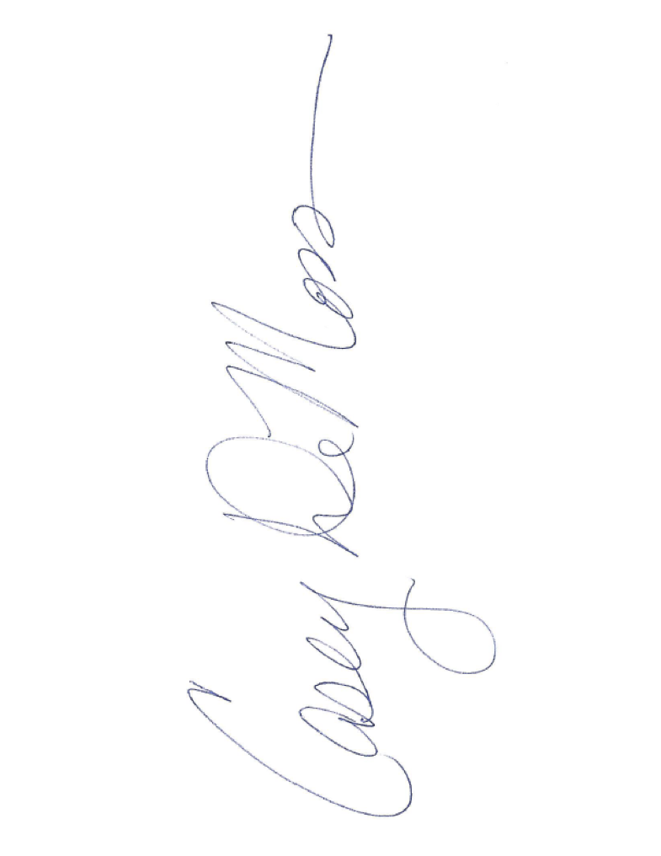
Thank you for your time and attention.
Sincerely,

Casey DeMoss
Alliance for Affordable Energy

Certificate of Service Docket No. UD-08-02
I hereby certify that I have this 6th day of September, 2016, served the required number of copies of the foregoing motion upon all other known parties of this proceeding, by electronic mail.

_________________________________________
Casey DeMoss
Alliance for Affordable Energy

ENTERGY NEW ORLEANS, INC
IN RE: PROPOSED RULEMAKING TO ESTABLISH INTEGRATED RESOURCES PLANNING COMPONENTS AND REPORTING REQUIREMENTS FOR
ENTERGY NEW ORLEANS, INC.
UTILITY DOCKET NO. UD-08-02
.
Lora W. Johnson, lwjohnson@nola.gov
Clerk of Council
City Hall - Room 1E09
1300 Perdido Street
New Orleans, LA 70112
(504) 658-1085 - office
(504) 658-1140 - fax
Service of Discovery not required

Pearlina Thomas, pthomas@nola.gov
Chief of Staff, Council Utilities Regulatory Office
W. Thomas Stratton, Jr., wtstrattonjr@nola.gov
Director, Council Utilities Regulatory Office
City Hall - Room 6E07
1300 Perdido Street
New Orleans, LA 70112
(504) 658-1110 - office
(504) 658-1117 – fax

Matt Lindsay, mjlindsay@nola.gov
Acting Chief of Staff
New Orleans City Council
City Hall - Room 1E06
1300 Perdido Street
New Orleans, LA 70112
(504) 658-1080 - office
(504) 658-1100 – fax

Rebecca Dietz
rhdietz@nola.gov
City Attorney
Law Department
City Hall - 5th Floor
New Orleans, LA 70112
(504) 658-9800 - office
(504) 658-9869 - fax
Service of Discovery not required

Norman S. Foster, nsfoster@nola.gov
Department of Finance
City Hall - Room 3W06
1300 Perdido Street
New Orleans, LA 70112
(504) 658-1519- office
(504) 658-1705 – fax

ADMINISTRATIVE HEARING OFFICER

Hon. Jeffrey S. Gulin, jgulin@verizon.net
3203 Bridle Ridge Lane
Lutherville, MD 21093
(410) 627-5357

NEW ORLEANS CITY COUNCIL CONSULTANTS

Clinton A. Vince, clinton.vince@dentons.com
Presley Reed, presley.reedjr@dentons.com
Emma F. Hand, emma.hand@dentons.com
1900 K Street NW
Washington, DC 20006
(202) 408-6400 - office
(202) 408-6399 - fax

Basile J. Uddo (504) 583-8604 cell, buddo@earthlink.net
J. A. “Jay” Beatmann, Jr. (504) 256-6142 cell, (504) 524-5446 office direct, jay.beatmann@dentons.com
c/o DENTONS US LLP
650 Poydras Street
Suite 2850
New Orleans, LA 70130

Walter J. Wilkerson, wwilkerson@wilkersonplc.com
Kelley Bazile, kbazile@wilkersonplc.com
Wilkerson and Associates, PLC
650 Poydras Street - Suite 1913
New Orleans, LA 70130
(504) 522-4572 - office
(504) 522-0728 - fax
Joseph Vumbaco, jvumbaco@ergconsulting.com
Victor M. Prep, vprep@ergconsulting.com
Joseph W. Rogers, jrogers@ergconsulting.com
Legend Consulting Group
8055 East Tufts Ave., Suite 1250
Denver, CO 80237-2835
(303) 843-0351 - office
(303) 843-0529 - fax

Errol Smith, ersmith@btcpas.com
Bruno and Tervalon
4298 Elysian Fields Avenue
New Orleans, LA 70122
(504) 284-8733 - office
(504) 284-8296 – fax

ENTERGY NEW ORLEANS, INC.

Gary E. Huntley, ghuntle@entergy.com
Entergy New Orleans, Inc.
Vice-President, Regulatory Affairs
1600 Perdido Street, L-MAG 505B
New Orleans, LA 70112
504-670-3680 office
504-670-3615 fax

Seth Cureington, scurein@entergy.com
Entergy New Orleans, Inc.
Manager, Resource Planning
1600 Perdido Street, L-MAG 505B
New Orleans, LA 70112
504-670-3602 office
504-670-3615 fax

Polly S. Rosemond, prosemo@entergy.com
Entergy New Orleans, Inc.
Manager, Regulatory Affairs
1600 Perdido Street, L-MAG 505B
New Orleans, LA 70112
504-670-3567 office
504-670-3615 fax

Derek Mills, dmills3@entergy.com
Project Manager
1600 Perdido Street, Bldg. #505
New Orleans, LA 70112
504-670-3527

Kathryn J. Lichtenberg (504) 576-2763 office, klichte@entergy.com
Tim Cragin (504) 576-6523 office, tcragin@entergy.com
Brian L. Guillot (504) 576-2603 office, bguill1@entergy.com
Alyssa Maurice-Anderson (504) 576-6523 office, amauric@entergy.com
Harry Barton (504) 576-2984 office, hbarton@entergy.com
Entergy Services, Inc.
Mail Unit L-ENT-26E
639 Loyola Avenue
New Orleans, LA 70113
(504) 576-5579 - fax

Joe Romano, III (504) 576-4764, jroman1@entergy.com
Suzanne Fontan (504) 576-7497, sfontan@entergy.com
Danielle Burleigh (504) 576-6185, dburlei@entergy.com
Therese Perrault (504-576-6950), tperrau@entergy.com
Entergy Services, Inc.
Mail Unit L-ENT-4C
639 Loyola Avenue
New Orleans, LA 70113
(504)576-6029 - fax

JACOBS TECHNOLOGY, INC.

Mr. Michael L. Winberry, michael.l.winberry@nasa.gov
Business Manager
Jacobs Technology Inc.
13800 Old Gentilly Road, Building 320
New Orleans, LA 70129

THE FOLGER COFFEE COMPANY (J.M. SMUCKER)

Rick Boyd, rick.boyd@jmsmucker.com
The Folger Coffee Company
14601 Old Gentilly Road
New Orleans, La 70129

USG CORPORATION

Mr. Fred M. Mazurski, CEM, CDSM, fmazurski@usg.com
Senior Manager, Energy USG Corporation
550 West Adams Street
Chicago, IL 60661-3676

SIERRA CLUB

Joshua Smith, joshua.smith@sierraclub.org
Staff Attorney
Sierra Club Environmental Law Program
85 Second Street, 2nd Floor
San Francisco, CA 94105
(415)977-5560
(415)977-5793 (fax)
(503)484-7194 (cell)

ALLIANCE FOR AFFORDABLE ENERGY

Casey DeMoss, CEO, casey@all4energy.org
4035 Washington Ave.,
New Orleans, LA 70125
(504) 208-9761

Logan Atkinson Burke, logan@all4energy.org
4035 Washington Ave.,
New Orleans, LA 70125
(504) 208-9761- office
(646) 942-7149 - cell

GULF STATES RENEWABLE ENERGY INDUSTRIES ASSOCIATION (GSREIA)

Jeff Cantin, President, jcantin@gsreia.org
643 Magazine St., Ste. 102
New Orleans, LA 70130
(504) 383-8936

Heather Pohnan, Administrative Director, hpohnan@gsreia.org
643 Magazine St., Ste. 102
New Orleans, LA 70130
Office: 888-647-7342
Mobile: 630-639-0631

GREEN COAST ENTERPRISES

Jacquelyn Dadakis, jackie@greencoastenterprises.com
Managing Director, GCE Services
2725 So. Broad Street
New Orleans, LA 70125
504-459-4006

Regina La Macchia, gina@greencoastenterprises.com
Development Manager
2725 So. Broad Street
New Orleans, LA 70125
Office: 504-459-4010
Mobile: 504-264-2394

SOUTHEAST ENERGY EFFICIENCY ALLIANCE

Abby Fox, afox@seealliance.org
Policy Manager
50 Hurt Plaza SE, Suite 1250
Atlanta, GA 30303
Office: 404-602-9665
Cell: 901-292-3544

POSIGEN SOLAR SOLUTIONS

Karla Loeb, kloeb@posigen.com
Director of Business Development
2424 Edenborn Ave., Suite 550
Metairie, LA 70001
504-293-5665

Margot Want, mwant@posigen.com
Associate General Counsel
2424 Edenborn Ave., Suite 550
Metairie, LA 70001
504-293-5670

BUILDING SCIENCE INNOVATORS LLC

Myron Katz, myron.bernard.katz@gmail.com
302 Walnut Street
New Orleans, LA 70118

SOUTH COAST SOLAR, LLC

Robert L. Suggs, Jr., CEO, rsuggs@southcoastsolar.com
2605 Ridgelake Drive
Metairie, LA 70002
504-529-7869

AIR PRODUCTS AND CHEMICALS, INC.

Ernest L. Edwards, Jr., ledwards@bmpllp.com
Beirne, Maynard & Parsons, L.L.P.
601 Poydras Street
Suite 2200
New Orleans, LA 70130-6097
(504) 584-9126 – office
(504) 450-4226 - cell
(504 584-9142 - fax

Mark Zimmerman, zimmermr@airproducts.com
Air Products and Chemicals, Inc.
7201 Hamilton Boulevard
Allentown, PA 18195-1501
(610) 481-1288 - office
(610) 481-2182 – fax

GREATER NEW ORLEANS HOUSING ALLIANCE

Andreanecia Morris, amorris@gnoha.org
Ross Hunter, rhunter@gnoha.org
1050 S. Jeff Davis Pkwy, Suite 301
New Orleans, LA 70125
(504) 821-7235

