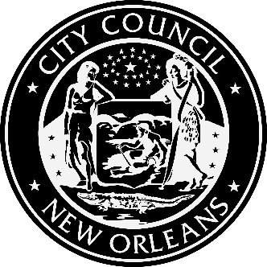

NOTICE OF KICKOFF MEETING,
DEMAND SIDE MANAGEMENT POTENTIAL STUDY
Wednesday, April 4, 2018, 9:00 A.M. - NOON
New Orleans City Council Chambers
City Hall First Floor, 1300 Perdido Street, New Orleans, LA

2018 TRIENNIAL INTEGRATED RESOURCE PLAN
OF ENTERGY NEW ORLEANS, INC.
Council Utility Docket UD-17-03

A Demand Side Management Potential Study is being performed by Optimal Energy, Inc., the Council’s Consultant. At this meeting Optimal will make a presentation on its Study Methodology, will receive comments and engage in discussion regarding that presentation, and will discuss and receive comments on a draft Measure List. A detailed agenda will follow.

This is not a meeting of the Council or its Utility, Cable, Telecommunications and Technology Committee, but is a meeting that is occurring as a part of the proceedings in the Council’s Utility Docket UD-17-03.

CITY COUNCIL UTILITY, CABLE, TELECOMMUNICATIONS AND TECHNOLOGY COMMITTEE
JASON ROGERS WILLIAMS, CHAIRPERSON, COUNCILMEMBER-AT-LARGE
STACY HEAD, COUNCILMEMBER-AT-LARGE
SUSAN G. GUIDRY, COUNCILMEMBER, DISTRICT “A”
JARED C. BROSSETT, COUNCILMEMBER, DISTRICT “D”
JAMES A. GRAY, II, COUNCILMEMBER, DISTRICT “E”
FOR MORE INFORMATION PLEASE CONTACT COUNCIL UTILITY REGULATORY OFFICE AT 658-1110

This meeting is accessible to people with disabilities. Should you require any accommodation to participate fully, please contact Tom Stratton at 504 658-1110 (Voice); TTY: 711, LA Relay Service or by email to wtstrattonjr@nola.gov at least 18 hours prior to this event. This communiqué’ is available in alterative formats upon request.
Posted: March 26, 2018 at 11:00 am

